**2019/11/20  
108學年度第一學期 高維度資料分析 期中考**

系級: 姓名:

# 貼上執行程式碼及執行結果及圖形   
(程式碼字形為Courier New，10點字，單行距。)

(貼圖時，請注意圖形之大小，應適中; 圖內之文字數字應可識別。)

# 1 使用之套件: “mice” & “VIM”

#(a)

> mamm <- read.table("108-1-HDDA-MidtermExam/mammographic_masses.data", sep = ",", na.strings = "?")

> names(mamm) <- c("BI-RADS", "Age", "Shape", "Margin", "Density", "Severity")

summary(mamm)

BI-RADS Age Shape Margin

Min. : 0.000 Min. :18.00 Min. :1.000 Min. :1.000

1st Qu.: 4.000 1st Qu.:45.00 1st Qu.:2.000 1st Qu.:1.000

Median : 4.000 Median :57.00 Median :3.000 Median :3.000

Mean : 4.348 Mean :55.49 Mean :2.722 Mean :2.796

3rd Qu.: 5.000 3rd Qu.:66.00 3rd Qu.:4.000 3rd Qu.:4.000

Max. :55.000 Max. :96.00 Max. :4.000 Max. :5.000

NA's :2 NA's :5 NA's :31 NA's :48

Density Severity

Min. :1.000 Min. :0.0000

1st Qu.:3.000 1st Qu.:0.0000

Median :3.000 Median :0.0000

Mean :2.911 Mean :0.4631

3rd Qu.:3.000 3rd Qu.:1.0000

Max. :4.000 Max. :1.0000

NA's :76

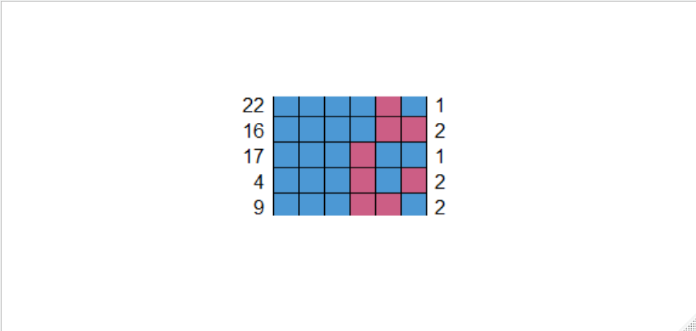

library(mice)

library(VIM)

md.pattern(mamm)

Severity BI-RADS Age Shape Margin Density

830 1 1 1 1 1 1 0

56 1 1 1 1 1 0 1

22 1 1 1 1 0 1 1

16 1 1 1 1 0 0 2

17 1 1 1 0 1 1 1

4 1 1 1 0 1 0 2

9 1 1 1 0 0 1 2

5 1 1 0 1 1 1 1

1 1 0 1 1 1 1 1

1 1 0 1 0 0 1 3

0 2 5 31 48 76 162

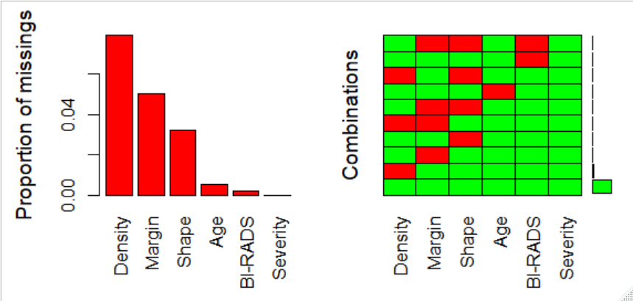

> matrixplot(mamm)

mamm.aggrplot <- aggr(mamm, col = c("green", "red"), nubers = T, prop = T, sortVars = T, labels = names(mamm))

Variables sorted by number of missings:

Variable Count

Density 0.079084287

Margin 0.049947971

Shape 0.032258065

Age 0.005202914

BI-RADS 0.002081165

Severity 0.000000000

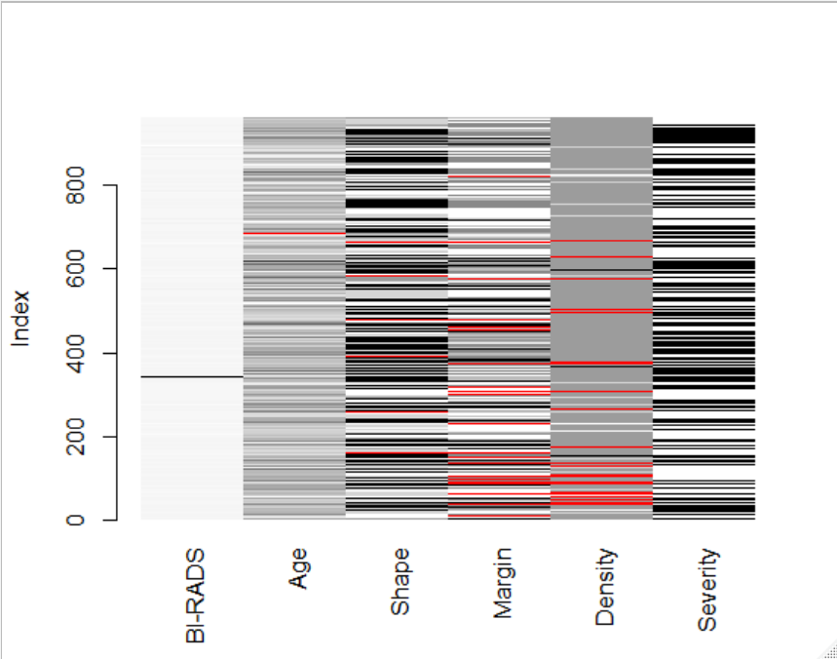

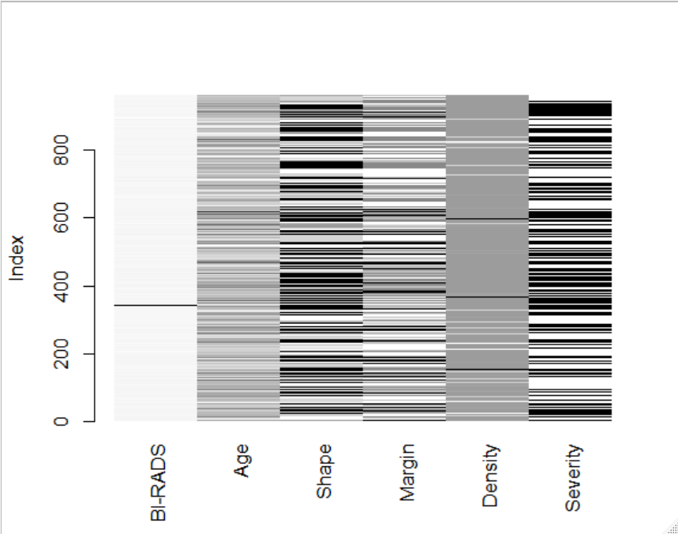

#(b)

> #Mean Substitution

> mean.subst <- function(x) {

+ x[is.na(x)] <- mean(x, na.rm = TRUE)

+ x

+ }

> mamm.m <- apply(mamm, 2, mean.subst)

> matrixplot(mamm.m)

#kNN

> mamm.kNN <- kNN(mamm, k = 5)

> matrixplot(mamm.kNN[1 : 6])