**2019/12/11  
108學年度第一學期 高維度資料分析 小考(2)**

系級: 姓名:

# 貼上執行程式碼及執行結果及圖形

# 大概解釋一下圖形所呈現的現象  
(程式碼字形為Courier New，10點字，單行距。)

(貼圖時，請注意圖形之大小，應適中; 圖內之文字數字應可識別。)

# 2

#(a)

> pheatmap(scale(wine[, 2 : 14]), annotation_row = wineclus)

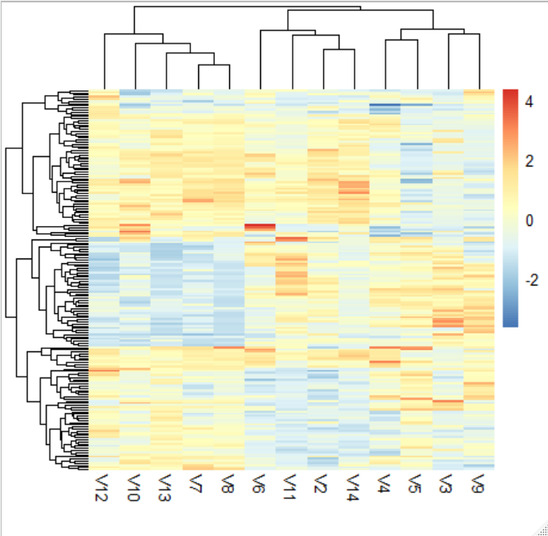

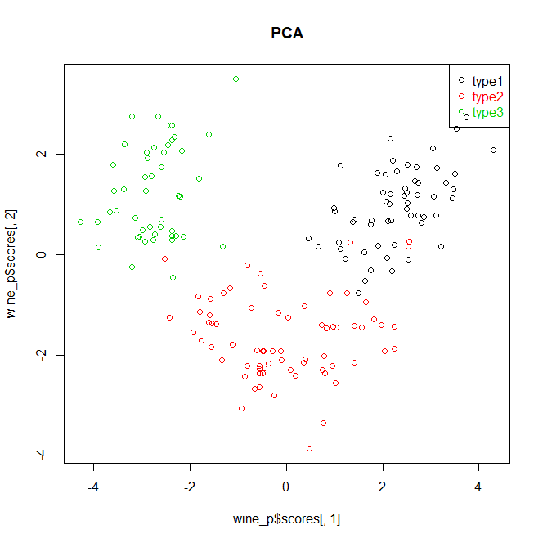

#(b)

> wine_p <- princomp(scale(wine[, 2 : 14]))

> windows()

> plot(wine_p$scores[, 1], wine_p$scores[, 2], col = wine[, 1], main = "PCA")

> legend("topright", c("type1", "type2", "type3"), col = c(1, 2, 3), pch = 1, text.col = c(1, 2, 3))

>

> wine.sd <- t(scale(wine[2 : 14]))

> wine.cor <- cor(wine.sd)

> wine.dis <- sqrt(2 * (1 - wine.cor))

> wine_mds <- cmdscale(wine.dis, k = 10)

> windows()

> plot(wine_mds[, 1], wine_mds[, 2], col = wine[, 1], main = "MDS")

> legend("topright", c("type1", "type2", "type3"), col = c(1, 2, 3), pch = 1, text.col = c(1, 2, 3))

>

> library(vegan)

> wine_isom <- isomap(wine.dis, k = 3)

> windows()

> plot(wine_isom, col = wine[, 1], main = "ISOMAP")

> legend("topright", c("type1", "type2", "type3"), col = c(1, 2, 3), pch = 1, text.col = c(1, 2, 3))

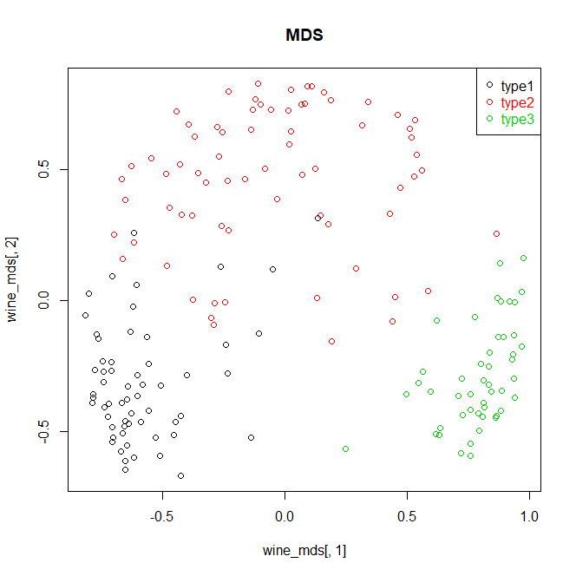

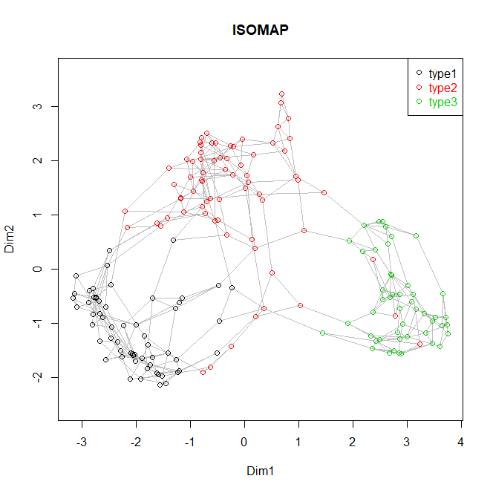

#(c)

library(e1071)

> x <- wine[, 2 : 14]

> y <- wine[, 1]

> model <- svm(x, y)

> pred <- predict(model, x)

> accuracy <- sum(diag(table(pred, y))) / length(y)

> accuracy

[1] 0.005617978

#PCA

> svmacc <- function(DR_data, num_dimesions, data_cate){

+ acc_vec <- rep(NaN, num_dimesions)

+

+ for (i in 1 : num_dimesions) {

+ x <- DR_data[, i]

+ y <- data_cate

+ model <- svm(x, y)

+ pred <- predict(model, x)

+ acc_vec[i] <- sum(diag(table(pred, y))) / length(y)

+ }

+ acc_vec

+ }

>

> wine_svm_pca <- svmacc(wine_p$scores, 10, wine[, 1])

>

> wine_svm_mds <- svmacc(wine_mds, 10, wine[, 1])

>

> wine_svm_isom <- svmacc(wine_isom$points, 10, wine[, 1])

>

> plot(wine_svm_pca, type = "l", ylim = c(0, 0.05))

> points(wine_svm_mds, type = "l", col = "green", lty = 2)

> points(wine_svm_isom, type = "l", col = "red", lty = 3)

> legend("topright", c("PCA", "MDS", "ISOMAP"), col = c("black", "green", "red"), lty = c(1, 2, 3))

