INTERNSHIP / TRAINING PROJECT
Week 1 Report

DATA COLLECTION & STRATEGY PLANNING
FOR TOURISM INSIGHTS

A data-collection plan and preliminary analysis based on
official tourism statistics (Tourism_raw_data.pdf)
Student Name Akshita
Programme B.Tech Computer Science and Engineering
Project Internship / Training Project (Data Science / Tourism Analytics)
Report Week 1
Academic Year 2026
Institution Amritsar Group of Colleges

Contents
1. Introduction
2. Project Objectives
3. Research Questions
4. Data Sources
5. Data Collection Strategy
6. Source Selection and Data Evaluation
7. Preliminary Data Collection and Analysis: Global Tourism
8. India-Specific Tourism Analysis
9. Long-Term Tourism Trend: 2001–2024
10. Source Country and Regional Analysis
11. Seasonality Analysis
12. Port and Mode of Arrival Analysis
13. Preliminary KPIs
14. Data Quality Issues and Mitigation
15. Challenges and Risk Mitigation
16. Expected Insights and Future Analysis
17. Proposed 33-Hour Action Plan
18. Research Log
19. Conclusion
References and Source Notes
Appendix A: Items Requiring Verification

Note on Sources and Conventions
This report is built around one supplied file, Tourism_raw_data.pdf (181 pages), which is a compilation of tourism tables. Every figure in Sections 7 to 12 was read from that PDF and entered into the report by hand. No figure comes from memory or from any other website or database. Before anything here is used in a formal publication, the numbers should be re-checked against the original table.
The following conventions are used throughout the report:
- "PDF Table 2.1.1" means Table 2.1.1 as numbered in the supplied PDF. Tables and figures created for this report are numbered separately as Table R1, R2, … and Figure 1, 2, … so that the two sets of numbers are never confused.
- Number format. The PDF prints Indian-style digit grouping (for example 1,09,30,355). In this report the same value is written as 10,930,355. One lakh is 100,000 and one crore is 10 million.
- Provisional values. The PDF marks 2024 values in the UN Tourism tables (PDF Tables 1.1.1 to 1.2.3) as provisional, and 2024 FEE values (PDF Tables 2.9.1 to 2.9.3) as revised estimates. These are marked with * or (P) in this report.
- Calculated values. Percentages and ratios that I calculated myself are written as "calculated" or marked with a dagger (†). Values printed in the PDF are labelled "as printed in the PDF".
- Plan versus work done. Sections 4, 5, 6, 15, 16 and 17 describe a proposed plan for the data work. They do not claim that every source was already collected. Section 18 states what has actually been done in Week 1.
- Term definitions. The six main terms (international tourist arrivals, FTAs, NRI arrivals, ITAs, international tourism receipts and FEE) are kept separate and are explained at the point where they are first needed.

1. Introduction
Tourism affects many parts of an economy at the same time. It brings in foreign exchange, supports jobs in transport, hotels and local trade, and puts demands on airports, roads and heritage sites. Governments, airlines, hotels and local tourism boards all plan their work using tourism statistics, so the quality of these statistics matters.
Tourism is also a good subject for data-driven work. Official agencies publish long yearly series, and many of them are broken down by month, country of origin, port of entry and purpose of visit. This gives the kind of data that a Data Science student normally works with: time series, categories, shares and growth rates. Alongside these numbers there is unstructured public information such as travel reviews and search interest, which can later be used to study how tourists feel about places.

Visitor volume and economic value
The number of tourists and the money they bring in are not the same thing, and they do not always move together. The supplied PDF shows this at the world level: international tourist arrivals in 2024 (1,465 million) were almost the same as in 2019 (1,466 million), while international tourism receipts were 1,731 billion US dollars in 2024 against 1,487 billion in 2019 (PDF Tables 1.1.2 and 1.2.2). A report that only looked at arrivals would say that tourism had returned to its 2019 position, and a report that only looked at receipts would say that it had grown a lot. Neither statement alone gives the full picture. For the same reason this project uses several indicators together and keeps their definitions separate: international tourist arrivals, Foreign Tourist Arrivals (FTAs), Non-Resident Indian (NRI) arrivals, International Tourist Arrivals in India (ITAs), international tourism receipts and Foreign Exchange Earnings (FEE).

Purpose of this Week 1 task
Week 1 is a planning and groundwork stage. The aims are to find reliable public data sources, to decide how the data will be collected and checked, to run a first set of simple calculations on official numbers, and to list the data-quality problems that must be handled before any deeper analysis. This report does not claim to give final conclusions about tourism. It gives a plan, a first look at the data, and a list of cautions.

Why reliable public data matters
Any model or chart built on weak data will give weak answers. Official statistics have a named publisher, a stated period and usually a stated method, so every number can be traced back to a table. That is why this project starts with official tourism statistics from the supplied PDF (UN Tourism for world figures, the Bureau of Immigration for India, and the Archaeological Survey of India and State/UT tourism departments for site-level and state-level figures). Supplementary sources such as reviews, social-media information and search trends can be added later, but only as supporting evidence, because they measure opinions and interest rather than actual arrivals.
The work in this report is the foundation for the later Data Science stages: cleaning, exploratory analysis, forecasting, clustering and sentiment analysis. These methods are listed in Section 16 as future work. None of them has been carried out yet.

2. Project Objectives
The Week 1 objectives are listed below. Each one is linked to a section of the report.
- Identify reliable public data sources for tourism statistics, reviews, social-media information and related datasets (Sections 4 and 6).
- Develop a structured data-collection strategy that goes from research question to insight (Section 5).
- Examine international tourist arrival trends at the world level for 2019, 2023 and 2024 (Section 7).
- Examine tourism receipt trends at the world level for the same years (Section 7).
- Compare tourist volume with tourism-related receipts without drawing causal conclusions (Section 7).
- Study India-specific inbound tourism, separating FTAs, NRI arrivals and ITAs (Sections 8 and 9).
- Examine source countries and regions that send tourists to India (Section 10).
- Examine seasonality using monthly and quarterly tables (Section 11).
- Examine modes and ports of arrival (Section 12).
- Identify data-quality problems and plan mitigation steps (Sections 14 and 15).
- Define useful tourism KPIs with clear formulas (Section 13).
- Establish a foundation for later statistical and machine-learning analysis (Section 16).

3. Research Questions
Eight research questions guide the project. Table R1 lists them with the PDF tables that will be used to answer them and the measures that will be calculated. The questions are kept simple on purpose, because Week 1 only prepares the ground for deeper work.
Table R1. Research questions, PDF tables to be used and planned measures
ID | Research question | Main PDF tables | Planned measures
RQ1 | How did international tourist arrivals and international tourism receipts change globally between 2019, 2023 and 2024? | 1.1.1, 1.1.2, 1.2.1, 1.2.2 | Percentage change; recovery ratio
RQ2 | Did changes in tourist arrivals correspond to changes in tourism receipts? | 1.1.2, 1.2.2 | Side-by-side growth rates; receipts-to-arrivals ratio (descriptive only)
RQ3 | How has India's inbound tourism changed over the long term? | 1.1.2, 1.2.2, 2.1.1, 2.9.1 | Growth rates; compound annual growth; India's share and rank
RQ4 | How have FTAs, NRI arrivals and ITAs changed in India? | 2.1.1, 2.2.3, 2.2.4 | Year-on-year change; recovery ratio; NRI share of ITAs
RQ5 | Which source countries and regions contribute the largest share of FTAs to India? | 2.1.2, 2.1.3, 2.1.4, 2.1.6 | Regional share; top-N share; concentration
RQ6 | What seasonal patterns can be observed in FTAs to India? | 2.2.1, 2.2.2, 2.2.5, 2.2.6 | Monthly share; quarterly share; peak-to-lean ratio
RQ7 | Through which modes and ports do foreign tourists enter India, and which entry points contribute the largest shares? | 2.3.1, 2.3.2, 2.4.1 to 2.4.4 | Share by mode; share by port or airport
RQ8 | What data-quality and methodological issues need attention before deeper analysis? | All tables used | Checklist of issues with detection and mitigation
Table R1 is the author's planning table. Table numbers in column 3 refer to the supplied PDF.

4. Data Sources
This section discusses ten possible sources. For each one it states what the source provides, why it is useful, which variables can be taken from it, its limits and biases, and how it could be used later. The first six are official or institutional sources. The last three (reviews, social media and search trends) are supplementary and are meant for exploratory use only.

4.1 Ministry of Tourism, Government of India
- What it provides. The national tourism ministry is the expected publisher of India's tourism statistics. The categories expected from it are FTAs, NRI arrivals, ITAs, country-wise and region-wise arrivals, monthly and quarterly arrivals, mode and port of arrival, foreign exchange earnings and long historical series.
- Evidence from the PDF. The supplied PDF contains all of these categories (Table R2 below). However, the table notes in the extracted text of the PDF name the Bureau of Immigration, UN Tourism, the Archaeological Survey of India and the State/UT tourism departments as sources. The Ministry of Tourism is not named anywhere in the extracted text. So the exact publication title and year of the PDF requires verification before it is cited formally.
- Why it is the primary source. The tables are official, cover many years, are broken into useful categories, and agree with each other in places that can be checked. For example, FTAs plus NRI arrivals add up exactly to ITAs in 2019, 2023 and 2024 (PDF Tables 2.1.1, 2.2.1, 2.2.3 and 2.2.4).
- Variables. Year, month, quarter, country of origin, region, mode of transport, port of arrival, number of arrivals, percentage share, percentage change, FEE in rupees and US dollars.
- Limitations. The 2024 values are provisional or revised estimates in some tables. Some tables (PDF Tables 1.1.2, 1.1.3, 1.2.2 and 2.9.1 to 2.9.3) carry no source line in the extracted text. The definition of each indicator must be read carefully, as explained in Section 14.
- Later use. Core dataset for the descriptive analysis, KPI calculation, seasonality study and the later forecasting and clustering work.
Table R2. Coverage of the supplied PDF: the tables used in this report
PDF Table | Content | Years / period | Source line printed in PDF
1.1.1 | International tourist arrivals by (sub)region | 2019, 2023, 2024* | UN Tourism, World Tourism Barometer, May 2025
1.1.2 | Tourist arrivals in World and India; % change; India's share and rank | 2001–2024 (P) | Not stated in extracted text
1.1.3 | Arrivals by country of destination (top 20) | 2019, 2023, 2024* | Not stated in extracted text
1.2.1 | International tourism receipts by (sub)region | 2019, 2023, 2024* | UN Tourism, World Tourism Barometer, May 2025
1.2.2 | Tourism receipts: World and India (FEE), share and rank | 2001–2024 (P) | Not stated in extracted text
1.2.3 | Top 15 countries by international tourism receipts | 2019, 2023, 2024* | UN Tourism Barometer, May 2025
2.1.1 | Inbound tourism: FTAs, NRI arrivals and ITAs | 1981, 1991, 2001, 2011–2024 | Bureau of Immigration (BOI), Govt. of India
2.1.2 | FTAs in India by region | 2019, 2023, 2024 | BOI
2.1.3 / 2.1.4 | Top 15 source countries; top 15 by growth | 2019, 2023, 2024 | BOI
2.1.5 / 2.1.6 | FTAs by selected country; top source countries year-wise | 2019–2024; 2001–2024 | BOI
2.2.1 to 2.2.4 | Monthly FTAs; peak/lean months; monthly NRI arrivals; monthly ITAs | 2019, 2023, 2024 | BOI
2.2.5 / 2.2.6 | Quarterly FTAs (all years); quarterly FTAs by country | 2001–2024; 2024 | BOI
2.3.1 / 2.3.2 | FTAs by mode of transport; by mode and country | 2001–2024; 2024 | BOI
2.4.1 to 2.4.4 | FTAs by major port; by airport; by port and country; by Indian region | 2001–2024; 2024 | BOI
2.9.1 to 2.9.3 | Foreign exchange earnings (FEE): yearly, monthly in ₹ crore and US$ | 1991, 2001, 2011–2024 | Not stated; 2024 = revised estimates
4.1.1 / 4.1.2 | Domestic and foreign tourist visits to States/UTs | 1991, 2001, 2011–2024; 2023–24 | States/UTs Tourism Departments (4.1.2)
4.2.1 to 4.2.3 | Visitors to centrally protected ticketed monuments | FY 1996 to FY 2024-25 | Archaeological Survey of India (ASI)
Source: compiled by the author from the contents of Tourism_raw_data.pdf. * = provisional; (P) = provisional. The PDF also contains PDF Tables 3.1.1 to 3.8.2 on departures of Indian nationals, which are outside the Week 1 scope.

4.2 UN Tourism
- What it provides. World and regional estimates of international tourist arrivals and international tourism receipts. In the supplied PDF these appear in PDF Tables 1.1.1 to 1.2.3, sourced to the UN Tourism World Tourism Barometer, May 2025.
- Why it is useful. It gives a common basis to compare countries and world regions, and to place India in a world context (for example India's share of world arrivals and receipts).
- Variables. Arrivals in millions, receipts in billion US dollars, sub-region, percentage change, rank and share.
- Limitations. Each country reports on its own definitions and methods, so international comparisons are only approximate. The 2024 numbers are provisional and may be revised in later editions.
- Later use. Benchmarking India against other destinations and comparing regional recovery patterns.

4.3 Bureau of Immigration
- What it provides. The Bureau of Immigration (BOI), Government of India, is the source line for the India arrival tables in the PDF (FTAs, NRI arrivals, ITAs, nationality, port, mode, month, quarter).
- Why it is useful. Immigration records are administrative data collected at the border, which is more direct than a survey. They allow detailed breakdowns by country, port and month.
- Variables. Count of arrivals by nationality, port of arrival, mode of transport, month and quarter.
- Limitations. Arrival counts measure arrivals, not unique people; the same traveller can arrive more than once in a year. The exact treatment is to be verified in the original methodology notes. Counts do not record what visitors do or spend after entry.
- Later use. Source-market analysis, seasonality analysis, port-capacity analysis and demand forecasting.

4.4 Reserve Bank of India
- What it may provide. The Reserve Bank of India (RBI) publishes balance-of-payments and foreign-exchange data. Travel-related receipts form one part of these statistics and could be used to cross-check the foreign exchange earnings (FEE) in the PDF.
- Evidence from the PDF. The RBI is not named in the PDF text, and the FEE tables (PDF Tables 2.9.1 to 2.9.3) show no source line. How the FEE series is compiled and whether it matches RBI travel receipts requires verification.
- Variables (to be confirmed). Monthly or quarterly travel receipts and payments, exchange rates.
- Limitations. Balance-of-payments categories may not match the tourism ministry's FEE definition exactly. Values may be revised.
- Later use. Converting between rupee and dollar values, and checking whether the FEE trend is consistent with an independent financial source.

4.5 State and Union Territory Tourism Departments
- What it provides. Visits to individual states and union territories. In the PDF, PDF Table 4.1.2 (source: States/UTs Tourism Department) lists domestic and foreign tourist visits by state for 2023 and 2024.
- Why it is useful. National tables hide destination-level differences. State data shows which destinations receive the visits. For example, for 2024 the table lists 0.542 million foreign tourist visits for Punjab and 2.072 million for Rajasthan.
- Variables. Domestic tourist visits (DTV), foreign tourist visits (FTV), growth rate and share by state.
- Limitations. A footnote in PDF Table 4.1.2 says that 2024 data is estimated by applying the all-India growth rate for 2023/19 to 2019 data. This applies to the entries marked with it, so the affected states cannot be treated as measured values. Also, foreign tourist visits to states (20,942,074 in 2024, PDF Table 4.1.1) are a different measure from FTAs to India (9,951,722) and the two must not be compared directly.
- Later use. Destination popularity analysis and regional comparison once state definitions are checked.

4.6 Archaeological Survey of India
- What it provides. Ticketed visitor numbers for centrally protected monuments, split into domestic and foreign visitors (PDF Tables 4.2.1 to 4.2.3, source: ASI).
- Why it is useful. It supplements national arrival counts with site-level information. In FY 2024-25 the PDF reports 56,646,255 visitors in total and 2,415,000 foreign visitors, of whom 645,624 (26.73%) visited the Taj Mahal (PDF Table 4.2.2).
- Variables. Monument name, financial year, domestic visitors, foreign visitors, growth rate.
- Limitations. Only ticketed monuments are counted, the period is a financial year (not a calendar year), and a foreign visitor to a monument is a different unit from an FTA to India.
- Later use. Heritage-site popularity analysis and linking arrival patterns to attractions.

4.7 Travel reviews
- What it provides. Public reviews of attractions, hotels and restaurants written by travellers. Platforms such as TripAdvisor or Google Maps reviews are examples of where such reviews exist. Their terms of use and data-access rules must be checked before any collection, and none has been collected in Week 1.
- Variables. Rating, review text, destination, review date, reviewer's stated country (if public), attraction type, and themes such as complaints about cleanliness, crowding, safety, price or service quality.
- Why it is useful. It gives tourist opinion, which official statistics do not contain, and could support sentiment analysis and topic analysis.
- Limitations and sampling bias. Reviewers are a self-selected group. People with very good or very bad experiences write more reviews than people with average ones. Popular places have many more reviews than small ones, review volume changes over time with platform popularity, and fake reviews exist. Review counts must not be used as a measure of tourist numbers.
- Later use. Sentiment by destination, common complaint themes, and comparison of sentiment before and after seasons or events.

4.8 Public social-media information
- What it provides. Public posts, hashtags, captions, geotags and engagement counts that show which places are being talked about.
- Variables. Hashtag counts, post dates, location tags, engagement (likes, comments), language of the post.
- Why it is useful. It can act as an early indicator of interest in a destination and can show trends in how places are presented to the public.
- Limitations. Users are not representative of all tourists, platforms differ by age group and country, bots and promotional posts distort counts, location tags are often missing or wrong, and platform rules and privacy law limit what can be collected. Only public, aggregated and anonymised information should be used.
- Later use. Trend indicators and topic analysis, always as a supporting source and never as a count of tourists.

4.9 Search trends
- What it provides. Relative search interest for tourism-related keywords (for example destination names or "visa" terms) over time and by region. Tools such as Google Trends report an index scaled within the chosen query, not raw search counts.
- Variables. Keyword, date, region, relative interest index.
- Why it is useful. Search interest may rise before people travel, so it could be tested later as a possible leading indicator for arrivals.
- Limitations. Search interest is a proxy and is not equivalent to actual tourist arrivals. People search out of curiosity, for news or for study. Index values are relative, change with the keyword set, and depend on language and region settings.
- Later use. Exploratory correlation checks with monthly arrivals. Any relationship found would be a correlation only.

4.10 Source selection criteria
Eight criteria are used to judge each source before it is included: authority (who publishes it), relevance (does it help answer a research question), public accessibility (can it be used legally and freely), historical coverage (how many years are available), granularity (month, country, port, state or site), consistency (same definitions and units across years and tables), traceability (can each number be traced to a table, page and publisher) and update frequency (how often it is published or revised). Table R3 compares the sources discussed above.
Table R3. Source comparison (proposed qualitative judgement)
Source | Type | Main content | Main caveat | Planned role
Ministry of Tourism compilation (supplied PDF) | Official | FTAs, NRI, ITAs, country, month, port, mode, FEE | Publisher and year to be confirmed; some 2024 values provisional | Core
UN Tourism | International body | World and regional arrivals and receipts | Country definitions differ; 2024 provisional | Core (benchmark)
Bureau of Immigration | Administrative | Arrivals by nationality, port, mode | Counts arrivals, not unique persons (to verify) | Core
Reserve Bank of India | Financial | Travel-related receipts, exchange rates | Not in PDF; definition match unknown | Cross-check
State/UT Tourism Departments | Official | Visits by state | Some 2024 values estimated; different unit | Supporting
Archaeological Survey of India | Official | Monument visitors | Ticketed sites only; financial year | Supporting
Travel reviews | Public opinion | Ratings and text | Self-selection bias | Exploratory
Public social media | Public opinion | Posts, hashtags, engagement | Non-representative; access rules | Exploratory
Search trends | Proxy | Relative search interest | Not arrivals | Exploratory
Table R3 is a qualitative judgement made by the author for planning purposes; it is not a numerical score.

5. Data Collection Strategy
The data collection is planned as a fixed sequence of steps so that every number in the final analysis can be traced back to a research question and to a source table. Figure 1 shows the workflow.
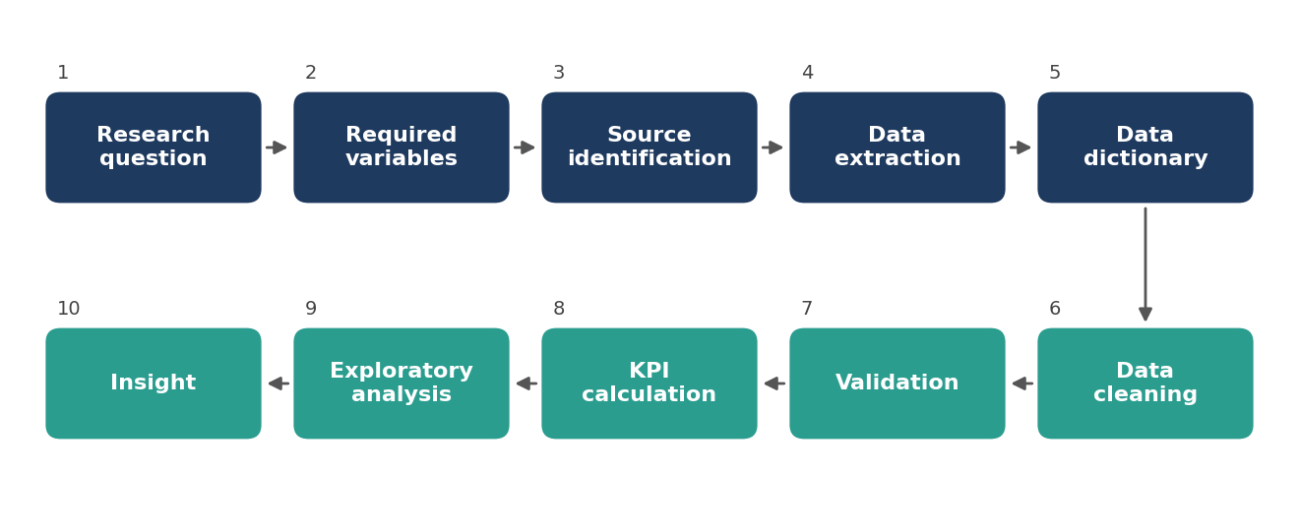
Figure 1. Planned workflow from research question to insight.

5.1 How the workflow will be applied
- Research question → required variables. For each of the eight questions the variables needed are written down first (Table R4), so that data is not collected without a purpose.
- Source identification → extraction. The source with the highest authority that contains the variable is used first. Reviews, social media and search trends are considered only after the official data is in place.
- Data dictionary. Every variable gets a name, a unit, a definition and a source before cleaning starts.
- Cleaning → validation. Values are standardised and then checked against totals, percentages and other tables (Section 14).
- KPI calculation → exploratory analysis → insight. Only validated data is used to calculate the KPIs in Section 13.
Table R4. Research areas, variables, sources, frequency and expected use
Research area | Variables | Source | Frequency | Expected use
World arrivals | International tourist arrivals (million); % change | UN Tourism; PDF Tables 1.1.1, 1.1.2 | Annual | Global trend; recovery ratio
World receipts | International tourism receipts (billion US$) | UN Tourism; PDF Tables 1.2.1, 1.2.2 | Annual | Compare with arrivals
FTAs | Foreign tourist arrivals in India | BOI; PDF Table 2.1.1 | Annual | India trend and recovery
NRI arrivals | Non-resident Indian arrivals | BOI; PDF Tables 2.1.1, 2.2.3 | Annual, monthly | Composition of ITAs
ITAs | FTAs + NRI arrivals | BOI; PDF Tables 2.1.1, 2.2.4 | Annual, monthly | Total inbound volume
Source country | Arrivals by nationality; rank; share | BOI; PDF Tables 2.1.3, 2.1.4, 2.1.6 | Annual | Market concentration
Region | Arrivals by region and sub-region | BOI; PDF Table 2.1.2 | Annual | Regional share and change
Month | Monthly FTAs, NRI arrivals, ITAs | BOI; PDF Tables 2.2.1, 2.2.3, 2.2.4 | Monthly (3 years) | Seasonality
Quarter | Quarterly share of FTAs | BOI; PDF Table 2.2.5 | Quarterly (many years) | Long-run seasonality
Port / mode | Share by port, airport and mode of transport | BOI; PDF Tables 2.3.1 to 2.4.4 | Annual | Capacity and transport planning
Receipts / FEE | FEE in ₹ crore and US$; monthly FEE | PDF Tables 2.9.1 to 2.9.3 (source line not stated) | Annual, monthly | Economic value; cross-check with RBI
Reviews / social / search (pilot) | Rating, text, date, hashtag, search index | Public platforms (to be selected) | As available | Exploratory sentiment and interest

5.2 Manual extraction for the pilot analysis
For the small Week 1 pilot, values were read directly from the PDF tables and typed into a working sheet (for example the world figures for 2019, 2023 and 2024). Manual entry is acceptable for a few dozen numbers, but it can cause typing errors. To reduce this risk, each entered total is compared with the total printed in the PDF, and each percentage is recalculated.

5.3 Structured extraction for larger datasets
Some tables are long, for example PDF Table 2.1.6 (year-wise arrivals from the top source countries, 2001–2024) and the country-wise tables. For these a table-extraction script should be used instead of typing. Because the PDF mixes Indian digit grouping (1,09,30,355), merged header cells and split country names across lines, the output of any script must be checked against the page image before it is trusted.

5.4 Recording source, table and page
Each extracted value carries its provenance. A simple record would hold the source name, the PDF table number, the PDF page, the indicator, the unit, the period type (year, month, quarter or financial year), the status (final, provisional, revised or estimated) and a note on any footnote or doubt. The PDF page number is recorded during extraction.

5.5 Raw and cleaned versions
The raw extracted data is saved once and never edited. All corrections are made in a separate cleaned file, and a short change log explains each correction (for example, converting units or fixing a misread digit). This allows any result to be reproduced from the raw file.

5.6 Data dictionary
The data dictionary lists every variable once, with a unit and a definition. A few examples are given in Table R5. The definitions of FTA, NRI and ITA follow the way the PDF uses them in PDF Table 2.1.1; the exact official definitions should still be copied from the source publication.
Table R5. Sample data dictionary entries
Variable | Unit | Meaning in this project | Do not confuse with
intl_tourist_arrivals_world | million | World international tourist arrivals (UN Tourism) | India arrivals
intl_tourism_receipts_world | billion US$ | World international tourism receipts (UN Tourism) | India FEE
fta_india | number or million | Foreign Tourist Arrivals to India | ITA, which also includes NRIs
nri_india | number or million | Non-Resident Indian arrivals to India | FTA
ita_india | number or million | International Tourist Arrivals in India = FTA + NRI | FTA
fee_inr_crore / fee_usd | ₹ crore / US$ million or billion | Foreign exchange earnings from tourism in India | Global tourism receipts
share_pct | percent | Part divided by total, times 100 | Percentage change

6. Source Selection and Data Evaluation
Before a source is used, it is evaluated against the seven checks described below. The checks are applied to every new source, including supplementary ones.
- Authority. Who is the publisher, and does the publisher have the legal or professional role to produce this statistic?
- Completeness. Are all years, months or countries present, or are there gaps (for example the "-" entries for China in PDF Table 1.1.3 for 2023 and 2024)?
- Consistency. Do totals, shares and growth rates agree inside the table and across tables?
- Timeliness. Is the latest value final or provisional, and when will it be revised?
- Granularity. Is the level of detail enough for the research question (month, country, port)?
- Reproducibility. Can another person find the same number from the same table?
- Definition clarity. Is it clear what is being counted (arrivals, visits, receipts, earnings)?
Table R6 gives an initial judgement for each source group. This is a proposed evaluation framework with qualitative labels only. No numerical scores are used. "Strong" or "Moderate" for the PDF-based sources reflects what was seen in the PDF in Week 1; "To verify" means the point could not be checked from the PDF.
Table R6. Proposed source evaluation matrix (qualitative)
Source | Authority | Complete-ness | Consistency | Timeliness | Granularity | Reproduc-ibility | Definition clarity
UN Tourism tables (PDF 1.x) | Strong | Moderate (some gaps) | Moderate | 2024 provisional | Region, country | Strong | To verify
BOI tables (PDF 2.1 to 2.4) | Strong | Strong | Strong (totals match) | 2024 listed | Country, port, month | Strong | Moderate
FEE tables (PDF 2.9.x) | To verify | Strong | Moderate | 2024 revised | Month, year | Moderate | To verify
State/UT tables (PDF 4.1.x) | Moderate | Moderate | Moderate | Some 2024 estimated | State | Moderate | Moderate
ASI tables (PDF 4.2.x) | Strong | Strong | Strong | FY 2024-25 | Monument | Strong | Moderate
RBI data | Strong | To verify | To verify | To verify | To verify | To verify | To verify
Reviews / social / search | Limited | Limited | Limited | Frequent | High | Limited | Limited
Labels in Table R6 are the author's planning judgement, not measured scores. "Totals match" refers to the checks reported in Sections 8 and 11.

7. Preliminary Data Collection and Analysis: Global Tourism
This section uses the world figures from the UN Tourism tables in the supplied PDF. All numbers in Section 7 are global figures. They are not India figures. The 2024 values are provisional.

7.1 Global tourism: 2019, 2023 and 2024
The three years chosen are the last year before the pandemic disruption (2019), the first year in which world arrivals came close to 2019 again (2023), and the latest year in the PDF (2024). The values are taken from PDF Table 1.1.1 (arrivals) and PDF Table 1.2.1 (receipts), and they are the same in PDF Tables 1.1.2 and 1.2.2.
Table R7. World international tourist arrivals and international tourism receipts, 2019, 2023 and 2024*
Year | International tourist arrivals (million) | International tourism receipts (billion US$)
2019 | 1,466 | 1,487
2023 | 1,306 | 1,536
2024* | 1,465 | 1,731
Source: UN Tourism, World Tourism Barometer, May 2025, as printed in PDF Tables 1.1.1 and 1.2.1. *Provisional. These are world totals.

7.2 Percentage changes
The percentage change between two years is calculated as (later value − earlier value) / earlier value × 100. The calculations are shown in full in Table R8 and the results are in Table R9.
Table R8. Worked calculations (calculated by the author)
Period | Arrivals | Receipts
2019 → 2023 | (1,306 − 1,466) / 1,466 × 100 = −160 / 1,466 × 100 ≈ −10.91% | (1,536 − 1,487) / 1,487 × 100 = 49 / 1,487 × 100 ≈ +3.29%
2023 → 2024* | (1,465 − 1,306) / 1,306 × 100 = 159 / 1,306 × 100 ≈ +12.17% | (1,731 − 1,536) / 1,536 × 100 = 195 / 1,536 × 100 ≈ +12.70%
2019 → 2024* | (1,465 − 1,466) / 1,466 × 100 = −1 / 1,466 × 100 ≈ −0.07% | (1,731 − 1,487) / 1,487 × 100 = 244 / 1,487 × 100 ≈ +16.41%
Table R9. Summary of percentage changes, world totals
Period | Arrivals change (%) | Receipts change (%) | Check against PDF
2019 → 2023 | −10.91 | +3.29 | Not printed in PDF (calculated)
2023 → 2024* | +12.17 | +12.70 | PDF prints 12.17 (Table 1.1.1) and 12.70 (Table 1.2.1)
2019 → 2024* | −0.07 | +16.41 | PDF prints −0.07 (Table 1.1.1) and 16.41 (Table 1.2.1)
Calculated from PDF Tables 1.1.1 and 1.2.1. The 2023→2024 and 2019→2024 results agree with the percentages printed in the PDF, which is a useful check on the manual entry.

7.3 Interpretation
Between 2019 and 2023, world international tourist arrivals decreased by about 10.9%, while world international tourism receipts increased by about 3.3%. Between 2023 and 2024, both increased, by about 12.2% and 12.7% respectively. Over the whole period from 2019 to 2024, arrivals were almost exactly at their 2019 level (−0.07%), while receipts were about 16.4% higher.
Careful reading. The 16.41% is the change in the total receipts figure. It does not prove that each tourist spent 16.41% more, because the total depends on the number of tourists, how much each spent, how long they stayed, prices and exchange rates, and the mix of trips. Also, a rise in arrivals and a rise in receipts in the same year show that the two series moved in the same direction. They do not show that one caused the other.
The yearly pattern in the PDF adds some context. In 2020 arrivals fell by 72.17% and receipts by 62.47%; in 2022 arrivals rose by 111.71% and receipts by 74.35% (PDF Tables 1.1.2 and 1.2.2, Table R10). In 2023 receipts (1,536 billion US$) were already above their 2019 level, while arrivals (1,306 million) were still below. This is the main reason for not using arrivals alone as a measure of tourism health.
Table R10. World arrivals and receipts, 2019 to 2024*, with year-on-year % change as printed in the PDF
Year | Arrivals (million) | Change (%) | Receipts (billion US$) | Change (%)
2019 | 1,466 | 3.75 | 1,487 | 3.34
2020 | 408 | −72.17 | 558 | −62.47
2021 | 461 | 12.99 | 655 | 17.38
2022 | 976 | 111.71 | 1,142 | 74.35
2023 | 1,306 | 33.81 | 1,536 | 34.50
2024 (P) | 1,465 | 12.17 | 1,731 | 12.70
Source: PDF Tables 1.1.2 and 1.2.2. (P) = provisional. The 2020 to 2022 years are disrupted years and are not treated as normal years in this report.

7.4 Chart: global tourist arrivals and tourism receipts, 2019–2024
Arrivals are measured in millions of people (trips) and receipts in billions of US dollars. These are different units, so they should not be drawn as raw values on one axis. Figure 2 therefore uses two separate panels with their own scales. Figure 3 puts both series on one chart by converting each to an index with 2019 = 100, which is acceptable because an index has no unit.
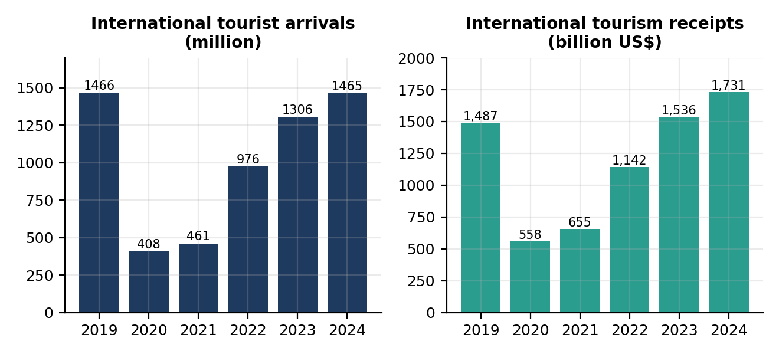
Figure 2. World international tourist arrivals (left) and international tourism receipts (right), 2019–2024*. Source: PDF Tables 1.1.2 and 1.2.2. The two panels have different units and different vertical scales.
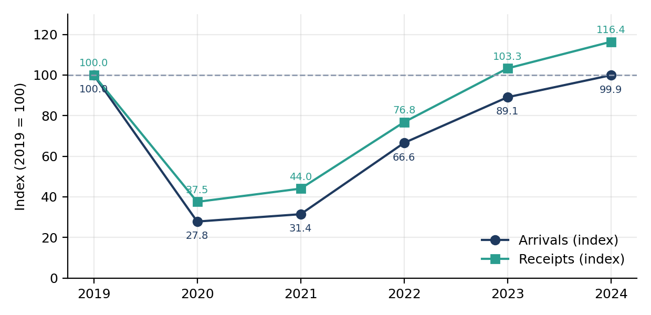
Figure 3. Recovery index (2019 = 100) for world arrivals and receipts. Calculated from PDF Tables 1.1.2 and 1.2.2. Index values do not show absolute levels.

7.5 Regional picture: volume and value are not the same
PDF Tables 1.1.1 and 1.2.1 also give regional figures. Table R11 puts the region's share of world arrivals next to its share of world receipts, and shows the change from 2019 to 2024* for both. The values are printed in the PDF; no calculation is involved.
Table R11. Regional shares and changes, 2024* compared with 2019 (as printed in the PDF)
Region | Share of world arrivals 2024* (%) | Share of world receipts 2024* (%) | Arrivals change 2024*/2019 (%) | Receipts change 2024*/2019 (%)
Europe | 51.58 | 42.32 | +1.59 | +25.13
Asia and the Pacific | 21.67 | 24.03 | −12.32 | −6.98
Americas | 14.78 | 22.66 | −1.23 | +18.52
Middle East | 6.91 | 8.53 | +41.34 | +63.46
Africa | 5.04 | 2.90 | +7.41 | +3.51
Source: PDF Tables 1.1.1 and 1.2.1 (UN Tourism, May 2025). Provisional 2024 values.
Europe had about half of world arrivals but a smaller share of receipts (42.32%), while the Americas had 14.78% of arrivals but 22.66% of receipts. Asia and the Pacific was below its 2019 level in both arrivals and receipts. The Middle East showed the largest increase in both. These are descriptive observations. The PDF does not give the reasons, so no cause is claimed here.
A consistency check that failed. The five regions in PDF Table 1.2.1 add up to about 1,738.5 billion US$ for 2024 (732.5 + 415.9 + 392.3 + 50.2 + 147.6), while the world total printed in the same table is 1,731.0. The same happens in 2019 (about 1,502.3 against 1,487.0) and 2023 (about 1,544.9 against 1,536.0). For arrivals the regions do add up to the world total within rounding. The reason for the receipts difference is not stated in the PDF and requires verification (it may be rounding, revision timing or a compilation difference). Regional receipts are therefore used only for comparison of shares and changes, not for exact totals.

7.6 Variables needed for a fuller analysis
To explain why receipts and arrivals moved differently, later work would need variables that are not in the Week 1 tables:
- expenditure per tourist and per trip,
- average length of stay (the PDF has this for India in PDF Tables 2.8.1 to 2.8.3, which have not been analysed yet),
- inflation and price changes (receipts in current US dollars are not adjusted for inflation),
- exchange rates,
- tourist composition (nationality, age, purpose of travel),
- destination mix (which countries received the tourists).

8. India-Specific Tourism Analysis

8.1 Three different measures: FTA, NRI and ITA
India's inbound tourism is reported in the PDF with three related but different measures in PDF Table 2.1.1:
- FTA (Foreign Tourist Arrivals): arrivals of foreign nationals.
- NRI arrivals: arrivals of Non-Resident Indians.
- ITA (International Tourist Arrivals in India): the total, ITA = FTA + NRI.
The sum can be checked from the monthly totals in the PDF. For 2019, 2023 and 2024 the FTA total (PDF Table 2.2.1) plus the NRI total (PDF Table 2.2.3) equals the ITA total (PDF Table 2.2.4) exactly: 10,930,355 + 6,983,159 = 17,913,514 for 2019; 9,520,928 + 9,378,282 = 18,899,210 for 2023; and 9,951,722 + 10,616,900 = 20,568,622 for 2024. FTA and ITA must therefore never be used as if they were the same number.

8.2 FTAs, NRI arrivals and ITAs, 2014–2024
Table R12. FTAs, NRI arrivals and ITAs in India, 2014–2024 (million)
Year | FTAs | NRI arrivals | ITAs | ITA % change (as printed)
2014 | 7.68 | 5.43 | 13.11 | –
2015 | 8.03 | 5.74 | 13.76 | 4.96
2016 | 8.80 | 6.22 | 15.03 | 9.23
2017 | 10.04 | 6.77 | 16.81 | 11.84
2018 | 10.56 | 6.87 | 17.42 | 3.63
2019 | 10.93 | 6.98 | 17.91 | 2.81
2020 | 2.74 | 3.59 | 6.33 | −64.66
2021 | 1.52 | 5.48 | 7.00 | 10.58
2022 | 6.44 | 7.89 | 14.33 | 104.71
2023 | 9.51 | 9.38 | 18.89 | 31.82
2024 | 9.95 | 10.62 | 20.57 | 8.89
Source: Bureau of Immigration, Govt. of India, as printed in PDF Table 2.1.1. Because the PDF rounds to two decimals, FTA + NRI can differ from ITA by 0.01 (for example 2015).
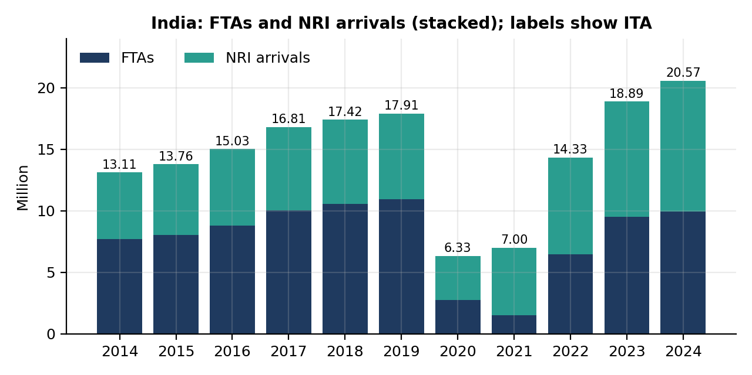
Figure 4. FTAs and NRI arrivals in India, 2014–2024 (stacked), with the ITA total shown above each bar. Source: PDF Table 2.1.1.

8.3 Long-term growth of FTAs
PDF Table 2.1.1 also gives FTAs for earlier years: 1.28 million in 1981, 1.68 million in 1991, 2.54 million in 2001 and 6.31 million in 2011. NRI arrivals and ITAs are not given for these years (shown as "-" in the PDF). Using the FTA series, which has a consistent definition from 1981 to 2024 in this table, FTAs rose from 2.54 million in 2001 to 10.93 million in 2019, which is about 4.3 times. The compound annual growth rate (CAGR) over these 18 years is (10.93 / 2.54)^(1/18) − 1 ≈ 8.4% per year (calculated). Between 2011 and 2019 the CAGR was about 7.1% per year (calculated). From 2014 to 2019, ITAs grew from 13.11 to 17.91 million, about 6.4% per year (calculated).

8.4 Recovery after 2020
The recovery ratio is the current value divided by the 2019 value, multiplied by 100. Table R13 shows it for FTAs, NRI arrivals and ITAs, together with the NRI share of ITAs.
Table R13. Recovery ratio (2019 = 100) and NRI share of ITAs, 2014–2024 (calculated)
Year | FTA recovery | NRI recovery | ITA recovery | NRI share of ITAs (%)
2014 | 70.3 | 77.8 | 73.2 | 41.4
2016 | 80.5 | 89.1 | 83.9 | 41.4
2018 | 96.6 | 98.4 | 97.3 | 39.4
2019 | 100.0 | 100.0 | 100.0 | 39.0
2020 | 25.1 | 51.4 | 35.3 | 56.7
2021 | 13.9 | 78.5 | 39.1 | 78.3
2022 | 58.9 | 113.0 | 80.0 | 55.1
2023 | 87.0 | 134.4 | 105.5 | 49.7
2024 | 91.0 | 152.1 | 114.9 | 51.6
Calculated by the author from the rounded million values in PDF Table 2.1.1. Using the exact counts in PDF Tables 2.2.1, 2.2.3 and 2.2.4 gives about 91.1, 152.0 and 114.8 for 2024.
Three points stand out from the table. First, in 2024 the ITA total was about 115% of its 2019 level, but FTAs alone were only about 91% of 2019 (9,951,722 against 10,930,355, a fall of 8.95% as printed in PDF Table 2.2.1). Second, NRI arrivals were about 152% of 2019. Third, the NRI share of ITAs rose from about 39% in 2019 to about 52% in 2024. So the recovery of the total is driven more by NRI arrivals than by FTAs, and an analysis that uses only ITAs would hide this. In the PDF, NRI arrivals were smaller than FTAs in every year from 2014 to 2019, and larger than FTAs in 2020, 2021, 2022 and 2024, but not in 2023 (9.51 million FTAs against 9.38 million NRI arrivals).
The year-on-year percentages printed in PDF Table 2.1.1 also show that the two groups behaved differently in the disrupted years. In 2020 FTAs fell by 74.93% and NRI arrivals by 48.57%. In 2021 FTAs fell again, by 44.53%, while NRI arrivals rose by 52.65%. In 2022 FTAs rose by 323.68% from a very low base. In 2024 FTAs grew by 4.52% and NRI arrivals by 13.22%.

8.5 Other India-specific tables
The remaining India-specific tables are analysed in the sections that follow: source countries and regions in Section 10 (PDF Tables 2.1.2 to 2.1.6), seasonality in Section 11 (PDF Tables 2.2.1 to 2.2.6), and mode and port of arrival in Section 12 (PDF Tables 2.3.1 to 2.4.4). Tables on gender, age group, purpose of visit and duration of stay (PDF Tables 2.5.1 to 2.8.3) and on Indian nationals' departures (PDF Tables 3.1.1 to 3.8.2) exist in the PDF but are left for later weeks.

9. Long-Term Tourism Trend: 2001–2024

9.1 Arrivals and receipts for selected years
PDF Table 1.1.2 gives world arrivals and the arrivals, share and rank of India for 2001–2024. PDF Table 1.2.2 gives world receipts and India's foreign exchange earnings (FEE) with share and rank. Table R14 shows selected years from both tables.
Table R14. World and India: arrivals and receipts, selected years 2001–2024
Year | World arrivals (million) | India value in Table 1.1.2 (million) | India share (%) | India rank | World receipts (US$ bn) | India FEE (US$ bn) | India share (%) | India rank
2001 | 683.4 | 2.54 | 0.37 | 51st | 463.8 | 3.20 | 0.69 | 36th
2005 | 803.4 | 3.92 | 0.49 | 43rd | 679.6 | 7.49 | 1.10 | 22nd
2010 | 948.0 | 5.78 | 0.61 | 42nd | 931.0 | 14.49 | 1.56 | 17th
2013 | 1,087.0 | 6.96 | 0.64 | 41st | 1,198.0 | 18.40 | 1.54 | 16th
2014 | 1,137.0 | 13.11 | 1.15 | 24th | 1,252.0 | 19.70 | 1.57 | 15th
2019 | 1,466.0 | 17.91 | 1.22 | 24th | 1,487.0 | 30.72 | 2.07 | 14th
2020 | 408.0 | 6.33 | 1.55 | 19th | 558.0 | 13.04 | 2.34 | 13th
2021 | 461.0 | 7.00 | 1.52 | 18th | 655.0 | 8.65 | 1.32 | 23rd
2022 | 976.0 | 14.33 | 1.47 | 17th | 1,142.0 | 21.36 | 1.87 | 16th
2023 | 1,306.0 | 18.89 | 1.45 | 20th | 1,536.0 | 32.19 | 2.10 | 14th
2024 (P) | 1,465.0 | 20.57 | 1.40 | 20th | 1,731.0 | 35.02 | 2.02 | 15th
Source: PDF Tables 1.1.2 and 1.2.2 as printed. (P) = provisional. India's FEE is not the same measure as world tourism receipts; see Section 9.3.
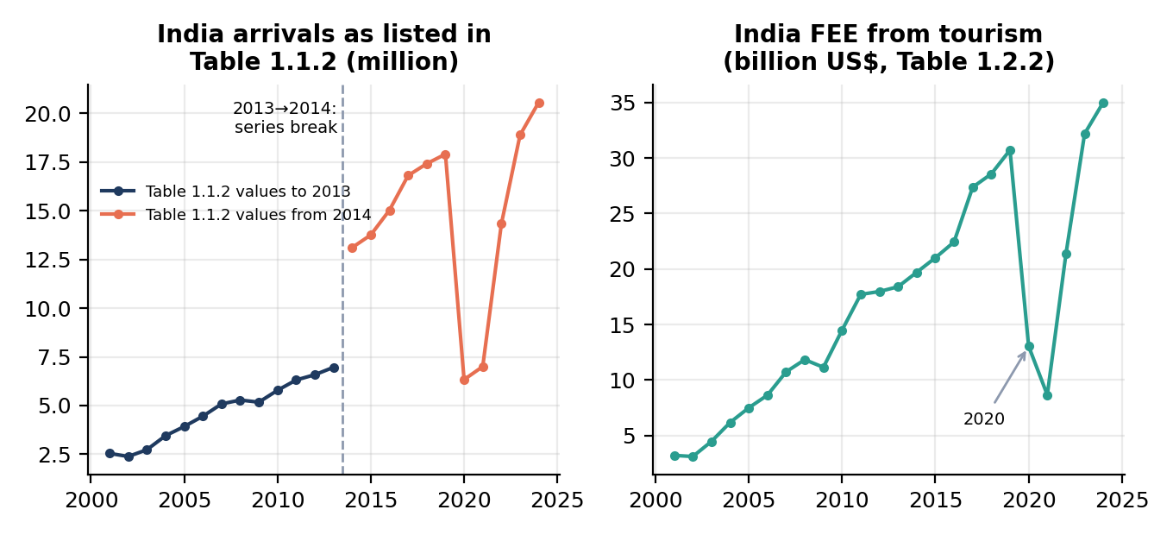
Figure 5. India's arrival values as listed in PDF Table 1.1.2 (left, with a break between 2013 and 2014) and India's FEE in billion US$ (right), 2001–2024. Source: PDF Tables 1.1.2 and 1.2.2.

9.2 A break in the arrivals series
Series break in PDF Table 1.1.2. For 2001 to 2013 the India column matches the FTA values (for example 6.96 million in 2013, close to 6.97 in PDF Table 2.1.1). For 2014 the value is 13.11 million, which is the ITA value in PDF Table 2.1.1 (7.68 FTAs + 5.43 NRI). The percentage change cell for 2014 is marked "$" in the PDF and no explanation is visible in the extracted text. The sudden rise from 6.96 to 13.11 million (about +88%, calculated) and the rise in India's world share from 0.64% to 1.15% therefore mainly reflect a change in what is counted, not a real doubling of tourism in one year. This should be confirmed in the official notes.
For this reason the long-term trend of foreign tourists is better studied with the FTA series in PDF Table 2.1.1 (Section 8.3), and the ITA series is used only from 2014. The world share and rank in PDF Table 1.1.2 must not be compared across 2013 and 2014.

9.3 Receipts and FEE
India's FEE rose from 3.20 billion US$ in 2001 to 30.72 billion US$ in 2019 (about 9.6 times, or about 13.4% per year, calculated), while world receipts rose from 463.8 to 1,487 billion US$ (about 6.7% per year, calculated). India's share of world receipts moved from 0.69% to 2.07% over this period. These are values in current US dollars and are not adjusted for inflation.
In PDF Tables 1.2.1 and 1.2.3, the values shown for India (30.72, 32.19 and 35.02 billion US$ for 2019, 2023 and 2024) are the same as the "India FEE" column of PDF Table 1.2.2. So the PDF places India's FEE alongside other countries' international tourism receipts. Whether the two are defined in exactly the same way requires verification, and FEE and receipts are therefore not treated as identical in this report
Units also matter. PDF Table 2.9.1 gives FEE in rupees as well as in dollars. From 2019 to 2024 the total FEE changed by +35.37% in rupees (₹216,467 crore to ₹293,033 crore) but by +13.98% in US dollars (30.721 to 35.016 billion), as shown in PDF Tables 2.9.2 and 2.9.3. The gap between the two growth rates is consistent with a change in the rupee–dollar exchange rate, but exchange-rate data would be needed to test this. The 2024 FEE figures are revised estimates. PDF Table 2.9.1 also prints the 2021 dollar value as "86,51", which appears to be a typing error for 8,651 million (Table 1.2.2 shows 8.65 billion).

9.4 India's rank
The rank in PDF Tables 1.1.2 and 1.2.2 is India's position among countries, ordered by that year's value. Rank is a relative measure. It depends on how other countries performed, so it cannot be read as a direct measure of India's own tourism performance. The table gives a clear example. In 2020 India's arrivals fell by 64.66%, yet its rank improved from 24th to 19th and its share of world arrivals rose from 1.22% to 1.55%, because world arrivals fell even more (−72.17%). In 2024 India was 20th in arrivals (about 1.40% of world arrivals, PDF Tables 1.1.1 and 1.1.3) and 15th in receipts (2.02%, PDF Table 1.2.3). Because the arrivals series has a break in 2014 (Section 9.2), arrivals ranks before and after 2014 are also not comparable.

9.5 The disrupted years 2020–2022
The years 2020 and 2021 were exceptional, and 2022 was a partial rebound. They are shown separately in Table R15 and are not treated as normal years for trend calculations.
Table R15. Year-on-year change (%) in the disrupted years, as printed in the PDF
Year | World arrivals | India arrivals (as in Table 1.1.2) | World receipts | India FEE (US$)
2020 | −72.17 | −64.66 | −62.47 | −57.57
2021 | +12.99 | +10.58 | +17.38 | −33.64
2022 | +111.71 | +104.71 | +74.35 | +146.91
Source: PDF Tables 1.1.2 and 1.2.2.
Large percentage changes in 2021 and 2022 are measured from a very small base and are not signs of normal growth. In 2021 world receipts rose by 17.38% while India's FEE fell by 33.64%, and India's rank in receipts fell from 13th to 23rd. The PDF does not explain these differences, so no reason is claimed here.

10. Source Country and Regional Analysis

10.1 Regional contribution
PDF Table 2.1.2 gives FTAs to India by region and sub-region for 2019, 2023 and 2024. Table R16 shows the main regions with the sub-regions that matter most for the later discussion.
Table R16. FTAs in India by region, 2019, 2023 and 2024
Region | 2019 | 2023 | 2024 | Share 2024 (%) | Change 2024/19 (%) | Change 2024/23 (%)
Asia and the Pacific | 5,527,521 | 4,373,856 | 4,279,663 | 43.00 | −22.58 | −2.15
South Asia | 3,375,819 | 2,762,763 | 2,409,812 | 24.22 | −28.62 | −12.78
South-East Asia | 930,540 | 764,230 | 867,210 | 8.71 | −6.81 | +13.48
North-East Asia | 782,225 | 311,923 | 395,930 | 3.98 | −49.38 | +26.93
Oceania | 438,937 | 534,940 | 606,711 | 6.10 | +38.22 | +13.42
Europe | 2,745,199 | 2,374,919 | 2,657,441 | 26.70 | −3.20 | +11.90
Americas | 1,962,822 | 2,160,766 | 2,372,058 | 23.84 | +20.85 | +9.78
North America | 1,884,658 | 2,093,531 | 2,299,267 | 23.10 | +22.00 | +9.83
Africa | 339,662 | 313,826 | 338,605 | 3.40 | −0.31 | +7.90
Middle East | 344,235 | 287,972 | 295,511 | 2.97 | −14.15 | +2.62
Others not classified | 10,916 | 9,589 | 8,444 | 0.08 | −22.65 | −11.90
Grand total | 10,930,355 | 9,520,928 | 9,951,722 | 100.00 | −8.95 | +4.52
Source: Bureau of Immigration, PDF Table 2.1.2. Values as printed (converted to international digit grouping). Sub-regions are indented.
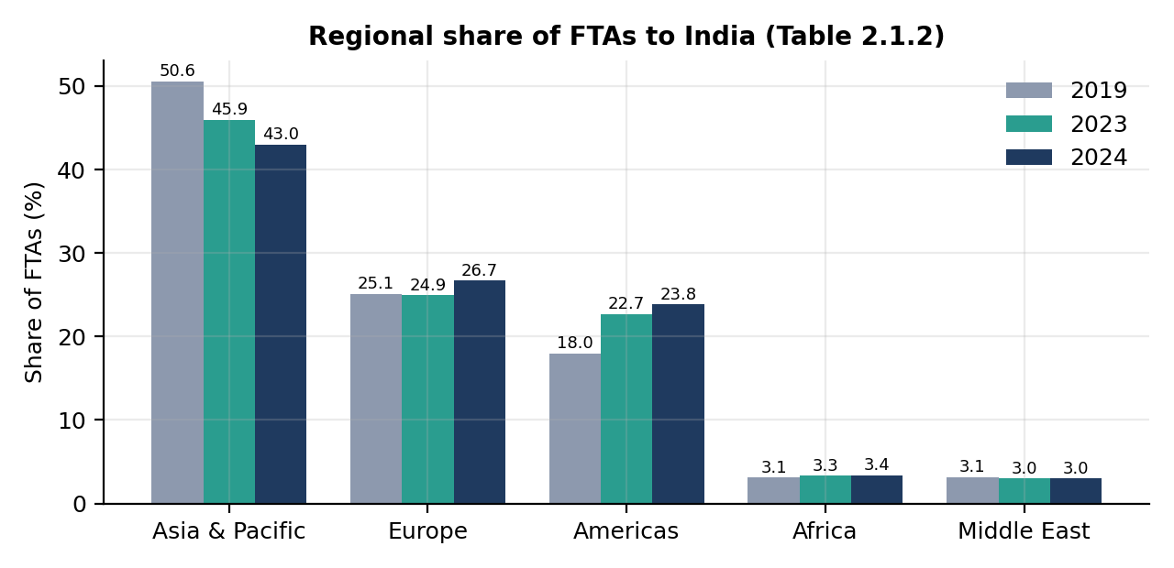
Figure 6. Regional share of FTAs to India, 2019, 2023 and 2024. Source: PDF Table 2.1.2.
Asia and the Pacific supplied the largest part of FTAs in all three years, but its share fell from 50.57% in 2019 to 43.00% in 2024. Within it, South Asia fell from 30.88% to 24.22%. The Americas rose from 17.96% to 23.84% and Europe from 25.12% to 26.70%.
Some simple calculations from the table add useful detail (all calculated from PDF Table 2.1.2). The total number of FTAs was 978,633 lower in 2024 than in 2019. The fall in South Asia alone was 966,007. If South Asia is left out, FTAs from the rest of the world were 7,554,536 in 2019 and 7,541,910 in 2024, a difference of only about −0.2%. So the gap between 2024 and 2019 in the total is almost entirely a South Asia gap, while other regions on balance returned to their 2019 level. The PDF does not explain why, and no cause is claimed.

10.2 Major source countries
Table R17 combines the top 15 source countries of 2024 (PDF Table 2.1.3) with their 2019 and 2023 values from PDF Tables 2.1.3 and 2.1.6. The changes are my own calculations.
Table R17. Top 15 source countries of FTAs to India, 2024, with 2019 and 2023 values
Rank 2024 | Country | 2019 | 2023 | 2024* | Share 2024 (%) | Change 2024/19† (%) | Change 2024/23† (%)
1 | United States | 1,512,032 | 1,691,498 | 1,804,586 | 18.13 | +19.3 | +6.7
2 | Bangladesh | 2,577,727 | 2,119,826 | 1,750,165 | 17.59 | −32.1 | −17.4
3 | United Kingdom | 1,000,292 | 920,591 | 1,022,587 | 10.28 | +2.2 | +11.1
4 | Australia | 367,241 | 456,167 | 518,205 | 5.21 | +41.1 | +13.6
5 | Canada | 351,859 | 385,938 | 476,273 | 4.79 | +35.4 | +23.4
6 | Malaysia | 334,579 | 262,458 | 307,526 | 3.09 | −8.1 | +17.2
7 | Sri Lanka | 330,861 | 280,327 | 281,827 | 2.83 | −14.8 | +0.5
8 | Germany | 264,973 | 223,575 | 256,348 | 2.58 | −3.3 | +14.7
9 | France | 247,238 | 188,981 | 206,855 | 2.08 | −16.3 | +9.5
10 | Singapore | 190,089 | 183,772 | 205,383 | 2.06 | +8.0 | +11.8
11 | Nepal | 164,040 | 195,445 | 202,501 | 2.03 | +23.4 | +3.6
12 | Japan | 238,903 | 150,521 | 194,875 | 1.96 | −18.4 | +29.5
13 | Russian Federation | 251,319 | 164,125 | 160,188 | 1.61 | −36.3 | −2.4
14 | Italy | 128,572 | 116,031 | 142,239 | 1.43 | +10.6 | +22.6
15 | Thailand | 169,956 | 116,060 | 140,489 | 1.41 | −17.3 | +21.0
Source: Bureau of Immigration, PDF Tables 2.1.3 and 2.1.6. † Calculated by the author. *Shown as 2024 in the PDF. 2019 figures for Italy are from PDF Table 2.1.6 because Italy was not in the 2019 top 15.
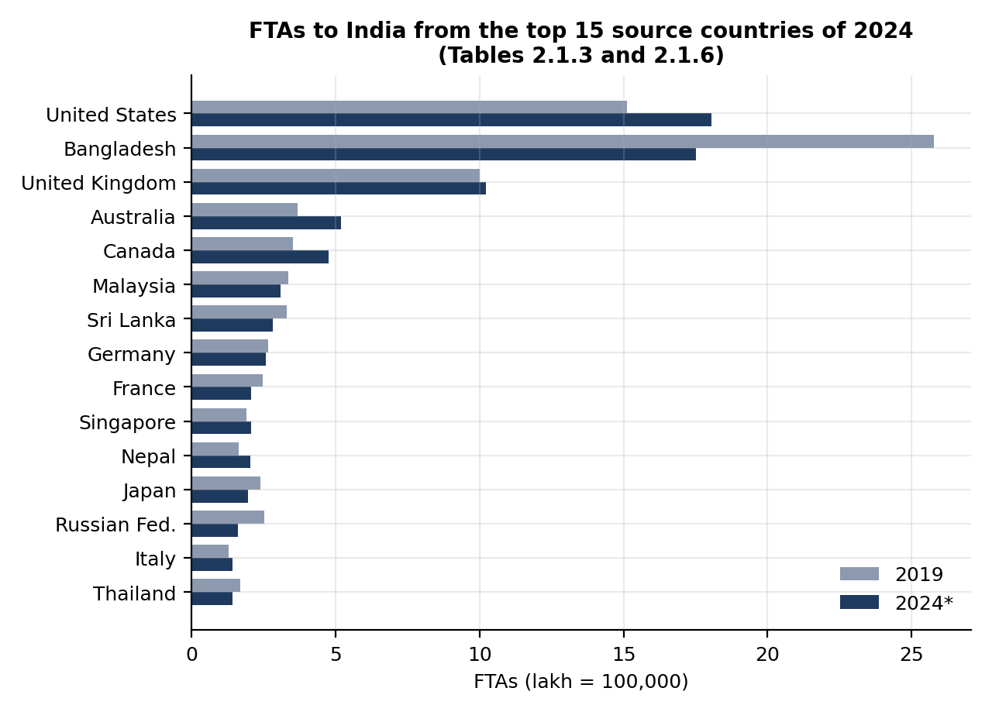
Figure 7. FTAs to India from the 2024 top 15 source countries, 2019 compared with 2024. Source: PDF Tables 2.1.3 and 2.1.6.
In 2019 Bangladesh was the largest source country (2,577,727, or 23.58% of FTAs), followed by the United States and the United Kingdom. In 2023 the order was the same. In 2024 the United States moved to first place with 1,804,586 FTAs (18.13%) and Bangladesh to second with 1,750,165 (17.59%). Bangladeshi arrivals were 17.4% lower than in 2023 and 32.1% lower than in 2019 (calculated); the 827,562 fall since 2019 is about 86% of the whole South Asia decline. Australia and Canada grew by more than 35% against 2019.

10.3 Concentration of arrivals
The PDF prints the share of the top 15 countries in total FTAs: 76.31% in 2019, 78.30% in 2023 and 77.07% in 2024 (PDF Table 2.1.3). I also calculated the share of the top 3 and top 5 countries. The same five countries (Bangladesh, United States, United Kingdom, Australia and Canada) were the top five in all three years.
Table R18. Source market concentration, 2019, 2023 and 2024
Measure | 2019 | 2023 | 2024
Top 15 countries, share of FTAs (%) (as printed) | 76.31 | 78.30 | 77.07
Top 5 countries, share of FTAs (%) (calculated) | 53.1 | 58.5 | 56.0
Top 3 countries, share of FTAs (%) (calculated) | 46.6 | 49.7 | 46.0
Calculated from PDF Tables 2.1.3 and 2.1.6. Top 3 and top 5 use the same countries in each year (Bangladesh, United States, United Kingdom, plus Australia and Canada for top 5).
About half of all FTAs come from three countries, and more than three-quarters from fifteen. This means that changes in just a few markets can move the national total, as the Bangladesh example shows. The concentration did not change much between the three years, but the order inside the top three did.

10.4 Countries with notable growth, and a note on China
PDF Table 2.1.4 lists the 15 countries with the highest growth in FTAs in 2024 over 2019, only among countries with more than 10,000 FTAs in 2024. The top entries are Somalia (+144.25%, from 5,044 to 12,320), Cambodia (+80.61%), Kazakhstan (+71.91%), Vietnam (+60.81%), Bhutan (+46.44%) and Uganda (+45.24%). All of these have a share of 0.54% or less of FTAs in 2024, so a large percentage rise on a small base adds little to the national total. Australia (+41.11%), Canada (+35.36%) and Nepal (+23.45%) also appear in the list and have larger bases (5.21%, 4.79% and 2.03% of FTAs).
PDF Table 2.1.5 shows that FTAs from China were 339,442 in 2019, 30,585 in 2023 and 38,960 in 2024, which is 88.52% lower in 2024 than in 2019. China was in the top 15 in 2019 but not in 2023 or 2024. This is a descriptive observation only. The PDF does not give reasons, and none is assumed here.

11. Seasonality Analysis
Seasonality is studied with two kinds of tables. PDF Table 2.2.1 gives monthly FTAs for only three years (2019, 2023 and 2024), so the monthly pattern is based on those three years and cannot be described as a pattern for every year from 2001 to 2024. PDF Table 2.2.5 gives quarterly shares for many years (2001, 2011–2024) and is used for the longer historical view.

11.1 Monthly pattern
Table R19. Monthly FTAs to India, 2019, 2023 and 2024, with monthly shares
Month | 2019 | 2023 | 2024 | Share 2019† (%) | Share 2023† (%) | Share 2024 (%) | Change 2024/19 (%)
January | 1,111,040 | 891,084 | 981,609 | 10.16 | 9.36 | 9.86 | −11.65
February | 1,090,516 | 893,352 | 1,032,301 | 9.98 | 9.38 | 10.37 | −5.34
March | 978,236 | 824,549 | 893,021 | 8.95 | 8.66 | 8.97 | −8.71
April | 774,651 | 625,772 | 672,684 | 7.09 | 6.57 | 6.76 | −13.16
May | 615,136 | 618,086 | 622,189 | 5.63 | 6.49 | 6.25 | +1.15
June | 726,446 | 667,720 | 722,615 | 6.65 | 7.01 | 7.26 | −0.53
July | 818,125 | 786,486 | 799,842 | 7.48 | 8.26 | 8.04 | −2.23
August | 800,837 | 664,155 | 661,322 | 7.33 | 6.98 | 6.65 | −17.42
September | 751,513 | 666,946 | 691,247 | 6.88 | 7.01 | 6.95 | −8.02
October | 945,017 | 832,233 | 840,330 | 8.65 | 8.74 | 8.44 | −11.08
November | 1,092,440 | 948,631 | 973,941 | 9.99 | 9.96 | 9.79 | −10.85
December | 1,226,398 | 1,101,914 | 1,060,621 | 11.22 | 11.57 | 10.66 | −13.52
Total | 10,930,355 | 9,520,928 | 9,951,722 | 100.00 | 100.00 | 100.00 | −8.95
Source: Bureau of Immigration, PDF Table 2.2.1. † Monthly shares for 2019 and 2023 calculated by the author as month / annual total × 100; the 2024 shares and the 2024/19 changes are as printed in the PDF.
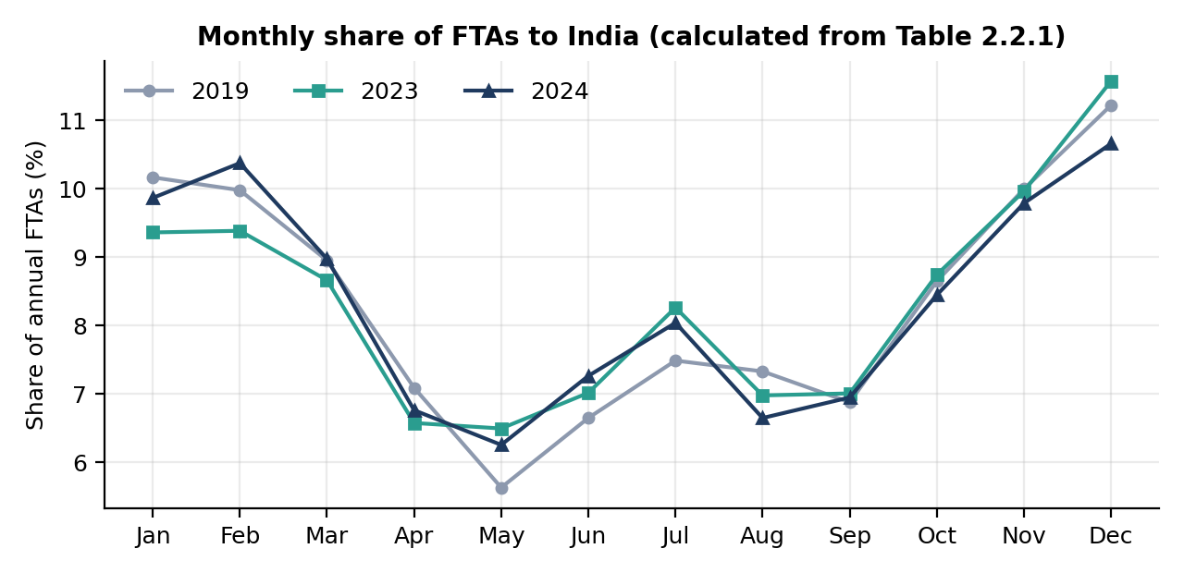
Figure 8. Monthly share of FTAs to India in 2019, 2023 and 2024. Calculated from PDF Table 2.2.1.
- Peak month. December was the largest month in all three years (11.22% in 2019, 11.57% in 2023, 10.66% in 2024). January and February were also high.
- Lean month. May was the smallest month in all three years (5.63%, 6.49% and 6.25%). April, June and August to September were also low.
- Peak-to-lean ratio (largest month divided by smallest month, calculated): about 2.0 in 2019, 1.8 in 2023 and 1.7 in 2024. The gap between busy and quiet months was smaller in the two later years, but three years are too few to call this a trend.
- 2024 against 2019. In each month except May (+1.15%) the 2024 count was lower than in 2019, with the largest gaps in August (−17.42%) and December (−13.52%), consistent with the overall −8.95%.

11.2 NRI arrivals and ITAs by month
The month-by-month pattern is not the same for every group. For NRI arrivals in 2024 (PDF Table 2.2.3) the largest shares were in December (10.39%), July (10.28%) and June (10.05%), and the smallest in September (6.57%) and February (6.64%). For ITAs in 2024 (PDF Table 2.2.4) December had the largest share (10.52%) and September the smallest (6.75%). This means an analysis that mixes NRI arrivals and FTAs can hide the FTA pattern, which is another reason to keep the two groups apart.

11.3 Peak and lean months by source country
Table R20. Peak and lean months of FTAs from the top 15 source countries, 2024
Country | Lean month (% share) | Peak month (% share) | Country | Lean month (% share) | Peak month (% share)
United States | April (5.14) | December (14.25) | Singapore | April (6.54) | December (12.47)
Bangladesh | December (3.60) | June (11.68) | Nepal | May (5.87) | October (12.04)
United Kingdom | May (4.20) | June (11.89) | Japan | May (5.94) | November (10.91)
Australia | May (4.22) | December (21.11) | Russian Federation | June (2.91) | December (14.33)
Canada | May (4.35) | December (12.80) | Italy | May (4.09) | December (12.95)
Malaysia | May (6.26) | February (13.47) | Thailand | June (3.77) | December (13.43)
Sri Lanka | June (5.82) | August (10.76) | Germany | June (4.66) | November (11.51)
France | May (4.46) | February (12.54)
Source: Bureau of Immigration, PDF Table 2.2.2 (2024).
December is the peak month for 7 of the 15 countries. Bangladesh and the United Kingdom peak in June, and Bangladesh has its lowest month in December, the opposite of most markets. Malaysia and France peak in February, Sri Lanka in August, Nepal in October, and Germany and Japan in November. Different source markets therefore have different seasonal patterns, so the national pattern is a mix of many smaller ones.

11.4 Quarterly pattern over a longer period
Table R21. Quarterly share of FTAs to India, 2001 and 2011–2024
Year | FTAs | Q1 Jan–Mar (%) | Q2 Apr–Jun (%) | Q3 Jul–Sep (%) | Q4 Oct–Dec (%) | Note
2001 | 2,537,282 | 31.30 | 20.20 | 23.00 | 25.50
2011 | 6,309,222 | 28.30 | 19.60 | 20.90 | 31.20
2015 | 8,027,133 | 28.40 | 19.50 | 22.10 | 30.00
2019 | 10,930,355 | 29.10 | 19.40 | 21.70 | 29.90
2020 | 2,744,766 | 91.00 | 1.00 | 2.00 | 6.00 | Disrupted year
2021 | 1,527,114 | 22.20 | 8.80 | 18.40 | 50.60 | Disrupted year
2022 | 6,437,467 | 12.90 | 21.80 | 27.10 | 38.20 | Partial recovery
2023 | 9,520,928 | 27.40 | 20.10 | 22.20 | 30.30
2024 | 9,951,722 | 29.21 | 20.30 | 21.60 | 28.90
Source: Bureau of Immigration, PDF Table 2.2.5 (as printed). The 2001 total is printed as 25,37,282 in the PDF.
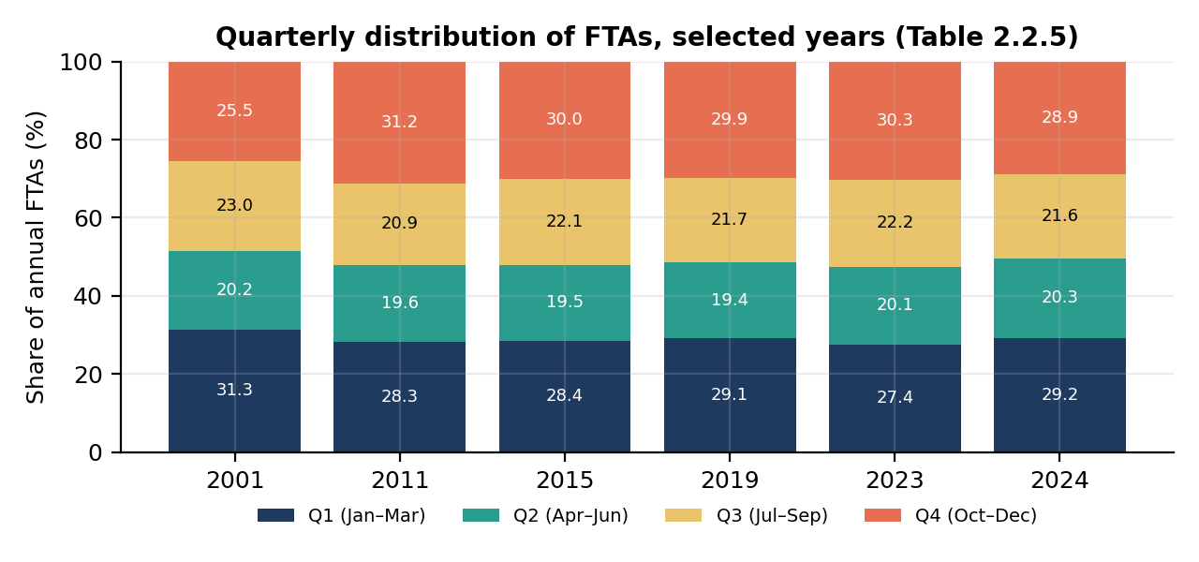
Figure 9. Quarterly share of FTAs to India, selected years. Source: PDF Table 2.2.5. Disrupted years 2020–2022 are not shown.
In the normal years from 2011 to 2019 and again in 2023 and 2024, the second quarter (April to June) was always the smallest, between 18.9% and 20.3% of the year, and the first and fourth quarters together made up about 57% to 60% of the year. In 2001 the first quarter was larger (31.30%) and the fourth smaller (25.50%) than in later years. The quarterly pattern in 2020, 2021 and 2022 reflects the disruption and recovery (for example 91% of 2020 FTAs arrived in the first quarter, and about half of the 2021 FTAs arrived in the fourth quarter), so these three years should not be used to describe normal seasonality. The 2024 shares calculated from the monthly table (29.21%, 20.27%, 21.63% and 28.89%) agree with the printed quarterly shares, which is a useful consistency check.

12. Port and Mode of Arrival Analysis

12.1 Mode of arrival
PDF Table 2.3.1 splits FTAs into air, land and water arrivals. Table R22 shows selected years; the full series is in the PDF table.
Table R22. FTAs to India by mode of transport (% of arrivals)
Year | FTAs | Air (%) | Land (%) | Water (%)
2001 | 2,537,282 | 87.10 | 12.00 | 0.90
2011 | 6,309,222 | 92.00 | 7.20 | 0.80
2014 | 7,679,099 | 86.10 | 13.50 | 0.40
2017 | 10,035,803 | 79.60 | 19.70 | 0.70
2019 | 10,930,355 | 77.40 | 21.70 | 0.90
2020 | 2,744,766 | 79.20 | 19.30 | 1.50
2021 | 1,527,114 | 87.49 | 11.80 | 0.70
2022 | 6,437,467 | 83.50 | 16.20 | 0.30
2023 | 9,520,928 | 79.40 | 20.10 | 0.50
2024 | 9,951,722 | 83.41 | 16.05 | 0.54
Source: Bureau of Immigration, PDF Table 2.3.1.
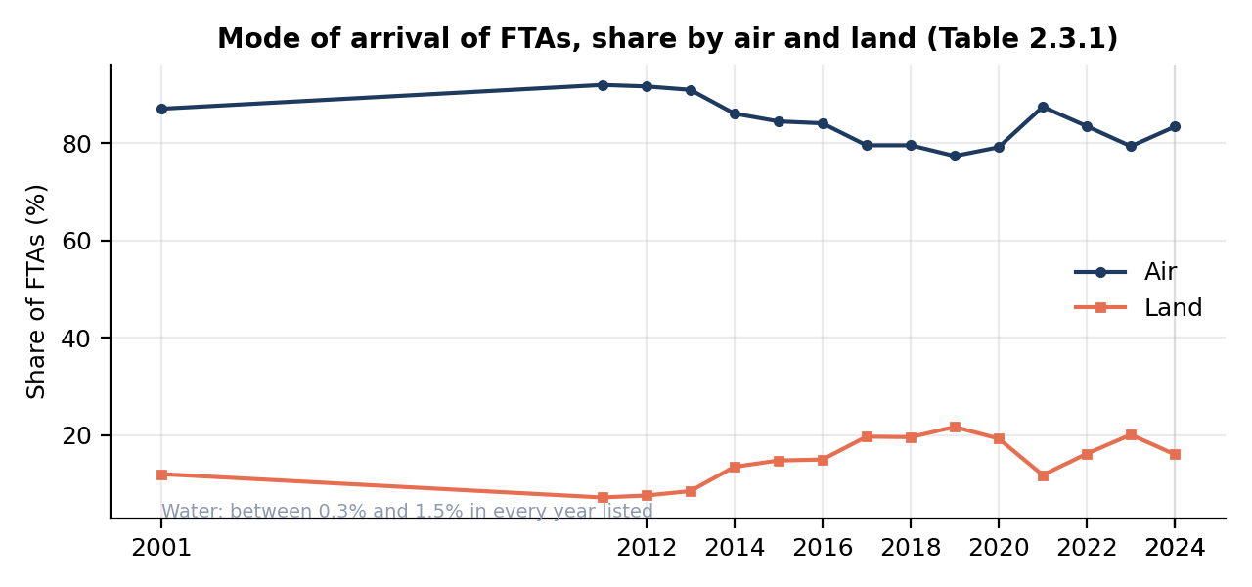
Figure 10. Share of FTAs arriving by air and by land, 2001–2024. Source: PDF Table 2.3.1.
Air was always the main mode, but its share fell from 92.00% in 2011 to 77.40% in 2019 as the land share rose from 7.20% to 21.70%. In 2024 the air share was 83.41% and land 16.05%. Water arrivals were 1.5% or less in every year listed. The land share is lower in 2021, 2022 and 2024 than in 2019 and 2023. Arrivals from Bangladesh come mainly by land (see below) and the Bangladesh count also changed over these years (Section 10), so the two may be connected, but this has not been tested and no cause is claimed.
PDF Table 2.3.2 shows the mode of transport by region and country for 2024. Table R23 gives selected rows. Arrivals from the Americas, Europe, and the large Western markets are almost entirely by air, while arrivals from South Asia are mostly by land.
Table R23. Mode of transport by selected regions and countries, 2024
Region / country | FTAs 2024 | Air (%) | Land (%) | Water (%)
Americas | 2,372,058 | 99.03 | 0.45 | 0.52
Europe | 2,657,441 | 98.95 | 0.41 | 0.64
Asia and the Pacific | 4,279,663 | 62.67 | 36.79 | 0.53
South Asia | 2,409,812 | 36.96 | 62.92 | 0.12
Bangladesh | 1,750,165 | 17.62 | 82.34 | 0.04
Nepal | 202,501 | 94.22 | 5.67 | 0.11
Sri Lanka | 281,827 | 89.94 | 9.39 | 0.66
United States | 1,804,586 | 99.14 | 0.36 | 0.50
United Kingdom | 1,022,587 | 99.23 | 0.32 | 0.45
All FTAs | 9,951,722 | 83.41 | 16.05 | 0.54
Source: Bureau of Immigration, PDF Table 2.3.2 (2024).

12.2 Major ports and airports
PDF Table 2.4.1 gives the share of FTAs by major port from 2001 to 2024. A "#" in the PDF means that the port is not shown separately in that year (its exact meaning should be verified), so those entries are left blank here rather than written as zero.
Table R24. Share of FTAs by major port of arrival, selected years (%)
Year | Delhi | Mumbai | Chennai | Haridas-pur | Bengaluru | Hyderabad | Cochin | Kolkata | Others
2001 | 33.70 | 26.70 | 12.00 | # | # | # | # | 4.40 | 23.20
2011 | 35.80 | 19.70 | 10.80 | # | 6.30 | # | # | 3.70 | 23.70
2016 | 29.70 | 17.20 | 8.10 | 8.60 | 6.20 | 3.40 | 3.60 | 4.00 | 19.20
2019 | 28.10 | 13.60 | 7.30 | 10.10 | 6.00 | 3.10 | 3.10 | 5.00 | 23.50
2020 | 29.60 | 14.60 | 6.60 | 8.70 | 5.60 | 2.70 | 3.10 | 4.50 | 24.50
2021 | 39.70 | 13.90 | 7.90 | 8.73 | 6.70 | 5.60 | 4.00 | 2.80 | 10.60
2023 | 30.30 | 15.10 | 8.30 | 10.10 | 6.00 | 3.70 | 3.70 | 3.30 | 19.50
2024 | 32.40 | 15.65 | 8.19 | 7.92 | 7.00 | 3.97 | 3.74 | 2.78 | 18.36
Source: Bureau of Immigration, PDF Table 2.4.1. "#" = not shown separately in that year (as printed).
Delhi and Mumbai together handled 48.05% of all FTAs in 2024 (32.40% + 15.65%, calculated), but their combined share was lower in 2019 (41.70%, calculated). Mumbai's share fell from 26.70% in 2001 to 13.60% in 2019, and then recovered a little. Haridaspur, a land port, appears in the list from 2016 and had 7.92% in 2024. The "Others" group is large (18.36% in 2024), which means a good part of arrivals are spread over smaller ports.
PDF Table 2.4.2 lists FTAs through international airports in 2024. The airport shares in that table are shares of air-mode FTAs only (8,300,540), not of all FTAs, which is why Delhi shows 38.85% there and 32.40% in PDF Table 2.4.1. A check confirms the two tables agree: 3,224,675 / 9,951,722 = 32.40%.
Table R25. Top 10 international airports by FTAs, 2024
Rank | Airport | FTAs | % share of air-mode FTAs
1 | Delhi | 3,224,675 | 38.85
2 | Mumbai | 1,557,196 | 18.76
3 | Chennai | 814,594 | 9.81
4 | Bengaluru | 696,924 | 8.40
5 | Hyderabad | 394,824 | 4.76
6 | Cochin | 372,217 | 4.48
7 | Kolkata | 276,667 | 3.33
8 | Ahmedabad | 219,993 | 2.65
9 | Amritsar | 148,237 | 1.79
10 | Tiruchirappalli | 116,499 | 1.40
 | Total FTAs by air (all airports) | 8,300,540 | 100.00
Source: Bureau of Immigration, PDF Table 2.4.2. Ranks 11 to 20 and "Others" are in the PDF but not shown here.
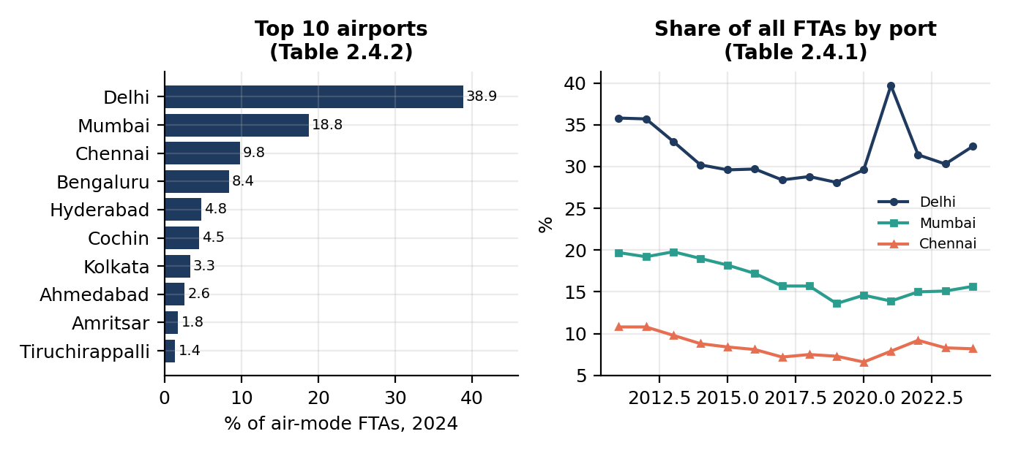
Figure 11. Top 10 airports by share of air-mode FTAs, 2024 (left), and the share of all FTAs through Delhi, Mumbai and Chennai, 2011–2024 (right). Sources: PDF Tables 2.4.2 and 2.4.1.

12.3 Port patterns by country and by Indian region
PDF Table 2.4.3 shows the share of each country's FTAs by port. Some examples for 2024: 71.34% of Nepalese FTAs arrived through Delhi; 55.64% of FTAs from Canada arrived through Delhi and 15.36% through Mumbai; for Australia the figures were 37.88% (Delhi), 12.68% (Mumbai) and 11.34% (Bengaluru). For Bangladesh, 44.94% arrived through Haridaspur, 37.78% through "Others" and only 4.94% through Delhi.
PDF Table 2.4.4 groups arrivals by the part of India where the port is located. For all FTAs in 2024 the printed distribution is North 35.62%, South 26.27%, West and Central 19.94% and East 16.60%; the North East value is printed as "160", which is most likely 1.60 with a missing decimal point (to be verified against the page image). For Bangladesh the East region received 80.37%, whereas for the Americas the North received 42.36%.

12.4 How this information could be used
- Airport infrastructure planning. The high concentration at Delhi and Mumbai (about 48% of all FTAs in 2024) shows where terminal capacity is most heavily used.
- Tourism capacity planning. Port shares by country show which source markets rely on which entry points, so hotel and transport capacity near those points can be matched to demand.
- Transport planning. The land-port share (16.05% in 2024) and its link with South Asian markets can guide planning of border facilities and road and rail links.
- Destination management. Combining port data with seasonality (Section 11) can help schedule staff, signage and services for peak months.
These are possible uses only. Port data counts arrivals, not where the tourist then travels, so it cannot show which destinations inside India they visit.

13. Preliminary KPIs
A KPI (key performance indicator) is a number with a fixed formula that can be calculated again in the same way for every year, month or country. The six KPIs requested for Week 1 are listed in Table R26 with worked examples from the PDF. The examples are calculated by the author from the PDF values and are meant to show the method, not to give final conclusions.
Table R26. Preliminary KPIs: definition, purpose and worked example
KPI | Formula / definition | Why it matters | Worked example (calculated from the PDF)
Tourist Arrival Growth | (Current − Previous) / Previous × 100 | Measures change in tourism volume | World arrivals 2023→2024*: (1,465 − 1,306) / 1,306 × 100 = +12.17%
Receipt Growth | (Current − Previous) / Previous × 100 | Measures change in tourism-related receipts | World receipts 2023→2024*: (1,731 − 1,536) / 1,536 × 100 = +12.70%
Recovery Ratio | Current year / 2019 × 100 | Measures recovery relative to the 2019 baseline | India FTAs 2024: 9,951,722 / 10,930,355 × 100 = 91.0. India NRI arrivals 2024: 152.0. India ITAs 2024: 114.8
Regional Share | Region arrivals / Total arrivals × 100 | Measures the contribution of a source region | Americas, 2024 FTAs: 2,372,058 / 9,951,722 × 100 = 23.84%
Monthly Share | Monthly arrivals / Annual arrivals × 100 | Measures seasonality | December 2024 FTAs: 1,060,621 / 9,951,722 × 100 = 10.66%
Source Market Concentration | Share of top source countries (top 3, top 5, top 15) | Measures dependence on a few markets | Top 3 in 2024: (1,804,586 + 1,750,165 + 1,022,587) / 9,951,722 × 100 = 46.0%
Table R27 lists additional indicators that were used in this report or are proposed for later weeks.
Table R27. Additional supporting indicators
Indicator | Formula / definition | Example | Caution
NRI share of ITAs | NRI arrivals / ITAs × 100 | 2019: 39.0%; 2024: 51.6% | Needs ITA, not FTA, as the denominator
Compound annual growth rate (CAGR) | (End / Start)^(1/years) − 1 | India FTAs 2001–2019: about 8.4% per year | Do not run across a series break or a disrupted year
Peak-to-lean ratio | Largest month / smallest month | FTAs 2019: about 2.0; 2024: about 1.7 | Only three years of monthly data are available
Mode share | Arrivals by mode / Total × 100 | Air share of FTAs in 2024: 83.41% | Check the denominator (all FTAs or air-mode FTAs)
Port concentration | Delhi + Mumbai arrivals / Total × 100 | 2024: 48.05% | Ports are named differently across tables
Receipts-to-arrivals ratio (world) | Receipts (billion US$) / Arrivals (million) × 1,000, in US$ | 2019: about 1,014; 2023: about 1,176; 2024*: about 1,182 | A crude descriptive ratio, not average spending per tourist
On the receipts-to-arrivals ratio. The ratio divides total receipts by total arrivals. Receipts are not limited to the arrivals counted, and both totals are measured in different ways in different countries. The ratio can be used to see whether the two totals drift apart over time, but it must not be reported as "each tourist spent X dollars".

Keeping KPI definitions consistent
- The same formula, the same denominator and the same unit are used in every year. A share of "all FTAs" is never compared with a share of "air-mode FTAs".
- FTAs, NRI arrivals and ITAs are kept in separate columns, and each KPI says which one it uses.
- Provisional (*, P) and revised (#2) values are flagged next to every KPI that uses them.
- Growth rates and CAGR are not calculated across a known series break (2013→2014 in PDF Table 1.1.2) without a warning.
- Disrupted years (2020–2022) are shown, but are not used as a base year for growth.
- All formulas are kept in one script or sheet so that they can be re-run if a source value is corrected.

14. Data Quality Issues and Mitigation
Data quality was checked while reading the PDF. The examples below come from the PDF itself, which shows that even an official compilation needs checking before it is analysed. Sub-sections 14.1 to 14.11 describe each issue; Table R28 gives detection and mitigation steps for all of them.

14.1 Different definitions
FTA, NRI arrivals and ITAs are different measures (Section 8). In 2024 ITAs were 20,568,622 but FTAs were 9,951,722, about 48% of ITAs. PDF Table 1.1.2 uses the FTA measure up to 2013 and the ITA measure from 2014 in the India column (Section 9.2). Using the wrong one would change the result by a factor of about two.

14.2 Different financial indicators
International tourism receipts (UN Tourism, world and country level) and India's foreign exchange earnings (FEE) are not automatically the same. The PDF uses India's FEE values as India's entry in the receipts tables (Section 9.3), but the match in definition is not stated. In addition, the regional receipts in PDF Table 1.2.1 add up to more than the world total (Section 7.5).

14.3 Provisional values
The UN Tourism values for 2024 are marked provisional (*) or (P). The FEE values for 2024 are marked "#2: Revised Estimates". PDF Table 4.1.1 marks 2023 as revised (®), and PDF Table 4.1.2 notes that some 2023 values were revised. Provisional numbers can change, so results that use them are marked as provisional.

14.4 Missing values
Missing values appear in several forms: "-" for China in PDF Table 1.1.3 for 2023 and 2024, "-" for NRI arrivals and ITAs before 2014 in PDF Table 2.1.1, "#" for ports not shown separately in PDF Table 2.4.1, and "N.A" for early years in PDF Table 4.2.1. A missing value is not zero. In the analysis it is kept as missing and the reason is recorded.

14.5 Changes in methodology
Two examples are visible in the PDF. First, the arrivals series in PDF Table 1.1.2 changes basis in 2014. Second, the number of centrally protected ticketed monuments in PDF Table 4.2.1 changes over time (68 in 1996, 126 in 2000, 116 from 2004, 144 in 2021-22 and 145 in 2024-25), so visitor totals for different years do not cover the same set of monuments. The state tables (PDF Table 4.1.2) also use an estimation method for some 2024 values. Methodology notes must be read before long periods are compared.

14.6 Different units
The PDF uses millions (world arrivals and India arrivals in PDF Tables 1.1.2 and 2.1.1), single counts (PDF Tables 2.1.2 to 2.4.4), billion US dollars (receipts), US$ million and ₹ crore (PDF Table 2.9.1), percentages, and Indian digit grouping (lakh and crore style). PDF Table 4.1.2 uses millions while PDF Table 4.1.1 uses single counts.

14.7 Duplicate records
The same total appears in many tables. For example the 2019 FTA total of 10,930,355 appears in PDF Tables 2.1.2, 2.1.3, 2.2.1 and 2.2.5. Adding values from different tables would count the same arrivals several times. PDF Table 2.1.6 also continues over several pages with repeated headings, so an automatic extraction could repeat rows. In PDF Table 1.1.1, India is listed as the last row after the regions but is also part of South Asia, so it must not be added to the regional rows.

14.8 Time-period mismatch
PDF Tables 2.1.1 to 2.4.4 use calendar years, PDF Table 4.2.1 uses financial years (for example 2024-25) for the ASI monuments, monthly data exist only for 2019, 2023 and 2024 (PDF Table 2.2.1), and the quarters in PDF Table 2.2.5 follow January to December. A calendar-year arrival figure should not be compared with a financial-year visitor figure without noting the difference.

14.9 Sampling bias
Reviews and social-media posts come from people who chose to write or post. They are not a random sample of tourists, and some groups (for example older visitors or visitors from some countries) are under-represented. Results from such data describe the people who wrote the reviews, not all tourists.

14.10 Proxy variables
Search interest and social-media activity are proxies. A rise in searches for a destination does not mean that more tourists arrived, and the opposite is also true. They should be tested against official arrivals and never replace them.

14.11 Source inconsistency
Small inconsistencies were found inside the PDF. The 2023 FTA grand total is 9,520,928 in PDF Tables 2.1.2, 2.1.3 and 2.2.1 but 9,520,924 in PDF Table 2.1.5. The 2013 value of India in PDF Table 1.1.2 is 6.96 million, while FTAs for 2013 in PDF Table 2.1.1 are 6.97 million. Two apparent typing errors were also seen: "86,51" in PDF Table 2.9.1 and "160" in PDF Table 2.4.4. When two sources or two tables disagree, the definition, the revision status and the reporting period are checked first, and the difference is recorded before one value is chosen.
Table R28. Data quality issues: risk, detection and mitigation
Data quality issue | Risk | Detection | Mitigation
Different definitions (FTA / NRI / ITA) | Wrong measure used; results off by a large factor | Compare values with PDF Table 2.1.1; check ITA = FTA + NRI | Keep separate columns; document the definition in the data dictionary
Receipts vs FEE | Different measures treated as identical | Compare India values in PDF Tables 1.2.1 and 1.2.2; read source notes | Label each series by its name; verify the definition before combining
Provisional values | Results change after revision | Look for *, (P), #2, ® marks | Store a status field; report provisional results as provisional; update when revised
Missing values | Bias if treated as zero | Search for "-", "#", "N.A", blanks | Keep as missing; record the reason; exclude from calculations with a note
Changes in methodology | Wrong long-term trend | Look for jumps (e.g. 6.96 → 13.11 million); read notes | Split the series at the break; do not calculate growth across it
Different units | Errors of 10 to 1,000 times | Check column headings and magnitude of values | Convert to one unit in the cleaned file; record original unit
Duplicate records | Double counting when summing | Check repeated headings and repeated totals; compare totals | Use one table per variable; remove repeated rows; compare with printed totals
Time-period mismatch | Wrong comparison (calendar vs financial year) | Check period labels (2024 vs 2024-25) | Add a period_type field; align periods before joining tables
Sampling bias (reviews, social media) | Results not representative of tourists | Compare reviewer profile and volume with official arrivals | State the bias; use as supporting evidence only; avoid population claims
Proxy variables (search, social media) | Interest read as actual arrivals | Test correlation with official arrivals | Treat as an indicator only; report correlation without causal claims
Source inconsistency | Two values for the same quantity | Compare totals across tables (e.g. 9,520,928 vs 9,520,924) | Check definitions, revision and period; record the choice and reason
Extraction and typing errors | Wrong digit or shifted column | Recalculate totals and percentages; view page image | Double-entry check of key values; keep raw and cleaned files separate

15. Challenges and Risk Mitigation
Besides the data-quality issues, there are practical challenges in carrying out the project. Table R29 lists them with a mitigation step for each.
Table R29. Project challenges and mitigation
Challenge | Why it matters | Mitigation
Large datasets | The supplied PDF has 181 pages and hundreds of country-level rows | Start with a pilot (world and national totals), then add tables in stages; use scripts for repeated tables
Inconsistent formats | Indian digit grouping, split cells, mixed units | Write a cleaning function for number formats; check every extracted table against its printed totals
Changing definitions | Series are not comparable over time | Record definitions per table; split series at breaks (Section 14.5)
Limited historical granularity | Monthly data exist for only three years | Use quarterly data for the long view; avoid claims about monthly trends over 2001–2024
Provisional values | Latest year may change | Flag status; re-check when new editions appear
Missing metadata | Some tables have no source line (e.g. PDF Tables 1.1.2, 2.9.1) | Record "source not stated"; find the original publication notes; ask the supervisor if needed
Source availability | A source may be removed, moved or restricted | Save a dated copy of each file; record the retrieval date; keep an alternative source
Web-page changes | A page layout or link may change and break a scraping script | Prefer downloadable files; keep scraping simple and re-test; store raw downloads
Manual extraction errors | Typing mistakes in a table of hundreds of numbers | Check totals and percentages; double-check key values; automate where possible
Bias in secondary sources | Reviews and social media over-represent some groups | State the bias; use as supporting evidence; compare with official data
Difficulty combining datasets | Different names (e.g. country spellings), periods and units | Create a country and period lookup table; add period_type and unit fields before merging

16. Expected Insights and Future Analysis
The Week 1 work prepares the ground for later analysis. Table R30 lists the topics that later weeks could investigate, with a possible approach. None of these methods has been applied yet. They are plans, not results.
Table R30. Possible future analysis (not yet carried out)
Topic | Question to investigate | Possible approach | Data needed
Tourism recovery | Which indicators and markets have recovered fully and which have not? | Recovery ratios; comparison by region and country | PDF Tables 2.1.1 to 2.1.6
Source-market dependence | How exposed is India to a few markets? | Concentration measures over time | PDF Tables 2.1.3, 2.1.6
Seasonality | How strong and stable is the seasonal pattern? | Seasonal indices; quarterly series; decomposition if more monthly data are found | PDF Tables 2.2.1 to 2.2.6
Port utilisation | Which entry points carry most arrivals and how has this changed? | Share analysis; link to airport capacity data (if available) | PDF Tables 2.4.1 to 2.4.4
Tourism receipts | How are FEE and arrivals related over time? | Descriptive comparison; unit and exchange-rate adjustment | PDF Tables 1.2.2, 2.9.1 to 2.9.3; exchange rates
Destination popularity | Which states and monuments attract most visitors? | Ranking and share analysis | PDF Tables 4.1.2, 4.2.1 to 4.2.3
Tourist sentiment | What do tourists praise or complain about? | Text cleaning, sentiment scoring, topic extraction | Public reviews (to be collected within platform rules)
Arrivals and receipts | Are changes in arrivals and receipts related? | Correlation and regression with care; control for price and exchange rate | Long series of arrivals, receipts, inflation, exchange rates
Forecasting | What might arrivals look like in the next years? | Time-series models after handling disrupted years | Annual or monthly series; more months needed
Clustering of source markets | Which countries have similar seasonal or port patterns? | k-means or hierarchical clustering | PDF Tables 2.2.2, 2.3.2, 2.4.3
Anomaly detection | Which values or years are unusual? | Simple rules, then statistical methods | All time-series tables
Predictive modelling | Can search interest or other signals help predict arrivals? | Regression or machine-learning models tested on held-out data | Search-trend data; official arrivals
Limits to keep in mind. The yearly series have only about 24 points, the monthly series only three years, and 2020–2022 are unusual years. Any forecasting or machine-learning model built on these data will have limited reliability, and results from such models would need to be presented with that limitation clearly stated. Correlations found in later analysis will not by themselves show causes.

17. Proposed 33-Hour Action Plan
Important: This is a proposed / projected work plan for the project. It is not a record of hours actually worked. The 33 hours are an estimate of how a full data-acquisition-to-report cycle could be organised.
Table R31. Proposed 33-hour project plan
# | Activity | Hours | Planned tasks and outputs
1 | Understand task and define research questions | 2 | Read the task; list objectives; write RQ1–RQ8; decide scope
2 | Research tourism data sources | 4 | List official, institutional and supplementary sources; note what each offers; read source documentation
3 | Evaluate and select sources | 3 | Apply selection criteria (Section 4.10); fill the evaluation matrix (Section 6); decide core and supporting sources
4 | Collect official tourism data | 4 | Extract values from the supplied PDF tables; record table and page; save raw files
5 | Collect supplementary / pilot data | 3 | Test small samples of reviews, social-media information or search trends within platform rules; record limitations
6 | Build data schema / data dictionary | 2 | Define variables, units and definitions; design provenance fields (Section 5.4)
7 | Clean and standardise data | 3 | Convert number formats and units; handle missing values; create cleaned files and a change log
8 | Investigate data-quality issues | 3 | Check totals, duplicates, definitions and provisional values; document inconsistencies (Section 14)
9 | Calculate KPIs | 2 | Compute growth, recovery, shares and concentration; check against printed percentages
10 | Create initial charts / observations | 2 | Draw line, bar and share charts; write careful descriptive notes
11 | Identify risks and limitations | 1.5 | List limitations; write mitigation steps (Section 15)
12 | Write and finalise report | 3.5 | Write sections; review figures and tables; check wording and references
 | Total | 33
Source: proposed plan prepared by the author. Hours are projected estimates.
Grouped into phases, the plan is: planning and source selection 9 hours (activities 1 to 3), data acquisition 7 hours (activities 4 and 5), data preparation 8 hours (activities 6 to 8), preliminary analysis 5.5 hours (activities 9 to 11) and reporting 3.5 hours (activity 12).

18. Research Log
This log lists what has been done for this Week 1 report. It does not give dates or hours, because none were recorded, and it does not claim any work that is not described in the report.
Table R32. Research log for Week 1
Item | Status
Initial task understanding and research-question formulation (RQ1–RQ8) | Done for this report
Review of the supplied official tourism data (Tourism_raw_data.pdf, 181 pages) and identification of its table structure | Done for this report
Preliminary extraction of global 2019, 2023 and 2024 values (PDF Tables 1.1.1, 1.1.2, 1.2.1, 1.2.2) | Done for this report
Calculation of percentage changes for world arrivals and receipts (Table R8, R9) | Done for this report
Identification of India-specific tables for further analysis (PDF Tables 2.1.1 to 2.4.4, 2.9.1 to 2.9.3, 4.1.1 to 4.2.3) | Done for this report
Preliminary charts and KPI calculations from PDF values (Sections 7 to 13) | Done for this report
Data-quality observations from the PDF (Section 14) | Done for this report
Report preparation | Done for this report
Manual re-check of every transcribed value against the original PDF pages | Still to be done before submission
Confirmation of the PDF's publisher, title and year, and of definitions (FTA, NRI, ITA, FEE) | Still to be done
Collection of supplementary data (reviews, social media, search trends, RBI data) | Not started; planned
Statistical and machine-learning analysis | Not started; planned for later weeks

19. Conclusion
The aim of Week 1 was to plan the data work for a tourism analysis and to take a first careful look at official data. The main points from this report are the following.
- Reliable data is the starting point. An official, traceable table gives a number that can be checked, which is why the project starts with the supplied PDF (UN Tourism for world figures, the Bureau of Immigration for India, the ASI and State/UT departments for sites and states).
- Arrivals and financial indicators must be used together. In the world data, arrivals in 2024* (1,465 million) were about the same as in 2019 (1,466 million, −0.07%), while receipts were 16.41% higher (1,731 against 1,487 billion US$). Neither indicator alone describes the change, and the data do not show why they differ.
- India-specific analysis adds detail. ITAs in 2024 were about 115% of their 2019 level, but FTAs were about 91% and NRI arrivals about 152%. South Asia, and Bangladesh in particular, explains most of the gap between 2024 and 2019 FTAs. December and the first quarter are the busiest periods, May the quietest, and Delhi and Mumbai handle about half of all FTAs.
- Source and definition checks are essential. The report found a break in the India arrivals series in 2014, a possible mismatch between receipts and FEE definitions, regional receipts that do not add to the world total, small differences between tables, and a few typing errors. Each one could mislead an analysis if ignored.
- The work forms a foundation for later analysis. The research questions, source plan, data dictionary, KPI definitions, quality checklist and project plan can now be used for the cleaning, exploratory analysis, forecasting, clustering and sentiment work planned for the following weeks.
These findings are preliminary and descriptive. They are based on one compiled PDF, some 2024 values are provisional, and no causal explanations have been tested. The next steps are to verify the transcribed values and definitions (Appendix A), to clean the larger tables, and to test one or two supplementary sources on a small pilot basis.

References and Source Notes
- Tourism_raw_data.pdf. Compiled tourism statistics tables (181 pages), supplied with the internship task. Publisher, title and year of the original publication to be confirmed.
- UN Tourism. World Tourism Barometer, May 2025. Used as cited in PDF Tables 1.1.1, 1.2.1 and 1.2.3.
- Bureau of Immigration (BOI), Government of India. Used as cited in PDF Tables 2.1.1 to 2.4.4.
- Archaeological Survey of India (ASI). Used as cited in PDF Tables 4.2.1 to 4.2.3.
- States/UTs Tourism Departments. Used as cited in PDF Table 4.1.2.
Sources 2 to 5 were read only through the supplied PDF and were not accessed directly. No web addresses are given because none were provided in the task materials. The Ministry of Tourism, the Reserve Bank of India, review platforms, social-media platforms and search-trend tools are discussed in Section 4 as proposed or candidate sources; they are not cited as evidence anywhere in this report.

Appendix A: Items Requiring Verification
The following points could not be settled from the PDF alone and should be checked before the report is finalised or used further.
- The publisher, title and year of the original publication behind Tourism_raw_data.pdf, since the Ministry of Tourism is not named in the extracted text.
- The exact official definitions of FTA, NRI arrivals and ITA, and whether arrivals are counted as trips or unique people.
- Why the India column of PDF Table 1.1.2 changes from the FTA basis to the ITA basis in 2014, and the meaning of the "$" mark in that row.
- Whether India's FEE is defined in the same way as the receipts reported by UN Tourism for other countries, and how FEE is compiled.
- Why the regional receipts in PDF Table 1.2.1 add up to more than the world total.
- The meaning of "#" in PDF Table 2.4.1 and "$" in PDF Tables 4.1.2 and 1.1.2.
- The North East value in the "Grand Total" row of PDF Table 2.4.4 (printed as "160") and the 2021 dollar FEE in PDF Table 2.9.1 (printed as "86,51").
- The 2023 FTA total in PDF Table 2.1.5 (9,520,924) compared with 9,520,928 in other tables, and the 2013 India value (6.96 against 6.97 million).
- Which state and union territory values in PDF Table 4.1.2 are estimated for 2024.
- Every value typed into the tables and charts of this report, against the original PDF pages.

