WEEK 3 REPORT | TOURISM ANALYTICS
Data Cleaning & Preprocessing for Tourism Analytics
A validation-first pipeline for India inbound tourism data (2001–2024) with a global benchmark

1. Executive Summary
This report documents the cleaning and preprocessing of six public-source tourism files covering inbound travel to India, 2001–2024, plus a global benchmark table (82 rows in total). A first-pass profile looked reassuring: no duplicate rows, no stray whitespace, and every derived percentage column recomputed to within 1e-13. A conventional "drop nulls, remove outliers" clean-up would have declared the data finished.
That would have been a mistake. The real defects were structural, and they would have silently corrupted any downstream trend or model. A 47-check validation suite (31 audit checks, 7 of which failed, followed by 16 post-cleaning checks, all passing) exposed them. The five that matter most:
- Hidden definition break (2014). India's "share of world arrivals" jumps from 0.64% to 1.15% (+79.7%) and its world rank from 41 to 24 in one year. Nothing happened to tourism: the series switches from foreign arrivals (FTAs) to total arrivals including NRIs (ITAs). Back-solving the world total shows it: 1,089M in 2013 falls to 668M on an FTA basis, but continues smoothly to 1,140M on an ITA basis.
- Structural missingness. NRI data is absent for 2001 and 2011–2013 (4 of 15 years, 12 null cells), and in exactly those years "ITAs" is identical to FTAs. A naive ratio-fill would invent a 2011 ITA figure of 10,609,805 against the reported 6,309,222, an overstatement of 68.2%. These cells were deliberately left missing and flagged.
- Shares that do not add up. Port-of-entry shares sum to only 90.3–96.9% in 10 of 12 years, and zeros in the Haridaspur and Bengaluru columns mean "not reported", not "no visitors".
- Double counting. The global file stores World, region, sub-region and India rows in one table. Summing the 2024 arrivals column gives 4,314.1M against a true world total of 1,465M (+194.5%).
- Partial country coverage. The 16 listed countries cover only 77.46% of 2024 FTAs, and China sits at rank 30 beside a "top-15" list. China's collapse (339,442 in 2019 to 38,960 in 2024) is a statistical outlier but a real event, so it is flagged, not deleted.
Design principle: flag, don't fabricate. No observation was deleted and no value was invented. Every fix is either a new flag column, a recomputation from authoritative fields, or a deductive repair using an accounting identity (ITA = FTA + NRI). In a stress test with six injected corruptions, the identity-based repair recovered 6 of 6 values exactly (error = 0 persons), whereas mean imputation of just the three null months left an average error of 36,409 visitors (up to 7.7%).
Deliverables: this report; clean_tourism.py (one reproducible script); six cleaned CSVs; a machine-readable data-quality log; and five figures. All numbers in this report are generated by the script, not typed by hand.

2. Data Inventory and Objectives
The goal is a standardised, trustworthy foundation for Week 4 onwards (modelling and forecasting). The inputs are:
File | Shape | Grain and period | Content
india_inbound_longterm | 15 × 14 | Annual; 2001, 2011–2024 | FTAs, NRIs, ITAs, foreign exchange earnings (FEE), world share and rank
india_fta_monthly | 12 × 20 | Monthly; 2019, 2023, 2024 | FTAs, NRIs, ITAs by month plus derived shares and seasonality indices
india_fta_regions | 6 × 9 | Region; 2019, 2023, 2024 | FTAs by source region
india_fta_top_countries | 16 × 11 | Country; 2019, 2023, 2024 | FTAs and ranks for 16 source countries
india_fta_ports_modes | 12 × 11 | Annual; 12 of 24 years | Share of FTAs by transport mode and by port of entry
global_tourism_trends | 21 × 14 | Region; 2019, 2023, 2024 | Global arrivals and receipts by region and sub-region, plus an India row

Objectives: (1) profile every file; (2) detect missing values, duplicates, inconsistencies and outliers using evidence, not assumption; (3) apply justified treatments; (4) validate the result automatically; and (5) hand over datasets that are ready for analysis, with every limitation labelled.

3. Cleaning Approach and Pipeline

3.1 Guiding principles
- Verify before trusting. Derived columns (growth, recovery, shares, per-visitor spend) were recomputed from base counts rather than accepted.
- Reconcile across files. The same quantity appears in several files, e.g. 2024 FTAs = 9,951,722 in the annual, monthly (sum of 12 months) and regional (sum of 5 regions plus unclassified) files. Agreement is strong evidence; disagreement locates an error.
- Never invent data. Imputation is used only when a value is exactly recoverable from other fields; otherwise the cell stays missing and is flagged.
- Flag, don't delete. Outliers and non-comparable rows are retained with a flag so analysts can choose.
- Everything is scripted. One script reproduces every table and figure from the raw files.

3.2 Pipeline stages
# | Stage | What happens | Main tools
1 | Ingest and profile | Shape, dtypes, null cells, duplicate rows, key uniqueness | pandas
2 | Standardise | snake_case columns, text canonicalisation, ISO3 codes, explicit unit suffixes | str methods, difflib
3 | Audit and reconcile | Recompute derived fields; test accounting identities; cross-file totals; sum-to-100 tests | numpy.allclose
4 | Treat | Flag, reclassify zeros as missing, add residuals, deductive repair, no statistical imputation | pandas
5 | Reshape | Monthly wide to tidy long (108 rows); hierarchy level column in the global file | melt
6 | Validate | 16 post-clean assertions plus a simulated-corruption stress test | check() logger
7 | Export | Cleaned CSVs, quality log (CSV and JSON), figures | to_csv, matplotlib

4. Data Quality Audit and Treatments
The profile found 12 null cells (all in the long-term file) and zero duplicates. The audit then tested what the numbers actually mean, which surfaced thirteen issues:
ID | File | Issue and evidence | Severity | Treatment
Q1 | longterm | NRIs missing for 2001, 2011–13 (4 of 15 years; 12 null cells) | High | Keep NaN; add nri_reported; no imputation
Q2 | longterm | ITAs equal FTAs in those same 4 years (definition change) | High | ita_definition, ita_comparable_flag
Q3 | longterm | World-share % switches FTA to ITA basis in 2014 (+79.7% artificial jump) | High | share_basis column; treat as two series
Q4 | ports | Port shares sum to 90.3–96.9% in 10 of 12 years | Medium | unreconciled_residual_pct column
Q5 | ports | Zero used for "not reported" (Haridaspur 2001, 2011, 2014; Bengaluru 2001) | Medium | Convert 0.0 to NaN
Q6 | ports | Only 12 of 24 years present; 2021 values given to 2 d.p., others 1 d.p. | Low | No interpolation; documented
Q7 | global | World, region, sub-region and India rows mixed; naive sum = +194.5% | High | level column
Q8 | global | India row is ITAs (20.57M) and FEE, not UN-style FTAs (9.95M) | Medium | Moved to national_reference; basis columns added
Q9 | countries | Listed countries = 77.46% of FTAs; China at rank 30 beside a top-15 list | Medium | iso3, in_top15_2024, rest-of-world residual
Q10 | countries | China recovery 11.5% vs IQR fence 36.8% (statistical outlier) | Info | Retain and flag
Q11 | longterm | FEE per FTA outliers: 2001, 2020, 2021 (robust z = −5.9, 8.1, 11.8) | Info | Retain; period and outlier_flag
Q12 | longterm | Million columns: 5 truncated not rounded, 1 unexplained (FTAs 2023: 9.51 vs 9.52) | Low | Derive millions from exact counts
Q13 | all | Mixed units: persons, millions, INR crore, USD million, USD billion | Medium | Unit suffixes; add fee_usd_million, receipts_*_usd_m

What passed (24 audit checks): ITA = FTA + NRI holds in all 11 rows where NRIs exist; the 12 monthly values sum exactly to the annual FTA and NRI totals for 2019, 2023 and 2024 (e.g. 9,951,722 for FTAs in 2024); regional shares sum to 100%; country shares recompute from totals; the implied INR/USD rate lies between 46.9 and 83.7; sub-region totals match region totals to within 0.1M.

4.1 Missing values
Missingness is concentrated and structural, not random. Figure 1 shows availability by year: NRIs begin in 2014, and the ports file contains only half of the 2001–2024 span.
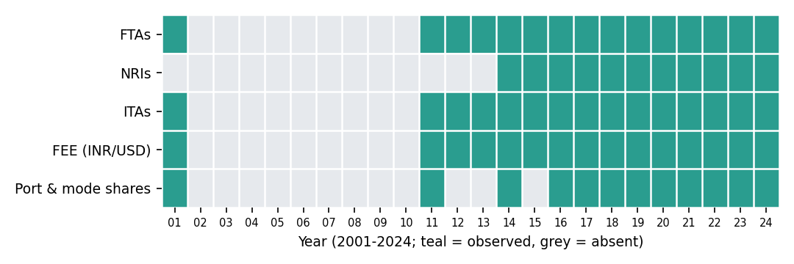
Figure 1. Data availability by variable and year. Grey cells are absent, not zero.
I considered three treatments for the missing NRI values. The decision for each variable is summarised below.
Variable | Options considered | Decision | Reason
NRIs, NRI share (2001, 2011–13) | Mean or ratio fill; linear interpolation; leave missing | Leave missing; flag | Series is defined only from 2014. Filling with the 2014–19 mean NRI share (40.53%) implies 2011 ITAs of 10,609,805, 68.2% above the reported figure.
Haridaspur, Bengaluru zeros | Keep 0; set NaN | Set NaN | Others fell from 29.6% (2014) to 19.2% (2016) the year Haridaspur appears at 8.6%: the port was previously bundled in Others.
Years absent from ports file (12) | Interpolate; leave gaps | Leave gaps | Delhi's share moves 30.3% (2014) to 39.7% (2021), so shares are not smooth; interpolation would fabricate precision.
Monthly counts | None missing | Deductive repair rule retained | Tested in the stress test (Section 5).

# Flag structural missingness rather than filling it
L["nri_reported"] = L["nris_exact"].notna()
L["ita_definition"] = np.where(L.nri_reported, "FTA+NRI", "FTA_only")
L["ita_comparable_flag"] = L.nri_reported # use ITAs only where True

# Ports: a 0.0 before a port was reported separately means "not reported"
P.loc[P.haridaspur_pct == 0, "haridaspur_pct"] = np.nan
P.loc[P.bengaluru_pct == 0, "bengaluru_pct"] = np.nan

4.2 Inconsistent definitions: the 2014 series break
The long-term file reports India's percentage share of world arrivals. Because the file also contains arrivals counts, the denominator can be back-solved: implied world total = India arrivals ÷ share. If the percentage always used the same numerator, the implied world total should be smooth and match published world figures.
Year | World arrivals reported in global file (M) | Implied world if share used FTAs (M) | Implied world if share used ITAs (M)
2019 | 1,466 | 896 | 1,468
2023 | 1,306 | 656 | 1,303
2024 | 1,465 | 711 | 1,469

For 2019, 2023 and 2024 the ITA-based figure matches the reported world total to within 0.3%, while the FTA-based figure is only 49–61% of it. Figure 2 extends the test to all years: up to 2013 the FTA basis tracks a plausible world total (about 1.0 billion in 2011–12); from 2014 only the ITA basis does. The "growth" in 2014 is therefore a change in definition, not in tourism.
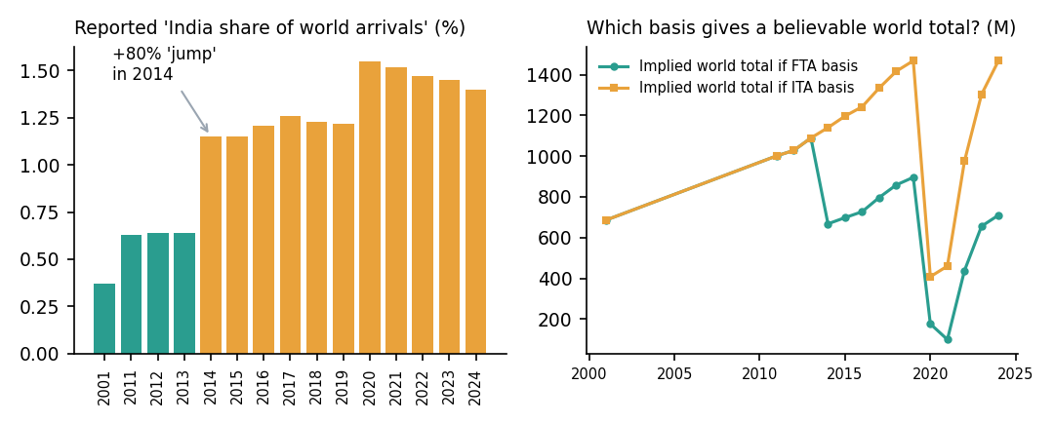
Figure 2. Left: reported share, coloured by inferred basis. Right: implied world total under each basis; the FTA line collapses in 2014.
L["implied_world_if_fta_m"] = L.ftas_million / L.india_share_world_arrivals_pct * 100
L["implied_world_if_ita_m"] = L.itas_million / L.india_share_world_arrivals_pct * 100
# anchor years: ITA-implied 1468/1303/1469 vs reported 1466/1306/1465
L["share_basis"] = np.where(L.year >= 2014, "ITA", "FTA") # compare shares only within a basis

Caveat: this basis is inferred by reconciliation, not read from source documentation. It should be confirmed against the original publication's footnotes before any 2013-to-2014 comparison is published.

4.3 Standardisation and format consistency
Raw | Cleaned | Why
Mixed-case headers (FTAs_2019, Arrivals_2019_M) | snake_case (ftas_2019, arrivals_2019_m) | Consistent joins and attribute access
FTAs_Million (2 d.p., partly truncated) | ftas integer persons; ftas_m derived (3 d.p.) | Exact counts reconcile to monthly sums; rounded copies do not
FEE_INR_Crore, FEE_USD_Million | Both kept, plus usd_inr_implied | Implied rate 46.9 to 83.7 confirms the two columns use consistent units
Receipts_*_USD_B (billions) | Kept, plus receipts_*_usd_m | Common unit with the India FEE series
Russian Federation, Others / Unclassified | Canonical names plus iso3 (e.g. RUS) | Stable join keys across sources
Monthly table: 12 × 20 wide | Tidy monthly_tidy.csv: 108 × 7 | Time-series and plotting ready; derived percentage columns dropped as recomputable

Rounding inconsistency. Of 41 "million" cells, 35 equal the exact count rounded to 2 d.p.; 5 are truncated instead (e.g. ITAs 2018: 17.4254M reported as 17.42, not 17.43) and 1 matches neither (FTAs 2023: reported 9.51, exact 9,520,928 = 9.52M). The exact columns are authoritative because they reconcile to the monthly sums, so the million columns were dropped and regenerated.
def canon_country(s):
k = " ".join(str(s).replace("-", " ").replace(".", " ").lower().split())
if k in ALIAS: return ALIAS[k] # "usa" -> United States
m = difflib.get_close_matches(k, [c.lower() for c in CANON], n=1, cutoff=0.8)
return next(c for c in CANON if c.lower() == m[0]) if m else None # fuzzy match

# wide -> tidy
ML = M.melt(id_vars=["month_no","month","quarter"], value_vars=cols, var_name="k", value_name="value")
ML["month_start"] = pd.to_datetime(dict(year=ML.year, month=ML.month_no, day=1))

4.4 Structural problems: ports and the global table

Port shares that do not sum to 100%
Mode shares (air, land, water) sum to 100 within 0.01 points in every year, but port shares do not. From 2014 the named ports plus "Others" total only 90.3–96.9%. The gap is largest in 2021 (9.67 points). Because it cannot be assigned to any port, it is stored as an explicit unreconciled_residual_pct column rather than being forced into "Others", which would hide it.
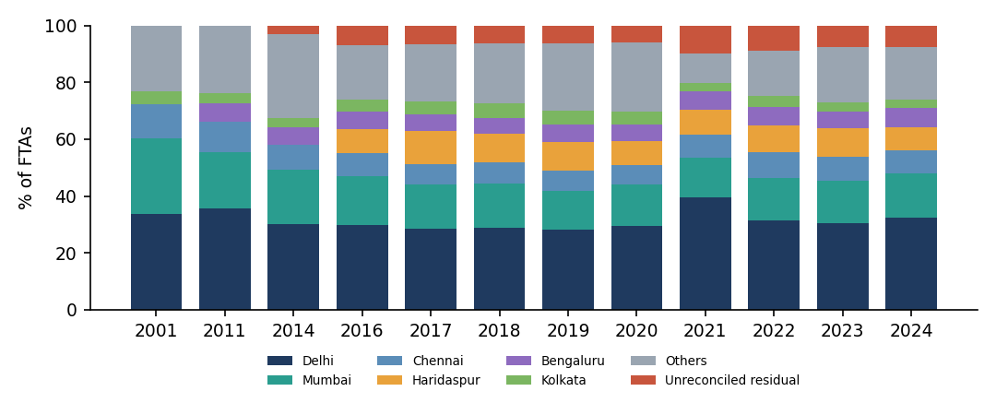
Figure 3. Port-of-entry shares by year, with the unreconciled residual shown in red.

Mixed hierarchy levels in the global file
The global file puts World, region, sub-region and India rows in the same columns. Any sum, mean or group-by over the arrivals column double-counts. A level column (world, region, sub_region, national_reference) was added so aggregates can filter correctly.
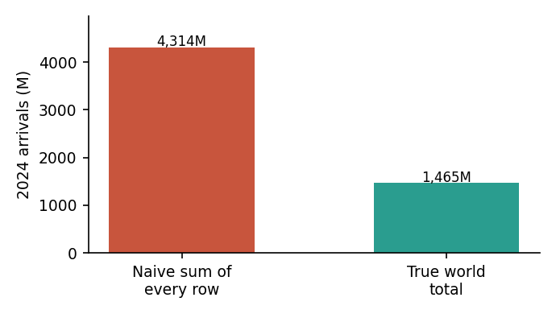
Figure 4. Naive column sum (4,314.1M) versus true 2024 world arrivals (1,465M).
Region | Region total 2024 (M) | Sum of sub-regions (M) | Gap (M)
Europe | 755.7 | 755.7 | 0.0
Asia and the Pacific | 317.5 | 317.5 | 0.0
Americas | 216.6 | 216.5 | -0.1
Africa | 73.9 | 73.9 | 0.0
Middle East | 101.2 | n/a | no sub-regions supplied

Sub-regions reconcile to their parent within rounding (the Americas gap of −0.1M). Region totals reconcile to the world total within 0.02% for arrivals, but receipts exceed the world figure by 1.03% in 2019 (US$1,502.3B vs 1,487B) and 0.43% in 2024; this is documented as a tolerance, not "fixed". The India row also uses a different measure (ITAs 20.57M, FEE) from the UN-style arrivals in the other rows (India FTAs: 9.95M), so it was moved to national_reference with arrivals_basis and receipts_basis labels.
W["level"] = np.select(
[W.region == "World", W.region.str.startswith("India"), W.sub_region == "Total"],
["world", "national_reference", "region"], default="sub_region")
W["arrivals_basis"] = np.where(W.level == "national_reference",
"ITA (FTA+NRI)", "International tourist arrivals")

4.5 Duplicates and outliers
Duplicates. None in any raw file (df.duplicated() = 0; keys such as year and country are unique). Because the raw files were clean on this point, the dedup logic was verified in the stress test (Section 5).
Outliers. With only 16 countries and 15 years, normality assumptions are weak, so two robust methods were used: the 1.5×IQR fence on country recovery rates and a MAD-based robust z-score (|z| > 3.5) on FEE per FTA.
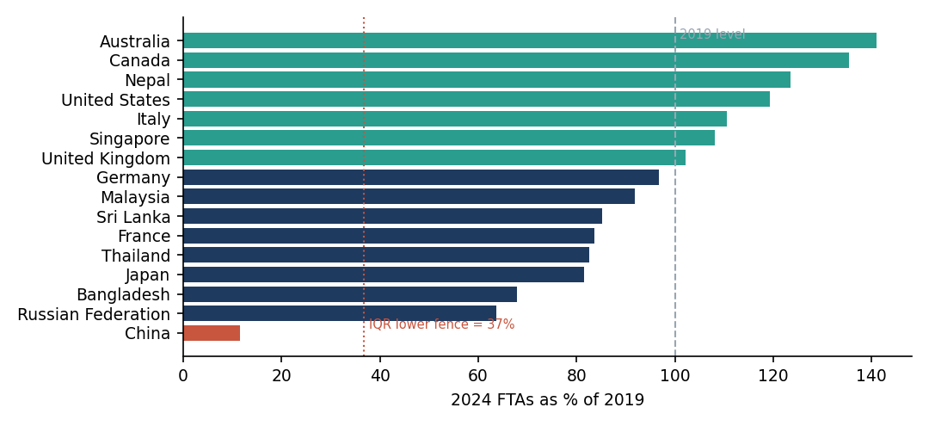
Figure 5. Recovery of FTAs, 2024 as % of 2019. China (red) falls below the IQR fence.
Flagged | Evidence | Decision and reasoning
China (country) | FTAs 339,442 (2019) to 30,585 (2023): −91.0%; recovery 11.5% vs fence 36.8% | Retain, flag. Real event (visa and flight suspensions). Deleting it would hide the largest market shift in the dataset.
2020, 2021 (FEE per FTA) | US$4,749 and US$5,665 vs median US$2,732; robust z = 8.1, 11.8 | Retain, flag. FTAs fell 74.9% in 2020 but FEE only 57.6%, so the ratio spikes. This is a COVID denominator effect; period column added.
2001 (FEE per FTA) | US$1,260; robust z = −5.9 | Retain, flag. Earliest year, different price level and FEE coverage.

q1, q3 = T.recovery_24_vs_19_pct.quantile([.25, .75]); iqr = q3 - q1
lo, hi = q1 - 1.5*iqr, q3 + 1.5*iqr # fence 36.8 to 158.4
T["outlier_flag"] = ~T.recovery_24_vs_19_pct.between(lo, hi)

med = x.median(); mad = (x - med).abs().median() # x = fee_per_fta_usd
L["fee_per_fta_robust_z"] = 0.6745 * (x - med) / mad
lo2, hi2 = 1548, 4430 # 1.5*IQR fences on x, computed as above
L["outlier_flag"] = (L.fee_per_fta_robust_z.abs() > 3.5) | (x < lo2) | (x > hi2)

5. Stress Test with Simulated Corruption
Because the raw data had no duplicates, no typos and no corrupted numbers, the generic cleaning steps could not be demonstrated on it. To prove the pipeline handles real-world mess, faults were injected into copies of two files (fixed random seed; the originals were not modified) and the pipeline was asked to find and repair them.
Injected fault (file) | Count | Detection rule | Repair | Result
Null FTA values (monthly 2024) | 3 | isna() | FTA = ITA − NRI | 3 of 3 exact
Unit error ×1,000 (May) | 1 | ITA ≠ FTA + NRI | same identity | 1 of 1 exact
Negative value (Nov) | 1 | value ≤ 0 | same identity | 1 of 1 exact
Text token "N/A" (Jan) | 1 | to_numeric(errors="coerce") | same identity | 1 of 1 exact
Exact duplicate rows (countries) | 3 | duplicated() after canonicalising names | drop_duplicates | 3 of 3 removed
Name variants (" united states", "UNITED KINGDOM", "Russian Fed.", "Banglades", "Sri-Lanka", "USA", "UK") | 7 | lower-case, strip, alias map, difflib cutoff 0.8 | map to canonical name | 7 of 7 resolved

Why the identity repair beats statistical imputation. Replacing the three null months with the mean of the other months would give 824,281 each, leaving errors of 7.7% (March), 3.1% (July) and 1.9% (October), averaging 36,409 visitors, because it ignores seasonality. Rebuilding each month as ITA − NRI gave zero error. The limitation is that this works only where redundant fields exist; for single-source variables (e.g. NRIs before 2014) there is nothing to reconstruct from, which is why those cells stay missing.
S["ftas_2024"] = pd.to_numeric(S.ftas_2024, errors="coerce") # "N/A" -> NaN
gap = (S.itas_2024 - S.nris_2024 - S.ftas_2024).abs()
bad = S.ftas_2024.isna() | (S.ftas_2024 <= 0) | (gap > 0)
S["fta_fixed"] = np.where(bad, S.itas_2024 - S.nris_2024, S.ftas_2024) # deductive repair
# result: 6 of 6 injected faults detected; max abs error after repair = 0

6. Validation Framework
Every check is logged to data_quality_log.csv with a stage, dataset, result and detail (full log in Appendix A). The logic is "audit, treat, re-test": the seven audit failures each correspond to a post-cleaning assertion that now passes.
Audit failure (raw data) | Evidence | Post-clean assertion (all PASS)
Million columns ≠ rounded exact | 5 truncated, 1 unexplained | Millions regenerated from exact counts
ITA identical to FTA | 4 rows: 2001, 2011–13 | Non-comparable ITA rows flagged (4 of 4)
Single basis for world share | Implied world 1,089M to 668M | All 15 years labelled with share_basis
Rank contiguous 1..n | Max rank 30 with 16 rows | Outlier retained and flagged; in_top15_2024 added
Port shares sum to 100 | 10 of 12 years short (90.3–96.9) | Residual column makes every year sum to 100
One entity level per row | World, region, sub-region, India mixed | level separates 4 levels
India row like-for-like | 20.57M (ITAs) vs 9.95M (FTAs) | Basis columns added; row isolated

6.1 Before and after
Dataset | Raw (rows × cols) | Cleaned | Null cells after | Added columns
inbound_longterm | 15 × 14 (12 nulls) | 15 × 19 | 8 (all intentional) | period, nri_reported, ita_definition, ita_comparable_flag, share_basis, usd_inr_implied, outlier_flag
monthly | 12 × 20 | 108 × 7 (tidy) | 0 | month_start, metric
regions | 6 × 9 | 6 × 9 | 0 | name standardised
top_countries | 16 × 11 | 16 × 15 | 0 | iso3, rank_change, in_top15_2024, outlier_flag
ports_modes | 12 × 11 | 12 × 14 | 4 (not-reported ports) | named_port_coverage_pct, unreconciled_residual_pct, precision_dp
global_trends | 21 × 14 | 21 × 19 | 0 | level, arrivals_basis, receipts_basis, receipts_*_usd_m

7. Why It Matters: Wrong Conclusions Avoided
Each row compares what an analyst would conclude from the raw files with the conclusion after cleaning.
Question | Naive answer from raw data | Answer after cleaning
Did India's global share jump in 2014? | +79.7% (0.64% to 1.15%); rank 41 to 24 | No real jump; basis changed. Within the ITA basis, share rose 1.15% to 1.40% (2014–2024, +21.7%).
What were world arrivals in 2024? | Column sum = 4,314.1M | 1,465M (filter level == "world")
What were India's ITAs in 2011? | ~10.61M if NRIs are imputed | 6.31M FTAs only; ITAs not comparable before 2014
Do ports account for all visitors? | Named ports plus Others = 92.3% (2024) taken as 100% | 7.7% is unallocated and shown explicitly
Is China a data error to drop? | Auto-removed by an outlier rule | Retained: a real −91% collapse and the largest market shift
Was 2020 spend per visitor anomalous? | US$4,749 looks like an error | COVID denominator effect (FTAs −74.9%, FEE −57.6%); flagged by period

8. Final Datasets, Limitations and Next Steps

8.1 Deliverables
File | Purpose
clean_tourism.py | Single reproducible pipeline (python clean_tourism.py raw_dir out_dir)
cleaned_data/*.csv (6 files) | Analysis-ready datasets described in Section 6.1
data_quality_log.csv / .json | 47 logged checks with PASS/FAIL and detail
results.json | All figures quoted in this report
figures/*.png (5 files) | Charts used in this report

8.2 Limitations
- Inferred, not documented. The 2014 basis switch and the "not reported" interpretation of port zeros are inferred from reconciliation. They should be verified against the source publications' notes.
- Thin coverage. Only three years of monthly data and 12 port observations exist, which limits seasonal and structural modelling. The ports series has irregular spacing.
- Unresolved gaps. The 9.67-point port residual in 2021 and the 1.03% region-versus-world receipts gap in 2019 cannot be explained from the files alone and are carried forward as documented tolerances.
- Stress test is synthetic. It demonstrates the pipeline's detection logic, not the prevalence of such errors in the real data (which had none of the injected types).

8.3 Readiness for Week 4
- Use 2014–2024 for any model needing ITAs or NRIs; use ita_comparable_flag to filter.
- Treat 2020–2021 with the period flag or a COVID indicator rather than dropping them.
- Use monthly_tidy.csv with month_start for seasonal features (e.g. the 2024 December peak of 1,060,621 FTAs against a May trough of 622,189).
- Aggregate the global file only after filtering on level.

Appendix A. Full Validation Log (47 checks)
Stage "audit" runs on raw data (FAIL = defect found); stage "post" runs on cleaned data (all PASS).
Stage | Dataset | Check | Result | Detail
audit | longterm | million cols == round(exact,2) | FAIL | 5 truncated, 1 unexplained (FTAs 2023: 9.51 vs 9.52)
audit | longterm | ITA = FTA + NRI (rows with NRI) | PASS | 11 rows tested, max gap 0
audit | longterm | ITA != FTA in every year | FAIL | ITA identical to FTA in 4 rows: [2001, 2011, 2012, 2013]
audit | longterm | share-of-world uses one basis for all years | FAIL | implied world total falls 1089M -> 668M on FTA basis in 2014
audit | longterm | implied INR/USD within 40-90 | PASS | range 46.9 - 83.7
audit | longterm | fee_per_fta recomputes | PASS
audit | longterm | fee_per_ita recomputes | PASS
audit | monthly | ITA=FTA+NRI 2019 | PASS
audit | monthly | 12-month FTA sum = annual FTA 2019 | PASS | 10,930,355 vs 10,930,355
audit | monthly | 12-month NRI sum = annual NRI 2019 | PASS
audit | monthly | ITA=FTA+NRI 2023 | PASS
audit | monthly | 12-month FTA sum = annual FTA 2023 | PASS | 9,520,928 vs 9,520,928
audit | monthly | 12-month NRI sum = annual NRI 2023 | PASS
audit | monthly | ITA=FTA+NRI 2024 | PASS
audit | monthly | 12-month FTA sum = annual FTA 2024 | PASS | 9,951,722 vs 9,951,722
audit | monthly | 12-month NRI sum = annual NRI 2024 | PASS
audit | monthly | FTA growth col recomputes | PASS
audit | monthly | seasonality index mean = 100 | PASS
audit | regions | regions sum to annual FTA 2019 | PASS
audit | regions | shares sum to 100 2019 | PASS
audit | regions | regions sum to annual FTA 2023 | PASS
audit | regions | shares sum to 100 2023 | PASS
audit | regions | regions sum to annual FTA 2024 | PASS
audit | regions | shares sum to 100 2024 | PASS
audit | countries | shares recompute from FTA totals | PASS
audit | countries | rank_2024 is contiguous 1..n | FAIL | max rank 30 with 16 rows
audit | ports | mode shares sum to 100 (+/-0.05) | PASS | max dev 0.01
audit | ports | port shares sum to 100 (+/-0.05) | FAIL | 10/12 years short, range 90.33-96.9
audit | global | spend/arrival recomputes | PASS
audit | global | one row per entity (no mixed levels) | FAIL | World, region, sub-region and India rows share one table
audit | global | India row compares like with like | FAIL | India row = 20.57M (ITAs), FTAs = 9.95M
post | longterm | no duplicate years | PASS
post | longterm | ITA=FTA+NRI where comparable | PASS
post | longterm | non-comparable ITA rows flagged | PASS
post | longterm | share basis labelled for all years | PASS
post | monthly | tidy rows = 3 metrics x 3 years x 12 months | PASS | 108 rows
post | monthly | no nulls in tidy table | PASS
post | countries | canonical names all mapped to ISO3 | PASS
post | countries | outlier retained & flagged (not dropped) | PASS
post | ports | zeros converted to NaN where port not reported | PASS
post | ports | residual column makes every year sum to 100 | PASS
post | global | level column separates World/region/sub/national | PASS
post | global | region rows sum to world within 1.1% | PASS | arrivals_2019_m:-0.02%; arrivals_2024_m:-0.01%; receipts_2019_usd_b:1.03%; receipts_2024_usd_b:0.43%
post | global | sub-region sums match region totals (<=0.2M) | PASS
post | stress | all injected monthly errors repaired exactly | PASS
post | stress | all injected duplicates removed | PASS
post | stress | all spelling variants resolved | PASS

