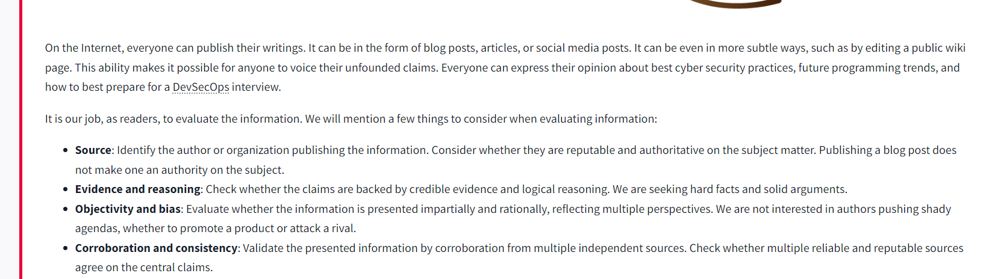

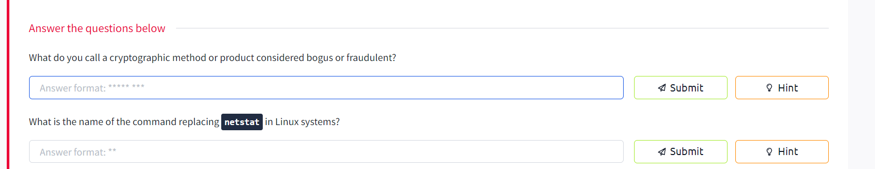

https://en.wikipedia.org/wiki/Snake_oil_(cryptography)

https://phoenixnap.com/kb/ss-command#:~:text=The%20ss%20command%20is%20considered,ss%20as%20the%20superior%20alternative.

Search Engines

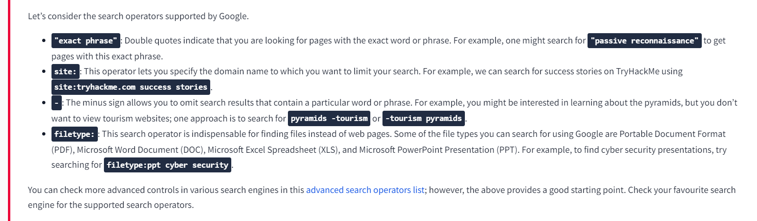
https://github.com/cipher387/Advanced-search-operators-list

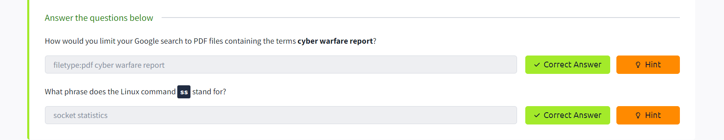

Specialiezd Search Engines

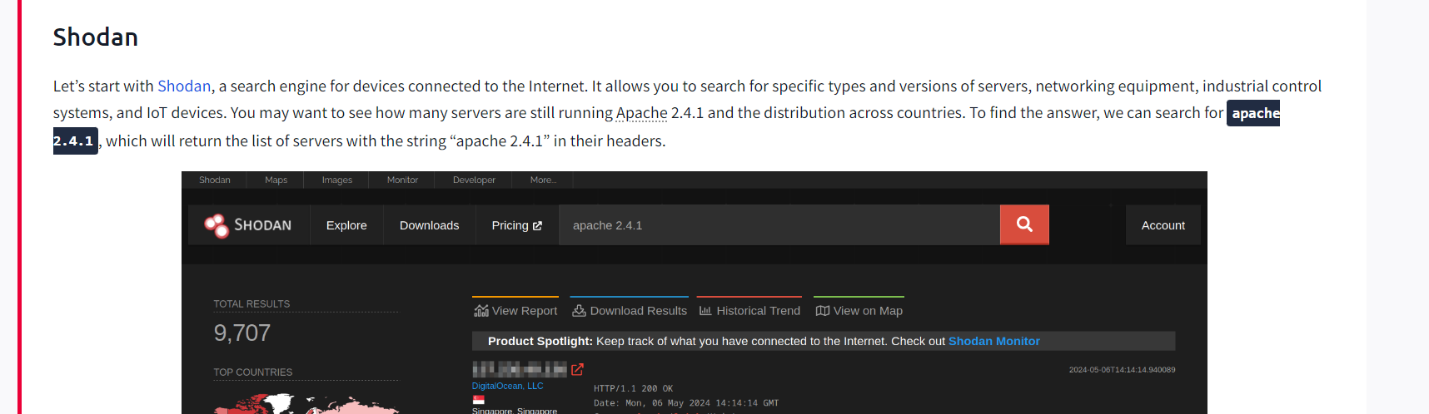
Shodan

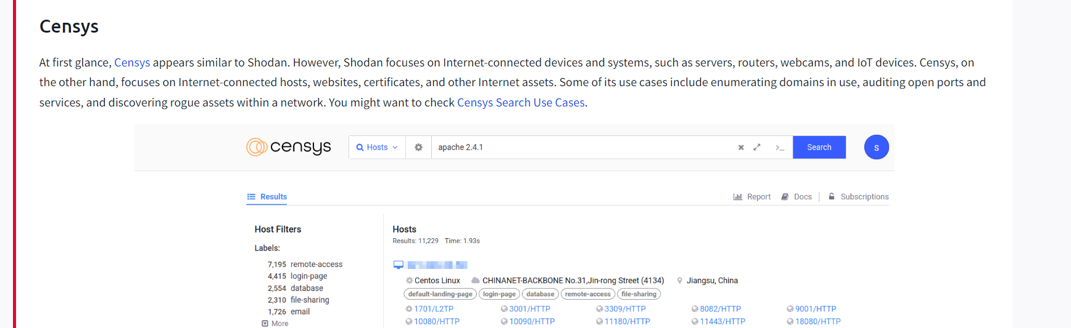
Censys
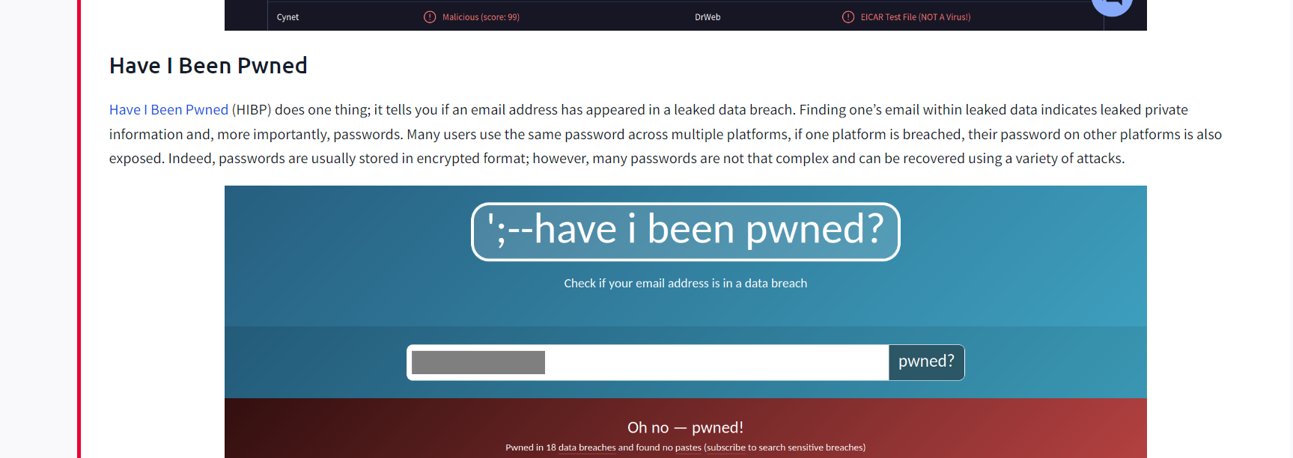
Have I Been Pwned

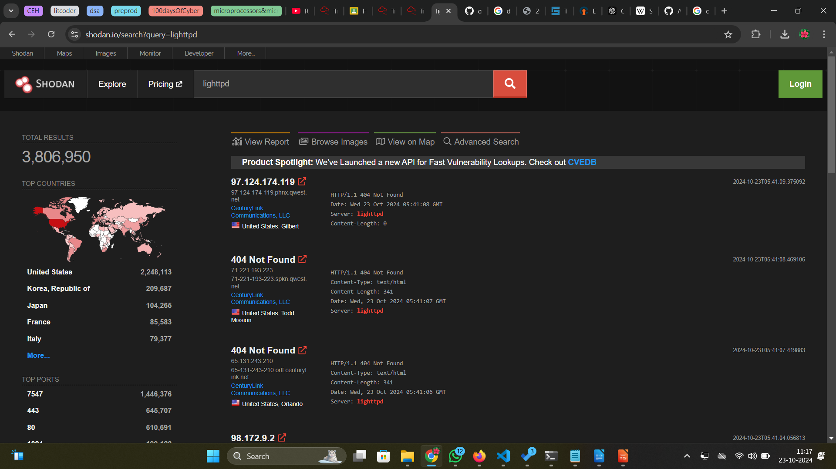
Lighttpd Search Results

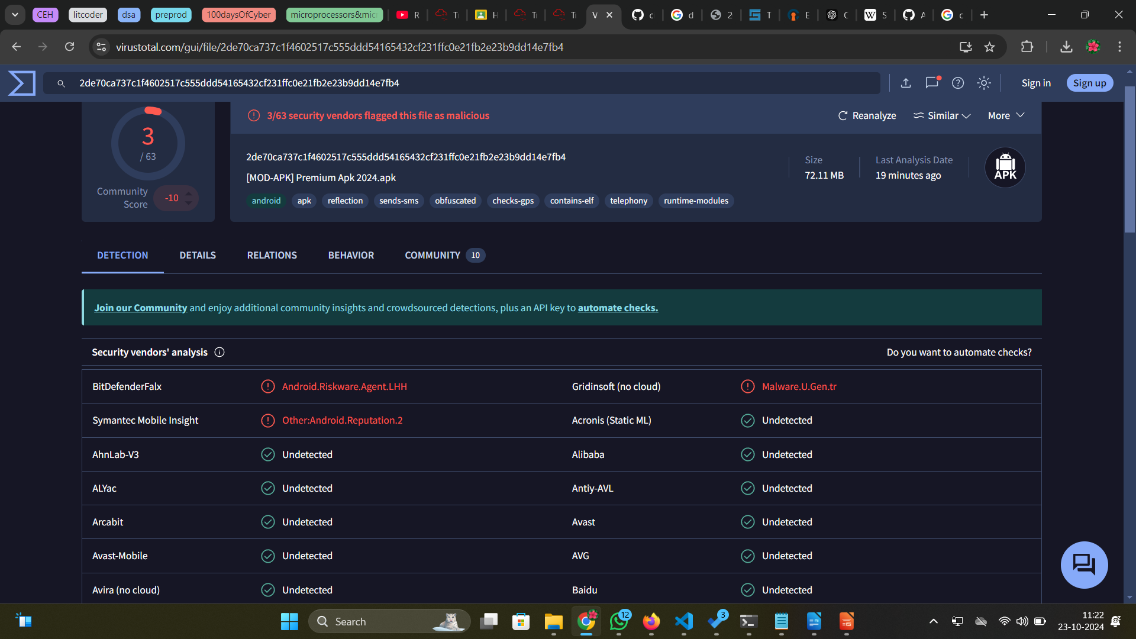
VirusTotal

Vulnerabilities and Exploits
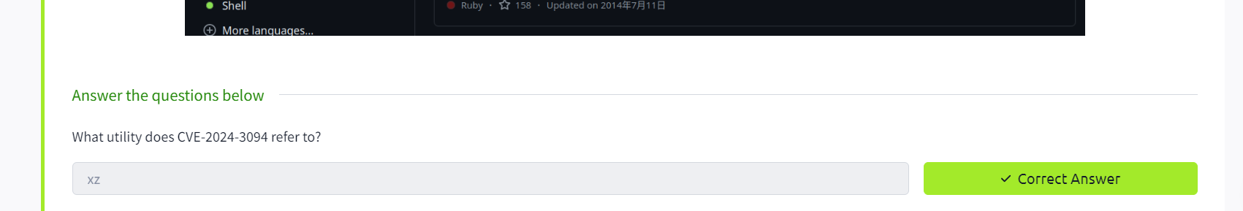
https://nvd.nist.gov/vuln/detail/CVE-2024-3094

Linux Man Pages

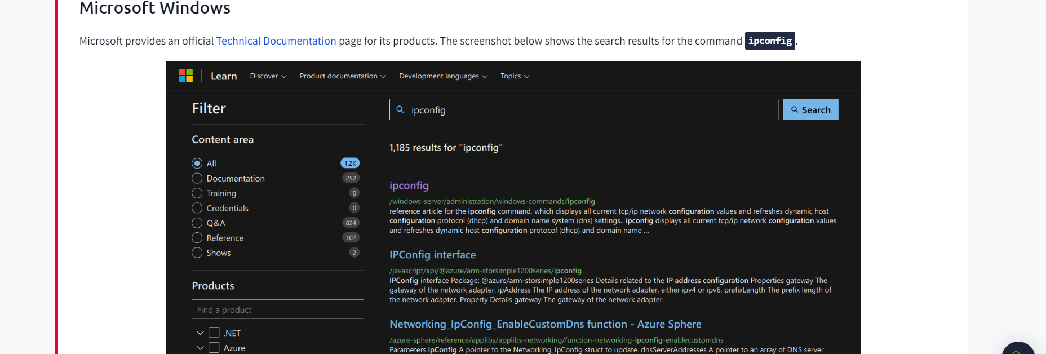
Windows Documentation page

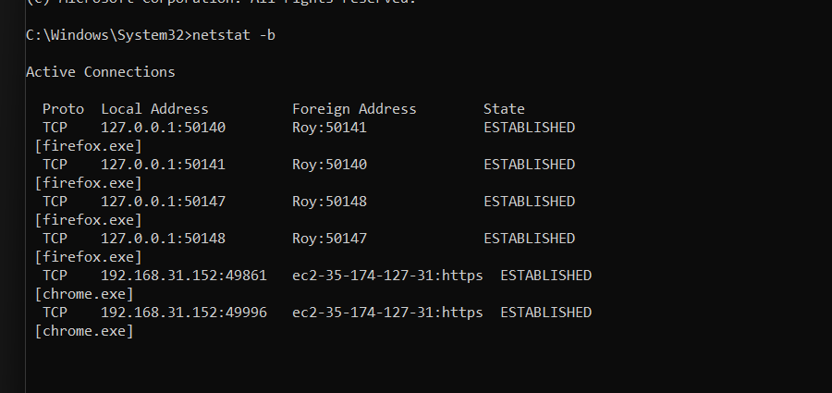
Executables associated with each active connection

https://learn.microsoft.com/en-us/windows-server/administration/windows-commands/netstat



