Introduction to Windows

https://www.cyberark.com/resources/threat-research-blog/explain-like-i-m-5-remote-desktop-protocol-rdp
https://medium.com/@laupeiip/how-to-rdp-into-a-tryhackme-windows-machine-with-your-kali-vm-f637cf7422d1
https://www.pcmag.com/how-to/how-to-use-microsofts-remote-desktop-connection

Key Notes on the Evolution of Windows Operating System

1. Initial Release and Dominance:
- Windows began in 1985 and has since become the dominant OS for personal and corporate use.
- Due to its popularity, Windows has been a major target for malware and hacker attacks.

2. Windows XP:
- Windows XP was highly popular and widely used across various sectors.
- Windows Vista followed but faced numerous issues, leading to its quick phase-out.

3. Transition to Windows 7:
- When Windows XP reached its end of life, there was a widespread transition to Windows 7.
- Companies and institutions had to test compatibility and, if incompatible, seek alternative vendors—a challenging process for many.

4. Short-Lived Windows Versions:
- Windows 8.x was another attempt that saw limited success and brief support, similar to Windows Vista.

5. Windows 10:
- Released in two main editions, Home and Pro, Windows 10 became the standard for desktop computers.
- Despite ongoing improvements, Microsoft announced end-of-support for Windows 10 by October 14, 2025

6. Windows for Servers:
- Windows Server 2019 is the current version for server environments.

7. Introduction of Windows 11:
- Windows 11 was launched on October 5, 2021, becoming the latest OS for end-users, emphasizing further security and usability improvements.

These milestones highlight Microsoft’s iterative improvements in usability, security, and compatibility while navigating both market demands and legacy software challenges.

GUI
Here are short notes on each component of the Windows 10 GUI:

The Desktop
- Function: Holds shortcuts for quick access to programs, files, and folders.
- Customization: Right-click for options like icon arrangement, display settings, and background personalization.
- Display Settings: Allows resolution and orientation changes, especially for multi-screen setups.
- Personalization: Customize wallpaper, themes, fonts, and colors.

Start Menu
- Purpose: Access apps, programs, and system utilities.
- Sections:
- User Shortcuts: Account settings, logout, documents, pictures, settings, and power options.
- App List: Recently added and all installed programs, arranged alphabetically.
- Tiles: Quick-access icons for specific apps; right-click to pin, resize, or view properties.

Taskbar
- Function: Displays running apps and shortcuts; provides preview thumbnails and tooltips.
- Customization: Right-click to enable/disable components, pin/unpin apps, and adjust toolbar visibility.

Notification Area
- Location: Bottom right corner, showing date, time, and system icons (e.g., volume, network).
- Customization: Add or remove icons via Taskbar settings; quick access to notifications and essential tools.

The File System
The file system used in modern Windows versions is NTFS (New Technology File System)

Before NTFS, FAT16/FAT32 (File Allocation Table) and HPFS (High Performance File System) were used
FAT partitions are still common in USB devices and MicroSD cards but are not typical on personal Windows computers or servers

NTFS is a journaling file system, which allows automatic repair of folders and files using log file data in case of a failure, a feature not available in FAT

NTFS supports files larger than 4GB, specific permissions on files and folders, file/folder compression, and encryption (Encryption File System or EFS)

To check the file system your Windows installation is using, right-click the C drive, select Properties, and view the File System

NTFS allows setting specific permissions for access control on files and folders, including Full Control, Modify, Read & Execute, List Folder Contents, Read, and Write
To view permissions for a file or folder, right-click it, select Properties, go to the Security tab, and choose a user or group to view permissions

NTFS also includes Alternate Data Streams (ADS), a feature allowing multiple data streams for each file. ADS isn’t shown in Windows Explorer by default and often requires PowerShell or third-party tools to view. ADS can be used both legitimately (like tagging downloaded files) and by malware writers for hiding data

The Windows/System32 Folders
- The Windows folder (C:\Windows) contains the Windows operating system, but it doesn’t necessarily need to be in the C drive; it can reside on other drives or in different folders

- The system environment variable %windir% points to the Windows directory location

- Environment variables store details about the OS environment, such as the OS path, number of processors, and location of temporary folders

- Within the Windows folder, one key subfolder is System32, which holds critical system files necessary for Windows to operate properly

- Extreme caution is advised when accessing System32, as deleting files or folders here can make the OS unusable

User Accounts, Profiles, and Permissions
User accounts can be one of two types on a typical local Windows system: Administrator & Standard User.
The user account type will determine what actions the user can perform on that specific Windows system.
- An Administrator can make changes to the system: add users, delete users, modify groups, modify settings on the system, etc.
- A Standard User can only make changes to folders/files attributed to the user & can't perform system-level changes, such as install programs.
You are currently logged in as an Administrator. There are several ways to determine which user accounts exist on the system.
One way is to click the Start Menu and type Other User. A shortcut to System Settings > Other users should appear.
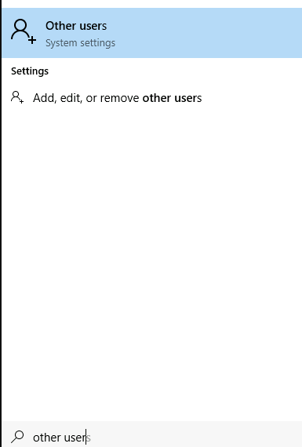
If you click on it, a Settings window should now appear. See below.
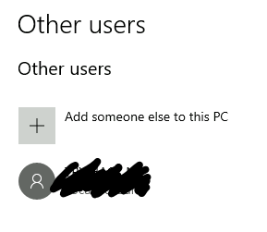
Since you're the Administrator, you see an option to Add someone else to this PC.
Note: A Standard User will not see this option.
Click on the local user account. More options should appear: Change account type and Remove.
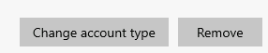
Click on Change account type. The value in the drop-down box (or the highlighted value if you click the drop-down) is the current account type.
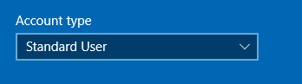
When a user account is created, a profile is created for the user. The location for each user profile folder will fall under is C:\Users.
For example, the user profile folder for the user account Max will be C:\Users\Max.
The creation of the user's profile is done upon initial login. When a new user account logs in to a local system for the first time, they'll see several messages on the login screen. One of the messages, User Profile Service, sits on the login screen for a while, which is at work creating the user profile. See below.

Once logged in, the user will see a dialog box similar to the one below (again), indicating that the profile is in creation.
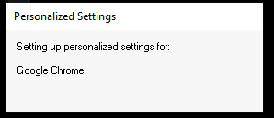
Each user profile will have the same folders; a few of them are:
- Desktop
- Documents
- Downloads
- Music
- Pictures
Another way to access this information, and then some, is using Local User and Group Management.
Right-click on the Start Menu and click Run. Type lusrmgr.msc. See below
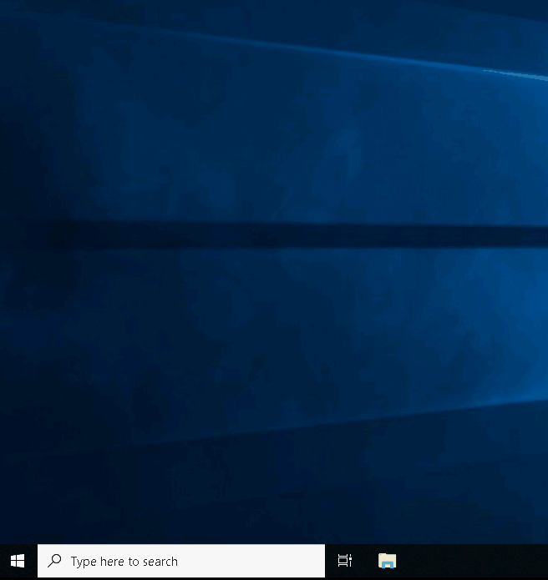
Note: The Run Dialog Box allows us to open items quickly.
Back to lusrmgr, you should see two folders: Users and Groups.
If you click on Groups, you see all the names of the local groups along with a brief description for each group.
Each group has permissions set to it, and users are assigned/added to groups by the Administrator. When a user is assigned to a group, the user inherits the permissions of that group. A user can be assigned to multiple groups.
Note: If you click on Add someone else to this PC from Other users, it will open Local Users and Management.

User Account Control
- Most home users log into Windows as local administrators, allowing them to make system changes
- Running daily tasks (e.g., internet browsing or document editing) doesn’t require elevated privileges, so elevated access increases malware risks by allowing it to execute changes in the user’s context
- To adress this, Microsoft introduced User Account Control (UAC), first seen in Windows Vista and maintained in later Windows versions
- UAC doesn’t apply by default to the built-in local administrator account
- UAC ensures that when an administrator logs in, the session doesn’t automatically have elevated permissions; any operation requiring elevated access prompts the user for permission
- Standard users see a shield icon on programs that require UAC confirmation, signaling a need for administrator credentials
- If the password is not entered in time, the prompt disappears, preventing installation—helping to protect the system against unauthorized changes
- The Security tab in program properties displays users/groups and their permissions
https://support.lenovo.com/nz/en/solutions/ht513708-how-to-set-administrators-account-in-windows-11

