Window F3
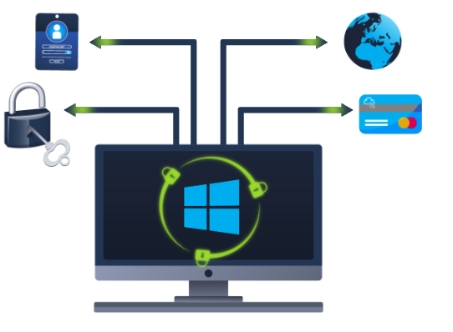

Windows Updates

Let's start things off with Windows Update.
Windows Update is a service provided by Microsoft to provide security updates, feature enhancements, and patches for the Windows operating system and other Microsoft products, such as Microsoft Defender.
Updates are typically released on the 2nd Tuesday of each month. This day is called Patch Tuesday. That doesn't necessarily mean that a critical update/patch has to wait for the next Patch Tuesday to be released. If the update is urgent, then Microsoft will push the update via the Windows Update service to the Windows devices.
Refer to the following link to see the Microsoft Security Update Guide here.
Windows Update is located in Settings. See below.
Tip: Another way to access Windows Update is from the Run dialog box, or CMD, by running the command control /name Microsoft.WindowsUpdate
n the attached VM, there are a few things to highlight.
- The Windows Update settings are 'managed'. (Typically, home users will not see this type of message)
- There are no available updates available for the virtual machine. (The attached virtual machine does not have Internet access to communicate with Microsoft to obtain new updates)
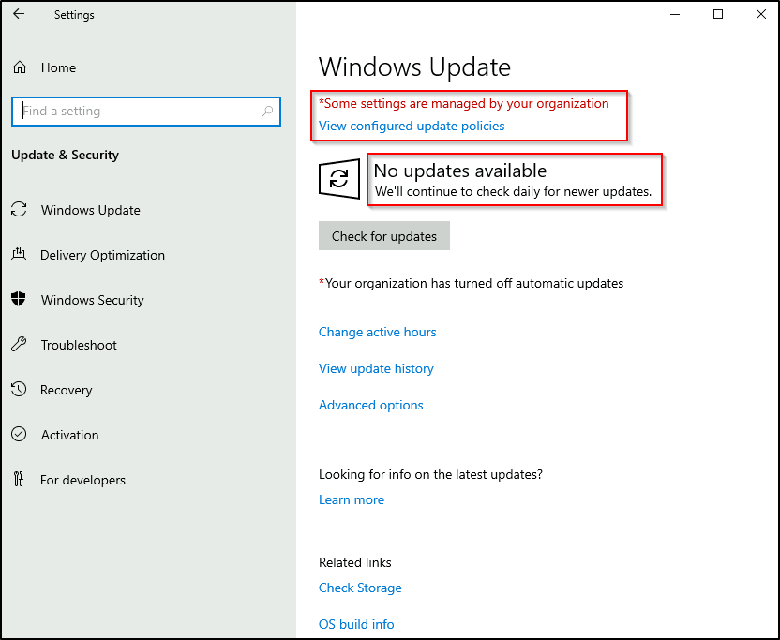
Throughout the years, Windows users have grown accustomed to pushing Windows Updates off to a later date or not installing the updates at all. Various reasons caused this action, one being the fact that a reboot is typically required after a Windows update.
Microsoft notably addressed this issue with Windows 10. The updates can no longer be ignored or pushed to the side until forgotten. Windows updates can only be postponed, but eventually, the update will happen, and your computer will reboot. Microsoft provides these updates to keep the device safe and secure.
Below is an image showing how a Restart required looks and the several options available regarding scheduling the restart.
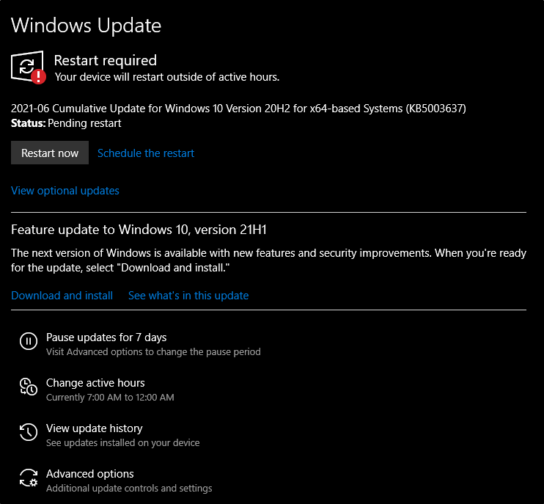

Windows Security
Per Microsoft, "Windows Security is your home to manage the tools that protect your device and your data".
In case you missed it, Windows Security is also available in Settings.
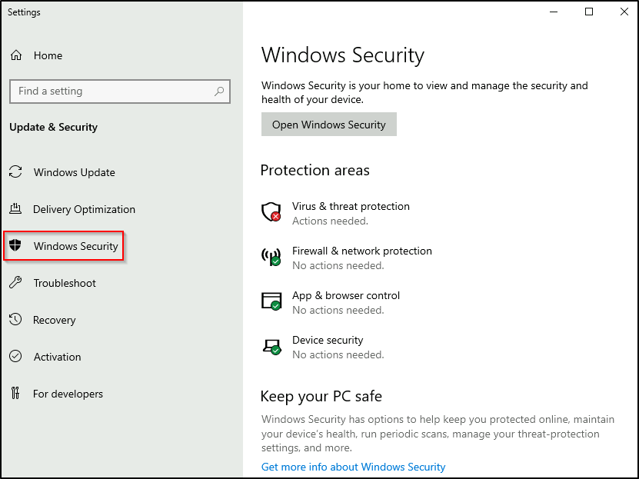
In the above image, focus your attention on Protection areas.
- Virus & threat protection
- Firewall & network protection
- App & browser control
- Device security
Each following task will briefly touch on these areas.
Before proceeding, let's provide a quick comment on the status icons.
- Green means your device is sufficiently protected, and there aren't any recommended actions.
- Yellow means there is a safety recommendation for you to review.
- Red is a warning that something needs your immediate attention.
Click on Open Windows Security.
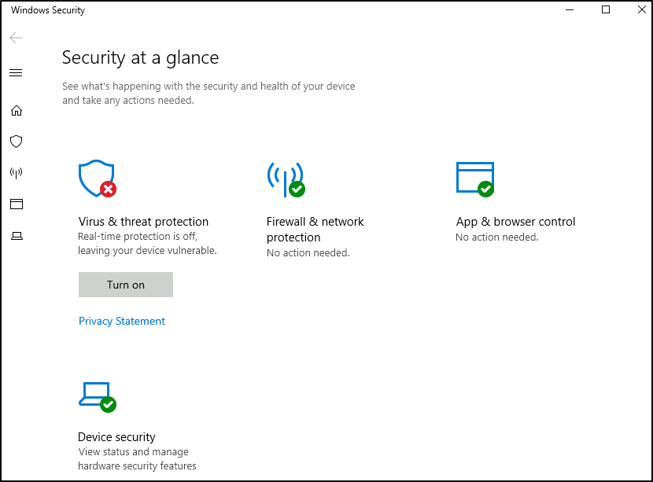
Note: Since the attached VM is a Windows Server 2019 edition, it looks different from a Windows 10 Home or Professional edition.
The below image is from a Windows 10 device.
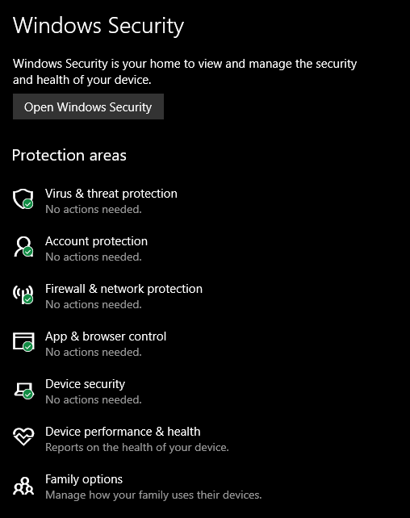
Next, we'll look at Virus & threat protection.

Virus & Threat Protection
Virus & threat protection is divided into two parts:
- Current threats
- Virus & threat protection settings
The image below only focuses on Current threats.
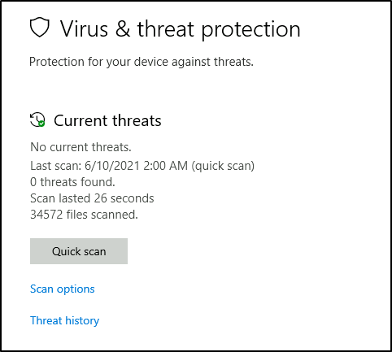
Current threats
Scan options
- Quick scan - Checks folders in your system where threats are commonly found.
- Full scan - Checks all files and running programs on your hard disk. This scan could take longer than one hour.
- Custom scan - Choose which files and locations you want to check.
Threat history
- Last scan - Windows Defender Antivirus automatically scans your device for viruses and other threats to help keep it safe.
- Quarantined threats - Quarantined threats have been isolated and prevented from running on your device. They will be periodically removed.
- Allowed threats - Allowed threats are items identified as threats, which you allowed to run on your device.
Warning: Allow an item to run that has been identified as a threat only if you are 100% sure of what you are doing.
Next is Virus & threat protection settings.
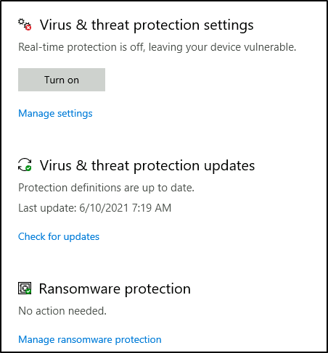
Virus & threat protection settings
Manage settings
- Real-time protection - Locates and stops malware from installing or running on your device.
- Cloud-delivered protection - Provides increased and faster protection with access to the latest protection data in the cloud.
- Automatic sample submission - Send sample files to Microsoft to help protect you and others from potential threats.
- Controlled folder access - Protect files, folders, and memory areas on your device from unauthorized changes by unfriendly applications.
- Exclusions - Windows Defender Antivirus won't scan items that you've excluded.
- Notifications - Windows Defender Antivirus will send notifications with critical information about the health and security of your device.
Warning: Excluded items could contain threats that make your device vulnerable. Only use this option if you are 100% sure of what you are doing.
Virus & threat protection updates
- Check for updates - Manually check for updates to update Windows Defender Antivirus definitions.
Ransomware protection
- Controlled folder access - Ransomware protection requires this feature to be enabled, which in turn requires Real-time protection to be enabled.
Note: Real-time protection is turned off in the attached VM to decrease the chances of performance issues. Since the VM can't reach the Internet and there aren't any threats in the VM, this is safe to do. Real-time protection should definitely be enabled in your personal Windows devices unless you have a 3rd party product that provides the same protection. Ensure it's always up-to-date and enabled.
Tip: You can perform on-demand scans on any file/folder by right-clicking the item and selecting 'Scan with Microsoft Defender'.
The below image was taken from another Windows device to show this feature.
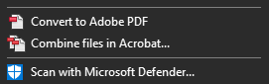

Windows Firewall
What is a firewall?
Per Microsoft, "Traffic flows into and out of devices via what we call ports. A firewall is what controls what is - and more importantly isn't - allowed to pass through those ports. You can think of it like a security guard standing at the door, checking the ID of everything that tries to enter or exit".
The below image will reflect what you will see when you navigate to Firewall & network protection.
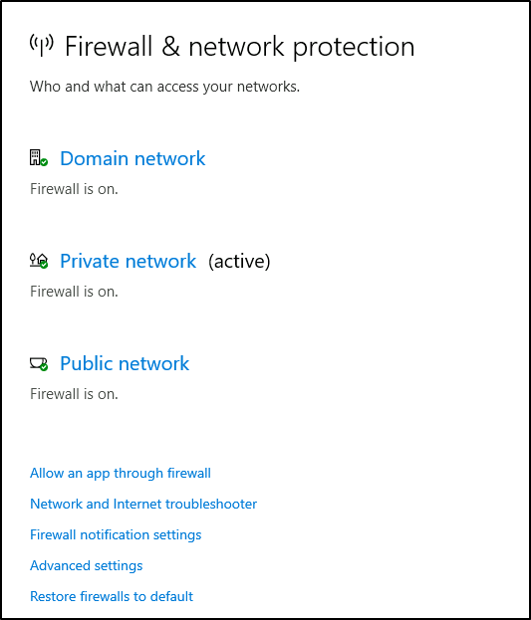
Note: Each network may have different status icons for you.
What is the difference between the 3 (Domain, Private, and Public)?
Per Microsoft, "Windows Firewall offers three firewall profiles: domain, private and public".
- Domain - The domain profile applies to networks where the host system can authenticate to a domain controller.
- Private - The private profile is a user-assigned profile and is used to designate private or home networks.
- Public - The default profile is the public profile, used to designate public networks such as Wi-Fi hotspots at coffee shops, airports, and other locations.
If you click on any firewall profile, another screen will appear with two options: turn the firewall on/off and block all incoming connections.
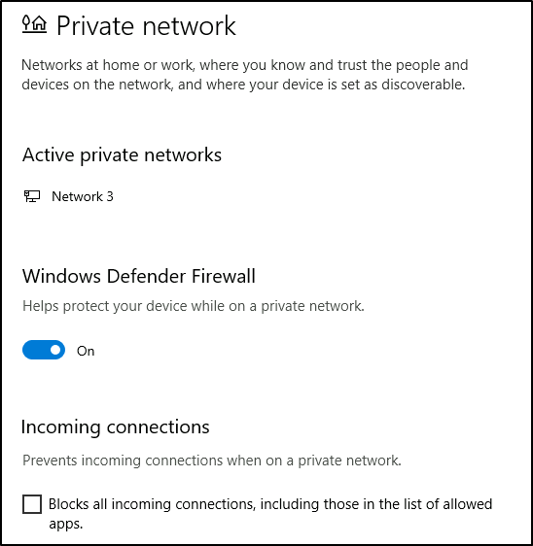
Warning: Unless you are 100% confident in what you are doing, it is recommended that you leave your Windows Defender Firewall enabled.

Allow an app through firewall
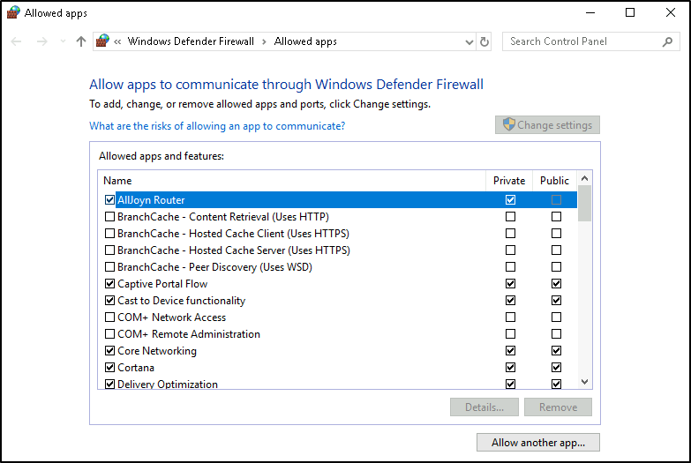
You can view what the current settings for any firewall profile are. In the above image, several apps have access in the Private and/or Public firewall profile. Some of the apps will provide additional information if it's available via the Details button.
Advanced Settings
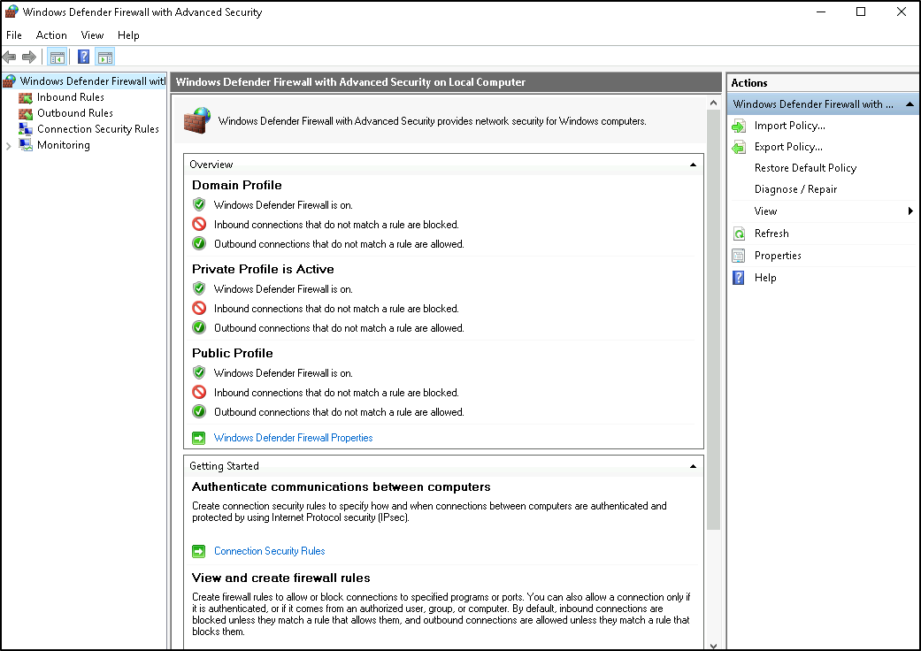
Configuring the Windows Defender Firewall is for advanced Windows users. Refer to the following Microsoft documentation on best practices here.
Tip: Command to open the Windows Defender Firewall is WF.msc.

App & Browser Controler
this section, you can change the settings for the Microsoft Defender SmartScreen.
Per Microsoft, "Microsoft Defender SmartScreen protects against phishing or malware websites and applications, and the downloading of potentially malicious files".
Refer to the official Microsoft document for more information on Microsoft Defender SmartScreen here.
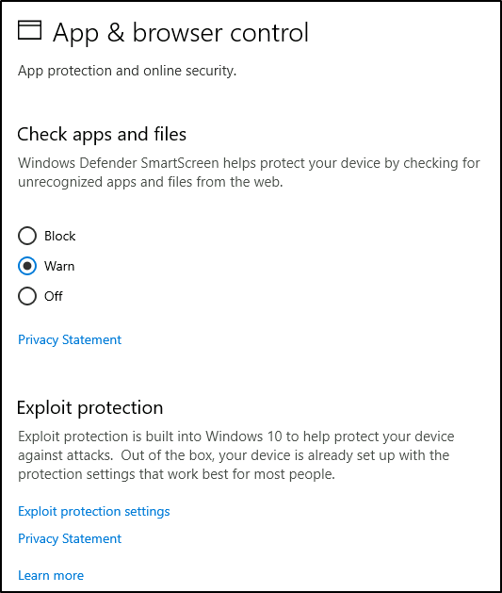
Check apps and files
- Windows Defender SmartScreen helps protect your device by checking for unrecognized apps and files from the web.
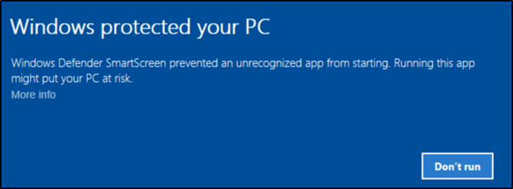
Exploit protection
- Exploit protection is built into Windows 10 (and, in our case, Windows Server 2019) to help protect your device against attacks.
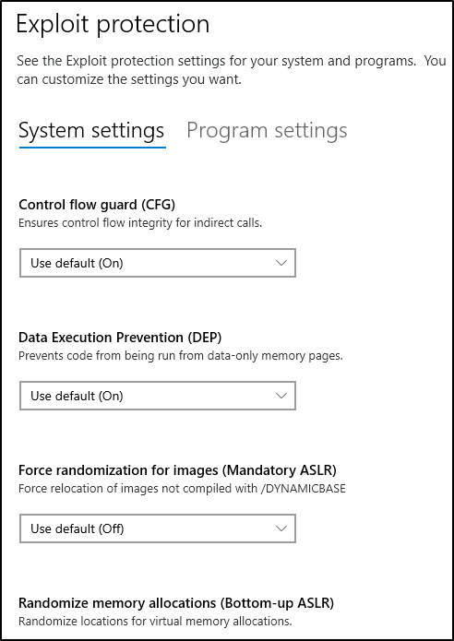
Warning: Unless you are 100% confident in what you are doing, it is recommended that you leave the default settings.

Device Security
Even though you'll probably never change any of these settings, for completion's sake, it will be covered briefly.
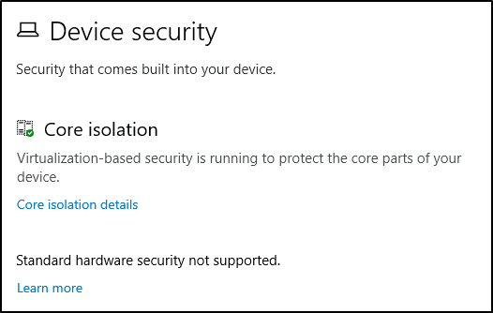
Core isolation
- Memory Integrity - Prevents attacks from inserting malicious code into high-security processes.
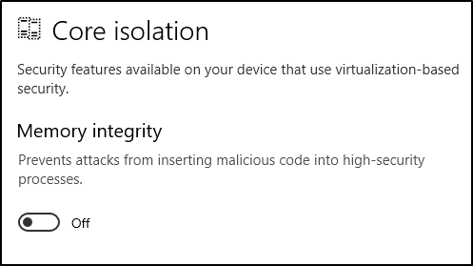
Warning: Unless you are 100% confident in what you are doing, it is recommended that you leave the default settings.
The below images are from another machine to show another security feature that should be available in a personal Windows 10 device.
Security processor
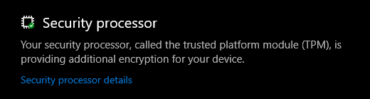
Below are the Security processor details.
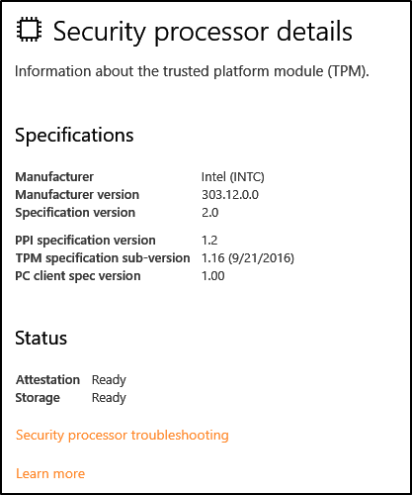
What is the Trusted Platform Module (TPM)?
Per Microsoft, "Trusted Platform Module (TPM) technology is designed to provide hardware-based, security-related functions. A TPM chip is a secure crypto-processor that is designed to carry out cryptographic operations. The chip includes multiple physical security mechanisms to make it tamper-resistant, and malicious software is unable to tamper with the security functions of the TPM".

What is BitLocker?
Per Microsoft, "BitLocker Drive Encryption is a data protection feature that integrates with the operating system and addresses the threats of data theft or exposure from lost, stolen, or inappropriately decommissioned computers".
On devices with TPM installed, BitLocker offers the best protection.
Per Microsoft, "BitLocker provides the most protection when used with a Trusted Platform Module (TPM) version 1.2 or later. The TPM is a hardware component installed in many newer computers by the computer manufacturers. It works with BitLocker to help protect user data and to ensure that a computer has not been tampered with while the system was offline".
Refer to the official Microsoft documentation to learn more about BitLocker here.
Note: The BitLocker feature is not included in the attached VM.

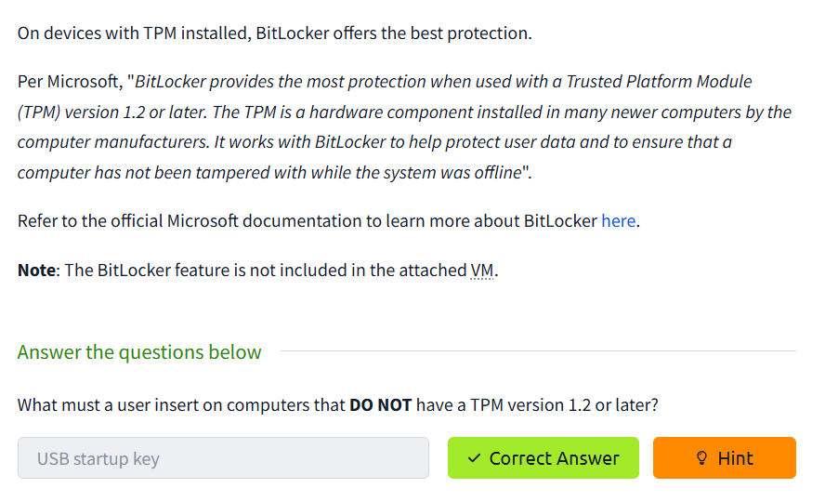
..

Volume shadow copy service

Per Microsoft, the Volume Shadow Copy Service (VSS) coordinates the required actions to create a consistent shadow copy (also known as a snapshot or a point-in-time copy) of the data that is to be backed up.
Volume Shadow Copies are stored on the System Volume Information folder on each drive that has protection enabled.
If VSS is enabled (System Protection turned on), you can perform the following tasks from within advanced system settings.
- Create a restore point
- Perform system restore
- Configure restore settings
- Delete restore points
From a security perspective, malware writers know of this Windows feature and write code in their malware to look for these files and delete them. Doing so makes it impossible to recover from a ransomware attack unless you have an offline/off-site backup.
If you wish to configure Shadow Copies within the attached VM, see below.
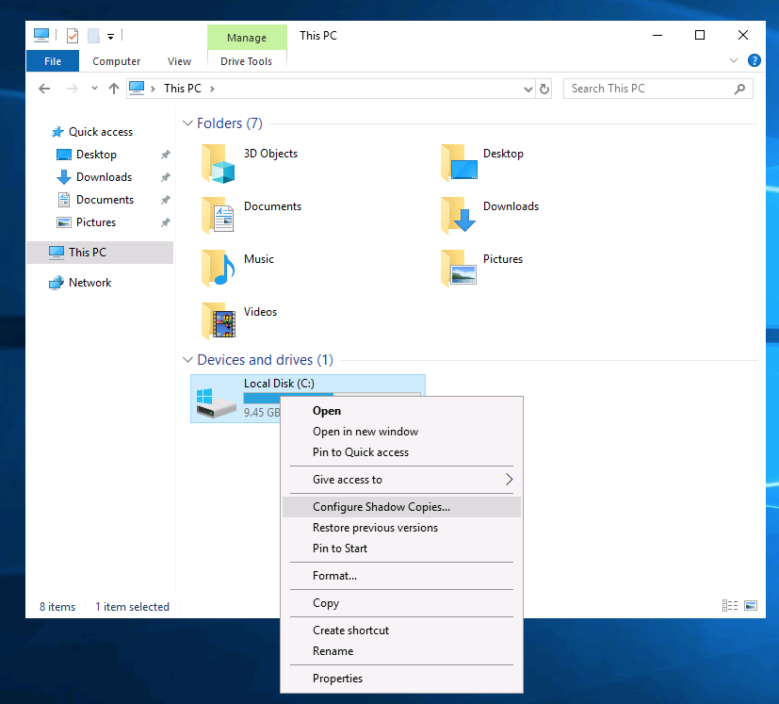
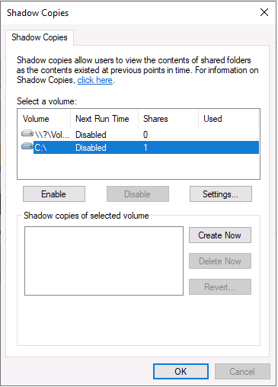
Bonus: If you wish to interact hands-on with VSS, I suggest exploring Day 23 of Advent of Cyber 2.

Advent of cyber 2 vssadmin
Ransomware is a real threat that enterprise defenders and casual computer users need to defend & prepare against. According to Wikipedia, ransomware is a type of malware that threatens to publish the victim's data or perpetually block access to it unless a ransom is paid. It can be a frightening experience to log into a machine only to realize that malware has encrypted all of your important documents.
There are numerous security products that can be implemented in the security stack to catch this type of malware. If ransomware infects an endpoint, depending on the actual malware, there might be a decryptor made available by a security vendor. If not then you must rely on backups in order to restore your machines to the last working state, along with its files. Windows has a built-in feature that can assist with that.
The Volume Shadow Copy Service (VSS) coordinates the actions that are required to create a consistent shadow copy (also known as a snapshot or a point-in-time copy) of the data that is to be backed up. (official definition)
Malware writers know of this Windows feature and write code in their malware to look for these files and delete them. Doing so makes it impossible to recover from a ransomware attack unless you have an offline/off-site backup. Not all malware deletes the volume shadow copies though.
Before diving into VSS on the endpoint let's talk briefly regarding the Task Scheduler.
The Task Scheduler enables you to automatically perform routine tasks on a chosen computer. Task Scheduler does this by monitoring whatever criteria you choose (referred to as triggers) and then executing the tasks when those criteria are met. (official definition)
Malware writers might have the malware create a scheduled task in order for the malware to run at a specific desired day/time or trigger. The Task Scheduler utility has been conveniently been placed in the taskbar for you. To view, the scheduled tasks click on Task Scheduler Library. You should see 2 scheduled tasks of interest: 1 with a weird name and the other related to VSS. Click on any of the scheduled tasks to populate more information about it, such as Triggers and Actions.
At this point you should realize that VSS is enabled and thanks to the scheduled task you know the ID of the volume.
The command to interact with VSS is vssadmin. Running the command alone will display brief information on how to run the utility with additional commands. Two commands of particular interest are List Volumes and List Shadows.
f you run vssadmin list volumes you will see that the C:\ drive has a different volume name/id. There must be another volume on the endpoint.
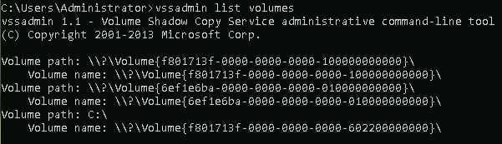
You can use Disk Management to check into that. Disk Management is a system utility in Windows that enables you to perform advanced storage tasks. (official definition) As with the other utilities, Disk Management has been placed in the taskbar for your convenience.
As you can see there is another volume but you're unable to view it within Windows Explorer. Right-click the partition to view its properties. Now, look at the Security tab. Confirm that the volume name/id from the Task Scheduler and vssadmin output is similar to the object name of this partition. Also, notice there is a tab titled Shadow Copies. Review the information and close the Properties window.
In order to see this partition within Windows Explorer, you must assign it a drive letter. Right-click the partition and select Change Drive Letter and Paths. Click Add. In the dropdown choose a letter, such as Z, and click OK. At the top, in the Volume column, you should now see that the partition has a letter assigned to it. Open Windows Explorer to navigate to the partition.
In a previous challenge, you managed to view hidden content in folders via the command-line. You can do the same within Windows Explorer. In the menu, select View, and checkmark Hidden Items. You should now see any hidden content right within Windows Explorer.
Back to VSS, to restore files to a previous version, simply right-click the folder and select Properties then select the Previous Versions tab. Select which shadow copy you would like to restore and click the Restorebutton. Accept the confirmation to restore the shadow copy. Close the Properties window and drill into the folder to find the restore file(s).
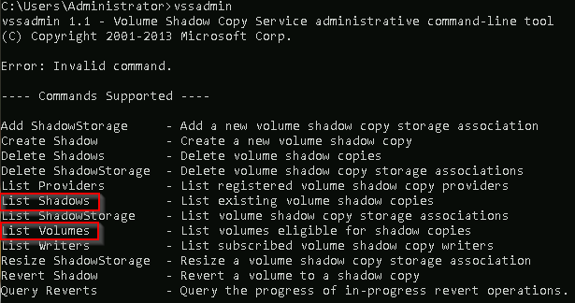
..

Conclusion
In this room, we covered several built-in Windows security tools that ship with the Windows OS to help keep the device protected.
There is still so much to explain and cover regarding the Windows OS. As mentioned in the Windows Fundamentals 1 room, "The content is aimed at those who wish to understand and use the Windows OS on a more comfortable level ."
To learn more about the Windows OS, you'll need to continue the journey on your own.
Further reading material:
- Antimalware Scan Interface
- Credential Guard
- Windows 10 Hello
- CSO Online - The best new Windows 10 security features
Note: Attackers use built-in Windows tools and utilities in an attempt to go undetected within the victim environment. This tactic is known as Living Off The Land. Refer to the following resource here to learn more about this.

