AN ADVOCACY PROJECT

Everyone matters

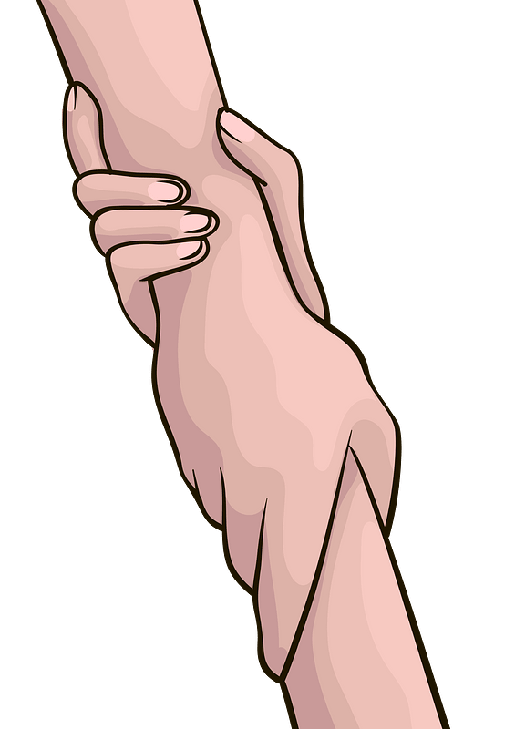

Christian Living Education

Grade 9E

Sir Rainheart Pinuela

Leader: Manojo, Ella

Members:

Rodriguez, Franz

Gatilago, Djohannah

Figalan, James

Medrano, Mitch

Project Proposal:

Leader of the Group- Ella Manojo

* In charge of splitting the tasks to the members of the group
* Edits, Revising the works of her groupmates
* In charge of submitting

Members;

Franz Rodriguez

* Helps the leader and the other members understand on how to do the work
* Submits his parts on time

Djohannah Gatilago

* Helps giving out creative ideas
* Submits her work on time

James Figalan

* He do his part and submits it on time

Mitch Medrano

* Does his part and submits it on time

Introduction:

One of the most common reason as to why people take their own lives, is losing a loved one, which causes depression. The feeling of sorrow and loss of interest in things that you used to be interested in. There are many roots to this problem. Racism, Bullying, Discrimination, any type of abuse and many more.

In the past, for the families of the people who committed suicide cannot conduct a proper farewell or funeral for their loved ones. However the forbidding of funerals for the suicide victims was lifted in the 1980’s.

Rationale:

A lot of us are suffering, and not all of us can notice the difference of what’s normal and what’s not. Many strive to get better, to be colorful again, and many loses hope, letting the darkness swallow them and give up on life. Everyone just really needs help. What we need is someone who would listen to all our worries, a person who can keep secret. That is why we conducted this project, a small greeting and words of affirmation can be a big help to people. Lending someone a shoulder for them to cry on can help them feel better and most of them, might change their decisions in life.

Solutions:

* If someone expresses a desire to commit suicide, listen to them and take their concerns seriously. Don't be afraid to inquire about their plans. Let them know you care and that they are not alone. Encourage them to seek immediate assistance from a qualified professional.
* To prevent more suicide cases, if a person is planning to kill himself. Tell him that he must delay it first, ask him of what is the reason as to why he is planning that. If he tells you the main reason then help him solve that it will light him up and it will give inspiration. Every one of us needs help.
* To prevent suicides, we have to know if the person is having suicidal thoughts. To tell that they are having suicidal thoughts, we have to know if they are often talking or writing about death, dying or suicide, making comments about being hopeless, helpless or worthless, withdrawal from friends, family and community and if they are talking about feeling trapped or being a burden to others. We can prevent these by offering mental support and help them solve their problems/conflicts, keeping them company and make sure they won’t have another thought about suicide.
* Suicide is the leading cause of death among school age youth. However, suicide is preventable. Youth who are contemplating suicide frequently give warning signs of their distress. Parents, teachers, and friends are in a key position to pick up on these signs and get help. Most important is to never take these warning signs lightly or promise to keep them secret. When all adults and students in the school community are committed to making suicide prevention a priority-and are empowered to take the correct actions-we can help youth before they engage in behavior with irreversible consequences.
* Helping them in what they do. Lessening the amount of work they do in a normal daily basis can help them feel at ease. Give words of encouragement and affirmations.

PRAYER

Dear Father in heaven,

We thank you for another day filled with

Blessings and love.

Please help us get through the toughest days of the year.

Thank you for being there for us,

Thank you for listening to our worries in life

And thank you for loving us.

Please continue to guide us on our journey,

We ask for your forgiveness from all the mistakes we have done,

I pray in Jesus name,

Our Lord and Our Savior

AMEN.

Sources:

<https://l.messenger.com/l.php?u=https%3A%2F%2Fen.m.wikipedia.org%2Fwiki%2FChristian_views_on_suicide&h=AT2vi7LUEiEgyaH8LGE7NQ003yhIIGdQaZBK9ijU0q-A4vz6v2LQE2IM9LBB3fgRtbsPDXidgaZZVPLAzslKZDnJBB8GLqq8h9uatC4C9gFNMJCGu33sGGoSEcYVQjtXZmdaGA>

<https://www.nasponline.org/resources-and-publications/resources-and-podcasts/school-safety-and-crisis/mental-health-resources/preventing-youth-suicide/preventing-youth-suicide-tips-for-parents-and-educators>