Version

1

By: vijay garothaya

Git Setup Guide

Table of Contents

* Introduction 2
* Signup at GitHub 3
* Download SourceTree 5

# Introduction

We are planning to use github for source code repository. This document includes steps on how to setup github account and git client (SourceTree)

# Signup at GitHub

Goto GitHub at <https://github.com/>

Select Unique Username and Enter Email Id, Password. Sample information:

# Download SourceTree

Go to <https://www.sourcetreeapp.com/>

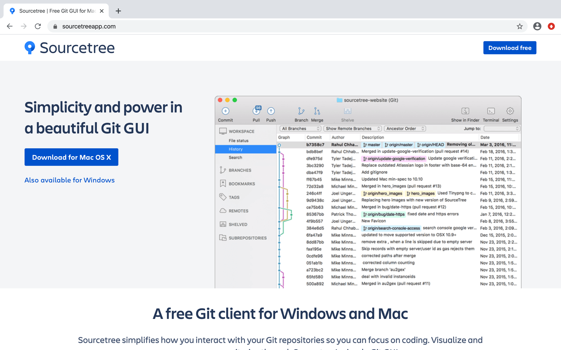

Download sourcetree app by clicking “Download for Mac OS X”

Accept Agreement and click “Download” to start download.

Most probably this file will be downloaded in “Downloads” folder. Downloaded folder looks like below:

Extract the zip file by double clicking zip file. Sourcetree.app file looks as below after unzip.

Move the sourcetree.app file in application folder for easy access.

For the first time, right click on Sourcetree.app and click on open.