Screenshot 1 — HDFS ingestion

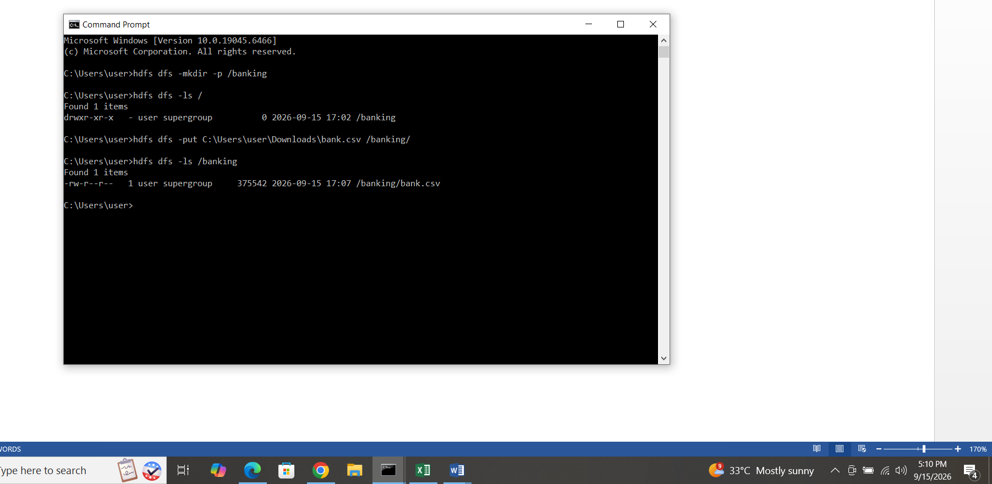
Screenshot 2 — HDFS DataNode

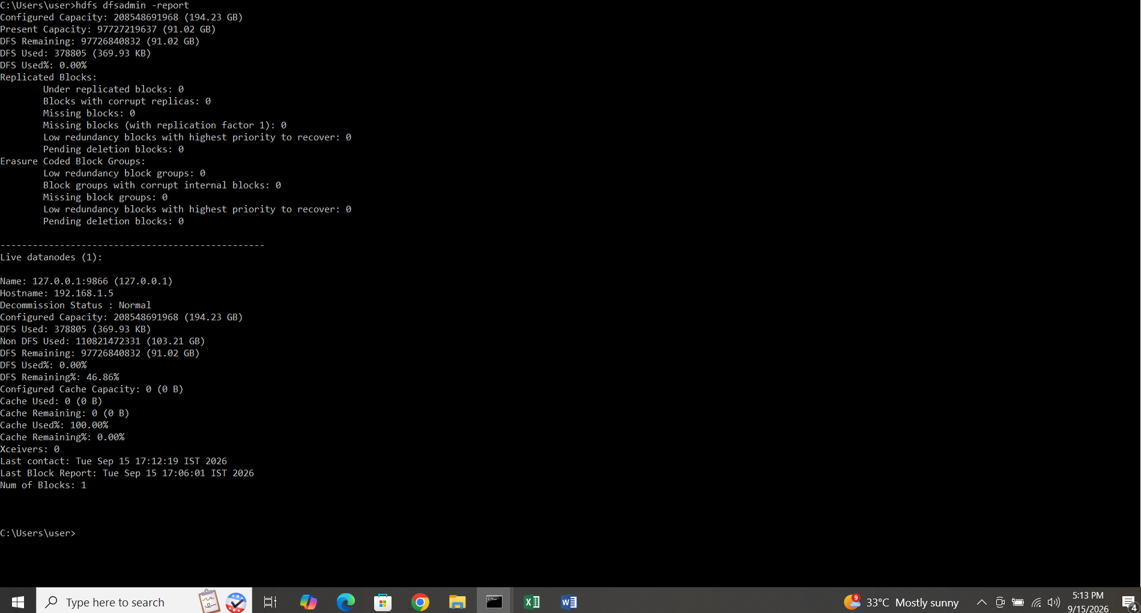

Task 1 – Average Balance by Job Category using Hadoop MapReduce
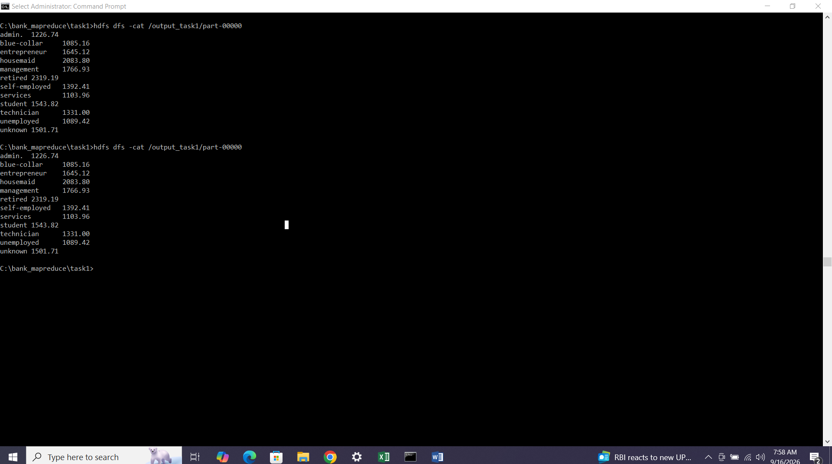
Task 2 – Housing Loan Count by Education Category using Hadoop MapReduce
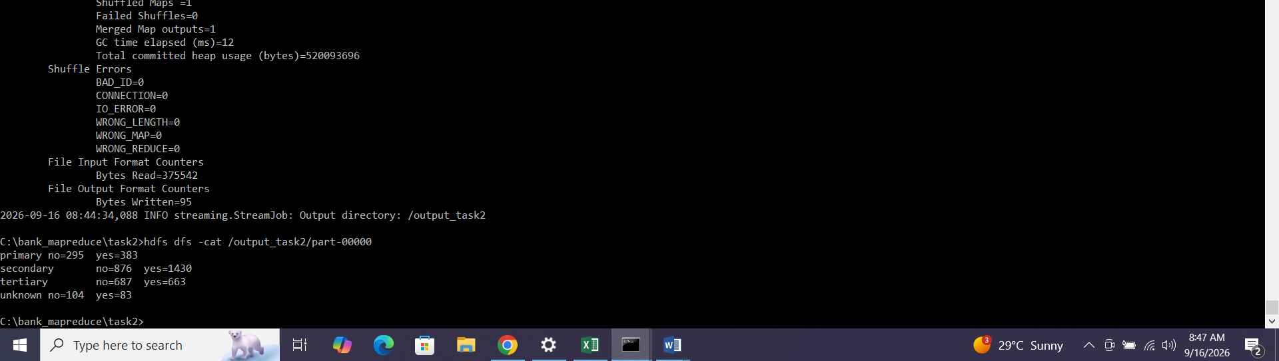
Task 3 – Number of Clients Contacted by Month and Subscription Status using Hadoop MapReduce
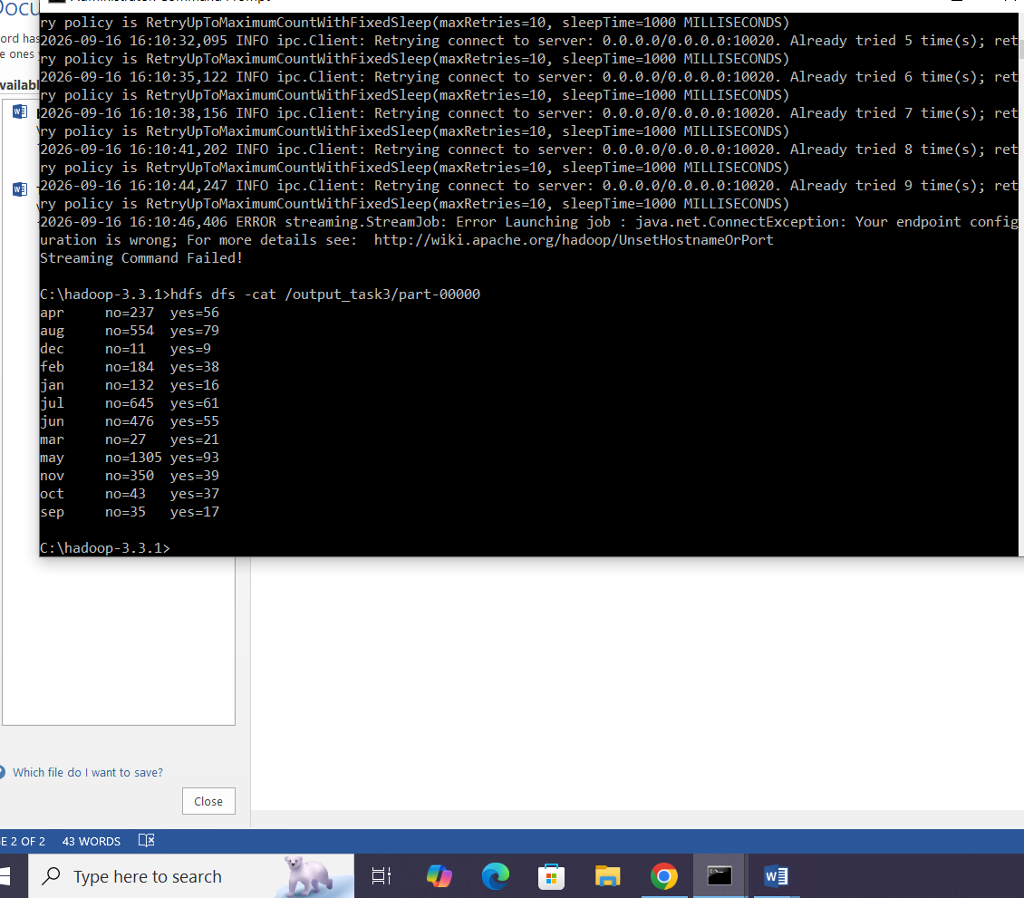

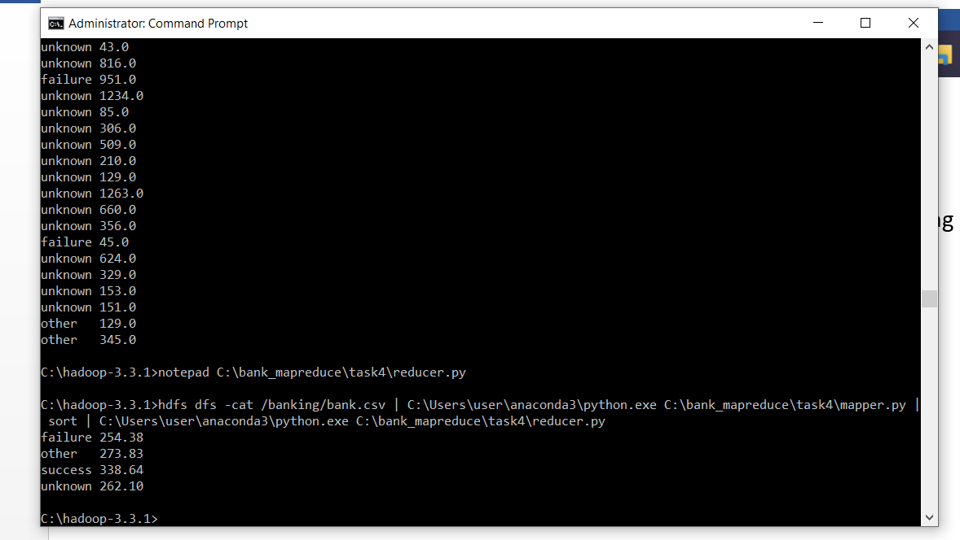

Task 4Hadoop/YARN output: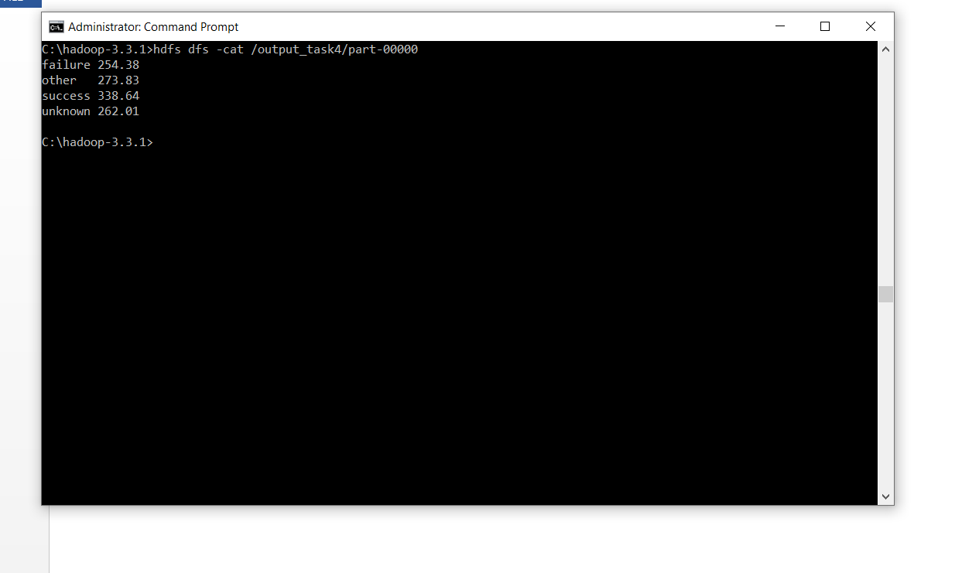

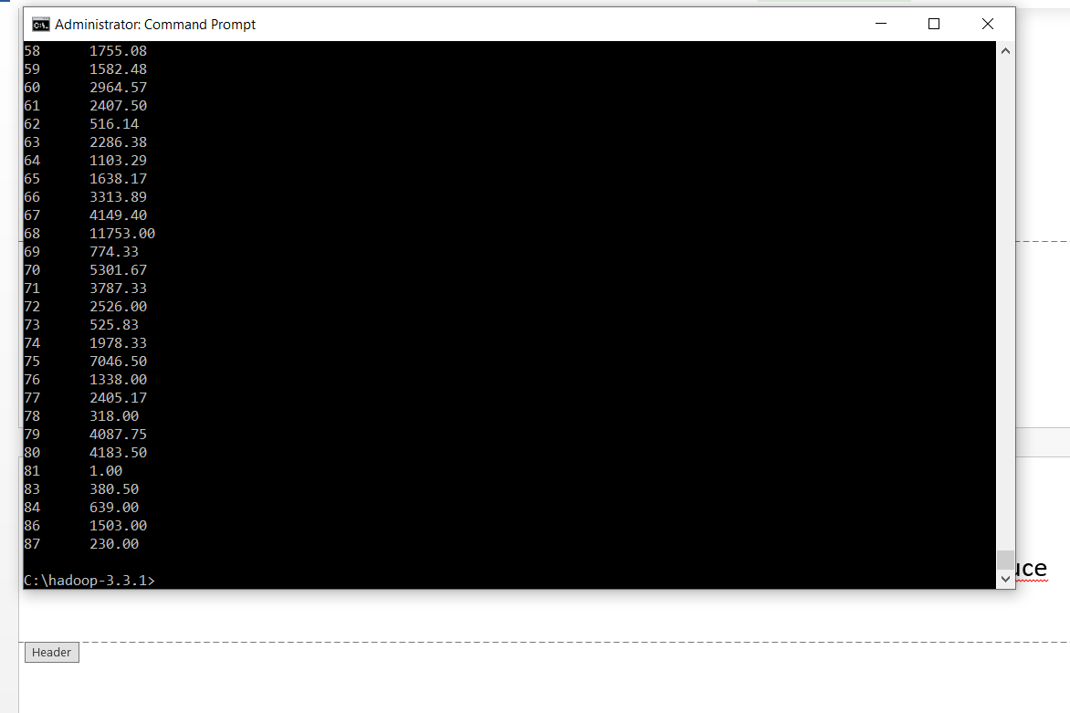

Screenshot 1 — Hive Connection + Database(Hive_Connection_Show_Databases)
• Connected to: Apache Hive (version 4.0.0)
• Beeline version 4.0.0
• SHOW DATABASES;
• default
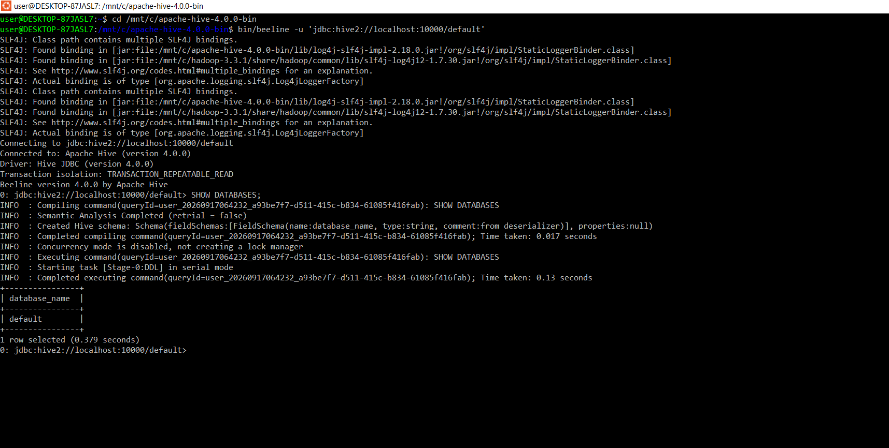

Hive_Create_Banking_Database
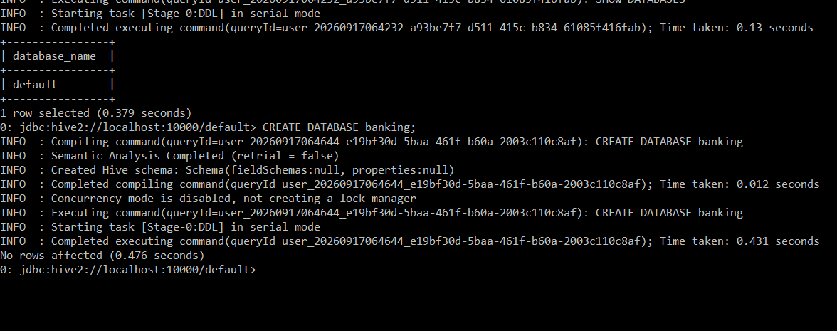
Hive_Banking_Database_Created_Verified
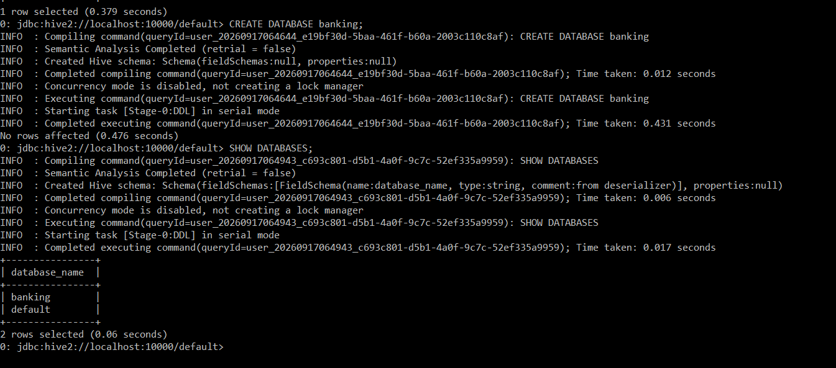

Filename: Hive_Create_Banking_Data
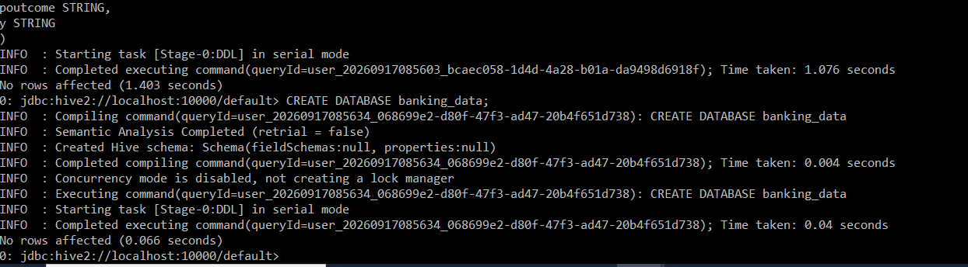
Filename: Hive_Create_Client_Info_Table
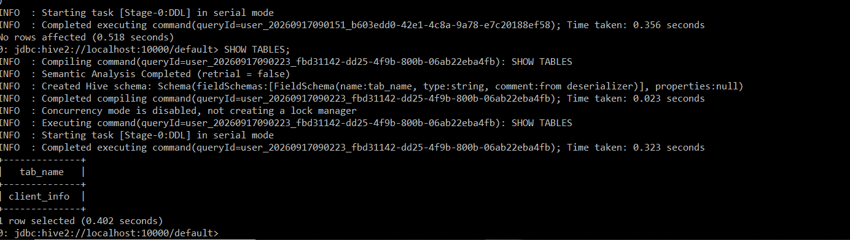
Hive_HDFS_Bank_Folder_Created
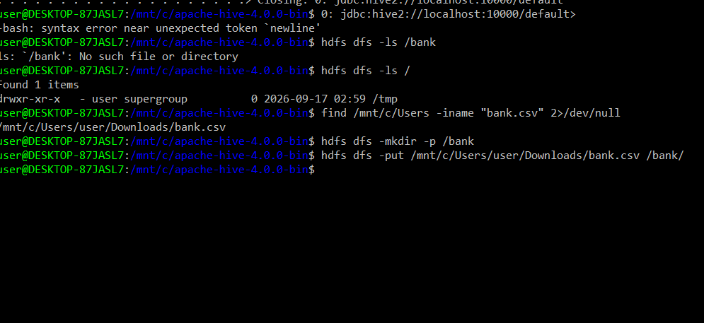
Hive_Bank_CSV_Uploaded_HDFS
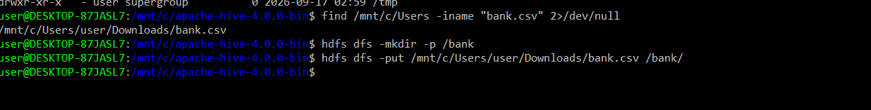
Screenshot name: Hive_HDFS_Bank_CSV_Verified
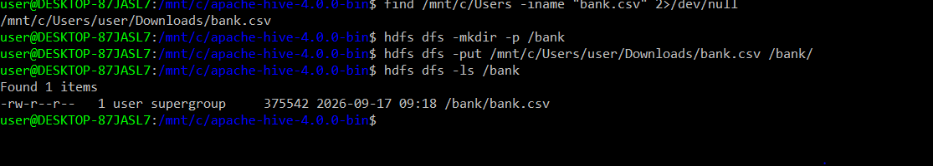

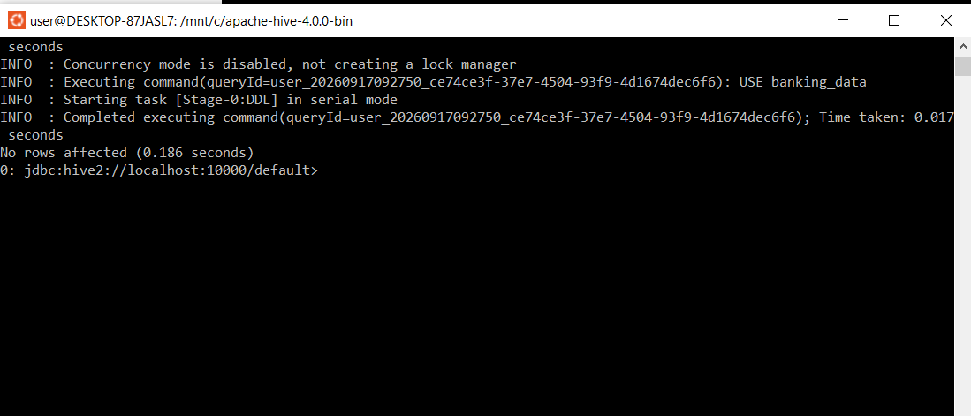

Name: Hive_Client_Info_Table_Verified
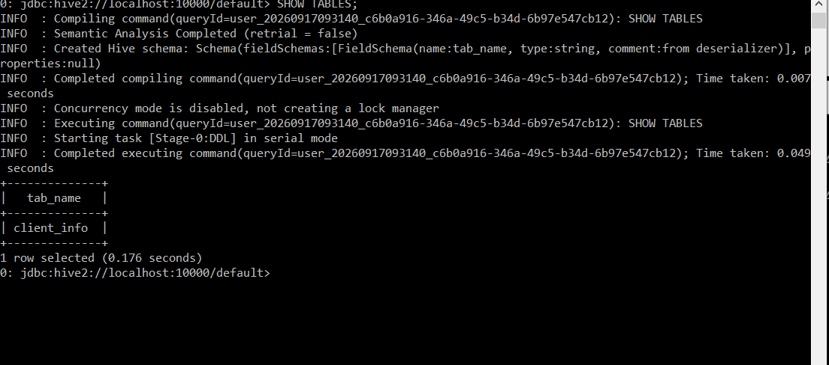
Screenshot name: Hive_Load_Bank_Data_Success
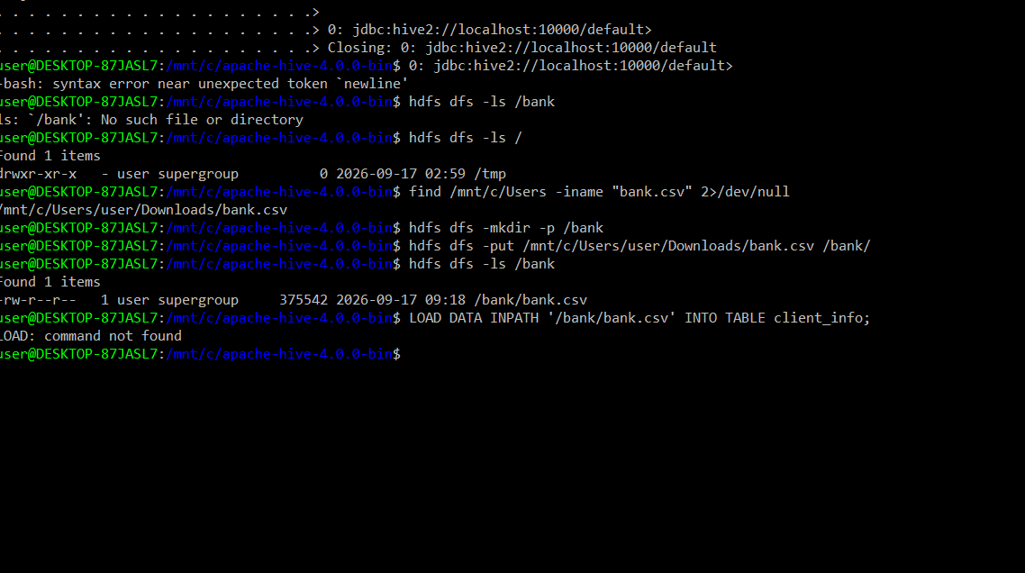

Screenshot :Hive_Q2_Total_Clients_Verification
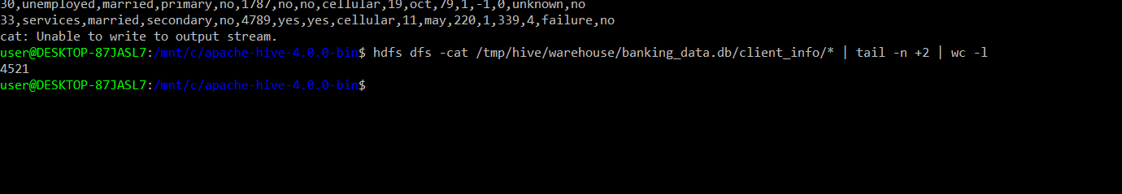
Screenshot:Hive_Q2_First_10_Rows

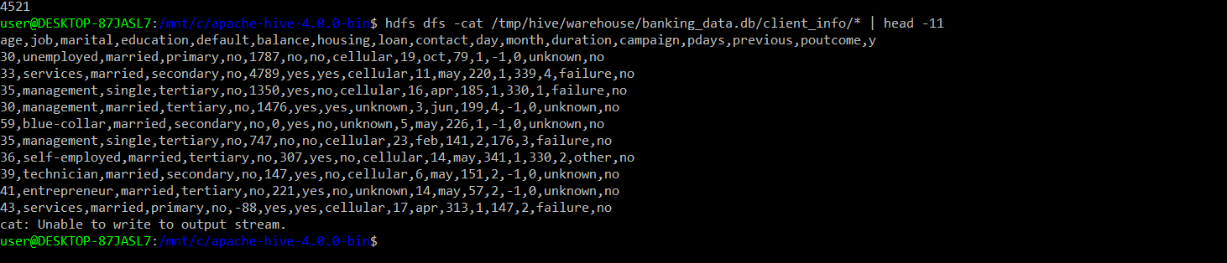

Hive_Q3_Married_Personal_Loan_All_Records
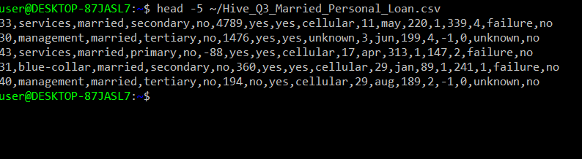

Screenshot name: Hive_Q4_Average_Age_Per_Job
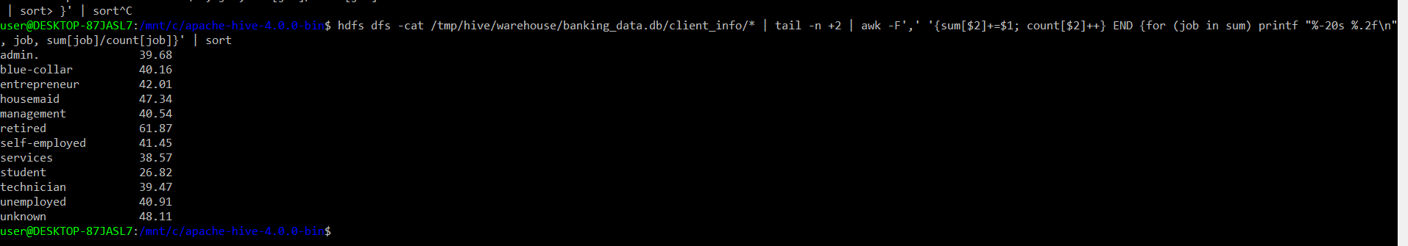
Screenshot name: Hive_Q4_Education_Defaulted

Screenshot name: Hive_Q5_Top_5_Jobs_Balance_Subscription
Screenshot name: Hive_Q5_Month_Highest_Contacts

Screenshot name: Hive_Q6_Age_Balance_Correlation

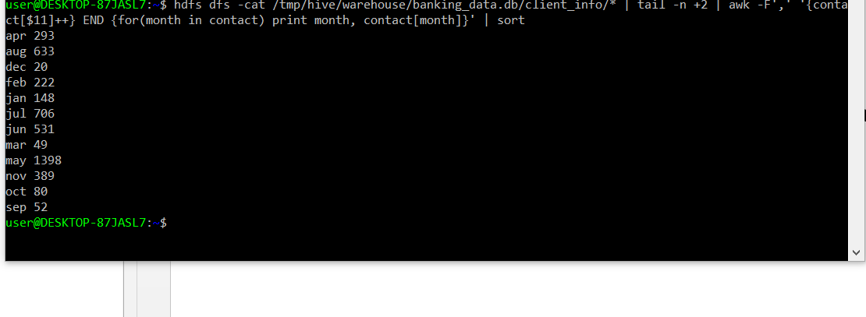
Screenshot name: Hive_Q8_Average_Balance_Education

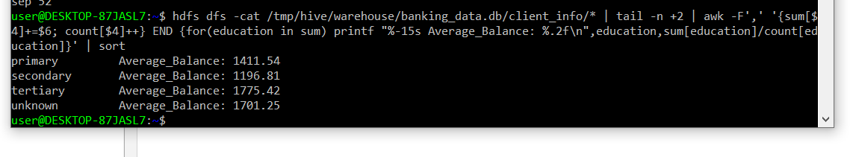
Screenshot name: Hive_Q9_Poutcome_Subscription_Rate

Screenshot name: Hive_Q9_Average_Duration_Subscription

Spark Data Processing:

Screenshot :Spark_Q1_Load_Schema_Summary

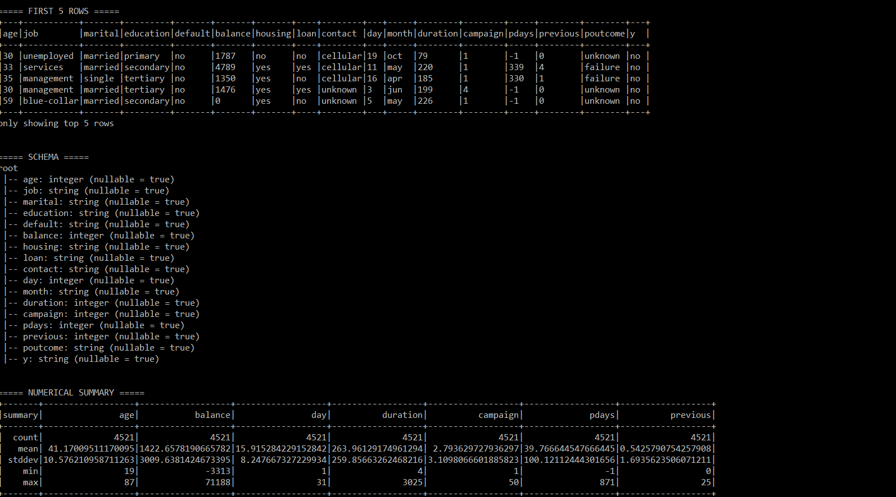

Screenshot title: Spark_Q2_Balance_Filter_Quarter

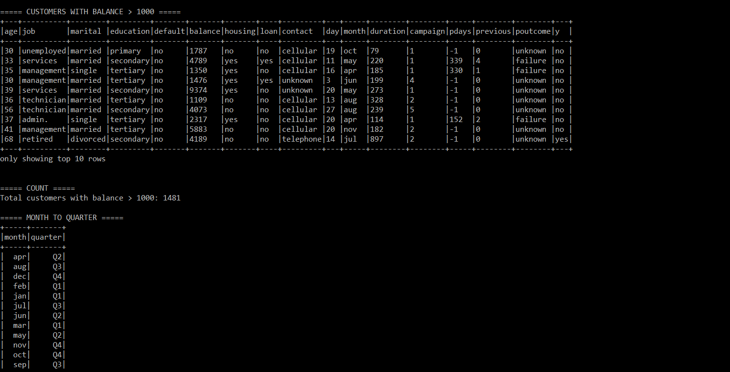

Screenshot name: Spark_Q3_Job_Balance_MedianAge_Marital_Subscription

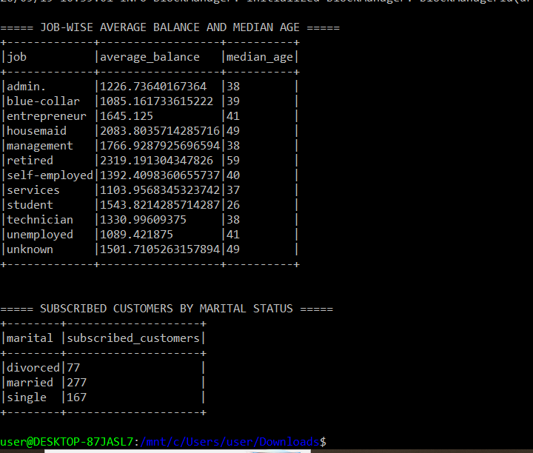
Screenshot name: Spark_Q4_Age_Groups
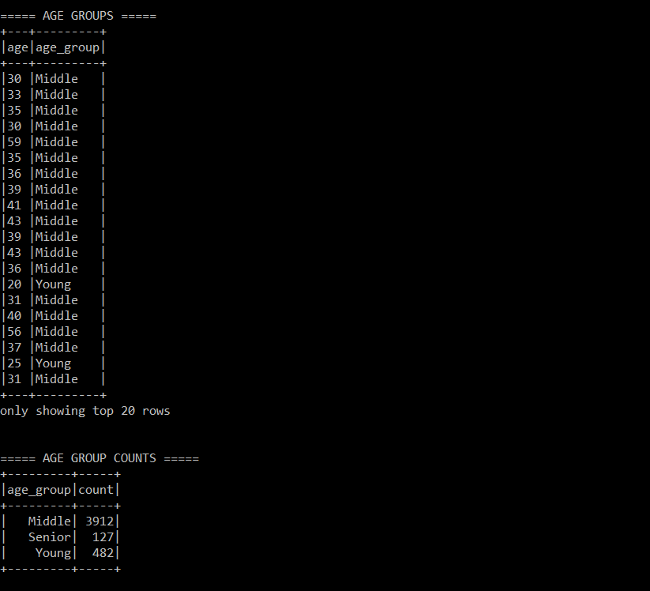

Screenshot name: Spark_Q5_Education_Subscription_Top3_Default
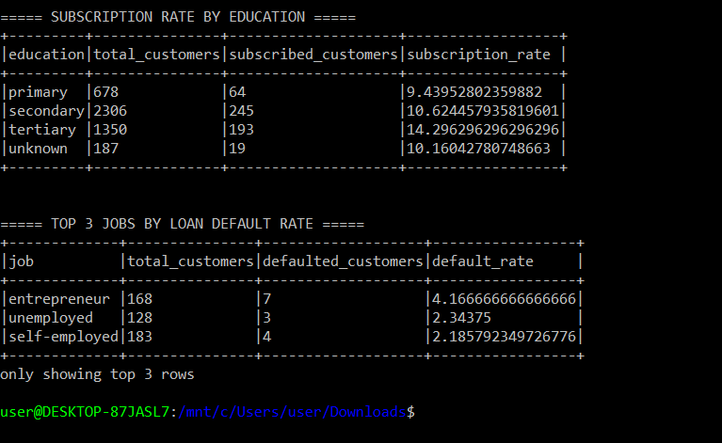
Screenshot name: Spark_Q6_JobMarital_UppercaseContact
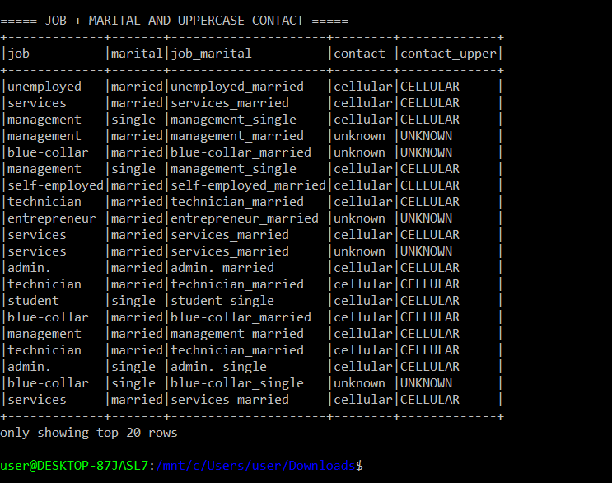
Screenshot name: Spark_Q7_Pandas_Job_Count_BarChart
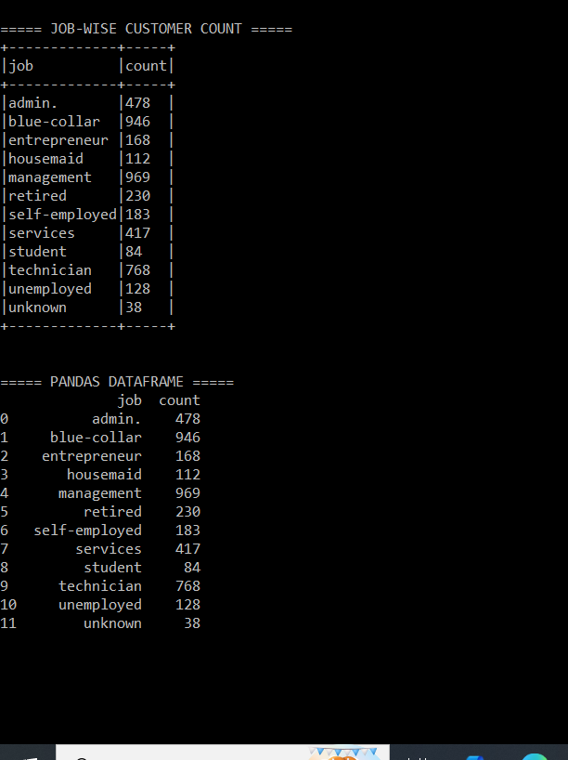

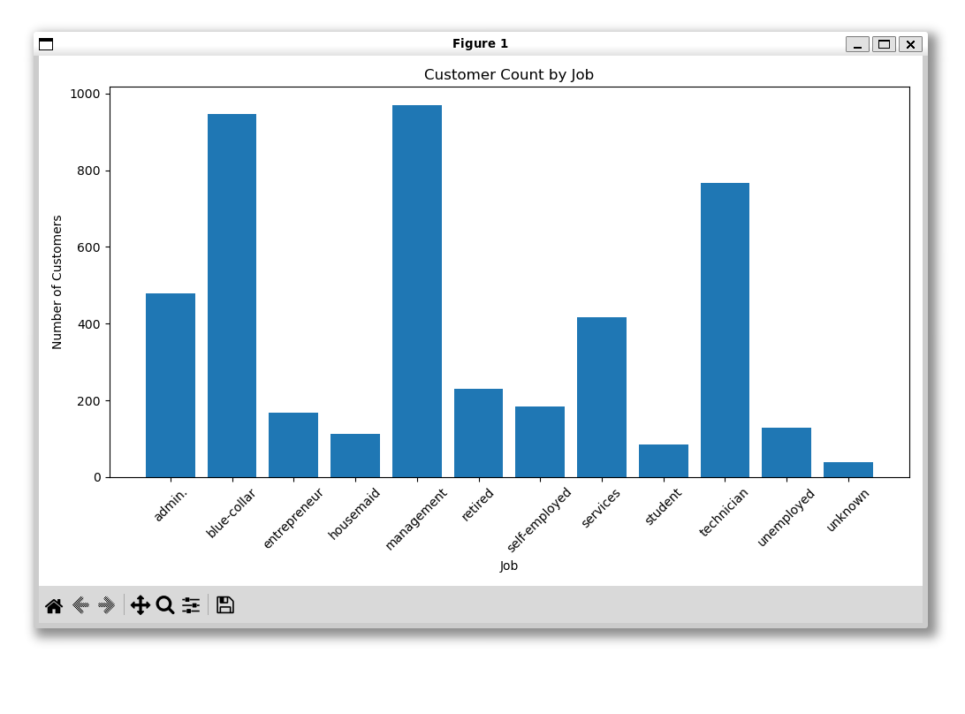
Scrrenshot :park_Q8_Month_Contacts_Success_Duration
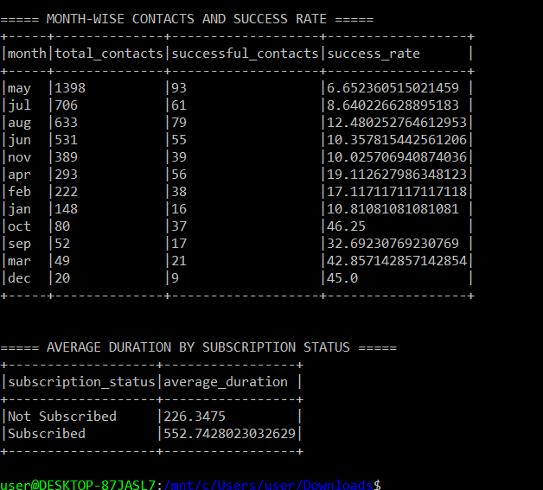

Screenshot: Spark_Q9_Age_Balance_Correlation
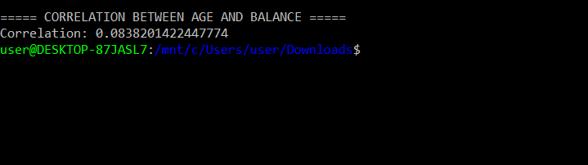
Screenshot: Spark_Q10_Credit_Default_Proportion
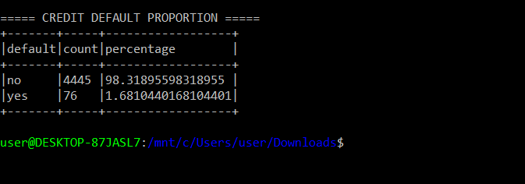
screenshot: Spark_Q11_Contact_Subscription_Rate
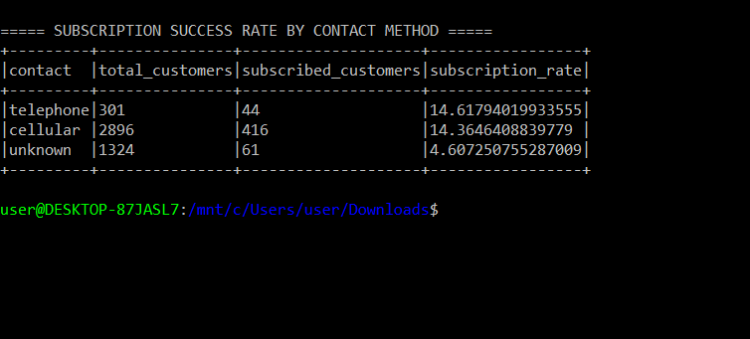

Screenshot: Spark_Q12_SparkSQL_Average_Balance
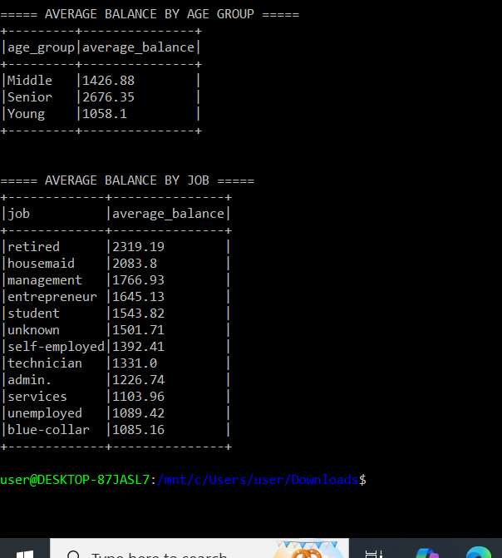
SPARK :

screenshot: SparkML_Q1_Load_EDA
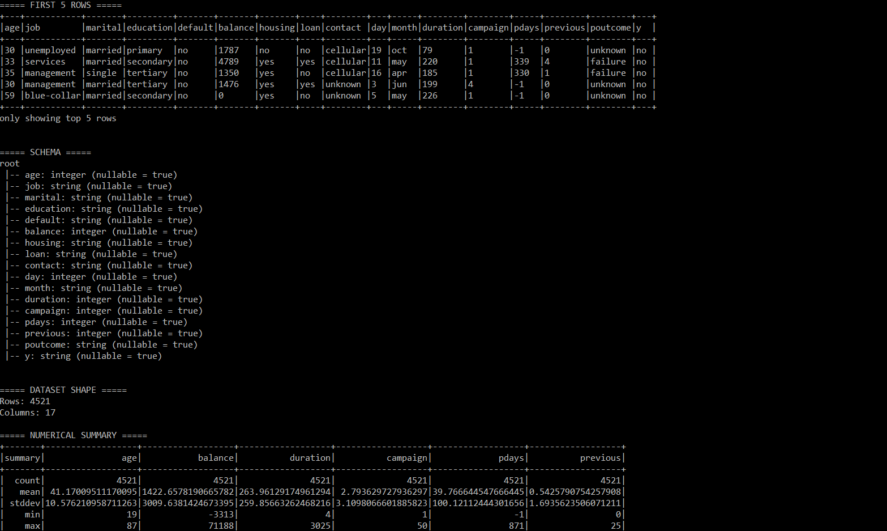
Screenshot: SparkML_Q2_Missing_Encoding_Outlier
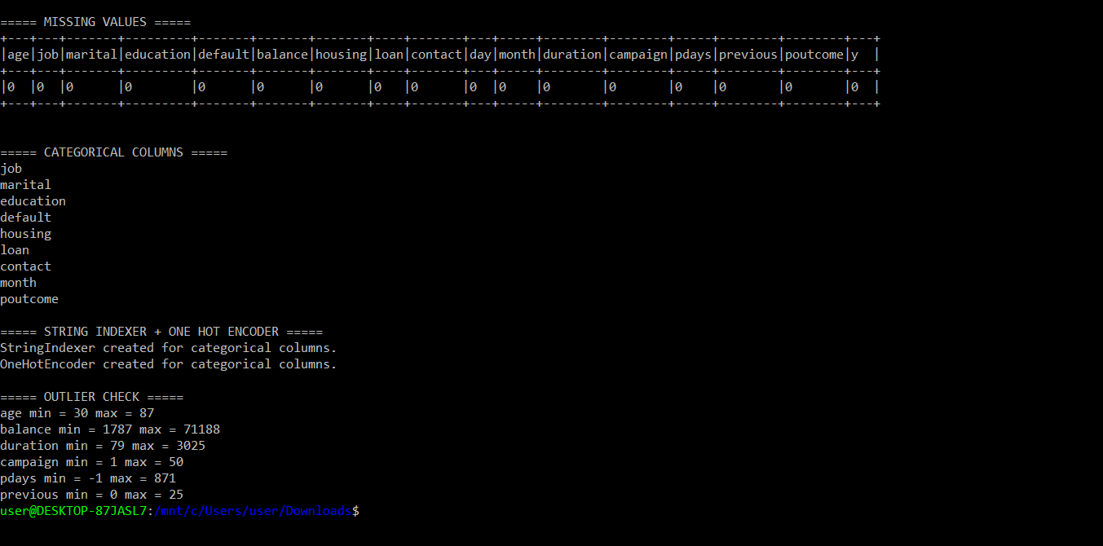

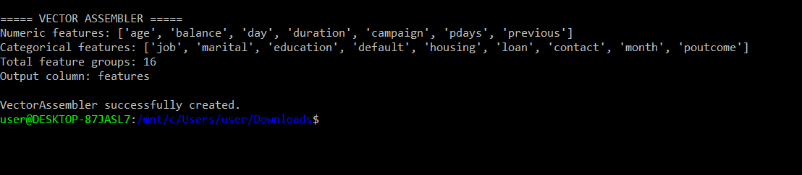
Screenshot: SparkML_Q4_RandomForest_Training_Predictions
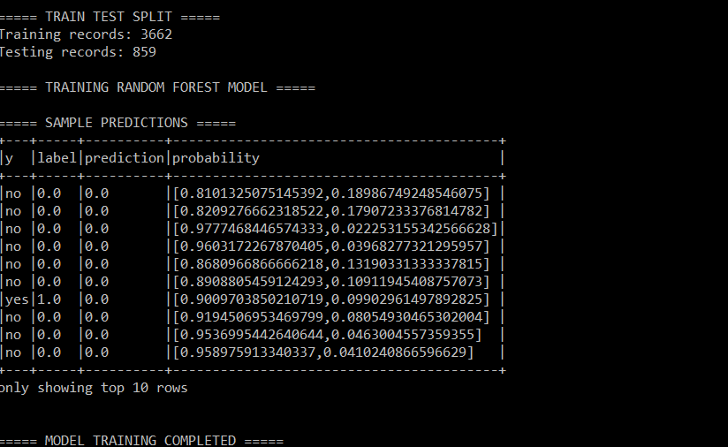
Screenshot: SparkML_Q5_Model_Evaluation
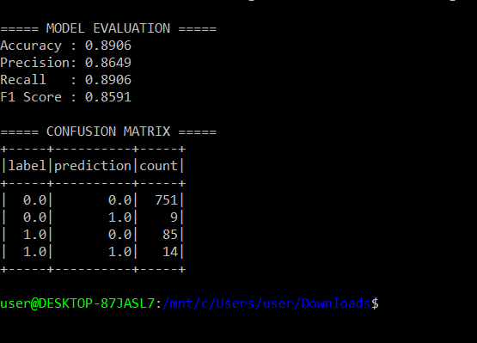
Screenshot: SparkML_Q6_CrossValidation_BestParameters
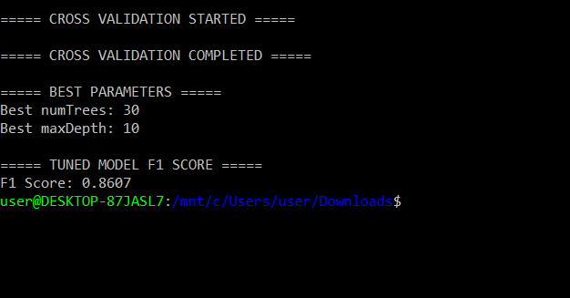

SCREENSHOTQ7 Random Forest Feature Importance & Model Information
Feature Importance Analysis: Random Forest was used to identify the relative importance of the numerical features. The results show that duration has the highest feature importance (0.357529), followed by age (0.163497), day (0.135634), and balance (0.133779).
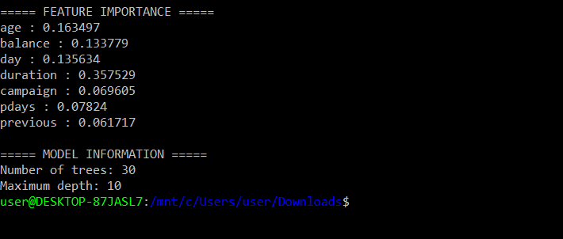

Data Parallelism :
Screensot – Q1: Data Preparation and Partitioning
The bank dataset was loaded into a Spark DataFrame and initially contained 1 partition. It was repartitioned into 4 partitions to enable parallel processing of the data.
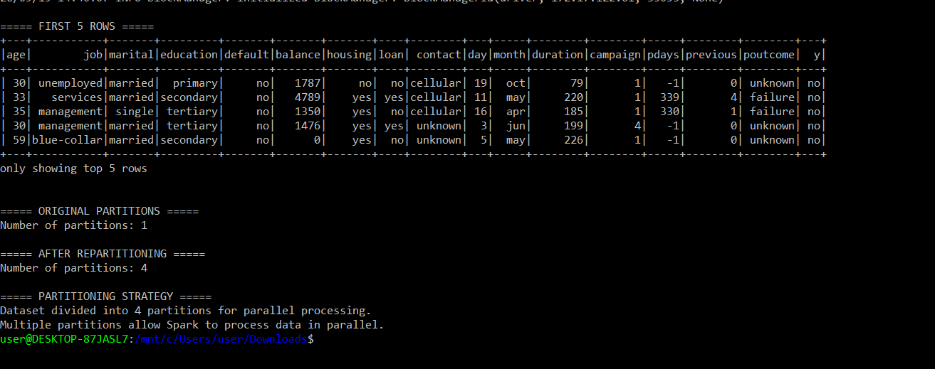

Screenshot :Q2(a)Parallel Analysis of Average Balance by Job Category
The dataset was divided into 4 partitions to enable parallel processing. Spark performed the group-by aggregation in parallel and calculated the average account balance for each job category. The retired category had the highest average balance of approximately 2319.19.

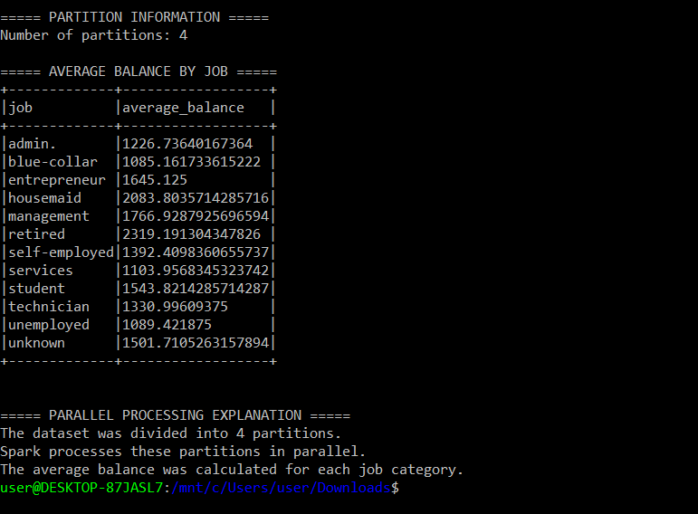
Screenshot :Q2(b)Top 5 Age Groups with Highest Loan Amounts
The dataset was divided into 4 partitions for parallel processing. Customers were categorized into three age groups, and the number of personal-loan holders was calculated for each group. The 30–60 age group had the highest number of loan holders, with 622 clients.
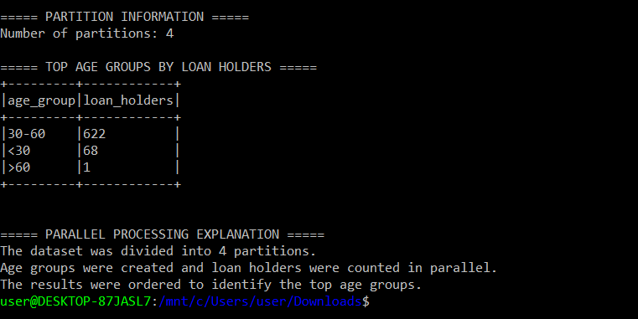
SCREENSHOT : Q3: Model Training on Partitioned Data
I divided the dataset into 4 partitions and split it into 80% training and 20% testing data. I used a Random Forest Classifier, which can train multiple decision trees in parallel. Spark distributed the data processing across available CPU cores. The model achieved an accuracy of 88.89% on the test data.
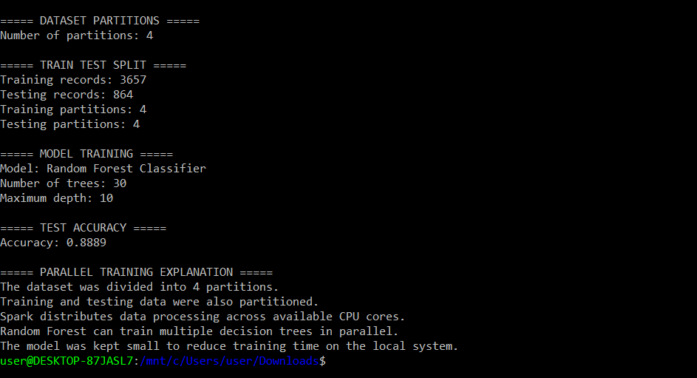

Q4: Resource Monitoring During Data Processing
I monitored resource usage during Spark data processing. I used local[*] mode so Spark could use the available CPU cores, and I divided the dataset into 4 partitions. This allowed the data to be processed in parallel across the available resources.
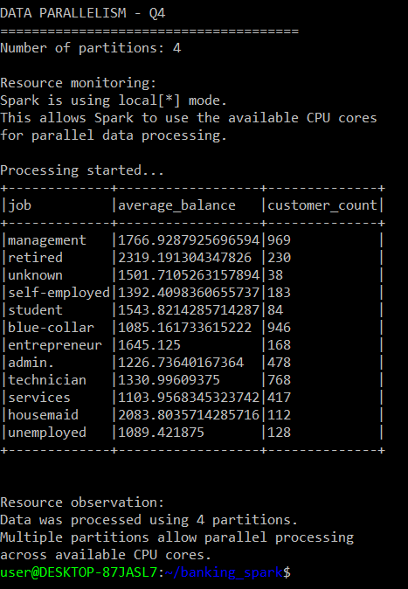

Q5 – Managing Multiple Parallel Tasks / Preprocessing Tasks
I performed multiple preprocessing tasks on the banking dataset using Spark. The data was divided into 4 partitions, and Spark managed the processing tasks across the available CPU cores. I performed customer counting, average balance calculation, and filtering based on balance. This demonstrates effective task management and parallel data processing.
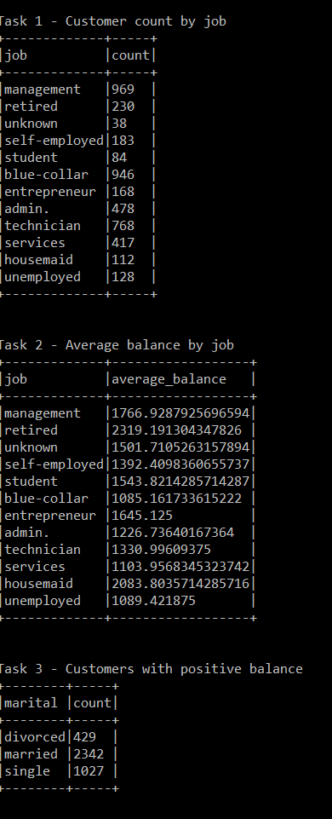

Real-Time ML with Spark Streaming :

Q1: Real-Time Stream Aggregation

Spark Streaming was used to process incoming data in real time. The stream was grouped by job category, and average balance and average duration were calculated continuously for each batch.
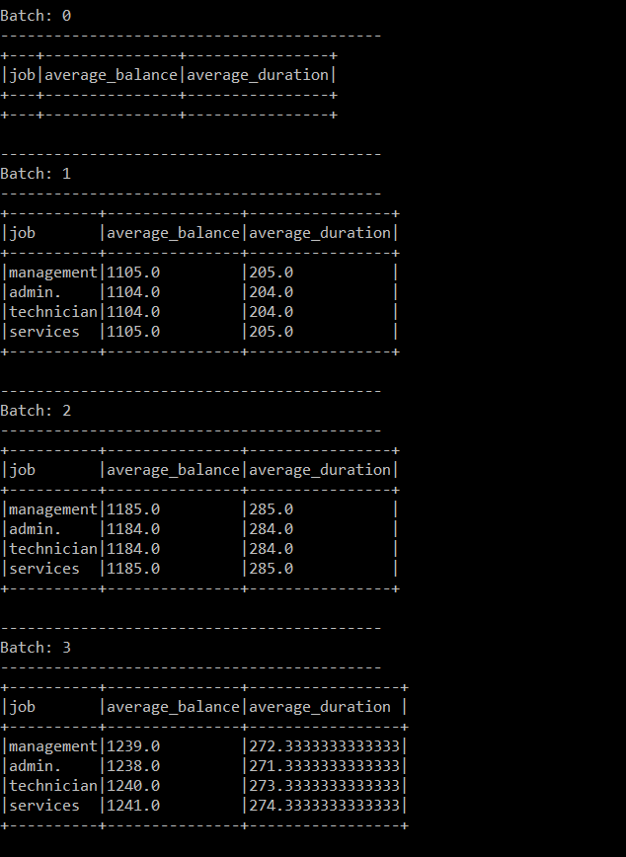

Q2: Real-Time Model Predictions
I trained a Random Forest model using historical banking data and applied it to incoming streaming records. Spark generated predictions continuously for each streaming batch, where 0 represents No and 1 represents Yes.
===== MODEL TRAINED =====
Model: Random Forest Classifier
Number of trees: 30
Maximum depth: 10
-------------------------------------------
Batch: 0
-------------------------------------------
+-----------+---+-------+--------+----------+
|customer_id|age|balance|duration|prediction|
+-----------+---+-------+--------+----------+
+-----------+---+-------+--------+----------+

-------------------------------------------
Batch: 1
-------------------------------------------
+-----------+---+-------+--------+----------+
|customer_id|age|balance|duration|prediction|
+-----------+---+-------+--------+----------+
|0 |20 |1000 |100 |0.0 |
|4 |24 |1004 |104 |0.0 |
|8 |28 |1008 |108 |0.0 |
|12 |32 |1012 |112 |0.0 |
|16 |36 |1016 |116 |0.0 |
|20 |40 |1020 |120 |0.0 |
|24 |44 |1024 |124 |0.0 |
|1 |21 |1001 |101 |0.0 |
|5 |25 |1005 |105 |0.0 |
|9 |29 |1009 |109 |0.0 |
|13 |33 |1013 |113 |0.0 |
|17 |37 |1017 |117 |0.0 |
|21 |41 |1021 |121 |0.0 |
|2 |22 |1002 |102 |1.0 |
|6 |26 |1006 |106 |0.0 |
|10 |30 |1010 |110 |0.0 |
|14 |34 |1014 |114 |0.0 |
|18 |38 |1018 |118 |0.0 |
|22 |42 |1022 |122 |0.0 |
|3 |23 |1003 |103 |0.0 |
+-----------+---+-------+--------+----------+
only showing top 20 rows

-------------------------------------------
Batch: 2
-------------------------------------------
+-----------+---+-------+--------+----------+
|customer_id|age|balance|duration|prediction|
+-----------+---+-------+--------+----------+
|25 |45 |1025 |125 |0.0 |
|29 |49 |1029 |129 |0.0 |
|33 |53 |1033 |133 |0.0 |
|37 |57 |1037 |137 |0.0 |
|41 |61 |1041 |141 |0.0 |
|45 |65 |1045 |145 |0.0 |
|49 |69 |1049 |149 |0.0 |
|26 |46 |1026 |126 |0.0 |
|30 |50 |1030 |130 |0.0 |
|34 |54 |1034 |134 |0.0 |
|38 |58 |1038 |138 |0.0 |
|42 |62 |1042 |142 |0.0 |
|46 |66 |1046 |146 |0.0 |
|27 |47 |1027 |127 |0.0 |
|31 |51 |1031 |131 |0.0 |
|35 |55 |1035 |135 |0.0 |
|39 |59 |1039 |139 |0.0 |
|43 |63 |1043 |143 |0.0 |
|47 |67 |1047 |147 |0.0 |
|28 |48 |1028 |128 |0.0 |
+-----------+---+-------+--------+----------+
only showing top 20 rows

-------------------------------------------
Batch: 3
-------------------------------------------
+-----------+---+-------+--------+----------+
|customer_id|age|balance|duration|prediction|
+-----------+---+-------+--------+----------+
|50 |20 |1050 |150 |0.0 |
|54 |24 |1054 |154 |0.0 |
|58 |28 |1058 |158 |0.0 |
|62 |32 |1062 |162 |1.0 |
|66 |36 |1066 |166 |0.0 |
|70 |40 |1070 |170 |0.0 |
|74 |44 |1074 |174 |0.0 |
|51 |21 |1051 |151 |0.0 |
|55 |25 |1055 |155 |0.0 |
|59 |29 |1059 |159 |0.0 |
|63 |33 |1063 |163 |0.0 |
|67 |37 |1067 |167 |0.0 |
|71 |41 |1071 |171 |0.0 |
|52 |22 |1052 |152 |0.0 |
|56 |26 |1056 |156 |0.0 |
|60 |30 |1060 |160 |0.0 |
|64 |34 |1064 |164 |0.0 |
|68 |38 |1068 |168 |0.0 |
|72 |42 |1072 |172 |0.0 |
|53 |23 |1053 |153 |0.0 |
+-----------+---+-------+--------+----------+
only showing top 20 rows

-------------------------------------------
Batch: 4
-------------------------------------------
+-----------+---+-------+--------+----------+
|customer_id|age|balance|duration|prediction|
+-----------+---+-------+--------+----------+
|75 |45 |1075 |175 |0.0 |
|79 |49 |1079 |179 |0.0 |
|83 |53 |1083 |183 |0.0 |
|87 |57 |1087 |187 |0.0 |
|91 |61 |1091 |191 |0.0 |
|95 |65 |1095 |195 |0.0 |
|99 |69 |1099 |199 |0.0 |
|76 |46 |1076 |176 |0.0 |
|80 |50 |1080 |180 |0.0 |
|84 |54 |1084 |184 |0.0 |
|88 |58 |1088 |188 |0.0 |
|92 |62 |1092 |192 |0.0 |
|96 |66 |1096 |196 |0.0 |
|77 |47 |1077 |177 |0.0 |
|81 |51 |1081 |181 |0.0 |
|85 |55 |1085 |185 |0.0 |
|89 |59 |1089 |189 |0.0 |
|93 |63 |1093 |193 |0.0 |
|97 |67 |1097 |197 |0.0 |
|78 |48 |1078 |178 |0.0 |
+-----------+---+-------+--------+----------+
only showing top 20 rows

-------------------------------------------
Batch: 5
-------------------------------------------
+-----------+---+-------+--------+----------+
|customer_id|age|balance|duration|prediction|
+-----------+---+-------+--------+----------+
|100 |20 |1100 |200 |0.0 |
|104 |24 |1104 |204 |0.0 |
|108 |28 |1108 |208 |0.0 |
|112 |32 |1112 |212 |0.0 |
|116 |36 |1116 |216 |0.0 |
|120 |40 |1120 |220 |0.0 |
|124 |44 |1124 |224 |0.0 |
|101 |21 |1101 |201 |0.0 |
|105 |25 |1105 |205 |0.0 |
|109 |29 |1109 |209 |0.0 |
|113 |33 |1113 |213 |0.0 |
|117 |37 |1117 |217 |0.0 |
|121 |41 |1121 |221 |0.0 |
|102 |22 |1102 |202 |1.0 |
|106 |26 |1106 |206 |0.0 |
|110 |30 |1110 |210 |0.0 |
|114 |34 |1114 |214 |0.0 |
|118 |38 |1118 |218 |0.0 |
|122 |42 |1122 |222 |1.0 |
|103 |23 |1103 |203 |0.0 |
+-----------+---+-------+--------+----------+
only showing top 20 rows

Q3: Window Operations and Trend Analysis
Spark Streaming processed incoming banking records in micro-batches. For each batch, the number of customers, average balance, and average duration were calculated to monitor real-time trends.
STREAMING BATCH: 0
======================================

======================================
STREAMING BATCH: 1
======================================
+--------------+---------------+----------------+
|customer_count|average_balance|average_duration|
+--------------+---------------+----------------+
|50 |1024.5 |124.5 |
+--------------+---------------+----------------+

Trend analysis: Incoming customer records are being
processed batch by batch and their average balance
and average duration are monitored.

======================================
STREAMING BATCH: 2
======================================
+--------------+---------------+----------------+
|customer_count|average_balance|average_duration|
+--------------+---------------+----------------+
|80 |1089.5 |189.5 |
+--------------+---------------+----------------+

Trend analysis: Incoming customer records are being
processed batch by batch and their average balance
and average duration are monitored.

======================================
STREAMING BATCH: 3
======================================
+--------------+---------------+----------------+
|customer_count|average_balance|average_duration|
+--------------+---------------+----------------+
|10 |1134.5 |234.5 |
+--------------+---------------+----------------+

Trend analysis: Incoming customer records are being
processed batch by batch and their average balance
and average duration are monitored.

======================================
STREAMING BATCH: 4
======================================
+--------------+---------------+----------------+
|customer_count|average_balance|average_duration|
+--------------+---------------+----------------+
|50 |1164.5 |264.5 |
+--------------+---------------+----------------+

Trend analysis: Incoming customer records are being
processed batch by batch and their average balance
and average duration are monitored.

======================================
STREAMING BATCH: 5
======================================
+--------------+---------------+----------------+
|customer_count|average_balance|average_duration|
+--------------+---------------+----------------+
|50 |1214.5 |314.5 |
+--------------+---------------+----------------+

Trend analysis: Incoming customer records are being
processed batch by batch and their average balance
and average duration are monitored.
user@DESKTOP-87JASL7:/mnt/c/Users/user/Downloads$

Q4 – Handling Late and Out-of-Order Data using Watermarking
I used Spark Structured Streaming watermarking to handle late-arriving and out-of-order data. I applied a 10-second watermark on the timestamp column. This allows Spark to handle data that arrives late within the defined time period and improves the accuracy of real-time analytics.
======================================
STREAMING BATCH: 0
======================================

======================================
STREAMING BATCH: 1
======================================
+-----------------------+-----------+-------+
|timestamp |customer_id|balance|
+-----------------------+-----------+-------+
|2026-09-19 16:19:40.592|0 |1000 |
|2026-09-19 16:19:40.992|4 |1004 |
|2026-09-19 16:19:41.392|8 |1008 |
|2026-09-19 16:19:41.792|12 |1012 |
|2026-09-19 16:19:42.192|16 |1016 |
|2026-09-19 16:19:42.592|20 |1020 |
|2026-09-19 16:19:42.992|24 |1024 |
|2026-09-19 16:19:43.392|28 |1028 |
|2026-09-19 16:19:43.792|32 |1032 |
|2026-09-19 16:19:44.192|36 |1036 |
+-----------------------+-----------+-------+
only showing top 10 rows

Watermark: 10 seconds
Late data within the watermark period can be handled.
This helps improve real-time analytics accuracy.

======================================
STREAMING BATCH: 2
======================================
+-----------------------+-----------+-------+
|timestamp |customer_id|balance|
+-----------------------+-----------+-------+
|2026-09-19 16:19:45.592|50 |1050 |
|2026-09-19 16:19:45.992|54 |1054 |
|2026-09-19 16:19:46.392|58 |1058 |
|2026-09-19 16:19:46.792|62 |1062 |
|2026-09-19 16:19:47.192|66 |1066 |
|2026-09-19 16:19:47.592|70 |1070 |
|2026-09-19 16:19:47.992|74 |1074 |
|2026-09-19 16:19:48.392|78 |1078 |
|2026-09-19 16:19:48.792|82 |1082 |
|2026-09-19 16:19:49.192|86 |1086 |
+-----------------------+-----------+-------+
only showing top 10 rows

Watermark: 10 seconds
Late data within the watermark period can be handled.
This helps improve real-time analytics accuracy.

======================================
STREAMING BATCH: 3
======================================
+-----------------------+-----------+-------+
|timestamp |customer_id|balance|
+-----------------------+-----------+-------+
|2026-09-19 16:19:51.592|110 |1110 |
|2026-09-19 16:19:51.992|114 |1114 |
|2026-09-19 16:19:52.392|118 |1118 |
|2026-09-19 16:19:52.792|122 |1122 |
|2026-09-19 16:19:53.192|126 |1126 |
|2026-09-19 16:19:53.592|130 |1130 |
|2026-09-19 16:19:53.992|134 |1134 |
|2026-09-19 16:19:54.392|138 |1138 |
|2026-09-19 16:19:51.692|111 |1111 |
|2026-09-19 16:19:52.092|115 |1115 |
+-----------------------+-----------+-------+
only showing top 10 rows

Watermark: 10 seconds
Late data within the watermark period can be handled.
This helps improve real-time analytics accuracy.

======================================
STREAMING BATCH: 4
======================================
+-----------------------+-----------+-------+
|timestamp |customer_id|balance|
+-----------------------+-----------+-------+
|2026-09-19 16:19:54.592|140 |1140 |
|2026-09-19 16:19:54.992|144 |1144 |
|2026-09-19 16:19:55.392|148 |1148 |
|2026-09-19 16:19:55.792|152 |1152 |
|2026-09-19 16:19:56.192|156 |1156 |
|2026-09-19 16:19:56.592|160 |1160 |
|2026-09-19 16:19:56.992|164 |1164 |
|2026-09-19 16:19:57.392|168 |1168 |
|2026-09-19 16:19:57.792|172 |1172 |
|2026-09-19 16:19:58.192|176 |1176 |
+-----------------------+-----------+-------+
only showing top 10 rows

Watermark: 10 seconds
Late data within the watermark period can be handled.
This helps improve real-time analytics accuracy.

======================================
STREAMING BATCH: 5
======================================
+-----------------------+-----------+-------+
|timestamp |customer_id|balance|
+-----------------------+-----------+-------+
|2026-09-19 16:19:59.592|190 |1190 |
|2026-09-19 16:19:59.992|194 |1194 |
|2026-09-19 16:20:00.392|198 |1198 |
|2026-09-19 16:20:00.792|202 |1202 |
|2026-09-19 16:20:01.192|206 |1206 |
|2026-09-19 16:20:01.592|210 |1210 |
|2026-09-19 16:20:01.992|214 |1214 |
|2026-09-19 16:20:02.392|218 |1218 |
|2026-09-19 16:20:02.792|222 |1222 |
|2026-09-19 16:20:03.192|226 |1226 |
+-----------------------+-----------+-------+
only showing top 10 rows

Watermark: 10 seconds
Late data within the watermark period can be handled.
This helps improve real-time analytics accuracy.
user@DESKTOP-87JASL7:~/banking_spark$

