Step1: Go to Labs URL: https://portal.azure.com/

Step2:
Put username: user99@avyuktitraining1gmail.onmicrosoft.com
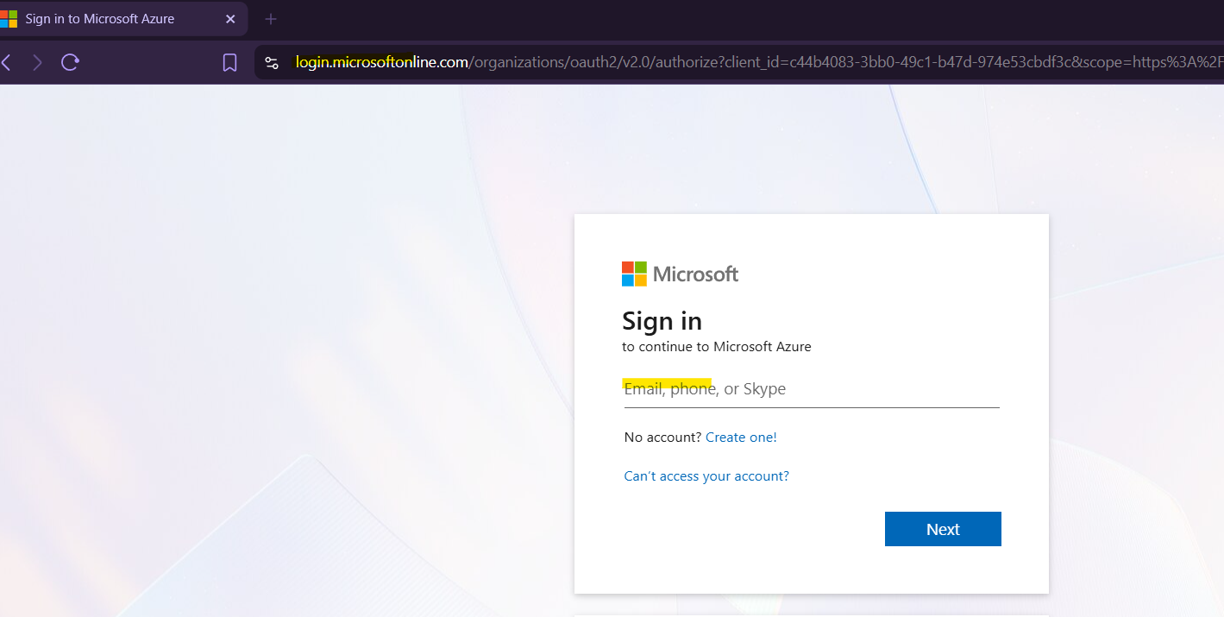

Put the password: *********
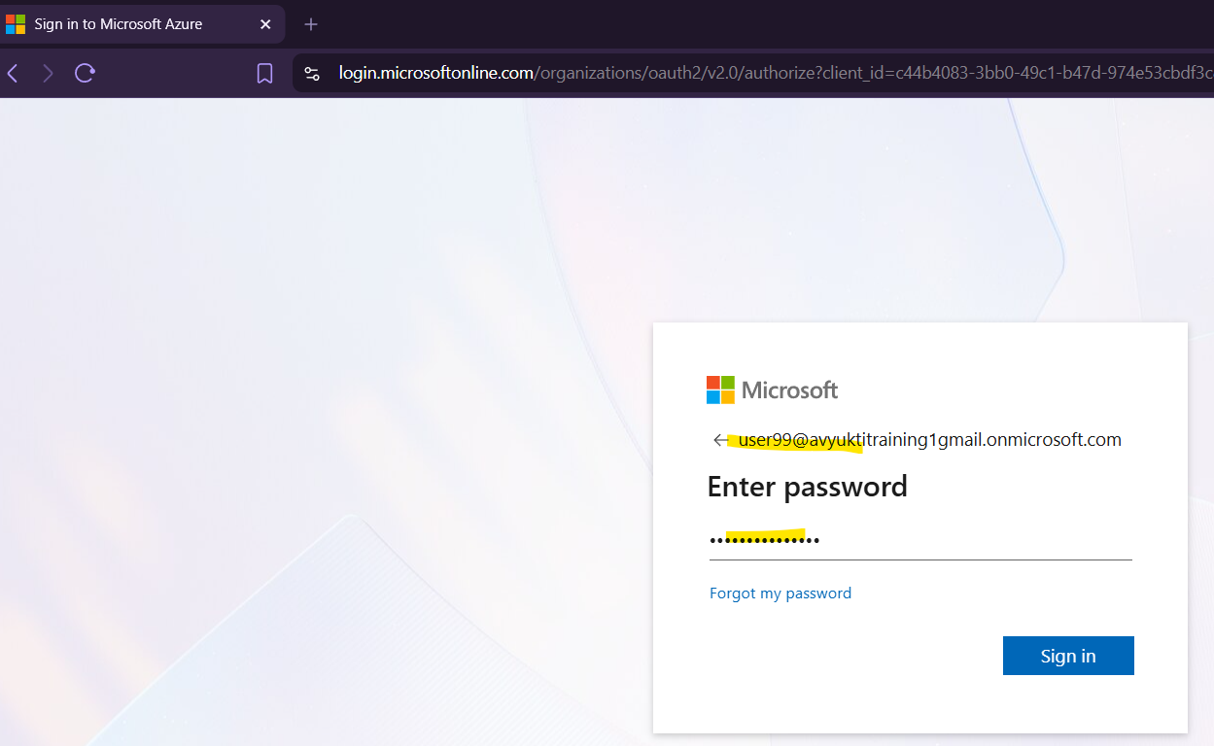

Step3: Update your password
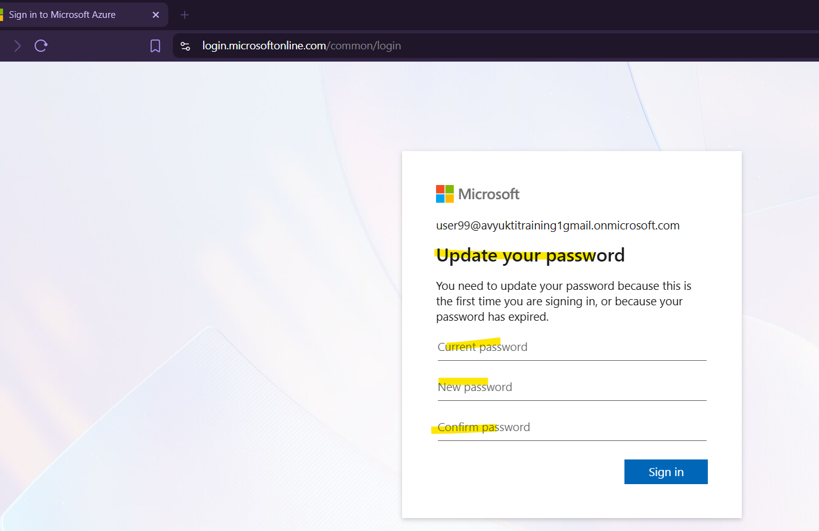

Step4: In Your Mobile -> Download Microsoft Authenticator app. & set up the Microsoft Authenticator app.
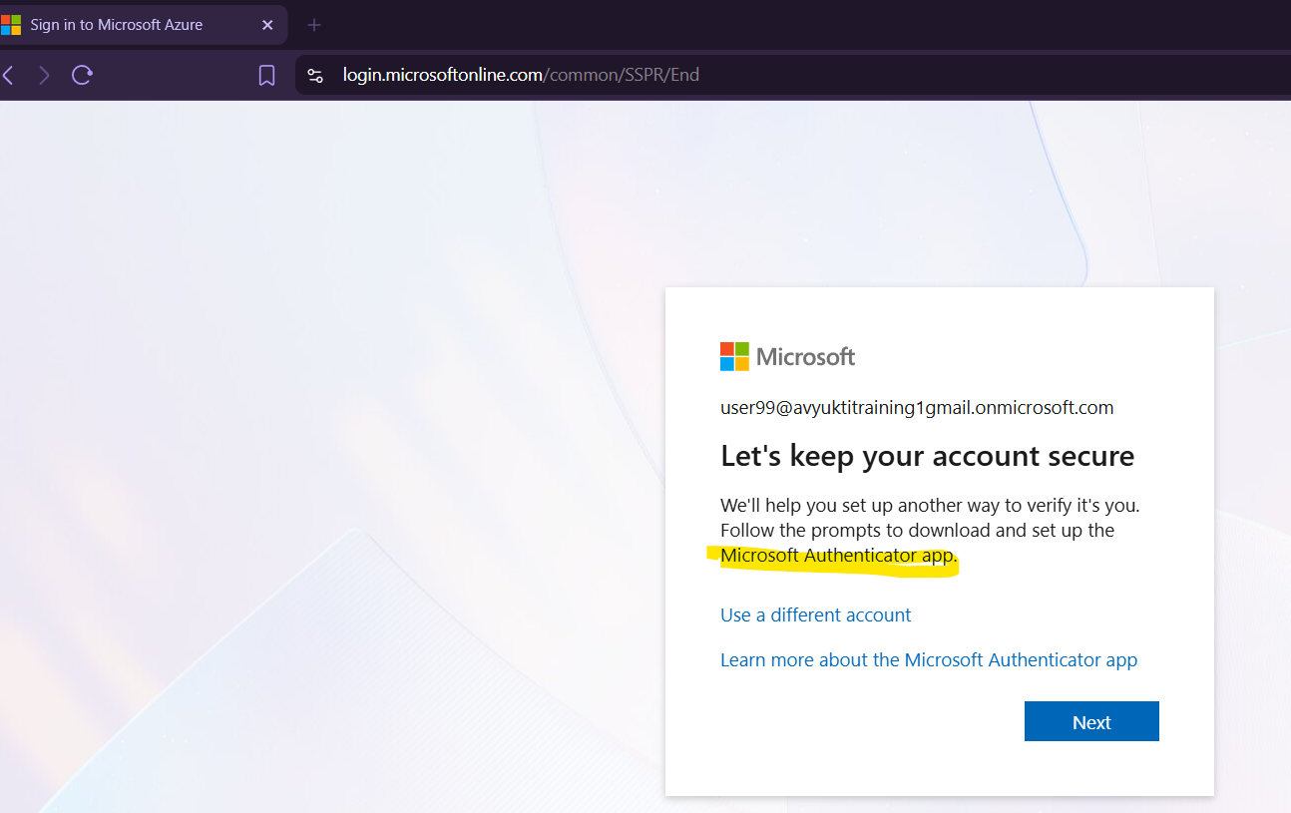

Step 5: Install the Microsoft Authenticator app in your Mobile –
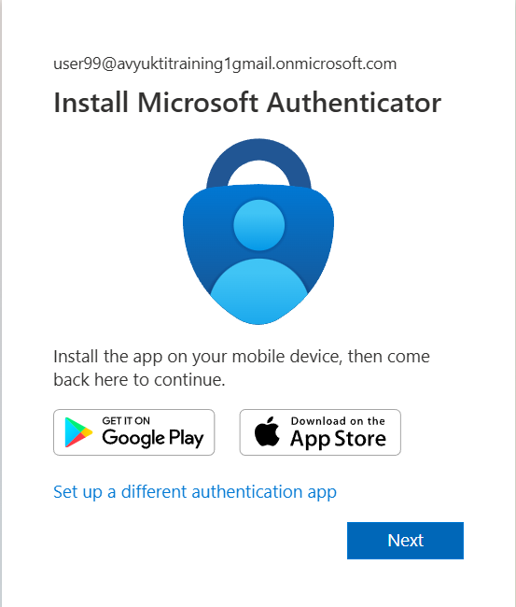
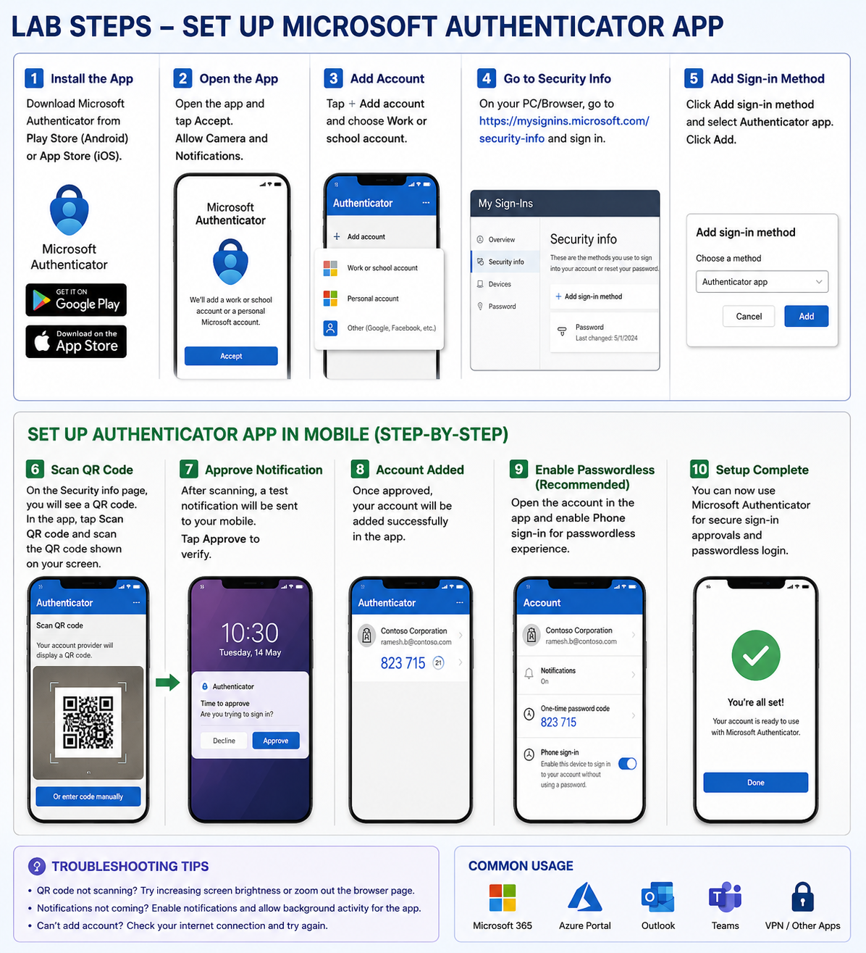
Apple devices use the App Store and Google devices use the Google Play Store.
- Search for the Microsoft Authenticator app
Microsoft Authenticator app for iOS devices
Microsoft Authenticator app for Google devices
- Tap on the Get button
The screenshot may vary based on the device and whether using Apple or Google.
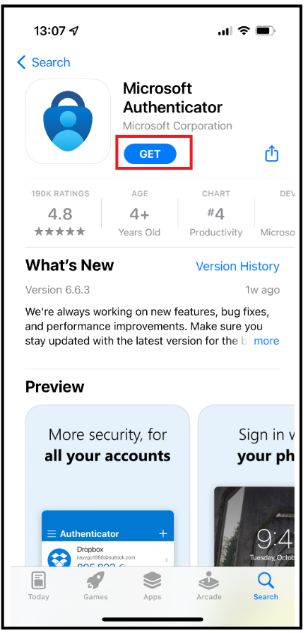
- Depending on the settings on the device, you may be required to enter a password for the appropriate App store.
Set up the App
Once the Microsoft Authenticator app is installed, tap to open it. The first couple steps may vary slightly based on if the app had previously been installed or not.
- Tap on the + (Plus) icon
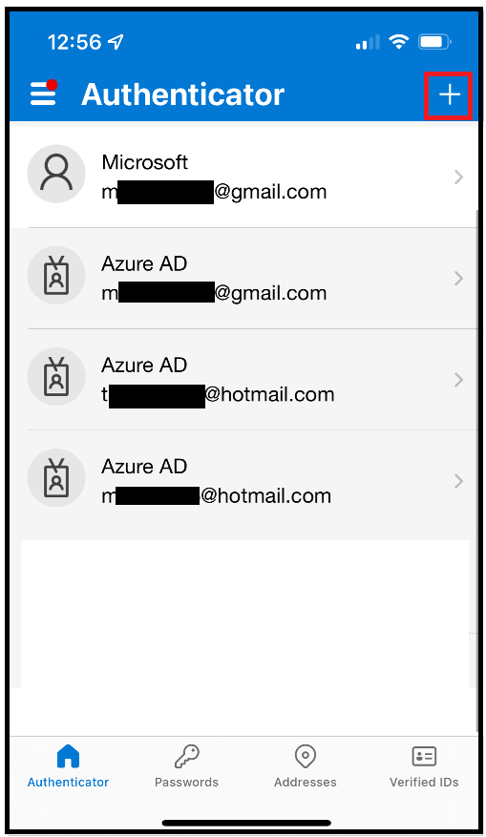
- Tap on the Work or school account option
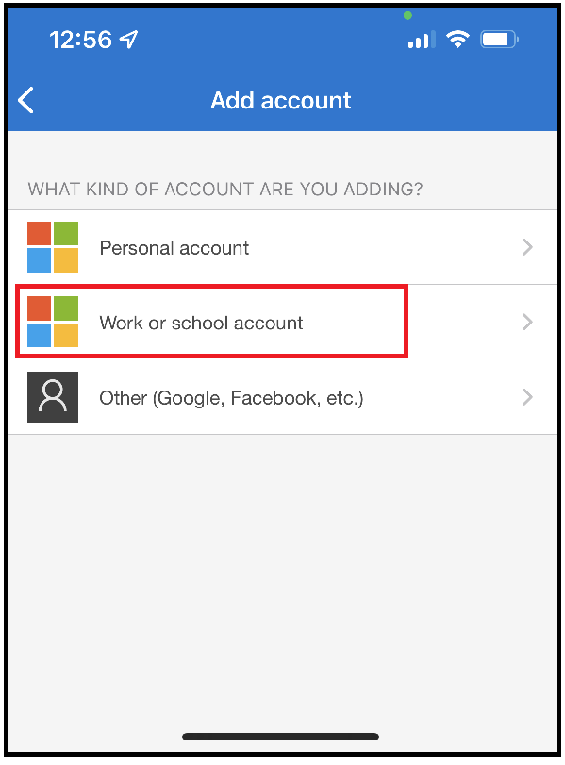
- Tapping the Sign in button will require the email and password to be manually entered again.
  - We recommend using the Scan QR Code button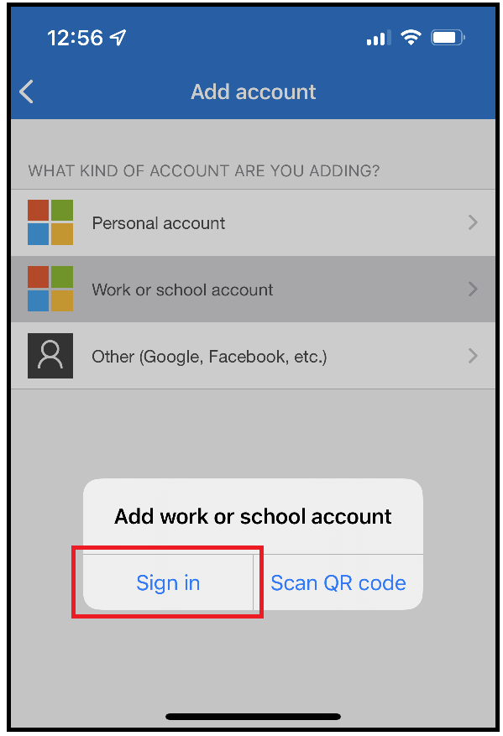
- Tap on the Scan QR Code button
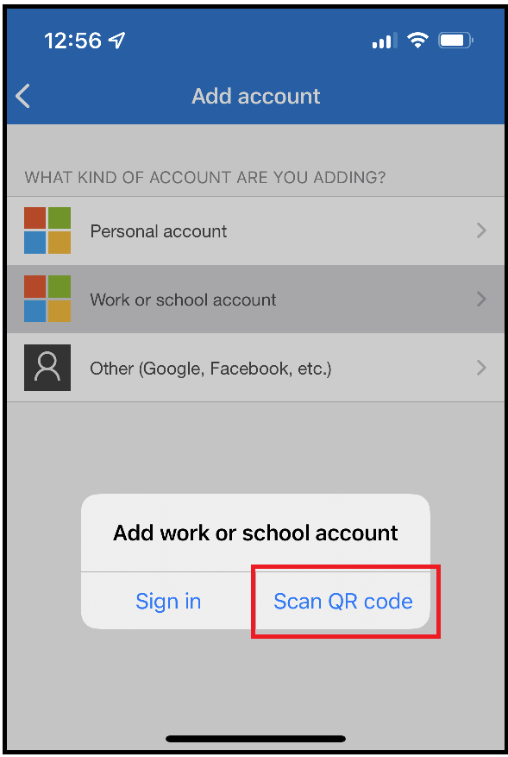
- There may be a prompt asking for permission to use the camera. Tap Approve or OK.
- Using your device, point it at the screen with the QR Code.
Note: The QR Code should be displayed in BOLD; if not then skip the QR Code and manually sign in. This is usually displayed when first using MFA and BOLD.
Device / Phone | Computer Screen
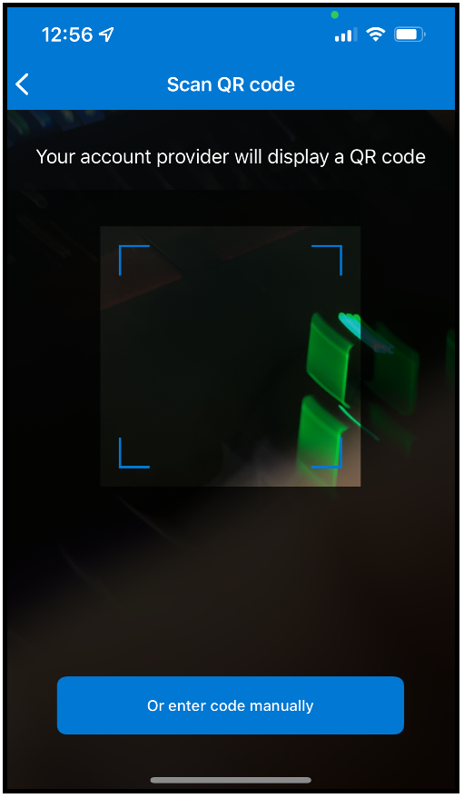 | 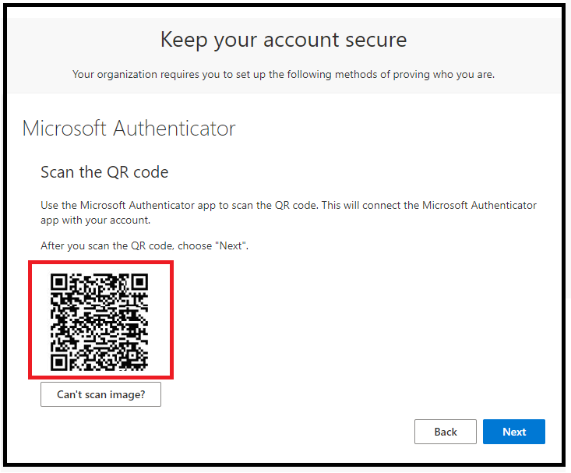
Once the Authenticator App recognizes the QR Code, there will be a brief loading screen.
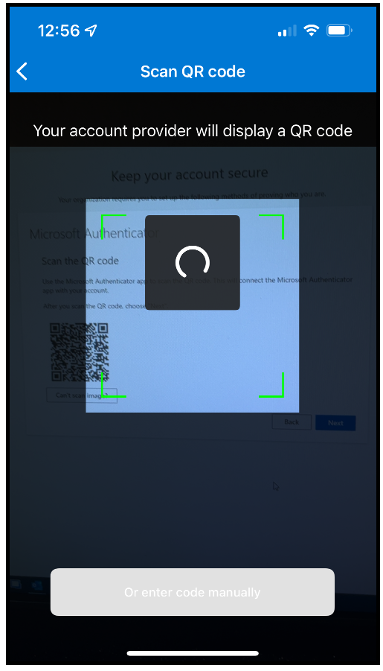
Notice the account is now listed on the Authenticator App
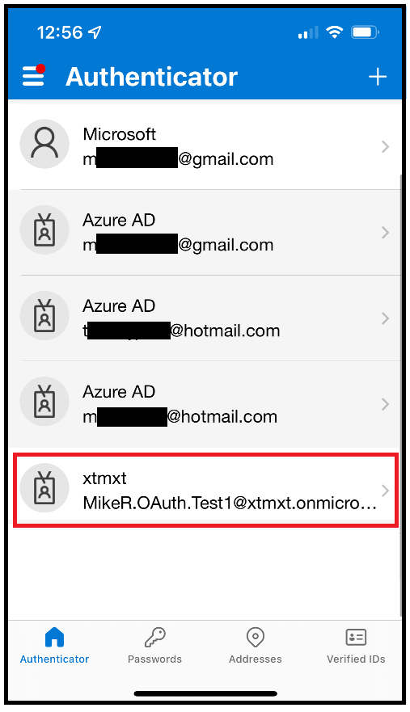

Approve the sign in
Once successfully signed in, stay in the Microsoft Authenticator app.
- Tap on the Approve button
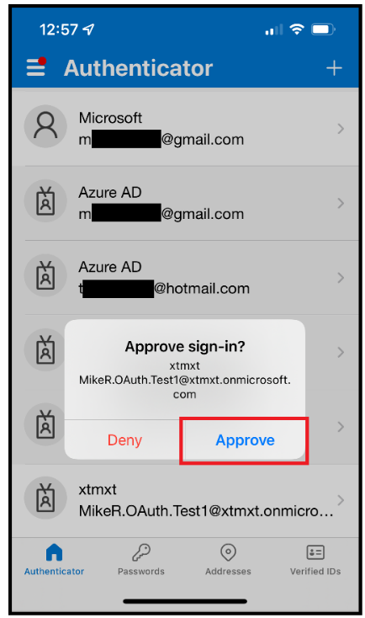
- If the message doesn't show up and are instead asking to enter a code.
- Tap on the name of the account.
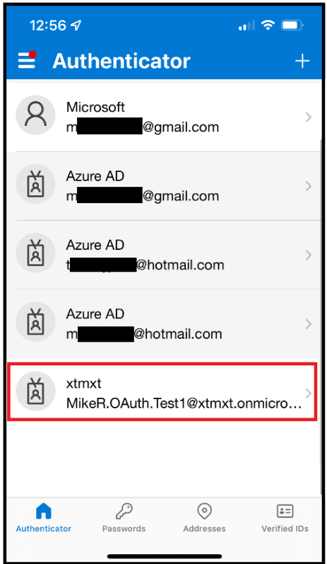
- Enter the code that is listed here.
