Direct PowerShell command to download and install Terraform on Windows:

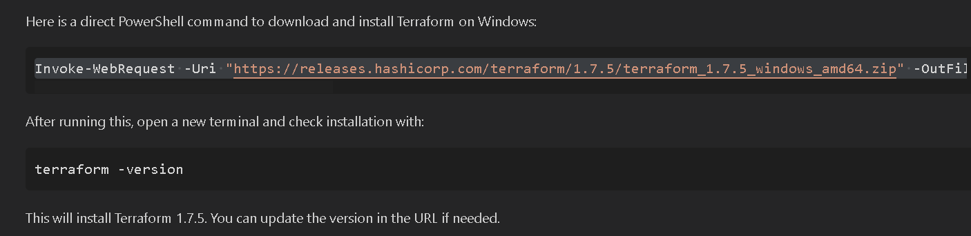
Invoke-WebRequest -Uri "https://releases.hashicorp.com/terraform/1.7.5/terraform_1.7.5_windows_amd64.zip" -OutFile "$env:TEMP\\terraform.zip"; Expand-Archive -Path "$env:TEMP\\terraform.zip" -DestinationPath "C:\\terraform" -Force; [Environment]::SetEnvironmentVariable("Path", $env:Path + ";C:\\terraform", [EnvironmentVariableTarget]::Machine)
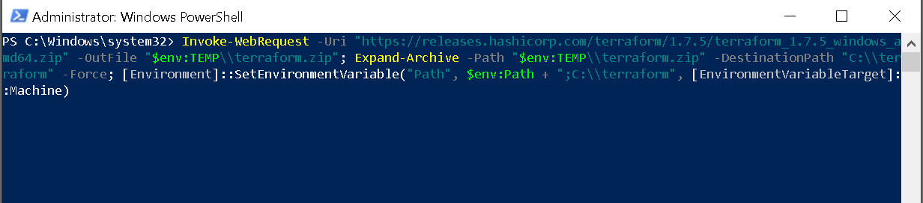
After running this, open a new terminal and check installation with:
terraform –version
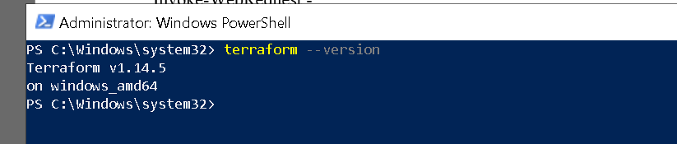
This will install Terraform 1.7.5. You can update the version in the URL if needed.
- Download Terraform:
Go to https://www.terraform.io/downloads.html and download the Windows 64-bit zip.
- Extract the zip file:
Extract terraform.exe to a folder, e.g., C:\terraform
- Add Terraform to your PATH:
Open PowerShell as Administrator and run:

[Environment]::SetEnvironmentVariable("Path", $env:Path + ";C:\terraform", [EnvironmentVariableTarget]::Machine)
- Verify installation: Open a new terminal and run:
terraform -version
Now Terraform is ready to use in VS Code!

