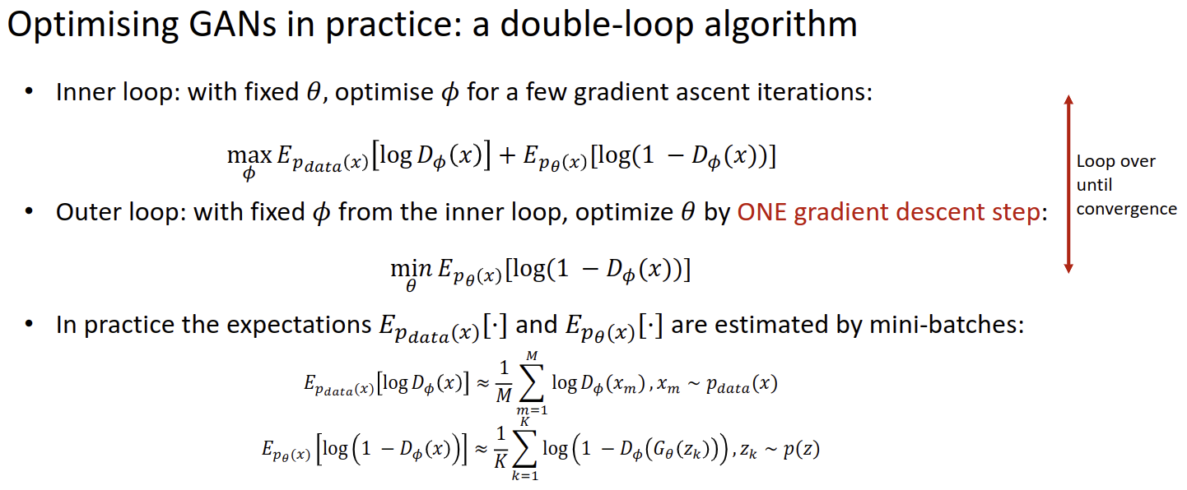
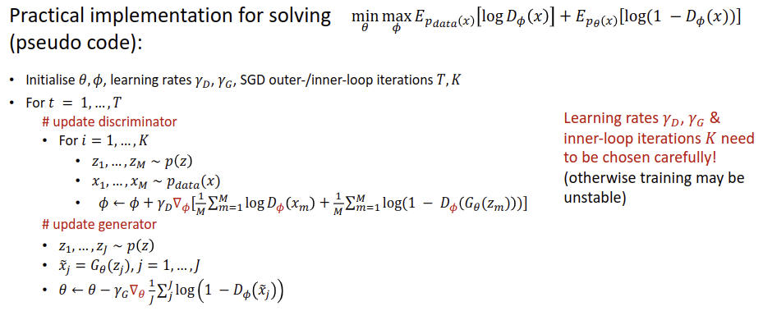
Universal Approximator Theorem: Let be a non-constant, bounded and monotonically increasing fn. and any continuous fn , there exists an integer , real constants and real vectors where such that: where is a sensible activation function. Problems: can be very large in practice, making approximation less useful, and curse of dimensionality.
Curse of Dimensionality:
Sample Explosion: As the number of features or dimensions grows, the amount of data we need to generalize accurately grows exponentially To approximate a (Lipschitz) continuous function with accuracy one needs samples.
Sparseness: The more features we use, the more sparse the data becomes such that accurate estimation of the classifier’s parameters (i.e. its decision boundaries) becomes more difficult, this sparseness is not uniformly distributed over the search space; the higher dimensions you have the higher probability that a data-point will sit in its own distinct corner in the hypercube.
Math: . this shows that the volume of the rind initially grows much faster, times faster than the rate at which the object is being shrunk (when and then ); In higher dims, small changes in distance lead to vast changes in vol.
Shift Invariance: The unchanging response when the input is shifted. For classifier and shift operator (no matter how the input is transformed, the output should remain constant) generalizes for unseen data.
Shift Equivariance: applying the shift operator after the function yields the same results as applying the function after the shift. i.e. . It is about consistent transformation.
Translation Invariance: shift in input should have a predictable shift in hidden representation (location shouldn’t matter)
Locality: we should not have to move far from location to learn valuable information to asses what the area contains.
Fully connected net: every input feature in an image influences ever neuron in the next layer: . Sparsely connected net: each neuron is connected to a subset of neurons : . Weight sharing net: weights are reused in a network
Convolution:
Correlation:
commutative: , associative distributive:
Factorized conv: 2 3x3 convolutions can act as an approx for 5x5 conv trading expressiveness for efficiency. Inserting a non-linearity between the 3x3s lets it capture more complex features.
Separable conv: approximate a 5x5 conv with a 5x1 and 1x5 reducing params (as above). Lossy.
Pooling: smaller res, hierarchal features (concentrates abstract features), shift/deform Invariance. Break shift-equivariance by blurring sample to avoid the shifting pooling issue.

standard CNNs are not naturally equivariant to rotations; Harmonic Networks/H-Nets; replacing kernel w/ 'circular harmonics'; rotation results in a proportionate rotation in the output.
Approximate Deformation Invar: deform img =deform factor
Activation Fns: introduce non-linearity for more complex data learning.
Unbounded outputs lead to numerical instability in training. High values cause issues with gradients leading to problems like exploding gradients.
Linear: network behaves single-layered model. Regression.
Sigmoid: more analogue continuous output than step, smooth gradient between (-2,2) rapid learning between there. Vanishing gradient problem. Good for n-classifiers.
Tanh: stronger gradient, outputs are zero-centred on avg. Vanishing gradient problem, requires good normalization.
ReLU: produces sparse activations, comp. Efficient (less dense activations), Dying ReLU problem often outputting 0.
Leaky ReLU: like ReLU – dying problem
PreLU: as above only , adaptability during training, scale invar.
SoftPlus: differentiable ReLU, if beta high, closer to ReLU, positive output only, non-linear.
ELU: CELU with element-wise, can be -ve, avg activation pushes to 0 → helps converge faster.
CELU: element-wise, when continuously differentiable
SELU: predefined scale and for mean 0 and var 1, internal normalizaiton, robust (no dying unit)
GELU: cdf for gaussian, introduces probabilistic, regularization.
ReLU6: saturates activations,
LogSigmoid: element-wise, better for cost functions,
SoftMin: rescale inputs to sum to 1, multi-dimensional non-linearity, resemble a probability distribution. Emphasises smallest values.
SoftMax: rescale to , multi-label class.
LogSoftmax: possible to simplify mathematical calculations and potentially improve the training process
Period activation: SIREN: deals with implicit representation involving finding a continuous function that represents sparse input data, such as images.
Loss: how well your network is doing, quantifying (predicted outputs, ground truth). Backprob updates model parameters, aiming to min. error.
L2-norm: regression.
L1-norm: sensitive to outliers, differentiable
Smooth L1: , for errors close to zero, it behaves like the L2 loss, else L1. Robust to outliers.
Negative Log-likelihood:
element-wise, weights assign importance,
Cross-entropy:
n-classification, weighted classes optional
Binary cross-entropy: , predicted positive, ground truth (0,1), weight. Binary/Multi classification
Kullback-Libeler
suitable when target is 1-hot, suffers with numerical stability issues
Margin Ranking Loss/Ranking Losses/Contrastive Loss: useful to push classes as far away as possible
Triplet Margin Loss: make samples from same classes close and different classes far away e.g. Siamese Networks
Cosine Embedding Loss
Measure whether two inputs are similar or dissimilar, 1 sim (tries to minimize the angle between the vectors), -1 not sim (aims to ensure that the cosine similarity is smaller than a specified margin).
LeNet: convolutions + avg pooling + fully connected last layer (small number of classes make this ok) performs object localization + recognition.
AlexNet: + dropout after 2 layers for robustness/regularization, ReLU, maxpool (more shift invariance, keep salient features, discard less useful), softmax for classification, increased kernel size, data augmentation, model ensemble, originally split into two streams due to hardware limitations.
VGG: bigger, didn’t add more dense layers, didn’t add more convolutional layers, but grouped layers into parametrized blocks. Using lots of narrow convolutions outperforms few wider ones, slower than others but performance is much better
Inception: introduces parallel dataflow, improves performance with width and depth. size=params=overfitting=comp resource. Patch alignment issues fixed with 1x1, 3x3 (1-padding) and 5x5 (2-padding). Naive version also includes a 3x3 maxpool in parallel for additional benefit. Detailed approach includes 1x1 convolutions to compute reductions before expensive 3x3 and 5x5. Channel size: 1x1 = 64 ch, (1x1=96ch→ 3x3=128ch), (1x1=16ch→ 5x5=32ch), (3x3 maxpool→ 1x1=32ch) because big kernels already come with large parameter count. √ It has low param count and FLOPs : implies that By varying no. chan and k we optimize network performance.
ResNet: parameterizes around an identity function instead of 0 function; you don’t have to learn the identity function from scratch, allows for the addition of new layers without disrupting the outputs of previous layers. 3X3→Batchnorm→RelU → 3x3→BatchNorm→combine with identity/1x1 → ReLU.
DenseNet: each layer gets the feature maps from all the preceding layers (taylor expansion style), efficient and less parameters, alleviate the vanishing gradient problem by improving the gradient flow through the network, making optimization easier, scalable, since you can easily adjust the number of layers. Occasionally need to reduce resolution (transition layer)
SqueezeNet: uses attention, Squeeze global average pool, fed into a Descriptor (small fully-connected NN) capture which channels are more important given the current global context of the image. Use descriptors to Excite and scale the original channels Re-weight channels if certain channels need to emphasis certain features
Outcomes: Dense layers are computationally and memory intensive. Real-world problems with big input tensors and many classes will prohibit their use, 1x1 convolutions act like pixel-wise muli-layer perceptron,
BatchNorm: during GD, Each layer’s learning destabilizes the next, causing a slow convergence process that takes a long time for all layers to adapt properly. BatchNorm normalizes the features within each mini-batch, thereby stabilizing the training process and speeding up convergence.
therefore where are learnable parameters var and mean to scale and shift. BatchNorm is effectively acting as a form of regularization by introducing noise into the model. Insert after conv but before activation.
Perform one batchnorm per channel, and in FCL one normalization for all. Not recommended for use with dropout.
U-Net: combination of 3x3 convs with ReLU x2 + maxpool 2x2 … up-conv 2x2 + conv 3x3 x 2 + skip connections + BatchNorm.
3D-UNet: H-DenseUNet: specific segmentation task Unet++: more powerful medical imaging+uses densely connected subnetworks nnU-Net auto
Supervised: learn function given , Unsupervised: learn a probabilistic model which describe hidden structure Generative Latent Models: , → where z is unobserved latent var and x is observed var.
PCA: explain the variability in data as orthogonal directions that capture most of the variance in the data. Probabilistic PCA: . and optimise by training with max log-likelihood, W contains K eigenvectors
Clustering: , and
VAE: we want to minimise divergence between prediction and actual: . Divergence is valid iff when D=0 → p=q and otherwise. We set D = Kullback-Libeler divergence: and remove the constant term. Since the data distribution is approximated by we achieve by using empirical risk (computing expectation w.r.t empirical measure). Fit where G is the neural network transform. Since we need to calculate the integral over the join distribution over the latent variable z; not tractable. Optimize the Variational Lower Bound by which is what we try to maximise. The gap between the two is the KL divergence; therefore the lowerbound improves as q(z) approaches to the exact posterior. Variational Auto Encoders Since the exact posterior depends on x, the variational lower-bound is tight when . Therefore, we define q to be the encoder: . Therefore the objectives become: and where q is defined by a NN as where . KL term has an analytical solution: . Reparametarization: this is still expensive to calculate because requires passing every z through the generative network. Therefore, use Monte-Carlo estimation to approximate the expected log likelihood. thus and then set to make 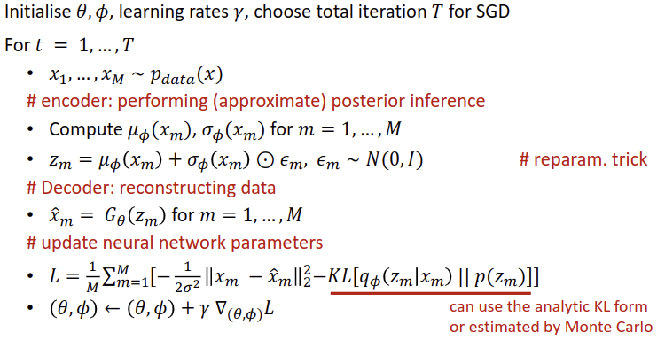. KL annealing is when you have beta parameter in-front of KL term in loss function.
GAN: constructs a binary classification task to assist learning generative model distribution to fit the data distribution . Objective is: i.e. log(real 1) + log(fake 0). Assuming the discriminator network has infinite capacity with fixed θ: and substituting you get the Jensen-Shannon divergence where and thus . We need to solve the 2 player game with a Double loop optimisaition: with fixed theta optimise phi, . With fixed phi, optimize theta . loop until convergence. Usually, these are batched: and . Initialisation issue: generator very bad in beginning, so loss is 0. Instead, use an alternative “non-saturate” loss: this maximises the probability of making a wrong decision on fake data. Wasserstein GAN: instead scores data . The original approach () doesn’t consider infinite capacity of the discriminator network (which should return infinity if a real image). This makes a spiky function. We therefore constrain the lipschitz constraint . Once again, after intractibility issues:
DataAugmentation: increases size and diversity of training set through artificial upsampling, e.g. random (flip, scale, rot, intensity/contrast var, cropping/padding, noise, affine/perspective transformations). Useful for anomaly detection, latent space measurement, input reconstruction,
Conditional Latent Models: the goal is to learn , instead of training C separate models for C classes (doesn’t generalise to continuous) make latent var and condition as input to generator: . However, Maximum Likelihood training is intractable again due to integral over z so apply variational lower-bound once more (it is similar to before, only the input y features also).
Jensen’s Inequality: if f is then
DCGAN: use full convolutional architecture by reshaping z into tensor, with strided convolutions for downsampling and fractional-strided convolutions for generator. LeakyReLU.
LAPGAN: generate a small image and upscale to create a sharper version by feeding it to the input of the next block. We introduce multiple discriminators at different scales; start from the full resolution and downsample into the ‘real’ image for the smaller block. Then, we can feed the upsampled blurry image as the ‘fake’ to the discriminator and the generated to see the result.
Progressive GAN: Progressively build GAN generator and discriminator from low resolution, and once trained, upsample resolution once again.
StyleGAN: latent variable represents the concept of “style” as it disentangles different sources of randomness. It is concatenated with noise in the synthesis network at each resolution scale. NVAE: multiscaled VAE Applications: superresolution (GAN), Image-to-image translation. Other generative models: normalizing flow, continuous time generative models, energy-based-models (NN parametrizes energy function)

