RNN: and where is the activation.
Backward Pass: calculate and is computed for each .
- and
- and . However, contribute to directly and indirectly. Next bullet-point describes why we also need and
- The entries in the Jacobian contains the total gradient of w.r.t . depends on which depends . Therefore:
If we continue expanding: which results in the Back-propogation through time. We may truncate this to .
contains products of activation and weight matrix; gradient vanish/explode as ! Therefore the long-term dependencies become harder to learn.
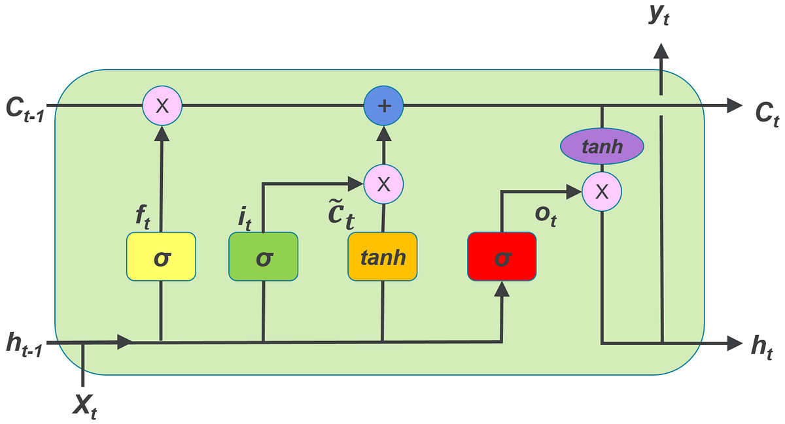LSTM:

then, simply.
Back propagation: we care about optimising the current state . Therefore, we find , ultimately this boils down to . This deals with the exploding gradient issue, as the gradient contains terms proportional to with Similarly, this alleviates gradient since the term is proportional to with ; TLDR; the gates can switch on or off the relevant terms in gradient computation. Struggles learn long-term deps.
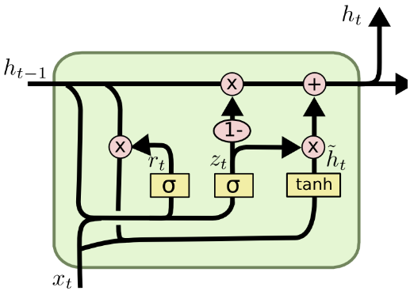Gated Recurrent Unit:

no longer has input/output gate but maintains forgetting mechanism. GRU more efficient computing & less overfitting but LSTM good default choice.
Sequence to Sequence (Seq2Seq) Auto-regressive Model: given two varying sentence length pairs, fit an LSTM model ‘sequence decoder’ with where the first hidden states are initialised by an encoder . We initialise the system by encoding the entirety of the x input. This LSTM will return the first word (upon seeing the <eos> and use the hidden state v to initialise the decoder LSTM. Alternatively, the first word can be an <sos> token. This can be extended to image captioning where we extract an image encoding with CNNs and feed it into an LSTM.
Generative Models for Sequence VAE: We use an encoder architecture like an LSTM to predict the mean and standard variation of the q distribution. The loss function is defined similarly to before:
Encoder: , where and the Generator: .
State-Space-Model: stochastic dynamic model for the latent space . The emission depends on zt only: . The joint distribution is thus
Hidden Markov Model (HMM) with a Linear Gaussian emission model
. State-space models + non-linear dynamics: embed an LSTM which will predict the mean and variance for the next latent variable z at t+1: with the joint distribution . We train it with
For the encoder, we can base the q distribution based on the current input x with: where
Attention: before, we use v (the hidden state from the last LSTM block). How, use such that with attention: with which are the features each weighted by attention and where (feature output of the encoder at time t) and similarity and
Single Head Attention: each key is paired with a value in the V matrix. The query matrix contains query matricies. Hard attention is when and Soft attention is when Masked attention is when we mask out some attention values (mask is 0 or 1 and sets the cell in the matrix as (useful for sequence prediction with a given ordering: in test time “future” is not available for the “current” to attend).
Complexity: time , space , # params (only key and value) so and in self attention this is i.e. Q=V=K

Multi Head Attention: , where and Attention is defined as before. This helps define different hidden similarity measures. Complexity: , , , then
time complexity
space complexity where to keep complexity similar we set to keep the costs close to performing single-head attention in the original space.
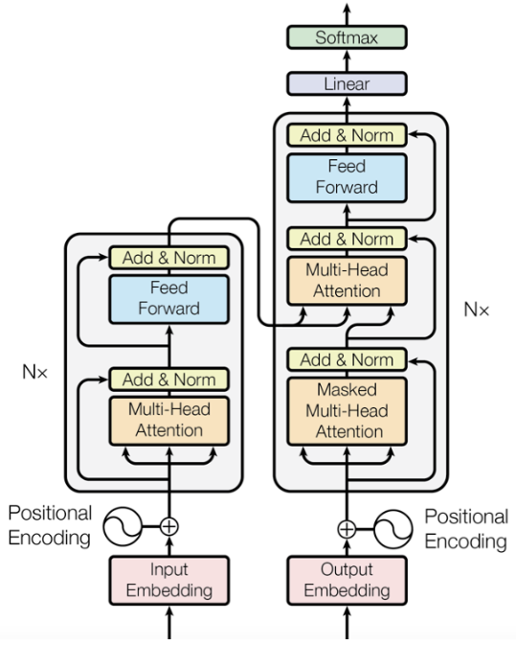Transformer Architecture: This model outputs with being masked out in the first layer of the decoder, and encoder attention outputs used in decoder. The input embedding receives and the output embedding receives
Encoder:
1) we obtain word embeddings and concatenate with positional encodings (which are also learnt). This is because single head attention is permutation equivariant (if we swap two rows in the query matrix then the attention output also has these two rows swapped). Thus, we break permutation equivariance by learning or pre-defined mapping. If we know max length then learnt positional encodings may be better.
2) norm is used within a single hidden layer output
3) the output of multi-head attention is further processed by a feed forward network which is applied to each row of the matrix.

Decoder:
1) after embedding and positional encoding, masked attention is used so during training only the previous words can be used.
2) The input representation is fed into the multi-head attention. The encoder output is used as the keys and values of the attention module. This allows the decoder to attend every word in the input for each of the predicted outputs so far.
The network is trained using maximum likelihood or cross entropy loss.
Floating Point is a way to represent numbers in a computer where the decimal can float. We have a sign, exponent and fraction. .
Calculate Memory footprint: Inference: bits per parameter x number parameters. Training: Model params (same), Gradients: bits per gradient x number parameters (gradient for each) Optimizer: need momentum and rms prop value: 2 * same again. Actviations also.
Floating Point Operations (FLOP): for , , , for
Deep Learning at Scale:
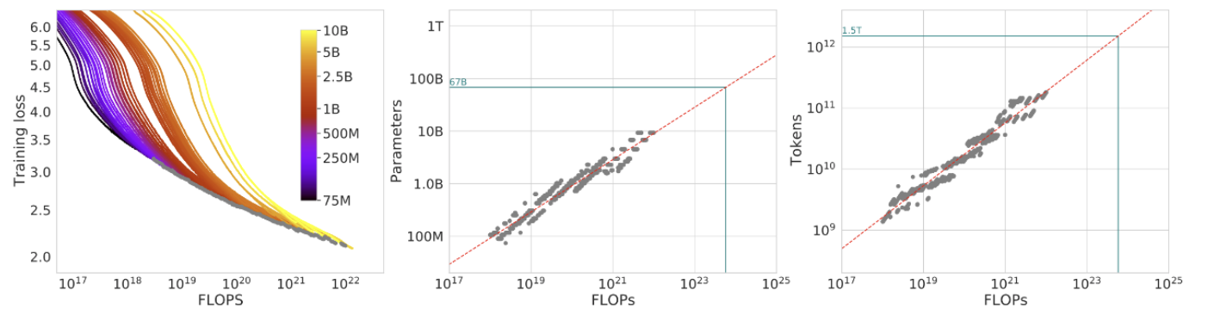To predict how many flops you’ll need read across. Reducible Loss: It is the actual loss - the irreducible loss, where irreducible loss is viewed as the true entropy of the data i.e. if I had a perfect fit of the data, what would be my loss even if I had a perfect fit? Loss – Irreducible Loss. You can predict improvement gain by drawing through the loss vs compute; if loss is better with compute then you’re seeing improvements.
Gradient Accumulation: accumulate the gradients without updating the optimizer, then when the mini-batch size
times the number of cumulative gradient accumulation steps equals the target batch then we do the step in the loss surface. Useful if you want a larger batch size. (addresses limitations of small batches, siginificant noise, many parameter updates).
Gradient Check-pointing: Compute forward pass as normal. Once you do backward propogation and you get to a layer whose activation isn’t in memory, recompute it up to that point. This is good for memory at the cost of computation. This way you can choose which activations to store (large matrix multiplication) and choose to recompute ReLU/other fast 1s.
Fine Tuning: if you have a pre-trained model you want to translate it into another task.
If you have pre-trained weights , you need to update . We have an auto-regressive model and context target tokens (that we’re fine tuning on) this requires us to store info about every parameter . This is also bad if you have a lot of fine-tuned downstream tasks.
Low Rank Adaption (LoRA): what if also has low intrinsic rank we can approximate with where . i.e. only update a subset of parameters.
S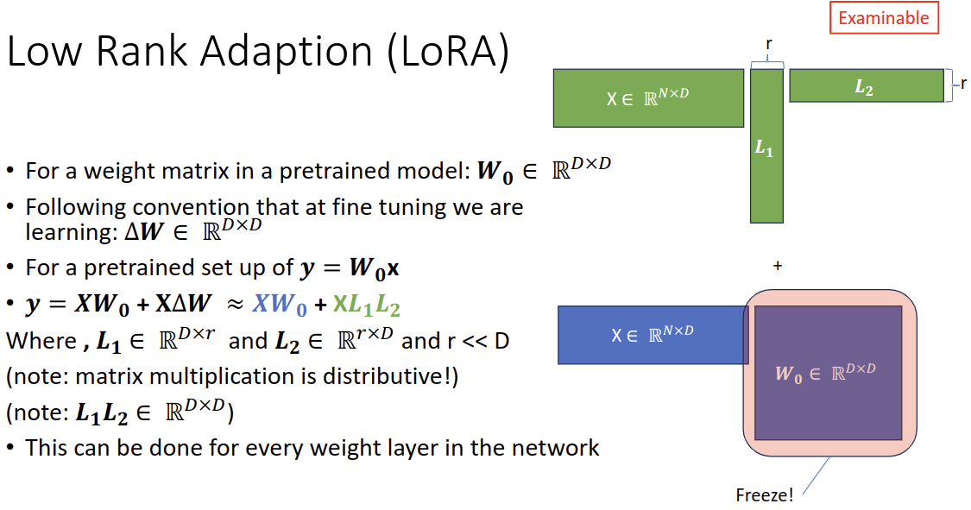urprisingly, r=1,2 give good results. At inference time you combine and we can swap s. However, you still need to store the parameters in order to do inference.
QloRA: this is going from a data type of higher precision or a higher bit rate to a lower bit rate.
and for dequantising: This is lossy. If you have outliers, the representation becomes sparse. Thus chunk the data and quantize each block separately with its own c^x
QloRA: BrainFloat: deep learning is more sensitive to underflow than overflow.
QloRA: Quantising W_0 from bfloat16 to 4 bit: store weights with BrainFloat in 4 bits
Double Quantisation: quantise the quantisation constants.
Finally, for inference, dequantise with
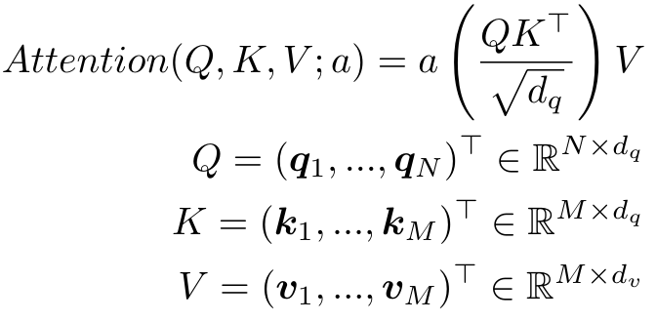a(.) activation function applied row-wise

