--- title: “Untitled” output: html_document date: “2023-06-21” ---

Ce document explique l’ensemble des codes utilisés pour le traitement des données à l’issu de la collecte.

##### PREAMBULE

# PREAMBULE

# La section PREAMBULE contient les packages et librairies nécessaires pour le traitement des données.

# PACKAGES ET LIBRAIRIES

# Nous chargeons les packages et librairies nécessaires pour l’analyse des données.

library(tidyverse)

## ── Attaching core tidyverse packages ──────────────────────── tidyverse 2.0.0 ──  
## ✔ dplyr 1.1.1 ✔ readr 2.1.4  
## ✔ forcats 1.0.0 ✔ stringr 1.5.0  
## ✔ ggplot2 3.4.1 ✔ tibble 3.2.1  
## ✔ lubridate 1.9.2 ✔ tidyr 1.3.0  
## ✔ purrr 1.0.1   
## ── Conflicts ────────────────────────────────────────── tidyverse_conflicts() ──  
## ✖ dplyr::filter() masks stats::filter()  
## ✖ dplyr::lag() masks stats::lag()  
## ℹ Use the conflicted package (<http://conflicted.r-lib.org/>) to force all conflicts to become errors

library(readxl)  
library(ggplot2)  
library(dplyr)  
library(RColorBrewer)  
library(factoextra)

## Welcome! Want to learn more? See two factoextra-related books at https://goo.gl/ve3WBa

library(FactoMineR)  
library(ggforce)  
library(tinytex)  
library(fivethirtyeight)

## Some larger datasets need to be installed separately, like senators and  
## house_district_forecast. To install these, we recommend you install the  
## fivethirtyeightdata package by running:  
## install.packages('fivethirtyeightdata', repos =  
## 'https://fivethirtyeightdata.github.io/drat/', type = 'source')

library(haven)  
library(broom)  
library(gmodels)  
library(ggthemes)  
library(fivethirtyeight)  
library(ggsci)  
library(ggpubr)

# Traitement de données

# Cette section comprend les codes qui permettent de définir l’espace de travail, de lire le fichier Excel et de supprimer les colonnes.

# Définition de l’espace de travail et lecture du fichier Excel dans R

# Nous définissons l’espace de travail et importons le fichier Excel contenant les données brutes.

setwd("/Users/user/Desktop/LA GESTION DE L'EAU /Analyse/R")  
  
filepath <- ("datacustom11062023.dta")  
data <- read_dta(filepath)  
#view(data)  
  
dataCm <- data %>%  
 filter(Q3LienavecleCM == 1)

REPARTION DES MENAGES PAR genre DU CM ################################################################################

mdl_sexe <- c("Homme", "Femme")  
couleurs_sexe <- c("#082567", "#8C001A")  
  
  
dataCm_genre_factor <- dataCm %>%  
 mutate(Genre_fc = as.factor(Genre))  
  
dataCm_sexe_count <- dataCm_genre_factor %>%  
 count(Genre_fc) %>%  
 mutate(prop = n / sum(n))  
  
gg_genre<-ggplot(data = dataCm_sexe_count, aes(x = "", y = prop, fill = Genre_fc)) +  
 geom_bar(width = 1, stat = "identity", position = position_fill(0.5)) +  
 coord_polar(theta = "y") +  
 scale_fill_manual(name = "", values = couleurs_sexe, labels = mdl_sexe) +  
 labs(title = " ", x = NULL, y = NULL) #+  
 #geom_text(aes(label = paste0(round(prop*100, 1), "%")),  
 # position = position_stack(vjust = 0.5)) +  
 #theme_void()  
  
  
gg_genre

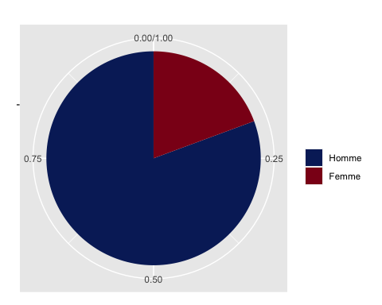

couleurs <- c("#1f77b4", "#ff7f0e", "#2ca02c", "#d62728", "#9467bd",   
 "#8c564b", "#e377c2", "#7f7f7f", "#bcbd22", "#17becf",   
 "#2f4b7c", "#ff9896", "#98df8a", "#d62728", "#ffbb78",   
   
 "#c5b0d5", "#c49c94", "#f7b6d2", "#c7c7c7", "#dbdb8d")

REPARTION DES MENAGES PAR Niveau d;education atteint par DU CM ################################################################################

# Définir les labels personnalisés pour chaque niveau  
labels_niv_educ <- c("Neant", "Niveau Primaire", "Niveau Collegiale", "Niveau secondaire", "Niveau supperieur")  
  
# Convertir la variable Niv_educ en un facteur avec les labels personnalisés  
dataCm$Niv_educ <- factor(dataCm$Niv_educ, levels = 0:4, labels = labels_niv_educ)  
  
mdl_niv_etu_ac<- c("Neant","Niveau Primaire","Niveau Collegiale","Niveau secondaire","Niveau supperieur")  
col_niv_etu_ac <- c("#2f4b7c", "#ff7f0e", "#2ca02c", "#d62728", "#9467bd")  
  
gg_niv_educ<-ggplot(data = dataCm, aes(x = fct_infreq(Niv_educ),   
 fill = factor(Niv_educ, levels = mdl_niv_etu_ac))) +  
 geom_bar(width = 0.35) +  
 scale_fill_manual(name = "",   
 values = col_niv_etu_ac,   
 labels = mdl_niv_etu_ac) +  
 labs(title = "",  
 x="", y=" ") +  
 guides(fill=FALSE) +  
 theme_classic() #+

## Warning: The `<scale>` argument of `guides()` cannot be `FALSE`. Use "none" instead as  
## of ggplot2 3.3.4.  
## This warning is displayed once every 8 hours.  
## Call `lifecycle::last_lifecycle_warnings()` to see where this warning was  
## generated.

# Ajouter les ÃƒÂ©tiquettes au-dessus des barres avec les proportions arrondies  
 # geom_text(aes(label = paste0(round((..count..)/sum(..count..)*100, 2), "%"),  
 # y=..count..), stat='count', position=position_stack(1.1))   
  
gg_niv_educ

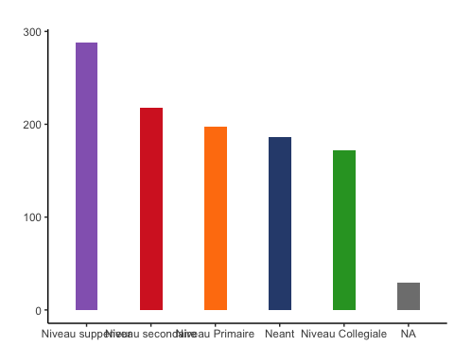 ################################################################################ REPARTION DES MENAGES PAR Statut d’ocuppation du logement ################################################################################

# Définir les labels personnalisés pour chaque niveau  
labels_statu_ocup <- c("Logé gratuitement (Logement de fonction)","Logé gratuitement (Famille ou Amis)","Propriétaire","Locataire","Autre")  
  
# Convertir la variable Niv_educ en un facteur avec les labels personnalisés  
dataCm$statut_occupation <- factor(dataCm$statut_occupation, levels = 0:4, labels = labels_statu_ocup)  
  
mdl_statu_ocup<- c("Logement de fonction)","Logé gratuitement","Propriétaire","Locataire","Autre")  
  
  
col_statu_ocup <- c("#98df8a", "#17becf", "#8c564b", "#2f4b7c", "#ffbb78")  
  
gg_statu_ocup<-ggplot(data = dataCm, aes(x = fct_infreq(statut_occupation),   
 fill = factor(statut_occupation, levels = mdl_statu_ocup))) +  
 geom_bar(width = 0.5) +  
 scale_fill_manual(name = "",   
 values = col_statu_ocup,   
 labels = mdl_statu_ocup) +  
 labs(title = "",  
 x="", y=" ") +  
 guides(fill=FALSE) +  
 theme_classic()# +  
 # Ajouter les ÃƒÂ©tiquettes au-dessus des barres avec les proportions arrondies  
 #geom_text(aes(label = paste0(round((..count..)/sum(..count..)*100, 2), "%"),  
 # y=..count..), stat='count', position=position_stack(1.3)) +  
 #coord_flip()  
  
gg_statu_ocup

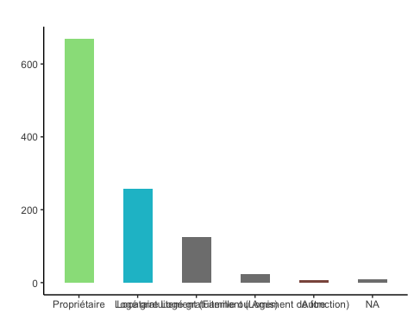 ################################################################################ REPARTION DES MENAGES PAR Montant de la facture  
################################################################################

labels_Mt_Eau_num <- c("50 Dirhams ou moins","Entre 51 et 99 Dirhams","Entre 100 et 150 Dirhams","Entre 151 et 200 Dirhams","Plus de 200 Dirhams")  
  
  
# Convertir la variable Niv_educ en un facteur avec les labels personnalisés  
dataCm$Mt_Eau_num <- factor(dataCm$Mt_Eau_num, levels = 1:5, labels = labels_Mt_Eau_num)  
  
mdl_Mt_Eau_num<- c("50 Dirhams ou moins","Entre 51 et 99 Dirhams","Entre 100 et 150 Dirhams","Entre 151 et 200 Dirhams","Plus de 200 Dirhams")  
  
col_Mt_Eau_num<-c("#133337","#006991" ,"#002d66" ,"#ff7600","#bcffe3")  
  
gg_Mt_Eau_num<-ggplot(data = dataCm, aes(x = fct_infreq(Mt_Eau_num),   
 fill = factor(Mt_Eau_num, levels = mdl_Mt_Eau_num))) +  
 geom_bar(width = 0.5) +  
 scale_fill_manual(name = "",   
 values = col_Mt_Eau_num,   
 labels = mdl_Mt_Eau_num) +  
 labs(title = "",  
 x="", y=" ") +  
 guides(fill=FALSE) +  
 theme_classic() +  
 coord_flip() #+  
 # Ajouter les ÃƒÂ©tiquettes au-dessus des barres avec les proportions arrondies  
 #geom_text(aes(label = paste0(round((..count..)/sum(..count..)*100, 2), "%"),  
 # y=..count..), stat='count', position=position_stack(1.3)) +  
 #coord_flip()  
  
gg_Mt_Eau_num

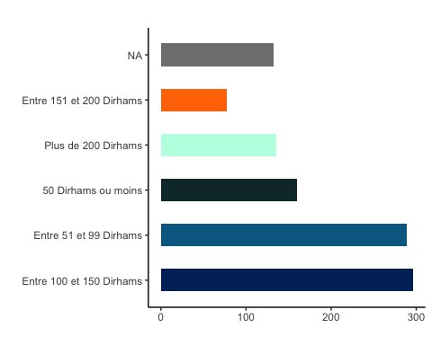 ################################################################################ REPARTION DES MENAGES PAR Type de Logemnt DU Menage ################################################################################

# Définir les labels personnalisés pour chaque niveau  
labels_type_logement <- c("Bidonville","Appart Habitat social","Appart Habitat économique","Appart std moyen","Appart haut std"," Villa")  
  
# Convertir la variable Niv_educ en un facteur avec les labels personnalisés  
dataCm$Type_logement <- factor(dataCm$Type_logement, levels = 0:5, labels = labels_type_logement)  
  
mdl_Type_logement<- c("Bidonville","Appart Habitat social","Appart Habitat économique","Appart std moyen","Appart haut std"," Villa")  
  
col_Type_logement<-c("#006991","#c4121a","#810000","#7857a1","#071d54" ,"#3232d6","#ffb034")  
  
gg_Type_logement<-ggplot(data = dataCm, aes(x = fct_infreq(Type_logement),   
 fill = factor(Type_logement, levels = mdl_Type_logement))) +  
 geom_bar(width = 0.5) +  
 scale_fill_manual(name = "",   
 values = col_Type_logement,   
 labels = mdl_Type_logement) +  
 labs(title = " ",  
 x="", y=" ") +  
 guides(fill=FALSE) +  
 theme_classic() +  
 # Ajouter les ÃƒÂ©tiquettes au-dessus des barres avec les proportions arrondies  
 #geom_text(aes(label = paste0(round((..count..)/sum(..count..)*100, 2), "%"),  
 #y=..count..), stat='count', position=position_stack(1.3)) +  
 coord_flip()  
  
gg_Type_logement

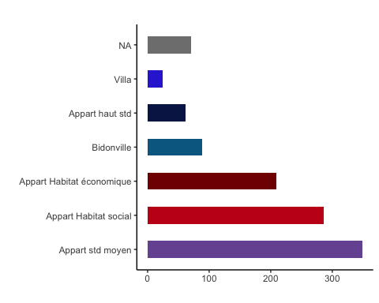

REPARTION DES MENAGES PAR REVENU DU CM ################################################################################

labels_Revenu_cm <- c("1500 ou moins","Entre 1501 et 2500 Dirhams","Entre 2501 et 4000 Dirhams","Entre 4001 et 9500 Dirhams","Plus de 9500 Dirhams")  
  
# Convertir la variable Niv_educ en un facteur avec les labels personnalisés  
dataCm$Revenu <- factor(dataCm$Revenu, levels = 1:5, labels = labels_Revenu_cm)  
  
mdl_Revenu_cm<- c("1500 ou moins","Entre 1501 et 2500 Dirhams","Entre 2501 et 4000 Dirhams","Entre 4001 et 9500 Dirhams","Plus de 9500 Dirhams")  
  
  
col_Revenu_cm<-c("#ff4800","#ffae93" ,"#ffcab5","#002d66","#f58220")  
  
gg_Revenu_cm<-ggplot(data = dataCm, aes(x = fct_infreq(Revenu),   
 fill = factor(Revenu, levels = mdl_Revenu_cm))) +  
 geom_bar(width = 0.5) +  
 scale_fill_manual(name = "",   
 values = col_Revenu_cm,   
 labels = mdl_Revenu_cm) +  
 labs(title = "",  
 x="", y=" ") +  
 guides(fill=FALSE) +  
 theme_classic() +  
 # Ajouter les ÃƒÂ©tiquettes au-dessus des barres avec les proportions arrondies  
 #geom_text(aes(label = paste0(round((..count..)/sum(..count..)*100, 2), "%"),  
 # y=..count..), stat='count', position=position_stack(1.3)) +  
 coord_flip()  
  
gg_Revenu_cm

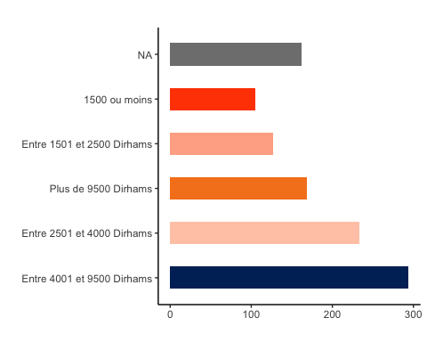 ################################################################################ REPARTION DES MENAGES PAR AGE DU CM ################################################################################

labels_Age_cm <- c("15 ans et moins ","Entre 16 et 25 ans","Entre 26 et 35 ans","Entre 36 et 45 ans","Entre 46 et 55 ans","Entre 56 et 65","66 ans et Plus")  
  
# Convertir la variable Niv_educ en un facteur avec les labels personnalisés  
dataCm$Age <- factor(dataCm$Age, levels = 1:7, labels = labels_Age_cm)  
  
mdl_Age_cm<- c("15 ans et moins ","Entre 16 et 25 ans","Entre 26 et 35 ans","Entre 36 et 45 ans","Entre 46 et 55 ans","Entre 56 et 65","66 ans et Plus")  
  
  
col_Age_cm<-c("#ff7600","#bcffe3","#cecece","#ff50a0","#ffb0f8" ,"#ff4800","#ffae93")  
  
gg_Age_cm<-ggplot(data = dataCm, aes(x = fct_infreq(Age),   
 fill = factor(Age, levels = mdl_Age_cm))) +  
 geom_bar(width = 0.5) +  
 scale_fill_manual(name = "",   
 values = col_Age_cm,   
 labels = mdl_Age_cm) +  
 labs(title = " ",  
 x="", y=" ") +  
 guides(fill=FALSE) +  
 theme_classic()+  
 # Ajouter les ÃƒÂ©tiquettes au-dessus des barres avec les proportions arrondies  
 #geom_text(aes(label = paste0(round((..count..)/sum(..count..)*100, 2), "%"),  
 # y=..count..), stat='count', position=position_stack(1.3)) +  
 coord_flip()  
  
gg_Age_cm

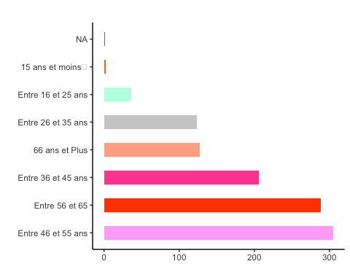

REPARTION DES MENAGES PAR Taille  
################################################################################

col<-c("#133337","#065535" ,"#000000" ,"#ff7600","#bcffe3","#cecece","#ff50a0","#ffb0f8" ,"#ff4800","#ffae93" ,"#ffcab5","#002d66","#f58220","#b279b4","#ed3896","#002361","#835237","#006991","#c4121a","#810000","#7857a1","#bcffe3","#071d54" ,"#3232d6","#ffb034")  
  
labels_taille_mn <- c("1 à 2 individus","3 à 4 individus","5 à 6 individus","Plus de 6 individus")  
  
# Convertir la variable Niv_educ en un facteur avec les labels personnalisés  
dataCm$taille_mn <- factor(dataCm$taille_mn, levels = 1:4, labels = labels_taille_mn)  
  
mdl_taille_mn<- c("1 à 2 individus","3 à 4 individus","5 à 6 individus","Plus de 6 individus")  
  
  
col_taille_mn<-c("#133337","#065535" ,"#000000" ,"#ff7600")  
  
gg_taille_mn<-ggplot(data = dataCm, aes(x = fct_infreq(taille_mn),   
 fill = factor(taille_mn, levels = mdl_taille_mn))) +  
 geom_bar(width = 0.25) +  
 scale_fill_manual(name = "",   
 values = col_taille_mn,   
 labels = mdl_taille_mn) +  
 labs(title = " ",  
 x="", y=" ") +  
 guides(fill=FALSE) +  
 theme_classic()   
 # Ajouter les ÃƒÂ©tiquettes au-dessus des barres avec les proportions arrondies  
 #geom_text(aes(label = paste0(round((..count..)/sum(..count..)*100, 2), "%"),  
 # y=..count..), stat='count', position=position_stack(1.3))   
#gg_taille_mn

Analyse BIVARIE ################################################################################

## Le Genre du CM VS Montant de la facture

gg_Mt_Eau_num_vs_genre <- ggplot(data = dataCm, aes(x = fct_infreq(Mt_Eau_num),   
 fill = factor(Genre))) +  
 geom_bar(width = 0.5, color = "white") +  
 scale_fill_manual(name = "Genre", # Ajout de la légende  
 labels = c("Homme", "Femme"), # Libellés personnalisés pour chaque genre  
 values = c("#bcffe3","#ff7600")) + # Couleurs personnalisées pour chaque genre  
 labs(title = " ",  
 x = "", y = "") +  
 guides(fill = guide_legend(title = NULL)) + # Titre de la légende vide  
 theme_classic() +  
 # Ajouter les étiquettes au-dessus des barres avec les proportions arrondies  
 #geom_text(aes(label = paste0(round((..count..)/sum(..count..) * 100, 2), "%"),  
 # y = ..count..), stat = 'count', position = position_stack(1.3)) +  
 coord_flip()   
  
gg_Mt_Eau_num_vs_genre

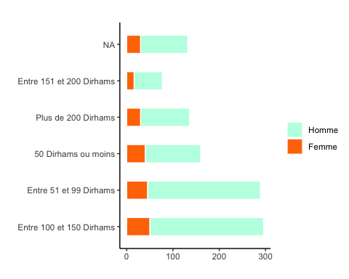

## Montant de la facture Vs Le Niveau d’education des CM

gg_Mt_Eau_num_vs_Niv_educ <- ggplot(data = dataCm, aes(x = fct_infreq(Mt_Eau_num),   
 fill = factor(Niv_educ))) +  
 geom_bar(width = 0.75, position = position_dodge2()) +  
 scale_fill_manual(name = "Niveau d'éducation du CM", # Ajout de la légende  
 labels = c("Neant", "Niveau Primaire", "Niveau Collegiale", "Niveau secondaire", "Niveau supérieur"), # Libellés personnalisés pour chaque niveau d'éducation  
 values = c("#2f4b7c", "#ff7f0e", "#2ca02c", "#d62728", "#9467bd")) + # Couleurs personnalisées pour chaque niveau d'éducation  
 labs(title = " ",  
 x = "", y = "") +  
 guides(fill = guide_legend(title = NULL)) + # Titre de la légende vide  
 theme_classic() +  
 coord_flip() +  
 theme(legend.text = element_text(size = 8)) # Ajustement de la taille du texte de la légende  
  
  
  
  
gg_Mt_Eau_num_vs_Niv_educ_warp <-ggplot(data = dataCm, aes(x = fct_infreq(Mt_Eau_num),   
 fill = factor(Niv_educ))) +  
 geom_bar(width = 0.30, position = position_dodge2()) +  
 scale_fill_manual(name = "Niveau d'éducation du CM", # Ajout de la légende  
 labels = c("Neant", "Niveau Primaire", "Niveau Collegiale", "Niveau secondaire", "Niveau supérieur"), # Libellés personnalisés pour chaque niveau d'éducation  
 values = c("#2f4b7c", "#ff7f0e", "#2ca02c", "#d62728", "#9467bd")) + # Couleurs personnalisées pour chaque niveau d'éducation  
 labs(title = " ",  
 x = "", y = "") +  
 guides(fill = guide_legend(title = NULL)) + # Titre de la légende vide  
 theme_classic() +  
 coord_flip() +  
 theme(legend.text = element_text(size = 8)) +  
 facet_wrap(~Niv_educ)   
  
  
 # geom_text(aes(label = paste0(round((..count..)/sum(..count..) * 100, 2), "%"),  
 # y = ..count..), stat = 'count', position = position_stack(1.3))  
   
gg_Mt_Eau_num_vs_Niv_educ

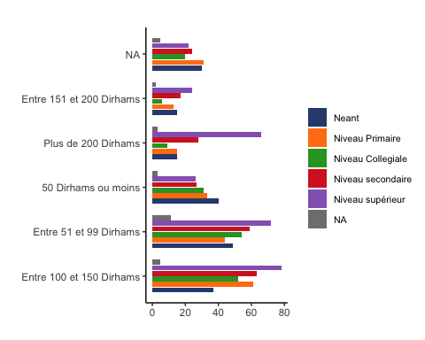

gg_Mt_Eau_num_vs_Niv_educ_warp

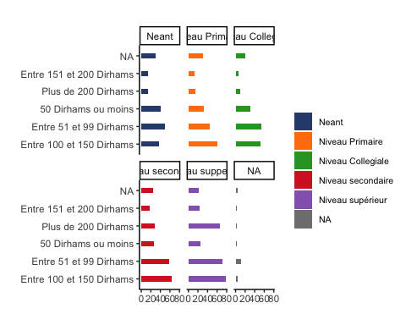

## Montant de la facture Vs Le Revenu des CM

gg_Mt_Eau_num_vs_Revenu <- ggplot(data = dataCm, aes(x = fct_infreq(Mt_Eau_num),   
 fill = factor(Revenu))) +  
 geom_bar(width = 0.75, position = position_dodge2()) +  
 scale_fill_manual(name = "Revenu du CM", # Ajout de la légende  
 labels = c("1500 ou moins","Entre 1501 et 2500 Dirhams","Entre 2501 et 4000 Dirhams","Entre 4001 et 9500 Dirhams","Plus de 9500 Dirhams"), # Libellés personnalisés pour chaque niveau d'éducation  
 values = c("#ff4800","#2ca02c" ,"#ffcab5","#002d66","#f58220")) + # Couleurs personnalisées pour chaque niveau d'éducation  
 labs(title = "",  
 x = "", y = "") +  
 guides(fill = guide_legend(title = NULL)) + # Titre de la légende vide  
 theme_classic()+  
 geom_text(aes(label = gsub("%", "", scales::percent(..count.. / sum(..count..)))),  
 stat = "count", vjust = -0.5, size = 2.5, angle = 45,   
 position = position_dodge(width = 1))+  
 theme(legend.text = element_text(size = 8),  
 legend.key.size = unit(0.25, "cm"),  
 axis.text.x = element_text(size = 7,angle = 25, hjust = 1))  
gg_Mt_Eau_num_vs_Revenu_warp <-ggplot(data = dataCm, aes(x = fct_infreq(Mt_Eau_num),   
 fill = factor(Revenu))) +  
 geom_bar(width = 0.35, position = position_dodge2()) +  
 scale_fill_manual(name = "Revenu du CM", # Ajout de la légende  
 labels = c("1500 ou moins","Entre 1501 et 2500 Dirhams","Entre 2501 et 4000 Dirhams","Entre 4001 et 9500 Dirhams","Plus de 9500 Dirhams"), # Libellés personnalisés pour chaque niveau d'éducation  
 values = c("#ff4800","#2ca02c" ,"#ffcab5","#002d66","#f58220")) + # Couleurs personnalisées pour chaque niveau d'éducation  
 labs(title = "",  
 x = "", y = "") +  
 guides(fill = guide_legend(title = NULL)) + # Titre de la légende vide  
 theme_classic()+  
 coord_flip() +  
 theme(legend.text = element_text(size = 8)) +  
 facet_wrap(~Revenu)   
  
  
gg_Mt_Eau_num_vs_Revenu

## Warning: The dot-dot notation (`..count..`) was deprecated in ggplot2 3.4.0.  
## ℹ Please use `after_stat(count)` instead.  
## This warning is displayed once every 8 hours.  
## Call `lifecycle::last_lifecycle_warnings()` to see where this warning was  
## generated.

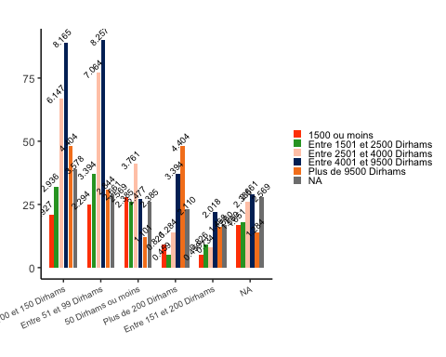

gg_Mt_Eau_num_vs_Revenu_warp

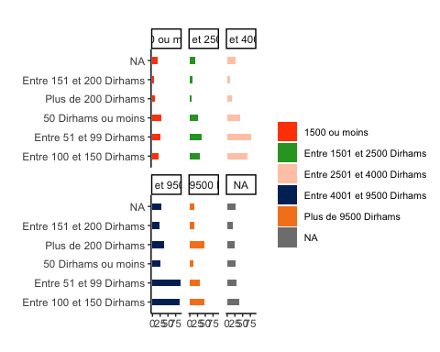

## Montant de la facture Vs La superficie du logement :

gg_Mt_Eau_num_vs_surface <- ggplot(data = dataCm, aes(x = fct_infreq(Mt_Eau_num),   
 fill = factor(surface))) +  
 geom_bar(width = 0.75, position = position_dodge2()) +  
 scale_fill_manual(name = "Superficie du logement", # Ajout de la légende  
 labels = c("50 m² ou moins","De 51 m² à 60 m²","De 61 m² à 70 m²","De 71 m² à 90 m²","De 91 m² à 140 m²","Plus de 140 m²"),  
 values = c("#8c564b", "#e377c2", "#bcbd22", "#17becf","#ff7600","#bcffe3")) + # Couleurs personnalisées pour chaque niveau d'éducation  
 labs(title = "",  
 x = "", y = "") +  
 guides(fill = guide_legend(title = NULL)) + # Titre de la légende vide  
 theme_classic()+  
 geom_text(aes(label = gsub("%", "", scales::percent(..count.. / sum(..count..)))),  
 stat = "count", vjust = -0.5, size = 2.5, angle = 45,   
 position = position_dodge(width = 1))+  
 theme(legend.text = element_text(size = 8),  
 legend.key.size = unit(0.25, "cm"),  
 axis.text.x = element_text(size = 7,angle = 25, hjust = 1))  
  
  
  
gg_Mt_Eau_num_vs_surface_warp <-ggplot(data = dataCm, aes(x = fct_infreq(Mt_Eau_num),   
 fill = factor(surface))) +  
 geom_bar(width = 0.40, position = position_dodge2()) +  
 scale_fill_manual(name = "Surface du Logement ", # Ajout de la légende  
 labels = c("50 m² ou moins","De 51 m² à 60 m²","De 61 m² à 70 m²","De 71 m² à 90 m²","De 91 m² à 140 m²","Plus de 140 m²"),  
 values = c("#8c564b", "#e377c2", "#bcbd22", "#17becf","#ff7600","#bcffe3")) + # Couleurs personnalisées pour chaque niveau d'éducation  
 labs(title = "",  
 x = "", y = "") +  
 guides(fill = guide_legend(title = NULL)) + # Titre de la légende vide  
 theme_classic()+  
 coord_flip() +  
 theme(legend.text = element_text(size = 8)) +  
 facet_wrap(~surface)   
   
gg_Mt_Eau_num_vs_surface

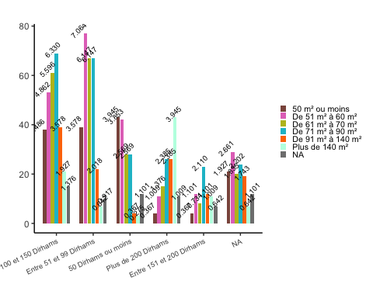

gg_Mt_Eau_num_vs_surface_warp

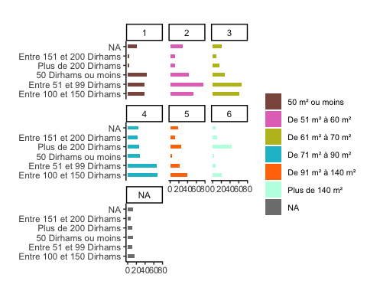

## Montant de la facture Vs Taille du Menage

gg_Mt_Eau_num_vs_taille_mn <- ggplot(data = dataCm, aes(x = fct_infreq(Mt_Eau_num),   
 fill = factor(taille_mn))) +  
 geom_bar(width = 0.75, position = position_dodge2()) +  
 scale_fill_manual(name = "Taille du menage", # Ajout de la légende  
 labels = c("1 à 2 individus","3 à 4 individus","5 à 6 individus","Plus de 6 individus"),  
 values = c("#ff7600","#bcffe3","#002361","#ff50a0")) + # Couleurs personnalisées pour chaque niveau d'éducation  
 labs(title = "",  
 x = "", y = "") +  
 guides(fill = guide_legend(title = NULL)) + # Titre de la légende vide  
 theme_classic() +  
 geom_text(aes(label = gsub("%", "", scales::percent(..count.. / sum(..count..)))),  
 stat = "count", vjust = -0.5, size = 2.5, angle = 45,   
 position = position_dodge(width = 1))+  
 theme(legend.text = element_text(size = 8),  
 legend.key.size = unit(0.25, "cm"),  
 axis.text.x = element_text(size = 7,angle = 25, hjust = 1))  
  
  
  
gg_Mt_Eau_num_vs_taille_mn_warp <-ggplot(data = dataCm, aes(x = fct_infreq(Mt_Eau_num),   
 fill = factor(taille_mn))) +  
 geom_bar(width = 0.40, position = position_dodge2()) +  
 scale_fill_manual(name = "Taille du menage", # Ajout de la légende  
 labels = c("1 à 2 individus","3 à 4 individus","5 à 6 individus","Plus de 6 individus"),  
 values = c("#ff7600","#bcffe3","#002361","#ff50a0")) + # Couleurs personnalisées pour chaque niveau d'éducation  
 labs(title = "",  
 x = "", y = "") +  
 guides(fill = guide_legend(title = NULL)) + # Titre de la légende vide  
 theme_classic() +  
 coord_flip() +  
 theme(legend.text = element_text(size = 8)) +  
 facet_wrap(~taille_mn)   
  
  
   
  
   
gg_Mt_Eau_num_vs_taille_mn

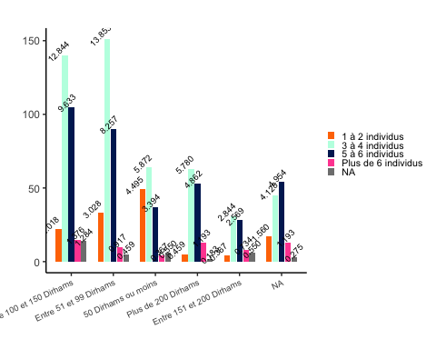

gg_Mt_Eau_num_vs_taille_mn_warp

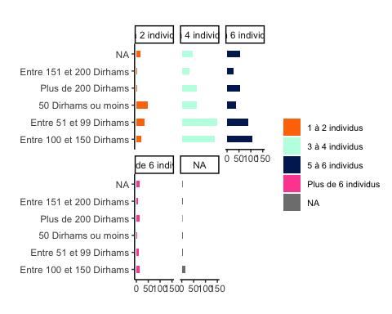

## Montant de la facture Vs L’Age du CM

gg_Mt_Eau_num_vs_Age_cm <- ggplot(data = dataCm, aes(x = fct_infreq(Mt_Eau_num),   
 fill = factor(Age))) +  
 geom_bar(width = 0.75, position = position_dodge2()) +  
 scale_fill_manual(name = "Taille du menage", # Ajout de la légende  
 labels = c("15 ans et moins ","Entre 16 et 25 ans","Entre 26 et 35 ans","Entre 36 et 45 ans","Entre 46 et 55 ans","Entre 56 et 65","66 ans et Plus"),  
 values = c("#ff7600","#bcffe3","#ffb034","#ff50a0","#bcbd22", "#17becf","#7857a1")) + # Couleurs personnalisées pour chaque niveau d'éducation  
 labs(title = "",  
 x = "", y = "") +  
 guides(fill = guide_legend(title = NULL, override.aes = list(size = 1)))+ # Titre de la légende vide  
 theme_classic() +  
 geom_text(aes(label = gsub("%", "", scales::percent(..count.. / sum(..count..)))),  
 stat = "count", vjust = -0.5, size = 2.5, angle = 45,   
 position = position_dodge(width = 1))+  
 theme(legend.text = element_text(size = 8),  
 legend.key.size = unit(0.25, "cm"),  
 axis.text.x = element_text(size = 7,angle = 25, hjust = 1))  
  
gg_Mt_Eau_num_vs_Age_cm

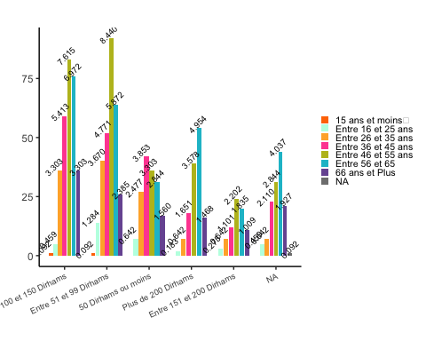

gg_Mt_Eau_num_vs_Age_cm_warp <-ggplot(data = dataCm, aes(x = fct_infreq(Mt_Eau_num),   
 fill = factor(Age))) +  
 geom_bar(width = 0.40, position = position_dodge2()) +  
 scale_fill_manual(name = "Taille du menage", # Ajout de la légende  
 labels = c("15 ans et moins ","Entre 16 et 25 ans",  
 "Entre 26 et 35 ans","Entre 36 et 45 ans",  
 "Entre 46 et 55 ans","Entre 56 et 65 ans",  
 "66 ans et Plus"),  
 values = c("#ff7600","#bcffe3","#ffb034","#ff50a0","#bcbd22", "#17becf","#7857a1")) + # Couleurs personnalisées pour chaque niveau d'éducation  
 labs(title = "",  
 x = "", y = "") +  
 guides(fill = guide_legend(title = NULL)) + # Titre de la légende vide  
 theme_classic() +  
 coord_flip() +  
 theme(legend.text = element_text(size = 8)) +  
 guides(fill = guide_legend(title = NULL, override.aes = list(size = 1)))+ # Titre de la légende vide  
 theme_classic() +  
 geom_text(aes(label = gsub("%", "", scales::percent(..count.. / sum(..count..)))),  
 stat = "count", vjust = -0.5, size = 2.5, angle = 25,   
 position = position_dodge(width = 1))+  
 theme(legend.text = element_text(size = 8),  
 legend.key.size = unit(0.25, "cm"),  
 axis.text.x = element_text(size = 7,angle = 25, hjust = 1))+  
 facet_wrap(~Age)   
  
gg_Mt_Eau_num_vs_Age_cm_warp

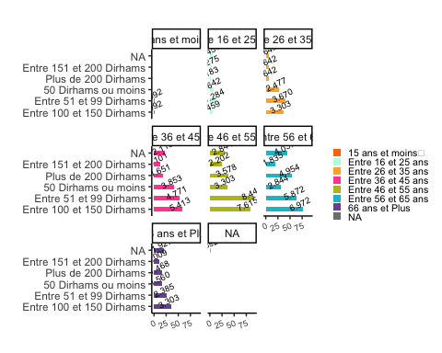

col<-c("#133337","#065535" ,"#000000" ,"#ff7600","#bcffe3","#cecece","#ff50a0","#ffb0f8" ,"#ff4800","#ffae93" ,"#ffcab5","#002d66","#f58220","#b279b4","#ed3896","#002361","#835237","#006991","#c4121a","#810000","#7857a1","#bcffe3","#071d54" ,"#3232d6","#ffb034")

liste_graphiques <- list(gg_taille_mn, gg_Age_cm, gg_Revenu_cm,  
 gg_Type_logement, gg_Mt_Eau_num,  
 gg_statu_ocup, gg_genre, gg_niv_educ,gg_Mt_Eau_num_vs_genre ,gg_Mt_Eau_num_vs_Niv_educ_warp,gg_Mt_Eau_num_vs_Revenu,  
gg_Mt_Eau_num_vs_Revenu_warp,gg_Mt_Eau_num_vs_taille_mn,  
gg_Mt_Eau_num_vs_taille_mn_warp,gg_Mt_Eau_num_vs_surface,  
gg_Mt_Eau_num_vs_surface_warp,gg_Mt_Eau_num_vs_Age_cm,  
gg_Mt_Eau_num_vs_Age_cm_warp)  
  
noms_fichiers <- c("gg_taille_mn", "gg_Age_cm", "gg_Revenu_cm",  
 "gg_Type_logement", "gg_Mt_Eau_num",  
 "gg_statu_ocup", "gg_genre", "gg_niv_educ","gg_Mt_Eau_num_vs_genre","gg_Mt_Eau_num_vs_Niv_educ_warp",  
 "gg_Mt_Eau_num_vs_Revenu","gg_Mt_Eau_num_vs_Revenu_warp",  
 "gg_Mt_Eau_num_vs_taille_mn",  
 "gg_Mt_Eau_num_vs_taille_mn_warp","gg_Mt_Eau_num_vs_surface",  
"gg_Mt_Eau_num_vs_surface_warp","gg_Mt_Eau_num_vs_Age_cm_mn  
","gg_Mt_Eau_num_vs_Age_cm_warp")  
  
  
for (i in 1:length(liste_graphiques)) {  
 nom_fichier <- paste0(noms_fichiers[i], ".png")  
 ggsave(filename = nom_fichier, plot = liste_graphiques[[i]], dpi = 1000)  
}

## Saving 5 x 4 in image  
## Saving 5 x 4 in image  
## Saving 5 x 4 in image  
## Saving 5 x 4 in image  
## Saving 5 x 4 in image  
## Saving 5 x 4 in image  
## Saving 5 x 4 in image  
## Saving 5 x 4 in image  
## Saving 5 x 4 in image  
## Saving 5 x 4 in image  
## Saving 5 x 4 in image  
## Saving 5 x 4 in image  
## Saving 5 x 4 in image  
## Saving 5 x 4 in image  
## Saving 5 x 4 in image  
## Saving 5 x 4 in image  
## Saving 5 x 4 in image  
## Saving 5 x 4 in image