Austin Wroblos

Professor Lehr

CIS-17A

12/18/2021

Project 1

Introduction

For the fall semester of CSC-17A my project two consists of the well-known card game blackjack. It features a working deck that follows suit and allows up to 11 players to choose to play. The purpose of this project is to display the knowledge I have gained from chapters 13-16 during my previous weeks in CSC-17A.

Summary

This project contains slightly over 1150 lines of code, these 1150 lines consist of 5 different classes with many of them inheriting certain properties from another. I have learned so much about inheritance while working on this project and can confidently say I have a good grasp of how classes work in C++. This project was definitely difficult but I enjoyed working all the little problems out over the past few weeks. The project took me over a week and a half to just get the code to run properly and the flowcharts themselves took me hours to do. A major tool used in the development of this project is the use of the vector class that allowed me to expand a player’s hand during runtime with ease. I have learned a Jurassic amount of programming concepts during my time in this class and this project has solidified my knowledge.

Description

For this project, the way I was able to get everything running smoothly was through the use of inheritance in many of my classes. This allowed me to transfer methods to other classes and overall made the time it took to do this project shorter. A very brief rundown of how the program works is that a class called “BlackJack” runs the game and is called in main using the “gameStart” method. This method triggers various other methods that deal the initial 2 cards to all the players and then the rest of the game is played out through the use of 2 different classes “CardDeck” and “PlayerDeck”. After this, another method is run to check for any blackjacks if no blackjack was found in any of the player’s hands the program continues. In combination with each other, the players are given cards from the card deck class through the use of methods, and the value held in a player’s hand is expressed with a method in “PlayerDeck”. With the value analyzed in each player’s hand every turn when a player goes over 21 they are notified and then removed from the game and can no longer be a possible winner.

NEXT PAGE

Sample Input/Output

Input

Plyer count = 3 and how many times to shuffle = 10

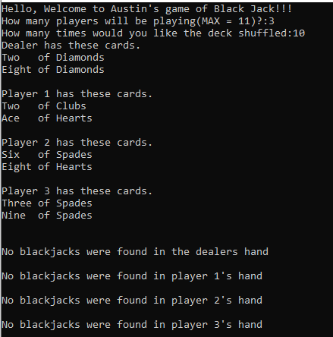

Determining aceValue = 11 (input = 1)

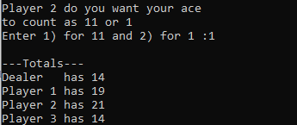

Determining hit or Stand - Hit (input = 1)

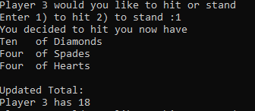

Endgame output

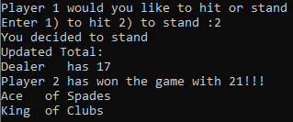

Flowchart examples

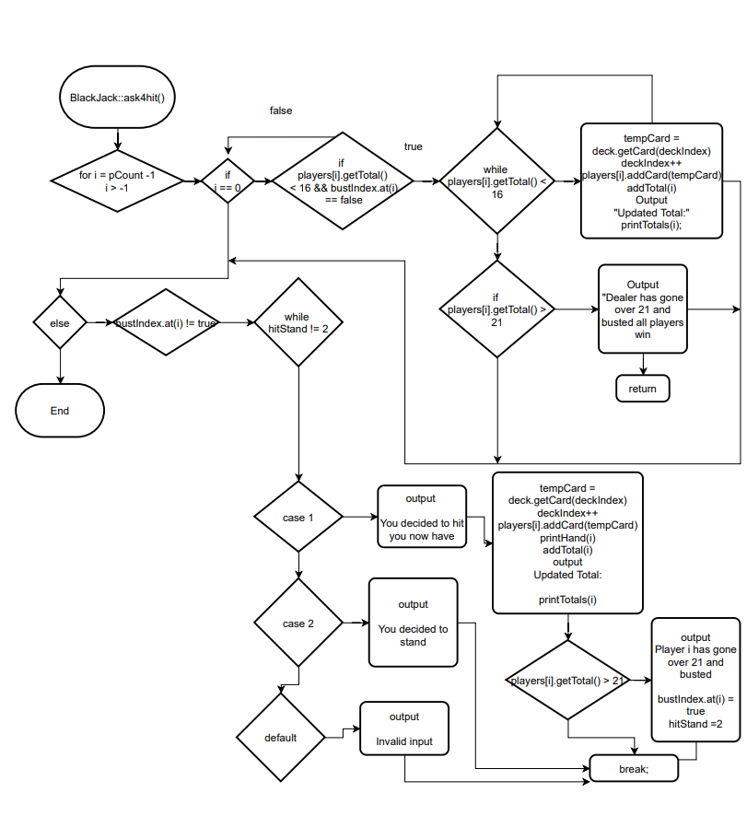

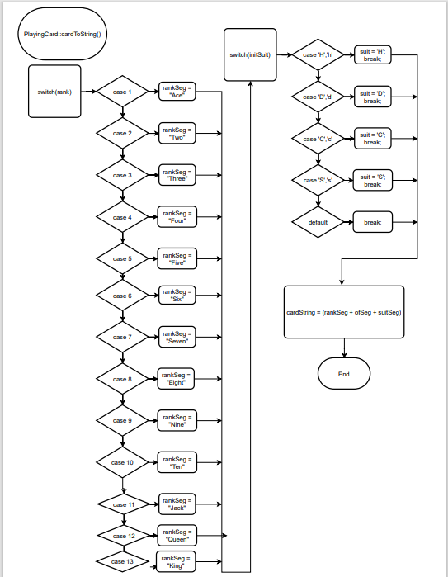

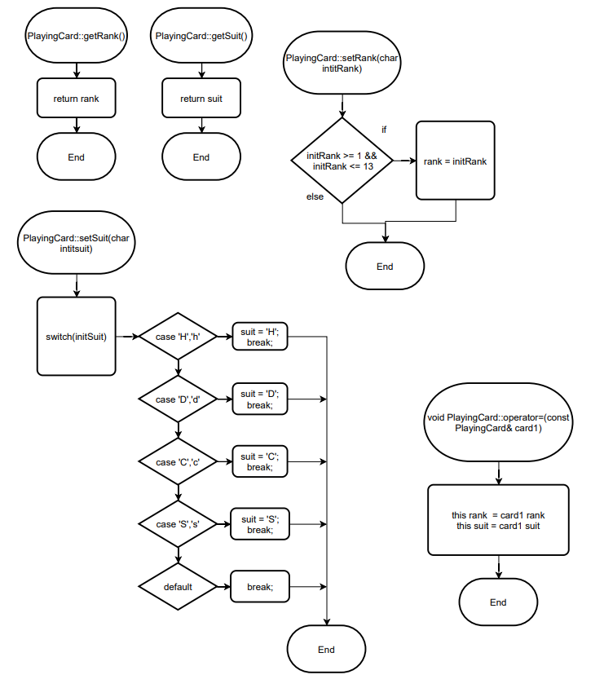

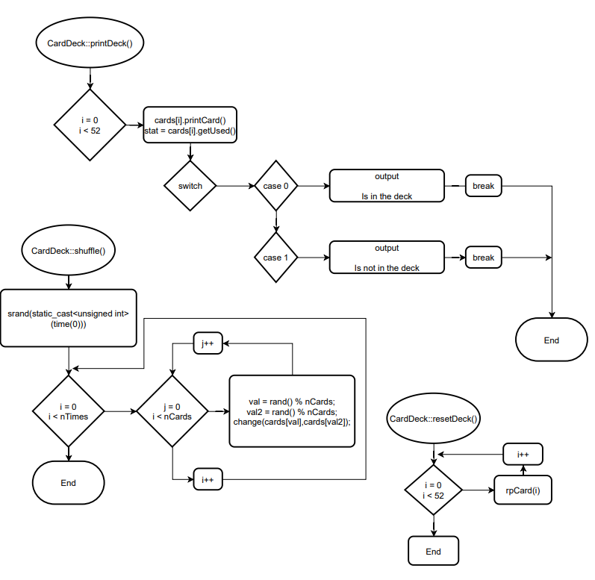

Program Code

