The Sixth Mass Extinction Event and Earth System Sphere Interactions

Amelia Wear

Virginia Earth System Science Scholars

Abstract

Mass extinction events are indicative of major environmental issues, and although all five mass extinction events in the past have been a result of natural processes, the current sixth mass extinction event that is thought to be underway is a direct result of human interactions and development. Multiple events around the globe are persuading scientists to support this theory, including the rise in sea levels, the loss of environmental habitats, and the rise in global temperatures. Current NASA missions such as Landsat are studying the effects of humans on the environment in an effort to be better prepared for when the pressures of a growing population are too much for the Earth to sustain.

The Sixth Mass Extinction Event and Earth System Sphere Interactions

Mass extinctions, in general, are periods of time when the rate at which life goes extinct is extremely high. Some scientists today are convinced that a mass extinction is currently underway, and there is increasing evidence to support it. The existence of a current mass extinction event would signal the beginning of a very detrimental era in recent human history.

**Mass Extinction**

A mass extinction event is generally defined as when at least half of all of the Earth’s species go extinct within a geologically short period of time ("Mass Extinction," n.d.). It is generally agreed upon by scientists that there have been five of such events in the Earth’s past: the Ordovician or Silurian, Devonian, Permian, Triassic, and Cretaceous in chronological order (*Module 8 Final*, n.d.). The causes of these events are still being theorized about, yet there has been some consensus among the scientific community. The Ordovician, which occurred approximately 440 million years ago (MYA), was likely caused by a short and intense ice age ("Earth's Major," 2017). Marine life was the most heavily impacted due to this event (*Module 8 Final*, n.d.). The Devonian, around 364 MYA, was thought to be mainly caused by oceanic oxygen concentration depletion as a result of a peak in algal blooms (*Module 8 Final*, n.d.). The Permian, the largest mass extinction event of the five, occurred about 251 MYA and was likely caused by large amounts of volcanic activity; it caused the extinction of approximately 95% of all species including a large number of insects, which has been more resilient than other forms of life during other extinction events ("Earth's Major," 2017). The cause of the Triassic mass extinction event, occurring about 200 MYA, is debated between high volcanic activity and a meteorite event ("Earth's Major," 2017). Finally, the Cretaceous, which happened approximately 65 MYA, was either caused by volcanic activity, a massive meteorite strike, or gradual climate change, for the primary cause is still being debated (*Module 8 Final*, n.d.).

**The Devonian Mass Extinction Event**

The causes of the Devonian mass extinction event are still debated, although there are several theoretical causes. Although the main cause is yet to be determined, a rise in algal blooms which depleted the ocean’s oxygen levels, called The Devonian Plant Hypothesis, is thought to be a leading cause of the mass extinction event (Murphy, 2005). However, there were multiple interactions among the four Earth system spheres that could have contributed to the mass extinction. The biosphere was the source of the Devonian Plant Hypotheses- the increase of land-dwelling plants actually impacted the lithosphere with their deeply penetrating root systems; with the soil sufficiently broken up, the nutrients they held were washed into the hydrosphere at an unprecedented rate (Baraniuk, 2015). Then again, the biosphere furthered the extinction event: the nutrients provided food for microorganisms such as algae, which, when in sufficient concentration and quantity, caused mass anoxia, the lack of dissolved oxygen, in the oceans (House, n.d.).

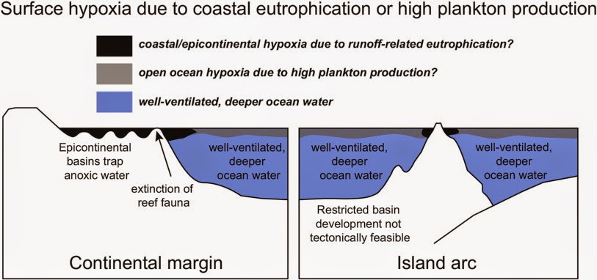

This anoxia virtually suffocated oceanic creatures that needed the oxygen to survive, severely impacting life in the tropical oceans (Murphy, 2005). However, the atmosphere could have also influenced how species survived without sufficient oxygen, since surface level water received some oxygen by mixing with the air above it; this could account for the fact that some species did not go extinct as a result of the anoxia (Baraniuk, 2015). Therefore, in the first phase of the Devonian mass extinction event, all four spheres interacted to produce the oceanic anoxia: the biosphere broke up the lithospheric, nutrient-rich topsoil, which was washed into the oceans by rain in the hydrosphere, where organisms changed gaseous, therefore an extension of the atmosphere, concentrations which resulted in the mass extinction.

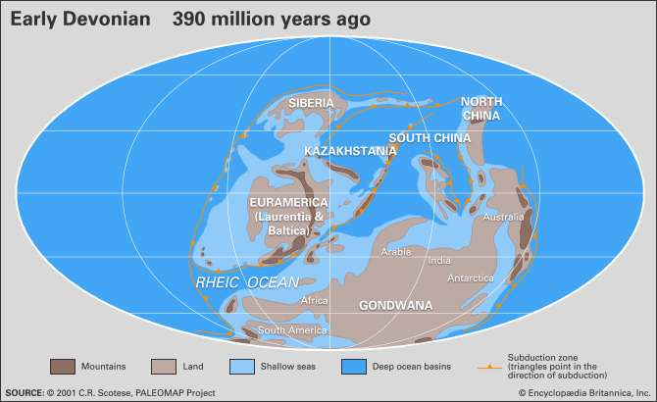 Moreover, the lithosphere had much to do with the concentration of nutrients which washed into the hydrosphere. Nutrient-rich soil, such as in black shales, was found mainly in the area of what was to become North America and Eurasia, causing higher oceanic nutrient concentrations off the coasts of those areas (Murphy, 2005). Furthermore, mountain-building events such as the creation of the Appalachian Mountains in Northern America, increased runoff into bodies of water, thereby increasing nutrient concentrations and extinction rates (Baraniuk, 2015). However, the anoxia in bodies of water was not the only event leading towards mass extinction. For instance, the rise in land-borne plants caused an increase in the formation of soil (pedogenesis), which in turn increased the rate of the weathering of silicates; this process ultimately removes CO2 from the atmosphere (Murphy, 2005). Coupled with the significant increase of plant populations, whose photosynthesis also takes CO2 out of the atmosphere, the warming effect of this greenhouse gas was substantially deteriorated, causing the rapid cooling of the Earth and its atmosphere, resulting an intense period of glaciation and the lowering of sea levels (Murphy, 2005). Other events such as volcanic activity and asteroid impact also had an affect on the extinction rates of the Devonian period, however, these events are seen as only contributing factors to the overall pressures of the extinction period (*Module 8 Final*, n.d.)

Overall, the Devonian mass extinction event was caused by, and resulted in, multiple rapid changes in all four spheres. A combination of increased plant life, lithospheric nutrient concentrations in the hydrosphere, and atmospheric temperature changes, caused a conglomeration of the multiple factors which led to the extinction of so many marine species.

**Recent Extinction Events and the Sixth Mass Extinction**

The scientific community is currently trending towards the recognition of a new mass extinction event- the sixth in the known history of the Earth. Multiple factors have led scientists to believe that this new wave of increased extinction rates, although the timing of when it began, or will begin, is still up to debate (*Module 8 Final*, n.d.). However, there is evidence that the sixth mass extinction event is currently taking place and that it is being caused by humans. Problems such as a large amount of endangered species, higher sea levels, and lower biodiversity levels are convincing scientists that there is a mass extinction occurring. The main hypothesis cast by scientists who support that there is a sixth mass extinction occurring is that if current trends continue, the sixth mass extinction will have severely detrimental impacts on human and ecological life.

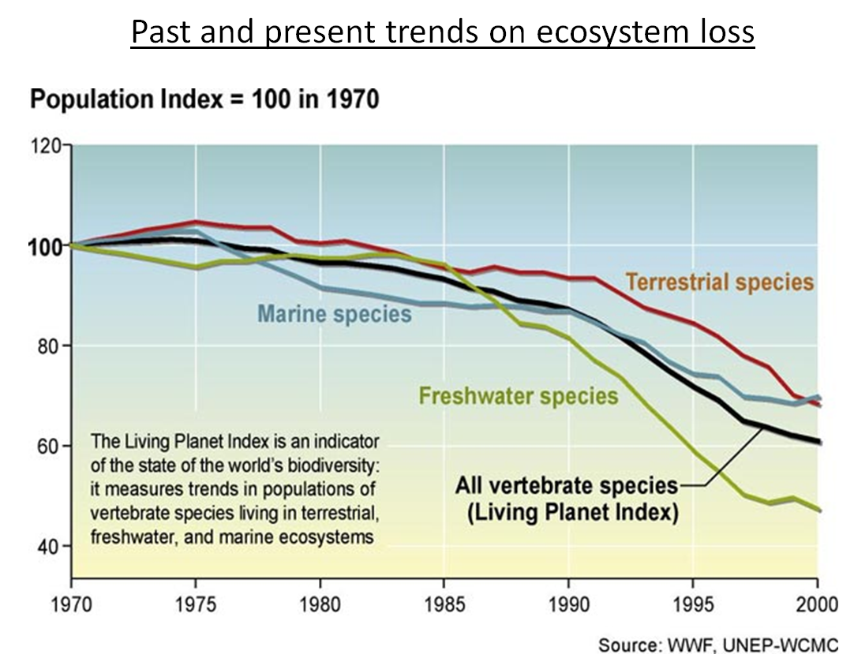

**Sea Level Rise**

Sea level is often used to gauge the overall standings of the environment, as the oceans are interconnected into so many of the vital ecological systems of the Earth. For instance, the Ordovician mass extinction event was most likely caused by a miniature ice age, which locked up sea water in glacial sheets, lowering the sea level, and leaving much of the coastal marine life with a minimal amount of habitable zones ("Earth's Major," 2017). However, since the previous mass extinction events do not report of rising sea levels, as is occurring currently, the causes and effects of ocean level changes are significantly different, but just as concerning. Global warming, mainly a result of human output of carbon dioxide into the atmosphere, is causing not only the ocean water to expand due to the higher temperatures, but it is also causing glacial matter to melt, putting massive amounts of previously locked water into the oceans. The overall effect of these events is that ocean levels are rising at an alarming rate- the average of which predicts that sea levels will rise another three to four feet by the end of the century ("Sea-level Rise," n.d.). Furthermore, some areas, such as sections along the eastern coast of the United States and the Hawaiian Islands, are experiencing sea level rise rates at three times the average global rate ("Sea-level Rise," n.d.). This could mean the catastrophic loss of coastal habitats and wildlife populations. Sea level rise is beneficial in some cases- there will be a higher area of shallow-water habitats, fit for a multitude of marine life. However, there are many downsides to sea level rise as well. The main concern is that coastal areas will be under water with sea level rise, causing wildlife and humans to have to move out of the area; this movement can be severely detrimental to wildlife due to the change in their environment, habitat, and food chain. Sea levels are predicted to rise by as much as six meters within the next 600 years, making a large amount of sea-level land mass submerged and inhospitable for land-dwelling wildlife and humans (Weiss, 2011).

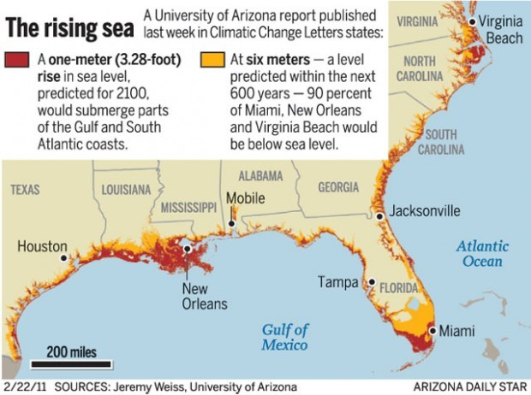

Also a threat to coastal life are increasing storm surges and rising groundwater salinity as a result of the impeding ocean water ("Sea-level Rise," n.d.). Rising storm surge intensity could flood habitats and create inhabitable zones for previously habited areas. Increasing the amount of salt in a certain watershed could also lead to plant communities diminishing as a result, causing a massive and degrading ripple effect up the food chain in that area ("Sea-level Rise," n.d.). One report claims that there are 223 threatened and endangered species, and 17% of federally protected species, in coastal states that are at risk because of sea level rise ("Sea-level Rise," n.d.). Scientists are mostly convinced that sea level rise is a huge problem for humans and wildlife alike, and that this rise is a sign of the impending sixth mass extinction event due to the vast array of issues it causes for life in the present.

**Global Temperature Rise.** Global temperature rise has been mainly attributed to the increase in greenhouse gasses such as carbon dioxide in the Earth’s atmosphere, which trap the energy from the sun, causing global climactic changes. The effects of these changes vary in intensity around the world, but overall, higher temperatures and changing environmental factors mean that sustaining life is becoming more difficult, causing populations to either diminish or find new sources of accommodating habitats. For instance, biomes around the world have been rapidly changing- raising temperatures mean that biomes in the far north are becoming more populated with plants which can now withstand the temperatures in the area; but it also means that biomes which are already within that habitable range are beginning to become too warm, causing the migration of species to more habitable climates.

One well known example of this is how the melting of the arctic glacial sheets are severely impacting polar bear populations as they need the ice for travel and hunting practices ("The Effects," n.d.). Another large debilitating factor for life as a result of rising temperatures is an increase in the length and intensity of droughts in recent years. For instance, the 81% of the United States experienced abnormally dry conditions in 2012 ("The Facts," 2016). Without as much water, plant species are diminishing and animals are migrating out of drought-prone areas, causing major shifts in population sizes and locations. A multitude of species are being affected by climate change. Birds, for example, are extremely affected by climate change: changing temperatures have caused birds to adjust their wintering and stopover habits, which in turn cause changes to their migratory and reproductive cycles ("The Effects," n.d.). Some species of birds in the United States have significantly changed their wintering locations, all trending towards more northern locations as temperatures rise ("TheEffects," n.d.). Such migratory changes and the detrimental effects this causes for bird populations is one of the supporting factors of a current sixth mass extinction event. Furthermore, the change of habitats due to global temperature rise and the massive amount of adaptation that wildlife must accomplish in order to survive as a result, supports the sixth extinction theory.

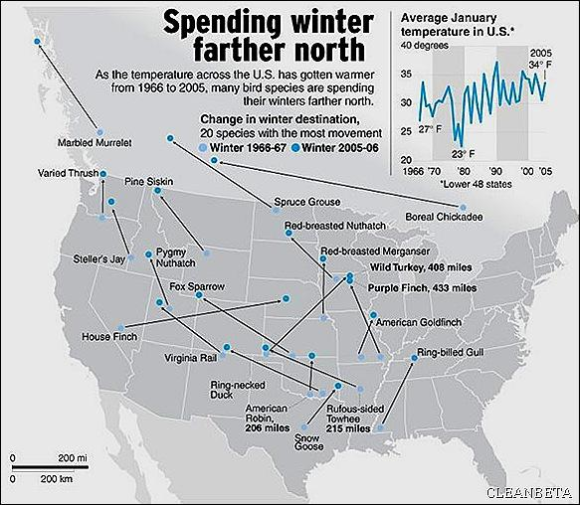

***Loss of Habitat.*** The loss of a species habitat can mean catastrophic effects on the species’ population and survival. There are many factors that are currently contributing to habitat loss, including global warming, drought increases, sea level rise, deforestation, and human development.

Forests house a large amount of the world’s animals, and the health and continuity of those environments are what maintains the continuity of a multitude of wildlife. However, human deforestation has severely impacted global forests, and therefore, the habitats of those creatures.

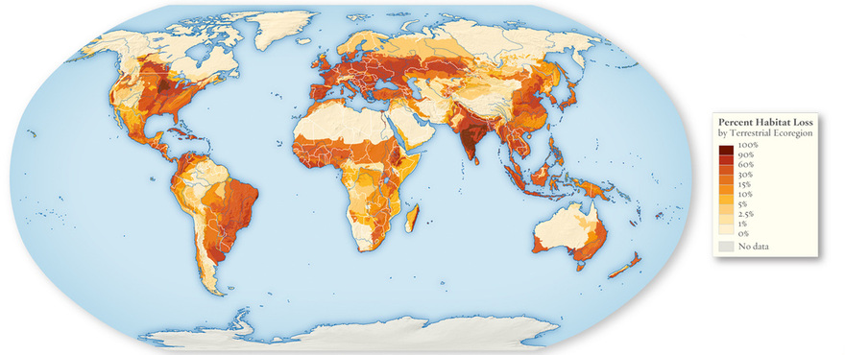

However, when forests are cut down, there are many more widespread and long-lasting effects other than the immediate loss of habitat and food sources. For instance, without large trees, sunlight for lower plants becomes readily available, effectively shifting the plant demographic in the area and changing food availability for the local wildlife. Another unanticipated effect is runoff, which significantly increases for a long time after the trees are cut down due the lack of their root systems. This water then flows into local rivers, streams, and lakes, causing water sedimentation and the alteration of the habitat for aquatic creatures as well. 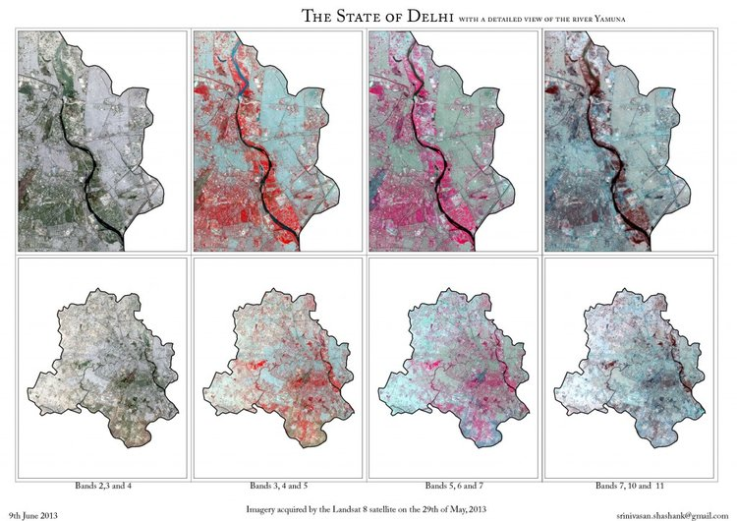 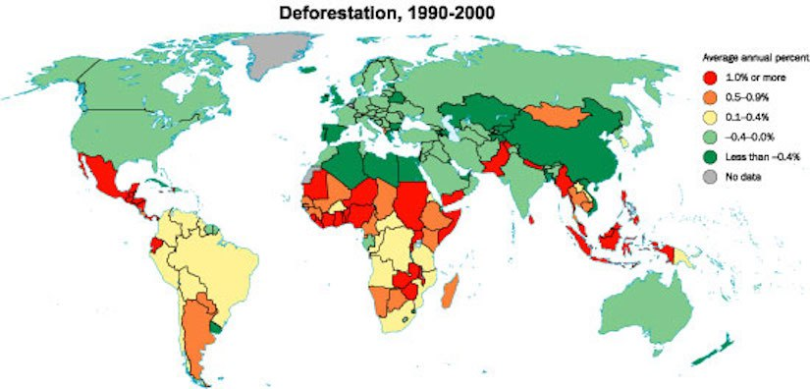

The loss of habitat at the hands of humans have seriously endangered many creatures, and current expansion trends are increasing, meaning that the loss of habitat will only increase in the future if significant reform is not made. Although deforestation is not prominent in most northern-hemisphere countries, in Africa and South America, deforestation is devastating to local wildlife populations, especially in tropical rainforests where deforestation is at a height, but so is the possibility of wildlife loss. Since adequate habitats are necessary for animals to survive, the loss of such habitats is directly linked to the existence of a sixth mass extinction event.

**Conclusion**

Mass extinction events like the five that occurred previously in the history of the Earth are extremely negative events which can have drastic impacts on the environment and the demographics of all life on Earth. The existence of a sixth mass extinction in the present day is extremely problematic since this mass extinction event is directly caused by humans and the expansion thereof. Therefore, it is unknown if the Earth will bounce back from such an extinction event like after the five previous ones, or if the forces of humanity will continue to spiral the Earth’s global ecosystem into extinction. Studying changes in the ecosystem as a result of humans is the only way to fully understand what is necessary to mitigate the effects of a growing population and a diminishing amount of biodiversity.

References

Baraniuk, C. (2015, June 23). The Devonian extinction saw the oceans choke to death. Retrieved April 8, 2018, from http://www.bbc.com/earth/story/20150624-the-day-the-oceans-died

Denayer, W. (2016, September 13). The demise of the great apes. Growth, GDP, capitalism, causes. Retrieved April 8, 2018, from http://www.flassbeck-economics.com/the-demise-of-the-great-apes-growth-gdp-capitalism-causes/

*Early Devonian* [Image]. (n.d.). Retrieved from https://www.britannica.com/science/Devonian-Period

Earth's major 'mass extinction' events. (2017, July 11). Retrieved April 8, 2018, from https://phys.org/news/2017-07-earth-major-mass-extinction-events.html

The effects of climate change on animal species. (n.d.). Retrieved from http://kanat.jsc.vsc.edu/student/swift/mainpage.htm

The facts about climate change and drought. (2016, June 15). Retrieved April 15, 2018, from https://www.climaterealityproject.org/blog/facts-about-climate-change-and-drought

[Home page]. (n.d.). Retrieved April 8, 2018, from IB DP Geography website: http://www.ibgeographypods.org/b-consequences-of-global-climate-change.html

House, M. R. (n.d.). Devonian extinctions. In *Encyclopaedia britannica*. Retrieved April 8, 2018, from https://www.britannica.com/science/Devonian-extinctions

Introducing: Habitat loss. (n.d.). Retrieved April 8, 2018, from http://habitatlossfragmentation.weebly.com/habitat-loss.html

LANDSAT. (n.d.). Retrieved April 15, 2018, from https://www.nasa.gov/mission_pages/landsat/main/index.html#.VPc9D0ggXNt

Landsat 8. (n.d.). Retrieved April 15, 2018, from https://landsat.gsfc.nasa.gov/landsat-data-continuity-mission/

Mass Extinction. (n.d.). Retrieved April 8, 2018, from https://www.amnh.org/exhibitions/dinosaurs-ancient-fossils-new-discoveries/extinction/mass-extinction/

Mass extinctions. (n.d.). Retrieved April 8, 2018, from https://www.nationalgeographic.com/science/prehistoric-world/mass-extinction/

*Module 8 final project*. (n.d.). Retrieved April 8, 2018, from https://vsgc.spacegrant.org/course/mod/assign/view.php?id=5357

Murphy, D. C. (2005, July 9). Late Devonian mass extinctions. Retrieved April 8, 2018, from http://www.devoniantimes.org/opportunity/massExtinction.html

Sea-level rise. (n.d.). Retrieved April 8, 2018, from http://www.biologicaldiversity.org/campaigns/sea-level_rise/index.html

*Species extinctions since 1800* [Image]. (n.d.). Retrieved from http://hugourearth.com/Species_Extinction.html

*Surface hypoxia due to coastal eutrophication or high plankton production* [Illustration]. (n.d.). Retrieved from http://thedragonstales.blogspot.com/2015/04/detection-of-devonian-hangenberg-event.html

Van Cotthem, W. (n.d.). Deforestation and desertification. Retrieved April 8, 2018, from https://desertification.wordpress.com/2017/03/05/deforestation-and-desertification/

Weiss, J. (2011, February 22). *The rising sea* [Image]. Retrieved from http://tucson.com/news/science/environment/ua-climate-research-big-stretch-of-us-coast-at-risk/article_b09c5564-4c90-57c2-8566-145b28b368dc.html

**LANDSAT 8**

* **Science Goals**- The science goals of the Landsat missions, and specifically for Landsat 8 are to provide continuous images of the Earth’s land surface over time to advance understanding of how humans are impacting the environment and to monitor resources, urban development, and the general state of the Earth’s systems and spheres. Landsat 8 has an Operational Land Imager (OLI) and a Thermal Infrared Sensor (TIRS) which seasonally gather data across the world with a spatial resolution of 30 meters (visible, NIR, SWIR), 15 meters (panchromatic), and 100 meters (thermal);
* **What are you measuring and why-** Landsat 8 is measuring the amount of emitted energy from the face of the Earth in all of the major wavelength groupings. Landsat also records, some infrared and blue, red, and green light so as to create images of the surface of the Earth which are then used to study habitat loss, glacial melting, and other visible phenomenon. These data points are being collected to understand how humans impact the environment and to monitor environmental changes ("Landsat 8," n.d.).  “Landsat data have been used to monitor water quality, glacier recession, sea ice movement, invasive species encroachment, coral reef health, land use change, deforestation rates and population growth” ("Landsat 8," n.d.).  The images gathered by Landsat 8 will also help with damage assessment of natural disasters and with disaster prevention plans ("Landsat 8," n.d.).
* **Mission Justification-** The gathering of a continuous body of surface images provides an unprecedented data body which can be used to not only monitor current environmental situations, but also for tracking changes over time and how the expansion of humans is impacting the environment. Therefore, as the Earth’s population expands, Landsat data will assist in planning and decision-making for a larger, and possibly overwhelming, population in the future.
* **Main Objective**- Landsat 8 is important because of how humans are expanding at an unprecedented rate, and the Earth is continuously being put under stress in order to support such a large population. The data collected on land coverage will show how the expansion of human development and agriculture are negatively affecting the environment. Landsat has been witnessing large amounts of development across the world, supporting the opinion that the Earth is in the midst of a sixth mass extinction.
* **Impact**-
  + Resources- The increasing use of resources by the increasing population across the globe is a concern that will only grow in the future. Data from Landsat 8 will assist in planning resource allocation and monitoring food supplies, water, and how humans can optimize our interactions with the environment.
  + Economy- Landsat 8 not only assists the managing and optimizing agricultural and energy practices around the world, it provides data for well-informed decisions regarding natural disasters, ecosystems, and urban development. Thus, Landsat 8 data will provide invaluable data for optimizing the future economy.
  + How does the event affect other spheres- Since Landsat 8 takes measurements of the entire Earth during every season of the year, Landsat 8 studies every sphere.