CS490 – Networking

Andrew West

Tomasz Klejmont

**User Documentation**

Open the source files in your preferred IDE.

Run the DirectoryServer.java file, and select the preferable option for slow mode. The server should be up and running now and ready to accept incoming requests.

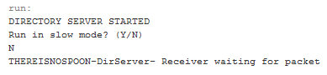

Now run the Client.java file. You’ll be prompted with the option to run in slow mode, followed by selecting the directory path that contains your sharable content and will also serve as the download directory. Then you’ll have to provide your IP and the directory server IP to establish a connection.

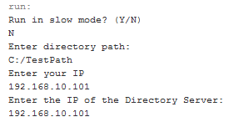

After that you should be greeted with a menu of available options for interacting with the Directory Server.

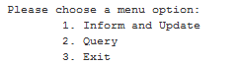

The P2P interaction is initiated after a successful Query. Upon receiving a directory listing or a response to a specific file search you’ll have the option to connect to a peer and choose whatever you’d like to download.

