Team Number: 9 Date: 2/5/2016

Lab Exercise: HTML

Lab Objectives

You will practice how to:
- Write HTML pages;
- Manipulate HTML tags;
- Traverse HTML document in Javascript;
- Use CSS

Description of the Problem

- [10 points] Moving the time display from the about.html to the top-right corner of the top-navigation bar.
- [20 points] Use the content of the file Web-Syllabus.pdf to create an HTML web page named syllabus.html. Load it into a web browser and make sure it can be displayed correctly.
- [10 points] Use a css file for syllabus.html such that the styles of the web page look similar to the pdf file.
- [10 points] Server-side scripting: Modify your server code so that it can send syllabus.html to clients’ upon user requests from a web browser.
  - Inside this lab report, paste a screenshot of the web browser with the beginning part of syllabus.html displayed.
- [30 points] Client-side scripting: upon syllabus.html loaded (use the window.onload property), use JavaScript to dynamically generate a “table of contents” node and insert it in the beginning of the page display. Your code should work for any document, not just the syllabus provided. The screenshot below shows the expected display.

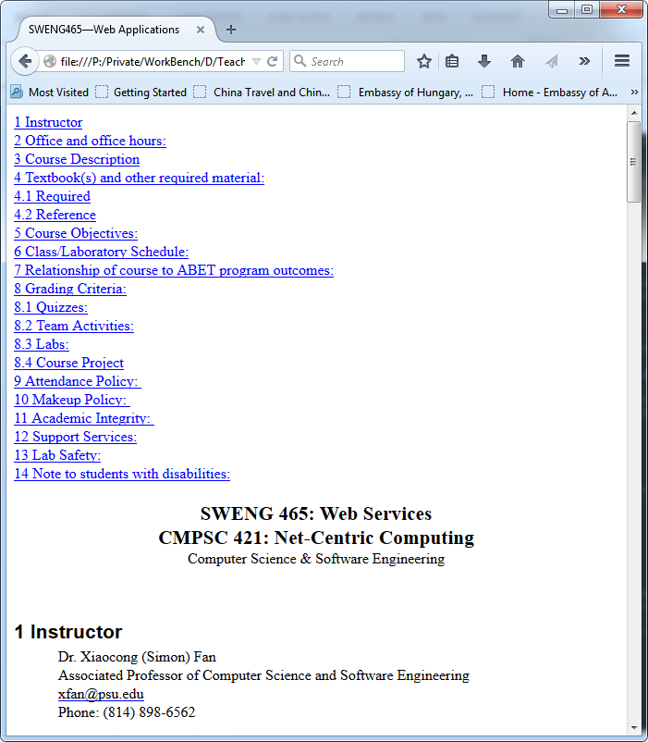

  - Inside this lab report, paste a screenshot of the web browser with the content part of syllabus.html displayed.
- [20 points] Self-learning credits: Click any link in the table of content, the corresponding part of the page should be the focus of display.

Lab Submission:
- Provide individual performance in the table below (performance factor is a real number between 0.0 and 1.0, individual grade is lab grade times his/her performance factor)
Student Name | Performance factor
Name 1
Name 2
Name 3
Add more rows if needed

- After pasting the 2 screenshots inside this lab report, save it to a PDF file with the name CSSE-WEB-Lab-3-Team-X.pdf, where X is your team number;
- Submit to Angel->Labs->Lab1 -> Submissions. Your submission should be one zip file with the name CSSE-WEB-Lab-3-Team-X.zip (where X is your team number) that includes:
  - CSSE-WEB-Lab-3-Team-X.pdf;
  - The Website folder, excluding the sub-folder node_modules generated by npm;

