**Index**

|  |  |  |
| --- | --- | --- |
| **Sr.no** | **Content** | **Page no.** |
| 1. | Brief introduction | **1** |
|  | Aim of microproject | **1** |
|  | Resources required | **1** |
|  | Action plan | **2** |
| 2. | Brief description | **3** |
|  | Aim of microproject | **3** |
|  | Course outcomes | **4** |
|  | Actual procedure followed | **4** |
|  | Actual resources used | **8** |
|  | Learning outcomes | **9** |
|  | References | **9** |

**Annexure: I**

**Mobile Technology is Hazardous Impact on Environment or**

**Health**

* **Brief introduction :-**

Mobile phones are universally popular due to their convenience. Mobile phones solve problems such as interacting with the people, transfer of data through offering new channels of communication by using a device small enough to fit into one hand. On the other hand, mobile phones may be harmful to the environment and health, and waste disposal issues may be associated with its discharge of radiation. Concerns have been raised recently about the sustainability of mobile phones and its effects on people’s health and the environment. The present study discusses the adverse effects associated in using mobile phones, and addresses sustainable perspectives to overcome the same.

* **Aim of project :**

1. Do not release dangerous toxins into our air and water when burned or deposited in landfills improperly.
2. Use less component used in mobiles which are less effect on environment.
3. Now a digital world, but use less work of mobile so to prevent form diseases.

* **Resources required :-**

|  |  |  |  |  |
| --- | --- | --- | --- | --- |
| **Sr.no** | **Name of resources** | **Specification** | **Qty** | **Remark** |
|  | Computer system | Computer i3  Ram 2GB | 1 | Ok |
|  | Website | Google | 1 | Ok |
|  | Environment studies | Book | 1 | Ok |

Page no:1

* **Action plan :-**

|  |  |  |  |  |
| --- | --- | --- | --- | --- |
| **Sr.no** | **Detail of activity** | **Planned start date** | **Planned finished date** | **Name of students** |
| 1. | Raw data | 06-01-2020  1:00 to 3:00 | 13-01-2020  1:00 to 3:00 |  |
| 2. | Design | 20-01-2020  1:00 to 3:00 | 27-01-2020  1:00 to 3:00 | Awad Deepak |
| 3. | Prepare coding | 03-02-2020  1:00 to 3:00 | 10-02-2020  1:00 to 3:00 | Lokre Rohit |
| 4. | Testing of project | 17-02-2020  1:00 to 3:00 | 24-02-2020  1:00 to 3:00 | Karke Irnath |
| 5. | Display output | 02-03-2020  1:00 to 3:00 | 09-03-2020  1:00 to 3:00 |  |
| 6. | Prepare report | 16-03-2020  1:00 to 3:00 | 23-03-2020  1:00 to 3:00 |  |

* **Name of team member :-**

1. Awad Deepak Fulchand.
2. Lokre Rohit Hanmant.
3. Karke Irnath siddheshwar.

Page no:2

**Annexure: II**

**Mobile Technology is Hazardous Impact on Environment or Health**

* **Brief description :-**

Mobile phones have become an intrinsic part of most people’s lives, connecting them with other people around the world. A mobile phone has several advantages, enabling communication with family, friends, and business wherever a signal is available. In addition, the 3G telephone enables users to access data; listen to music; play games; send and receive simple text messages known as short message service (SMS); access multimedia messaging services (MMS), voice, and video, as well as internet access through wireless application protocol (WAP). Even though mobile phones have several advantages, there are also significant disadvantages associated with its use. Chemical substances from mobile phones such as arsenic, lithium, cadmium, copper, lead, mercury and zinc are considered toxic.  When mobiles are discarded, these toxic substances may be released or exposed from decomposing waste in landfills, contaminate the soil and seep into groundwater. Plastics are the leading chemical substance found in mobile phones followed by other miniature materials. Metals build-up in the soil, which can enter the food chain, and in sufficient concentrations may cause health problems. Using mobile phones can harm the brain, and excessive use of mobile phones has been associated with dizziness. The radiations emitted from the phone are also harmful for the eardrum. World Health Organization (WHO, 2013) said that exposure to the radiofrequency (RF) fields emitted by mobile phones are generally 1000 times more than that emitted from base stations, and noted that research had almost exclusively conducted on the possible effects of mobile phones, such as electromagnetic interference, road traffic accidents, cancer and other health-related effects.

* **Aim of project :-**

1. Do not release dangerous toxins into our air and water when burned or deposited in landfills improperly.
2. Use less component used in mobiles which are less effect on environment.
3. Now a digital world, but use less work of mobile so to prevent form diseases.

Page no:3

* **Course outcomes :-**

1. Develop public awareness about environment.
2. Develop the concept of 4R.

* **Actual procedure followed :-**

Mobile phones solve problems such as interacting with the people, transfer of data through offering new channels of communication by using a device small enough to fit into one hand.  On the other hand, mobile phones may be harmful to the environment and health, and waste disposal issues may be associated with its discharge of radiation.

* **Energy Consumption :-**

The production of new mobile phones contribute to the climate change by exhausting energy and virgin materials in processes, thereby releasing greenhouse gases into the atmosphere. The United Nations Environment Programme (Kick the Habit, 2008) estimated that the manufacture of a mobile phone produces about 60 kg of CO2eand using a mobile phone for a year produces about 122 kg of CO2e. he main impact associated with day to day mobile phone use is the power used during the charging process, and the charger represents about 7% of the life-time energy consumption of a typical mobile phone (Nokia, 2006). Most consumers are not aware of the effect of mobile phones on CO2production and its emissions are expected to raise 55 million metric tons due to the increase in mobile communications by 2020.

* **Environment Risks:-**

Mobile or Cell phones are fabricated with heavy metals such as cadmium, lead, lithium, mercury and brominated flame retardants, which are used in the parts of printed circuit board (PCB), liquid crystal display (LCD), keypad, plastic casing, batteries and chargers. These substances cause severe environmental collision due to their levels of toxicity. Replacing the handsets every year, as new models become available every year, creates an unnecessary carbon footprint and hazardous waste. Mobile recycled wastes led to contamination of the soil, water, fish, and wildlife. For example, the leakage of cadmium in the battery from a single phone could contaminate 600,000 liters of water.

Page no:4

Semiprecious metals like copper is extracted when mobile phones are recycled casually, leading to the discharge of toxicants into groundwater below and the air above when mercury makes its way into water it is transformed into methylated mercury and eventually ends up in food causing brain damage. Lithium has a high degree of chemical activity which by itself can pollute the water when exposed (Clean Up Mobile Phones).

* **Health Risks:-**

Mobile phones emit radiofrequency energy, a form of non-ionizing electromagnetic radiation, which can be absorbed by tissues close to the phone. The amount of radiofrequency energy a mobile phone user is exposed depend on many factors as the technology of the phone, the distance between the phone and the user, the extent and type of mobile phone use and the user’s distance from cell phone towers. In 2011, International Agency for Research on Cancer (IARC) classified mobile phone radiation possibly carcinogenic, means that there “could be some risk” of carcinogenicity, so additional research into the long-term, heavy use of mobile phones needs to be conducted. While an increased risk of brain tumours from the use of mobile phones is not established, the increasing use of mobile phones and the lack of data for mobile phone use over time periods longer than 15 years warrant further research of mobile phone use and brain cancer risk. Scientists have reported adverse health effects of using mobile phones including changes in brain activity, reaction times, and sleep patterns. Certain neurological symptoms occur due to the frequent use of mobile phones, such as depression, sadness, irritability and headaches, anxiety, loss of memory and lack of sleep. Mobile phone’s electromagnetic radiations and listening to loud music will cause hearing defects. Apart from the health risks of mobile phone’s radiation, this article also brings to light the mobile phones-related road accidents. The use of mobile phones by vehicle drivers and pedestrians will cause road accidents due to their loss of concentration. confirmed that 36% of road accidents are due to the use of mobile phones while driving a vehicle.

* **To reduce the environmental and health risk of mobile phones following criteria is used:-**
* **Designing and manufacturing of mobile phones:-**

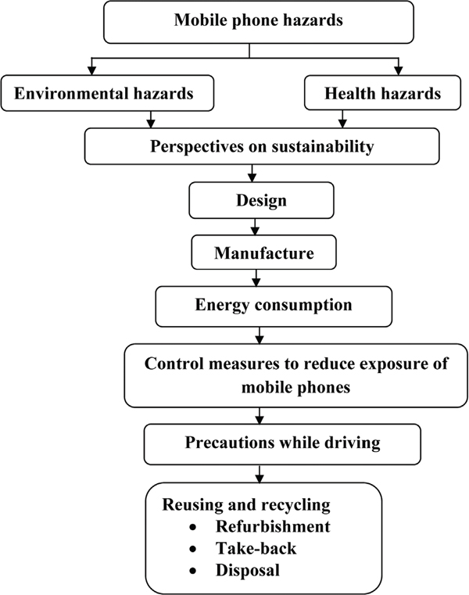

* **Energy consumption:-**

In order to satisfy consumer expectations about talk and standby time, there have been significant improvements in the energy efficiency of mobile phones. Over the last 20 years, the standby operating time of a mobile phone on a single battery charge has increased from around 4 hours to up to 12 days or more, while the size of batteries has been greatly reduced. Industries have also been focusing on reducing the phone’s power consumption during the charging period. However, consumers can also make an important environmental difference by simply switching off the phone and charger whenever possible. Vodafone is a signatory to the GSMA’s industry-wide commitment to introduce a universal charger. This initiative aims to reduce electronic waste by eliminating the need for consumers to replace their charger when they buy a new phone. Vodafone also offered solar-powered charging solutions that can reduce environmental impacts from charging phones and extend access to reliable, renewable-energy supplies in remote areas of emerging markets Nokia (2005) proposed these options for improvements in mobile phones: optimization of life-span; reduction in energy consumption and environment friendly chemicals used during component manufacture; influencing the buying, usage and disposal patterns of consumers; end-of-life, management of disposed mobile phones; reduction of energy consumption of network infrastructure; development of suitable environmental assessment methods; and development of a conducive policy environment

Page no:6

* **Control measures to reduce the exposure of mobile phones:-**

Better Health suggested the following measures to reduce exposure of mobile phones:-

Choosing a mobile phone model that has a low specific absorption rate (SAR), that refers to the amount of radio frequency (RF) radiations absorbed by body tissues. Using a landline phone if one is available. Keeping your mobile phone calls short. Using a hands-free kit. Not carrying your mobile phone close to your body when it is switched on. Turn off your wireless router at night to minimize exposure to radiation. Eat green vegetables and get a good night’s sleep in a dark room to enhance natural repair of DNA that may have been damaged by radiation.

* **Precautions while driving:-**

For avoiding road accidents follow they are:-

During any emergency call, stop the vehicle and then attend the call. Slowed the vehicle down. Choose a time when there was little traffic. Choose a time when the traffic was still or moved slowly.

* **Reduce Reuse and Recycle of mobiles:-**
* Reuse :-

According to the Basel Convention and the Mobile Phone Partnership Initiative (MPPI) guidance document published in November 2006, “Re-use, directly or via repair or refurbishment is usually the preferable option over recycling and disposal from an environmental perspective. Re- use can extend product life and means less environmentally damaging extraction, less energy consumption and less waste. Re-use of second-hand equipment can also often mean a lower price for products, thus increasing accessibility for more people who might not otherwise be able to afford the product”.

* Solution for Reduce:-

Extend the lifespan of your phone. To extend the data storage life – aka keep your phone from slowing down, you can:

Clear out unused apps frequently. Back up your data onto an external source. Clear your cache regularly. Turn your phone off at least once a week. Run an antivirus program. Update your phone’s software. To keep your phone in good shape. To maintain your battery capacity.

Page no:7

* Recycle:-

Mobile phones can be separated into their different components and recycled. For example, the copper, gold, lead, cadmium, silver and nickel; the gold and silver recovered can be made into jewelry. Often the batteries are first separated from the mobile phone and sorted into their various types before reprocessing by specialist recyclers. Nickel cadmium, nickel-metal hydride and lithium ion/polymer batteries have their metals recovered and reused in products such as power tools, saucepans and new batteries. The metals extracted during this process including gold, platinum, palladium and silver are put back into productive use. Phones deemed to be beyond repair or simply too old still have a residual value, and their parts may be reused. Therefore, practical and environmentally responsible methods for the recycling of end-of-life phones have to be developed in conjunction with those for electronic equipment. Groupe Speciale Mobile Association (2012) suggested that phones may be further dismantled and some parts shredded, or processed intact for material and energy recovery. Chargers, accessories and even packaging should be recycled.

* **Conclusion:-**

From the above strategy, sustainable strategies are needed in guiding and developing proactive customer intentions to use mobile phones with minimum risks to health and the environment. While developing awareness among customers in using mobile phones so as to minimize risks, manufacturers should develop safe measures with greenery quotes that would influence customer buying behavior and customer retention of mobiles.

* **Resources required :-**

|  |  |  |  |  |
| --- | --- | --- | --- | --- |
| **Sr.no** | **Name of resources** | **Specification** | **Qty** | **Remark** |
|  | Computer system | Computer i3  Ram 2GB | 1 | Ok |
|  | Website | Google | 1 | Ok |
|  | Environment studies | Book | 1 | Ok |

Page no:8

* **Learning Outcomes:-**
  1. plan a recycling program.
  2. I studied about what is effect on our environment.
  3. I will learn the concept of reuse, recycle and reduce of phone technology.
  4. I will studied that Control measures to reduce the exposure of mobile phones.
* **References:-**

1. [www.google.com](http://www.google.com)
2. [www.Environmentstudies.com](http://www.Environmentstudies.com)
3. [www.books.com](http://www.books.com)

Page no:9