**Index**

|  |  |  |
| --- | --- | --- |
| **Sr.no** | **Content** | **Page no.** |
| 1. | Brief introduction | **1** |
|  | Aim of microproject | **1** |
|  | Resources required | **1** |
|  | Action plan | **2** |
| 2. | Brief description | **3** |
|  | Aim of microproject | **3** |
|  | Course outcomes | **3** |
|  | Actual procedure followed | **4** |
|  | Actual resources used | **10** |
|  | Learning outcomes | **10** |
|  | References | **10** |

**Annexure: I**

**ATM Machine System**

* **Brief introduction :-**

An automated teller machine (ATM) is an electronic banking outlet that allows customers to complete basic transactions without the aid of a branch representative or teller. Anyone with a credit card or debit card can access cash at most ATMs. ATMs are convenient, allowing consumers to perform quick self-service transactions such as deposits, cash withdrawals, bill payments, and transfers between accounts. Fees are commonly charged for cash withdrawals by the bank where the account is located, by the operator of the ATM, or by both. Some or all of these fees can be avoided by using an ATM operated directly by the bank that holds the account.

* **Aim of project :-**

1. It convenient to manage a bank account holder's funds.
2. It allows a person to check account balances, withdraw or deposit money.
3. Access hard cash to Anywhere at any time.

* **Resources required :-**

|  |  |  |  |  |
| --- | --- | --- | --- | --- |
| **Sr.no** | **Name of resources** | **Specification** | **Qty** | **Remark** |
|  | Computer system | Computer i3  Ram 2GB | 1 | Ok |
|  | Website | Google | 1 | Ok |
|  | Python | Book | 1 | Ok |

Page no:1

* **Action plan :-**

|  |  |  |  |  |
| --- | --- | --- | --- | --- |
| **Sr.no** | **Detail of activity** | **Planned start date** | **Planned finished date** | **Name of students** |
| 1. | Raw data | 06-01-2020  1:00 to 3:00 | 13-01-2020  1:00 to 3:00 |  |
| 2. | Design | 20-01-2020  1:00 to 3:00 | 27-01-2020  1:00 to 3:00 | Awad Deepak |
| 3. | Prepare coding | 03-02-2020  1:00 to 3:00 | 10-02-2020  1:00 to 3:00 | Mohite Krushna |
| 4. | Testing of project | 17-02-2020  1:00 to 3:00 | 24-02-2020  1:00 to 3:00 | Karke Irnath |
| 5. | Display output | 02-03-2020  1:00 to 3:00 | 09-03-2020  1:00 to 3:00 | Sourabh Bhalerao |
| 6. | Prepare report | 16-03-2020  1:00 to 3:00 | 23-03-2020  1:00 to 3:00 |  |

* **Name of team member :-**

1. Awad Deepak Fulchand.
2. Karke Irnath Siddheshwar.
3. Bhalerao Sourabh Baliram.
4. Mohite Krushna Vishwanath

Page no:2

**Annexure: II**

**ATM Machine System**

* **Brief description :-**

An automated teller machine (ATM) is an electronic banking outlet that allows customers to complete basic transactions without the aid of a branch representative or teller. Anyone with a credit card or debit card can access cash at most ATMs. ATMs are convenient, allowing consumers to perform quick self-service transactions such as deposits, cash withdrawals, bill payments, and transfers between accounts. Fees are commonly charged for cash withdrawals by the bank where the account is located, by the operator of the ATM, or by both. Some or all of these fees can be avoided by using an ATM operated directly by the bank that holds the account.

* **Aim of project :-**

1. It convenient to manage a bank account holder's funds.
2. It allows a person to check account balances, withdraw or deposit money.
3. Access hard cash to Anywhere at any time.

* **Course outcomes :-**

1. Display message on screen using python script or IDE.
2. Develop a python program to demonstrate the use of operators.
3. Handle Exceptions.

Page no:3

* **Actual procedure followed :-**
* **Code:-**

import time

print("Enter your Atm Card")

time.sleep(10)

print(“Card Inserted successfully”)

password=12345

balance = 5000

Name="Pankaj Jadhav"

Address="Shree Nagar, Latur"

Gender="Male"

Father_Name="Dhiraj Jadhav"

pin = int(input("Enter your Atm pin:"))

if pin==password:

while True:

print("""

1 == Profile

2 == balance

3 == withdrdwal balance

4 == deposit balance

5 == exit

""")

try:

option=int(input("Please enter your choice:"))

except:

print("Enter valid option")

if option==1:

print("========================================")

print("My Profile is:")

print(f"Name:{Name}")

print(f"Father_Name:{Father_Name}")

print(f"Gender:{Gender}")

print(f"Address:{Address}")

print("========================================")

Page no:4

if option==2:

print("========================================")

print(f"Your current balance is {balance}")

print("========================================")

if option==3:

print("========================================")

withdrdwal_amount=int(input("please enter your withdrawl amount"))

print("========================================")

balance=balance-withdrdwal_amount

print(f"{withdrdwal_amount} is debited from your account")

print("========================================")

print(f"your current balance is {balance}")

print("========================================")

if option==4:

print("========================================")

deposit_amount=int(input("please enter your deposit amount:"))

print("========================================")

balance=balance+deposit_amount

print(f"{deposit_amount} is depositd to your account.")

print("========================================")

print(f"your current balance is {balance}")

print("========================================")

if option==5:

break

else:

print("Something Error Check your Atm pin")

Page no:5

* **Output:-**

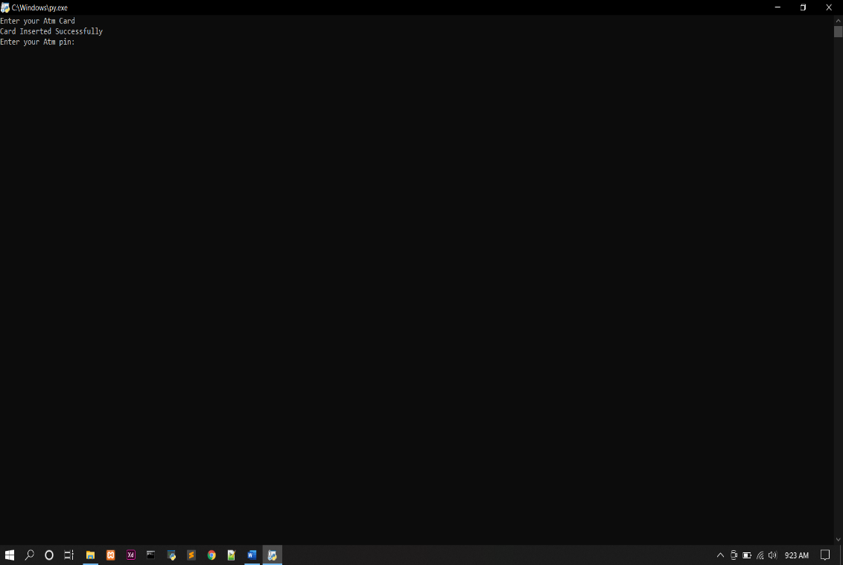

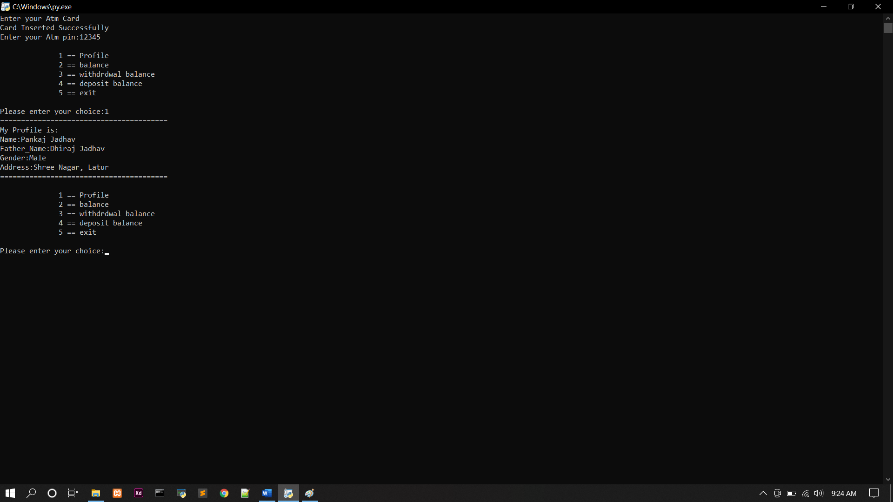

Page no:6

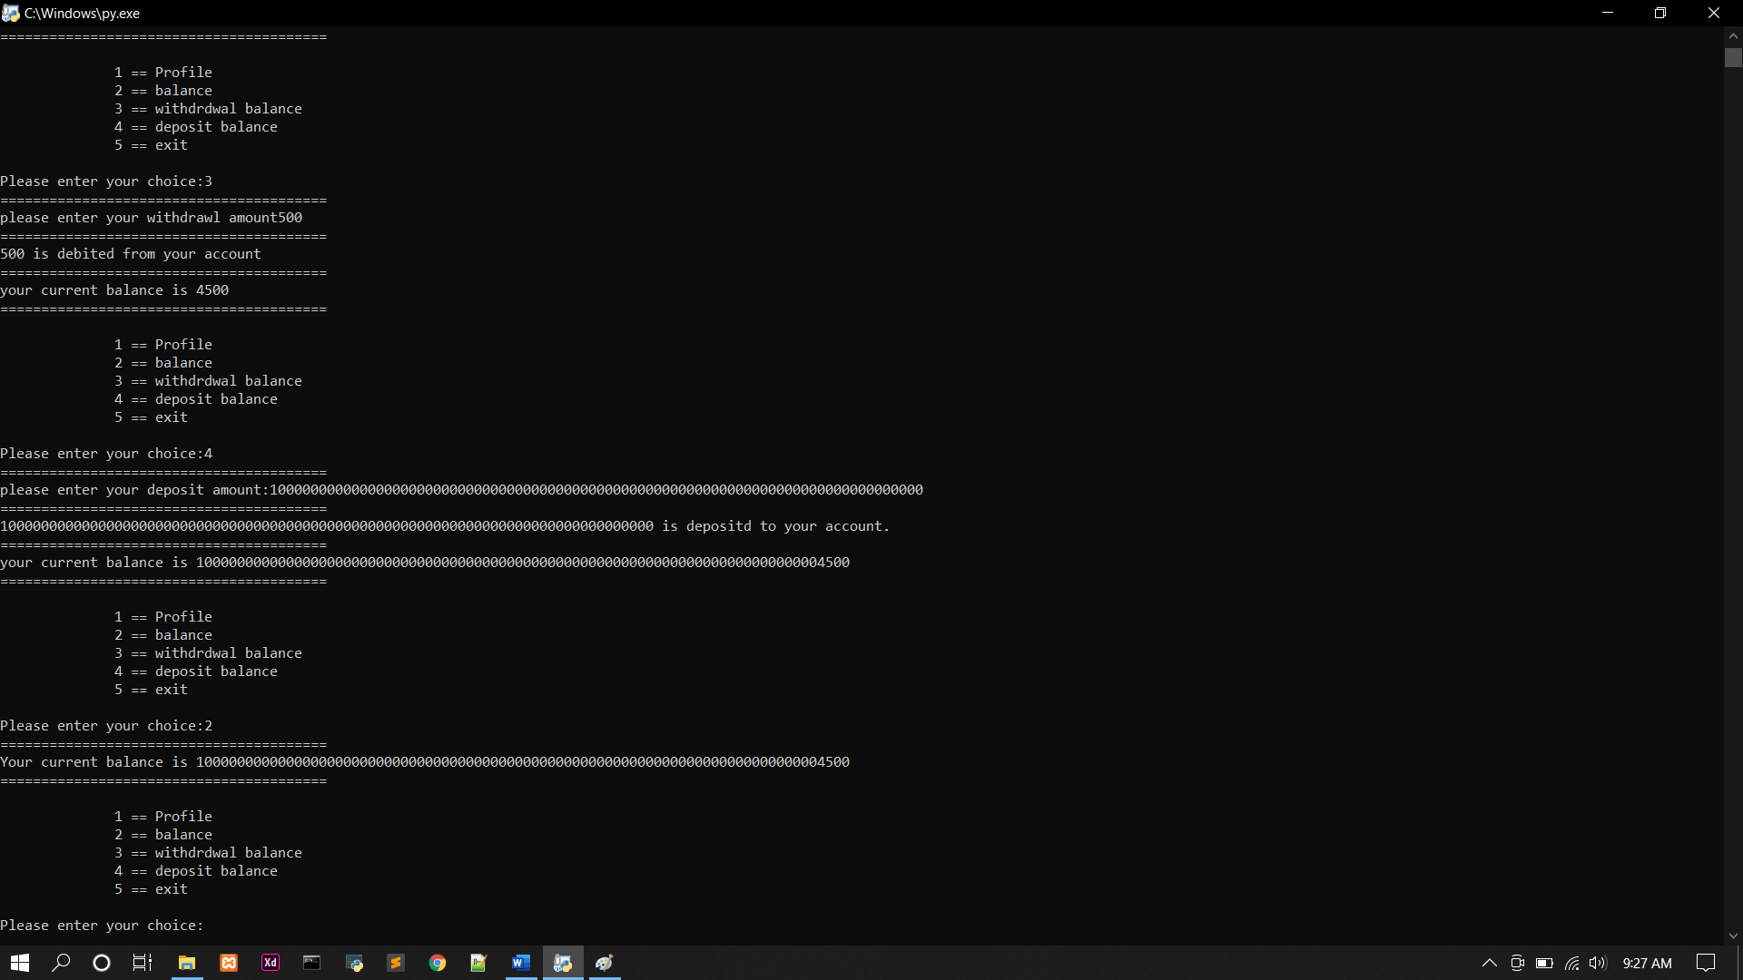

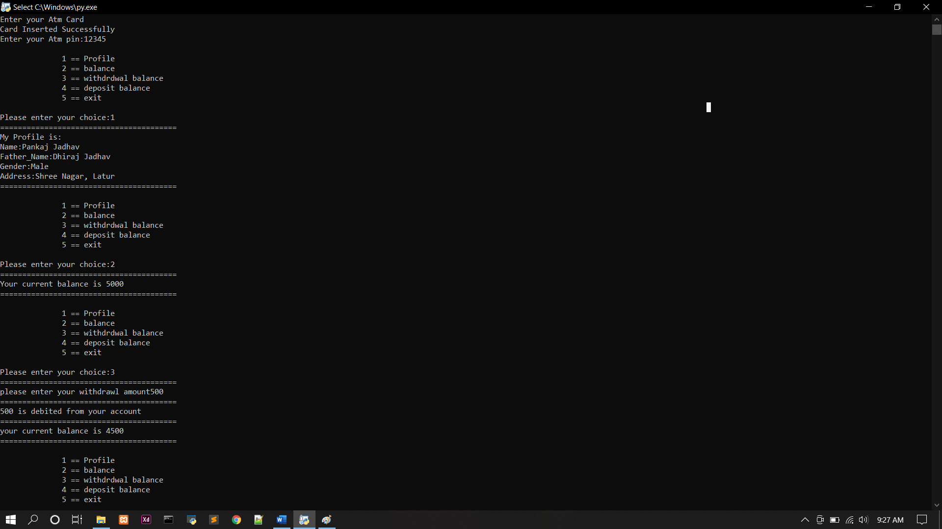

Page no:7

* **Resources required :-**

|  |  |  |  |  |
| --- | --- | --- | --- | --- |
| **Sr.no** | **Name of resources** | **Specification** | **Qty** | **Remark** |
|  | Computer system | Computer i3  Ram 2GB | 1 | Ok |
|  | Website | Google | 1 | Ok |
|  | Python | Book | 1 | Ok |

* **Learning Outcomes:-**
  1. I will learn the concept of deadlock.
  2. I will studied about ATM Machine System
  3. I will learn use of concept used in ATM Machine System.
  4. I will studied that exceptions handling, operators in ATM Machine System.
* **References:-**

1. [www.google.com](http://www.google.com)
2. [www.TutorialsPoint.com](http://www.TutorialsPoint.com)
3. [www.guru99.com](http://www.guru99.com)

Page no:8