# C#

1. Constructor
   1. Constructor Chaining
   2. Private constructor
   3. Copy constructor
   4. Static constructor
   5. Can static constructor have parameter
   6. How to call another constructor from constructor

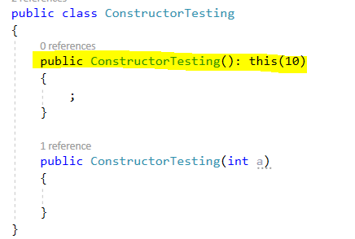

1. Abstract Class
   1. Abstract Class vs Interface
      1. When to use one over another
   2. Can abstract class have constructor – Yes
   3. Can abstract class have static constructor – Yes
   4. Can abstract class constructor have parameter: yes
   5. Can abstract class have static member
2. Garbage Collection
   1. When memory is reclaimed
   2. Generation of Garbage collection
   3. Object memory allocation
3. Thread & Task
4. IEnumerable vs IQuerable
5. Shallow vs Shadow copy vs Deep Copy
6. Method Hiding Vs Overriding
7. Late binding vs Early Binding
8. Read only vs Constant
9. Ref vs out
10. Array vs ArrayList
11. String vs Stringbuilders
12. CTS vs CLS
13. Indexers
14. IComparable
15. Finalize vs Dispose vs Distructor
16. Throw vs Throw ex

# Angular

1. Map vs SwitchMap vs MergeMap
2. Guards in Angular
3. Lifecycle hook of Angular
4. Directives in Angular
5. Pipe – Pure vs Non-pure
6. Routing
7. Router-outlet
8. Interceptor
9. Dependency Injection
10. Bootstrapping
11. Change Detection
12. Observable vs Promise
13. Subject Vs Behaviour Subject Vs Replay Subject Vs Async Subject
14. Template Form vs Reactive Form
15. RxJs
16. Lazy loading
17. Providers vs ViewProviders
18. Angular optimization
19. Angular identifying performance issues