**Digital Design 2**

**Mini Project**

**DEF to SVG**

**By**

**Ahmed Abouzaid 900163141**

**Ahmed Fahmy 900160127**

**Objective:**

* Convert DEF and LEF files to SVG file.
* Create a viewer to display the generated output.
* Support zooming and panning.
* Highlight the DFF and CLK Nets (Added Bonus).

**Dependencies:**

* 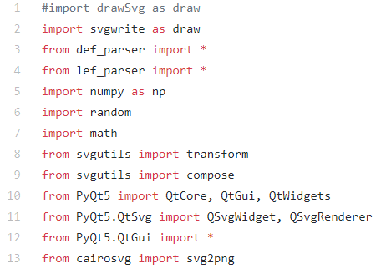To run the program, installing the following libraries is needed:
* 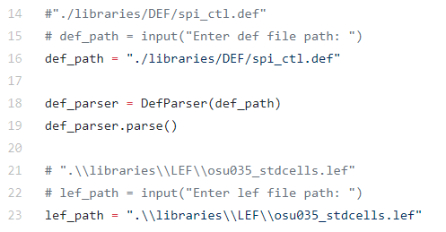DEF and LEF directory file must be provided.

**Implementation:**

* The program firstly calls the parsing function to parse the chosen DEF and LEF files
* The user will be asked whether to highlight the DFF and CLK Nets or not
* 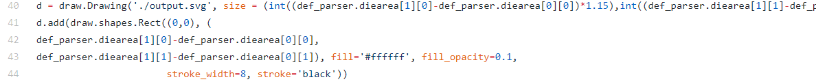The program gets the die area from the LEF file and draw it into the SVG image.
* 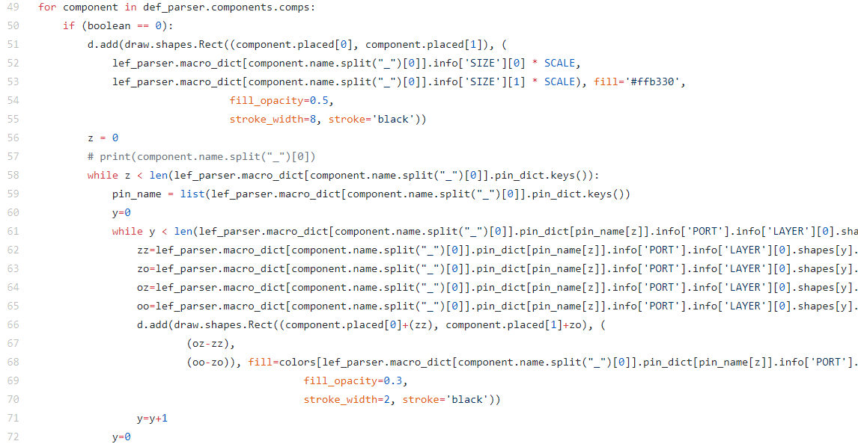The program gets components coordinates and names to draw them on the SVG file
* 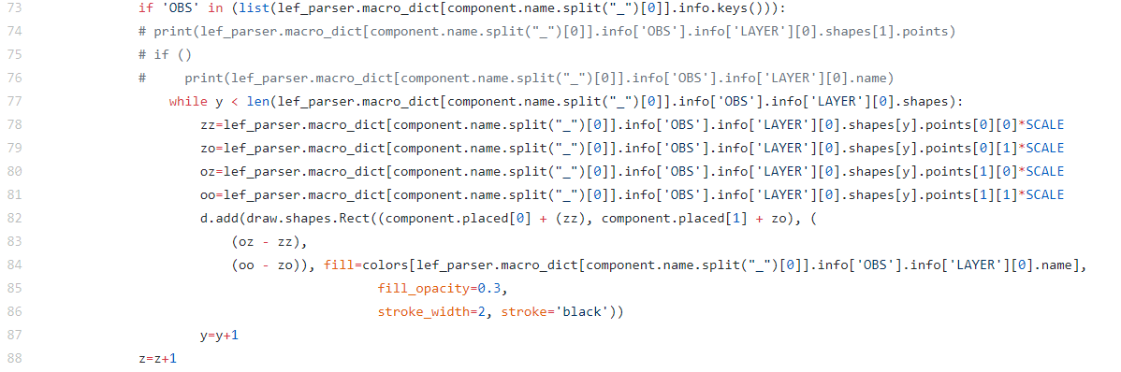The program draws the OBS layers
* 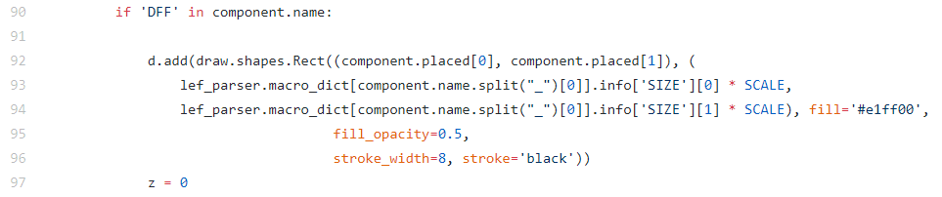The program draws and highlights the DFF
* 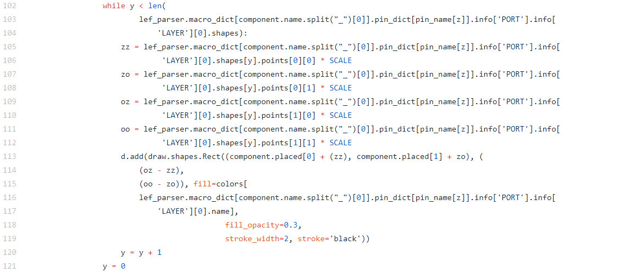The program draws the pins and nets according to their coordinates from the LEF File

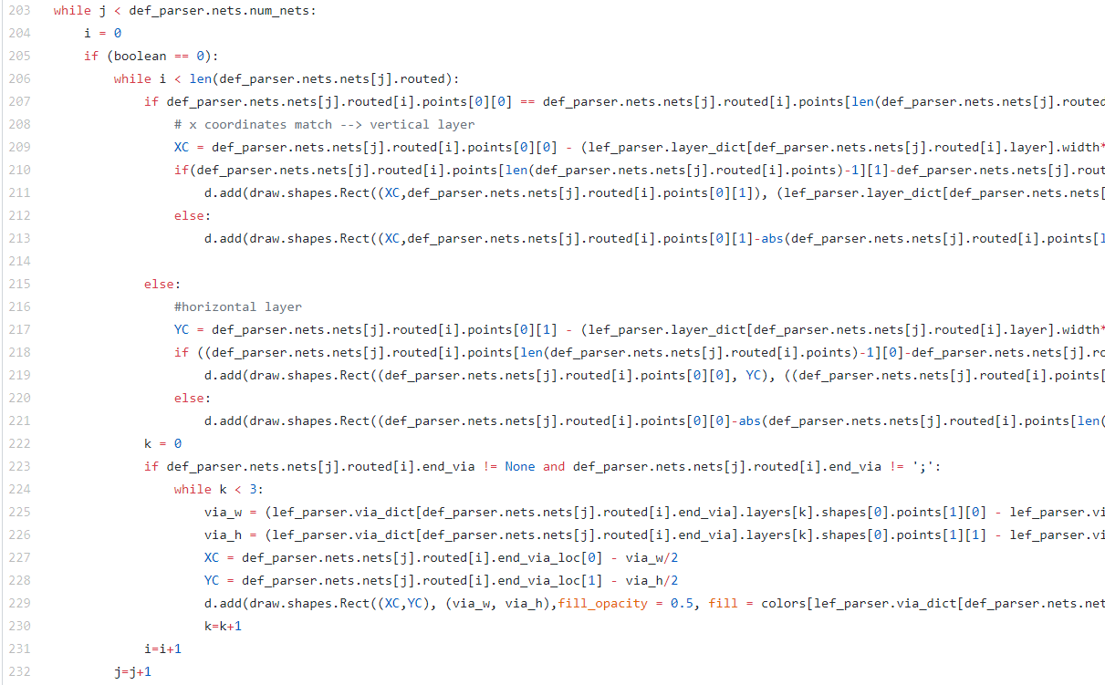

* 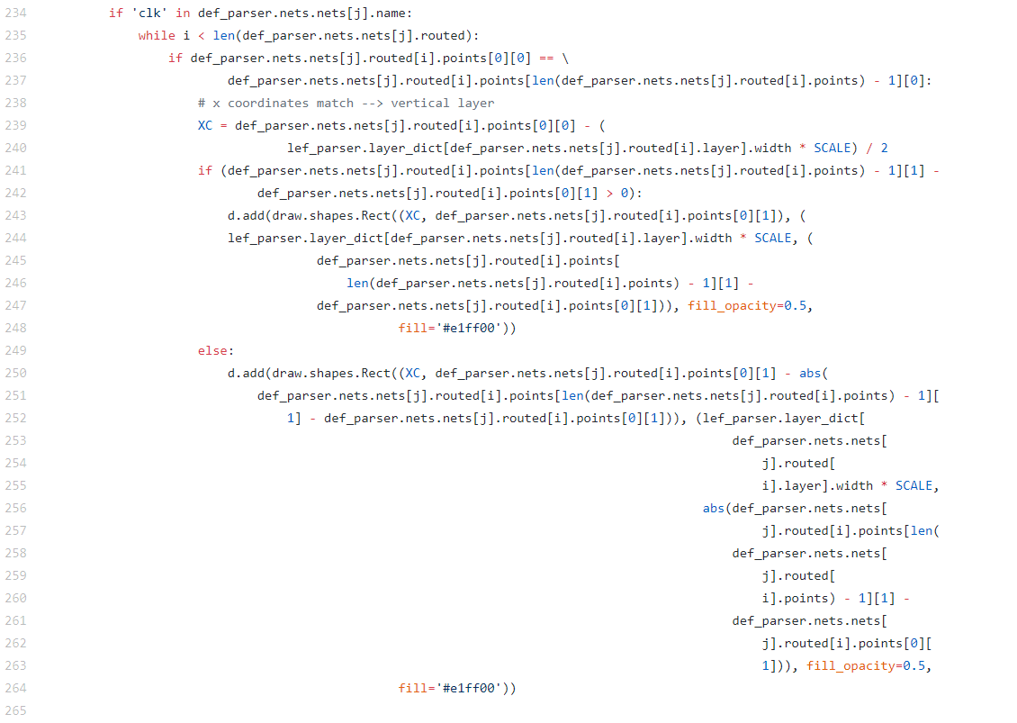The program highlights the clk nets if the user chose to highlight them.
* 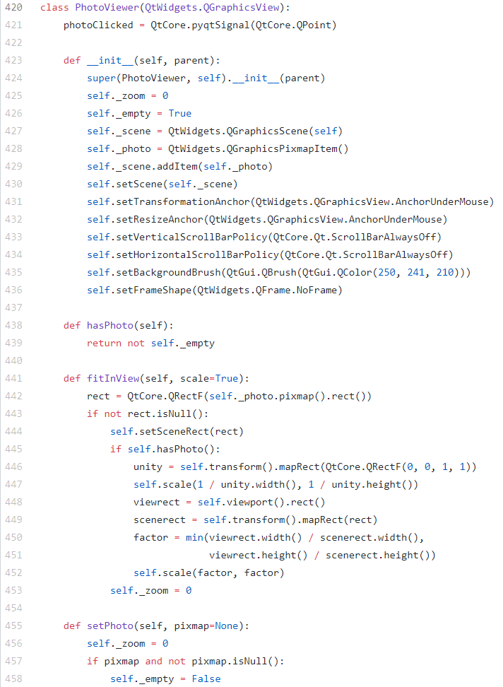The program initiates the photo viewer and set the zooming and panning feature

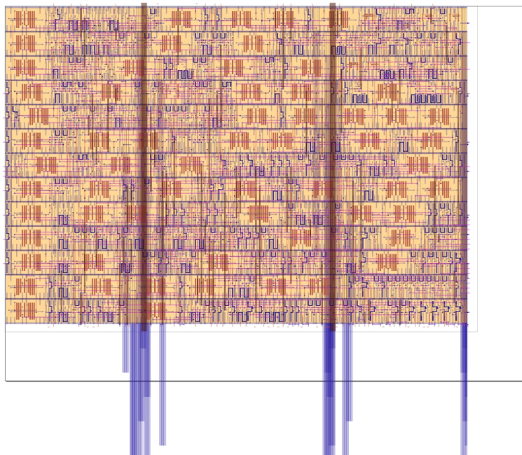**Output (Highlighted CLK Nets and DFF)**

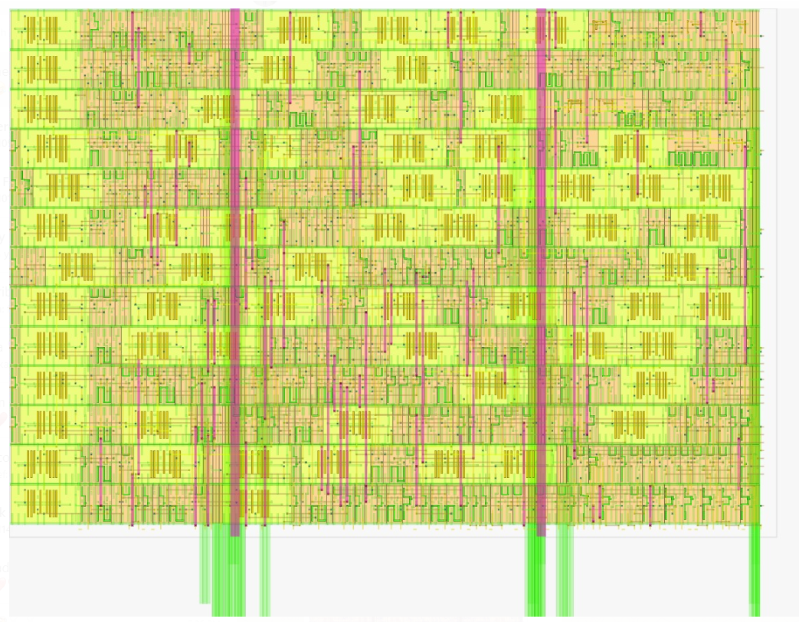**Output (Highlighted CLK Nets and DFF)**