# Bytewise Fellowship Program

Task 01

Submitted by: Awais Anwer

Data Science Group 2

**Task**: An introduction to Git. This will include installing Git and learning some basic commands: init, add, and commit, etc.

Here’s what you need to do:

Install Git: Make sure Git is installed on your machine. You can find the installation instructions here: https://git-scm.com/book/en/v2/Getting-Started-Installing-Git

Basic Commands (for example):

git init: Initialize a new Git repository.

git add: Add files to the staging area.

git commit: Commit your changes to the repository.

**Installing git:**

Git was already installed and set up on my system.

**Basic Commands:**

**The init command:**

The git init command is used to create a new Git repository, initializing the necessary metadata for tracking changes in the project directory.

I created a new folder on my system, opened git in that directory and run the following command:

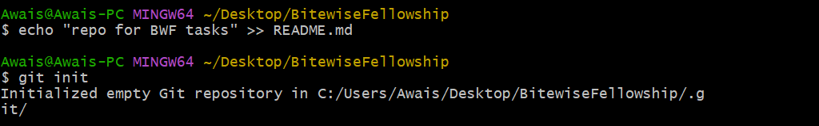

**Checking the status using git status command:**

**Git add command:**



**Git commit command:**

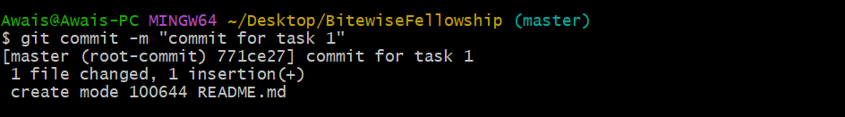

**Defining main branch:**



I have created a new repository on my GitHub account, so I am going to add that.

Add **remote origin** and **push command** to push the changes.

