How to Download and Install SQL Server

Pre-Requisites

How to download SQL Server Setup
Step 1) Go to URL: https://www.microsoft.com/en-in/sql-server/sql-server-downloads
Microsoft provides two specialized free editions to work on MS SQL server:
- Developer – It has all feature which MS SQL server offers but we cannot use it in production. From the learning perspective, is it an ideal candidate to start.
- Express: This is also a free version but with the limited set of features with no business intelligence applications.
We will select the Developer edition for installation.
Step 2) Click on "Download now"

We will get set up as 'SQLServer2017-SSEI-Dev.exe'.
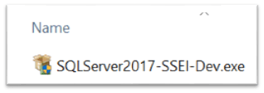

How to Install SQL Server
Step 1) Double click on "SQLServer2017-SSEI-Dev.exe". Below screen will appear with three options: Basic, Custom and Download files.
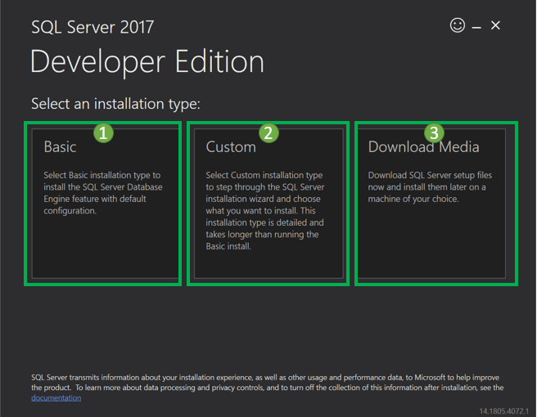
Step 2) Choose the basic version by clicking on the 'Basic' option, as it has all default configuration required to learn MS SQL.
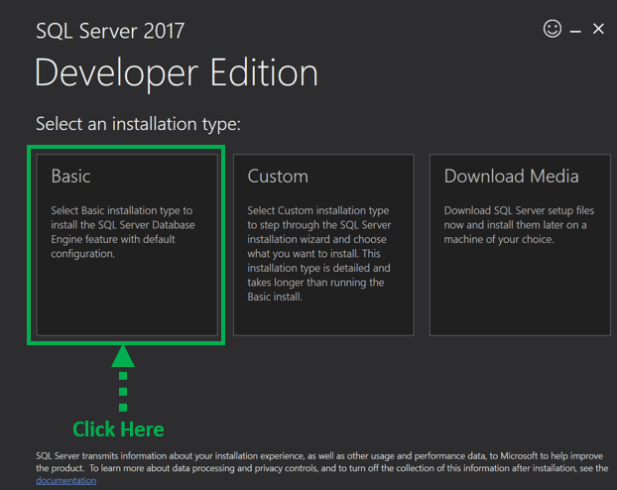
Step 3) 'Microsoft Server License Terms' screen will appear. Read the License Terms and then click 'Accept.'
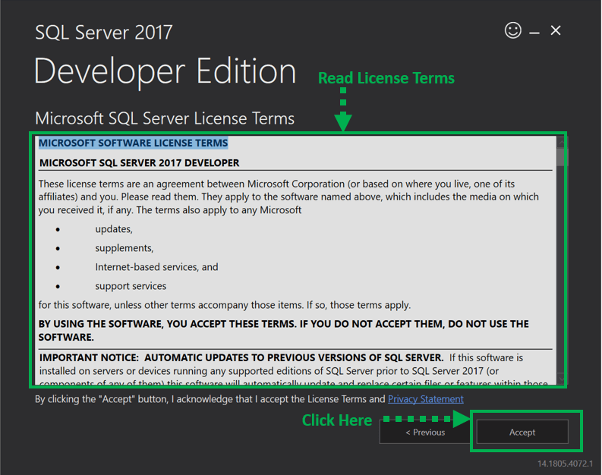
Step 4) Below 'SQL server install location' window will appear.
- The Default location is C:\Program Files\Microsoft SQL Server.
- Optionally, we can also change the installation location by clicking on Browse.3. Once the location is selected, click the 'Install' button.
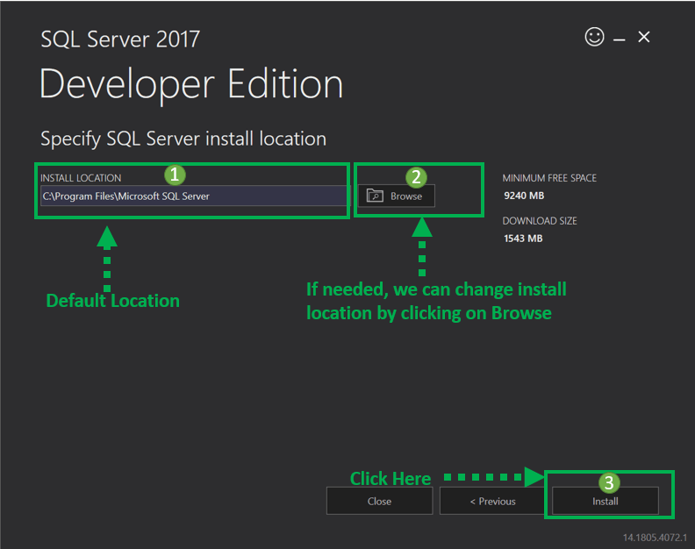
Below 'Downloading install package' progress screen will be displayed. Wait until the download is complete.
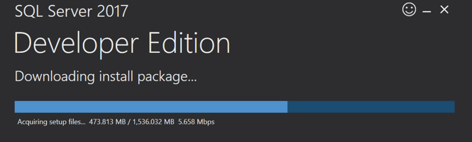
Once, the download is complete; the system will initiate installing developer edition.
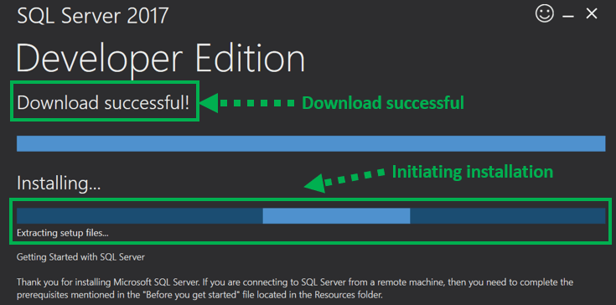
Below screen show installation progress.
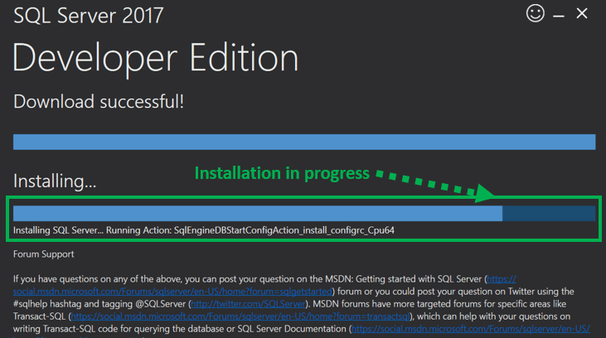
Step 5) Once installation is completed successfully, below screen will appear.
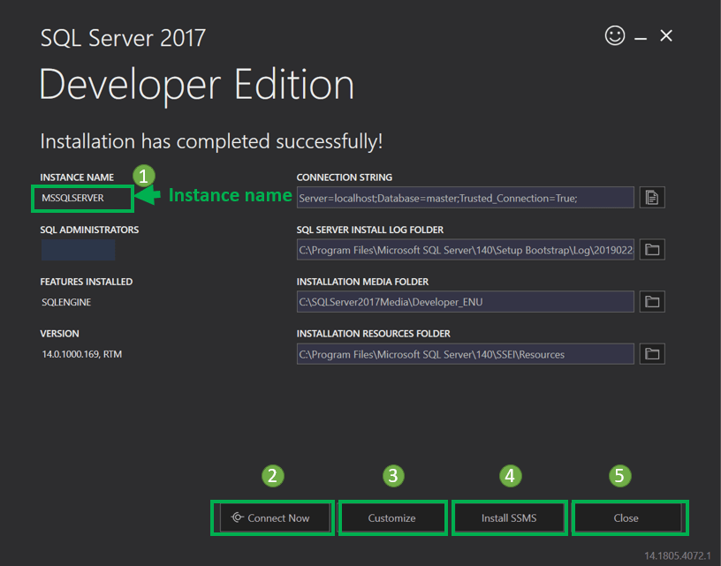
This setup is self-sufficient for proceeding further with learning SQL server, and we can 'Close' this window.
However, below is a summary of the label and button:
- Instance name: This is by default labeled as MSSQLSERVER.
- Connect now: This will open a separate command line window for connection testing of what we have just installed.
The system will run by default 'select @@Version' statement to confirm that we can connect to new MSSQLSERVER instance successfully.
