**LAB 6 : SQL**

**Roll No : 20SW048**

**Section : 2**

**TASK 1**

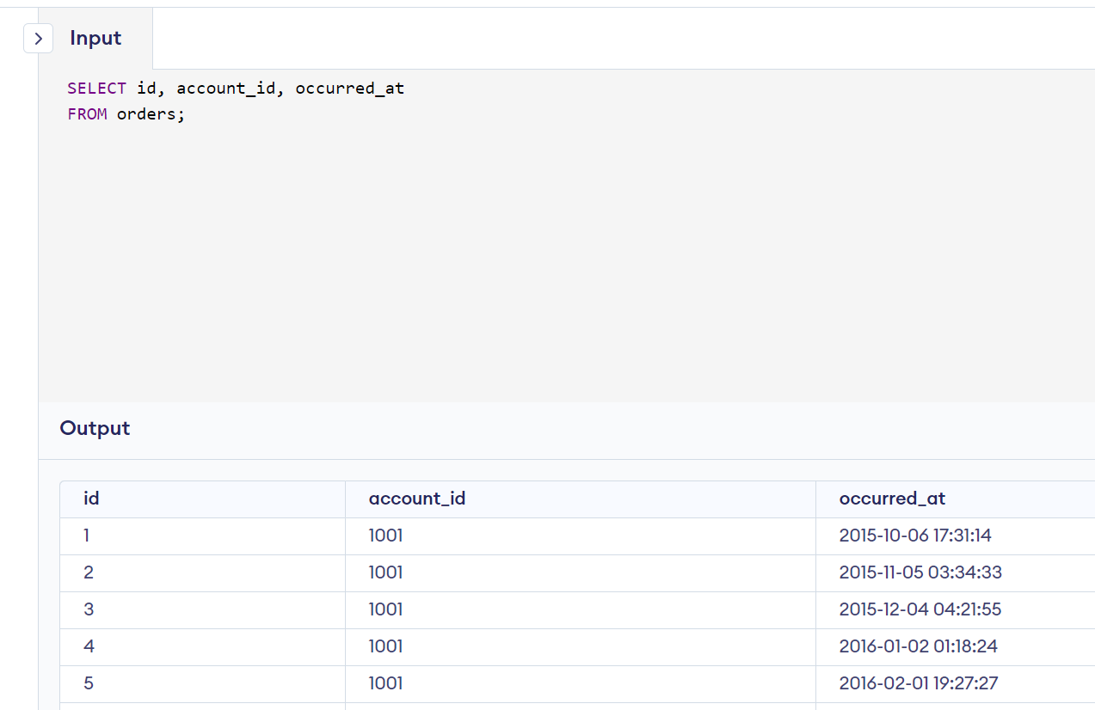

**TASK 2**

**TASK 3**

**TASK 4**

**TASK 5**

**TASK 6**

**TASK 7**

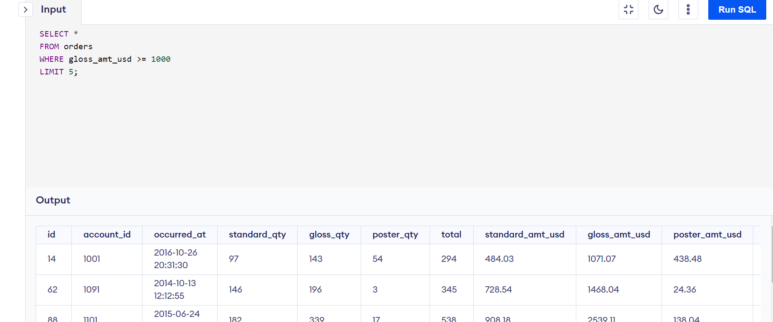

**TASK 8**

**TASK 9**

**TASK 10**

**TASK 11**

**TASK 12**

**TASK 13**

**TASK 14**

**TASK 15**

**TASK 16**

