**Introduction:**

*Every project should have a specific set of goals*

*and associated benefits.... what are you trying*

*to accomplish, and why?*

*The right set of goals can ensure that your project*

*suits a true development purpose,*

*and it creates a common purpose*

**Design and implementation:**

*1 :- The design and actual realization of our project*

*guide is a document that includes*

*the design patterns for the future product.*

*It also describes all possible UI elements*

*and content types used, defining the rules*

*of how they should be arranged and work*

*with each other.*

*2 :- Any project, there will almost always*

*be unexpected problems and questions that crop up.*

*When these issues arise, you have to be ready to deal*

*with them, i have encountered data-toggle, carousel,*

*or jquery issues when i run the code sometimes my code*

*didn't work.*

*3 :- In programming, a library is a collection of precompiled*

*routines that a program can use. The routines,*

*sometimes called modules, are stored in object format.*

*Libraries are particularly useful for storing frequently*

*used routines because you do not need to explicitly*

*link them to every program that uses them.*

**include a few screenshots of your websites in the report:**

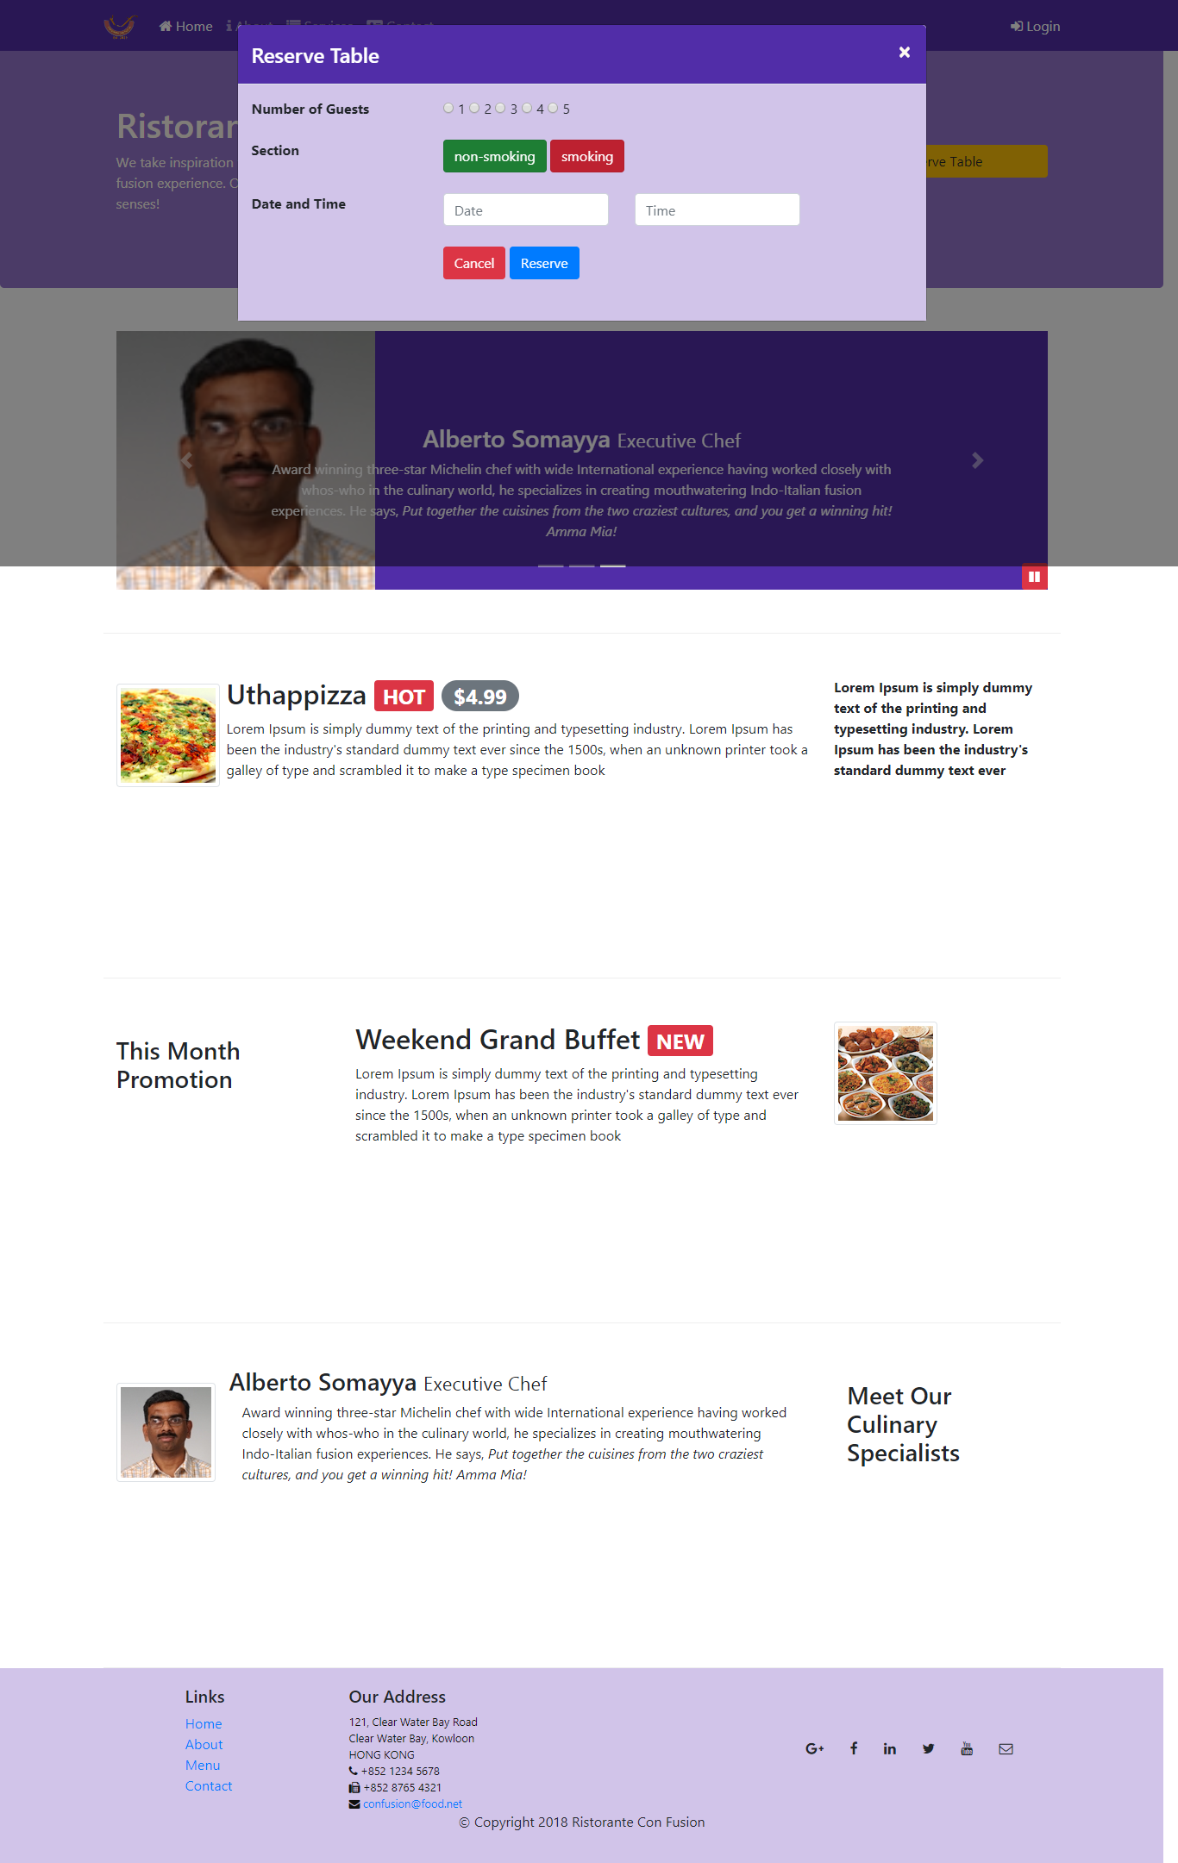

**Conclusions:**

*1 :- A project is temporary in that it has a defined beginning*

*and end in time, and therefore defined*

*scope and resources in my bootstrap-4 project we realize that*

*how to manage or analysis project assignments and deadlines*

*2 :- In my bootstrap-4 project, then, is the application*

*of knowledge, skills, tools, and techniques to project activities*

*to meet the project requirements*

*3 :- i think we create many things to do different in bootstrap-4*

*project like jquery code.*

**References:**

*in my opinion you go to https://www.youtube.com and type in*

*the search box geeky shows open the first channel watch the*

*tutorials.*