**BIO-DATA FORM U/T OFFICER**

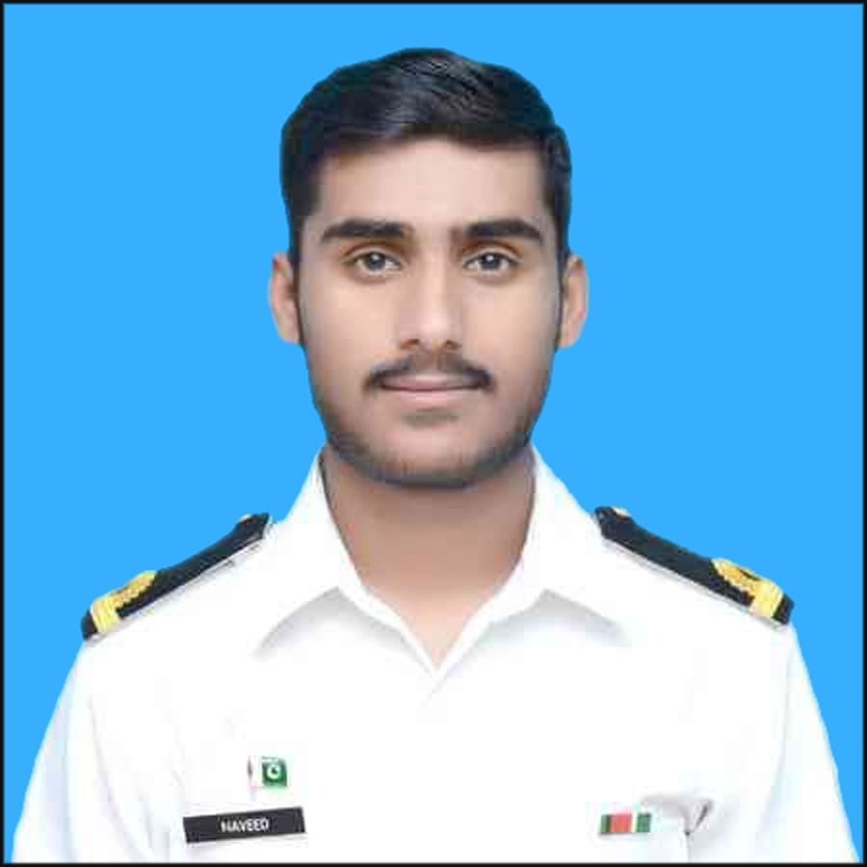

1. Rank & Name S/LT NAVEED AHMED PN
2. P No 11023 3. Course 2017-B 4.Branch OPERATIONS

5. CNIC No. 51401-1617108-1 6. Service ID NO N/A

7. Date of Joining Navy. 27-DEC-2017

8. Passport No. N/A 9. Nationality PAKISTANI

10. Duration From N/A To N/A

11. Mobile No. 03321503497 12. Emergency No. 03337854119

13. Room No. 08 14. Ex PN/ Army/ PAF N/A

15. Serviced From N/A To: N/A

16. Date of Birth 25-FEB1999 17. Place of Birth KHUZDAR

18. Height 5’8’’ 19. Weight 65KG 20. Blood Group B(+VE)

21. Identification Marks

a. N/A

b. N/A

22. Father's Name M.TARIQ Father's Occupation ASSISTANT ENGINEER

23. Father From Arm Forces (if any) N/A

24. Name of Next of Kin (NOK) MUHAMMAD TARIQ

25. NOK Address ASAD ABAD NEAR FRONTIER CORP OFFICER’S MESS KHUZDAR BALOCHISTAN

(Husband Wife in case of married) N/A

26. NOK Contact Numbers a. Mobile 03337854119

b. Office 03351205211 c. Res 03322442043

27. Permanent Address ASAD ABAD NEAR FRONTIER CORP OFFICER’S MESS KHUZDAR BALOCHISTAN

28. Near Relative in Defense service ELDER BROTHER IS CAPTAIN IN PAK ARMY 29. Whether Having Any Car/Motorcycle MOTOR BIKE

a. Registration No MS-5786 b. Make UNIQUE 100CC

b. Model 2016 d. Color RED

c. Driving License No. 5140116171081 / 980 f. Valid Upto14-MAR-2022

30. BAHADUR Entry Card No. N/A Valid Upto N/A

31. Qualifications GRADUATION IN BS(MIS)

32. Hobbies/ Sports FOOTBALL,VOLLEYBALL,SQUASH

33. Relations in Arm forces ELDER BROTHER IS CAPTAIN IN PAK ARMY

a. N/A

b. N/A

c. N/A

34. Blood Relations in Karachi (Name Address & Contact No)

a. N/A b. N/A

c. N/A

35. My Good Points

a. HAVING GOOD HEALTH AND PHYSIQUE

b. CURIOSITY FOR NEW THINGS AND IDEAS

c. SELF MOTIVATED

36. My Weak Points

a. HANDWRITING IS NOT SO GOOD

b. MISS PRAYERS SOMTIMES

c. LIKE TO TAKE TEA MORE OFTEN

37. Sports

|  |  |  |
| --- | --- | --- |
| S NO | Sports you Play | Sports you play in BAHADUR |
| a. | FOOTBALL | FOOTBALL |
| b. | VOLLEYBALL | VOLLEYBALL |
| c. | SQUASH | SWIMMING |

38. My Achievement (Distinct in academics or extra-curricular activities)

a. REWARDED WITH SWORD OF HONUR (2017-B)

b. REWARDED WITH CJCSC GOLD MEDAL AT PNA(TERM-III)

c. N/A

**JOTO Sign:_______________**