# Wensta

Url : <https://wensta.com> email: [superadmin@demo.com](mailto:superadmin@demo.com) password: 123456

1: check this screenshot old product not show

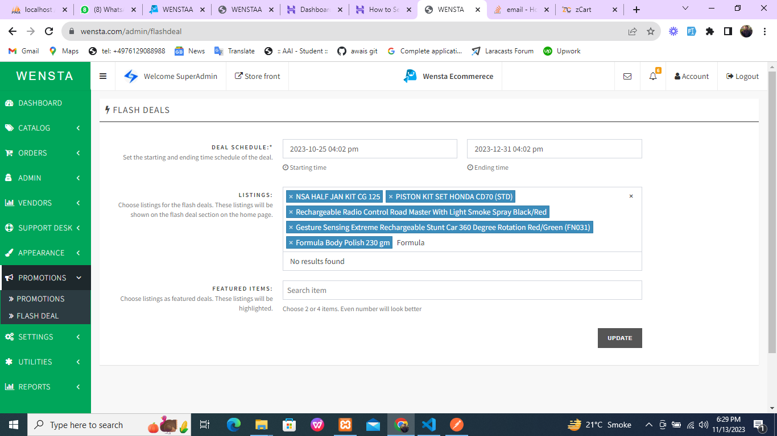

2: check this home page section Deal Of the Day image not show

