**Requirements and Design Specification Document**



**Solar Hub**

Project Code:

Advisor:

Waqas Allyas

Project Team:

**Group Leader-Muhammad Umar(181400113)**

**Muhammad Raheel(181400114) Bilal Hassan(181400091)**

**Kinza Iman(19100130)**

Submission Date:

Oct 20,2023

**Document Information**

| **Category** | **Information** |
| --- | --- |
| Customer |  |
| Project | Solar Hub |
| Document | Requirement Specifications |
| Document Version | 1.1 |
| Identifier |  |
| Status | Submitted |
| Author(s) | Muhammad Umar, Muhammad Raheel, Bilal Hassan, Kinza Iman |
| Approver(s) | Waqas Illyas |
| Issue Date | Oct 20,2023 |
| Document Location |  |
| Distribution |  |

**Definition of Terms, Acronyms and Abbreviations**

| **Term** | **Description** |
| --- | --- |
|  |  |
|  |  |
|  |  |
|  |  |
|  |  |
|  |  |
|  |  |
|  |  |

**Table of Contents**

1. **Introduction 4**
   1. Purpose 4
   2. Scope 4
   3. Definitions, Acronyms, and Abbreviations 4
   4. Overview 4
2. **Overall Description 4**
3. **Specific Requirements 5**
   1. Functionality 5
   2. Usability 6
   3. Reliability 6
   4. Performance 6
   5. Supportability 6
   6. Availability: 6
4. **System Architecture 6**
5. **Use Cases 6**
   1. Use Case Diagram 6
   2. Use Case Description 8
6. **Research and Development 12**
7. **Learning Outcomes 12**
8. **Practical Applications 12**

# Introduction

This document covers up all the details and requirements of our module, i.e.,Solar Hub. A subsection of this document will provide complete detail to the reader.

## Purpose

The purpose of this document is to facilitate users that are interacting with the systemThis

document will provide guidance, help to the users. We are developing a “Solar Hub”.

## Scope

Our system helps users to ease their work and make selling and purchasing easy for both customer and seller. Solar Hub provide the following features:

* + - Calculate the amount of the solar panel system needed
    - Suggest the price of the solar panel system on different quality
    - Allow user to buy the suggested solar panel system
    - Show other product that are needed with the solar panel system
    - Order the product
    - Allow admin to add the quantity of product and show the amount are available in stock
    - Recommended the panels according to area\weather situation
    - Suggest panels to new users through feedback

## Definitions, Acronyms, and Abbreviations

| FR | Function Requirement |
| --- | --- |
| NFR | Non Functional Requirement |
| BR | Business Requirement |

*[This subsection provides the definitions of all terms, acronyms, and abbreviations required to properly interpret the* ***SRS/DS****.]*

## Overview

This document includes product perspective, user classes, user characteristics, constraints, assumptions and dependencies, external interface requirements, specific requirements. The document has all the requirements that the user will read while interacting with the system.

# Overall Description

There are many other solar panel websites that are offering to buy their solar panel products online but they are not offered online to calculate power to customers to get the information of power they consumed.

Our system allows users to calculate the price of the solar panel system with the cost of every expense that is needed to install the solar panel system in their houses.There are many systems that sell solar panel system.But they only allow users to buy solar panel systems and suggest the exact amount of solar panel needed for their houses.

Main functionality of the solar panel hub is to:

* Ask users about their accessories and give them fair amount of their solar panel system
* Suggest user to buy online from our website and give them service
* Recommend the product on the rating and purchasing
* Show solar panel according the area

Solar Hub does not waste user time on searching the quality and amount of solar panel panels.solar panel Hub provides the user to buy a solar panel system separately and suggest the exact amount of the solar panel system needed for the user house.

# Specific Requirements

BR-01: The system shall be able to show household accessories that are selected by the customer.

BR-02: The system shall be able to calculate the watt of the accessories.

BR-03: The system shall be able to suggest the solar panel on the basis of the area. BR-04: The system should be able to recommend the product on the basis of ratings.

BR-05: The system shall be able to login the customer

BR-06: The system shall be able to register the customer.

BR-07: The system should be able to show the product added by the admin.

BR-08: The system should be able to save the product in the cart

BR-09: The system should be able to order the product selected by the customer

BR-10: The system should be able to show orders to the admin which are ordered by the customer.

BR-11: The system should be able to add products by the admin.

BR-12: The system should be able to show the user to the admin.

BR-13: The system should be able to add the accessories details that are shown in the customer side. BR-14: The system should be able to ask the user to select the panel on the basis of the quality.

BR-15: The system should be able to keep tract of the stock in inventory.

BR-16: The system should be able to recommend the user on the basis of the feedback.

BR-17-The system should be able to take feedback of the product from the user to recommend.

## Functionality

**Customer:**

FR-01: The customer shall be able to login. FR-02: The customer shall be able to register.

FR-03: The customer shall be able to select the accessories

FR-04: The customer shall be able to select the quality of the solar panel.

FR-05: The customer shall be able to see the calculated price of the system by the watt of accessories.

FR-06: The customer shall be able to order the suggested products with extra products.

FR-07: The customer should be able to see products that are needed with the solar panel or added by the admin.

FR-08: The customer should be able to add the products to cart.

FR-09: The customer should be able to order the products.

FR-10:The customer should be able to see recommendation by the system.

FR-11:The customer should be able give the feedback on the product that are ordered.

**Admin:**

FR-12: The admin shall be able to login.

FR-13: The admin shall be able to register.

FR-14: The admin shall be able to add accessories details and power consumption.

FR-15: The admin shall be able to manage the product.

FR-16: The admin shall be able to see the registered customer.

FR-17: The admin shall be able to manage the order.

FR-18:The admin should be able to manage inventory.

FR-19:The admin should be able to manage sale and purchase.

## Usability

NFR-01: The system shall be easy to use and understandable. NFR-02:The system must have a user-friendly interface.

## Reliability

NFR-03:The system must perform function without any errors.

## Performance

NFR-04: The system must perform action within 30 seconds.

## Supportability

NFR-05:The system must be maintainable and easy to understand the code.

## Availability:

NFR-06: The system must be available 24/7 to customers.

# System Architecture

# Use Cases

## Use Case Diagram

**Customer**

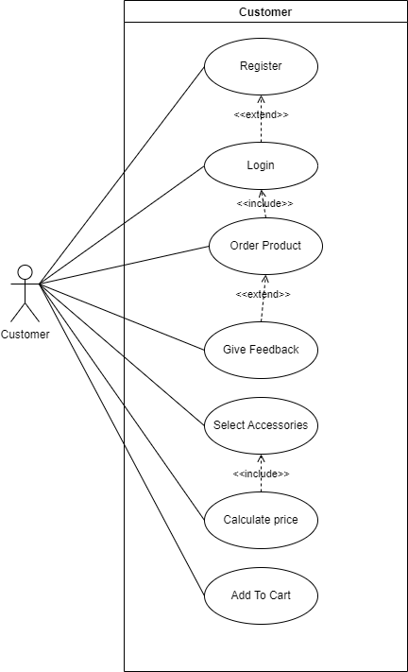

**Admin**

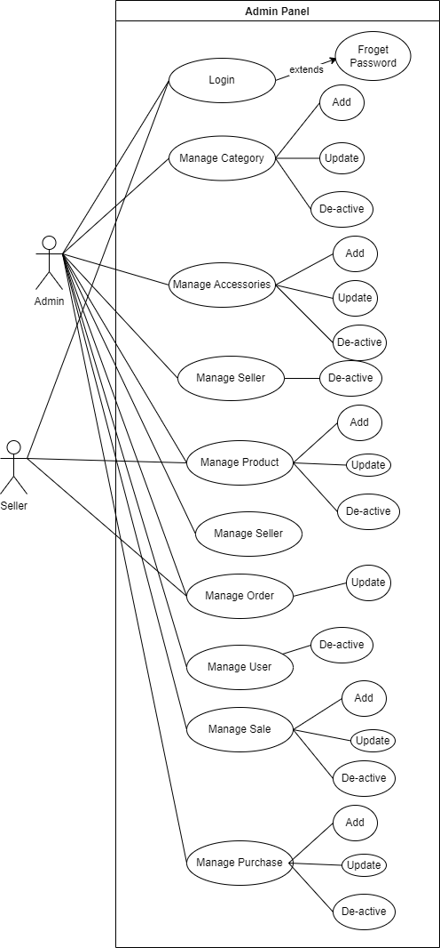

## Use Case Description

| **Use case Id: Login** | | | |
| --- | --- | --- | --- |
| **Actors:** Admin, Customer, Register | | | |
| **Feature:** The user should be login in the system | | | |
| **Use case Id:** | | 1 | |
| **Pre-condition:** | | The system must be connected to the internet | |
| **Scenarios** | | | |
| **Step#** | **Action** | | **Software Reaction** |
| **1** | Go to system login page | | login page shown |
| **2** | enter the credentials | | Check credentials |
| **Alternate Scenarios** | | | |

| **2a:**wrong credential and show the message | | |
| --- | --- | --- |
| **Post Conditions** | | |
| **Step#** | **Description** | |
| **1** | Home page show to user | |
| **Use Case Cross referenced** | | Include: Order Product, Manage Category |
| **User Interface reference** | |  |

| **Use case Id: Register** | | | | |
| --- | --- | --- | --- | --- |
| **Actors:** Admin, Customer | | | | |
| **Feature:** The user should be register in the system | | | | |
| **Use case Id:** | | 2 | | |
| **Pre-condition:** | | The system must be connected to the internet | | |
| **Scenarios** | | | | |
| **Step#** | **Action** | | | **Software Reaction** |
| **1** | Go to system register page | | | login page shown |
| **2** | enter the credentials | | | register credentials |
| **Alternate Scenarios** | | | | |
| **2a:**Password does not match  **2b:**Email Already exist | | | | |
| **Post Conditions** | | | | |
| **Step#** | **Description** | | | |
| **1** | Redirect to the login page | | | |
| **Use Case Cross referenced** | | |  | |
| **User Interface reference** | | |  | |

| **Use case Id: Order Product** | | | |
| --- | --- | --- | --- |
| **Actors:** Customer | | | |
| **Feature:** The user should be place order in the system | | | |
| **Use case Id:** | | 3 | |
| **Pre-condition:** | | The system must be login to the system | |
| **Scenarios** | | | |
| **Step#** | **Action** | | **Software Reaction** |
| **1** | Go to system login page | | login page shown |
| **2** | enter the credentials | | Check credentials |
| **3** | Check the product | | show all product |
| **4** | place order | | order has been placed |
| **Alternate Scenarios** | | | |
| **3a:** Product are out of stock | | | |
| **Post Conditions** | | | |
| **Step#** | **Description** | | |
| **1** | Order has been placed | | |

| **Use Case Cross referenced** |  |
| --- | --- |
| **User Interface reference** |  |

| **Use case Id: Select Accessories** | | | | |
| --- | --- | --- | --- | --- |
| **Actors:** Customer | | | | |
| **Feature:** The user should be select accessories in the system | | | | |
| **Use case Id:** | | 4 | | |
| **Pre-condition:** | | The system must be connected to the internet | | |
| **Scenarios** | | | | |
| **Step#** | **Action** | | | **Software Reaction** |
| **1** | Go to system landing page | | | show the landing page |
| **2** | select the number accessories with  quantity | | | Accessories has select |
| **Alternate Scenarios** | | | | |
| **2a:**Warning to exceed the quantity limit | | | | |
| **Post Conditions** | | | | |
| **Step#** | **Description** | | | |
| **1** | Accessories has been selected | | | |
| **Use Case Cross referenced** | | | Calculate Price | |
| **User Interface reference** | | |  | |

| **Use case Id: Calculate Price** | | | | |
| --- | --- | --- | --- | --- |
| **Actors:** Customer | | | | |
| **Feature:** The system should calculate the price | | | | |
| **Use case Id:** | | 5 | | |
| **Pre-condition:** | | The system must be connected to the internet | | |
| **Scenarios** | | | | |
| **Step#** | **Action** | | | **Software Reaction** |
| **1** | User add the accessories that are in his/her house | | | Selected Accessories has shown |
| **2** | User enter selected the field  according to his/her need | | | Data has been saved in the system |
| **3** | User click the calculate price | | |  |
| **Alternate Scenarios** | | | | |
| **2a:** | | | | |
| **Post Conditions** | | | | |
| **Step#** | **Description** | | | |
| **1** | Home show to user | | | |
| **Use Case Cross referenced** | | | Order Product, Manage Category | |
| **User Interface reference** | | |  | |



| **Feature:** The system should product to the user | | | | |
| --- | --- | --- | --- | --- |
| **Use case Id:** | | 7 | | |
| **Pre-condition:** | | The system must be connected to the internet | | |
| **Scenarios** | | | | |
| **Step#** | **Action** | | | **Software Reaction** |
| **1** | Go to system landing page | | | landing has been shown |
| **2** | Select the category | | | Category has been selected |
| **Alternate Scenarios** | | | | |
|  | | | | |
| **Post Conditions** | | | | |
| **Step#** | **Description** | | | |
| **1** | Product has been according to the selected the category | | | |
| **Use Case Cross referenced** | | |  | |
| **User Interface reference** | | |  | |

| **Use case Id: Add To Cart** | | | | |
| --- | --- | --- | --- | --- |
| **Actors:** Customer | | | | |
| **Feature:** The user should be able to add product to the cart in the system | | | | |
| **Use case Id:** | | 8 | | |
| **Pre-condition:** | | The system must be logged in to the system | | |
| **Scenarios** | | | | |
| **Step#** | **Action** | | | **Software Reaction** |
| **1** | Search the product | | | Searched product has been shown |
| **2** | Click the add to cart button | | | Product has been add to the cart |
| **Alternate Scenarios** | | | | |
| **2a:**No Product has shown  **2b:**Product is out of stock | | | | |
| **Post Conditions** | | | | |
| **Step#** | **Description** | | | |
| **1** | Product has been add to the cart | | | |
| **Use Case Cross referenced** | | |  | |
| **User Interface reference** | | |  | |

# Research and Development

*[This section of the* ***SRS/DS*** *contains the background research done regarding the project. It will also highlight the research required to accomplish the project e.g. studying any specific area of study like HCI. In references the research papers, articles and/or books read for R&D purposes must be mentioned]*

1. **Learning Outcomes**

In this project, we learn about the following tools and skill:

* laravel (php framework)
* Database management
* Team work
* Design the web(html, css , js)
* Project documentation

1. **Practical Applications**

This system will allow solar panel sellers relief from the extra headache like calculating the amount of the solar panel system or price of the solar panel system to be installed.