Queen Mary University of London

Sustainability Assessments for Design

EMS622U

Life Cycle Assessment on Laptop Batteries

Awais Amjad



# **Introduction**

In today's technological landscape, LIBs (Lithium-Ion batteries) play a pivotal role in powering laptops, boasting higher energy density, longer lifespan, and lower weight [1]. Their widespread adoption is evident in the global LIB laptop market, valued at $21.3 billion in 2023 and projected to reach $57.9 billion by 2030 [2]. However, this growth brings challenges such as increased waste, emissions, and energy usage. Estimates suggest between 200 million and 500 million tons of spent battery waste are generated annually as of 2020 [3]. This LCA (Life Cycle Assessment) aims to evaluate the environmental impact of laptop LIBs, identifying hotspots of large emissions, waste etc. for potential improvement. It will also assess the environmental benefits of LIBs and explore opportunities for enhancement. To provide context, NiCadB (Nickel Cadmium batteries), the pioneers of laptop batteries [4] will serve as a comparator product, enabling a comparison of environmental sustainability improvements over time.

# **Life Cycle and Scope**

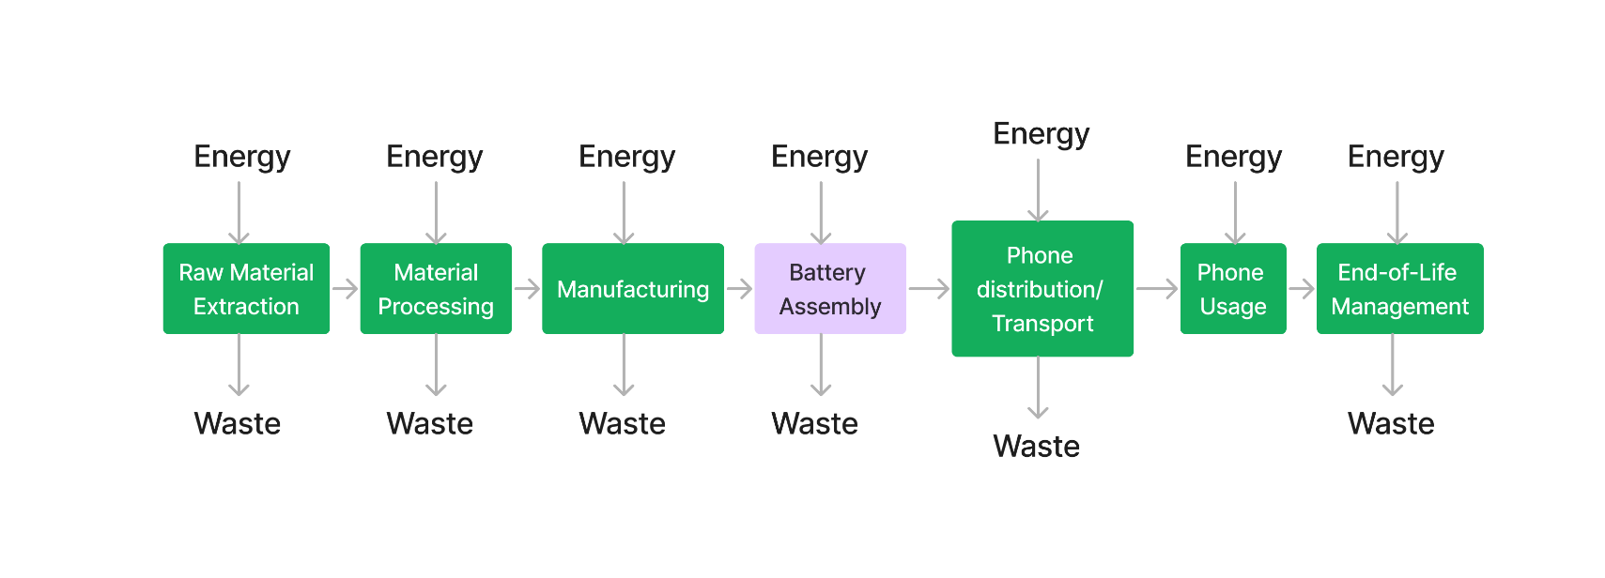

The stages highlighted in green will be the scope of this LCA.

**Functional Unit**

I intend to assess the environmental effects caused by both batteries which is determined by their respective materials and properties. As the comparison must be between the batteries themselves, my functional unit will be ‘Per battery.’ However, due to the large scale of battery production and the possibility of optimisations in stages such as Manufacturing, due to mass manufacture, a final functional unit of ‘Per 1000 battery’ is chosen.

## **Sustainability indicators**

|  |  |  |
| --- | --- | --- |
| **Sustainability Indicator** | **Unit** | **Reasoning** |
| Water Consumption | m3 | A finite resource essential for various stages of battery production, including raw material extraction and processing. High water consumption can lead to depletion of local water sources, ecosystem degradation, and conflicts over water access. [26] |
| CO2 Emissions | kg | CO2 emissions are a primary contributor to climate change and global warming. Battery production and usage generate CO2 emissions through energy-intensive processes, such as mining, refining, manufacturing, and transportation. Monitoring CO2 emissions allows us to quantify the carbon footprint of different battery technologies and assess their contribution to climate change. [27] |
| Energy Usage | MJ | Energy usage is intricately linked to CO2 emissions and resource depletion, as it reflects the amount of energy required to extract, process, and manufacture battery materials as well as during the usage of the laptops. High energy usage not only contributes to CO2 emissions but also increases the demand for fossil fuels and other finite energy resources. [28] |
| Toxicity | N/A | Exposure to toxic substances can have adverse effects on human health, wildlife, and ecosystems, leading to pollution, contamination, and long-term environmental damage. [27] |

## **Data Sources**

The primary data source utilized for this LCA was EduPack [29], a specialized software tool designed for materials education and selection. EduPack emerged as an optimal choice for this evaluation due to its vast repository of materials and properties, which are fundamental for conducting LCAs effectively. Additionally, EduPack incorporates an Eco Audit tool, facilitating the identification of CO2 emissions and energy usage hotspots throughout the product life cycle. Furthermore, EduPack's ability to integrate rechargeable LIBs and NiCadBs into the audit process provided valuable insights. Notably, LIB data was sourced from laptop batteries, while the origin of NiCadB data remained unknown. Despite some limitations, such as data presented in range formats and unavailable materials like LiPF6, EduPack remained an invaluable resource for comprehensive data acquisition. In addition to EduPack, supplementary data sources were consulted, including manufacturer data sheets, existing LCAs, and updates from the battery industry. Extensive fact-checking and cross-referencing were conducted to ensure data accuracy, albeit acknowledging the potential risk of misinformation. In any instances where data was lacking, engineering-based assumptions were made, or the absence of information was explicitly stated. While this approach may have reduced data robustness, it enabled the derivation of suitable results and conclusions for the assessment.

# **Battery Components and Materials**

Appendix A provides an explanation of how the batteries operate, shedding light to the battery components. Variations in these component materials lead to distinct environmental effects, highlighting the significance of analysing each component. To streamline this process, common materials utilised in various battery parts have been carefully selected for inclusion in this LCA, ensuring a comprehensive assessment while maintaining focus. Alternative material types will be omitted from consideration to streamline the analysis.

**Battery component Data Table**

|  |  |  |
| --- | --- | --- |
| **Battery Component** | **LIB** | **NiCad** |
| **Anode** | Lithium carbonate such as graphite [5] | Nickel Oxide Hydroxide (NiOOH) [6] |
| **Cathode** | Lithium Cobalt Oxide (LiCoO2) [7] | Cadmium [8] |
| **Electrolyte** | Lithium hexafluorophosphate (LiPF6) [9] | Consists of a potassium hydroxide (KOH) solution [10] |
| **Casing** | Nickel coated steel [11] | Steel, Nylon, Propylene [12] |
| **Anode Current Collector** | Copper [13] | Nickel [14] |
| **Cathode Current Collector** | Aluminium [15] | Nickel [14] |
| **Separator** | Polyethylene [16] | Polyamide [17] |

# **Eco Audit**

An Eco Audit of LIBs and NiCadBs was conducted through EduPack to assess their CO2 Emissions and Energy Usage throughout the life cycle. To ensure precision for the two batteries, it was necessary to establish specific assumptions regarding their characteristics. Given the considerable variability in factors like weight and power rating across different battery types, these variables were standardised for both LIB and NiCadB. These assumptions were informed by thorough research on various battery types. [18, 19, 20, 21].

|  |  |  |
| --- | --- | --- |
| **Assumption** | **Factor** | **Value** |
| **Equal** | Weight | 650 grams (*Both*) |
| **Equal** | Years of Use | 5 (*Both*) |
| **Equal** | Days of Use | 200 (*Both*) |
| **Equal** | Hours of Use | 6 (*Both*) |
| **Not Equal but Constant** | Power Rating | 9200 W (*LIB*) 1200 W (*NiCadB*) |

The purpose of making these assumptions was to isolate the impact of materials and their quantities throughout the life cycle stages. The data was sourced from EduPack, which provided electronic component data. For my analysis, I selected the Li-Ion rechargeable battery (for laptops) as the primary product and compared it to Ni-Cd rechargeable batteries as the secondary product. This choice was driven by the unavailability of Ni-Cd data specifically for laptops. It's important to note that the data obtained cannot be considered a precise reflection of the battery component data table. The data table relies on assumptions, while the EduPack database contains its own set of materials and compositions, albeit without clear indications of their usage contexts.

For transport considerations, the following journey was assumed: Lithium, typically mined in Chile (although also sourced from Australia, which was not considered), is transported to China for refinement and battery production [30, 31]. Subsequently, the batteries are shipped to the UK for use. In the case of nickel-cadmium, since cadmium is a byproduct of zinc processing, which primarily occurs in China [22], the batteries are manufactured in China and then sent to and used in the UK.

# **Results and Analysis**

## **CO2 Emissions and Energy**

LIBs have a significantly larger CO2 footprint compared to NiCadBs across all stages of the life cycle. During the material stage, LIBs exhibit an extremely high CO2 footprint of approximately 50,000 kg per 1000 batteries. This can be attributed to the energy-intensive processes involved in extracting and refining lithium, such as brine extraction and rock ore mining (see Appendix B), as well as the manufacturing of complex electrode materials like LiCoO2. In contrast, NiCadBs have a lower CO2 footprint of around 5,000 kg per 1000 batteries during the material stage. As cadmium, the main material for NiCadBs, is often a byproduct of manufacturing processes for zinc and other materials, its CO2 footprint is understandably lower.

The transport and use stages also show that LIBs have a greater CO2 footprint than NiCadBs, although the differences are not as pronounced as in the material stage. The observed trend aligns with the current battery market landscape, where LIBs dominate and are expected to continue growing. This dominance is fuelled by the widespread adoption of LIBs in various applications such as electric vehicles (EVs), consumer electronics, and grid energy storage systems, driven by their higher energy density and longer lifespan. In contrast, NiCadBs have reached a plateau or even a decline in usage due to regulatory bans and environmental concerns associated with the toxicity of cadmium [23].

Regarding the End of Life (EoL) potential, the data suggests that LIBs typically have a much higher recycling potential compared to NiCadBs. This can be attributed to several factors:

1. **Availability**: LIBs are more widely used and available than NiCadBs, resulting in a larger supply for recycling processes.
2. **Material Composition**: LIBs contain valuable materials such as lithium, cobalt, and nickel, which can be efficiently recovered and reused in the production of new batteries or other applications, making their recycling more economically viable.
3. **Recycling Infrastructure**: There is a well-established and growing infrastructure for LIB recycling, with specialized facilities capable of extracting and purifying valuable materials from spent batteries, enabling a more efficient recycling process.

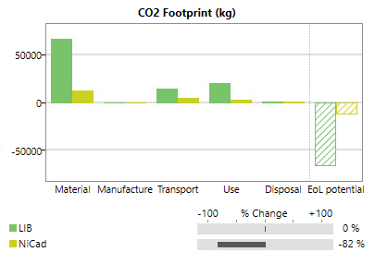 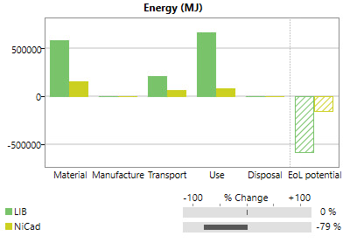

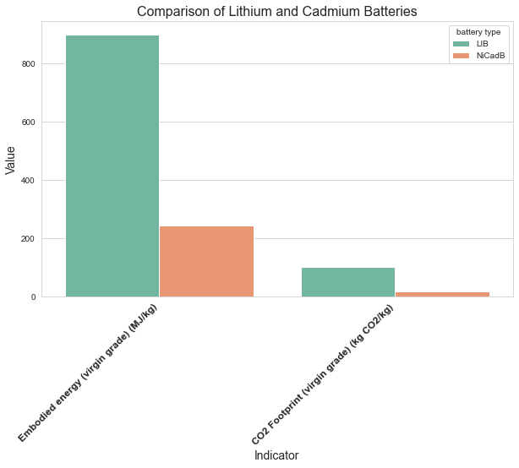

While NiCadBs have a lower environmental impact during their production and use stages, their lower recycling potential and the presence of toxic cadmium pose additional challenges for responsible end-of-life management.

## **Toxicity**

To assess the toxicity of batteries effectively, it is essential to consider several factors such as the presence of toxic materials, their quantities, susceptibility to leakage, and their environmental impact. According to [24, 25], both lithium and cadmium are assigned hazard ratings, indicating their potential risks to health and the environment. Cadmium, notably, receives a higher hazard rating, indicating greater damage to health and a higher susceptibility to flammability. In scenarios involving material leakage due to battery misuse, accidents, or disposal in landfills, cadmium presents a more significant toxic risk, as it can be inhaled or ingested. The hazard rating key, ranging from 0 (minimal) to 4 (severe), provides insights into the relative toxicity levels of lithium and cadmium.

|  |  |  |
| --- | --- | --- |
| **Hazard Rating** | **Lithium** | **Cadmium** |
| **Health** | 3 | 4 |
| **Flammability** | 2 | 3 |
| **Reactivity** | 2 | 1 |

*Hazard Rating Key: 0=minimal; 1=slight; 2=moderate; 3=serious; 4=severe*

**Toxicity of Components**

|  |  |  |
| --- | --- | --- |
| **Battery Component** | **LIB** | **NiCad** |
| **Anode** | Graphite - Non-poisonous | Nickel Oxide Hydroxide (NiOOH) |
| **Cathode** | Lithium Cobalt Oxide (LiCoO2) - poses significant health risks when inhaled or ingested in excessive amounts. Exposure can lead to chronic respiratory and cardiovascular issues, as well as reproductive system complications in both genders. Those involved in cobalt mining and processing face the highest risk. | Cadmium - poses significant health risks. Ingestion or inhalation of cadmium compounds can lead to severe respiratory issues and long-term health problems, including kidney damage and cancer. |
| **Electrolyte** | LiPF6 – can impact the digestive, circulatory, respiratory, and nervous systems, as well as the skin and bones. Ingestion poses the highest risk, but inhalation and skin contact can also cause harm. | Potassium hydroxide (KOH) solution - Exposure to battery electrolytes can cause serious harm. Contact can corrode eye tissues, potentially leading to blindness, while skin exposure may result in severe burns. Ingestion can damage throat tissues, and the presence of cadmium and nickel compounds poses carcinogenic risks. |
| **Casing** | Nickel coated steel – Coal-fired nickel smelters emit carcinogenic sulphur dioxide into the air, leading to deformities and respiratory issues linked to pollution exposure. | typically made from metal or plastic materials and houses the internal components, including the positive and negative electrodes, electrolytes, and separators. |
| **Anode Current Collector** | Copper – Non-poisonous | Nickel – *Check previous* |
| **Cathode Current Collector** | Aluminium – can be a major threat to humans, animals, and plants | Nickel – *Check previous* |
| **Separator** | Polyethylene – Non-Hazardous | Polyamide – Non-poisonous |

Examining the toxicity of materials reveals significant risks to both humans and animals when exposed to leakage or fires. While the high-grade casings of these batteries typically prevent harm under normal conditions, there remains a substantial risk during manufacturing, processing, and end-of-life stages. Studies indicate that NiCadBs generally pose greater toxicity concerns due to cadmium and that the vast investments into lithium recycling mean more lithium is being reused and not mined. Combined with its longer life cycle, in terms of toxicity, lithium-ion batteries are less harmful than nickel-cadmium batteries. [32, 33, 34, 35, 36]

## **Water consumption**

The Eco Audit tool did not have the option to assess water consumption at each stage so the data that was used was the Water Usage which was the total water consumed throughout the life cycle. Furthermore, this data was only available for LIBs and not NiCadBs. To overcome this lack of data, an assessment for the Water Consumption of both batteries was attempted but only partially completed for the LIB. This assessment only managed to cover the material water consumption as well as some manufacturing consumption.

The following parts were considered in the water consumption assessment, revealing that most of the water consumption occurs is for the casing and lithium. Other components were deemed negligible either due to minimal water usage during the extraction process (anode) or insufficient information available for assessment (separator). The process of coating nickel to steel was not considered.

|  |  |  |
| --- | --- | --- |
| **Part** | **Material** | **Water Consumption (m3) per 1000 Batteries** |
| Casing | Nickel Coated Steel | 10 - 100 |
| Anode | Graphite | *Negligible* |
| Lithium parts – Cathode and Electrolyte | LiCoO2  LiPF6 | 189 - 244  *Majority of the water consumption comes from the lithium so the other materials will not be considered* |
| Current Collectors | Copper  Aluminium | 0.039 |
| Seperator | Polyethylene | *Negligible* |
| **Total** |  | **199.04 - 344.04** |

From EduPack, the LIB has a Water Usage of 626 – 725 L/kg. For our assumption of the battery, this translates to 406.9 to 471.25 m3. Based on the assessment, majority of the water consumption happens through the material stage. However, this assessment lacks robustness.

**Conclusion and further work**

Through the analysed data, it becomes evident that LIBs have a greater environmental impact compared to NiCadBs. Despite their higher demand, LIBs consume substantial energy and generate significant amounts of CO2 and toxic waste. The highest energy usage occurs during the Use and Material stages, while CO2 emissions peak during the Material phase. NiCadBs are inherently more toxic than LIBs due to the presence of the heavy metal cadmium. However, with the phase-out and ban of cadmium, LIBs now contribute more to environmental harm. Nevertheless, LIBs demonstrate greater EoL potential compared to NiCadBs. A comprehensive assessment of water consumption for both battery types is still pending and requires further research. Future work involves conducting case studies on actual laptop batteries to delve deeper into their environmental impact. Additionally, firsthand investigation of both battery types aims to gain insights into their day-to-day usage differences. Based on environmental, economic, and social findings, plans are underway to explore, analyse, and propose viable solutions to address hotspot areas and other concerns for improvement. These solutions may involve modifications in design, materials, and processes, among other considerations.

Further data needs to be found during the manufacturing and transport stages for all sustainability indicators and overall, more data is needed to measure toxicity and water consumption allowing me to complete my environmental analysis.

**Plans for Economic Assessment**

My economic assessment will examine costs across various stages of battery production, including material extraction, manufacturing, and waste management. I'll explore waste reduction methods like recycling and assess supply chain costs, labour expenses, and energy usage and any data analysis will involve cost estimation methods. An investigation into the economic benefits and drawbacks for a consumer such as better cost-to-lifespan ratio will be necessary as these may be the driving force for LIBs popularity.

### **Plans for Social Assessment**

For the social assessment, I'll examine labour impacts during battery production stages, including extraction, manufacturing, and processing, to assess conditions like pay and safety. I'll also evaluate social effects at end-of-life, particularly for those involved in battery recycling at landfills. An investigation into the social benefits such as improved battery life is also necessary as these may be the driving force for LIBs popularity. This analysis aims to understand the social implications of battery production and disposal processes, including challenges faced by workers and communities.

# References

1. Lenovo. (n.d.). Laptop Battery Glossary. Retrieved from <https://www.lenovo.com/us/en/glossary/laptop-battery/>
2. LinkedIn. (n.d.). Li-ion Battery for Laptop Market: Global Outlook & Forecast. Retrieved from <https://www.linkedin.com/pulse/li-ion-battery-laptop-market-global-outlook-forecast-kdnyf/>
3. Data Center Knowledge. (n.d.). Environmental Impact of Lithium-Ion Batteries: How Green Are They Really? Retrieved from <https://www.datacenterknowledge.com/hardware/environmental-impact-lithium-ion-batteries-how-green-are-they-really>
4. FireFold. (n.d.). From Then to Now: The Advancements in Laptop Battery Types. Retrieved from <https://www.firefold.com/blogs/news/from-then-to-now-the-advancements-in-laptop-battery-types>
5. Prevor. (n.d.). Li-ion Batteries: Chemical Hazard Inside Our Cars. Retrieved from <https://www.prevor.com/en/li-ion-batteries-chemical-hazard-inside-our-cars/>
6. FireFold. (n.d.). From Then to Now: The Advancements in Laptop Battery Types. Retrieved from <https://www.firefold.com/blogs/news/from-then-to-now-the-advancements-in-laptop-battery-types>
7. Aqua Metals. (n.d.). Lithium-Ion Anode and Cathode Materials. Retrieved from <https://www.aquametals.com/recyclopedia/lithium-ion-anode-and-cathode-materials/>
8. FireFold. (n.d.). From Then to Now: The Advancements in Laptop Battery Types. Retrieved from <https://www.firefold.com/blogs/news/from-then-to-now-the-advancements-in-laptop-battery-types>
9. Dragonfly Energy. (n.d.). Battery Electrolyte. Retrieved from <https://dragonflyenergy.com/battery-electrolyte/>
10. FireFold. (n.d.). From Then to Now: The Advancements in Laptop Battery Types. Retrieved from <https://www.firefold.com/blogs/news/from-then-to-now-the-advancements-in-laptop-battery-types>
11. ScienceDirect. (n.d.). Nickel-Cadmium Battery. Retrieved from <https://www.sciencedirect.com/topics/engineering/nickel-cadmium-battery>
12. Motorola Solutions. (n.d.). Nickel-Cadmium Battery Product Data Sheet. Retrieved from <https://www.motorolasolutions.com/content/dam/msi/docs/about-us/cr/NiCd_pds2021_mot_solutions.pdf>
13. MSE Supplies. (n.d.). Current Collectors for Lithium-Ion Batteries. Retrieved from <https://www.msesupplies.com/blogs/news/current-collectors-for-lithium-ion-batteries>
14. ScienceDirect. (n.d.). Nickel-Cadmium Battery. Retrieved from <https://www.sciencedirect.com/topics/engineering/nickel-cadmium-battery>
15. MSE Supplies. (n.d.). Current Collectors for Lithium-Ion Batteries. Retrieved from <https://www.msesupplies.com/blogs/news/current-collectors-for-lithium-ion-batteries>
16. National Center for Biotechnology Information. (n.d.). A Review on the Progress of Metal-Organic Frameworks for Electrochemical Energy Storage Applications. Retrieved from <https://www.ncbi.nlm.nih.gov/pmc/articles/PMC7831081/>
17. ScienceDirect. (n.d.). Electrochemical aspects of the cathodic process during the discharge of nickel–cadmium batteries. Retrieved from <https://www.sciencedirect.com/science/article/abs/pii/S0378775304006147>
18. Large Power. (n.d.). Battery Technology - Past, Present, and Future. Retrieved from <https://www.large.net/news/93u43n6.html>
19. Large Power. (n.d.). Lithium Battery Manufacturer. Retrieved from <https://www.large.net/product/8nu43ds.html>
20. Torch Direct. (n.d.). Lithium Battery Guide. Retrieved from <https://www.torchdirect.co.uk/pages/lithium-battery-guide>
21. Torch Direct. (n.d.). Lithium Battery Guide. Retrieved from <https://www.torchdirect.co.uk/pages/lithium-battery-guide>
22. Minerals Education Coalition. (n.d.). Cadmium. Retrieved from <https://mineralseducationcoalition.org/minerals-database/cadmium/>
23. Aceon Group. (n.d.). The Banning of Cadmium and Mercury from Batteries. Retrieved from <https://www.aceongroup.com/news/the-banning-of-cadmium-and-mercury-from-batteries/>
24. New Jersey Department of Health. (n.d.). Hazardous Substance Fact Sheet: Cadmium. Retrieved from <https://www.nj.gov/health/eoh/rtkweb/documents/fs/0305.pdf>
25. New Jersey Department of Health. (n.d.). Hazardous Substance Fact Sheet: Nickel Cadmium Batteries. Retrieved from <https://nj.gov/health/eoh/rtkweb/documents/fs/1119.pdf>
26. Danwatch. (n.d.). How Much Water is Used to Make the World's Batteries? Retrieved from <https://danwatch.dk/en/undersoegelse/how-much-water-is-used-to-make-the-worlds-batteries/>
27. MIT Climate. (n.d.). How Much CO2 is Emitted Manufacturing Batteries? Retrieved from <https://climate.mit.edu/ask-mit/how-much-co2-emitted-manufacturing-batteries>
28. Nature Energy. (n.d.). Towards Sustainable Battery Manufacturing. Retrieved from <https://www.nature.com/articles/s41560-023-01355-z>
29. Ansys GRANTA EduPack software, ANSYS, Inc., Cambridge, UK, YEAR ([www.ansys.com/materials](http://www.ansys.com/materials))
30. MIT Climate. (n.d.). How is Lithium Mined? Retrieved from <https://climate.mit.edu/ask-mit/how-lithium-mined>
31. Statista. (n.d.). Lithium-ion Battery Industry. Retrieved from <https://www.statista.com/topics/2049/lithium-ion-battery-industry/>
32. Alsym. (n.d.). Lithium-based Batteries Are Toxic from Start to Finish. Retrieved from <https://www.alsym.com/blog/lithium-based-batteries-are-toxic-from-start-to-finish/>
33. SBS Battery. (n.d.). Safety Data Sheet: Nickel Cadmium. Retrieved from <https://www.sbsbattery.com/PDFs/SDS-nickel-cadmium-pp-containers.pdf>
34. Cell Pack Solutions. (n.d.). NiCd Technical Data. Retrieved from <https://cellpacksolutions.co.uk/wp-content/uploads/2020/09/esp-nicd.pdf>
35. EcoFlow. (n.d.). Nickel Cadmium vs. LiFePO4 Battery. Retrieved from <https://blog.ecoflow.com/uk/nickel-cadmium-vs-lifepo4-battery/>
36. EcoFlow. (n.d.). Nickel Cadmium vs. LiFePO4 Battery: Less Environmental Impact. Retrieved from <https://blog.ecoflow.com/uk/nickel-cadmium-vs-lifepo4-battery/#Less_Environmental_Impact>

# Appendix

# A

## How do the Batteries work

Lithium-ion (Li-ion) and nickel-cadmium (NiCd) batteries operate based on different electrochemical principles, but they both rely on the movement of ions between the anode and cathode to generate an electrical current.

LIBs are composed of several key components:

1. Anode (negative electrode): Typically made of graphite, which can store and release lithium ions during charging and discharging.
2. Cathode (positive electrode): Commonly made of lithium metal oxides like lithium cobalt oxide (LiCoO2), which can accept and release lithium ions.
3. Electrolyte: A lithium salt solution (e.g., lithium hexafluorophosphate, LiPF6) in an organic solvent, allowing the flow of lithium ions between the electrodes.
4. Separator: A microporous polymer membrane that separates the anode and cathode while allowing lithium ions to pass through.

During discharge, lithium ions move from the anode through the electrolyte and separator to the cathode, while electrons flow through the external circuit, generating an electrical current. During charging, the process is reversed, with lithium ions moving back to the anode and being stored in the graphite structure.

NiCadBs have a similar structure but utilise varied materials and reactions:

1. Anode (negative electrode): Made of cadmium hydroxide (Cd (OH)2), which can store and release electrons during discharge and charging.
2. Cathode (positive electrode): Composed of nickel oxyhydroxide (NiOOH), which can accept and release electrons.
3. Electrolyte: An alkaline solution, typically potassium hydroxide (KOH), which allows the flow of hydroxide ions (OH-) between the electrodes.

During discharge, cadmium ions from the anode combine with hydroxide ions from the electrolyte to form cadmium hydroxide (Cd (OH)2), while nickel oxyhydroxide at the cathode is reduced to nickel hydroxide (Ni (OH)2), generating an electrical current. During charging, this process is reversed, with cadmium hydroxide being oxidized back to cadmium and nickel hydroxide being oxidized to nickel oxyhydroxide.

Both Li-ion and NiCd batteries rely on reversible electrochemical reactions, which allow them to be recharged and used multiple times. However, Li-ion batteries have higher energy density, longer lifespan, and lower environmental impact compared to NiCd batteries, which contain toxic cadmium and have been phased out in favour of Li-ion and other battery technologies. [<https://dragonflyenergy.com/battery-electrolyte/>] [<https://ease-storage.eu/wp-content/uploads/2016/07/EASE_TD_Electrochemical_NiCd.pdf>]

# B

# How Lithium is mined

[<https://samcotech.com/what-is-lithium-extraction-and-how-does-it-work/>]

Lithium extraction is a set of chemical processes where lithium is isolated from a sample and converted into a saleable form, typically lithium carbonate. As lithium is highly reactive, it is not found in nature as a pure element but rather as a constituent of salts or compounds.

The two major sources of commercial lithium are:

1. Underground Brine Deposits

* Found beneath salt flats (salars) in South America and China.
* Also includes geothermal and oil field brines.

2. Mineral Ore Deposits

* Spodumene is the most common lithium-bearing mineral, followed by lepidolite, petalite, amblygonite, and eucryptite.

Extraction Methods

1. Conventional Lithium Brine Extraction

* Brine is pumped from underground deposits to evaporation ponds.
* Solar evaporation concentrates the lithium content over months or years.
* Concentrated brine undergoes filtration, chemical treatment, and precipitation to produce lithium carbonate.

2. Hard Rock/Spodumene Lithium Extraction

* Mineral ore is mined from hard rock formations.
* Ore is crushed, heated, and chemically treated to extract lithium.
* Energy-intensive process, making it costlier than brine extraction.

Other Potential Sources

* Hectorite clay (still uneconomical)
* Seawater (emerging membrane technologies show promise)
* Recycled brines from energy plants
* Recovered oil field brine
* Recycled lithium-ion batteries

While these sources are being explored, salar brine mining and mineral ore mining remain the most economically viable options for lithium extraction currently.