
Quiz: 01




Name: Muhammad Awais Asjad
Reg Id: 2630373
Class: BS-CYFS-F26-B
Subject: Application of ICT Lab
Submitted To: Mr Ghulam Raza

- Application of ICT Lab Quiz 01

1. Use filetype: and site: together to return only PDF files from a single domain.
Answer:
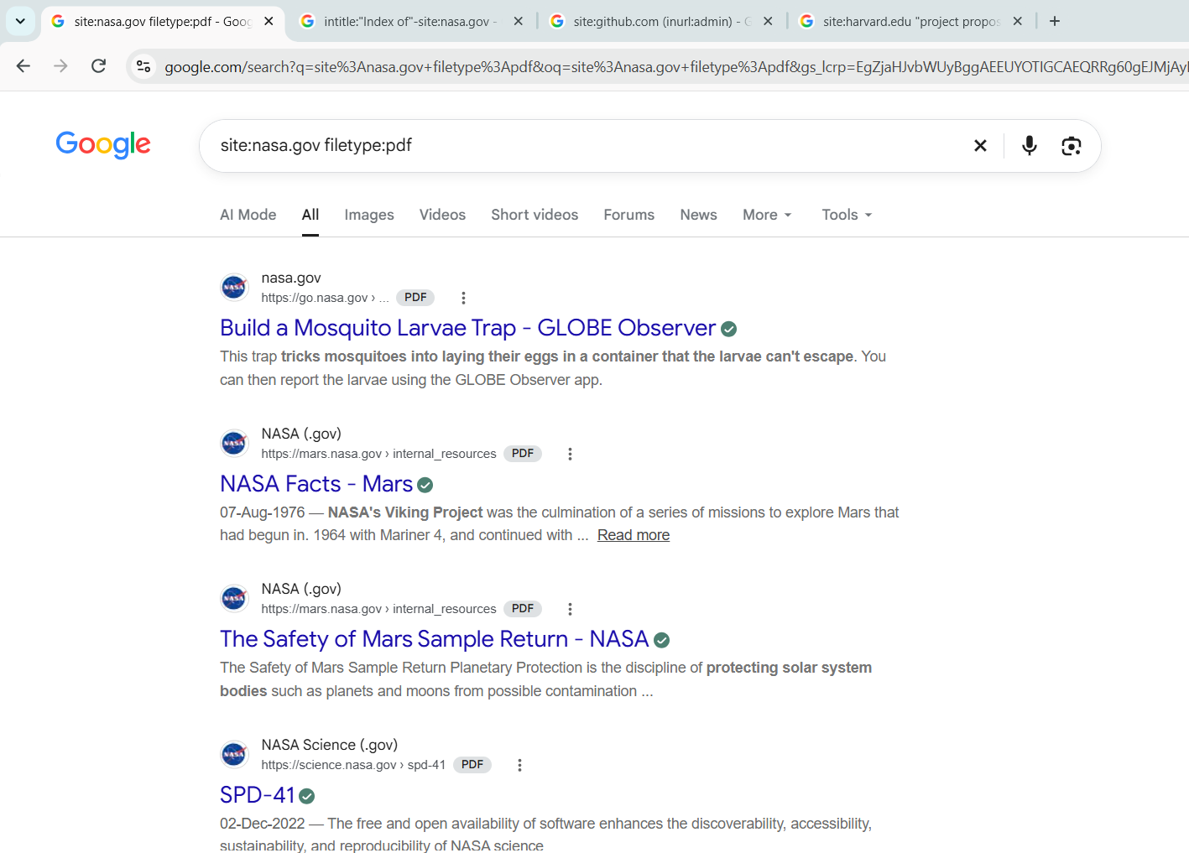
2. Use Intitle: to find pages with "Index of" in the title, and use -site: to exclude one domain.
Answer:
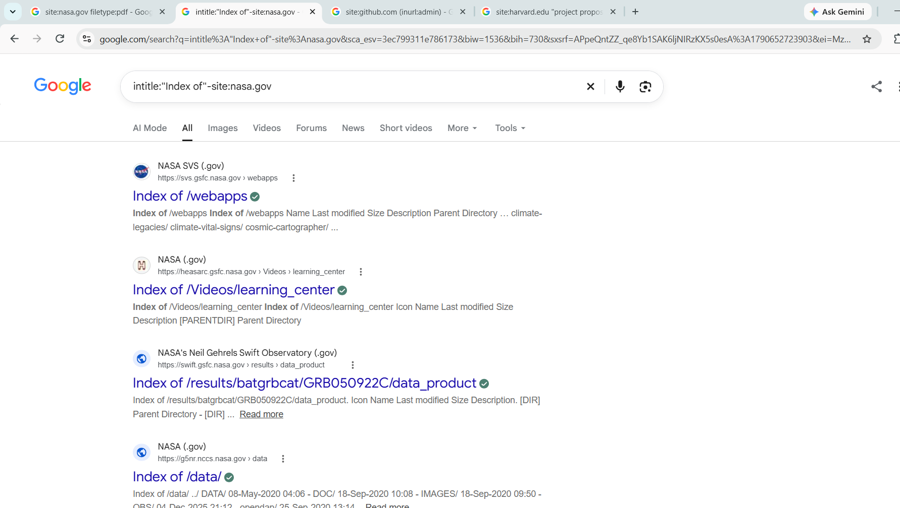
3. Use Inurl: to find pages on example.com whose URL contains "admin" or "login”.
Answer:
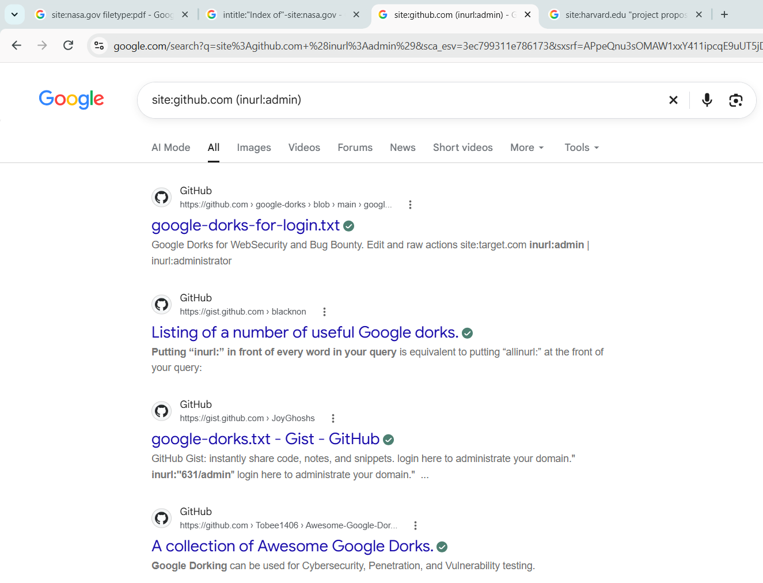
4. Use parentheses and OR to find doc or docx files about "project proposal on edu sites.
Answer:
