**Please select the appropriate category of your project**

** E-** Smartphone Application

### 

# Project Description

The product to be developed is an Android application which will facilitate visually impaired people to use basic applications in a smartphone which include Call, Text messaging, and Contacts. This application will be operated using hand gestures.

## Problem Statement

It is the right of every individual to get benefitted from the latest technology and ease provided today in cell phones. However, visually impaired are still deprived from using their smartphones because of the complexities they cannot handle. Although there are many related applications present today, like Google Talkback (1) and Speech Recognition (2) which benefit the users with disabilities. Google Talkback, for example, targets users who have poor or no visibility and provides voice assistance for usage. Whereas, Speech recognition facilitates usage on voice commands. But, there is no single application (one app) which provides full control over the above mentioned applications to them.

## Problem Solution

In order to provide a solution to the stated problem, this proposed product, comprising of features of two major market applications, Talkback and speech recognition, along with additional features (gesture and other) will provide a complete control over the list-based applications of the smartphone under a single application. A user will not need to install different applications to use all the desired features, instead, this one application will facilitate him. Using simple hand gestures (keeping in mind the sign language of visually impaired and others) and a user-friendly application it is possible to achieve all the limitations mentioned above.

## Advantages/Benefits of proposed system

The advantages include:

1. Ease to Special people.
2. No human dependency for phone usage.
3. Perform basic operation like Phone calling, SMS etc. easily.
4. User-friendly service.
5. Can be used by all age groups.
6. Easy to learn.
7. Interactive system.
8. No complicated hardware involvement.
9. Affordable.
10. Access to use all other applications of the smartphone.

## Scope

This system will be an android application which will work using hand gestures. The product will capture and manipulate these hand gestures and set control/functionality for every specific gesture. This project will require use of some existing API’s which will provide the system with features like speech to text etc. The product will give control over the list-based applications to the user. It will facilitate the user with all the basic features that are used daily (Phone calling, adding a contact, reading a text message etc.). However, the visually impaired user would not be able to perform complex operations like playing games, editing a pdf document using this product. Furthermore there will be AI based learning techniques in this product which will train the application according the users. As all of this requires a lot of research, we have started surfing the internet for related articles and research papers. Our research also includes help from an MSC thesis “Accelerometer-Based Gesture Recognition with the iPhone” by Marco Klingmann.

|  |  |
| --- | --- |
| **Modules** | **Features** |
| Capturing Gesture | * Gesture input * Learning based mechanism for recognizing gestures * Training application according to the user |
| Action on Gesture | * Move to next and previous * Make selection * Launching applications |
| Messaging | * Text to Speech (using and existing API) * Sound verifications * Haptic Feedback |

## Constraints

This project will require knowledge about accelerometers, their usage and design, which will be a complicated task as we have not studied about accelerometers before.

## Tools and Technologies

* Android studio 1.2.2
* Java
* Voice to text API
* All APIs related to accelerometers

# Project Approach

## Planned Approach

The requirements for this project will be gathered through surveys and informal interviews. Furthermore, general observations and meeting the supervisor of this project will improve clarity about the modules and all the features to be included in the project. As for the development phase, implementation will be divided into increments and every module will be integrated in the system once it is completed and tested properly.

## Software Methodology

This project will use incremental model in which the requirements will be divided into various milestones. These milestones will be further divided into smaller, more easily managed modules.  Each module passes through the requirements, design, implementation and [testing](http://istqbexamcertification.com/what-is-a-software-testing/) phases.

# Project Estimates

## Estimated Schedule

Key Project milestones relative to project start are as follows:

|  |  |
| --- | --- |
| **Project Milestones** | **Target Date** |
| Project Start | 15/02/2016 |
| Starting collecting the requirements | 16/02/2016 |
| End collecting the requirements(Expected) | 25/02/2016 |
| Discussion | 27/02/2016 |
| Module-I | 10/03/2016 |
| Module-II | 25/3/2016 |
| Module-III | 10/4/2016 |
| First documentation | 20/4/2016 |
| Second documentation | 24/4/2016 |
| Testing phase | 27/4/2016 |
|  |  |
|  |  |
|  |  |
| Project Completion | 1/5/2016 |

## Resource Requirements – Team and Support Resources

The following personnel resources are required to complete this project:

|  |  |
| --- | --- |
| **Personnel Resource Types** | **Quantity** |
| Laptop Computers | 2 |
| Smartphones | 2 |
|  |  |
| **Total Personnel Resources** | 4 |

## Mockups

Setting general control:

(3)

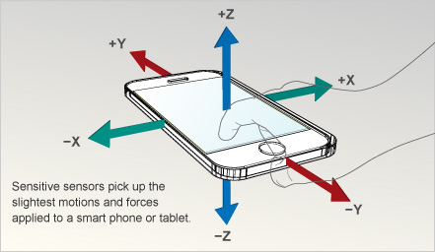

Moving control previous (left) and next (right):

(4)

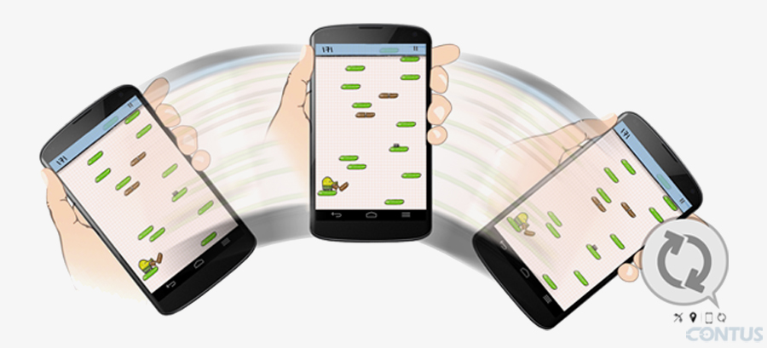

Capturing the input (gesture):

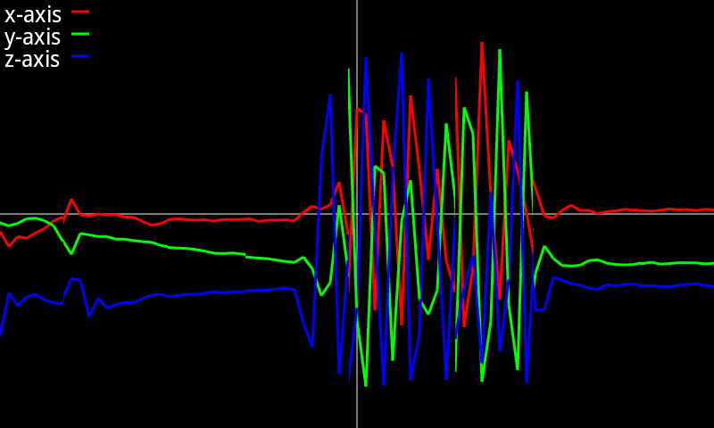

(5)

## Gantt chart

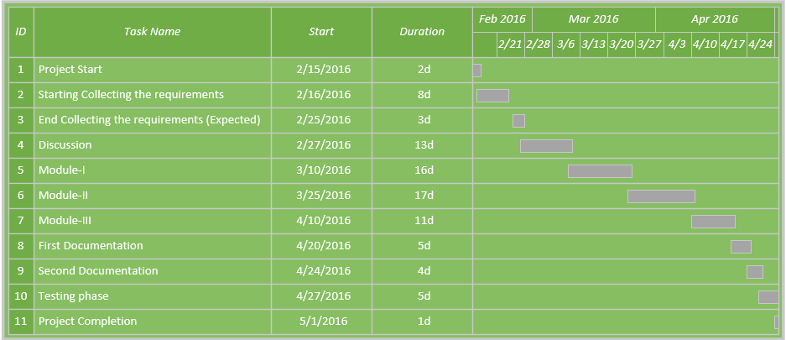

References:

1: http://www.androidcentral.com/what-google-talk-back

2:<https://play.google.com/store/apps/details>?id=appinventor.ai_xenom_apps.SpeechToText&hl=en

3: <http://www.egonomicslab.com/internet-of-things/sensors-and-sensibility/>

4: http://blog.contus.com/how-to-measure-acceleration-in-smartphones-using-accelerometer/

5:http://stackoverflow.com/questions/24299631/how-to-play-around-with-my-android-accelerometer-data