JUMPAVERSE
Complete SDL2 Developer Documentation

From SDL2 Basics to Advanced 2D Game Development
SDL2 Core • SDL2_image • SDL2_ttf • SDL2_gfx
Author: Muhammad Awais Malik
GitHub: awaismalik8107-source/Jumpa-Verse

Table of Contents
1. Project Overview — JumpaVerse
2. SDL2 Fundamentals
2.1 What is SDL2?
2.2 Installation & Setup
2.3 SDL2 Coordinate System
2.4 Window & Renderer
2.5 The Game Loop
3. SDL2 Core API — Deep Dive
3.1 Initialization & Shutdown
3.2 Events & Input
3.3 Rendering Basics
3.4 Colours & Drawing Primitives
4. SDL2_image Library
4.1 Loading Textures
4.2 Rendering Images
5. SDL2_ttf Library
5.1 Fonts & Text Rendering
5.2 TTF in JumpaVerse
6. SDL2_gfx Library
6.1 Drawing Shapes
6.2 filledTrigonRGBA — Spike Traps
7. Object-Oriented Architecture
7.1 UML Class Diagram
7.2 hitBox — Base Class
7.3 ground_Class
7.4 trapSpike
7.5 optionBoxes
7.6 mainMenuColor
8. Camera & Scrolling System
9. Procedural Ground Generation
10. Memory Management
11. Delta Time & FPS Cap
12. Complete Build Guide

1. Project Overview — JumpaVerse
JumpaVerse is a 2D infinite side-scrolling platformer built entirely in C++ using the SDL2 multimedia library. The game features procedurally generated terrain, spike traps, a camera scrolling system, a main menu with hover-state buttons, texture-mapped ground tiles, and TTF font rendering — all written without any game engine.

This documentation covers every concept used in the project — from setting up SDL2 for the first time to understanding the full object-oriented class hierarchy. Each section includes code examples, diagrams, and plain-English explanations so any beginner can follow along.

Key Features at a Glance
Procedural Ground | Ground platforms are generated randomly using std::mt19937 (Mersenne Twister) RNG, giving infinite replayable terrain.
Pseudo-Camera | SDL2 has no built-in camera — JumpaVerse fakes it by offsetting all object positions each frame.
Spike Traps | filledTrigonRGBA() from SDL2_gfx renders filled white triangles as deadly spikes.
Texture Mapping | SDL2_image loads JPEG textures for grass and underground soil tiles.
TTF Text | The game title and buttons use a custom .ttf font rendered with SDL2_ttf.
60 FPS Cap | A frame-time limiter using SDL_GetTicks() keeps the game smooth on all hardware.
Delta Time | Physics and camera speed are multiplied by deltaTime for frame-rate-independent motion.
OOP Design | All game objects inherit from a shared hitBox base class, keeping collision data unified.

File Structure
Jumpa-Verse/
├── main.cpp // Entry point — game loop, init, SDL lifecycle
├── object.h // All class definitions (hitBox, ground_Class, trapSpike, optionBoxes)
├── functions.h // Function declarations (forward declarations)
├── Error_Handlers.cpp// init() and close() — SDL/TTF/IMG setup and teardown
├── ground.cpp // Procedural ground generation + memory management
├── camera.cpp // Camera offset application across all objects
├── traps.cpp // Spike trap spawning and cleanup
├── menuScreen.cpp // Main menu loop, hover detection, button rendering
├── debrosee-font/ // Custom TTF font file
└── Images_textures/ // ground.jpeg + underGround.jpeg

2. SDL2 Fundamentals

2.1 What is SDL2?
SDL2 (Simple DirectMedia Layer 2) is a free, open-source, cross-platform C library that gives you direct access to hardware: graphics, audio, keyboard, mouse, joystick, and more. It works on Windows, Linux, macOS, iOS, and Android.

SDL2 is NOT a game engine — it is a low-level hardware abstraction layer. You are responsible for every pixel, every frame, every collision. This makes it the perfect tool for learning how games really work.

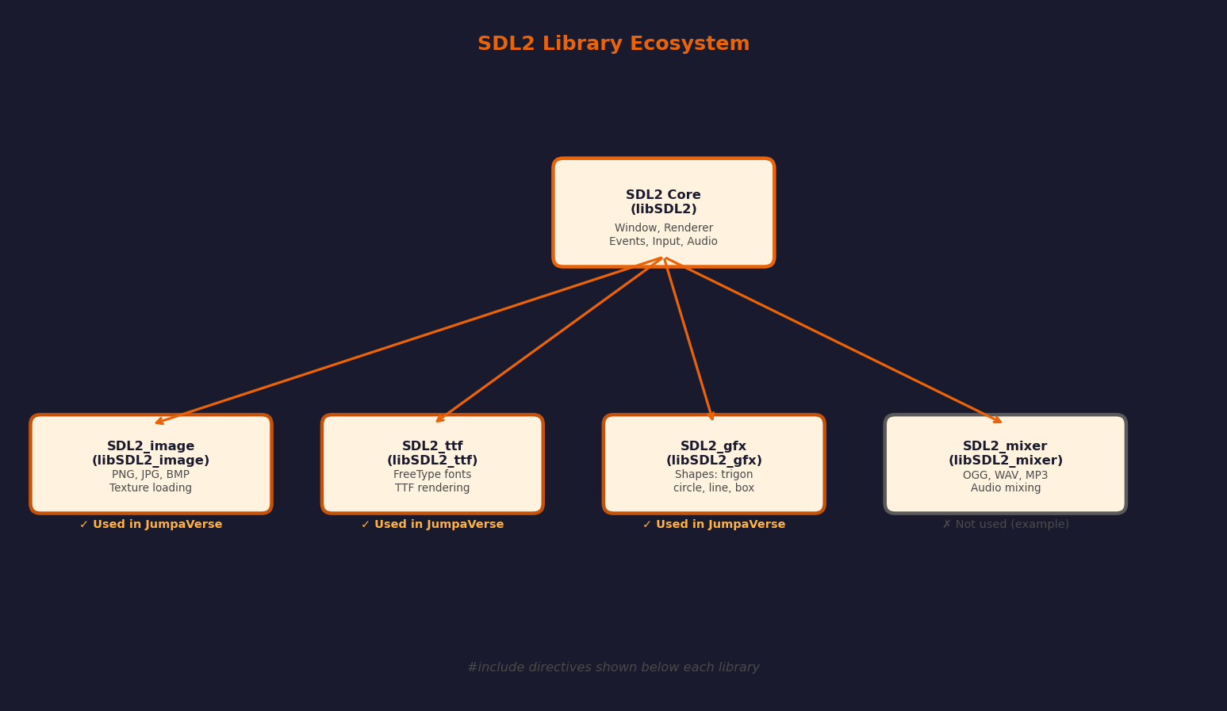
Figure 2.1 — SDL2 library ecosystem and which sub-libraries JumpaVerse uses

2.2 Installation & Setup

Linux (Ubuntu / Debian)
sudo apt-get update
sudo apt-get install libsdl2-dev libsdl2-image-dev libsdl2-ttf-dev libsdl2-gfx-dev

Windows (MinGW)
# Download SDL2 development packages from https://libsdl.org
# Place headers in MinGW/include/SDL2/
# Place .dll and .a files in MinGW/lib/

Compilation Command
JumpaVerse compiles all source files together and links all four SDL2 libraries:
g++ main.cpp ground.cpp camera.cpp traps.cpp menuScreen.cpp Error_Handlers.cpp \
-o jumpaverse \
-lSDL2 -lSDL2_image -lSDL2_ttf -lSDL2_gfx \
-std=c++17

2.3 SDL2 Coordinate System
SDL2 uses a screen-space coordinate system where (0, 0) is the top-left corner of the window. X increases to the right, and Y increases downward. This is the opposite of traditional mathematics, where Y goes upward.

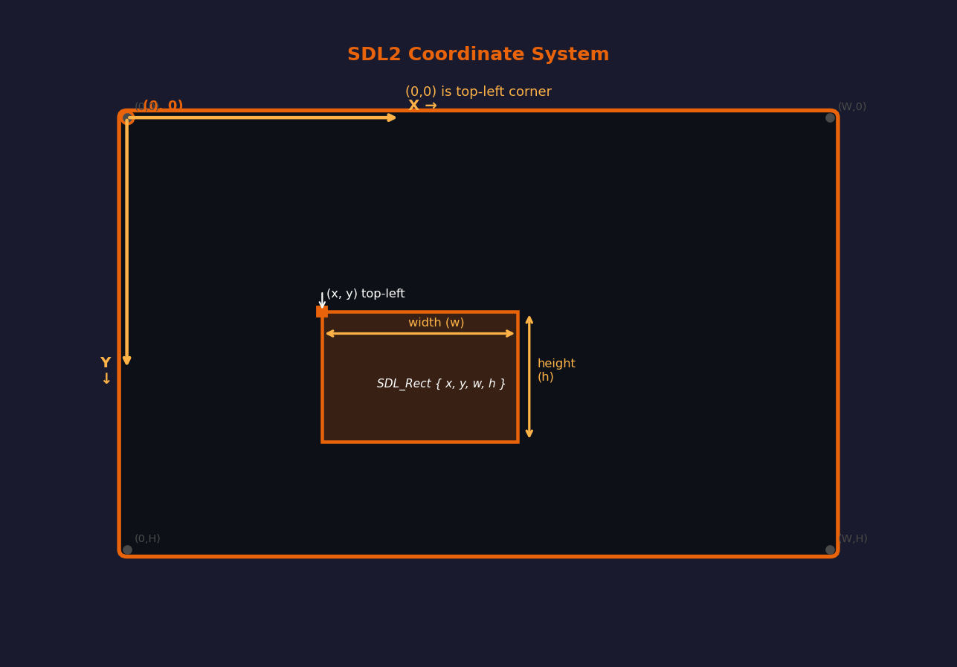
Figure 2.2 — SDL2 coordinate system with SDL_Rect layout
SDL_Rect — The Most Used Structure
SDL_Rect represents a rectangle with four integers:
• x — horizontal position of the left edge
• y — vertical position of the top edge
• w — width of the rectangle in pixels
• h — height of the rectangle in pixels
Nearly every render and collision operation in SDL2 uses SDL_Rect.

SDL_Rect myRect;
myRect.x = 100; // 100 pixels from left
myRect.y = 200; // 200 pixels from top
myRect.w = 50; // 50 pixels wide
myRect.h = 50; // 50 pixels tall

// Or use compound initialiser:
SDL_Rect myRect = { 100, 200, 50, 50 };

2.4 Window & Renderer
Every SDL2 application needs two core objects: a Window (the OS window shown on screen) and a Renderer (the hardware-accelerated 2D drawing context attached to that window).

SDL_Window | What each argument does
SDL_Window* win = SDL_CreateWindow(  "Title",  SDL_WINDOWPOS_CENTERED,  SDL_WINDOWPOS_CENTERED,  1920, 1080,  SDL_WINDOW_SHOWN  ); | Function to create the OS window  Title bar text  X position — auto-centered  Y position — auto-centered  Width × Height in pixels  SDL_WINDOW_SHOWN = visible immediately  Returns NULL on failure

// Create an accelerated renderer (uses GPU)
SDL_Renderer* renderer = SDL_CreateRenderer(
window, // attach to this window
-1, // use first available graphics driver
SDL_RENDERER_ACCELERATED // GPU-accelerated
);

From JumpaVerse — Error_Handlers.cpp
The init() function in JumpaVerse creates a 1980×1260 window and an accelerated renderer. If either step fails, SDL_GetError() is called to print the exact error message and the function returns false, cleanly stopping the game before any crash occurs.

2.5 The Game Loop
A game loop runs every frame — typically 60 times per second. It has three phases: Process Input → Update State → Render. JumpaVerse adds a fourth concern: time management (delta time and FPS capping).

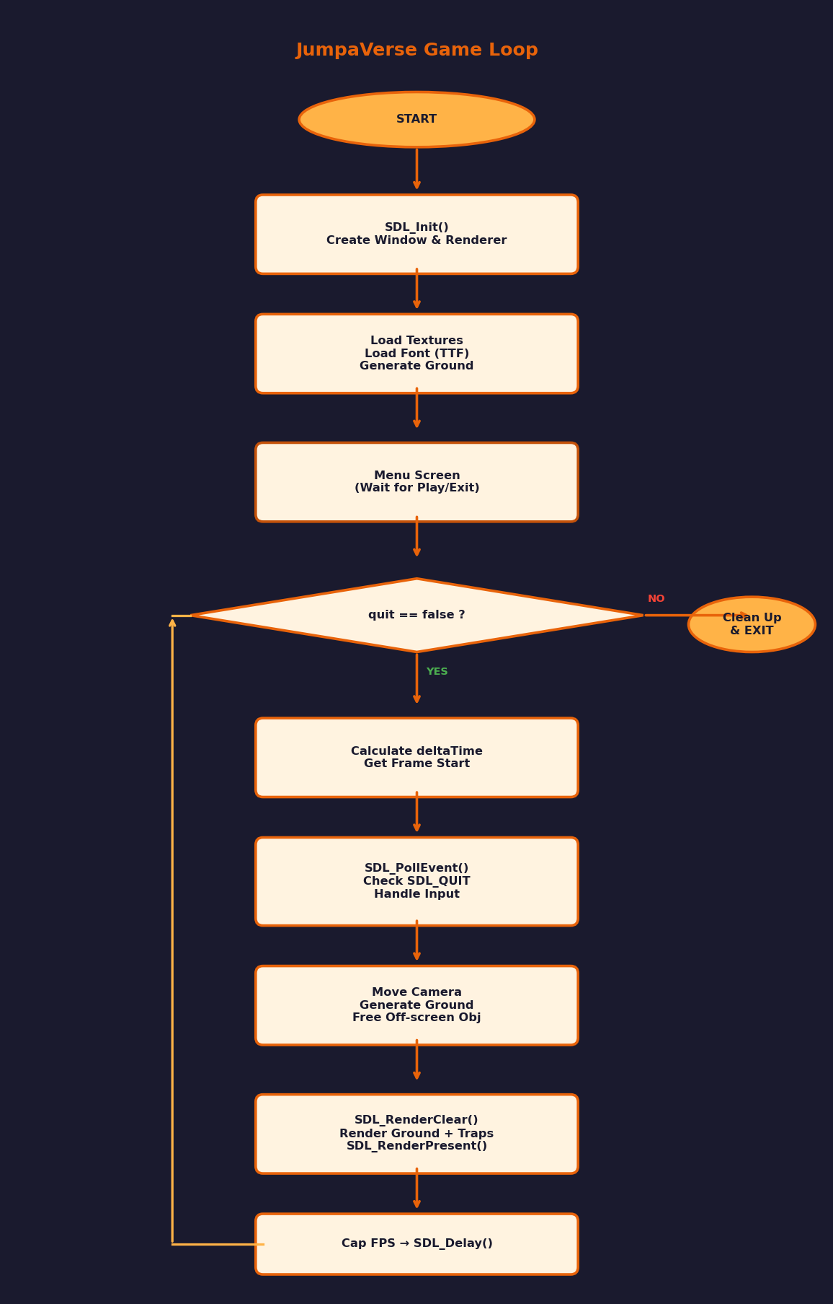
Figure 2.3 — JumpaVerse game loop flowchart
bool quit = false;
SDL_Event event;

while (!quit) {
// 1. PROCESS INPUT
while (SDL_PollEvent(&event)) {
if (event.type == SDL_QUIT) quit = true;
}

// 2. UPDATE GAME STATE
cameraMovmentObj(ground, cameraOffset, traps);

// 3. RENDER
SDL_SetRenderDrawColor(renderer, 135, 206, 235, 255);
SDL_RenderClear(renderer);
for (auto& g : ground) g.render(renderer);
SDL_RenderPresent(renderer);
}

3. SDL2 Core API — Deep Dive

3.1 Initialization & Shutdown
SDL2 must be initialized before any other call. SDL_Init() takes a flags parameter that selects which subsystems to start. Always call SDL_Quit() before exiting, and match each subsystem init with its cleanup.
#include <SDL2/SDL.h>

// Initialize VIDEO subsystem
if (SDL_Init(SDL_INIT_VIDEO) < 0) {
std::cerr << "Error: " << SDL_GetError() << std::endl;
return -1;
}

// ... your game ...

SDL_Quit(); // Always call at exit

SDL_Init Flag | What It Enables
SDL_INIT_VIDEO | Window creation and 2D rendering — the most common flag
SDL_INIT_AUDIO | Audio output (needed for SDL2_mixer)
SDL_INIT_EVENTS | Event handling (auto-included with VIDEO)
SDL_INIT_JOYSTICK | Gamepad and joystick input
SDL_INIT_EVERYTHING | All of the above — convenient but slower startup

3.2 Events & Input
SDL2 has a unified event system. Every frame you call SDL_PollEvent() in a loop until all pending events are consumed. The SDL_Event union holds the event type and type-specific data in sub-structs.
SDL_Event event;

while (SDL_PollEvent(&event)) {
switch (event.type) {

case SDL_QUIT: // Window X button pressed
quit = true;
break;

case SDL_KEYDOWN: // A key was pressed
if (event.key.keysym.sym == SDLK_SPACE)
player.jump();
break;

case SDL_MOUSEBUTTONDOWN: // Mouse click
int mx = event.button.x;
int my = event.button.y;
break;
}
}

// Poll mouse position without event:
int mx, my;
Uint32 buttons = SDL_GetMouseState(&mx, &my);

JumpaVerse uses both SDL_PollEvent for quit detection and SDL_GetMouseState for the hover-state buttons in the main menu — checking if the cursor is inside a button's SDL_Rect each frame.

3.3 Rendering Basics
The rendering pipeline in SDL2 is: Clear → Draw → Present. SDL_RenderClear fills the backbuffer with a solid colour. All draw calls write to this backbuffer. SDL_RenderPresent swaps the backbuffer onto screen (double buffering).
// --- Each frame:

// Step 1: Set clear colour (sky blue in JumpaVerse)
SDL_SetRenderDrawColor(renderer, 135, 206, 235, 255);
// R G B Alpha

// Step 2: Fill backbuffer with that colour
SDL_RenderClear(renderer);

// Step 3: Draw everything here
SDL_RenderCopy(renderer, texture, nullptr, &destRect);

// Step 4: Show the frame
SDL_RenderPresent(renderer);

3.4 Colours & Drawing Primitives
SDL2 core can draw filled/outlined rectangles and lines. Colours in SDL2 are RGBA bytes (0–255 each). SDL_Color is a convenience struct with .r .g .b .a members.
SDL_Color orange = {255, 127, 0, 255}; // R G B A

// Draw a filled rectangle
SDL_SetRenderDrawColor(renderer, 255, 127, 0, 255);
SDL_Rect rect = {100, 100, 200, 100};
SDL_RenderFillRect(renderer, &rect);

// Draw outline only
SDL_RenderDrawRect(renderer, &rect);

// Draw a line
SDL_RenderDrawLine(renderer, 0, 500, 1920, 500);

// Draw a single pixel
SDL_RenderDrawPoint(renderer, 960, 540);

4. SDL2_image Library
SDL2 core can only load BMP images. SDL2_image extends this to support PNG, JPEG, GIF, TIFF, WebP, and more. JumpaVerse uses it to load JPEG textures for the ground tiles.

4.1 Initializing and Loading Textures
#include <SDL2/SDL_image.h>

// Initialize with the formats you need (IMG_INIT_JPG | IMG_INIT_PNG)
if (!(IMG_Init(IMG_INIT_JPG) & IMG_INIT_JPG)) {
std::cerr << IMG_GetError() << std::endl;
return false;
}

// Load directly to GPU texture (most efficient method)
SDL_Texture* tex = IMG_LoadTexture(renderer, "path/to/image.jpg");

if (!tex) {
std::cerr << IMG_GetError() << std::endl;
}

// At program exit:
SDL_DestroyTexture(tex);
IMG_Quit();

Why IMG_LoadTexture instead of IMG_Load?
IMG_Load() returns an SDL_Surface (CPU memory). You would then call SDL_CreateTextureFromSurface() and SDL_FreeSurface(). IMG_LoadTexture() does all three steps in one call, going directly to the GPU. Always prefer IMG_LoadTexture when you just need to display an image.

4.2 Rendering Images
SDL_RenderCopy draws a texture into a destination SDL_Rect on screen. The third argument (source rect) can be nullptr to use the entire texture.
SDL_Texture* groundTex = IMG_LoadTexture(renderer, "Images_textures/ground.jpeg");

// Draw the texture filling this rectangle:
SDL_Rect dest = {100, 500, 50, 50};
SDL_RenderCopy(
renderer, // the renderer
groundTex, // texture to draw
nullptr, // source rect — nullptr = whole texture
&dest // destination rect on screen
);

JumpaVerse renders ground tiles in a grid. Each tile's SDL_Rect is pre-computed in ground_Class::rebuild() and stored in vectors. The render() method just loops through those rects calling SDL_RenderCopy, which is very efficient because all tiles share one texture pointer — the GPU only stores the image once.

5. SDL2_ttf Library
SDL2_ttf uses the FreeType library under the hood to render TrueType (.ttf) and OpenType (.otf) fonts. It converts font glyphs into SDL_Surfaces, which you then upload to the GPU as textures.

5.1 Initialization & Font Loading
#include <SDL2/SDL_ttf.h>

// Must be called before any TTF function
if (TTF_Init() < 0) {
std::cerr << "TTF error: " << TTF_GetError() << std::endl;
return false;
}

// Load font at a given point size
TTF_Font* font = TTF_OpenFont("debrosee-font/Debrosee-ALPnL.ttf", 100);
// path size in pts

if (!font) {
std::cerr << TTF_GetError() << std::endl;
}

5.2 Rendering Text
SDL2_ttf offers three rendering quality modes. Solid is fastest. Blended is highest quality with proper alpha blending (used in JumpaVerse for smooth anti-aliased text).
SDL_Color textColor = {255, 127, 0, 255}; // Orange

// TTF_RenderText_Solid — fast, no anti-aliasing
// TTF_RenderText_Shaded — anti-aliased with a background box
// TTF_RenderText_Blended — best quality, transparent background
SDL_Surface* surface = TTF_RenderText_Blended(font, "Play", textColor);

// Upload to GPU
SDL_Texture* textTex = SDL_CreateTextureFromSurface(renderer, surface);
SDL_FreeSurface(surface); // CPU copy no longer needed

// Get rendered size
int textW, textH;
SDL_QueryTexture(textTex, NULL, NULL, &textW, &textH);

// Center the text inside button box
SDL_Rect destRect = {
box.x + (box.w - textW) / 2,
box.y + (box.h - textH) / 2,
textW, textH
};
SDL_RenderCopy(renderer, textTex, NULL, &destRect);

JumpaVerse TTF Usage — optionBoxes
The optionBoxes class stores two SDL_Texture* pointers (textTexture for 'Play', exitTexture for 'Exit'). The box_Initializer() method is called every frame when hover state changes — it destroys the old texture, re-renders the text in orange (hover) or grey (normal), and creates a new GPU texture. SDL_QueryTexture extracts the rendered pixel dimensions so the text can be perfectly centred in the button.

// From JumpaVerse — optionBoxes::box_Initializer()
SDL_Color color = !state ? SDL_Color{255,127,0,255} // normal = orange
: SDL_Color{192,192,192,255}; // hover = grey

SDL_Surface* surf = TTF_RenderText_Blended(font, text.c_str(), color);
textTexture = SDL_CreateTextureFromSurface(renderer, surf);
SDL_FreeSurface(surf);
// Cleanup (destructor)
~optionBoxes() {
if (textTexture) SDL_DestroyTexture(textTexture);
if (exitTexture) SDL_DestroyTexture(exitTexture);
}

6. SDL2_gfx Library
SDL2_gfx (SDL2 Graphics Primitives + Framerate) extends SDL2's basic drawing with filled shapes: circles, ellipses, arcs, bezier curves, polygons, and trigons (triangles). It is the go-to library for drawing shapes SDL2 core cannot.

6.1 Drawing Shapes — Quick Reference
#include <SDL2/SDL2_gfxPrimitives.h>

// Circle (outline)
circleRGBA(renderer, cx, cy, radius, R, G, B, A);

// Filled circle
filledCircleRGBA(renderer, cx, cy, radius, R, G, B, A);

// Line with width
thickLineRGBA(renderer, x1, y1, x2, y2, width, R, G, B, A);

// Filled polygon (array of points)
filledPolygonRGBA(renderer, vx, vy, n, R, G, B, A);

// Rectangle with rounded corners
roundedBoxRGBA(renderer, x1, y1, x2, y2, radius, R, G, B, A);

6.2 filledTrigonRGBA — Spike Traps
A trigon in SDL2_gfx is a three-point filled triangle defined by three (x, y) coordinate pairs. JumpaVerse uses filledTrigonRGBA to draw all spike traps as white triangles pointing upward, then draws a black outline on top with trigonRGBA.

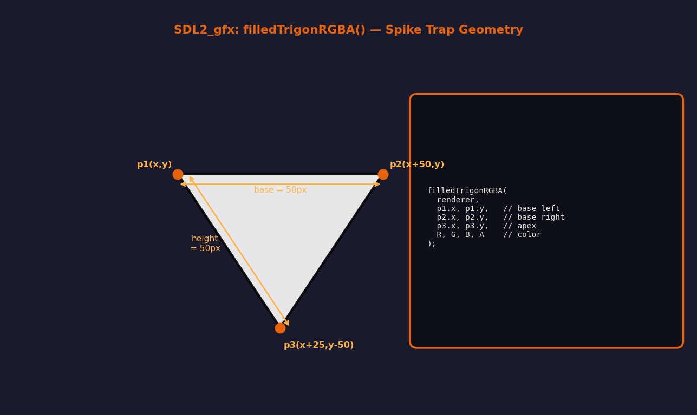
Figure 6.1 — Trigon geometry used for JumpaVerse spike traps
// From object.h — trapSpike constructor
// p1 = bottom-left, p2 = bottom-right, p3 = apex
p1 = {x, y }; // base left
p2 = {x + 50, y }; // base right (50px wide)
p3 = {x + 25, y - 50}; // tip (25px right, 50px above base)

// Drawing in trapSpike::render()
filledTrigonRGBA(renderer,
p1.x + cameraOffset, p1.y, // bottom-left
p2.x + cameraOffset, p2.y, // bottom-right
p3.x + cameraOffset, p3.y, // apex
255, 255, 255, 255); // white fill

trigonRGBA(renderer, // black outline
p1.x + cameraOffset, p1.y,
p2.x + cameraOffset, p2.y,
p3.x + cameraOffset, p3.y,
0, 0, 0, 255);

Why cast cameraOffset to int?
filledTrigonRGBA takes Sint16 (signed 16-bit integers) for coordinates. The cameraOffset is a float. Passing float directly would truncate. The cast (int) is safe here because pixel coordinates don't need sub-pixel precision for a spike trap outline. For smooth physics, always keep your logical position as float and only convert to int at render time.

7. Object-Oriented Architecture
JumpaVerse uses classical C++ inheritance. A single base class — hitBox — stores the fundamental position and size data. All game objects inherit from it, ensuring every object has consistent x, y, w, h fields that can be used for collision detection or positioning without casting.

7.1 UML Class Diagram
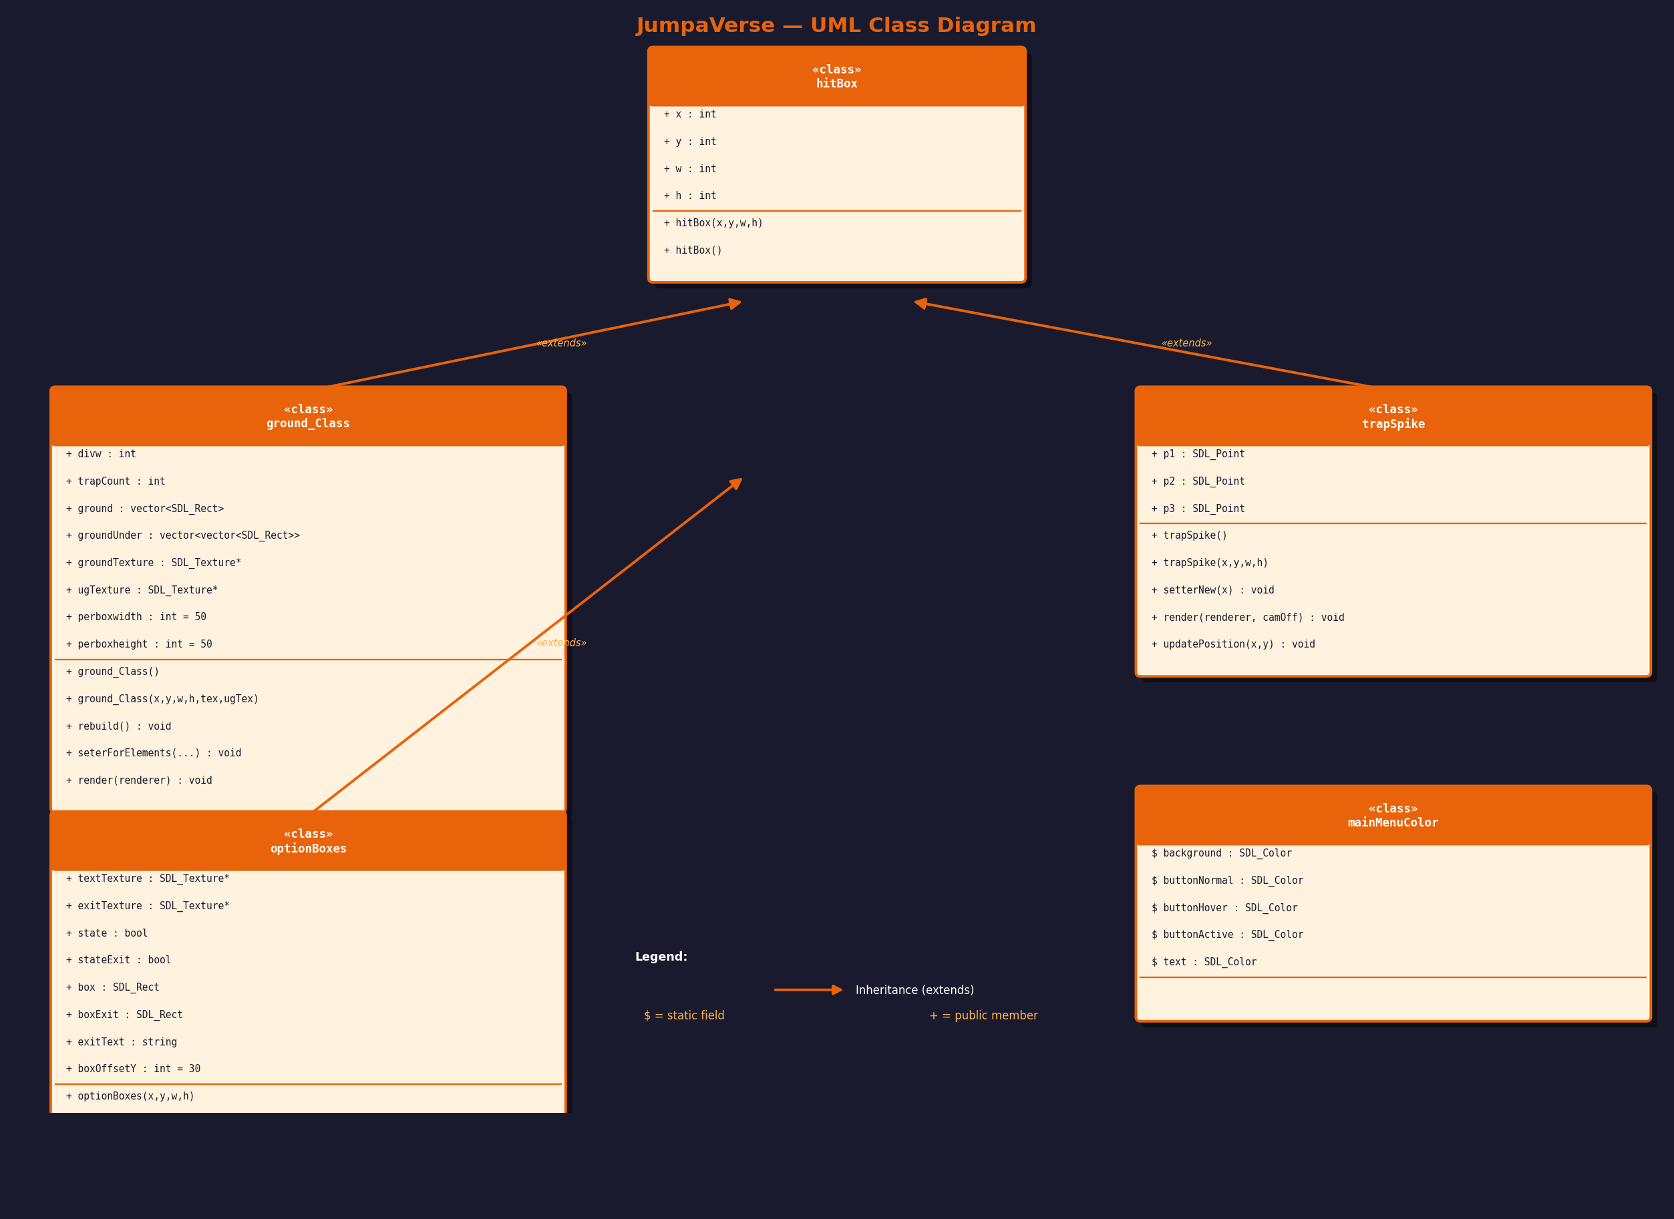
Figure 7.1 — Full UML class hierarchy of JumpaVerse

7.2 hitBox — The Base Class
hitBox is a pure data class. It stores a bounding rectangle (x, y, w, h) and is inherited by every interactive object in the game. Using a base class for this means all collision and camera code only needs to know about hitBox, not each specific subclass.
class hitBox {
public:
int x, y, w, h; // position and size

// Parameterised constructor
hitBox(int x, int y, int w, int h)
: x(x), y(y), w(w), h(h) {}

hitBox(); // default constructor
};

7.3 ground_Class
ground_Class represents one platform segment. It inherits hitBox for its bounding box, and builds a grid of SDL_Rect tiles internally. Two shared texture pointers (not owned, just borrowed) point to the GPU textures loaded in main.
class ground_Class : public hitBox {
public:
int divw = 0; // how many tiles wide
int trapCount = 0; // traps spawned on this segment

// 1D array of top-surface tiles
std::vector<SDL_Rect> ground;

// 2D array of underground tiles
std::vector<std::vector<SDL_Rect>> groundUnder;

// Borrowed texture pointers (not owned — no delete)
SDL_Texture* groundTexture = nullptr;
SDL_Texture* ugTexture = nullptr;

int perboxwidth = 50; // tile size
int perboxheight = 50;

// rebuild() recalculates all SDL_Rects from x,y,w,h
void rebuild();
void seterForElements(int x, int y, int w, int h);
void render(SDL_Renderer* renderer);
};

The key insight in ground_Class is the separation of geometry from data. The constructor just stores the texture pointer and calls rebuild(). rebuild() does the actual math — dividing width by perboxwidth to get divw tiles, creating a row of top tiles and a 2D grid of underground tiles. This means seterForElements() can reposition the whole platform cheaply by updating x/y/w/h and calling rebuild().

7.4 trapSpike
trapSpike represents a single spike trap. It stores three SDL_Point values (p1, p2, p3) which define the three vertices of the triangle rendered by filledTrigonRGBA.
class trapSpike : public hitBox {
public:
SDL_Point p1; // bottom-left vertex
SDL_Point p2; // bottom-right vertex
SDL_Point p3; // apex (top, pointed up)

trapSpike(int x, int y, int w, int h) : hitBox(x, y, w, h) {
p1 = {x, y };
p2 = {x + 50, y };
p3 = {x + 25, y - 50};
}

void setterNew(int x) { // update x, recalculate all 3 points
this->x = x;
p1 = {x, y};
p2 = {x + 50, y};
p3 = {x + 25, y - 50};
}

void render(SDL_Renderer* renderer, float cameraOffset = 0);
};

7.5 optionBoxes
optionBoxes is the UI button class. It manages two clickable SDL_Rect buttons (Play and Exit), handles hover colour changes, and renders TTF-generated text textures centred inside each button.
class optionBoxes : public hitBox {
public:
SDL_Texture* textTexture = nullptr; // 'Play' text
SDL_Texture* exitTexture = nullptr; // 'Exit' text
bool state = false; // is 'Play' being hovered?
bool stateExit = false; // is 'Exit' being hovered?
SDL_Rect box; // Play button rect
SDL_Rect boxExit; // Exit button rect

void box_Initializer(SDL_Renderer*, TTF_Font*, std::string text);
void render(SDL_Renderer*);
void stateHolder(SDL_Renderer*, TTF_Font*, std::string, bool, bool);
};

7.6 mainMenuColor
mainMenuColor is a static-only class (no instances needed) that centralises all menu colour definitions. Static members are defined once in menuScreen.cpp and accessible anywhere via mainMenuColor::background etc. This makes theme changes trivial — one file, one change.
class mainMenuColor {
public:
static SDL_Color background; // {30, 30, 30, 255} — dark
static SDL_Color buttonNormal; // {70, 130, 180, 255} — steel blue
static SDL_Color buttonHover; // {100, 160, 210, 255}
static SDL_Color buttonActive; // {40, 90, 140, 255}
static SDL_Color text; // {255, 255, 255, 255} — white
};

8. Camera & Scrolling System
SDL2 has no built-in 2D camera. JumpaVerse creates the illusion of a moving camera by shifting every object's x-coordinate by a negative offset each frame. As cameraOffset decreases, all objects slide to the left — simulating forward movement.

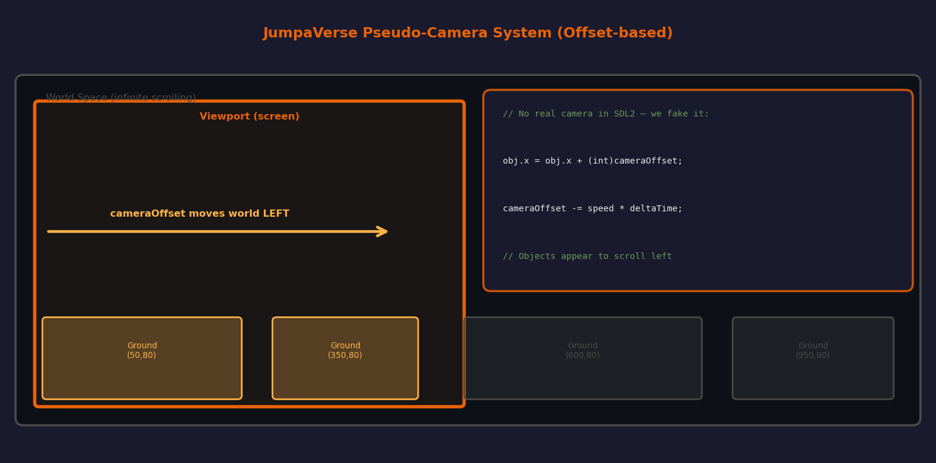
Figure 8.1 — JumpaVerse pseudo-camera offset system
// camera.cpp — cameraMovmentObj()
void cameraMovmentObj(std::vector<ground_Class>& ground,
float cameraOffset,
std::vector<trapSpike>& trap) {
for (int i = 0; i < ground.size(); i++) {
ground[i].seterForElements(
ground[i].x + (int)cameraOffset, // shift x
ground[i].y, // y unchanged
ground[i].w,
ground[i].h
);
}
}

// main.cpp — update cameraOffset using delta time
float speed = 2.0f; // pixels per second
if (cameraOffset > -9.0f)
cameraOffset -= speed * deltaTime;

Why is cameraOffset a float?
Integer arithmetic causes jittery movement at low speeds because one pixel is the smallest step. By keeping cameraOffset as a float and multiplying by deltaTime, you get smooth sub-pixel accumulation. The cast to int only happens at render time in seterForElements, so the internal state is always precise.

9. Procedural Ground Generation
JumpaVerse uses the C++ <random> library with a Mersenne Twister (std::mt19937) RNG to procedurally generate each new ground segment as the player scrolls. This gives infinite, varied terrain without storing any data.
#include <random>

// Seed the generator with a true random value
std::random_device rd;
std::mt19937 gen(rd());

// Create a uniform distribution in a range
std::uniform_int_distribution<> distx(
prevGround.back().x + prevGround.back().w + 120, // min gap after last platform
prevGround.back().x + prevGround.back().w + 200 // max gap
);

std::uniform_int_distribution<> distw(300, 2450); // platform width
std::uniform_int_distribution<> disth(50, 400); // platform height
std::uniform_int_distribution<> disty(
prevGround.back().y - 100, // can be slightly higher
prevGround.back().y + 600 // or much lower
);

int x = distx(gen);
int y = disty(gen);
// y is validated to be between 100–800 before accepting

The main game loop checks if the ground vector has fewer than 30 elements. If so, groundRandomgenerator() is called to append a new segment. Once a segment's x position has scrolled past x >= 2400 (far right, off screen to the right side), freeMemory() erases it from the vector. This keeps the vector bounded in size — never growing unboundedly.
// ground.cpp — freeMemory()
void freeMemory(std::vector<ground_Class>& ground) {
for (int i = 0; i < ground.size(); ) {
if (ground[i].x >= 2400) // off the right edge
ground.erase(ground.begin() + i);
else
i++;
}
}

10. Memory Management
JumpaVerse uses two memory strategies: shared textures and bounded vectors. Understanding both is critical for any SDL2 project.

Shared Textures (Non-Owning Pointers)
The most important pattern in JumpaVerse is that ground_Class stores a pointer to a texture but does NOT own it. The texture is loaded once in main.cpp and passed into every ground_Class and trapSpike. When a ground object is erased, it does NOT call SDL_DestroyTexture — that would corrupt the shared texture for all remaining objects.
// main.cpp — textures loaded ONCE
SDL_Texture* groundTex = IMG_LoadTexture(renderer, "Images_textures/ground.jpeg");
SDL_Texture* ugTex = IMG_LoadTexture(renderer, "Images_textures/underGround.jpeg");

// ground_Class stores a borrowed pointer
SDL_Texture* groundTexture = nullptr; // NOT owned — do not delete!

// close() destroys the textures at the very end:
SDL_DestroyTexture(groundTex);
SDL_DestroyTexture(ugTex);

Trap Vector Bounded Cleanup
// traps.cpp — trapFreeMemory()
void trapFreeMemory(std::vector<trapSpike>& trap) {
if (trap.size() > 20)
trap.erase(trap.begin()); // remove oldest
}

trapSpike objects do not hold GPU resources (they are rendered via SDL2_gfx directly each frame, no textures). So erasing them from the vector is safe and immediate — no cleanup needed beyond the erase.

TTF Texture Cleanup
optionBoxes creates new TTF textures every time hover state changes. It must destroy the previous texture before creating the replacement, or it leaks GPU memory. The destructor and box_Initializer both handle this:
void box_Initializer(SDL_Renderer* renderer, TTF_Font* font, std::string text) {
// Step 1: destroy OLD textures before making new ones
if (textTexture) SDL_DestroyTexture(textTexture);
if (exitTexture) SDL_DestroyTexture(exitTexture);

// Step 2: re-render text with new colour
SDL_Surface* surface = TTF_RenderText_Blended(font, text.c_str(), color);
textTexture = SDL_CreateTextureFromSurface(renderer, surface);
SDL_FreeSurface(surface); // free CPU copy immediately
}

11. Delta Time & FPS Cap
Delta time is the number of seconds that have passed since the last frame. Multiplying any speed value by deltaTime ensures the game runs at the same perceived speed on all hardware, regardless of actual frame rate.
Uint32 lastTime = SDL_GetTicks(); // ms since SDL_Init

while (!quit) {
Uint32 frameStart = SDL_GetTicks();
Uint32 currentTime = SDL_GetTicks();
float deltaTime = (currentTime - lastTime) / 1000.0f; // to seconds
lastTime = currentTime;

// Clamp — prevents physics explosions after a hiccup
if (deltaTime > 0.05f) deltaTime = 0.05f; // max 50ms per frame

// Frame-rate independent movement
float speed = 2.0f; // pixels per second
cameraOffset -= speed * deltaTime;

// --- render everything ---

// FPS cap at 60
const float targetFrameTime = 1000.0f / 60.0f; // 16.67ms
Uint32 frameTime = SDL_GetTicks() - frameStart;
if (frameTime < targetFrameTime)
SDL_Delay((Uint32)(targetFrameTime - frameTime));
}

Why clamp deltaTime?
If the OS pauses your process for any reason (background load, disk I/O) the next delta could be 500ms or more. Without clamping, objects would jump across enormous distances in one update step, breaking procedural generation and camera maths. Clamping at 50ms (0.05f) gives a safe maximum step while still allowing slight hitches to pass through gracefully.

12. Complete Build Guide

Prerequisites
- C++17 compiler: g++ (GCC 7+) or clang++
- SDL2 development libraries installed (see Chapter 2.2)
- All source .cpp files in the same directory

Clone the Repository
git clone https://github.com/awaismalik8107-source/Jumpa-Verse.git
cd Jumpa-Verse

Compile
g++ main.cpp ground.cpp camera.cpp traps.cpp menuScreen.cpp Error_Handlers.cpp \
-o jumpaverse \
-lSDL2 -lSDL2_image -lSDL2_ttf -lSDL2_gfx \
-std=c++17 -Wall

Run
./jumpaverse

Library Linker Flags Summary
Flag | Library | Used For
-lSDL2 | SDL2 Core | Window, Renderer, Events, Timer
-lSDL2_image | SDL2_image | Loading JPEG/PNG textures
-lSDL2_ttf | SDL2_ttf | TrueType font rendering
-lSDL2_gfx | SDL2_gfx | Trigon (spike trap) drawing

Common Errors & Fixes
Error | Fix
cannot find -lSDL2_gfx | Install: sudo apt install libsdl2-gfx-dev
SDL_image could not initialize | Pass IMG_INIT_JPG to IMG_Init() and check return value
TTF NOT FOUND (init fails) | sudo apt install libsdl2-ttf-dev
Segfault on render | Check that groundTexture != nullptr before SDL_RenderCopy
Black window / no texture | Verify file path is relative to working directory of the executable

End of JumpaVerse Documentation — Happy Coding!
github.com/awaismalik8107-source/Jumpa-Verse

