1. Management Accounts – Structural Issues

1.1 BDO sheet not correctly replicated
In “Management Accounts Q3 2025 – Draft 1”, the newly created BDO sheet is not pasted consistently with prior quarters:
- Row 1 titles are missing
- Category subtitles (bold headers in column A) are missing
- Calculated rows at the bottom (present in earlier quarters) are not included
This indicates the automation is pasting raw values rather than cloning the full structural template and injecting data, which causes downstream issues. Screenshot 1 is the expected output and screenshot 2 is the current incorrect output
Screenshot 1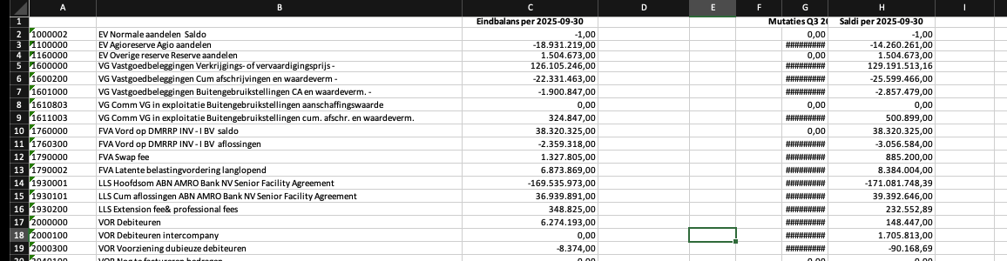
Screenshot 2
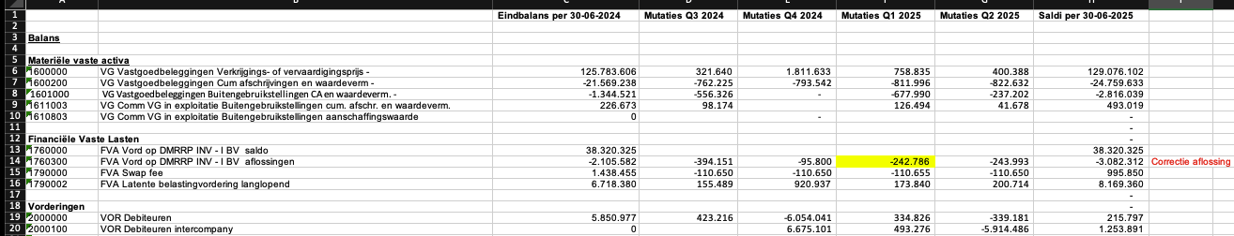
Example of calculated rows that are missing 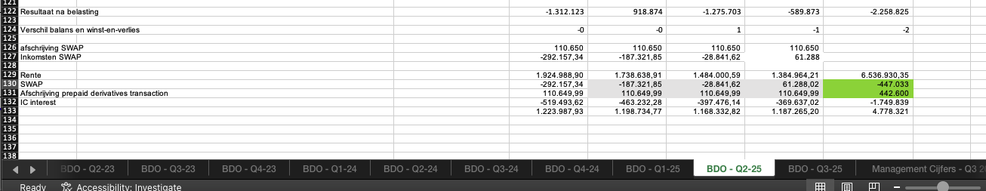

2. Management cijfers – Column Creation Logic

2.1 Quarterly + LTM columns incorrect
In “Management cijfers – Q3 2025”, the column roll-forward logic does not match historical structure:
- Expected:
  - Column AA: Q3 2025
  - Column AB: LTM Q3 2025 (highlighted blue)
  - Empty spacer column, then commentary columns
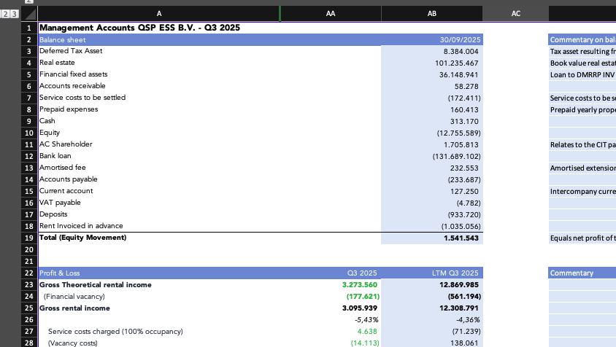
- Actual output:
  - Q3 column is highlighted blue instead of LTM
  - Column spacing/order is incorrect
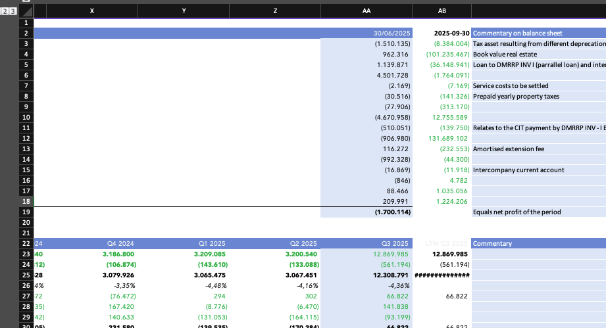
This breaks both visual consistency and downstream assumptions.

3. Formula Integrity & Reconciliation

3.1 Incorrect formulas (example: Accounts Receivable)
Not all formulas are correct in “Management cijfers – Q3 2025”.
Example:
- Automation uses:
=-('BDO - Q3-25'!H17+'BDO - Q3-25'!H18+'BDO - Q3-25'!H19)
- Reference uses:
='BDO - Q3-25'!H19+'BDO - Q3-25'!H21+'BDO - Q3-25'!H22
Even accounting for row shifts caused by missing subtitles, the automation is summing the wrong logical rows, suggesting positional rather than semantic mapping. Please carefully review this for the full sheet to ensure accuracy.

3.2 Mandatory validation failing
Per the handover instructions:
Final check: Total (Equity Movement) = Direct Result
This check fails in the automated output. If this reconciliation does not hold, the Management Accounts are incorrect and should not propagate further. In our current automated output this was not met.

4. Reporting Dates Not Fully Updated
In “Management cijfers – Q3 2025”, the bottom section (e.g. Bank account overview, ~line 106):
- Still shows “Per 30-6-2025”
- Should show “Per 30-9-2025”
Date roll-forward logic is only partially applied. This is probably consistent with the earlier issue of not taking the correct column/quarter.
Correct (in case of Q3 2025)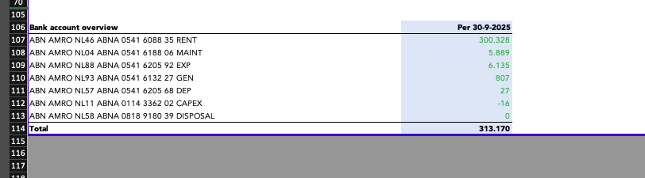
Automation behavior:
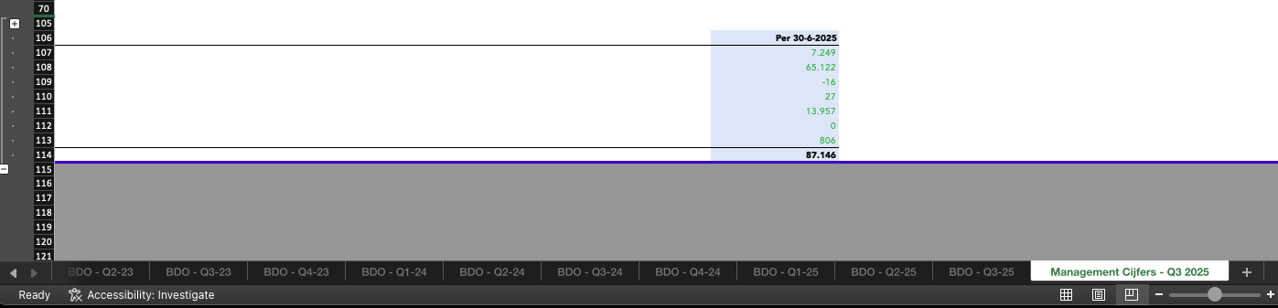

5. Compliance Certificate Issues (Upstream Dependency)
Because the Management Accounts output is incorrect, the following instruction is not executed correctly:
“We paste the management accounts from ‘Management Accounts Q3 2025 – Draft 1’ into Q3 Management Accounts.”
As a result, the Compliance Certificate Q3 2025 output is also incorrect. This is an upstream dependency issue.

6. Compliance Sheets – Quarter Roll-forward Logic
The following steps are not working as required:
- Adding the new quarter column in “Suppl. Calc” and “Impact Unit Sales”
- Ensuring SFA CC links correctly to:
  - Suppl. Calc
  - Impact Unit Sales
  - Q3 Management Accounts
In the Q3 test:
- Actuals stop at Q2 2025
- Q3 actuals are missing
- Only forecasts for later quarters appear

7. Word Report – Quarter & Date Inconsistencies

7.1 Mixed quarter references
The generated Word/PDF output still contains Q2 references (e.g. “Actions Q2 2025”, “Portfolio highlights – Q2 2025”) while other parts correctly show Q3 2025. Quarter replacement is incomplete.

7.2 Cover page date
The cover page copies the prior report’s date (e.g. 21 juli 2025).
Requirement: the date should be generated dynamically at runtime (run date).

8. PDF Assembly Order
The final merged PDF does not follow the reference structure:
- In the example, each section introduction is immediately followed by its attachment
- In the automated output, all attachments are appended in bulk at the end
The example PDF should be treated as the canonical ordering.

9. Excel → PDF Export Errors
From page 34 through 39 of the final PDF:
- Visible #NAME? errors appear
- These errors do not exist in Excel, only in the PDF
This indicates a systemic issue in the Excel-to-PDF export (e.g. recalculation or unsupported formulas).

10. Signature Page Incomplete
The final PDF is missing a proper signature page structure:
- Signature itself should not be pre-filled (correct)
- But the full layout and signing option should be present, as in the reference

11. QA Expectation
The issues listed above are examples, not exhaustive.
Given the nature of the errors, a full end-to-end QA pass is required across:
- Management Accounts
- Compliance Certificate
- Word document (headers, tables, body text)
- Final merged PDF (ordering, rendering, completeness)
The provided reference files should be treated as ground truth.

