

Woning Portefeuille Nederland - I
(QSP ESS B.V.)



Quarterly Report Q3 2025

21 oktober 2025

Confidential

DISCLAIMER
This report and the information therein is provided to on a confidential basis and is solely intended for the use by the recipient. The information contained herein does not constitute any (individual) advice, commitment or any offer to commit to any transaction or financing by D.M. Equity General Partners B.V. (“DMEP”), any of its affiliates or subsidiaries or any of the investment funds managed by DMEP. The information contained herein has been obtained from sources that DMEP considers to be reliable. However, DMEP makes no representation, guarantee or warranty as to, and accepts no responsibility or liability whatsoever for, the accuracy or completeness of the information contained herein.

The recipient should make an independent evaluation and judgement with respect to the matters referred to herein. Any use of the information contained herein without verification and further advice will be at the recipient’s own risk.

DMEP is not subject to the supervision of the Netherlands Authority for the Financial Markets (Autoriteit Financiële Markten, the “AFM”) and the Dutch Central Bank (De Nederlandsche Bank). Neither the investment fund referred herein nor its manager is required to obtain a license under the Dutch Financial Supervision Act (Wet op het financieel toezicht), and accordingly, neither the investment fund nor its manager is regulated by the AFM.

WPNL
Contents

- Portfolio Reporting
- Portfolio Overview
- Executive Summary
- Investments/divestments
- Maintenance (as per article 20.4 (A) (1) of the Senior Facility Agreement)
- Sustainability

- Rent Roll (as per article 20.4 (A) (1) of the Senior Facility Agreement)

- Management accounts (as per article 20.4 (A) (2) of the Senior Facility Agreement)

- Sales Report

- Compliance certificates (as per article 20.2 (B) of the Senior Facility Agreement)

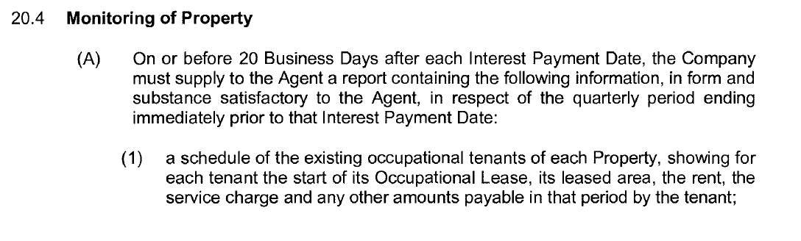
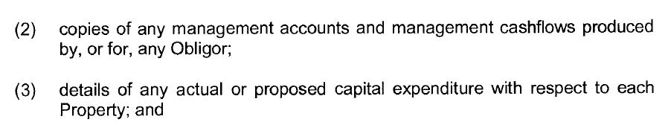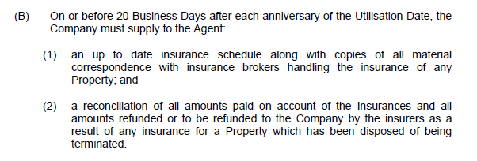

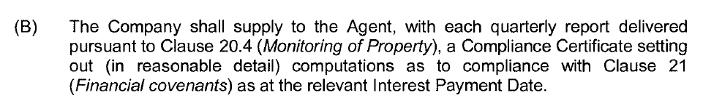
WPNL
- Portfolio Reporting: Overview

Portfolio Overview

The Company: DMRRP INV – I B.V.

Shareholders: DMEP INV - IX B.V. (99.0%)
Semmats Investments B.V. (0.5%)
J.C. Pape (0.5%)

Original closing date: 31 March 2018

Legal structure: DMRRP INV-I B.V. is the 100.0% shareholder of QSP ESS B.V. (the “Borrower”)

Financial year end: 31 December

Currency of portfolio: Euro

Domicile: The Netherlands

16
WPNL
- Portfolio Reporting: Executive Summary

- Rent performance
  - The Gross Theoretical Rental Income (“GTRI”) of the portfolio amounted to €3,273,6k in Q3 2025
  - Additionally, the Company has re-rented #15 units in Q3 2025, thereby renewing lease contracts, which resulted in an increase in annual GTRI of these units from €177,5k to €204,7k (+15%)
  - The portfolio delivered in €3,095.9k gross rental income in Q3 2025
  - The rent roll per 1-10-2025 yields €13,317.9k
  - The financial vacancy amounted to 5.4% in Q3 2025

- Investments / divestments
  - The increased interest rate has provided incentive to reduce debt at an accelerated rate for which we intend to increase the number of divestments in the coming quarters

- Maintenance
  - On an annual basis, the Company reserves €1.8m (€150k/month) for maintenance & CAPEX expenditures on the maintenance account
  - In Q3 2025, the Company spent €244k on maintenance

- Sustainability
  - In the third quarter of 2025 we placed solar panels and improved insulation at various addresses

Portfolio highlights – Q3 2025
Gross Theoretical rental income: €3,273.6k
Gross rental income: €3,095.9k
Financial vacancy: 5.4%
Unit sale proceeds: €203.5k

WPNL
- Portfolio Reporting: Investments / Divestments
Strategy:
- The Company executes a buy and hold strategy with respect to the portfolio, complemented by unit sales to meet financing requirements
- The Company targets to sell approximately #5 units per quarter (c. #20 units p.a.) from units that become vacant
- Units are in principle only sold if they are not part of a wholly owned complex and if the voting rights are <50% in a given complex
- A substantial uplift with respect to the CBRE valuation (c. 10%-20%) is targeted as a minimum sales price of a unit

Actions Q3 2025:
  - The Company divested 1 unit in Q3 2025
  - The Company has put additional focus into unit sales and expects to sell around 4 units next quarter
  - The last 12 months, the Company sold 12 units for in total €2,719k

WPNL
- Portfolio Reporting: Maintenance
Strategy:
- On an annual basis, the Company reserves €1.8m (€150k/month) for maintenance
- The Company expects to spend ~€75k/month on average on regular maintenance
- The remaining ~€75k/month is reserved for large maintenance on the maintenance reserve account
- Per annum, large maintenance work at selected complexes will be executed
- Liquidity on the maintenance reserve account is actively tracked and large maintenance expenses are timed based on the liquidity forecast
- Maintenance expenditure on the portfolio will be in the normal course of business and not to exceed the annual budget of €1.8m

Actions Q3 2025:
- In Q3 2025, the Company spent €244k on maintenance in the course of ordinary business

CAPEX (c. €345k):
- The majority of the CAPEX relates to sustainability projects
WPNL
- Portfolio Reporting: Sustainability

2025 – Q3
- Single glass was replaced with insulated glazing (HR++) in Grou, Wijk bij Duurstede en Rheden
- Insulation measures were taken at various addresses which were under financial vacancy
- Started with placing insulated glazing (HR++) at the Brouwerijweg

WPNL
- Rent Roll
File enclosed

WPNL
- Management accounts
File enclosed

c\
WPNL
4. Sales Report
File enclosed

WPNL
5. Compliance Certificates
File enclosed

