LAB # 03

Inductive Reactance



# Submitted by: Awais Saddiqui

Reg-No: 21PWCSE1993

Section: “A”

# Submitted To: Engineer Faiz Ullah Sir

# UNIVERSITY OF ENGINEERING AND TECHNOLOGY PESHAWAR

# COMPUTER SYSTEM ENGINEERING

ASSESSMENT RUBRICS

|  |  |  |  |  |  |
| --- | --- | --- | --- | --- | --- |
|  | LAB REPORT ASSESSMENT | | | | |
|  | Criteria | Excellent | Average | Nil | Marks Obtained |
| 1. | Objectives of Lab | All objectives of lab are properly covered [Marks 1] | Objectives of lab are partially covered [Marks 0.5] | Objectives of lab are  not shown  [Marks 0] |  |
| 2. | Procedure | All experimental steps are shown. [Marks 2] | Some of the steps are shown.  [Marks 1] | Experimental steps  not shown [Marks 0] |  |
| 3. | Demonstration of Concepts | The student demonstrated a clear understanding of the assignment concepts  [Marks 2] | The student demonstrated a clear understanding of some of the assignment concepts [Marks 1] | The student failed to demonstrate a clear understanding of the assignment concepts  [Marks 0] |  |
| 4. | Experimental  Results | All experimental results are completely shown in  form of table [Marks 3] | Experimental results are partially shown and some of the observations are missing [Marks 1.5] | No experimental results are shown  [Marks 0] |  |
| 5. | conclusion | Conclusion of the lab is properly written  [Marks 2] | Conclusion of the lab is partially written  [Marks 1] | Conclusion of lab is not written [Marks 0] |  |
|  | Total Marks Obtained: __________    Instructor Signature: ______________________ | | | | |

Lab 3

Inductive Reactance

## Objective:

# Inductive reactance will be examined in this exercise. In particular, its relationship to inductance and frequency will be investigated, including a plot of inductive reactance versus frequency.

## Inductive Reactance:

# Inductive reactance is the property of an inductive coil that resists the change in alternating current (AC) through it and is similar to the opposition to direct current (DC) in a resistance.

## Procedure

## Current Source

# Using Figure 1 with Vin=10 Vp-p and R=10 kΩ, and assuming that the reactance of the inductor is much smaller than 10k and can be ignored, determine the circulating current using measured component values and record in Table 1.

## Measuring Reactance

# Build the circuit of Figure 1 using R=10 kΩ, and L=10 mH. Place one probe across the generator and another across the inductor. Set the generator to a 1000 Hz sine wave and 10Vp-p. Make sure that the Bandwidth Limit of the oscilloscope is engaged for both channels. This will reduce the signal noise and make for more accurate readings.

* Calculate the theoretical value of XL using the measured inductor value and record in Table2.
* Record the peak-to-peak inductor voltage and record in Table 2.
* Using the source current from Table 1 and the measured inductor voltage, determine the experimental reactance and record it in Table 2. Also compute and record the deviation.
* Repeat steps three through five for the remaining frequencies of Table 2.
* Replace the 10 mH inductor with the 1mH unit and repeat steps two through six, recording results in Table 3.

Using the data of Tables 2 and 3, create plots of inductive reactance versus frequency.

## Equipment

1. AC Function Generator
2. Oscilloscope DMM

## Components

* 1 mH actual: __________________
* 10 mH actual: __________________

. 10 kΩ actual: __________________

## Circuit Diagram:

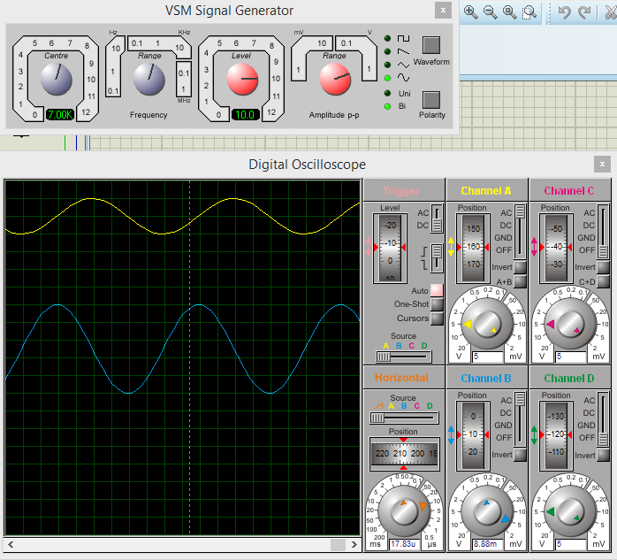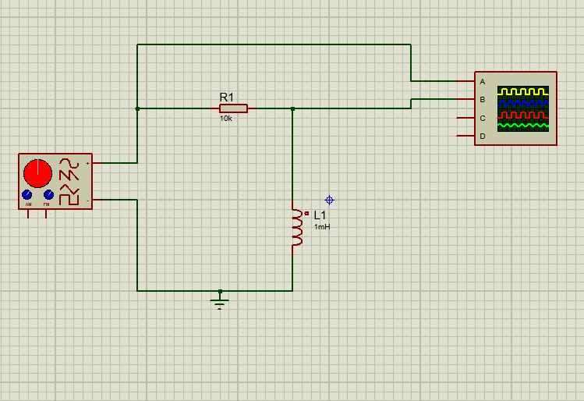



## Table-1:

|  |  |  |  |  |
| --- | --- | --- | --- | --- |
| Frequency | XL Theory | VL(p-p) Exp | XL Exp | %Dev |
| 1k | 6.28 | 6.64 | 6.64 | 5.7 |
| 2k | 12.56 | 12.92 | 12.92 | 2.78 |
| 3k | 18.84 | 19.38 | 19.38 | 2.87 |
| 4k | 25.12 | 25.6 | 25.6 | 1.95 |
| 5k | 31.4 | 32 | 32 | 1.84 |
| 6k | 37.68 | 38.16 | 38.16 | 1.27 |
| 7k | 43.96 | 44.8 | 44.8 | 1.91 |
| 8k | 50.24 | 53.55 | 53.55 | 5.58 |
| 10k | 62.8 | 62.64 | 62.64 | 0.25 |

## Table-2:

|  |  |  |  |  |
| --- | --- | --- | --- | --- |
| Frequency | XL Theory | VL(p-p) Exp | XL Exp | %Dev |
| 10k | 62.8 | 62.64 | 62.64 | 0.25 |
| 20k | 125.6 | 0.13 | 130 | 3.38 |
| 30k | 188.4 | 0.196 | 196 | 3.8 |
| 40k | 251.2 | 0.26 | 260 | 3.38 |
| 50k | 314 | 0.32 | 320 | 1.875 |
| 60k | 376.8 | 0.39 | 390 | 3.38 |
| 80k | 502.4 | 0.51 | 510 | 1.49 |
| 100k | 628 | 0.65 | 650 | 3.38 |

## Questions:

# What is the relationship between inductive reactance and frequency?

Ans:

# Inductive reactance is the property of an inductive coil that resists the change in alternating current (AC) through it and is similar to the opposition to direct current (DC) in a resistance.

# The Inductive reactance is directly proportional to frequency.

# XL=2πfL



# What is the relationship between inductive reactance and inductance?

Ans:

# Inductance is the tendency of an electrical conductor to oppose a change in the electric current flowing through it. The flow of electric current creates a magnetic field around the conductor.

# L=Nθ/I

# Where ϕ is flux, N is number of turns, and I is current.

# Do the coil resistances have any effect on the plots?

# Ans:

# After creating the geometry (the coil), assigning a material (copper) and assigning electric potentials, the current through the coil can be calculated. I suppose this is calculated from the potentials and from the resistance. I also suppose that the resistance is determined from the conductivity, length and cross-sectional surface. I want to know the value of the total resistance.