MUHAMMAD AWAIS
023-23-O328
Basic Linkedlist tasks

Task 1
Write a function to get the nth node from the end of the linked list.
Function name: int nthFromLast(int n);
Case-1: (List Empty) Head=Null then return LIST_EMPTY
Case-2: (List Non-Empty) Head != Null then return nth element from the end of list
Example
Input: 10 -> 20 -> 30 -> 40 -> 50, n = 2
Output: 40 (From the last, second node conatins the data 40) Code
public class Task1 {

static final int LIST_EMPTY = -1;
static final int INVALID_INPUT = -2;

static class Node { int data;
Node next;

Node(int data) { this.data = data;
this.next = null;
}
}

Node head;

public int nthFromLast(int n) {
if (head == null) {
return LIST_EMPTY;
} if (n <= 0) {
return INVALID_INPUT;
}

Node first = head;
Node second = head;

for (int i = 0; i < n; i++) { if (first == null) {
return INVALID_INPUT;
}
first = first.next;
}

while (first != null) { first = first.next;
second = second.next;
}

return second.data;
}

public void add(int data) {
Node newNode = new Node(data);
if (head == null) {
head = newNode;
} else {
Node temp = head; while (temp.next != null) {
temp = temp.next;
}
temp.next = newNode;
}
}

public static void main(String[] args) { Task1 list = new Task1(); list.add(10); list.add(20); list.add(30); list.add(40); list.add(50);

System.out.println(list.nthFromLast(2)); // Output: 40 }
}
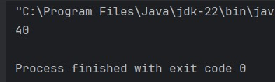
Task 2
Write a function to sort the given single linked list. (Don’t swap the data present in the nodes, swap the nodes itself.)
Function name: void sort();
Case-1: (List Empty) Head=Null then return LIST_EMPTY
Case-2: (List Non-Empty) Head != Null then swap the nodes to sort them
Example
Input: 50 -> 40 -> 30 -> 20 -> 10
Output: 10 -> 20 -> 30 -> 40 -> 50 Code
public class Task2 {

static final int LIST_EMPTY = -1;

static class Node { int data;
Node next;

Node(int data) { this.data = data;
this.next = null;
}
}

Node head;

public int sort() { if (head == null) {
return LIST_EMPTY;
}

boolean swapped; Node ptr1;
Node lptr = null;

do { swapped = false;
ptr1 = head;

while (ptr1.next != lptr) { if (ptr1.data > ptr1.next.data) {
// Swap nodes swapNodes(ptr1, ptr1.next); swapped = true;
}
ptr1 = ptr1.next;
}
lptr = ptr1;
} while (swapped);

return 0;
}

private void swapNodes(Node node1, Node node2) {
int temp = node1.data; node1.data = node2.data;
node2.data = temp;
}

public void add(int data) { Node newNode = new Node(data); if (head == null) {
head = newNode;
} else {
Node temp = head; while (temp.next != null) {
temp = temp.next;
}
temp.next = newNode;
}
}

public void printList() { Node temp = head; while (temp != null) {
System.out.print(temp.data + " -> "); temp = temp.next;
}
System.out.println("null");
}

public static void main(String[] args) { Task2 list = new Task2(); list.add(50); list.add(40); list.add(30); list.add(20); list.add(10);

System.out.println("Before sorting:"); list.printList();

list.sort();

System.out.println("After sorting:"); list.printList();
}

}
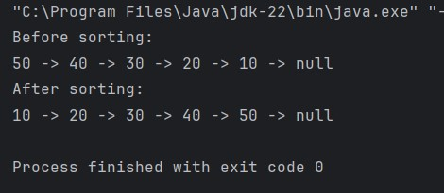
Task 3
Write a function to reverse the single linked list.
Function name: void reverse();
Case-1: (List Empty) Head=Null then return LIST_EMPTY
Case-2: (List Non-Empty) Head != Null then reverse the list
Example
Input: 50 -> 40 -> 30 -> 20 -> 10
Output: 10 -> 20 -> 30 -> 40 -> 50 Code
public class Task3 {

static final int LIST_EMPTY = -1;

static class Node { int data;
Node next;

Node(int data) { this.data = data;
this.next = null;
}
}

Node head;

public int reverse() { if (head == null) {
return LIST_EMPTY;
}

Node previous = null;
Node current = head;
Node next = null;

while (current != null) { next = current.next; current.next = previous; previous = current;
current = next;
}

head = previous;
return 0;
}

public void add(int data) {
Node newNode = new Node(data);
if (head == null) { head = newNode;
} else {
Node temp = head; while (temp.next != null) {
temp = temp.next;
}
temp.next = newNode;
}
}

public void printList() { Node temp = head; while (temp != null) { System.out.print(temp.data + " -> "); temp = temp.next;
}
System.out.println("null");
}

public static void main(String[] args) { Task3 list = new Task3(); list.add(50); list.add(40); list.add(30); list.add(20); list.add(10);

System.out.println("Before reversing:"); list.printList();

list.reverse();

System.out.println("After reversing:"); list.printList();
}
}
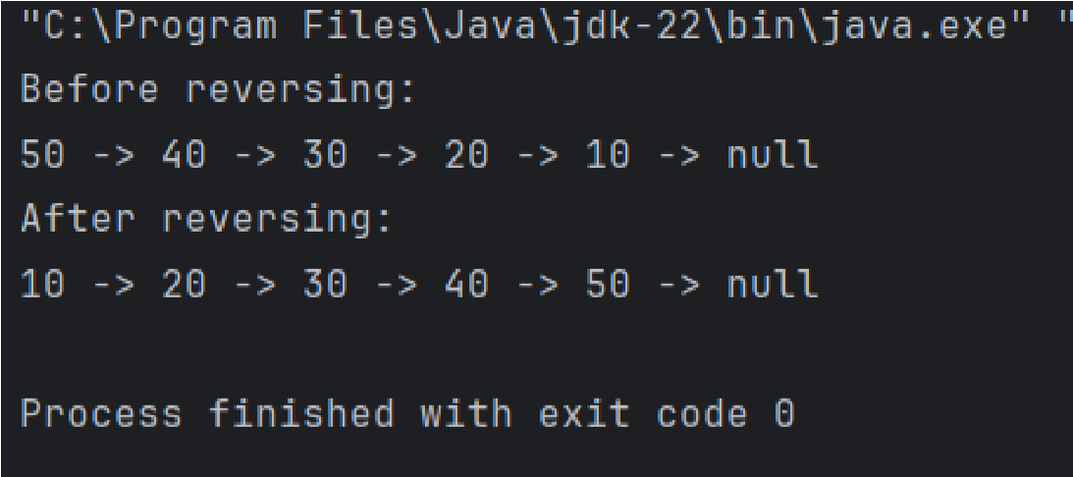
Task 4
Write a function to remove the duplicates data present in the single linked list.
Function name: void removeDuplicates();
Case-1: (List Empty) Head=Null then return LIST_EMPTY
Case-2: (List Non-Empty) Head != Null then remove duplicate elements
Example
Input: 5 -> 3 -> 4 -> 5 -> 2 -> 1 -> 4 -> 5 -> 3
Output: 5 -> 3 -> 4 -> 2 -> 1 Code
import java.util.HashSet;
public class Task4 {

static final int LIST_EMPTY = -1;

static class Node { int data;
Node next;

Node(int data) { this.data = data;
this.next = null;
}
}

Node head;

public int removeDuplicates() {
if (head == null) {
return LIST_EMPTY;
}

HashSet<Integer> seen = new HashSet<>();
Node current = head;
Node previous = null;

while (current != null) {
if (seen.contains(current.data)) {

previous.next = current.next;
} else {

seen.add(current.data);
previous = current;
}
current = current.next;
}

return 0;
}

public void add(int data) {
Node newNode = new Node(data);
if (head == null) { head = newNode;
} else {
Node temp = head; while (temp.next != null) {
temp = temp.next;
}
temp.next = newNode;
}
}

public void printList() { Node temp = head; while (temp != null) {
System.out.print(temp.data + " -> "); temp = temp.next;
}
System.out.println("null");
}

public static void main(String[] args) { Task4 list = new Task4();
list.add(5); list.add(3); list.add(4); list.add(5); list.add(2); list.add(1); list.add(4); list.add(5); list.add(3);

System.out.println("Before removing duplicates:"); list.printList();

list.removeDuplicates();

System.out.println("After removing duplicates:"); list.printList();
}

}
