Design

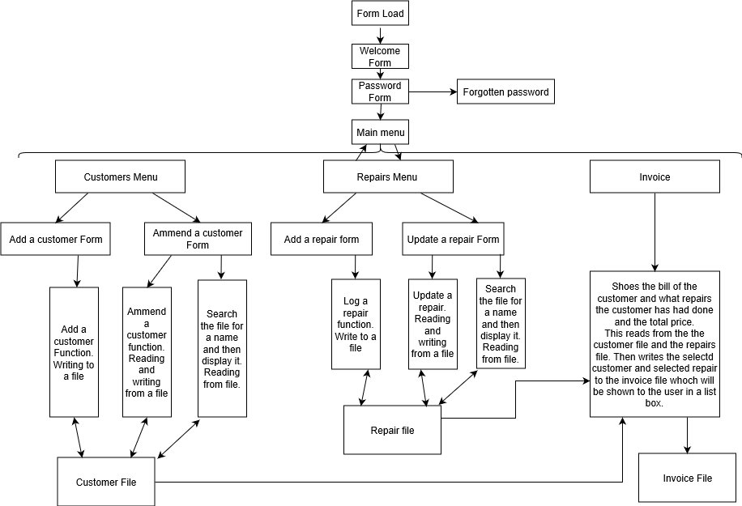

1. Form Load: Welcomes the user.
2. Login: Logs the user into the program with a unique id and password.
3. Forgotten Password: Allows staff members to retrieve passwords.
4. Customer: The user can access customer data. The user can add data and delete data

Processes

1. Repairs Form: This is where all the repaiurs and services will be stored.
2. Invoice: This is the recipt or bill that will beprinted and given to the customer.

Customer id file

Name the file: Customer No

Description of the file: The file contains personal information on the customer. The file contains data such as customer id, first name, surname and contact numbers.

Expected number of users: the number of user will increase as more new customers come to the shop. The more customers come, then more details will be needed to be recorded.

Access method: I will use Random (Direct) access to store and retrieve any details or data stored in the Customers file. This will allow the data to be viewed and amended whilst using some of the features that the program provides.

|  |  |  |  |  |
| --- | --- | --- | --- | --- |
| **Name of field** | **Type of field** | **Description** | **Size of field** | **Example data** |
| **Customer No\*** | Integer | The customers unique ID number to be sued to identify a customer and his past orders. | 3 | 1 |
| **Title** | String | Title of the customer. | 4 | Miss |
| **Frist name** | String | Name of the customer. | 20 | Sarah |
| **Surname** | String | The customers surname. | 20 | Jones |
| **Door No** | Integer | The customers door numer. | 3 | 54 |
| **Street Name** | String | The customers Street. | 20 | Cornwall |
| **Town** | String | The customers town. | 20 | Oldham |
| **County** | String | The customers county. | 20 | Lancashire |
| **Postcode** | String | The current postcode of the customers member. | 7 | PV63 4YT |
| **Mobile Number** | String | The customers mobile number | 11 | 07890567892 |
| **Landline Number** | String | The cusomers landline number | 11 | 01615879853 |
| **Email** | String | The customers email. | 30 | Fred123@gmai.com |

* = Key Field.

~ = Foreign Key Field.

Repairs file

Name the file: Reapirs

Description of the file: The file contains information and data on the repairs and services the business sales. This file will store information such as Repair Id, Name and Quantity and price.

Expected number of users: The number of repairs in this file is likely to increase as the business develops and sales increase.

Access method: I will use Random (Direct) access to store and retrieve any details or data stored in the repair file. This will allow the data to be viewed and amended whilst using some of the features that the program provides.

|  |  |  |  |  |
| --- | --- | --- | --- | --- |
| **Name of field** | **Type of field** | **Description** | **Size of field** | **Example Data** |
| **Repair no\*** | Integer | The unique Id of the repairs, used to find individual products and scan to pay. | 3 | 1 |
| **Repair name** | String | The name of the product. | 30 | Iphone 5s replacement screen |
| **Price** | String | The price of the reapir or service. | 8 | £5.00 |

* = Key Field.

~ = Foreign Key Field.

Invoice file

Name the file: Invoice

Description of the file: This file contains the details of the custome and the reapir that a customer has had. It will use foreign keys from other tables.

Expected number of users: There will be 1 invoice for each customer for everytime they come to the shop to purchase a repair or service.

Access method: I will use Random (Direct) access to store and retrieve any details or data stored in the invoice file. This will allow the data to be viewed and amended whilst using some of the features that the program provides.

|  |  |  |  |  |
| --- | --- | --- | --- | --- |
| **Name of field** | **Type of field** | **Description** | **Size of field** | **Example Data** |
| **Customer No~** | Integer | The customers unique ID number to be sued to identify a customer and his past orders. | 3 | 1 |
| **Forname** | String | This is the Forename of the customer. | 20 |  |
| **Surname** | String | This is the surname of the customer. | 20 |  |
| **Repair No~** | Integer | The unique Id of the repairs, used to find individual products and scan to pay. | 3 | 1 |
| **Repair name~** | String | This will be the name of the repair or service that the customer has requested. | 30 |  |
| **Price~** | String | The price of the reapir or service. | 8 | £5.00 |

* = Key Field.

~ = Foreign Key Field.

**Validation**

One of the problems with the current system is that there are no validation checks which is not good for data integrity. For this reason, I will make sure to implement varies different checks most of the fileds fields as I can with a suitable validation. This will make sure that that data inputted into the system is going to be reasonable and legal. Below are the validation checks that I am going to implement in the new system.

**Presence check:** Data must be entered in the filed or the record will not be accepted. This is mandatory and requires data inside the field. For example, if a user is trying to login into the application and the user doesn’t enter a username and passwordthen the application wont load the the next form and give them an error message.

If txtUsername.Text = "" and txtPassword = “” then

‘If the password and username textbox is empty then the following applies’

MsgBox "Please type a username or password"

‘A message box is displayed informing the user to input the username and password’

**Type check:** This checks that the type of data entered. E.g. a letter or an integer. I will use this to check that the characters in mobile and landline number text box are all integers.

**Length check:** Some data that will need to be entered into the system are of a certain length such as a phone number. This check will ensure that the data is the right length not shorter or longer than it needs to be. For example, the max length for a number is 11, hen I wll set the vriable to a fixed length of 11 charecters.

Output content and format and input content, capture and format

Form Load

Company name

Company Logo

King Communication

Background Colour: Control Font: Microsoft Sans Serif

Font colour: Black Label Font Size: 20 Command Size: 15

Command Button

Welcome

Label

Login

Text Box

Login

Username

Login

Password

Forgotten Password

Command Button

Background Colour: Not decided Font: Microsoft Sans Serif

Font colour: Black Label Font Size: 8.25 Command Size: 8.25

Login label font size: 20

Label

Main Menu

Customers

Command Button

Repairs

Background Colour: Control

Font: Microsoft Sans Serif

Font colour: Black

Label Font Size: 20.25

Command Size: 8.25

Invoice

Close

Command Button

Label

Close

Customer Menu

Main Menu

Text box

Town

Customer No

Text box

Title

Text box

County

Text box

Number of files

Forname

Postcode

Text box

Text box

Surname

Mobile No

Text box

Text box

Add Record

Door No

Landline No

Text box

Text box

Text box

Email

Street Name

Text box

Background Colour: Control Label Font Size main menu: 20.25

Font: Microsoft Sans Serif Label Font Size : 8.25

Font colour: Black Command Size: 8.25

Command Button

Label

View a customer

Close

List Box

Display Customer Details

Main Menu

Search Forname

Text Box

Customer No

Title

Forname

Street Name

Surname

Door No

Text box

Text box

Text box

Text box

Text box

Text box

Town

Text box

Text box

Text box

Text box

Text box

Text box

County

Postcode

Mobile No

Landline No

Email

Update

Background Colour: Control Label Font Size Display a customer: 20.25

Font: Microsoft Sans Serif Label Font Size : 8.25

Font colour: Black Command Size: 8.25

Add a repair

Label

Close

Command Button

Text Box

Main Menu

Repair No

Number of repairs

Text Box

Repair Name

Add Repair

Text Box

Repair Price

Label

Background Colour: Control

Font: Microsoft Sans Serif

Font colour: Black

Label Font Add a Repair Size: 20.25

Lable Fornt size : 8.25

Command Size: 8.25

Label

Display a record

List Box

Close

Show Repairs

Update

Main Menu

Command Button

Search for repair name

Text Box

Repair No

Repair Price

Repair Name

Text Box

Text Box

Text Box

Label

Background Colour: Control

Font: Microsoft Sans Serif

Font colour: Black

Label Font Display a record Size: 20.25

Lable Fornt size : 8.25

Command Size: 8.25

Customer Details

Command Button

Background Colour: Control

Font: Microsoft Sans Serif

Font colour: Black

Label Font Size: 20.25

Command Size: 8.25

View Orders

List Box View Orders

Text Box

Text Box

Text Box

Repair No

Repair Name

Price

Text Box

Text Box

Text Box

Customer No

Customer Surname

Customer Forname

Save Order

Main Menu

Show Repais

Show Customers

List Box Repair Details

List Box Customer Details

Repairs

Customers

Number of records

Invoice

Close

Customers Menu Menu

Label

Command Button

Background Colour: Control

Font: Microsoft Sans Serif

Font colour: Black

Label Font Size: 20.25

Command Size: 8.25

Main Menu

Close

Add a customer

Disply or ammened a customer

Disply or ammened a repair

Repair Menu Menu

Add a Repair

Main Menu

Close

Label

Command Button

Background Colour: Control

Font: Microsoft Sans Serif

Font colour: Black

Label Font Size: 20.25

Command Size: 8.25

Processing Stages

Below I have shown the data structure for the customer and repairs files in the module. This then allows access to the files during the use of the program.

Module

Customer Structure

CustomerNo

Tittle

Forename

Surname

DoorNo

Streetname

Town

County

Postcode

MobileNo

LandlineNo

Email

End

Repairs Structure

RepairNo

RepairName

RepairPrice

End

Order Structure

CustNo

CustFor

CustSur

RepNo

RepName

RepPrice

Public Variables

OneCustomer = CustomerType ‘This is the file for the customer details

NumbeOfRecords = Integer ‘This is the number of records in the customer file

NoOfRecrods = integer ‘This is the number of records I the repair file

OneRepair = RepairType ‘This is the file name of the repairs file

OneOrder = OrderType ‘This is the file name of the repairs file

Orderpositionofrecord = Intger ‘This is the number of records in rhe order file

End

Welcome

Begin proc

**Form Load**

**If Welcome button clicked:**

Open the password form.

Hide the current form.

End sub.

End proc.

Add Customer

Begin proc.

**From Load:**

Open the file, calculate the number of records in the file.

And close the file again.

End Sub.

**If Main Menu button is selected:**

Display the main menu and hide the current form.

End Sub.

**If add customer button is clicked:**

Generate a new unique customer NO using the hashing algorithm then display this NO in a text box.

Open the Customer file and adds the new record to the end of the file.

Displays a message box to inform the user the record has been saved.

Clear all the text boxes.

Update the label number of records.

End Sub.

**If close button is clicked:**

Close the main welcome form which wll close the application.

End sub.

End proc

Add Repair

Begin proc.

**From Load:**

Open the file, calculate the number of records in the file.

**If main menu button is selected:**

Display the main menu and hide the current form.

End Sub.

**If add repair button is clicked:**

Generate a new unique repair NO using the hashing algorithm then display this NO in a text box.

Open the repair file and adds the new record to the end of the file.

Displays a message box to inform the user the record has been saved.

Clear all the text boxes.

Update the label number of records.

End Sub.

**If close button is clicked:**

Close the main welcome form which wll close the application.

End sub.

End proc.

Password log in form

Begin proc.

**If login button is clicked:**

Check the username and password entered by the user matches the username and password set in the application code.

If they match display the Add customer form and hide the current form.

If they enter an incorrect username or password display a message explaining the error.

If the textboxes are left empty then display a please enter a username and password error message.

End Sub.

**If the forgotten password button is clicked:**

Display a message box that gives the user instruction n how t recovr the password.

End Sub.

**If close button is clicked:**

Close the main welcome form which wll close the application.

End sub.

End proc.

Main Menu

Begin proc.

**If customer button is clicked:**

Display the customer menu form and close the current form.

End sub.

**If repairs button is clicked:**

Display the repairs menu form and close the current form.

End sub.

**If invoice button is clicked:**

Display the invice forma and close the current form.

End sub.

**If close button is clicked:**

Close the main welcome form which wll close the application.

End sub.

End proc.

Customr Menu

Begin proc.

**If Add a customer button is clicked:**

Display the Add a customer form and close the current form.

End sub.

**If View a customer button is clicked:**

Display the view a customer form and close the currnet form.

End sub.

**If the main menu button is clicked:**

Display the main menu form and close the current form.

End sub.

**If the close button is clicked:**

Close the main welcome form.

End sub.

End proc.

Repair Menu

Begin proc.

**If Add a repair button is clicked:**

Display the Add a repair form and close the current form.

End sub.

**If View a repair button is clicked:**

Display the view a repair form and close the currnet form.

End sub.

**If the main menu button is clicked:**

Display the main menu form and close the current form.

End sub.

**If the close button is clicked:**

Close the main welcome form.

End sub.

End proc.

View Customers

Begin proc.

**If Display Customer button is clicked:**

Open the customers file.

Display all the records in the file in a list box.

End sub.

**If search button is clicked:**

Open the file.

Look through the file until the requested record is found.

Display the record in textboxes.

End sub.

**If update button is clicked:**

Open the file and go to the position of the record is selected.

Save the new record in that position.

Then clear the textboxes.

End sub.

**If the main menu button is clicked:**

Display the main menu form and close the current form.

End sub.

**If the close button is clicked:**

Close the main welcome form.

End sub.

End proc.

View repair

Begin proc.

**If Show Repairs button is clicked:**

Open the repairs file.

Display all the records in the file in a list box.

End sub.

**If search button is clicked:**

Open the file.

Look through the file until the requested record is found.

Display the record in textboxes.

End sub.

**If update button is clicked:**

Open the file and go to the position of the record is selected.

Save the new record in that position.

Then clear the textboxes.

End sub.

**If the main menu button is clicked:**

Display the main menu form and close the current form.

End sub.

**If the close button is clicked:**

Close the main welcome form.

End sub.

End proc.

Invoice Form

Begin Proc.

**If Show Customer button is clicked:**

Open the customers file.

Display all the records in the file in a list box.

End Sub.

**If show repair button is clicked:**

Open the customers file.

Display all the records in the file in a list box.

End sub.

**If Save order button is clicked:**

Open the order file and adds the new record to the end of the file.

Displays a message box to inform the user the record has been saved.

Clear all the text boxes.

Update the label number of records.

End Sub.

**If View orders button is clicked:**

Open the orders file.

Display all the records in the file in a list box.

End sub.

**If the main menu button is clicked:**

Display the main menu form and close the current form.

End sub.

**If the close button is clicked:**

Close the main welcome form.

End sub.

End proc.