**LTCC Based L-Band Bandpass Filters for Communication Devices**

* Determining Specifications
* Centre frequency
* Bandwidth
* Insertion Loss
* Return Loss
* Determining Topology
* Coupled resonator
* Inter-digital filter
* Hairpin filter
* Stepped Impedance filter
* Piezoelectric tuned filter
* Designing in Matlab
* Signal processing
* Filter design tools
* Simulating filter in CST Design Suite (Microwave)
* I plan to design 3 filters using above parameters, then see results of each simulation and select the best/most efficient one.

**Selected filters:** hairpin, stepped impedance and inter-digital.

**Stepped Impedance Filter**

**Specifications:-**

* Centre frequency(fₒ): 2.65 GHz
* 3dB bandwidth(B): 50 MHz
* Number of stages(N): 3
* Characteristic impedance(Zₒ): ~50 Ohms

**Design:-**

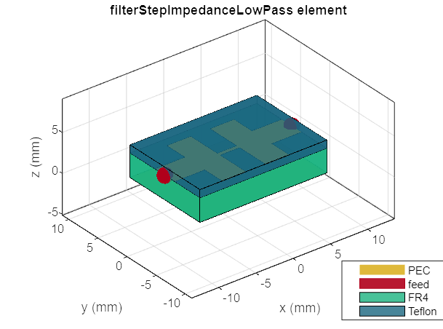 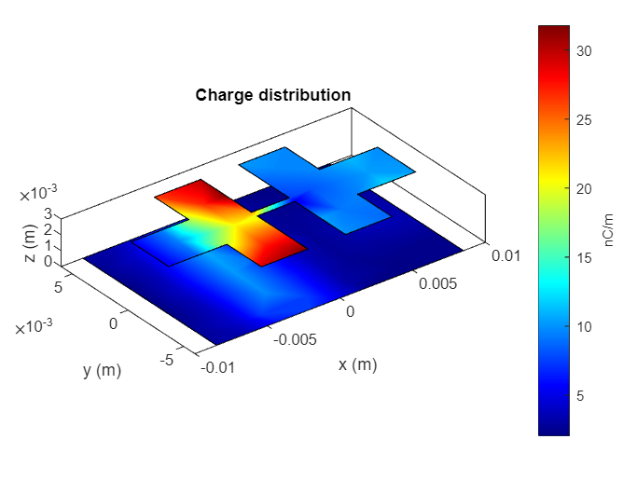

**Response Plot (freq, amplitude):-**

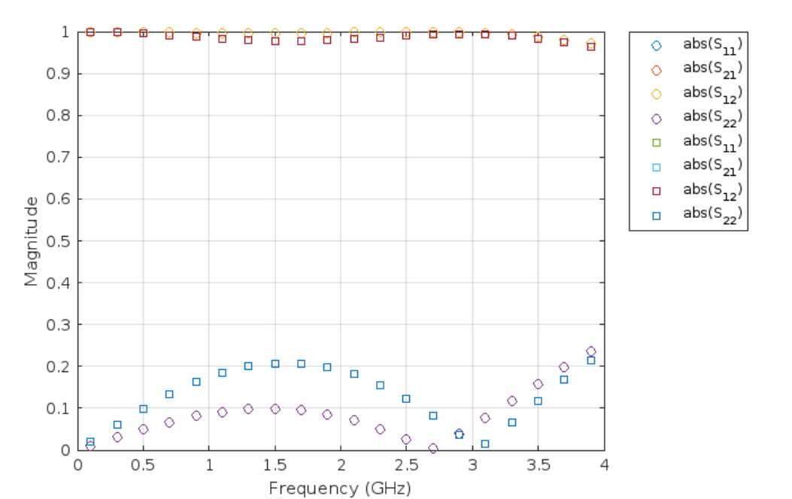

**Hairpin Filter**

**Specifications:-**

* Centre frequency(fₒ): 1.25 GHz
* 3dB bandwidth(B): 50 MHz
* Number of stages(N): 3
* Characteristic impedance(Zₒ): ~50 Ohms

**Design:-**

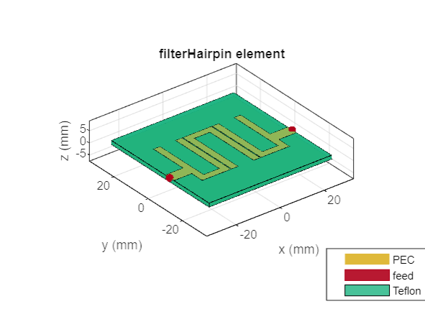 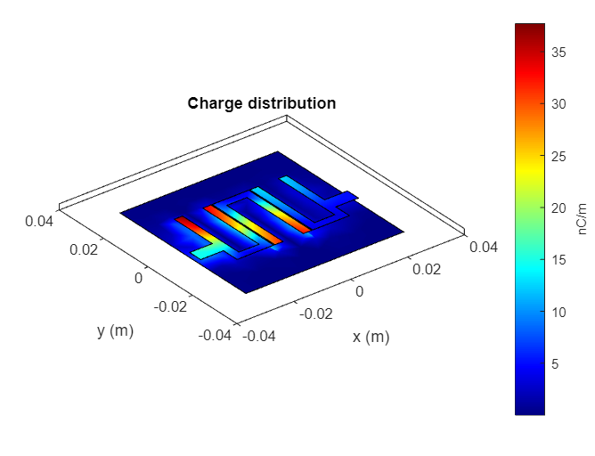

**Response Plot (freq, amplitude):-**

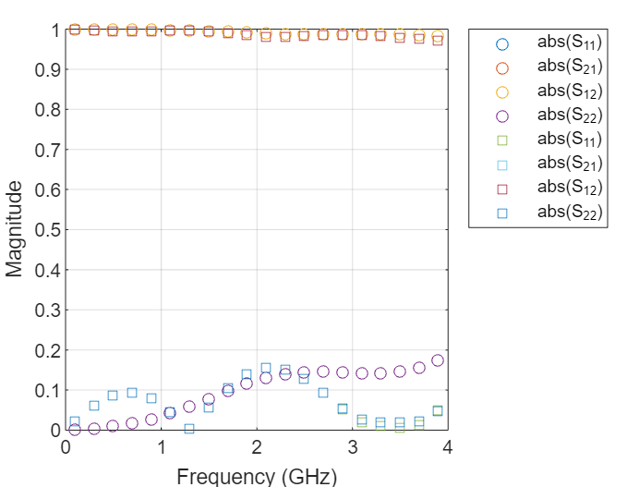

**Inter-digital Filter**

**Specifications:-**

* Centre frequency(fₒ): >4 GHz
* 3dB bandwidth(B): 50 MHz
* Number of stages(N): 5
* Characteristic impedance(Zₒ): ~50 Ohms

**Design:-**

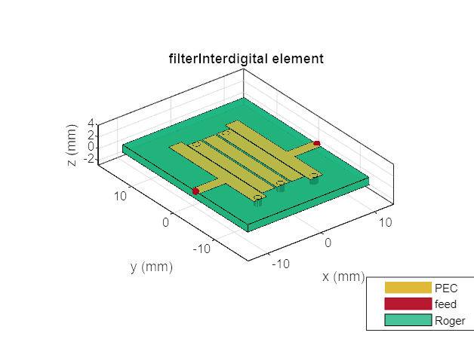 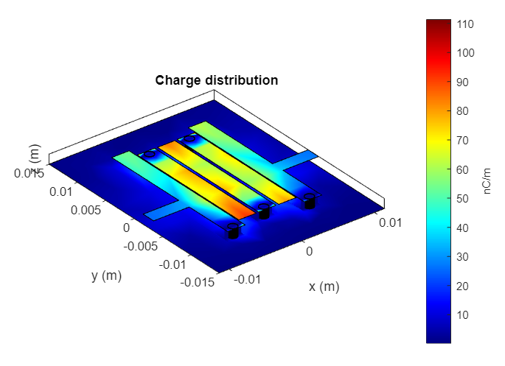

**Response Plot (freq, amplitude):-**

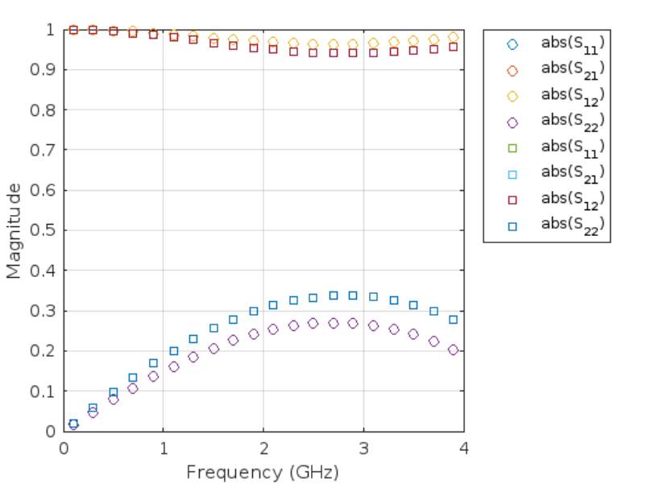

**Conclusion**

By simulating above 3 designs we find that the best suited filter for L-Band Microwave is the Hairpin filter, as it has a centre frequency of 1.25 GHz hence we use this design to construct and simulate in CST Studio.