**OOP Project setup and execution instructions**

**Step1: Setup project in Eclipse**

**Project Folder Structure in Eclipse:** (Use ‘OOPproject’ folder in GitHub instead of ‘test’. Subfolders are the same as below.)

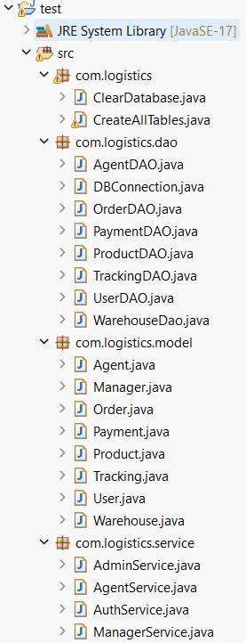

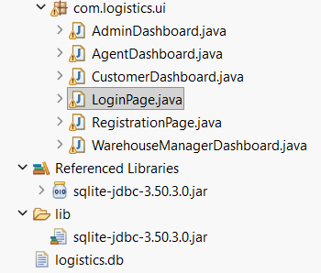

**Step2: Run the below 2 files in the order given**

This is to delete any existing data in DB and create them fresh with dummy data

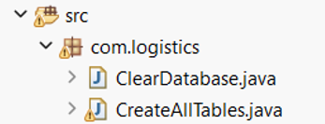

**Step3: Understand the user ids in DB.**

|  |  |  |
| --- | --- | --- |
| **Userid** | **Password** | **Role** |
| [alice@example.com](mailto:alice@example.com) | pass123 | Customer |
| [bob@example.com](mailto:bob@example.com) | pass123 | Admin |
| [charlie@example.com](mailto:charlie@example.com) | pass123 | Agent |
| [diana@example.com](mailto:diana@example.com) | pass123 | Manager |

Note: All passwords are kept as pass123 for now.

**Step4: To add additional users(if reqd).**

**To add additional users**, you can run **RegistrationPage.java**

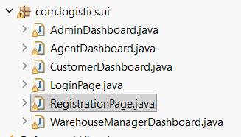

**Step4: To Login with various roles**

**To login**, you can run **LoginPage.java, give email, password and select role**

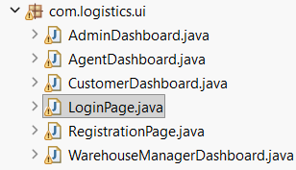**.**

**Step5: Test end to end flow**

1. **Login as customer(Alice)**
   1. **View existing data in UI tabs**
   2. **From Products tab, you can Place Order**
   3. **From Payments tab, you can Make Payment**
   4. **Check the status in Active Orders and Tracking tabs. Will be “Pending”.**
2. **Login as Admin(Bob)**
   1. **View existing data in UI tabs- Warehouses and Agents**
   2. **You have option to add Warehouse and add Agent**
3. **Login as Agent(Charles)**
   1. **View existing data in UI tabs- Available Orders and My Shipments**
   2. **Available Orders pane will have your newly placed order. Click Accept button to move it “My Shipments”.**
   3. **From My Shipments pane, you have option to select an order and move it to a particular warehouse. Also you can update delivery status here. Any changes made here can be seen in Customer Dashboard if you login again as Alice and check “Active Orders” and “Tracking” tabs.**
   4. **Once order is made as “Delivered in Agent dashboard, it will disappear from Tracking tab in Customer Dashboard. Will be shown as “Delivered” in Active Orders” tab in. Customer Dashboard**
4. **Re-Login as customer(Alice)**
   1. **Any changes made in Agent Dashboard can be seen in Customer Dashboard if you check “Active Orders” and “Tracking” tabs.**
   2. **Once order is made as “Delivered in Agent dashboard, it will disappear from Tracking tab in Customer Dashboard. Will be shown as “Delivered” in Active Orders” tab in Customer Dashboard**
   3. **Place one more order from “Products” tab for testing warehouse manager functionality.**
5. **Login as Manager(Diana)**
   1. **You can select the warehouses managed by Diana from dropdown.**
   2. **Click “View Orders” button . It will show active orders . Manager can assign an agent to any active order here. Remember: agent id for Charles is “3” in your DB.**
   3. **Click View Stock. It will show current stock in inventory in the bottom pane-Warehouse Inventory.**
   4. **Select a product and click “Update Stock” to update the quantity.**
6. **Re-Login as Agent(Charles)**
   1. **View existing data in My Shipments**
   2. **Newly assigned order by manager will appear here. Follow the earlier flow to deliver it and come back to customer dashboard to check final status.**