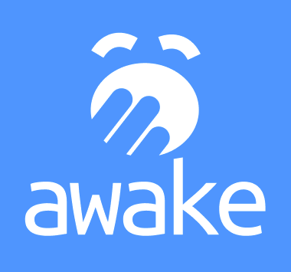

# Recommendation System

Machine Learning and Neural Networks / Awake AI

LEO Michele (*Login : michele.leo*)

[awaketogether.netlify.app](http://awaketogether.netlify.app)

Epitech 2022

### Introduction

Today, there are so many different techniques used to treat data, which one to use depends deeply on the results needed and on the type of data itself. In our mission to understand **human movement & sleep data** and to give experts a tool that can correctly detect patterns that could theoretically help diagnose patients with **clinical sleep disorders**, we decided to take a look at the **Recommendation Systems** technique/theory and its different architectures.

Huge amounts of data is collected every minute in clinical databases representing patients’ health, this document contains my research and final decision on the applicability of a data oriented technique in a healthcare scenario.

### Recommender Systems

Recommender systems are utilized in a variety of areas and are most commonly recognized as playlist generators for video and music services like **Netflix**, **YouTube** and **Spotify**, product recommenders for services such as **Amazon**, or content recommenders for social media platforms such as **Facebook** and **Twitter**. These systems can operate using a single input, like music, or multiple inputs within and across platforms like news, books, and search queries. Recommender systems have also been developed to explore research articles and experts, collaborators, and financial services.

The main families of methods for **RecSys** are:

**Collaborative Filtering:** This method makes automatic predictions (filtering) about the interests of a user by collecting preferences or taste information from many users (collaborating). The underlying assumption of the collaborative filtering approach is that if a person **A** has the same opinion as a person **B** on a set of items, **A** is more likely to have **B**'s opinion for a given item than that of a randomly chosen person.

**Content-Based Filtering:** This method uses only information about the description and attributes of the items users have previously consumed to model user's preferences. In other words, these algorithms try to recommend items that are similar to those that a user liked in the past (or is examining in the present). In particular, various candidate items are compared with items previously rated by the user and the best-matching items are recommended.

**Hybrid methods:** Recent research has demonstrated that a hybrid approach, combining collaborative filtering and content-based filtering could be more effective than pure approaches in some cases. These methods can also be used to overcome some of the common problems in recommender systems such as cold start and the sparsity problem.

### Collaborative vs Content

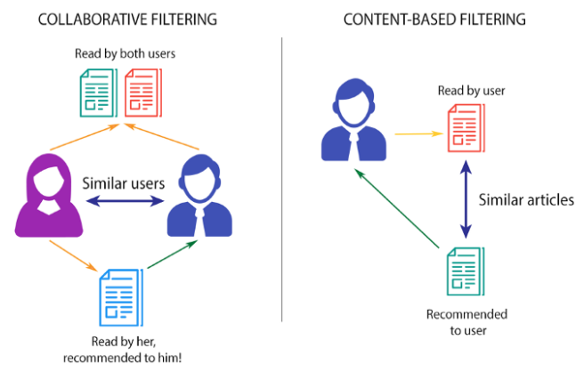

For systems using collaborative filtering one needs to measure the similarity of user profiles. In this case, it is crucial to have a reasonably large set of well maintained user profiles because otherwise, no users similar to the one under consideration can be found. This problem is known as the startup problem and in the case of collaborative filtering, it comes on top of the new user problem.

Research argues that collaborative filtering is an inappropriate approach for healthcare because collaborative filtering inspects user profiles across users. Considering the high degree of confidentiality required for these types of systems, this would incur too high a security risk.

But given that **Awake** architecture is meant to be **local**, experts do normally compare and get insight from different patients to help them diagnose newly registered ones. This may not be a huge problem to us.

### Patients Relationship

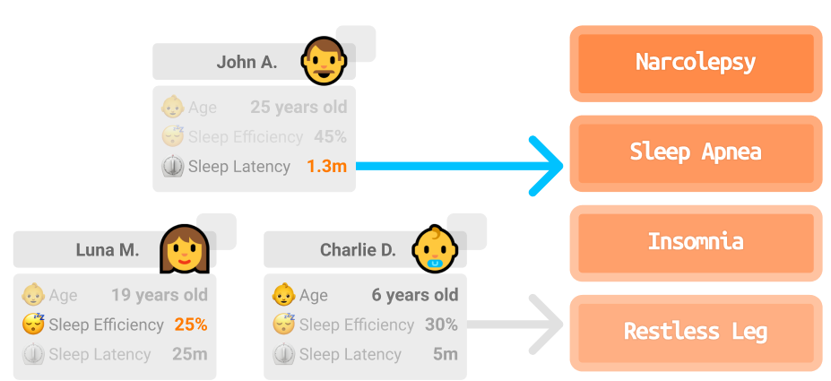

Now that we know how the basics of a **Collaborative RecSys** works, what about taking a patient’s profile and using the actual personal data + the related information from other patients to **recommend** a possible pathology?

There are many different types of sleep disorders. They're often grouped into **categories** that explain why they happen or how they affect a person. Sleep disorders can also be grouped according to **behaviors**, problems with the natural sleep-wake cycles, breathing problems, difficulty sleeping or how sleepy a person feels during the day.

However, information overload and irrelevant information are major obstacles for drawing conclusions on personal health status and taking adequate actions everytime a system like this is used in healthcare. BUT, given that **Awake**’s usage is not for the masses, experts would highly benefit from these quick/fast results.

### BigData in Healthcare

A **big data** approach to health is nothing new, here is a list of highly interesting articles & sources.

* [Item-Based Collaborative Filtering Recommendation Algorithms](http://files.grouplens.org/papers/www10_sarwar.pdf)
* [Health Recommender Systems: Concepts, Technical Basics and Challenges](https://www.ncbi.nlm.nih.gov/pmc/articles/PMC3968965/)
* [Sleep disorders](https://www.mayoclinic.org/diseases-conditions/sleep-disorders/symptoms-causes/syc-20354018)
* [Recommender Systems in Python](https://www.kaggle.com/gspmoreira/recommender-systems-in-python-101/comments)
* [Google Collaborative Filtering](https://developers.google.com/machine-learning/recommendation/collaborative/basics)
* [Simple Recommender Systems in Python](https://medium.com/swlh/how-to-build-simple-recommender-systems-in-python-647e5bcd78bd)
* [Quick and Dirty Recommender System](https://towardsdatascience.com/how-to-build-a-recommendation-engine-quick-and-simple-aec8c71a823e)

### 

### Conclusion

Deeper technical analysis is needed to actually prove that the results of a **Recommendation System** could actually be relevant in sleep oriented diagnosis. Nevertheless, it may generate really important data that experts could be interested in obtaining.

In our mission to provide automatic technical analysis and structure to **sleep data**, implementing a **Recommendation System** to link patients and possible pathologies can actually be the first step towards building a program that can generate **decision making** grade results.

This research proved that a new internal **Awake** module using **RecSys** to create relationships between patients' data could ease their diagnosis.