KIGALI INDEPENDENT UNIVERSITY (ULK)
SCHOOL OF COMPUTING AND INFORMATION SCIENCE
DEPARTMENT OF COMPUTER SCIENCE / DATA SCIENCE
P.O Box 2280, Kigali

FORECASTING AIR QUALITY USING TIME-SERIES ANALYSIS:
A STUDY OF PM2.5 CONCENTRATION TRENDS AND PREDICTIVE MODELING AT JALI STATION, KIGALI

By:
FRANCIS MICHAEL SUBAH
Registration Number: 202211503
Supervisor: Mr. Jonas Niyitegeka

A Dissertation Submitted in Partial Fulfilment of the Requirements for the Award of a Bachelor of Science Degree in Computer Science / Data Science at Kigali Independent University (ULK).

Kigali, October 2026

DECLARATION
I, Francis Michael Subah, hereby declare that this dissertation, titled “FORECASTING AIR QUALITY USING TIME-SERIES ANALYSIS: A STUDY OF PM2.5 CONCENTRATION TRENDS AND PREDICTIVE MODELING AT JALI STATION, KIGALI,” is my original work carried out under the supervision of Mr. Jonas Niyitegeka in partial fulfilment of the requirements for the award of a Bachelor of Science degree in Computer Science / Data Science at Kigali Independent University (ULK).
To the best of my knowledge, this work has not been submitted, in whole or in part, for any other academic award. All sources used in the dissertation have been acknowledged, and the analytical results reported in the study were generated from the documented modelling workflow.
Student’s Name: Francis Michael Subah
Signature: ______________________________
Date: ______________________________

SUPERVISOR’S APPROVAL
This dissertation entitled “FORECASTING AIR QUALITY USING TIME-SERIES ANALYSIS: A STUDY OF PM2.5 CONCENTRATION TRENDS AND PREDICTIVE MODELING AT JALI STATION, KIGALI” has been submitted for examination with my approval as the University Supervisor.
Supervisor’s Name: Mr. Jonas Niyitegeka
Signature: ______________________________
Date: ______________________________

DEDICATION
This work is dedicated to my family for their unwavering support, patience, encouragement, and sacrifices throughout my university education and the completion of this research.

ACKNOWLEDGEMENT
I sincerely thank my supervisor, Mr. Jonas Niyitegeka, for his guidance, constructive criticism, and continued support throughout the research process. His feedback on data quality, model comparison, leakage prevention, and interpretation strengthened the methodological rigour of this work.
I am grateful to Kigali Independent University (ULK), the School of Computing and Information Science, and the Department of Computer Science / Data Science for providing the academic environment in which this research was completed. I also acknowledge the Rwanda Environment Management Authority (REMA) and Meteo Rwanda for providing the environmental and meteorological records used in the study.
Finally, I thank my family, friends, classmates, and all those who encouraged me during the research, analysis, writing, and finalisation of this dissertation.

TABLE OF CONTENTS
DECLARATION i
SUPERVISOR’S APPROVAL------------------------------------------------------------------------------- ii
DEDICATION---------------------------------------------------------------------------------------------------iii
ACKNOWLEDGEMENT------------------------------------------------------------------------------------- iv
LIST OF TABLES---------------------------------------------------------------------------------------------- xi
LIST OF FIGURES--------------------------------------------------------------------------------------------xii
LIST OF ABBREVIATIONS --------------------------------------------------------------------------------xiii
ABSTRACT---------------------------------------------------- xiv
CHAPTER ONE: GENERAL INTRODUCTION
1.1 Introduction 1
1.2 Background of the Study 1
1.3 Problem Statement 2
1.4 Research Objectives 3
1.4.1 General Objective 3
1.4.2 Specific Objectives 3
1.5 Research Questions 3
1.6 Scope of the Study 3
1.7 Significance of the Study 4
1.8 Methodology (Summary) 5
1.9 Ethical Considerations 6
1.10 Limitations of the Study 7
CHAPTER TWO: LITERATURE REVIEW 8
2.1 Introduction 8
2.2 Conceptual Review 9
2.2.1 Air Quality and PM2.5 9
2.2.2 Time-Series Data and Forecasting 9
2.2.3 Stationarity, Autocorrelation and Seasonality 9
2.2.4 ARIMA, SARIMA and SARIMAX 9
2.2.5 Random Forest and XGBoost 10
2.2.6 Prophet 10
2.2.7 Baseline Forecasting 10
2.2.8 Forecast Evaluation and Data Leakage 10
2.3 Theoretical Review 11
2.3.1 Time-Series and Decomposition Theory 11
2.3.2 Box-Jenkins and Information-Criterion Theory 11
2.3.3 Ensemble-Learning Theory 11
2.3.4 Correlation and Environmental Forecasting 11
2.4 Review of Related Literature 11
2.4.1 Global and African PM2.5 Evidence 11
2.4.2 Kigali and Rwanda Context 12
2.4.3 Comparative Forecasting Literature 12
2.4.4 Meteorological Variables 12
2.4.5 Research Gap 13
2.5 Conceptual Framework 13
2.5.1 Framework Description 14
2.5.2 Alignment with Research Objectives 14
2.6 Summary of the Chapter 15
CHAPTER THREE: METHODOLOGY 16
3.1 Introduction 16
3.2 Research Design 16
3.2.1 Structural Design Principles 17
3.3 Data Sources and Collection 17
3.3.1 REMA Air-Quality Data 18
3.3.2 Meteo Rwanda Data 18
3.3.3 Temporal Overlap 19
3.4 Data Preprocessing 19
3.4.1 Data Loading and Initial Inspection 19
3.4.2 PM2.5 Missing-Value Treatment 19
3.4.3 Outlier Detection and Treatment 19
3.4.4 Meteorological Preprocessing 20
3.4.5 Feature Engineering for Machine Learning 20
3.4.6 Leakage Prevention 20
3.5 Exploratory Data Analysis 20
3.6 Model Development 21
3.6.1 Seasonal Naive Baseline 21
3.6.2 ARIMA 21
3.6.3 SARIMA 21
3.6.4 Random Forest 21
3.6.5 XGBoost 21
3.6.6 Prophet 21
3.6.7 SARIMAX Supplementary Analysis 22
3.7 Model Evaluation 22
3.7.1 Performance Metrics 22
3.7.2 Chronological Train-Test Split 23
3.7.3 Diagnostic Assessment 23
3.7.4 Model Selection Rule 24
3.8 Dashboard Development 24
3.8.1 Technology Stack 24
3.8.2 Architecture and Data Flow 25
3.8.3 API Design 26
3.8.4 Key Features 27
3.9 Software and Tools 29
3.10 Ethical Considerations 30
3.11 Limitations of the Methodology 30
3.12 Summary of the Chapter 31
CHAPTER FOUR: RESULTS AND ANALYSIS 32
4.1 Introduction 32
4.2 Data Preprocessing Results 32
4.2.1 Missing-Value Treatment 32
4.2.2 Outlier Detection and Treatment 33
4.3 Exploratory Data Analysis Results 34
4.3.1 Descriptive Statistics 34
4.3.2 Temporal Patterns 35
4.3.3 Time-Series Decomposition 36
4.3.4 Stationarity and Autocorrelation 37
4.4 Primary Model Results 38
4.4.1 ARIMA Results 39
4.4.2 SARIMA Results 39
4.4.3 Random Forest Results 39
4.4.4 XGBoost Results 39
4.4.5 Prophet Results 40
4.4.6 Seasonal Naive Results 40
4.5 Supplementary SARIMAX and Meteorological Results 40
4.6 Comparative Forecast Behaviour 43
4.7 Model Selection 44
4.8 Seven-Day Forecast Results 44
4.9 Dashboard Output 45
4.10 Summary of Results 46
CHAPTER FIVE: DISCUSSION 46
5.1 Introduction 47
5.2 Temporal Patterns and Data Quality 47
5.3 Comparative Model Performance 47
5.4 Meteorological Variables 48
5.5 Forecasting and Practical Application 48
5.6 Methodological Contributions 49
5.7 Comparison with Existing Literature 49
5.8 Strengths of the Study 49
5.9 Limitations 50
5.10 Summary 50
CHAPTER SIX: CONCLUSION AND RECOMMENDATIONS 50
6.1 Introduction 51
6.2 Summary of the Study 51
6.3 Summary of Principal Findings 51
6.4 Achievement of Research Objectives and Answers to Research Questions 52
6.4.1 Objective 1 and Research Question 1 52
6.4.2 Objective 2 and Research Question 2 52
6.4.3 Objective 3 and Research Question 3 52
6.4.4 Objective 4 52
6.5 Recommendations 53
6.5.1 Recommendations for REMA 53
6.5.2 Recommendations for Meteo Rwanda 53
6.5.3 Recommendations for Environmental and Public-Health Authorities 53
6.5.4 Recommendations for Future Researchers 53
6.6 Contribution of the Study 54
6.7 Reflection on the Research Process 54
6.8 Concluding Remarks 54
REFERENCES 54
APPENDICES 57
APPENDIX A: Final Preprocessing and Feature Engineering Code 57
APPENDIX B: Primary Model Comparison and Selection Code 58
APPENDIX C: Native Seven-Day Forecast Output 60
APPENDIX D: Dashboard and Deployment Notes 61
APPENDIX E: Model-Selection Audit 61

LIST OF TABLES
Table 3.1: Application of the CRISP-DM Framework in This Study 17
Table 3.2: Summary of Primary Data Sources 17
Table 3.3: REMA Dataset Variable Summary 18
Table 3.4: Meteo Rwanda Dataset Variable Summary 18
Table 3.5: Effective temporal coverage for primary and supplementary analyses 19
Table 3.6: Chronological evaluation split used for the primary model comparison 23
Table 3.7: Dashboard Technology Stack 25
Table 3.8: Dashboard REST API Endpoints 26
Table 3.9: Software and Tools Used 29
Table 4.1: PM2.5 missingness and maximum value across preprocessing stages 32
Table 4.2: PM2.5 distribution statistics before and after 1.5×IQR capping 34
Table 4.3: Descriptive statistics of the final daily PM2.5 series 35
Table 4.4: Augmented Dickey-Fuller stationarity results 37
Table 4.5: Primary model comparison on the common 72-day test period 38
Table 4.6: Pearson associations between PM2.5 and meteorological variables over the 206-day overlap 41
Table 4.7: Supplementary SARIMAX coefficients from the 206-day overlap 42
Table 4.8: Native seven-day forecast produced by the selected Random Forest model 45
Table C.1: Native seven-day forecast output 60
Table E.1: Model-selection audit 62

LIST OF FIGURES
Figure 2.1: Conceptual framework linking data inputs, preprocessing, comparative modelling, evaluation, and forecasting application 14
Figure 3.1: PM2.5 forecasting dashboard prototype for Jali Station, Kigali 26
Figure 4.1: PM2.5 series before and after imputation 33
Figure 4.2: Missing observations by variable before and after treatment 33
Figure 4.3: Raw and capped PM2.5 distributions 34
Figure 4.4: Hourly PM2.5 observations flagged by the 1.5×IQR rule 34
Figure 4.5: Daily mean PM2.5 concentration at Jali Station 35
Figure 4.6: Monthly mean PM2.5 concentration at Jali Station 36
Figure 4.7: Average PM2.5 by day of week 36
Figure 4.8: Seven-day additive decomposition of the daily PM2.5 series 37
Figure 4.9: ACF and PACF of the first-differenced daily PM2.5 series 38
Figure 4.10: RMSE, MAE, and MAPE for the six primary models 39
Figure 4.11: Feature importance for Random Forest and XGBoost 40
Figure 4.12: Pearson correlation matrix for PM2.5 and meteorological variables 41
Figure 4.13: Standardised SARIMAX coefficients with 95% confidence intervals 42
Figure 4.14: Actual and forecasted PM2.5 values for all primary models over the common test window 43
Figure 4.15: Zoomed comparison of the leading primary models 43
Figure 4.16: Forecast error over the common test window 43
Figure 4.17: Comparison of seven-day native and 72-day test-window performance 44
Figure 4.18: Seven-day PM2.5 forecast from the selected Random Forest model 45

LIST OF ABBREVIATIONS
Abbreviation | Meaning
ACF | Autocorrelation Function
ADF | Augmented Dickey-Fuller test
AIC | Akaike Information Criterion
AQI | Air Quality Index
ARIMA | Autoregressive Integrated Moving Average
CO | Carbon Monoxide
CRISP-DM | Cross-Industry Standard Process for Data Mining
IQR | Interquartile Range
MAE | Mean Absolute Error
MAPE | Mean Absolute Percentage Error
NO₂ | Nitrogen Dioxide
O₃ | Ozone
PACF | Partial Autocorrelation Function
PM2.5 | Particulate Matter with aerodynamic diameter ≤ 2.5 µm
PM10 | Particulate Matter with aerodynamic diameter ≤ 10 µm
REMA | Rwanda Environment Management Authority
RMSE | Root Mean Square Error
SARIMA | Seasonal Autoregressive Integrated Moving Average
SARIMAX | Seasonal ARIMA with Exogenous Variables
SO₂ | Sulphur Dioxide
ULK | Kigali Independent University
WHO | World Health Organization
XGBoost | Extreme Gradient Boosting

ABSTRACT
Air pollution, particularly fine particulate matter (PM2.5), remains an important environmental and public-health concern in rapidly urbanising cities. This study investigated temporal patterns and short-term forecasting of daily PM2.5 concentration at the Jali monitoring station in Kigali, Rwanda. The analysis used 8,274 hourly REMA air-quality observations covering 5 March 2022 to 29 February 2024 and 94,672 ten-minute Meteo Rwanda observations covering 7 August 2023 to 8 April 2026. A single, consistent preprocessing pipeline was applied to the PM2.5 series: timestamps were ordered and de-duplicated, extreme observations were capped using the 1.5×IQR rule, short gaps were linearly interpolated, remaining gaps were treated using hour-of-day means and boundary interpolation, and the resulting series was aggregated to daily means. The final daily series contained 727 observations. Six primary forecasting approaches were evaluated on the same chronological 72-day held-out test period: Seasonal Naive, ARIMA, SARIMA, Random Forest, XGBoost, and Prophet. ARIMA and SARIMA orders were selected using AIC-guided searches, while Random Forest and XGBoost used lag, rolling, and calendar features designed to avoid leakage. Model performance was evaluated using RMSE, MAE, and MAPE. Random Forest produced the lowest test-set RMSE (5.93 µg/m³), MAE (4.42 µg/m³), and MAPE (22.08%), narrowly outperforming XGBoost (RMSE 5.95 µg/m³). It was therefore selected empirically and refitted on the full daily series for a native seven-day forecast from 1 to 7 March 2024, with point forecasts ranging from 15.30 to 16.51 µg/m³. Meteorological analysis was treated separately because only 206 daily observations overlapped between the REMA and Meteo Rwanda records. Pearson associations were generally weak; radiation had the largest absolute correlation (r = −0.2511). In the supplementary SARIMAX association analysis, humidity, lagged temperature, and lagged humidity were statistically significant at the 5% level, while the short overlap limits generalization. A Flask-based dashboard prototype was developed as a practical presentation layer. The study concludes that tree-based lag forecasting is promising for this dataset, but longer records, stronger quality control, multi-station data, and rolling-origin validation are required before operational deployment.
Keywords: PM2.5; air-quality forecasting; time-series analysis; Random Forest; XGBoost; SARIMA; SARIMAX; Jali Station; Kigali; Rwanda.

CHAPTER ONE: GENERAL INTRODUCTION

1.1 Introduction
This chapter introduces the study of PM2.5 forecasting at the Jali air-quality monitoring station in Kigali, Rwanda. It presents the background to the study, the research problem, objectives and questions, scope, significance, summary methodology, ethical considerations, and study limitations. The chapter frames the research as an empirical comparison of forecasting approaches rather than as a study in which a particular model is selected in advance.

1.2 Background of the Study
Air pollution is a major environmental and public-health challenge, and fine particulate matter (PM2.5) is of particular concern because its small aerodynamic size enables penetration deep into the respiratory system. The World Health Organization (WHO, 2021) provides health-based guideline levels for PM2.5 and other major pollutants, reflecting evidence that adverse health effects occur at concentrations lower than previously recognised. Global burden-of-disease research has also established a substantial contribution of ambient air pollution to premature mortality and disease (Cohen et al., 2017).
Kigali provides a relevant setting for locally focused air-quality research. The city has experienced urban growth, changes in mobility and land use, and continuing development of environmental monitoring infrastructure. Research in Kigali has documented spatial and temporal variation in ambient pollutants and has examined the contribution of local environmental conditions and human activities to air-quality patterns (Elisephane, 2025; Omodieke et al., 2026). The Jali monitoring station provides a useful single-site time series for studying how PM2.5 changes over time.
Observation alone, however, does not provide information about what pollution levels may be expected in the following days. Time-series forecasting uses the temporal dependence in historical observations to estimate future values (Box & Jenkins, 1976; Hyndman & Athanasopoulos, 2021). Classical statistical models such as ARIMA and SARIMA explicitly represent serial dependence and differencing, while machine-learning models such as Random Forest and XGBoost can learn non-linear relationships from lagged and rolling features (Breiman, 2001; Chen & Guestrin, 2016). Prophet provides an additional decomposition-based benchmark (Taylor & Letham, 2018).
The present study therefore adopts a comparative forecasting perspective. Rather than assuming that one model family is appropriate beforehand, it evaluates several approaches using a common chronological test period. Meteorological data are also examined, but because the available REMA and Meteo Rwanda records overlap for only 206 daily observations after alignment, the weather-informed analysis is treated as supplementary rather than as a directly comparable primary forecasting experiment.

1.3 Problem Statement
Fine particulate matter (PM2.5) is an important air-quality and public-health concern because its small particle size allows it to penetrate deeply into the respiratory system and is associated with respiratory and cardiovascular health effects. PM2.5 concentrations are influenced by emission sources such as road traffic, domestic and biomass combustion, waste burning, industrial activity and dust, while meteorological conditions such as rainfall, wind, humidity, temperature and solar radiation influence pollutant dispersion, removal and atmospheric behaviour.
The health implications are particularly important for groups that may be more vulnerable to air pollution or more exposed to it, including children, pregnant women, older adults, people with respiratory or cardiovascular conditions, and outdoor workers. For these groups, knowing only the current concentration of PM2.5 provides limited opportunity for proactive exposure management. Short-term forecasts can instead provide advance information that may support precautionary decisions by individuals, schools, health facilities and environmental authorities.
Rwanda has established air-quality monitoring infrastructure through REMA, including monitoring at Jali Station in Kigali. However, monitoring observations primarily describe measured conditions, while converting historical measurements into validated location-specific forecasts requires additional data-quality assessment, temporal analysis and model evaluation. The Jali dataset used in this study contains missing observations and extreme values that can materially affect model estimation if they are not treated consistently.
The specific problem addressed by this research is therefore the need for a transparent and reproducible framework that can transform historical Jali PM2.5 observations into short-term predictive information while explicitly accounting for data quality, temporal dependence and uncertainty. The study evaluates statistical time-series and machine-learning approaches and demonstrates the practical application of the selected model through a seven-day forecasting dashboard. The dashboard is intended as a research prototype and does not replace official REMA monitoring or public-health advisories.

1.4 Research Objectives

1.4.1 General Objective
To develop and empirically evaluate a short-term forecasting workflow for daily PM2.5 concentration at the Jali monitoring station in Kigali using historical air-quality data, appropriate statistical and machine-learning models, and a practical seven-day forecasting output.

1.4.2 Specific Objectives
- To analyse the temporal distribution, variability, trend, and weekly/seasonal patterns of PM2.5 concentration at the Jali monitoring station.
- To develop and compare Seasonal Naive, ARIMA, SARIMA, Random Forest, XGBoost, and Prophet forecasting approaches using a common chronological out-of-sample test period.
- To assess the association between PM2.5 and available meteorological variables and examine weather-informed modelling using the limited REMA–Meteo overlap.
- To generate a seven-day PM2.5 forecast from the empirically selected model and present the forecasting workflow through a practical dashboard prototype.

1.5 Research Questions
- What temporal patterns, including trend, weekly behaviour, and seasonality, are observable in the Jali PM2.5 series?
- How do the candidate forecasting approaches compare when evaluated on the same chronological held-out test period?
- What is the nature of the association between PM2.5 and the available meteorological variables over the common observation period?

1.6 Scope of the Study
The scope of this study was defined to ensure feasibility within the constraints of an undergraduate research project while maintaining sufficient depth to generate meaningful findings.
Geographically, the study is confined to the Jali monitoring station in Kigali, operated by REMA. Due to data-availability constraints, this station was the only location for which a consistent, reasonably complete time series could be obtained. The findings are therefore specific to the Jali area and do not capture spatial variability across other districts of Kigali.
In terms of time frame, the study covers the period March 2022 to February 2024 for the REMA air-quality dataset, which spans the post-COVID-19 recovery phase during which industrial and traffic activity resumed. Meteorological data from Meteo Rwanda span August 2023 to April 2026, with an effective overlap of approximately 206 days (August 2023 to February 2024).
Theoretically, the study compares six candidate modelling approaches: Seasonal Naive (baseline), ARIMA, SARIMA, Random Forest, XGBoost, and Prophet. SARIMAX is retained as a supplementary, non-forecasting analysis to estimate meteorological associations on the overlap window. Deep-learning approaches such as LSTM and Temporal Convolutional Networks are deliberately placed outside the scope, on the grounds of their data-volume requirements and the priority placed on model interpretability in an undergraduate study.
In terms of content, the primary variable of interest is PM2.5 concentration measured in micrograms per cubic metre (µg/m³). Secondary variables include temperature (°C), relative humidity (%), rainfall (mm), wind speed (m/s), and solar radiation (W/m²), which are incorporated as contextual variables in correlation analysis and in the supplementary SARIMAX model.
In terms of forecasting horizon, the study focuses on a seven-day ahead daily forecast, a horizon chosen to balance practical utility with modelling feasibility.
In terms of deliverable, the study includes a prototype interactive dashboard for seven-day PM2.5 forecasting, developed using the Flask web framework with Plotly.js visualisation. The dashboard is positioned as a research prototype rather than an operational early-warning system.

1.7 Significance of the Study
This study holds significance at multiple levels: academic, methodological, practical, and public-health.
Academically, the study contributes a documented, reproducible comparison of statistical and machine-learning forecasting approaches for PM2.5 in an East African urban context — a domain that remains under-represented in the time-series and environmental data-science literature. By evaluating six candidate models under one consistent preprocessing pipeline and a single chronological evaluation framework, the study provides a methodological template that can be adopted and extended by future researchers, students, and practitioners in Rwanda and the broader region.
Methodologically, the study demonstrates the value of empirical model selection over a priori assumption, and of a single, transparent preprocessing pipeline over multiple divergent configurations. It also documents the practical importance of leakage prevention in time-series machine learning and of honest disclosure of a selected model's limitations.
From a practical standpoint, the developed pipeline, candidate models, and dashboard constitute tangible outputs that can be shared with relevant stakeholders, including REMA and academic institutions. The study provides proof-of-concept evidence that predictive tools can be constructed from publicly available data using open-source software, without the need for expensive proprietary systems or additional sensor deployment.
In public-health terms, the study's outputs have direct relevance for the management of pollution-related health risks in the Jali area. Even an imperfect seven-day forecast provides lead time for health authorities to issue advisories, for schools and event organisers to modify outdoor activities, and for individuals in vulnerable groups to take preventive measures.
At the policy level, the study contributes an evidence base for Rwanda's efforts to integrate predictive analytics into urban environmental governance, and it highlights the value of sustained investment in air-quality monitoring and data accessibility.

1.8 Methodology (Summary)
This study adopts a quantitative, non-experimental research design based on secondary analysis of historical air-quality and meteorological data. The CRISP-DM framework structures the analytical workflow. The analysis was documented to support reproducibility and auditability, consistent with the broader principles of reproducible computational research (Peng, 2011).
Data are sourced from REMA for the Jali monitoring station (8,274 hourly records of PM2.5, PM10, SO₂, CO, NO₂, and O₃ spanning March 2022 to February 2024) and from Meteo Rwanda (temperature, humidity, rainfall, wind speed, and solar radiation at ten-minute resolution spanning August 2023 to April 2026).
A single, consistent preprocessing pipeline is applied to the PM2.5 series: timestamp parsing and sorting, duplicate removal, 1.5 × IQR outlier capping, short-gap linear interpolation (≤ 6 hours), hour-of-day mean imputation, daily mean aggregation, and remaining daily-gap interpolation. This pipeline produces one cleaned daily PM2.5 series used by all primary candidate models.
Six candidate models are then developed and evaluated: Seasonal Naive (baseline), ARIMA, SARIMA, Random Forest, XGBoost, and Prophet. All primary models are evaluated on the same 72-day chronological test window, using RMSE, MAE, and MAPE. For the machine-learning models, feature engineering is restricted to lagged, rolling, and calendar features that use only information available before each prediction day, and recursive seven-day forecasting is applied. SARIMAX is fitted only on the REMA–Meteo overlap (approximately 206 days) and is used as a supplementary analysis of meteorological association rather than as a forecasting candidate.
The final model is selected empirically on the basis of out-of-sample RMSE, with MAE and MAPE as secondary criteria, and is refit on the full series to generate a seven-day forecast. A Flask-based interactive dashboard is developed as a prototype decision-support tool.
Full methodological detail is provided in Chapter Three.

1.9 Ethical Considerations
This study adhered to established principles of academic and research ethics throughout its execution (ACM, 2018). Given that the research relied exclusively on environmental datasets obtained through official data-sharing agreements with REMA and Meteo Rwanda, no ethical approval for human-subjects research was required. Nevertheless, several important ethical commitments were upheld.
Data integrity. All data sources were transparently cited, and no measurements were fabricated, altered, or selectively omitted. The identification and treatment of the sensor anomaly in the raw PM2.5 record were documented explicitly, and the raw values were retained for audit.
Academic honesty. All code and writing were the student's original work, with proper attribution for referenced methodologies and code snippets.
Data privacy and confidentiality. The study utilised only anonymised environmental measurements obtained through official agreements. No personally identifiable information was collected or analysed.
Communication of findings. Results are presented objectively, including negative findings, and the model's assumptions and limitations are stated clearly to avoid misinterpretation or unwarranted alarm.
Responsible deployment. The dashboard carries an explicit staleness warning to prevent the demonstration forecast being mistaken for a validated operational service.
Institutional approval. The research was conducted as part of undergraduate studies under the supervision of faculty members at Kigali Independent University.

1.10 Limitations of the Study
Several limitations bound the scope and applicability of this research.
- First, the study relies on data from a single monitoring station (Jali). The findings may not represent air-quality conditions in other parts of Kigali with different land use, traffic density, population levels, or emission sources. Forecasts apply only to the Jali area.
- Second, data-quality and completeness constraints affect the reliability of the analysis. Approximately 19.4% of PM2.5 and PM10 hourly observations were missing, and the raw hourly PM2.5 series contained a sensor anomaly with a maximum reading of 3,335 µg/m³. Missing values were imputed and anomalies were capped using a documented pipeline, but both introduce a degree of uncertainty.
- Third, all candidate models are limited in their capacity to represent complex non-linear dynamics, abrupt structural breaks, or exogenous shocks. Future research could explore deep-learning approaches such as LSTM networks.
- Fourth, the REMA–Meteo overlap is only approximately 206 days, limiting the meteorological association analysis (SARIMAX). Results from SARIMAX are therefore reported as indicative associations rather than as stable estimates.
- Fifth, the study focuses exclusively on PM2.5, while other pollutants also pose health risks and exhibit different dynamics.
- Sixth, the study evaluates forecasts primarily at the seven-day horizon. Longer-term forecasts were not assessed.
- Seventh, the models were calibrated on historical data specific to the Jali station and may not generalise to other stations without re-estimation.
- Despite these limitations, the study provides valuable insights into PM2.5 forecasting for the Jali monitoring station and establishes a foundation for future research and operational development.

CHAPTER TWO: LITERATURE REVIEW

2.1 Introduction
This chapter reviews the concepts, theories, and empirical studies that underpin PM2.5 forecasting. It covers air quality and particulate matter, time-series analysis, ARIMA-family models, machine-learning forecasting, Prophet, baseline forecasting, evaluation metrics, data leakage, and meteorological associations. The review is used to justify a comparative framework rather than a predetermined model choice.

2.2 Conceptual Review

2.2.1 Air Quality and PM2.5
Air quality describes the composition of ambient air in relation to pollutants that can affect health, ecosystems, visibility, or climate. PM2.5 refers to particulate matter with an aerodynamic diameter of approximately 2.5 micrometres or less. Because these particles are small enough to penetrate deeply into the respiratory system, exposure is associated with respiratory and cardiovascular health effects (Xing et al., 2016; Cohen et al., 2017). The WHO global air-quality guidelines provide health-based reference concentrations that are useful for interpreting the magnitude of measured pollution, but a forecast should not be treated as an official health advisory (WHO, 2021).

2.2.2 Time-Series Data and Forecasting
A time series is an ordered sequence of observations indexed by time. Forecasting attempts to estimate future observations using information available at the forecast origin. Temporal ordering matters because future observations must not be used to train a model intended to predict the past or a held-out future period (Hyndman & Athanasopoulos, 2021).

2.2.3 Stationarity, Autocorrelation and Seasonality
Stationarity concerns whether the statistical properties of a series remain sufficiently stable over time. ARIMA-type methods use differencing to address non-stationarity. Autocorrelation measures dependence between observations separated by specified lags, while partial autocorrelation helps identify relationships after accounting for intermediate lags. Seasonality refers to systematic patterns that repeat at a known period; in this study, a seven-day period is investigated because daily pollution can exhibit weekly structure.

2.2.4 ARIMA, SARIMA and SARIMAX
ARIMA combines autoregressive terms, differencing, and moving-average terms. SARIMA extends ARIMA by adding seasonal components, allowing recurring patterns to be represented explicitly (Box & Jenkins, 1976; Box et al., 2015). SARIMAX further includes exogenous variables such as meteorological measurements. Its usefulness depends on having appropriately aligned predictors that would legitimately be available at the forecast time.

2.2.5 Random Forest and XGBoost
Random Forest is an ensemble of decision trees that introduces randomness in tree construction and aggregates tree predictions. Breiman (2001) showed that the method can be applied to regression as well as classification. XGBoost is a gradient-boosting system that builds an ensemble of trees sequentially and incorporates regularisation and computational optimisations (Chen & Guestrin, 2016). For time-series forecasting, these models require the temporal structure to be represented explicitly through lagged, rolling, and calendar features.

2.2.6 Prophet
Prophet is a decomposable forecasting model designed to represent trend and seasonal components in an interpretable framework (Taylor & Letham, 2018). It was included as a benchmark in the present study. The final notebook also generated a warning that yearly seasonality was being estimated with less than approximately two years of training history, which is an important limitation when interpreting its performance.

2.2.7 Baseline Forecasting
A baseline provides a reference against which more complex models can be judged. The Seasonal Naive method predicts a value using the corresponding value from the previous seasonal cycle. Including such a benchmark prevents a complex model from being interpreted as useful merely because it produces forecasts.

2.2.8 Forecast Evaluation and Data Leakage
RMSE penalises larger errors more strongly than MAE, while MAE measures average absolute error in the original unit. MAPE expresses error relative to the observed value, but can become unstable when observations are close to zero (Hyndman & Koehler, 2006). In time-series work, leakage occurs when information unavailable at prediction time enters model training or feature construction (Kaufman et al., 2012). This study therefore constructs rolling statistics using values shifted by one day and avoids random shuffling.

2.3 Theoretical Review

2.3.1 Time-Series and Decomposition Theory
Time-series decomposition separates an observed series into interpretable components such as trend, seasonal variation, and residual variation. The approach provides a diagnostic view of whether recurring structure is present before forecasting models are fitted.

2.3.2 Box-Jenkins and Information-Criterion Theory
The Box-Jenkins tradition emphasises identification, estimation, diagnostic checking, and forecasting. In the present study, candidate ARIMA and SARIMA orders are searched using Akaike Information Criterion (AIC), while final predictive comparison is based on out-of-sample error rather than AIC alone. This distinction is important because an in-sample information criterion and a held-out predictive metric answer different questions (Akaike, 1974).

2.3.3 Ensemble-Learning Theory
Ensemble methods combine multiple tree-based learners to improve predictive stability or reduce bias and variance. Random Forest uses aggregation across trees, while gradient boosting builds successive trees that focus on residual error. Their suitability for a time series depends on whether features encode the temporal information without leakage.

2.3.4 Correlation and Environmental Forecasting
Meteorological conditions affect pollutant transport, dilution, deposition, and atmospheric chemistry. Temperature, humidity, rainfall, wind, and radiation can therefore be associated with PM2.5, but an observed correlation does not by itself establish causation. A variable may also be statistically associated with the target without being a legitimately available future predictor.

2.4 Review of Related Literature

2.4.1 Global and African PM2.5 Evidence
Global evidence establishes PM2.5 as a major environmental health risk (Cohen et al., 2017; WHO, 2021). African cities face additional challenges associated with monitoring coverage, heterogeneous emission sources, meteorology, and data continuity. Petkova et al. (2013) highlighted the importance of understanding particulate pollution in African urban settings, while recent work has increasingly used statistical and machine-learning methods to study regional PM2.5 variability (Ndehedehe et al., 2026).

2.4.2 Kigali and Rwanda Context
Kigali-specific research has documented variation in particulate pollution and relationships with urban and environmental conditions. Studies have considered ambient pollution, school environments, heatwave conditions, and citywide monitoring (Korukire et al., 2024; Elisephane, 2025; Kalisa & Sudmant, 2025; Omodieke et al., 2026). These studies establish the importance of local context and support the use of station-specific forecasting rather than assuming that a model estimated elsewhere will transfer unchanged to Jali.

2.4.3 Comparative Forecasting Literature
Bogale et al. (2024) compared ARIMA, LSTM, and TCN approaches for PM2.5 prediction in Kigali and reported stronger performance from the deep-learning approach in their setting. This demonstrates the value of empirical comparison but does not determine which model should be selected for the Jali dataset used here. The present study broadens the comparison to include a seasonal naive benchmark, ARIMA, SARIMA, Random Forest, XGBoost, and Prophet.
Statistical forecasting remains valuable because ARIMA-family models are interpretable and provide established diagnostic procedures (Box & Jenkins, 1976; Hyndman & Athanasopoulos, 2021). At the same time, tree ensembles can represent non-linear relationships and interactions among lagged features (Breiman, 2001; Chen & Guestrin, 2016). Prophet offers a distinct decomposition-based benchmark (Taylor & Letham, 2018). Comparing these families under the same test period provides evidence that is specific to the data-generating characteristics of Jali.

2.4.4 Meteorological Variables
Meteorological conditions influence air-pollution dispersion and transformation (Seinfeld & Pandis, 2016). Regional studies have reported relationships between meteorological variables and PM2.5, although the strength and direction vary by location and season. The present study includes temperature, humidity, rainfall, wind speed, radiation, dry-season indicators, and one-day lags in the supplementary analysis. Because the meteorological record does not cover the full REMA period, the analysis is deliberately separated from the primary model comparison.

2.4.5 Research Gap
- Jali-specific forecasting research remains limited relative to broader Kigali air-quality research.
- Comparative evidence across statistical, tree-based, decomposition-based, and baseline forecasting methods is limited for this station.
- Environmental datasets can contain missing values and sensor faults that materially affect model estimates if they are not handled consistently.
- The REMA–Meteo temporal mismatch limits direct evaluation of weather-informed forecasting over the full air-quality period.
- A reproducible workflow that explicitly separates empirical predictive performance from supplementary weather association is useful for future research and deployment.

2.5 Conceptual Framework
The conceptual framework links historical PM2.5 and contextual meteorological information to data-quality processing, exploratory analysis, candidate model development, chronological evaluation, empirical model selection, and a seven-day forecasting output. The six primary candidate models are Seasonal Naive, ARIMA, SARIMA, Random Forest, XGBoost, and Prophet. Meteorological variables are treated as contextual or supplementary predictors because their effective overlap with the REMA series is limited.
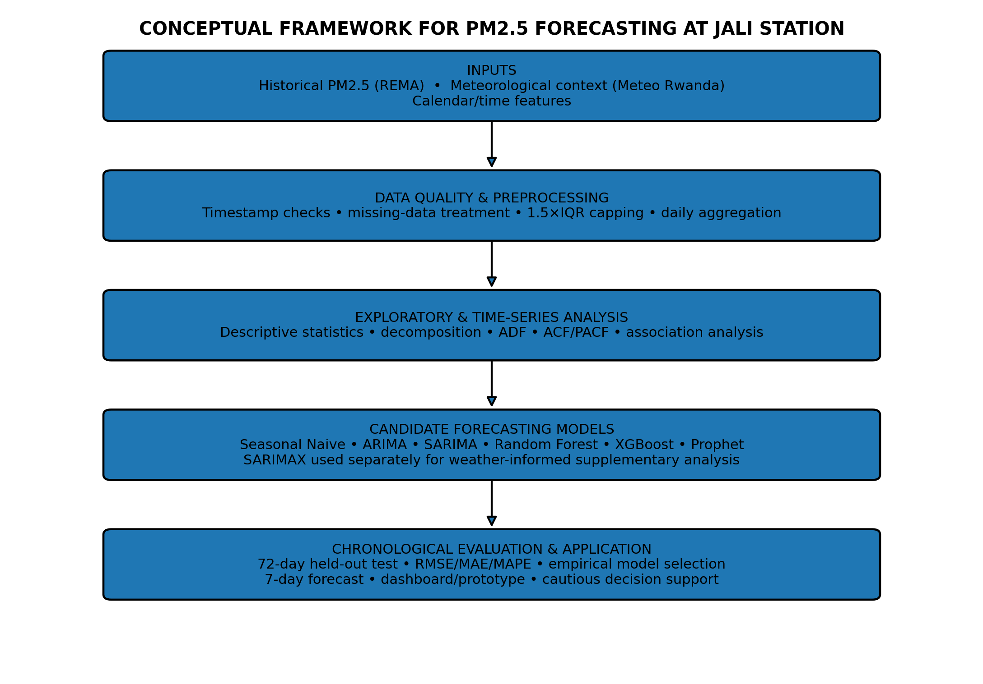
Figure 2.1: Conceptual framework linking data inputs, preprocessing, comparative modelling, evaluation, and forecasting application

2.5.1 Framework Description
Historical PM2.5 observations provide the primary forecasting signal. Data-quality processing creates the model-ready series. Exploratory analysis identifies temporal structure. Candidate models are then fitted without assuming a winner. A chronological held-out period provides common evidence for model comparison. The model with the lowest RMSE on the common test period is selected, with MAE and MAPE used as supporting measures. Meteorological association is assessed separately because its effective sample differs from the primary evaluation.

2.5.2 Alignment with Research Objectives
Objective | Framework component | Evidence produced
Objective 1 | Exploratory/time-series analysis | Descriptive statistics, monthly/weekly patterns, decomposition, ADF and ACF/PACF
Objective 2 | Candidate modelling and chronological evaluation | RMSE, MAE, MAPE for six primary models on the same 72-day test period
Objective 3 | Meteorological overlap and supplementary SARIMAX | Pearson associations and SARIMAX coefficient significance for 206 observations
Objective 4 | Final refit and dashboard/prototype | Seven-day forecast and practical presentation layer

2.6 Summary of the Chapter
The literature establishes PM2.5 as an important health-relevant pollutant and supports the use of time-series forecasting in urban environmental monitoring. It also shows that no single model family should be assumed to be optimal across datasets. The conceptual framework therefore centres on consistent preprocessing, leakage-aware feature construction, chronological evaluation, empirical model comparison, and cautious application of the final forecast. This framework guides the methodology presented in Chapter Three.

CHAPTER THREE: METHODOLOGY

3.1 Introduction
This chapter presents the methodological framework employed to develop and evaluate forecasting models for PM2.5 concentrations at the Jali monitoring station in Kigali, Rwanda. The methodology is structured according to the research objectives stated in Chapter One: (1) to analyse the temporal distribution and seasonality of PM2.5 and to quality-assure the dataset using one consistent preprocessing pipeline; (2) to develop and evaluate candidate PM2.5 forecasting models using statistical and machine-learning approaches and compare them on a common chronological test window; (3) to select the most suitable forecasting model empirically and generate a seven-day forecast; and (4) to develop a prototype dashboard and formulate recommendations.
The chapter describes the research design, data sources, the single preprocessing pipeline, exploratory analysis, candidate model development, evaluation framework, dashboard development, and software tools. The approach follows the CRISP-DM framework (Wirth & Hipp, 2000). A distinguishing feature is that the methodology was designed, from the outset, to support a single consistent preprocessing pipeline and a common chronological evaluation framework for all primary candidate models, so that model selection is based on genuine out-of-sample evidence.

3.2 Research Design
CRISP-DM Phase | Application in This Study
Business Understanding | Identify the need for PM2.5 forecasting to support air-quality awareness in the Jali area
Data Understanding | Collect and explore PM2.5 (REMA, 2022–2024) and meteorological (Meteo Rwanda, 2023–2026) datasets
Data Preparation | Apply a single consistent preprocessing pipeline; feature engineering for ML models
Modelling | Develop six candidate models: Seasonal Naive, ARIMA, SARIMA, Random Forest, XGBoost, Prophet; plus supplementary SARIMAX
Evaluation | Assess performance using RMSE, MAE, MAPE on a common chronological test window; residual diagnostics
Deployment | Develop a prototype Flask-based dashboard for seven-day forecasting; formulate recommendations
Table 3.1: Application of the CRISP-DM Framework in This Study

3.2.1 Structural Design Principles
- One final PM2.5 preprocessing pipeline feeds all primary forecasting models.
- Model comparison uses the same 72-day chronological test period.
- Random shuffling is not used.
- Feature construction for machine-learning models uses only information available before the forecast date.
- Model selection is based on held-out predictive performance rather than a predetermined preferred model.
- SARIMAX is reported separately because the weather overlap has a different sample size and evaluation context.

3.3 Data Sources and Collection
The study relied on data obtained from two official Rwandan institutions, summarised in Table 3.2. The REMA monitoring network has been used in previous studies of Kigali air quality (Omodieke et al., 2026; Ramiza & Kalisa, 2026), and Meteo Rwanda records have supported studies of meteorological influences on air quality in the region (Ndehedehe et al., 2026).
Table 3.2: Summary of Primary Data Sources
Source | Data Type | Period | Location | Format
Rwanda Environment Management Authority (REMA) | Hourly air pollutant concentrations (SO₂, CO, PM10, NO₂, O₃, PM2.5) | 2022-03-05 to 2024-02-29 | Jali monitoring station | Excel (.xlsx)
Meteo Rwanda | 10-minute meteorological variables (Temperature, Radiation, Rain, Humidity, Wind Direction, Wind Speed) | 2023-08-07 to 2026-04-08 | Jali station | Excel (.xlsx)

3.3.1 REMA Air-Quality Data
The REMA Jali workbook contained 8,274 observations and six pollutant variables: SO₂, CO, PM10, NO₂, O₃, and PM2.5. The timestamps range from 5 March 2022 at 12:00 to 29 February 2024 at 23:00. PM2.5 had 1,607 missing observations.
Table 3.3: REMA Dataset Variable Summary
Variable | Description | Unit | Missing Count | Missing %
DateTime | Date and time stamp | — | 0 | 0.0%
SO₂ | Sulphur dioxide | µg/m³ | 0 | 0.0%
CO | Carbon monoxide | µg/m³ | 0 | 0.0%
PM10 | Particulate matter < 10 µm | µg/m³ | 1,607 | 19.4%
NO₂ | Nitrogen dioxide | µg/m³ | 0 | 0.0%
O₃ | Ozone | µg/m³ | 0 | 0.0%
PM2.5 | Fine particulate matter < 2.5 µm | µg/m³ | 1,607 | 19.4%

3.3.2 Meteo Rwanda Data
The Meteo Rwanda workbook contained 94,672 ten-minute observations from 7 August 2023 at 15:10 to 8 April 2026 at 20:30. Variables retained for the analysis were temperature, radiation, rainfall, humidity, wind direction, and wind speed. The meteorological data were resampled to hourly and then daily means for the supplementary analysis.
Table 3.4: Meteo Rwanda Dataset Variable Summary
Variable | Description | Unit | Missing Count | Missing %
Temperature | Air temperature | °C | < 200 | < 0.2%
Radiation | Solar radiation | W/m² | 162 | 0.2%
Rain | Rainfall | mm | 23,600 | 24.9%
Humidity | Relative humidity | % | 1,805 | 1.9%
WindDirection | Wind direction | degrees | 1 | 0.0%
WindSpeed | Wind speed | m/s | 247 | 0.3%

3.3.3 Temporal Overlap
After daily alignment and creation of one-day meteorological lags, 206 observations remained for the supplementary weather-informed analysis. The effective overlap was 8 August 2023 to 29 February 2024. This is substantially shorter than the 727-day PM2.5 series and is the reason SARIMAX is not included in the primary common-test-set ranking.
Dataset relationship | Effective period | Observations | Role
Primary PM2.5 series | 05 Mar 2022–29 Feb 2024 | 727 daily | Primary forecasting
REMA–Meteo overlap | 08 Aug 2023–29 Feb 2024 | 206 daily | Supplementary meteorological association
Table 3.5: Effective temporal coverage for primary and supplementary analyses

3.4 Data Preprocessing

3.4.1 Data Loading and Initial Inspection
REMA timestamps were parsed to datetime, sorted, and de-duplicated. Meteorological timestamps were parsed similarly, and location fields not required for the single-station analysis were removed. Missing-value counts were recorded before transformation.

3.4.2 PM2.5 Missing-Value Treatment
The PM2.5 series contained 1,607 missing hourly values. Consistent treatment of missing observations is important because the way missingness is handled can influence subsequent estimates and model behaviour (Little & Rubin, 2019). The final pipeline first preserved the raw series for auditing, then applied linear interpolation for gaps up to six consecutive hours. Remaining gaps were filled using hour-of-day means calculated from the partially completed series, followed by bidirectional interpolation for boundary gaps. The cleaned hourly series was aggregated to daily means and any remaining daily gaps were interpolated bidirectionally.

3.4.3 Outlier Detection and Treatment
Outlier treatment was performed before imputation using the 1.5×IQR rule. Values outside the lower and upper fences were capped rather than deleted, preserving the temporal structure. The lower bound was constrained to zero because PM2.5 concentration cannot be negative. The final upper fence was 61.83 µg/m³. Seventy-five non-missing hourly observations (1.12%) were flagged and capped. The raw maximum of 3,335.06 µg/m³ was therefore reduced to 61.83 µg/m³ in the model-ready series.

3.4.4 Meteorological Preprocessing
Meteorological observations were resampled from ten-minute to hourly means. Rainfall missing values were treated using hour-month means and then an overall mean where required; other weather variables were linearly interpolated with a six-hour limit and then boundary-filled. Daily means were subsequently calculated. These operations were applied only to the supplementary meteorological analysis.

3.4.5 Feature Engineering for Machine Learning
The Random Forest and XGBoost models used lag1, lag2, lag3, lag7, and lag14 PM2.5 values; seven- and fourteen-day rolling means; seven-day rolling standard deviation; day-of-week; month; and weekend indicators. Rolling statistics were shifted by one day before calculation, ensuring that the feature for day t did not use the target value from day t.

3.4.6 Leakage Prevention
Leakage prevention was a central design requirement. Random train-test shuffling was avoided. Future PM2.5 values were not used to construct training features. The recursive seven-day forecast for tree models used each prediction as the next lagged input, rather than using unavailable future observations. This distinction is important because a variable can be historically correlated with PM2.5 without being legitimately known at the forecast time.

3.5 Exploratory Data Analysis
Exploratory analysis included descriptive statistics, daily and monthly visualisation, weekday summaries, additive decomposition with a seven-day period, Pearson correlation analysis, ADF stationarity testing, and ACF/PACF analysis of the first-differenced series. These procedures were used to characterise the data and inform model specification rather than to predetermine the final model.

3.6 Model Development

3.6.1 Seasonal Naive Baseline
The Seasonal Naive model forecasts each test observation using the value from seven days earlier. It provides a simple benchmark that captures weekly persistence.

3.6.2 ARIMA
ARIMA models were searched over p and q values from 0 to 3 with d fixed at 1. The order with the lowest AIC was retained. The final ARIMA specification selected by the notebook was ARIMA(2,1,3).

3.6.3 SARIMA
SARIMA models were searched over p and q values 0–2, seasonal P and Q values 0–1, d=1, D=0, and seasonal period s=7, with a complexity limit. The final specification was SARIMA(0,1,2)(0,0,1)₇. AIC was used for order selection within the training data, while held-out error was used for final empirical comparison.

3.6.4 Random Forest
Random Forest used 300 trees, unrestricted maximum depth, minimum leaf size of 2, and random state 42. The model was trained on the lag/rolling/calendar feature matrix. The primary test evaluation used 72 model-ready observations. The final selected model was refitted on the full feature set and used recursively to generate the seven-day forecast.

3.6.5 XGBoost
XGBoost used 400 estimators, learning rate 0.05, maximum depth 4, subsample 0.9, column subsampling 0.9, regularisation λ=1.0, and random state 42. It used the same feature set and chronological evaluation design as Random Forest.

3.6.6 Prophet
Prophet was fitted with yearly and weekly seasonality and without daily seasonality. It was included as a benchmark. The notebook reported a warning that the training history was shorter than the approximately 730 days recommended for stable yearly seasonality, so its results are interpreted with caution.

3.6.7 SARIMAX Supplementary Analysis
SARIMAX used meteorological variables including temperature, humidity, rainfall, wind speed, dry-season status, and one-day lagged temperature and humidity. An 80/20 chronological split was used within the 206-day overlap for a supplementary predictive assessment. A separate full-overlap SARIMAX fit was then used to examine coefficient significance after accounting for PM2.5 autocorrelation. Neither result was used to rank the primary forecasting models.

3.7 Model Evaluation

3.7.1 Performance Metrics
RMSE, MAE, and MAPE were computed for the primary models. RMSE and MAE are expressed in µg/m³, while MAPE is expressed as a percentage. Lower values indicate smaller errors. MAPE is interpreted cautiously because percentage-based metrics can be sensitive to small denominators.

Root Mean Square Error, which penalises large errors quadratically and is reported in µg/m³:
$$RMSE=\sqrt{\frac{1}{n}\sum_{t=1}^{n}{{\left(y_{t}-{\hat{y}}_{t}\right)}^{2}}}$$
Mean Absolute Error, which is less sensitive to extreme errors and shares the units of the series:
$$MAE=\frac{1}{n}\sum_{t=1}^{n}{\left|y_{t}-{\hat{y}}_{t}\right|}$$
Mean Absolute Percentage Error, a scale-free measure useful for communication with non-technical audiences:
$$MAPE=\frac{100}{n}\sum_{t=1}^{n}{\left|\frac{y_{t}-{\hat{y}}_{t}}{y_{t}}\right|}$$
Observations for which were excluded from the MAPE computation to avoid division by zero. A structural caveat attaches to MAPE and is important for interpreting the results in Chapter Four: because the denominator is the actual value, MAPE is inflated by periods in which the true concentration is low, even when the absolute error is small. Consequently MAPE can rank models differently from RMSE and MAE on the same data, and it should not be used in isolation (Hyndman & Koehler, 2006).

3.7.2 Chronological Train-Test Split
The 727-day daily series was divided into 655 training days and 72 test days without shuffling. Training covered 5 March 2022 to 19 December 2023, while testing covered 20 December 2023 to 29 February 2024. The same test window was used for Seasonal Naive, ARIMA, SARIMA, Random Forest, XGBoost, and Prophet.
Split | Dates | Observations | Purpose
Training | 05 Mar 2022–19 Dec 2023 | 655 | Model estimation
Testing | 20 Dec 2023–29 Feb 2024 | 72 | Common out-of-sample comparison
Table 3.6: Chronological evaluation split used for the primary model comparison

3.7.3 Diagnostic Assessment
For ARIMA and SARIMA, Ljung-Box tests were examined at lags 5, 10, and 15. The purpose was to assess whether residual autocorrelation remained after fitting. Model diagnostics were considered alongside predictive error rather than being treated as a substitute for out-of-sample evaluation.The test statistic is:
$$Q\left(m\right)=n\left(n+2\right)\sum_{k=1}^{m}{\frac{{\hat{ρ}}_{k}^{ 2}}{n-k}} ∼ χ_{m-k^{*}}^{2}$$
where is the residual autocorrelation at lag, the number of lags tested, and the number of estimated ARMA parameters. Under the null hypothesis, the residuals are independently distributed (white noise). A model was deemed to pass if all p-values exceeded 0.05; failure indicates that systematic temporal structure remains uncaptured. Residual diagnostic plots- residuals against time, histogram, residual ACF, and normal Q-Q plot were additionally generated for the selected model.

3.7.4 Model Selection Rule
The final primary model was selected using the lowest RMSE on the common 72-day test period. MAE and MAPE were retained as supporting evidence. This approach avoids selecting a model in advance and makes the final choice depend on empirical predictive performance under a common evaluation design.

3.8 Dashboard Development

3.8.1 Technology Stack
An interactive web dashboard was developed to deploy the selected forecasting model and provide a usable interface for non-technical stakeholders. Interactive air quality dashboards have been shown to improve public awareness and to support health-protective behaviour (Riley et al., 2021).

Layer | Technology | Version | Role in the Dashboard
Programming language | Python | 3.12 | Backend logic, data loading, API computation
Web framework | Flask | 3.0.3 | HTTP routing, request handling, template rendering
WSGI server | Gunicorn | 22.0.0 | Production-grade process manager on Render
Frontend markup | HTML5 | — | Semantic page structure across six dashboard views
Frontend styling | CSS3 (Flexbox / Grid, CSS variables) | — | Responsive layout, professional scientific aesthetic
Frontend scripting | JavaScript (ES2022, vanilla) | — | Tab navigation, asynchronous API calls, DOM updates
Charting library | Plotly.js | 2.35.2 (via CDN) | Interactive line, bar, scatter and heatmap charts
Data manipulation | Pandas | 2.2.2 | CSV ingestion, resampling, daily aggregation of forecasts
Numerical computing | NumPy | 1.26.4 | Daily CI interpolation, numeric clipping
CORS handling | Flask-Cors | 4.0.1 | Enables local development across ports
Configuration | python-dotenv | 1.0.1 | Loads .env in local development
Cloud host | Render | — | Managed container-based deployment
Runtime entry point | run.py (run:app) | — | Exposes the Flask app factory for Gunicorn
Static hosting | Render edge CDN | — | Serves static/ and templates/ assets
Version control | Git / GitHub | — | Source hosting and Render auto-deploy trigger
Table 3.7: Dashboard Technology Stack

3.8.2 Architecture and Data Flow
The dashboard implements a dynamic data-loading architecture. At runtime, the Flask backend reads four artifacts generated by the modelling pipeline:
- forecast_native.csv — the forecast anchored to the end of the training record (scientifically valid horizon);
- forecast_demo.csv — the same forecast relabelled to the current date for demonstration;
- model_metadata.json — model name, order, seasonal order, RMSE, MAE, MAPE, Ljung-Box outcome, last training date, and staleness gap;
- model_comparison.json — the full six-model comparison table.
No metric, model name, or parameter is hard-coded in either the frontend or the backend. This guarantees that the dashboard cannot drift out of alignment with the modelling pipeline: if the pipeline is re-executed and the artefacts regenerated, the dashboard reflects the updated values on the next page load. The data flow is: modelling pipeline → CSV/JSON artefacts → Flask backend → REST API → frontend → user.
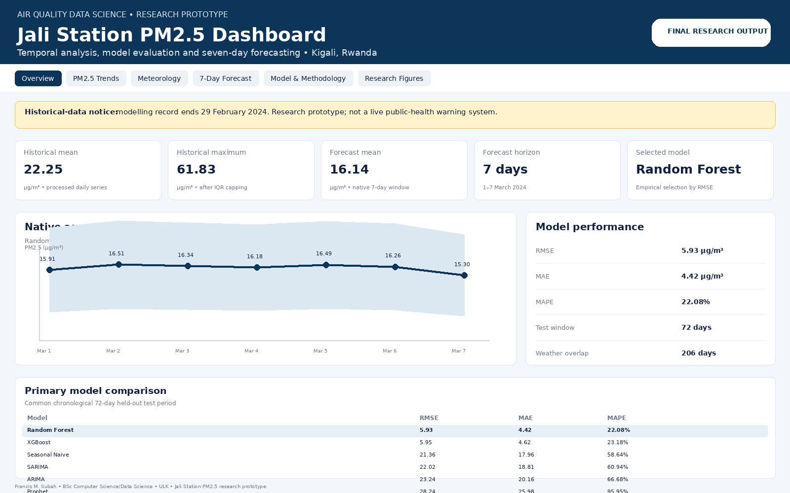
Figure 3.1: PM2.5 forecasting dashboard prototype for Jali Station, Kigali

3.8.3 API Design
Table 3.8: Dashboard REST API Endpoints
# | Method | Endpoint | Query Parameters | Returns | Frontend Consumer
1 | GET | / | — | HTML dashboard shell | Browser (all tabs)
2 | GET | /api/health | nocache=1 (optional) | File-presence JSON for all nine data artifacts | Global startup check
3 | GET | /api/forecast | kind=native | kind=demo | Daily forecast series with 95 % prediction intervals | Forecast tab, Overview chart
4 | GET | /api/forecast/summary | — | Mean, min, max, highest day, start/end for both windows | Overview Early Warning panel
5 | GET | /api/forecast/download | kind=native | kind=demo | CSV file attachment | "Download Forecast CSV" button
6 | GET | /api/metrics | — | Selected model metadata (AIC, BIC, RMSE, MAE, MAPE, Ljung-Box pass) | Overview cards, Forecast header
7 | GET | /api/metrics/comparison | — | All six primary models with RMSE/MAE/MAPE | Forecast tab comparison table + bar chart
8 | GET | /api/model | — | Selected model name, order, seasonal order, training cut-off | Model & Methodology panel
9 | GET | /api/trends | — | Daily, monthly and weekday PM2.5 series | PM2.5 Trends tab (Charts 1–4)
10 | GET | /api/correlations | — | Correlation coefficients of PM2.5 with pollutants and meteorology | Meteorology tab heatmap
11 | GET | /api/meteorology | — | Sampled meteorological scatter data (≤ 2,000 rows) | Meteorology tab scatter plots

3.8.4 Key Features
The dashboard is organised around six navigable views — Overview, PM2.5 Trends, Meteorology, 7-Day Forecast, Model & Methodology, and Research Figures — mapped to the study objectives. A persistent research-prototype notice communicates that the dashboard uses the historical Jali Station dataset and is not connected to a live air-quality feed. A staleness banner is displayed when the training record is materially older than the current date, so a historical forecast is not mistaken for a validated current forecast.
The Overview view presents summary cards for the historical daily mean, processed historical maximum, native seven-day forecast mean, forecast horizon, and selected model, followed by the main forecast visualisation. The card values are intended to be loaded dynamically from the model artefacts rather than manually duplicated in the interface.
The PM2.5 Trends view communicates the temporal behaviour of the processed daily series through the daily trend, monthly pattern, weekday pattern, and seven-day decomposition. Supporting stationarity and ACF/PACF evidence is included to connect the exploratory analysis with the time-series modelling.
The Meteorology view supports Objective 3 with an interactive correlation heatmap of PM2.5 against PM10, CO, O3, NO2, and SO2, a PM2.5-versus-solar-radiation scatter plot reflecting the strongest reported meteorological association (r = −0.251), and a small-multiples scatter grid for temperature, humidity, wind speed, and rainfall where the corresponding columns are present. A short disclaimer notes that correlation describes statistical association and does not establish causation, and a text caption records that generally weak linear associations were observed between PM2.5 and the examined meteorological variables.
The 7-Day Forecast view supports Objectives 2 and 4 by presenting the selected Random Forest model, the native forecast for 1–7 March 2024, the forecast table, and the model-comparison results. The dashboard distinguishes the scientifically anchored historical forecast from any current-date demonstration output and displays a staleness warning because the training record ends on 29 February 2024. The primary model comparison contains six models: Seasonal Naive, ARIMA, SARIMA, Random Forest, XGBoost, and Prophet.
The Model & Methodology view documents the dataset sizes, the final preprocessing pipeline, the six primary forecasting approaches, the empirical model-selection rule, the selected Random Forest configuration, the 72-day chronological evaluation design, the 206-day meteorological overlap, and the limitations associated with data quality and deployment. The dashboard therefore mirrors the final thesis methodology rather than the superseded SARIMA-only workflow.
Across all views, charts render placeholder skeletons while data are being fetched and are replaced by a meaningful empty state — including the instruction to run the modelling notebook and the preparation script — whenever the corresponding data file is unavailable. All API endpoints return a stable JSON envelope with a top-level status flag and never surface an unhandled exception to the interface. Every numeric value displayed by the dashboard is read from the accompanying data artifacts at request time, so that regenerating the model outputs automatically propagates to the interface without any change to the application code.

A Flask-based dashboard prototype was used as a presentation layer for the forecasting workflow. The application concept separates model artifacts from the interface so that forecasts and metrics can be loaded dynamically. The dashboard is intended as a research prototype and decision-support demonstration, not as an operational public-health warning system.

3.9 Software and Tools
The final notebook uses Python with pandas and NumPy for data processing, matplotlib and seaborn for visualisation, statsmodels for ARIMA/SARIMA/SARIMAX and diagnostics, scikit-learn for Random Forest and evaluation metrics, XGBoost for gradient boosting, Prophet for decomposition-based forecasting, and SciPy for statistical tests. A fixed random state of 42 was used for reproducibility.

Table 3.9: Software and Tools Used
Category | Software / Tool | Version | Purpose in the Study
Development environment | Google Colab (Jupyter) | — | Executing the corrected modelling notebook end to end
 | Python | 3.12 | Primary programming language across analysis and dashboard
Data ingestion & manipulation | pandas | 2.2.2 | Loading REMA / Meteo Excel files, resampling, joins, imputation
 | NumPy | 1.26.4 | Numerical operations, random seed control
 | openpyxl | — | Reading the two source .xlsx files
Time-series modelling | statsmodels (SARIMAX) | 0.14.x | Fitting and forecasting all four SARIMA/SARIMAX variants
 | statsmodels (seasonal_decompose) | 0.14.x | Decomposing daily PM2.5 into trend / seasonal / residual
 | statsmodels (adfuller, acorr_ljungbox) | 0.14.x | Stationarity and residual diagnostic tests
 | Prophet (Meta) | — | Benchmark forecasting model (Model 5)
Model evaluation | scikit-learn (mean_absolute_error, mean_squared_error) | — | Computing RMSE, MAE, MAPE for every candidate
 | SciPy | — | Q–Q plot for residual normality
Visualisation (notebook) | Matplotlib | — | Static diagnostic figures saved as PNG
 | Seaborn | — | Correlation matrix heatmap
Dashboard backend | Flask | 3.0.3 | Serving all REST API endpoints
 | Flask-Cors | 4.0.1 | Enabling cross-origin local development
 | Gunicorn | 22.0.0 | WSGI production server on Render
 | python-dotenv | 1.0.1 | Environment variable management
Dashboard frontend | Plotly.js | 2.35.2 | Interactive browser charts
 | HTML5 / CSS3 / JavaScript | — | Responsive single-page application shell
Deployment & hosting | Render | — | Cloud Platform-as-a-Service hosting the live dashboard
 | Git / GitHub | — | Version control and Render auto-deploy trigger
Development tunnelling (Colab only) | pyngrok | — | Exposing the Colab Streamlit prototype before the Flask migration
Version control & QA | Jupyter nbformat | 4.5 | Notebook storage format

3.10 Ethical Considerations
The analysis uses environmental observations without personal identifiers. Ethical safeguards therefore focus on faithful reporting, transparent preprocessing, reproducible computation, appropriate citation, and avoidance of overstating forecast certainty.

3.11 Limitations of the Methodology
- The common evaluation uses a single hold-out period rather than repeated rolling-origin evaluation.
- The weather-informed analysis uses a substantially smaller sample than the primary forecasting comparison.
- Outlier capping can reduce the influence of genuine but extreme pollution episodes if they are not sensor faults.
- Recursive machine-learning forecasts can accumulate errors across the seven-day horizon.
- Prophet's yearly component is weakly identified with the available training history.

3.12 Summary of the Chapter
The methodology combines consistent data preparation, leakage-aware feature engineering, chronological evaluation, multiple forecasting families, and a supplementary meteorological analysis. The final model is selected from empirical held-out performance rather than from a predetermined preference.

CHAPTER FOUR: RESULTS AND ANALYSIS

4.1 Introduction
This chapter presents the final empirical results generated by the supplied modelling notebook. All primary model metrics reported here use the common 72-day test period unless explicitly identified as supplementary.

4.2 Data Preprocessing Results

4.2.1 Missing-Value Treatment
The raw REMA dataset contained 1,607 missing PM2.5 observations out of 8,274 hourly records. After capping, the same 1,607 observations remained missing because outlier treatment did not create observations. Short-gap interpolation reduced the remaining missing count to 1,600. Hour-of-day mean imputation then reduced the missing count to zero, and the final bidirectional interpolation stage confirmed a complete hourly PM2.5 series.
Pipeline stage | Missing PM2.5 observations | Maximum PM2.5 (µg/m³)
Raw | 1,607 | 3,335.06
After 1.5×IQR capping | 1,607 | 61.83
After short-gap interpolation (≤6 h) | 1,600 | 61.83
After hour-of-day mean imputation | 0 | 61.83
After final interpolation | 0 | 61.83
Table 4.1: PM2.5 missingness and maximum value across preprocessing stages
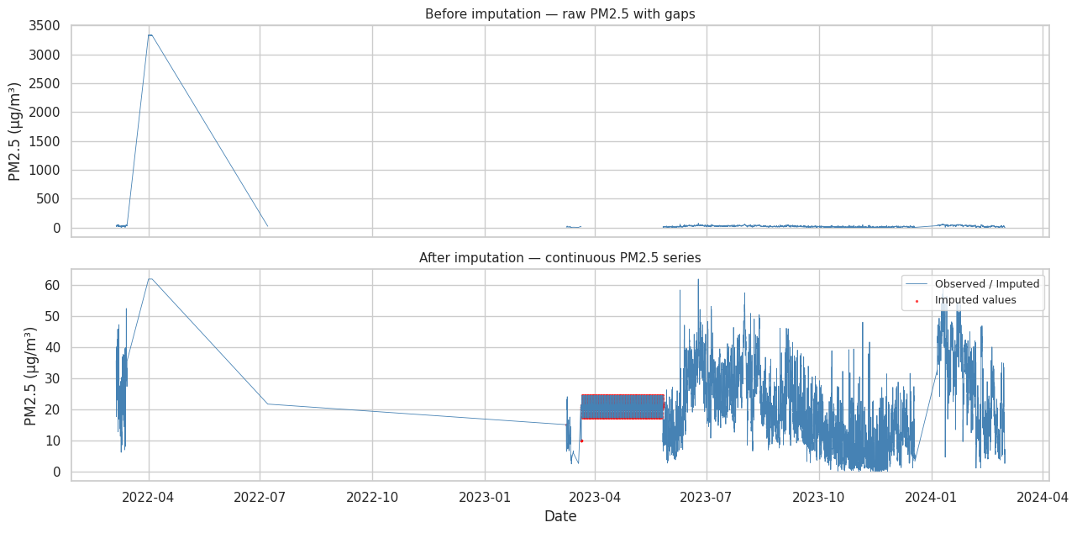
Figure 4.1: PM2.5 series before and after imputation
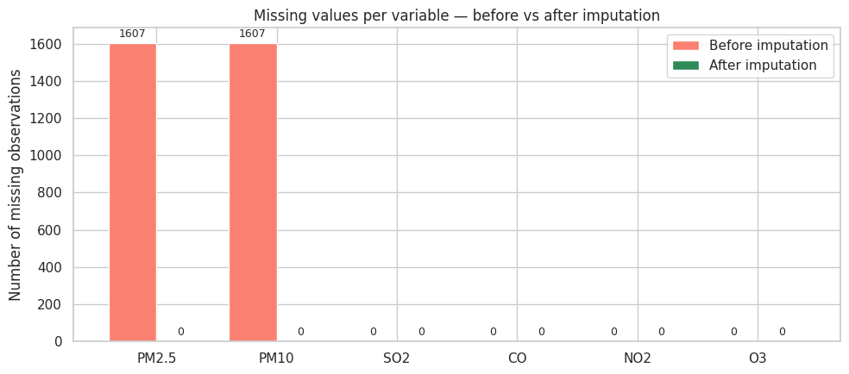
Figure 4.2: Missing observations by variable before and after treatment

4.2.2 Outlier Detection and Treatment
The 1.5×IQR rule flagged 75 hourly PM2.5 observations, representing 1.12% of the 6,667 non-missing PM2.5 observations. The raw maximum was 3,335.06 µg/m³, whereas the upper IQR fence was 61.83 µg/m³. The extreme observation was therefore not allowed to dominate the daily mean series used for forecasting.
Measure | Before capping | After capping
Count | 6,667 | 6,667
Mean (µg/m³) | 56.51 | 20.69
Standard deviation | 344.90 | 13.48
Median | 18.33 | 18.33
Maximum | 3,335.06 | 61.83
Skewness | 9.381 | 0.615
Table 4.2: PM2.5 distribution statistics before and after 1.5×IQR capping
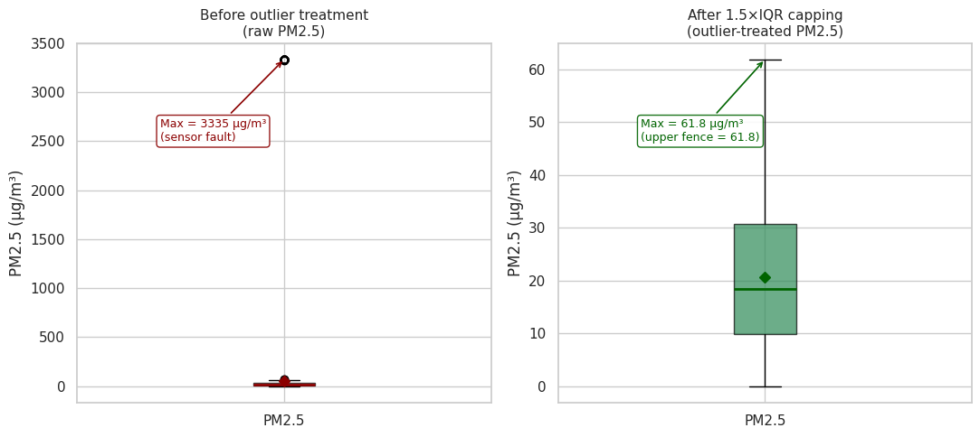
Figure 4.3: Raw and capped PM2.5 distributions
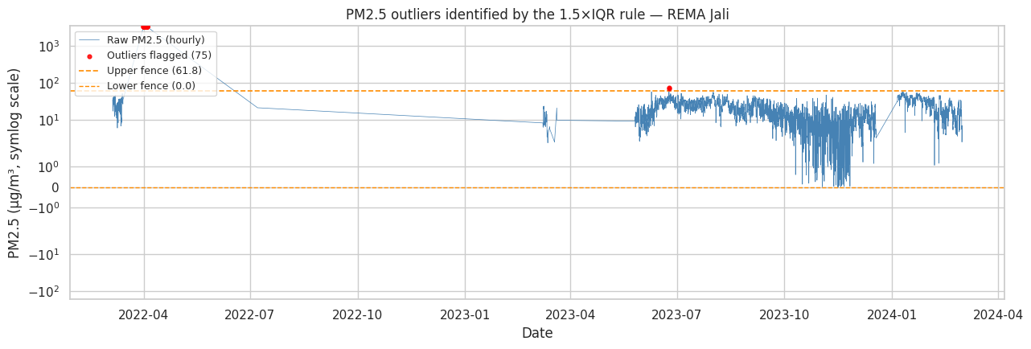
Figure 4.4: Hourly PM2.5 observations flagged by the 1.5×IQR rule

4.3 Exploratory Data Analysis Results

4.3.1 Descriptive Statistics
The final daily series contained 727 observations. Its mean concentration was 22.25 µg/m³, with a standard deviation of 12.76 µg/m³. The minimum was 2.64 µg/m³ and the maximum was 61.83 µg/m³. The first quartile was 13.43 µg/m³, the median was 19.39 µg/m³, and the third quartile was 27.86 µg/m³.
Statistic | Daily PM2.5 (µg/m³)
Count | 727
Mean | 22.25
Standard deviation | 12.76
Minimum | 2.64
25th percentile | 13.43
Median | 19.39
75th percentile | 27.86
Maximum | 61.83
Table 4.3: Descriptive statistics of the final daily PM2.5 series

4.3.2 Temporal Patterns
The monthly means show substantial variation across the study period. The highest monthly mean in the notebook output was 56.50 µg/m³ in April 2022, while the lowest was 6.84 µg/m³ in November 2023. The weekday means were closely grouped: Monday 22.25, Tuesday 22.27, Wednesday 22.49, Thursday 21.97, Friday 22.22, Saturday 22.24, and Sunday 22.33 µg/m³. Thus, the final weekday summary does not show a large peak-to-trough weekly difference.
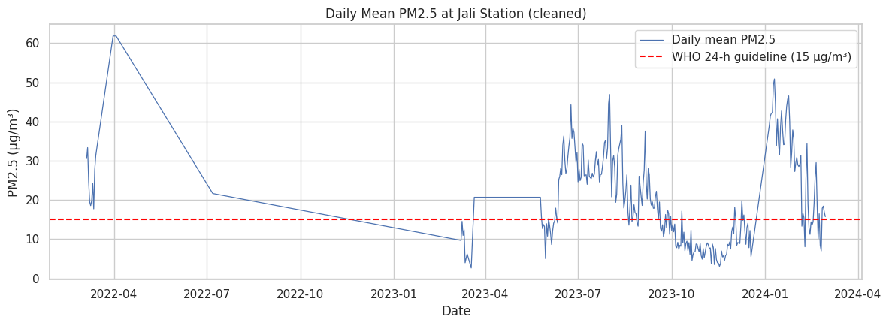
Figure 4.5: Daily mean PM2.5 concentration at Jali Station
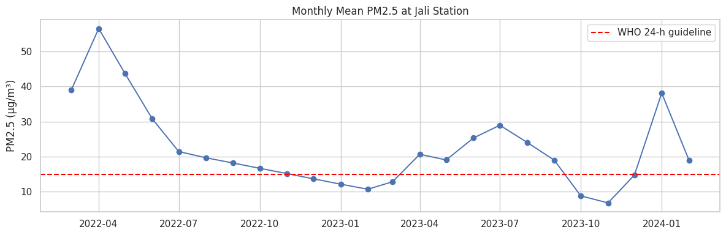
Figure 4.6: Monthly mean PM2.5 concentration at Jali Station
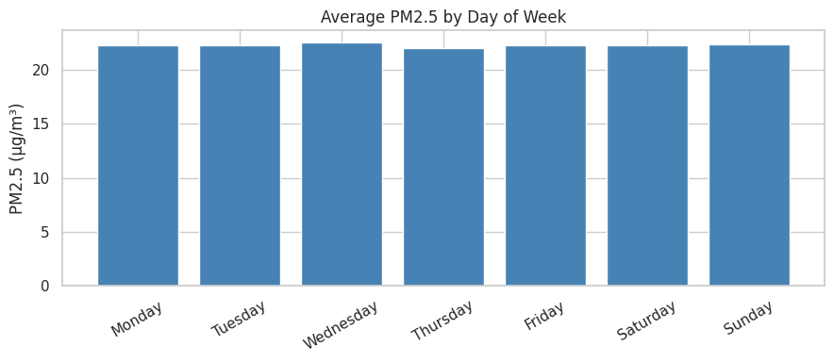
Figure 4.7: Average PM2.5 by day of week

4.3.3 Time-Series Decomposition
Additive decomposition using a seven-day period was applied to the daily series. The decomposition provides evidence of recurring weekly structure while also showing substantial residual variation. The result supports inclusion of weekly information in the SARIMA specification and in the lag features used by the tree-based models.
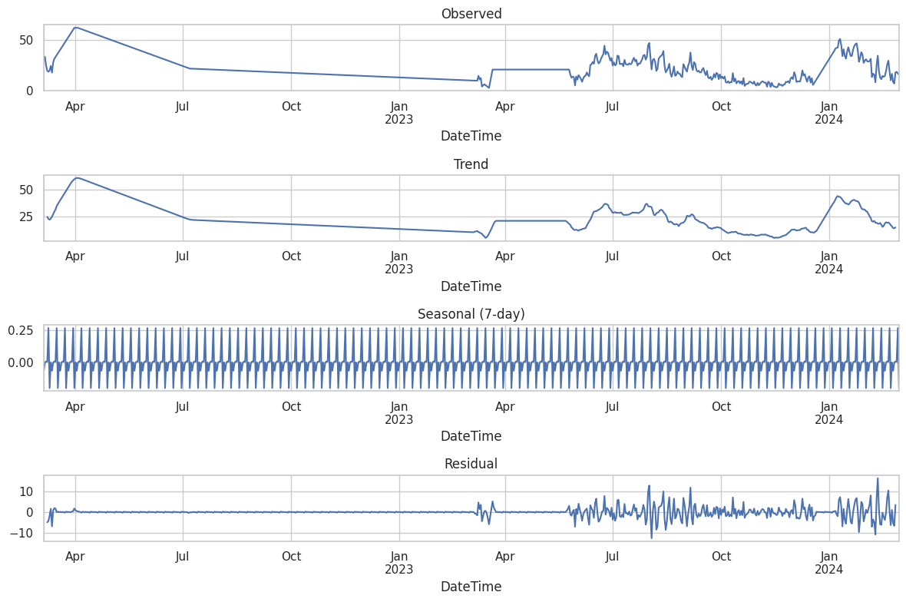
Figure 4.8: Seven-day additive decomposition of the daily PM2.5 series

4.3.4 Stationarity and Autocorrelation
The ADF test on the level series produced a statistic of −2.855 with p = 0.0509, so the level series was treated as non-stationary at the 5% threshold. After first differencing, the statistic was −6.898 with p < 0.001, indicating stationarity after differencing. ACF/PACF plots of the differenced series were used as diagnostic evidence alongside AIC-based order search.
Series | ADF statistic | p-value | Interpretation
Level | −2.855 | 0.0509 | Non-stationary at 5%
First difference | −6.898 | <0.001 | Stationary
Table 4.4: Augmented Dickey-Fuller stationarity results
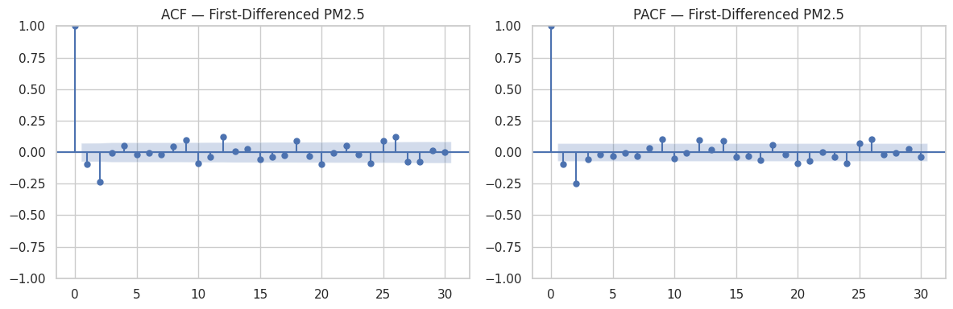
Figure 4.9: ACF and PACF of the first-differenced daily PM2.5 series

4.4 Primary Model Results
The six primary models were evaluated on the same 72-day test period from 20 December 2023 to 29 February 2024. This common evaluation makes the resulting error metrics directly comparable across the primary models.
Model | Specification / role | RMSE (µg/m³) | MAE (µg/m³) | MAPE
Random Forest | Tree ensemble | 5.93 | 4.42 | 22.08%
XGBoost | Gradient-boosted trees | 5.95 | 4.62 | 23.18%
Seasonal Naive | Weekly baseline | 21.36 | 17.96 | 58.64%
SARIMA | (0,1,2)(0,0,1)₇ | 22.02 | 18.81 | 60.94%
ARIMA | (2,1,3) | 23.24 | 20.16 | 66.68%
Prophet | Weekly + yearly seasonality | 28.24 | 25.98 | 95.95%
Table 4.5: Primary model comparison on the common 72-day test period
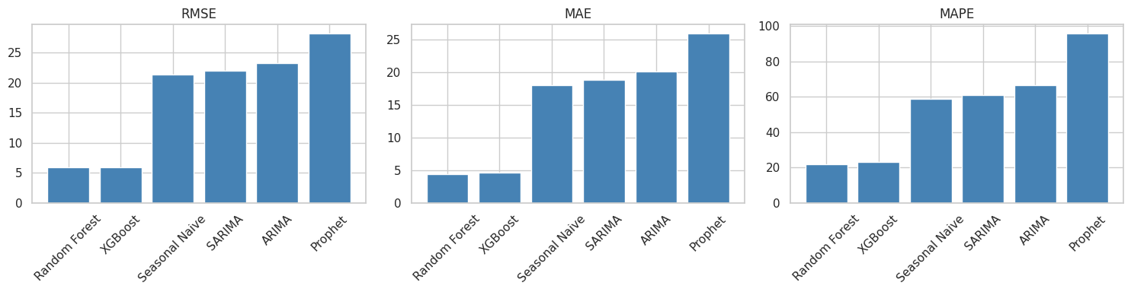
Figure 4.10: RMSE, MAE, and MAPE for the six primary models

4.4.1 ARIMA Results
The AIC-guided ARIMA search selected ARIMA(2,1,3), with AIC = 3095.045. On the held-out test period it produced RMSE = 23.24 µg/m³, MAE = 20.16 µg/m³, and MAPE = 66.68%. The Ljung-Box p-values were 0.366933 at lag 5, 0.102866 at lag 10, and 0.000089 at lag 15, indicating remaining serial dependence at the longer tested lag.

4.4.2 SARIMA Results
The SARIMA search selected SARIMA(0,1,2)(0,0,1)₇ with AIC = 3026.156. The test RMSE was 22.02 µg/m³, MAE 18.81 µg/m³, and MAPE 60.94%. Ljung-Box p-values were 0.058391, 0.001785, and 0.000003 at lags 5, 10, and 15 respectively, indicating that residual dependence remained.

4.4.3 Random Forest Results
Random Forest achieved RMSE = 5.93 µg/m³, MAE = 4.42 µg/m³, and MAPE = 22.08%. Its feature importance was strongly concentrated in lag1 (0.9043), followed by lag2 (0.0331), roll_mean7 (0.0184), and lag3 (0.0166). The remaining features each contributed less than 0.01 importance except for month (0.0069) and roll_mean14 (0.0061). These values indicate predictive contribution within the fitted model, not causation.

4.4.4 XGBoost Results
XGBoost produced RMSE = 5.95 µg/m³, MAE = 4.62 µg/m³, and MAPE = 23.18%. Its feature importance was also dominated by lag1 (0.7042), with roll_mean7 (0.1133), lag2 (0.0450), month (0.0446), and lag3 (0.0435) contributing the next largest shares.
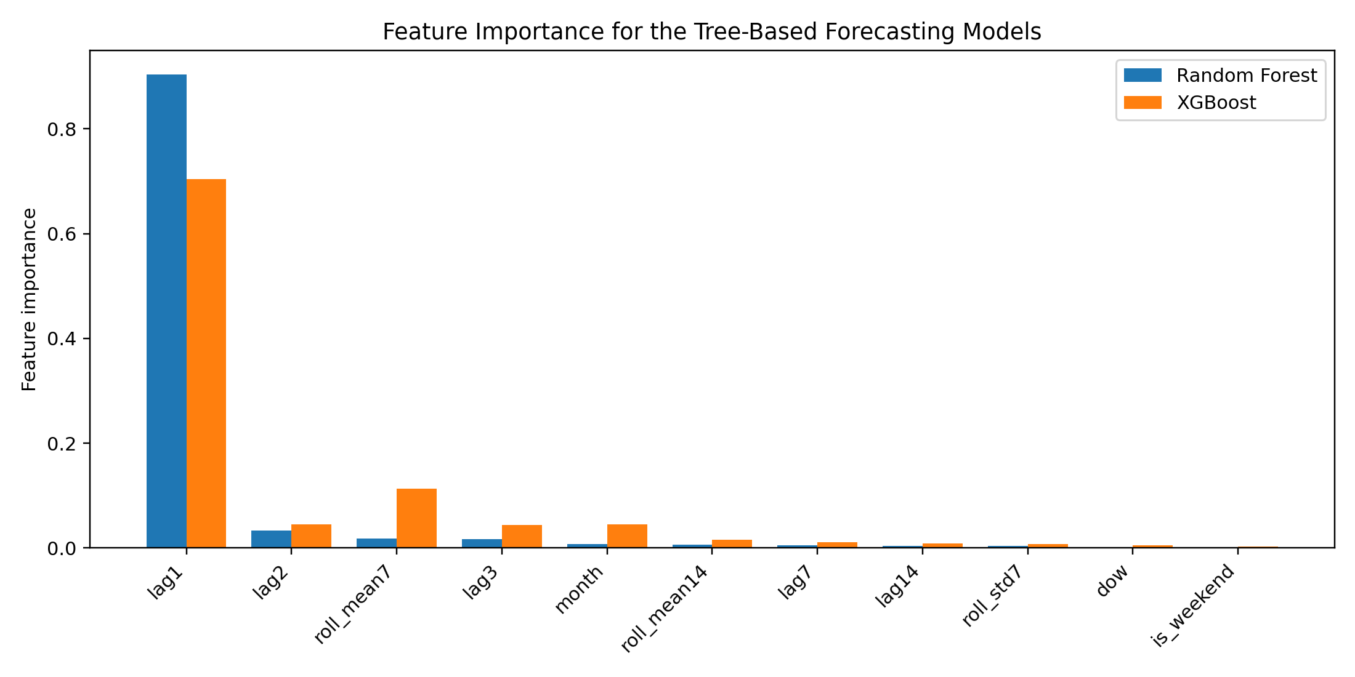
Figure 4.11: Feature importance for Random Forest and XGBoost

4.4.5 Prophet Results
Prophet produced RMSE = 28.24 µg/m³, MAE = 25.98 µg/m³, and MAPE = 95.95%. The notebook also issued a warning that yearly seasonality was being estimated with less than approximately 730 days of history. This warning provides an important context for interpreting the comparatively large test error.

4.4.6 Seasonal Naive Results
The Seasonal Naive baseline produced RMSE = 21.36 µg/m³, MAE = 17.96 µg/m³, and MAPE = 58.64%. Its inclusion establishes a simple weekly-persistence reference against which the more complex models can be evaluated.

4.5 Supplementary SARIMAX and Meteorological Results
The weather-informed SARIMAX analysis used 206 overlapping daily observations from 8 August 2023 to 29 February 2024. In the supplementary forecasting split, SARIMAX(0,1,2)(0,0,1)₇ achieved RMSE = 16.10 µg/m³, MAE = 13.77 µg/m³, and MAPE = 93.66%. These values are not directly comparable with the primary model metrics because the sample and evaluation period differ.
Meteorological variable | Pearson r | p-value | Interpretation
Radiation | −0.2511 | 0.0003 | Weak negative association; statistically significant
WindSpeed | −0.1082 | 0.1216 | Weak; not significant
Temperature_lag1 | 0.0432 | 0.5377 | Weak; not significant
Temperature | 0.0348 | 0.6190 | Weak; not significant
Humidity | 0.0348 | 0.6196 | Weak; not significant
Rain | −0.0206 | 0.7684 | Weak; not significant
Humidity_lag1 | −0.0016 | 0.9816 | Very weak; not significant
Table 4.6: Pearson associations between PM2.5 and meteorological variables over the 206-day overlap
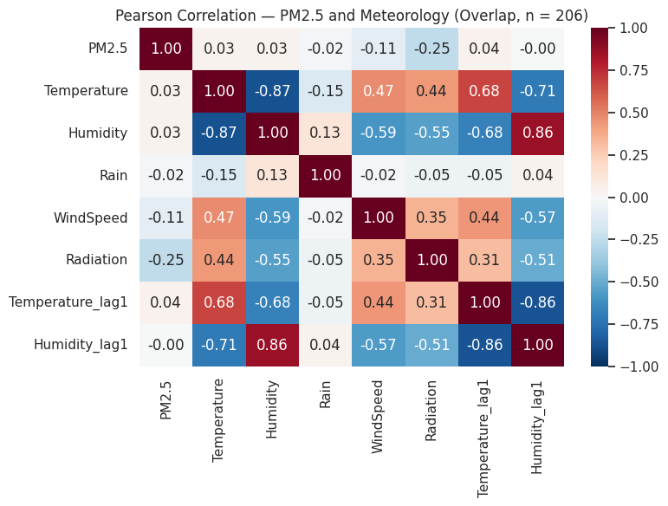
Figure 4.12: Pearson correlation matrix for PM2.5 and meteorological variables
In the full-overlap inferential SARIMAX analysis, humidity (p = 0.001), wind speed (p = 0.047), lagged temperature (p = 0.002), and lagged humidity (p < 0.001) were statistically significant at the 5% level; temperature, rainfall, and dry-season status were not. The notebook's standardised coefficient output shows that statistical significance in this model should not be interpreted as causal influence, especially given the limited overlap and model convergence warnings recorded during estimation.
Variable | Coefficient | p-value | Significant at 5%
Temperature | 1.1853 | 0.124 | No
Humidity | 3.5533 | 0.001 | Yes
Rain | −0.1285 | 0.725 | No
WindSpeed | −0.5649 | 0.047 | Yes
IsDrySeason | 1.3442 | 0.834 | No
Temperature_lag1 | −2.0315 | 0.002 | Yes
Humidity_lag1 | −3.1622 | <0.001 | Yes
Table 4.7: Supplementary SARIMAX coefficients from the 206-day overlap
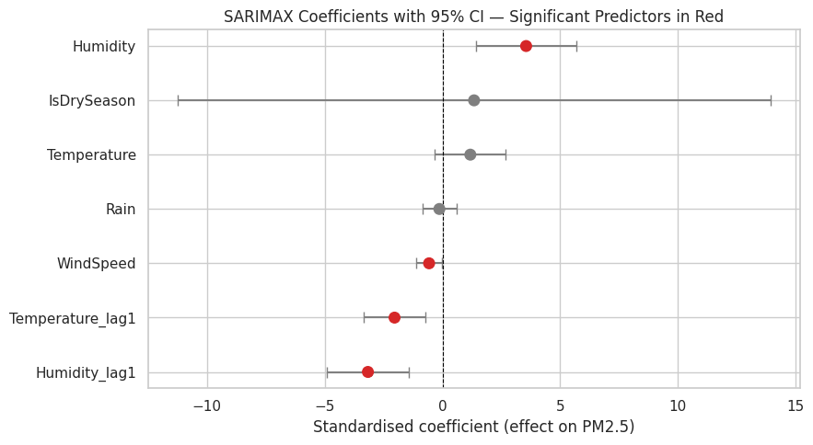
Figure 4.13: Standardised SARIMAX coefficients with 95% confidence intervals

4.6 Comparative Forecast Behaviour
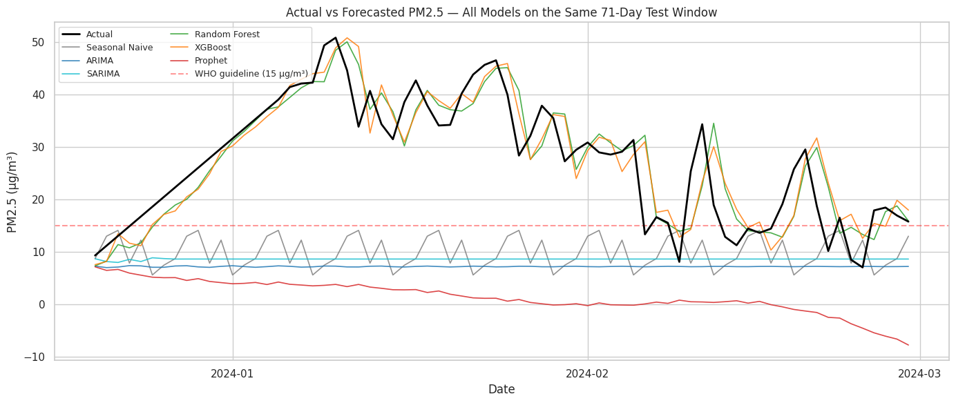
Figure 4.14: Actual and forecasted PM2.5 values for all primary models over the common test window
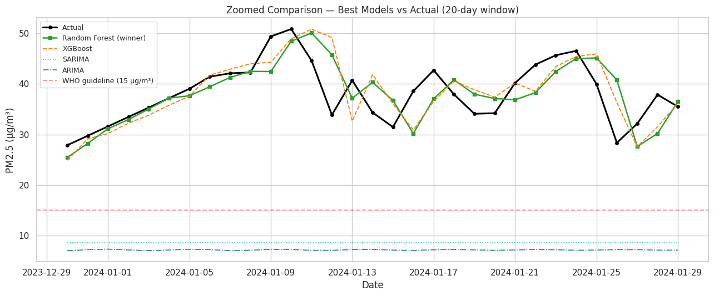
Figure 4.15: Zoomed comparison of the leading primary models
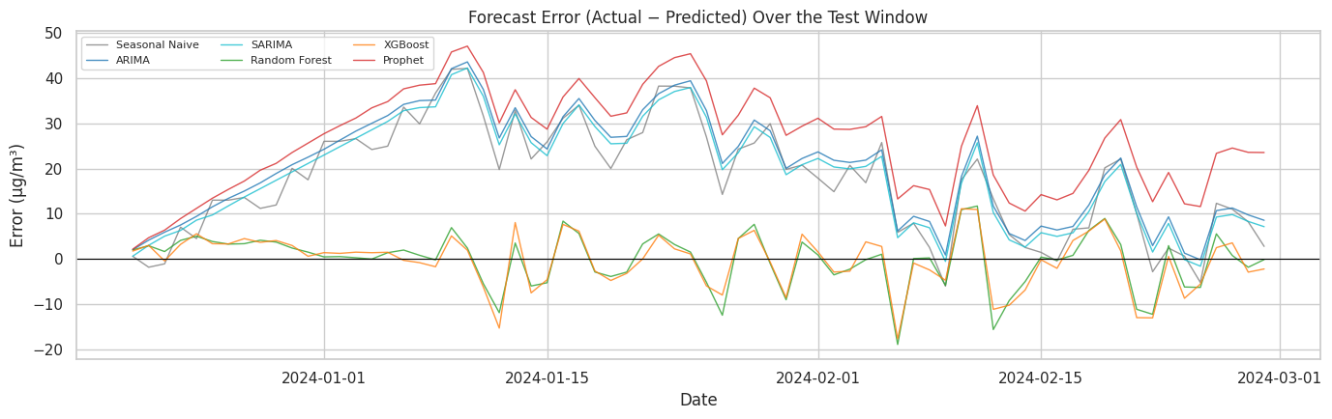
Figure 4.16: Forecast error over the common test window
The test-window plots show that the tree-based models track the observed series more closely than the statistical and decomposition-based benchmarks. Random Forest and XGBoost are visually close, consistent with their very similar numerical error. The error-over-time plot also shows that no model follows every short-term movement perfectly; therefore, low aggregate error should not be interpreted as exact prediction of individual pollution episodes.

4.7 Model Selection
Random Forest was selected empirically because it achieved the lowest RMSE on the common 72-day test period (5.93 µg/m³), narrowly ahead of XGBoost (5.95 µg/m³). It also recorded the lowest MAE and MAPE among the primary models. The selection was therefore based on out-of-sample evidence, not on an assumption that machine learning, SARIMA, or any other model family should perform best.
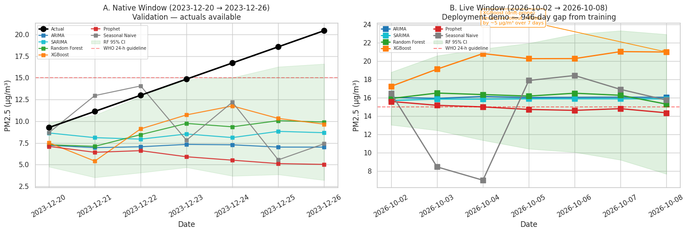
Figure 4.17: Comparison of seven-day native and 72-day test-window performance
The notebook also examined ranking stability over a seven-day native slice. XGBoost had the lower RMSE over that single seven-day window (6.28 µg/m³ versus 6.59 µg/m³ for Random Forest), but the notebook explicitly treated the larger 72-day test window as authoritative because it covers a wider range of conditions. Over the full test period, Random Forest remained first by RMSE.

4.8 Seven-Day Forecast Results
After empirical selection, Random Forest was refitted on the full daily series and used to generate a native seven-day forecast beginning on the day after the final observation. The forecast period was 1–7 March 2024.
Date | Forecast PM2.5 (µg/m³) | Lower interval | Upper interval
01 Mar 2024 | 15.91 | 11.14 | 20.68
02 Mar 2024 | 16.51 | 11.55 | 21.46
03 Mar 2024 | 16.34 | 11.44 | 21.24
04 Mar 2024 | 16.18 | 11.32 | 21.03
05 Mar 2024 | 16.49 | 11.54 | 21.44
06 Mar 2024 | 16.26 | 11.38 | 21.14
07 Mar 2024 | 15.30 | 10.71 | 19.89
Table 4.8: Native seven-day forecast produced by the selected Random Forest model
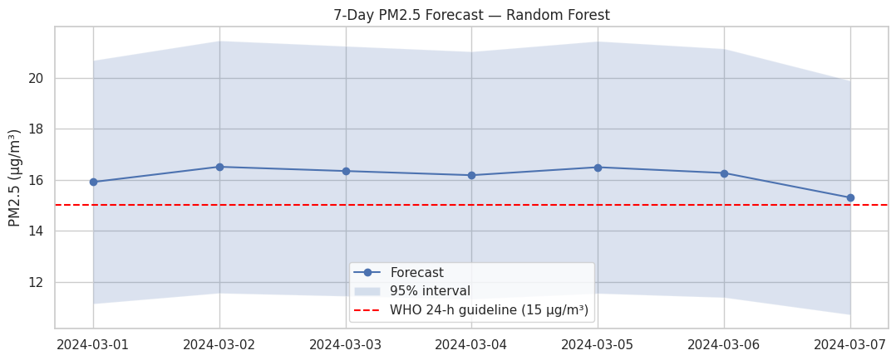
Figure 4.18: Seven-day PM2.5 forecast from the selected Random Forest model
The forecast mean is approximately 16.14 µg/m³ across the seven days. Forecast values are close to the WHO 24-hour guideline reference of 15 µg/m³, but the intervals are wide enough that individual days should not be interpreted as certain threshold exceedances. The notebook also generated a dynamic 2026 forecast demonstration, but because the training series ends in February 2024, the 946-day gap triggered a staleness warning. That dynamic output is therefore treated only as a capability demonstration, not as a validated current forecast.

4.9 Dashboard Output
The dashboard component provides a practical presentation layer for the forecast values, model metrics, data-quality context, and research outputs. Figure 3.1 shows the dashboard prototype used to communicate the final analysis. In the context of the final study, the dashboard is a research presentation layer rather than a live public-health warning service. Any operational deployment would require current observations, automatic quality control, retraining, rolling-origin validation, model-version tracking, and formal governance of public advisories.

4.10 Summary of Results
The final cleaned daily PM2.5 series contained 727 observations with a mean of 22.25 µg/m³. The 1.5×IQR procedure identified 75 outliers and reduced the raw maximum from 3,335.06 to 61.83 µg/m³. On the common 72-day test period, Random Forest and XGBoost substantially outperformed the statistical, baseline, and Prophet models, with Random Forest selected by lowest RMSE. The meteorological analysis was limited by a 206-day overlap and produced weak marginal correlations but several significant coefficients in the supplementary SARIMAX association model. The selected Random Forest generated a seven-day native forecast for 1–7 March 2024 with values between 15.30 and 16.51 µg/m³.

CHAPTER FIVE: DISCUSSION

5.1 Introduction
This chapter interprets the final results in relation to the research objectives and the literature. The discussion distinguishes predictive association from causation and primary model comparison from supplementary meteorological analysis.

5.2 Temporal Patterns and Data Quality
The final daily mean of 22.25 µg/m³ indicates a substantial level of PM2.5 in the cleaned Jali series relative to the WHO 24-hour guideline reference of 15 µg/m³ (WHO, 2021). The monthly series varies considerably, indicating that a single average would conceal important temporal variation. The weekday means, however, are closely grouped, so the final daily summary does not support a strong weekday peak-to-trough interpretation. This differs from a simplistic expectation that weekends must always be cleaner; the measured pattern at Jali should be described from the data rather than assumed from theory.
The raw maximum of 3,335.06 µg/m³ is a major data-quality finding. Capping 75 observations reduced the extreme influence of the sensor-related values while retaining the observations in the chronological series. The resulting reduction in standard deviation from 344.90 to 13.48 µg/m³ in the non-missing hourly distribution demonstrates how strongly the extreme tail affected the raw data. This supports the principle that environmental forecasting should treat data-quality assessment as part of model validity rather than as a cosmetic preprocessing step.

5.3 Comparative Model Performance
The primary comparison provides clear evidence that model family and feature representation matter for this dataset. Random Forest and XGBoost achieved RMSE values of 5.93 and 5.95 µg/m³ respectively, while the Seasonal Naive, SARIMA, ARIMA, and Prophet models ranged from 21.36 to 28.24 µg/m³. The small difference between Random Forest and XGBoost means that the empirical selection should not be interpreted as evidence of a large superiority of one tree ensemble over the other.
The strong contribution of lag1 in both tree models is consistent with short-term persistence in PM2.5. The Random Forest importance of 0.9043 for lag1 indicates that the model relies heavily on the most recent observed value. This is a predictive finding, not a causal conclusion. It also means that the model's performance depends on the availability and quality of recent PM2.5 observations.
The statistical models provide useful benchmarks but retained higher error on the common test window. SARIMA performed better than ARIMA in RMSE, which is consistent with the value of incorporating a weekly seasonal structure when such structure is present. Nevertheless, the Ljung-Box results indicate remaining residual dependence, so the statistical models do not capture all temporal structure in the data.
Prophet produced the highest test error among the primary models. The notebook warning about insufficient history for yearly seasonality provides a methodological explanation for caution: a decomposition model with a yearly component has limited information when the training history is shorter than approximately two years. The result therefore should not be generalised into a claim that Prophet is intrinsically unsuitable for environmental forecasting.

5.4 Meteorological Variables
The strongest marginal meteorological association was between radiation and PM2.5, with r = −0.2511. This is classified as weak under the notebook's rule and should not be interpreted as proof that radiation causes lower PM2.5. Other marginal correlations were also weak. When serial dependence was accounted for in the supplementary SARIMAX analysis, humidity, wind speed, lagged temperature, and lagged humidity reached the 5% significance threshold.
The difference between marginal correlation and conditional SARIMAX significance illustrates why environmental predictor analysis requires context. The short overlap, model convergence warnings, and possible spatial/temporal mismatch mean that these coefficients should be treated as evidence of association within the analysed sample rather than stable causal effects. Longer co-located records would be needed to establish whether these relationships persist.

5.5 Forecasting and Practical Application
The selected Random Forest forecast for 1–7 March 2024 ranges from 15.30 to 16.51 µg/m³, with a seven-day mean of approximately 16.14 µg/m³. The forecast is close to the WHO 24-hour guideline reference, but the intervals are broad. Therefore, the appropriate practical interpretation is that the model provides a short-term estimate with uncertainty, not a deterministic statement that a particular day will exceed a health threshold.
The notebook's dynamic forecast demonstration for October 2026 is explicitly stale because the training data end on 29 February 2024. The 946-day gap is an important deployment-safety signal. A dashboard should make such staleness visible rather than silently presenting old-model predictions as current information.

5.6 Methodological Contributions
- A single consistent preprocessing pipeline was used for the primary model comparison.
- The primary models were evaluated on the same chronological 72-day test window.
- Machine-learning features were shifted to prevent target leakage.
- Model selection was empirical and based on out-of-sample predictive error.
- SARIMAX was separated from the primary comparison because its weather overlap was only 206 observations.
- The analysis distinguishes a validated historical forecast from a stale current-date capability demonstration.

5.7 Comparison with Existing Literature
The results are consistent with the broader literature in showing that forecasting performance is dataset-specific. Kigali research has already demonstrated that machine-learning and deep-learning methods can be useful for PM2.5 prediction (Bogale et al., 2024), while classical ARIMA-family methods remain valuable as interpretable benchmarks. The present results add a Jali-specific comparison that includes tree ensembles and a Seasonal Naive benchmark under a common test design. This extends the local evidence base without claiming that the result should generalise to other stations or periods.

5.8 Strengths of the Study
- The final notebook provides a reproducible and internally consistent primary comparison.
- The model-selection rule is transparent and based on held-out performance.
- Data-quality problems are explicitly quantified rather than hidden.
- Feature engineering addresses a key time-series leakage risk.
- The meteorological analysis clearly distinguishes its limited sample from the primary evaluation.

5.9 Limitations
- Only one monitoring station is analysed.
- The historical air-quality period is relatively short for learning annual seasonality.
- Imputation and outlier capping can alter the representation of genuine extreme events.
- The primary test design is a single hold-out rather than rolling-origin validation.
- The meteorological overlap is limited to 206 observations.
- Recursive multi-step tree forecasts may accumulate error.
- The dashboard is a prototype and not an operational warning system.

5.10 Summary
The discussion indicates that the main empirical result is the strong performance of the tree-based models under the common test period, with Random Forest selected by the lowest RMSE. The result is credible within the evaluation design but should be interpreted alongside data-quality, temporal-coverage, and deployment limitations. Meteorological findings are useful as exploratory evidence but require longer co-located records for stronger inference.

CHAPTER SIX: CONCLUSION AND RECOMMENDATIONS

6.1 Introduction
This chapter summarises the study, reports the principal findings against the objectives and research questions, presents recommendations, identifies the contribution of the research, reflects on the research process, and concludes the dissertation.

6.2 Summary of the Study
The study investigated PM2.5 temporal behaviour and forecasting at the Jali monitoring station in Kigali. It combined 8,274 hourly REMA air-quality observations with a separate Meteo Rwanda record. A single preprocessing pipeline was applied to PM2.5, followed by exploratory time-series analysis and a comparative evaluation of six primary forecasting approaches. Meteorological variables were analysed separately because only 206 observations overlapped effectively with the air-quality series.

6.3 Summary of Principal Findings
- The final daily PM2.5 series contained 727 observations with a mean of 22.25 µg/m³ and standard deviation of 12.76 µg/m³.
- 1,607 hourly PM2.5 values were missing in the raw REMA series; the final pipeline produced a complete model-ready series.
- Seventy-five observations (1.12% of non-missing values) were flagged by the 1.5×IQR rule; the raw maximum of 3,335.06 µg/m³ was capped at 61.83 µg/m³.
- The level series was treated as non-stationary by the ADF test (p = 0.0509), while the first difference was stationary (p < 0.001).
- Random Forest achieved the lowest primary test RMSE (5.93 µg/m³), followed by XGBoost (5.95 µg/m³).
- The selected Random Forest produced RMSE = 5.93 µg/m³, MAE = 4.42 µg/m³, and MAPE = 22.08% on the 72-day test period.
- The native seven-day forecast for 1–7 March 2024 ranged from 15.30 to 16.51 µg/m³.
- The meteorological overlap contained 206 observations; radiation had the strongest marginal correlation in absolute value (r = −0.2511), while humidity, wind speed, lagged temperature, and lagged humidity showed statistical significance in the supplementary SARIMAX analysis.

6.4 Achievement of Research Objectives and Answers to Research Questions

6.4.1 Objective 1 and Research Question 1
Objective 1 was achieved through descriptive statistics, monthly and weekday summaries, decomposition, stationarity testing, and ACF/PACF analysis. The series displayed substantial month-to-month variability and weekly structure, while the final weekday means were closely grouped. The level series was non-stationary at the 5% threshold and became stationary after first differencing.

6.4.2 Objective 2 and Research Question 2
Objective 2 was achieved by evaluating six primary approaches on the same 72-day chronological test period. Random Forest recorded the lowest RMSE, MAE, and MAPE and was selected empirically. XGBoost was extremely close, demonstrating that the selection is not evidence of a large performance gap between the two leading models.

6.4.3 Objective 3 and Research Question 3
Objective 3 was achieved through Pearson correlation and supplementary SARIMAX analysis. Marginal correlations were generally weak, with radiation having r = −0.2511. Several variables were statistically significant in the conditional SARIMAX analysis. Because the overlap was short and convergence warnings occurred, these findings should be treated as exploratory associations rather than causal evidence.

6.4.4 Objective 4
Objective 4 was achieved through refitting the empirically selected Random Forest on the full daily series and generating a native seven-day forecast. A Flask-based dashboard prototype provides a practical presentation layer. The system should be regarded as a research prototype because the underlying training record ends in February 2024.

6.5 Recommendations

6.5.1 Recommendations for REMA
- Implement automated range, rate-of-change, missingness, and sensor-consistency checks before data are released for analysis.
- Investigate and document the extreme PM2.5 sensor readings identified in this study.
- Maintain metadata on maintenance, calibration, downtime, and known sensor faults.
- Continue and expand the historical monitoring record so that longer seasonal and annual patterns can be estimated.

6.5.2 Recommendations for Meteo Rwanda
- Support longer co-located meteorological records for air-quality stations.
- Maintain consistent machine-readable formats and precise timestamps.
- Coordinate data-retention periods across environmental agencies to reduce temporal mismatch.

6.5.3 Recommendations for Environmental and Public-Health Authorities
- Treat research forecasts as supplementary evidence and retain official advisories as authoritative.
- Use conservative threshold-based communication if a forecasting model is integrated into future decision-support systems.
- Require current-data validation and visible staleness indicators before forecasts are presented to the public.

6.5.4 Recommendations for Future Researchers
- Use rolling-origin or walk-forward validation in addition to a single hold-out period.
- Extend the historical record and evaluate multiple stations across Kigali.
- Investigate additional non-linear and deep-learning approaches when sufficient data are available.
- Develop probabilistic and multi-horizon forecasting rather than relying only on point forecasts.
- Integrate meteorological predictors using longer, co-located records.
- Examine whether the strongest lag features remain stable across seasons and across monitoring stations.

6.6 Contribution of the Study
The study contributes a reproducible Jali-specific forecasting workflow, a common empirical comparison of six primary forecasting approaches, quantified evidence of data-quality constraints, and a supplementary assessment of meteorological associations. It also demonstrates how a forecasting dashboard can be structured while making model staleness and uncertainty visible.

6.7 Reflection on the Research Process
A central lesson from the research was that model selection should follow the evidence produced by a consistent experiment. The revised workflow makes the preprocessing and test period common to the primary models, reducing ambiguity about whether differences in performance arise from modelling choices or inconsistent data preparation. A second lesson was the importance of treating deployment constraints as part of the analytical problem: a strong historical metric does not remove the need for current data, quality control, retraining, and appropriate validation.

6.8 Concluding Remarks
This study demonstrates that daily PM2.5 forecasting at the Jali station can be approached effectively with a leakage-aware feature-based Random Forest model under the supplied historical dataset. The empirical evidence favours Random Forest over the other primary models on the common 72-day test period, while XGBoost performs almost identically. The forecast generated for 1–7 March 2024 provides a concrete seven-day output, but the limitations of the historical record and the staleness of any current-date demonstration mean that the model should not be represented as a validated operational public-health warning system.
The most important path forward is therefore not simply to select a more complex model. It is to improve the data foundation: longer and cleaner station records, stronger automated quality control, co-located meteorological observations, rolling-origin evaluation, and multi-station validation. These improvements would provide a stronger basis for determining whether the predictive relationships identified at Jali remain stable and whether the forecasting workflow can support operational environmental decision-making.

REFERENCES
ACM. (2018). ACM code of ethics and professional conduct. Association for Computing Machinery.
Akaike, H. (1974). A new look at the statistical model identification. IEEE Transactions on Automatic Control, 19(6), 716–723. https://doi.org/10.1109/TAC.1974.1100705
Bogale, Y. A., Arinloye, C., & Muragijemariya, J. (2024). Prediction of PM2.5 concentration based on ARIMA, LSTM, and TCN models in Kigali, Rwanda. NeurIPS 2024 Workshop on Tackling Climate Change with Machine Learning.
Box, G. E. P., & Jenkins, G. M. (1976). Time series analysis: Forecasting and control. Holden-Day.
Box, G. E. P., Jenkins, G. M., Reinsel, G. C., & Ljung, G. M. (2015). Time series analysis: Forecasting and control (5th ed.). Wiley.
Breiman, L. (2001). Random forests. Machine Learning, 45, 5–32. https://doi.org/10.1023/A:1010933404324
Chen, T., & Guestrin, C. (2016). XGBoost: A scalable tree boosting system. Proceedings of the 22nd ACM SIGKDD International Conference on Knowledge Discovery and Data Mining, 785–794. https://doi.org/10.1145/2939672.2939785
Cohen, A. J., Brauer, M., Burnett, R., et al. (2017). Estimates and 25-year trends of the global burden of disease attributable to ambient air pollution: An analysis of data from the Global Burden of Diseases Study 2015. The Lancet, 389(10082), 1907–1918. https://doi.org/10.1016/S0140-6736(17)30505-6
Dickey, D. A., & Fuller, W. A. (1979). Distribution of the estimators for autoregressive time series with a unit root. Journal of the American Statistical Association, 74(366), 427–431. https://doi.org/10.2307/2286348
Elisephane, I. (2025). Environmental determinants of ambient air pollution in urban East Africa: Unveiling critical insights from Kigali, Rwanda. Scientific African, 30, e03055. https://doi.org/10.1016/j.sciaf.2025.e03055
Elisephane, I., & Ming'ate, M. K. (2026). Statistical and machine learning modeling of long-term PM2.5 variability across East, Central, and Southern Africa. Water, Air, and Soil Pollution, 237(14), 826.
Hyndman, R. J., & Athanasopoulos, G. (2021). Forecasting: Principles and practice (3rd ed.). OTexts.
Hyndman, R. J., & Koehler, A. B. (2006). Another look at measures of forecast accuracy. International Journal of Forecasting, 22(4), 679–688.
Kalisa, E., & Sudmant, A. (2025). Heatwaves amplify air pollution risks in Sub-Saharan Africa. Scientific Reports, 15(1), Article 26448. https://doi.org/10.1038/s41598-025-12210-4
Kaufman, S., Rosset, S., Perlich, C., & Stitelman, O. (2012). Leakage in data mining: Formulation, detection, and avoidance. ACM Transactions on Knowledge Discovery from Data, 6(4), 1–21. https://doi.org/10.1145/2020408.2020496
Korukire, N., Godson, A., Mukamurigo, J., Memunat, A. O., Izabayo, J., Bashaija, D., & Ntakirutimana, T. (2024). Patterns and disparities in indoor particulate matter levels in selected primary schools in Kigali, Rwanda. Heliyon, 10(15), e35411. https://doi.org/10.1016/j.heliyon.2024.e35411
Little, R. J. A., & Rubin, D. B. (2019). Statistical analysis with missing data (3rd ed.). Wiley.
Ljung, G. M., & Box, G. E. P. (1978). On a measure of lack of fit in time series models. Biometrika, 65(2), 297–303.
Omodieke, A., Twum, D., & Kalisa, E. (2026). Spatial and temporal variations of ambient PM2.5, NO₂, and O₃ in Kigali: Evidence and policy implications from a multi-year, citywide monitoring network. Environmental Science: Advances, 5(6), 1556–1565. https://doi.org/10.1039/d5va00433k
Peng, R. D. (2011). Reproducible research in computational science. Science, 334(6060), 1226–1227.
Petkova, E. P., Jack, D. W., Volavka-Close, N. H., & Kinney, P. L. (2013). Particulate matter pollution in African cities. Air Quality, Atmosphere & Health, 6(3), 603–614.
Ramiza, F., & Kalisa, E. (2026). Concentration of black carbon and particulate matter air pollution and source apportionment in Rwanda, East Africa. Environmental Research Communications, 8(4), 045021. https://doi.org/10.1088/2515-7620/ae5765
Seinfeld, J. H., & Pandis, S. N. (2016). Atmospheric chemistry and physics: From air pollution to climate change (3rd ed.). John Wiley & Sons.
Taylor, S. J., & Letham, B. (2018). Forecasting at scale. The American Statistician, 72(1), 37–45.
WHO. (2021). WHO global air quality guidelines: Particulate matter (PM2.5 and PM10), ozone, nitrogen dioxide, sulfur dioxide and carbon monoxide. World Health Organization. https://www.who.int/publications/i/item/9789240034228
Wirth, R., & Hipp, J. (2000). CRISP-DM: Towards a standard process model for data mining. Proceedings of the 4th International Conference on the Practical Applications of Knowledge Discovery and Data Mining, 29–39.
Xing, Y., Xu, Y., Shi, M., & Lian, Y. (2016). The impact of PM2.5 on the human respiratory system. Journal of Thoracic Disease, 8(1), 69–74. https://doi.org/10.3978/j.issn.2072-1439.2016.01.19

APPENDICES

APPENDIX A: Final Preprocessing and Feature Engineering Code
# Final PM2.5 preprocessing pipeline
def cap_outliers_iqr(series, k=1.5):
q1, q3 = series.quantile(0.25), series.quantile(0.75)
iqr = q3 - q1
lower = max(0, q1 - k * iqr)
upper = q3 + k * iqr
return series.clip(lower=lower, upper=upper)
df["PM2.5_capped"] = cap_outliers_iqr(df["PM2.5"])
df["PM2.5_shortgap"] = df["PM2.5_capped"].interpolate(
method="linear", limit=6
)
df["PM2.5_hourmean"] = df["PM2.5_shortgap"].fillna(
df["PM2.5_shortgap"].groupby(df.index.hour).transform("mean")
)
df["PM2.5_imputed"] = df["PM2.5_hourmean"].interpolate(
limit_direction="both"
)
daily_pm25 = df["PM2.5_imputed"].resample("D").mean()
daily_pm25 = daily_pm25.asfreq("D").interpolate(limit_direction="both")
# Leakage-aware ML features
df["lag1"] = df["y"].shift(1)
df["lag2"] = df["y"].shift(2)
df["lag7"] = df["y"].shift(7)
df["roll_mean7"] = df["y"].shift(1).rolling(7).mean()
df["roll_mean14"] = df["y"].shift(1).rolling(14).mean()

APPENDIX B: Primary Model Comparison and Selection Code
TEST_SIZE = 72
train = daily_pm25.iloc[:-TEST_SIZE]
test = daily_pm25.iloc[-TEST_SIZE:]
comparison = pd.DataFrame(all_metrics).sort_values("RMSE")
winner = comparison.iloc[0]["model"]
# Final empirical selection in the supplied notebook:
# Random Forest — RMSE 5.93, MAE 4.42, MAPE 22.08%

APPENDIX C: Native Seven-Day Forecast Output
Table C.1: Native seven-day forecast output
Date | Forecast PM2.5 | Lower | Upper
2024-03-01 | 15.91 | 11.14 | 20.68
2024-03-02 | 16.51 | 11.55 | 21.46
2024-03-03 | 16.34 | 11.44 | 21.24
2024-03-04 | 16.18 | 11.32 | 21.03
2024-03-05 | 16.49 | 11.54 | 21.44
2024-03-06 | 16.26 | 11.38 | 21.14
2024-03-07 | 15.30 | 10.71 | 19.89

APPENDIX D: Dashboard and Deployment Notes
The dashboard prototype should load model metadata, comparison metrics, and forecast artefacts at run time. A production implementation should include automated data refresh, quality-control checks, retraining triggers, model-version tracking, staleness monitoring, and clear separation between research forecasts and official public-health advisories.

APPENDIX E: Model-Selection Audit
Table E.1: Model-selection audit
Audit item | Final status
Primary preprocessing pipeline | Single consistent pipeline
Primary evaluation design | 655-day train / 72-day test, chronological
Primary models | Seasonal Naive, ARIMA, SARIMA, Random Forest, XGBoost, Prophet
Primary selected model | Random Forest
Selection criterion | Lowest RMSE on common test period
Primary RMSE | 5.93 µg/m³
Primary MAE | 4.42 µg/m³
Primary MAPE | 22.08%
Meteorological overlap | 206 daily observations
Current-date forecast demonstration | Not validated; 946-day training-to-live gap

