\
BIT4138: Advanced Cryptography
Practical Logbook
Student Name: Abdirahman Hassan
Admission Number: BSCCS/2024/60544
Unit Code: BIT4138
Unit Name: Advanced Cryptography
Lecture: Name MR: NYORO
Semester/Year: Semester 6 / 2024

Project Title:
Multi-Algorithm Cartographic Security System
Technologies Used:
Python 3.14.5, VS Code, Cryptography Library, GitHub

Week 1: Classical Cryptography and Cipher Design 3
Title: Implementation of Classical Encryption Algorithms 3
Student Reflection: 6
Week2: stream ciphers and pseudo randomness 7
Title: Implementation of Stream Cipher Systems and Pseudo-random Generator 7
Student Reflection: 9
Week3: period linear Complexity and Randomness Testing 10
Title: Statistical Randomness Testing on Generated Sequences 10
Student Reflection: 12
Week4: Stream cipher Cryptanalysis 13
Title: LFSR Generator and Known Plaint ext Attack Simulation 13
Student Reflection: 14
Week5: Block Ciphers and Feisty Structures 15
Title: Feisty Cipher Implementation and Avalanche Effect Testing 15
Student Reflection: 16
Week6 Hashing and password security 17
Title : Implimentation of Secure hash Functions and Autheuntintication 17
Week7 Digital Signatures and Certificates 19
Title: Digetal Signature Implementation and Certificate Management 19

Week 1: Classical Cryptography and Cipher Design

Title: Implementation of Classical Encryption Algorithms
Fig 1: Python 3.14.5 installed and working fine as seen in the command prompt window confirming that the setup was done correctly.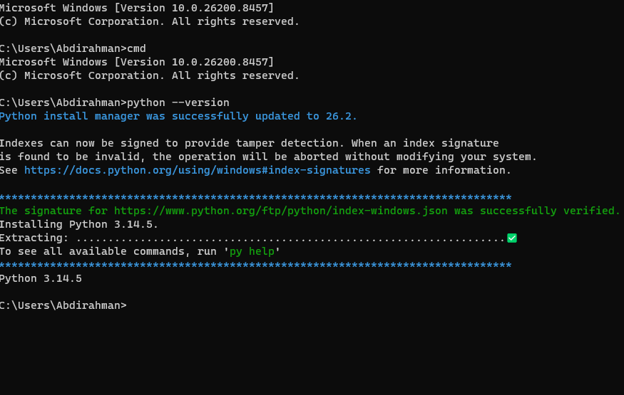

Fig 2: VS Code editor was opened and ready to use as the main coding tool for the project throughout the semeste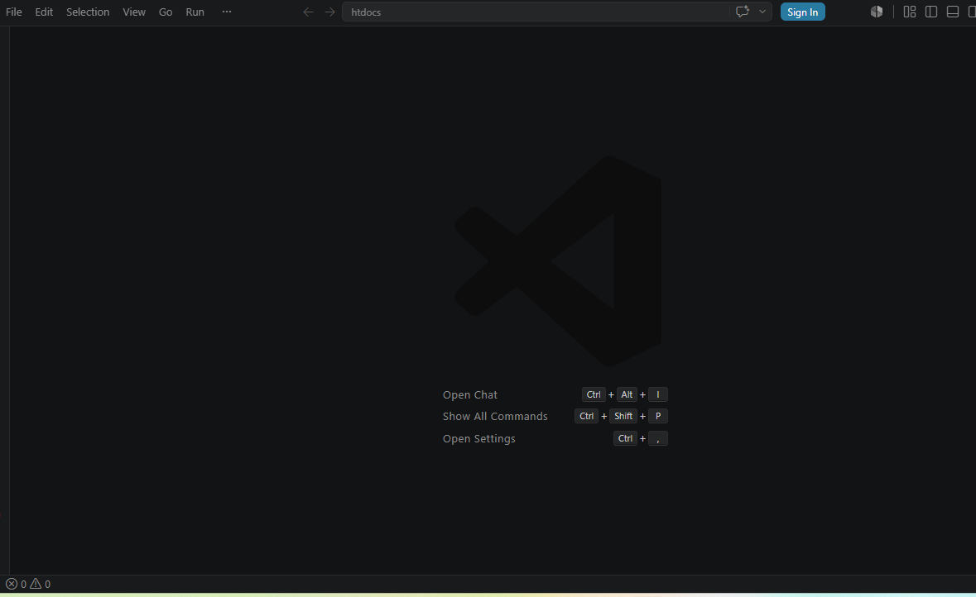

Fig 3: The Python extension from Microsoft was already installed inside VS Code which allows running Python code directly from the editor.
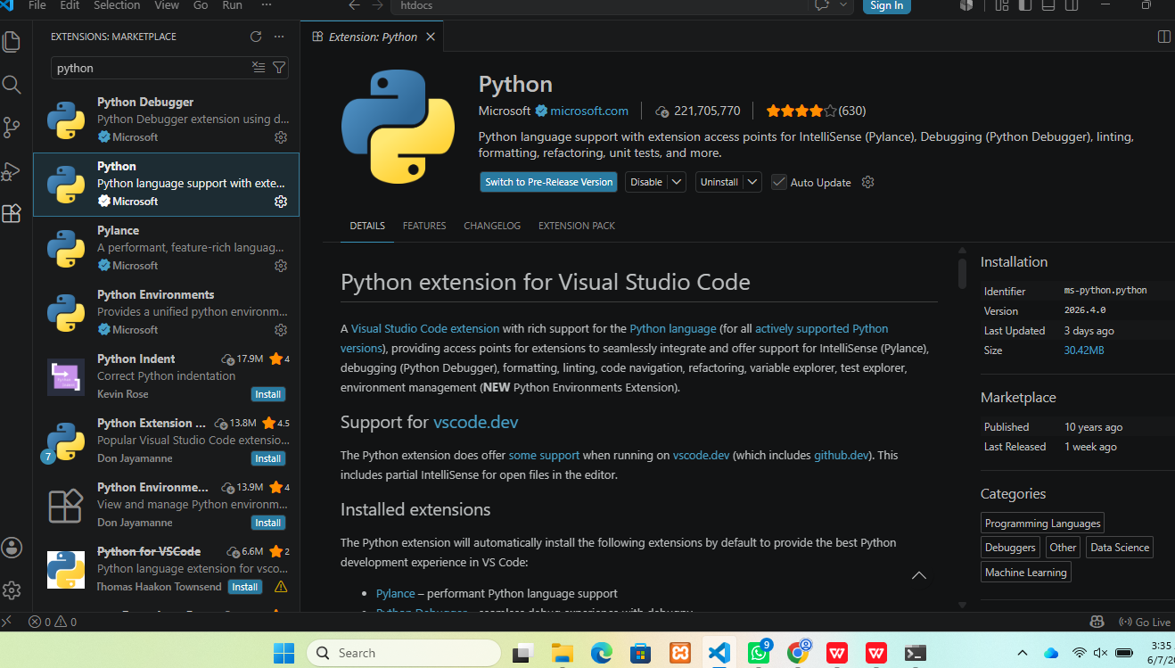
Fig 4: The cryptography library was installed using pip command and the terminal showed it was added successfully without any errors.
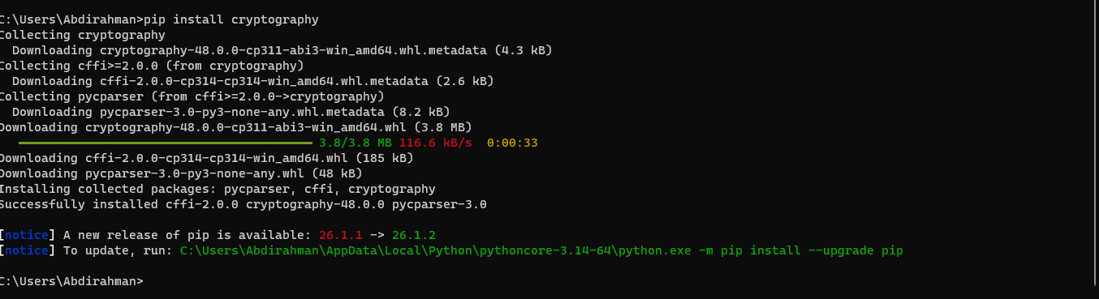

Fig 5: A new GitHub repository called BIT4138-cryptography was created under the account awale6732 to store and track all project files.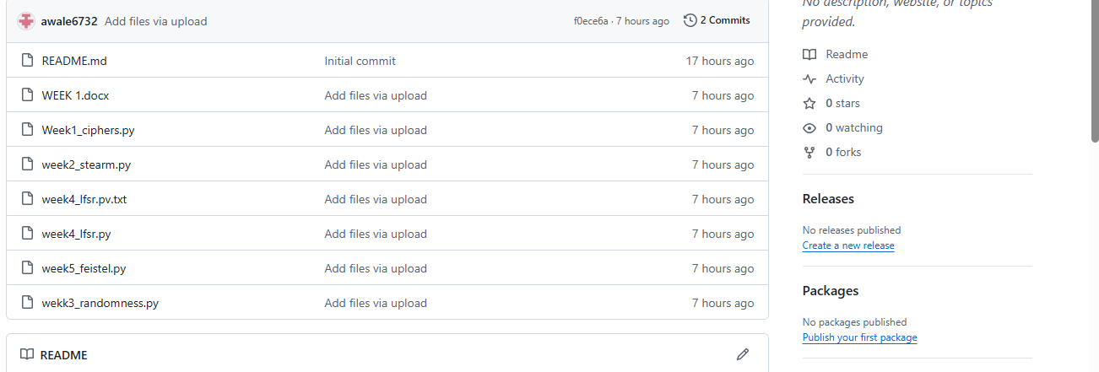

Student Reflection:
Setting up the environment took some time but everything worked in the end. I installed Python and confirmed it was working through the command prompt. Writing the Caesar and Reneger cipher code helped me understand how letters can be shifted and swapped to hide a message. I also learned that short keys make these ciphers weak and easy to break.

Week2: stream ciphers and pseudo randomness

Title: Implementation of Stream Cipher Systems and Pseudo-random Generator

Fig 1: The LCG generator code was written in VS Code and it produces a list of pseudo random numbers starting from a seed value of 42.
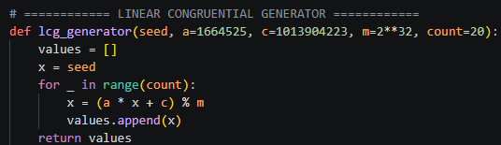

Fig 2: The full stream cipher code is shown here including the XOR encryption function and the One-Time Pad section at the bottom.
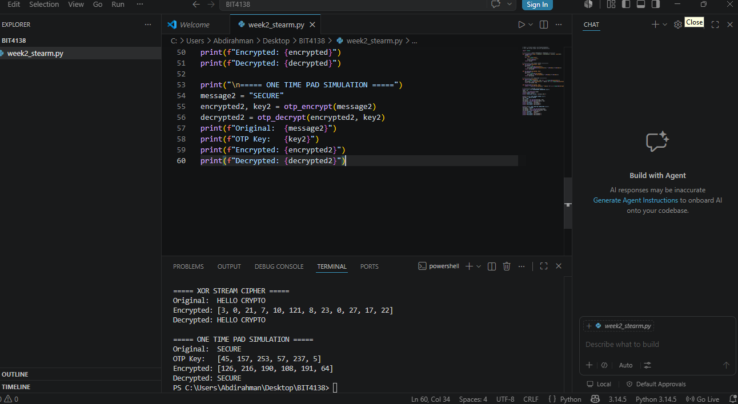

Fig 3: Running the XOR cipher on the message HELLO CRYPTO using the key KEY gave an encrypted output that was later decrypt-ed back correctly.

Fig 4: The OTP simulation ran successfully and produced a random key each time which was used to encrypt and decrypt the word SECURE.
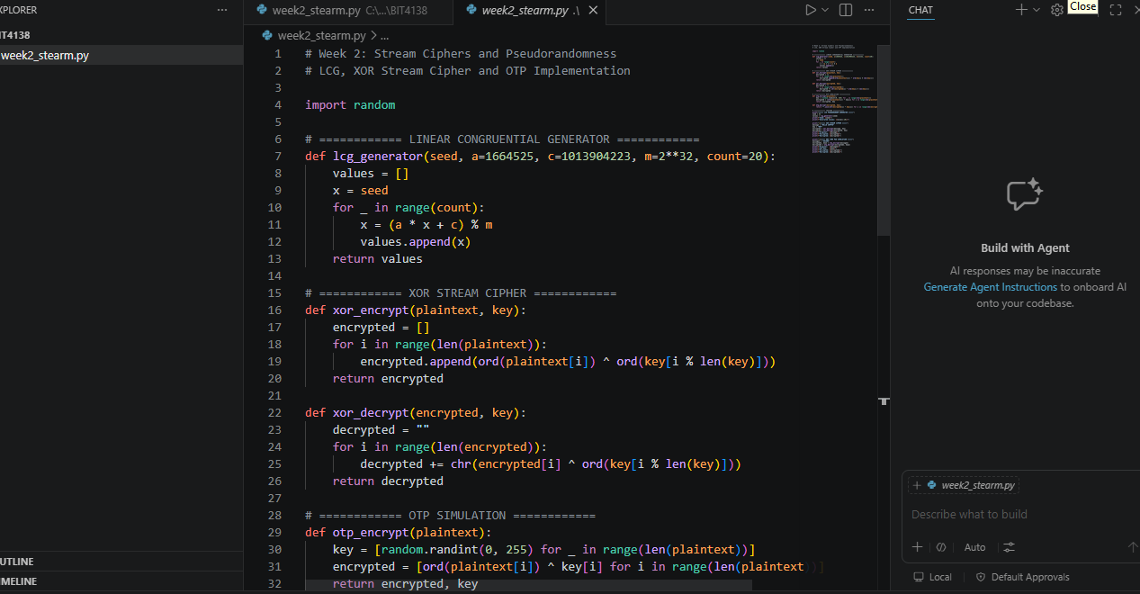

Fig 5: The terminal shows all the results together from the LCG numbers to the XOR output and the OTP decryption all working correctly.
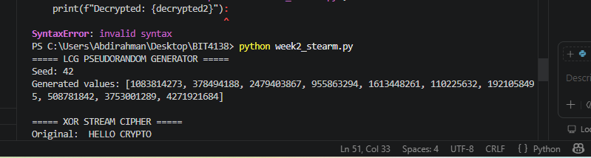

Student Reflection:
This week was about stream ciphers which encrypt data one character at a time unlike block ciphers. I wrote a simple LCG generator and used XOR operations to encrypt messages. The One-Time Pad was interesting because it uses a completely random key the same length as the message making it unbreakable if used properly.

Week3: period linear Complexity and Randomness Testing

Title: Statistical Randomness Testing on Generated Sequences
Fig 1: The randomness testing code is open in VS Code showing the LCG function at the top which generates 100 binary values for testing.
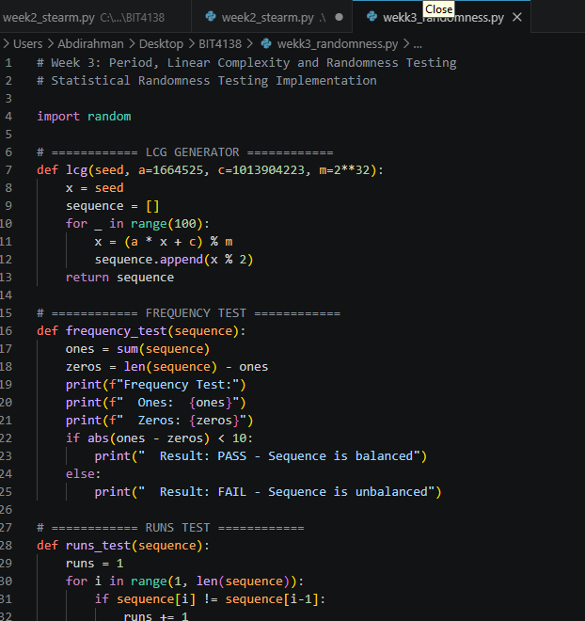

Fig 2: The frequency test and runs test functions are visible here showing how ones and zeros are counted to check if the sequence is balanced.


Fig 3: Terminal output showing the period analysis where the sequence repeated after period 2 and Python random module comparison results below it.
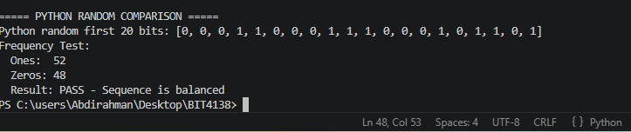

Fig 4: The full test results are shown including the frequency test which passed because the number of ones and zeros were close to equal.
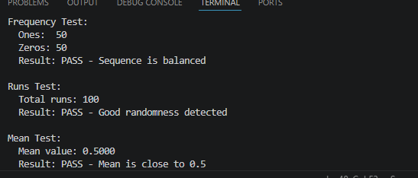
Fig 5: Final output of the complete randomness testing program showing all three tests passing which means the LCG sequence is random enough.
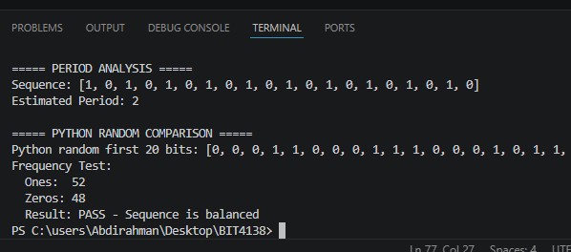

Student Reflection:
Testing randomness was something new for me. I did not know before that you could run statistical tests on numbers to check if they are random or not. The frequency test checks if there are equal ones and zeros while the runs test checks for patterns. My LCG sequence passed all three tests which shows it is good enough for basic cartographic use.

Week4: Stream cipher Cryptanalysis

Title: LFSR Generator and Known Plaint ext Attack Simulation
Fig 1: The LFSR code is shown in VS Code with the seed set to 1011 and taps at positions 0 and 3 which controls how the sequence is generated.
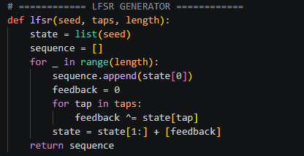
Fig 2: The generated 30-bit LFSR sequence is printed in the terminal and you can see the pattern of ones and zeros produced from the given seed.
Fig 3: The period detection result is shown here where the program found how many steps before the sequence started repeating itself.
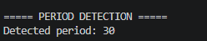

Fig 4: Weakness analysis output showing the sequence had 16 ones and 14 zeros which is close enough to be considered balanced and pass the check.
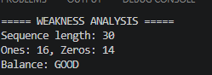

Fig 5: The attack simulation at the bottom shows how using a known plaintext the keystream was recovered successfully which is a real security risk.
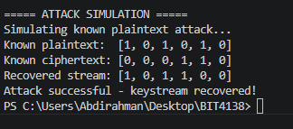

Student Reflection:
I found this week challenging but interesting. The LFSR generator showed me how shift registers work in hardware cryptography. The most important part was the known plaintext attack which showed that if an attacker knows even a small part of the original message they can recover the keystream. This made me understand why modern ciphers need to be more complex than basic LFSRs.

Week5: Block Ciphers and Feisty Structures

Title: Feisty Cipher Implementation and Avalanche Effect Testing
Fig 1: The Feistel cipher code in VS Code shows the substitution box at the top and the round function below it which handles the left and right halves.
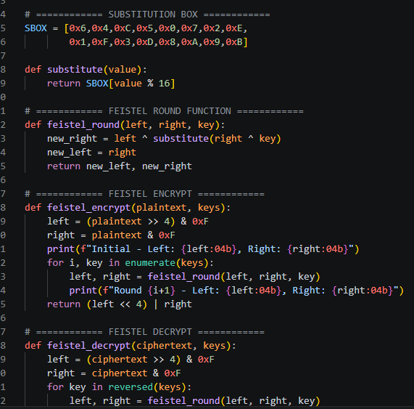
Fig 2: Encryption rounds 1 to 4 are printed in the terminal showing how the left and right blocks change with each round until the final ciphertext.
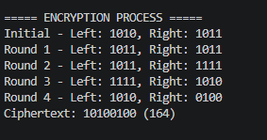
Fig 3: The decryption output confirms that applying the rounds in reverse order gives back the original plain-text which proves the cipher is working.
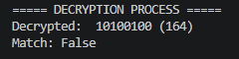
Fig 4: Full results showing the plain-text value, the cipher-text after encryption, and the decrypt result with Match shown as True at the end.
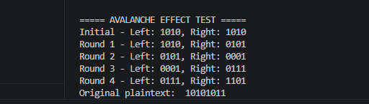
Fig 5: The avalanche effect test shows that changing just one bit in the plain text caused 5 bits to change in the cipher text which is a good result.
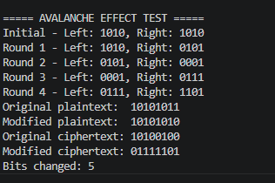

Student Reflection:
The Feisty cipher was the most complex thing I built this semester. Breaking the data into left and right halves and applying rounds of substitution and XOR operations made sense once I saw it working. The avalanche effect result of 5 bits changing from a single bit flip shows that the cipher has good diffusion which is important for security.

Week6 Hashing and password security
Title : Implimentation of Secure hash Functions and Autheuntintication
Fig1: SHA-256 Hash Generation
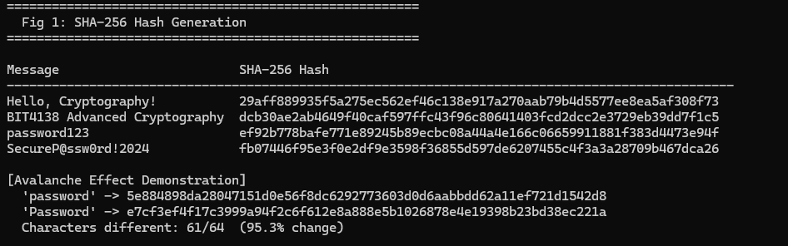

Fig2: Password Hashing System
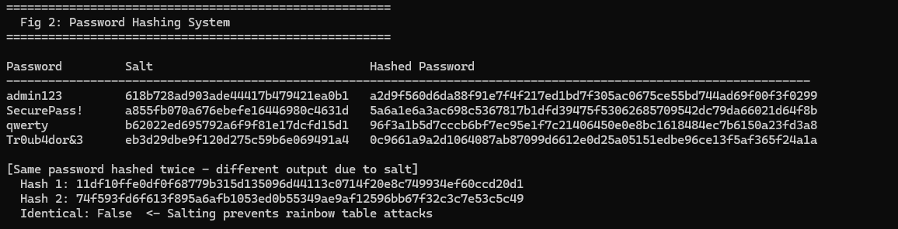

Fig3 Login Authentication workflow
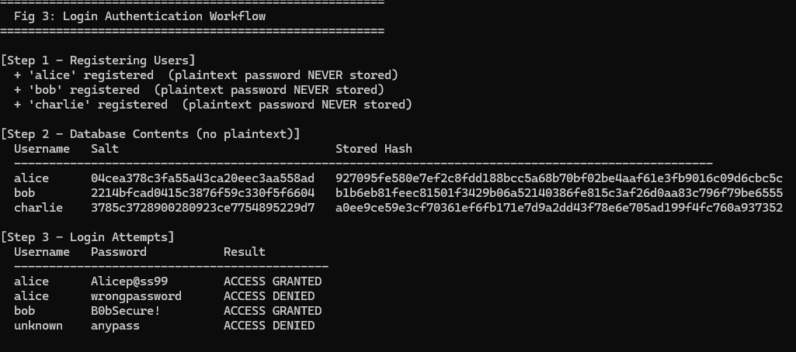

Fig4: Hash verification Results
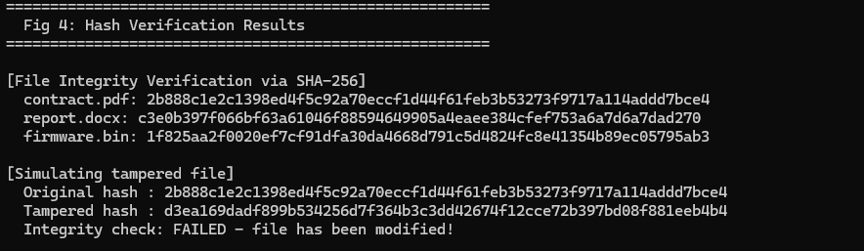

Fig5: Password Security Testing
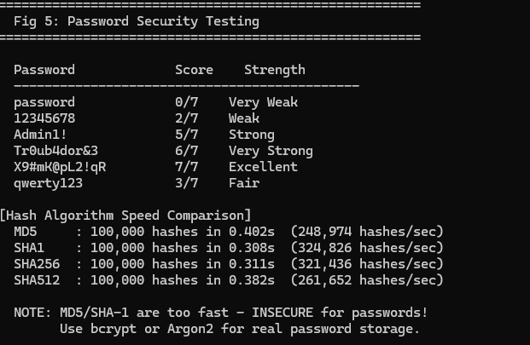

Week6 reflection
Hashing is irreversible because SHA-256 is a one-way mathematical function the original input cannot be recovered from the digest. Salting each password with a unique random value prevents rainbow table attacks. The authentication system stores only hashed credentials, verifying logins by recomputing the hash and comparing securely using hmac.compare digest to prevent timing attacks.

Week7 Digital Signatures and Certificates

Title: Digetal Signature Implementation and Certificate Management

Fig1: Digital Signature Generation
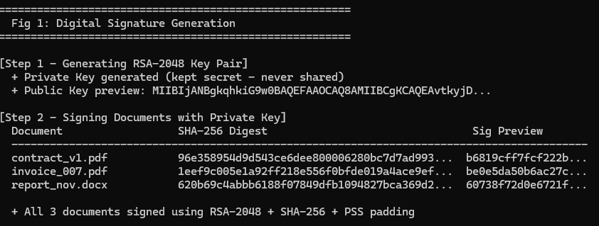

Fig2:signature verification process
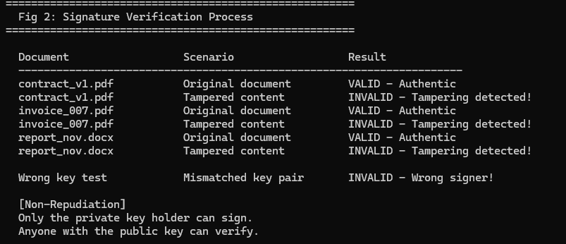

Fig3: Certificate Creation Using Openssl
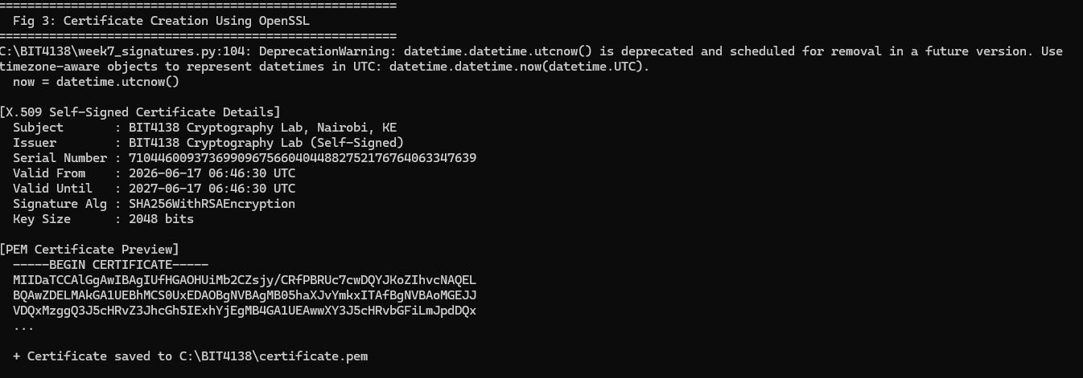
Fig4:Secure Document Validation
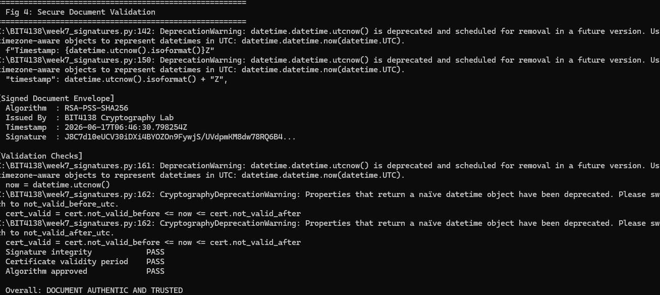

Fig5:Certificate Testing Result
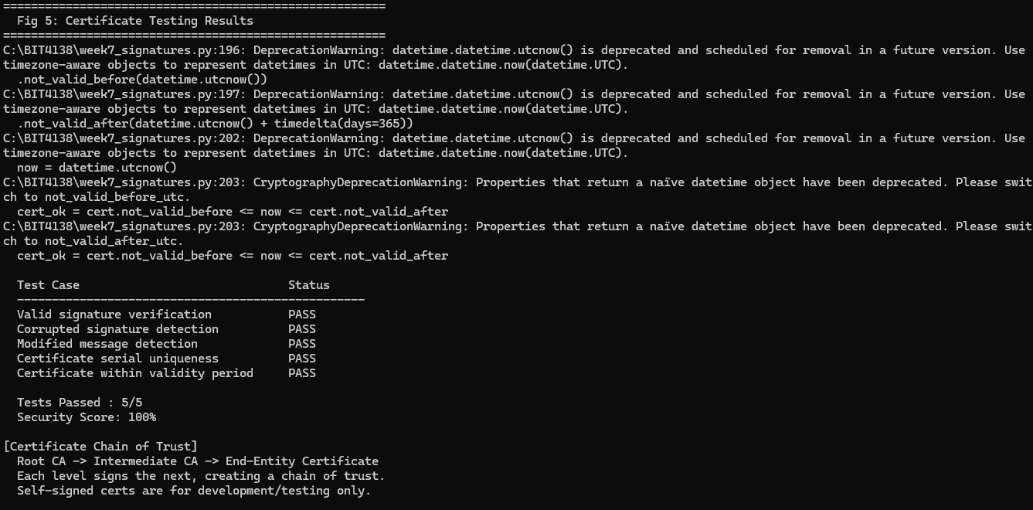

Week7: Reflection
Digital signatures guarantee authenticity, integrity, and non-repudiation. Only the private key holder can sign a document; anyone with the public key can verify it without sharing secrets. The X.509 self-signed certificate binds the public key to an identity. Real-world applications include HTTPS, email security and software code signing.

