

NAME : Abdirahman Hassan
REG NO : BSCCS/2024/60544
UNIT: ETHICAL HACKING AND COUNTERMEASURES
UNIT CODE :4139

WEEK 1: DOWLOADING AND KALI LINUX SETUP 3
Fig 1:Kali Linux running in virtual box 3
Fig 2:Kali version 4
REFLECTION: 4
WEEK 2: PENETRATION TESTING BASICS 5
Fig 1: Nmap port scanning 5
Fig: 2 Detailed scan 6
REFLECTION: 6
WEEK 3 FOOTPRINTING AND RECONNAISANCE 7
Fig: 1 Workspace Creation, Listing and available modules 7
Fig: 2 Whois lookup 8
REFLECTION: 8
WEEK 4 DNS & OSINT FOOTPRINTING 9
Fig: 1Whois results 9
Fig 2:DNS information gathering 10
REFLECTION: 10
WEEK 5: NETWORK SCANNING 11
Fig: 1 Nmap full network scanning 11
Fig 2: Scanning and service interaction 12
REFLECTION: 12
Week6 Vulnerability Assessment and scanning 12
Figure1 Active hosts discovered on network 13
Figure2 open port on localhost 13

WEEK 1: DOWLOADING AND KALI LINUX SETUP

Fig 1:Kali Linux running in virtual box
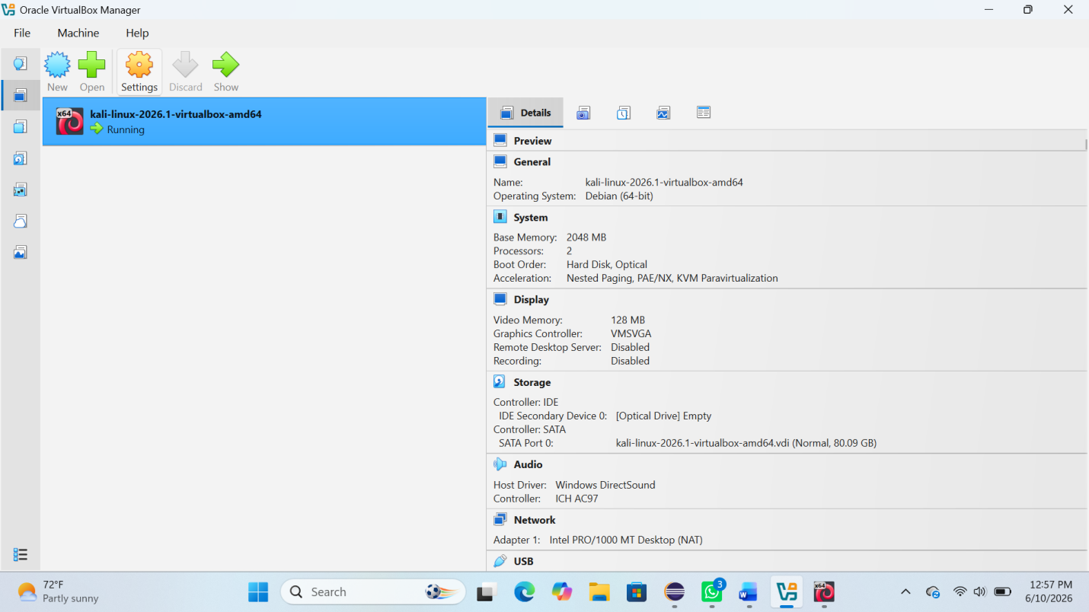

Fig 2:Kali version
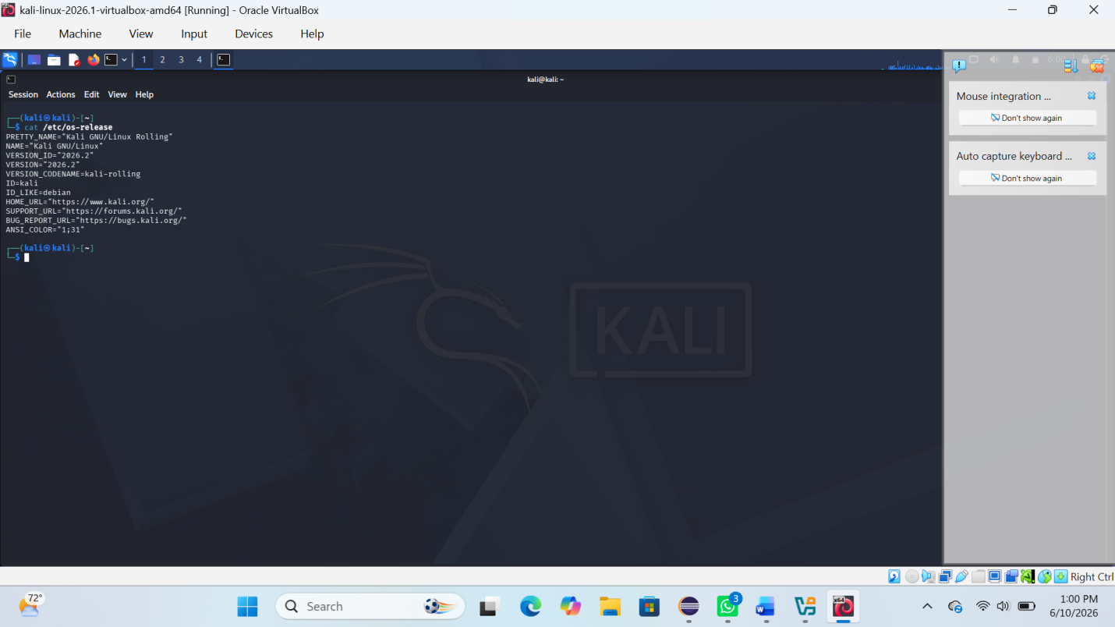

REFLECTION:
I learned how to set up a virtual ethical hacking lab using Kali Linux. I understood the importance of a controlled environment for safe security testing.

WEEK 2: PENETRATION TESTING BASICS

Fig 1: Nmap port scanning
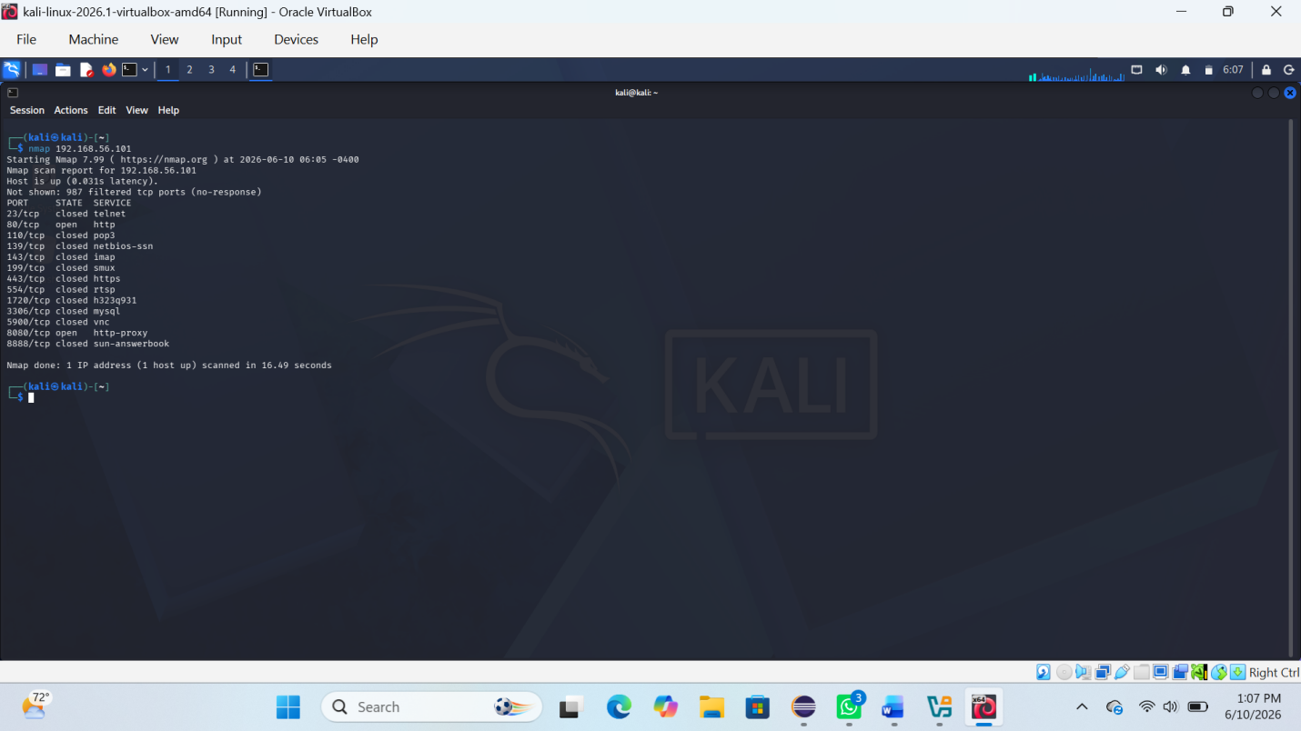

Fig: 2 Detailed scan
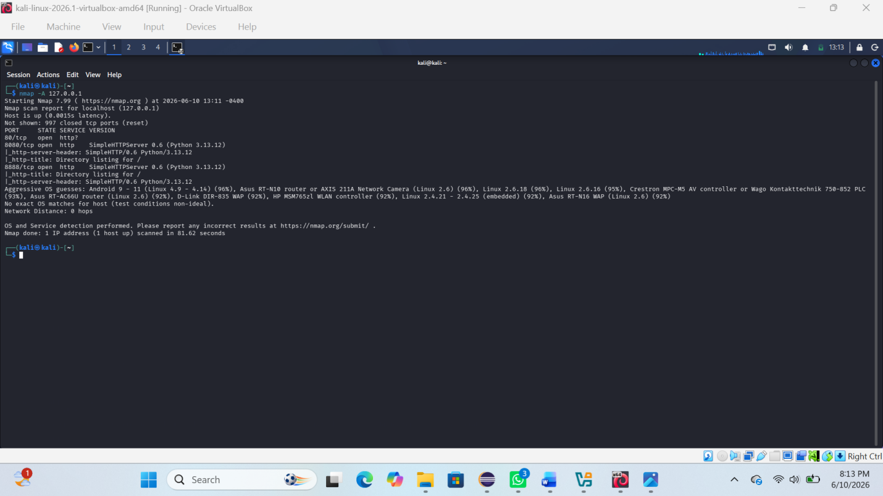

REFLECTION:
I learned basic penetration testing concepts and how tools like Nmap are used to identify open ports and services on a target system

WEEK 3 FOOTPRINTING AND RECONNAISANCE

Fig: 1 Workspace Creation, Listing and available modules
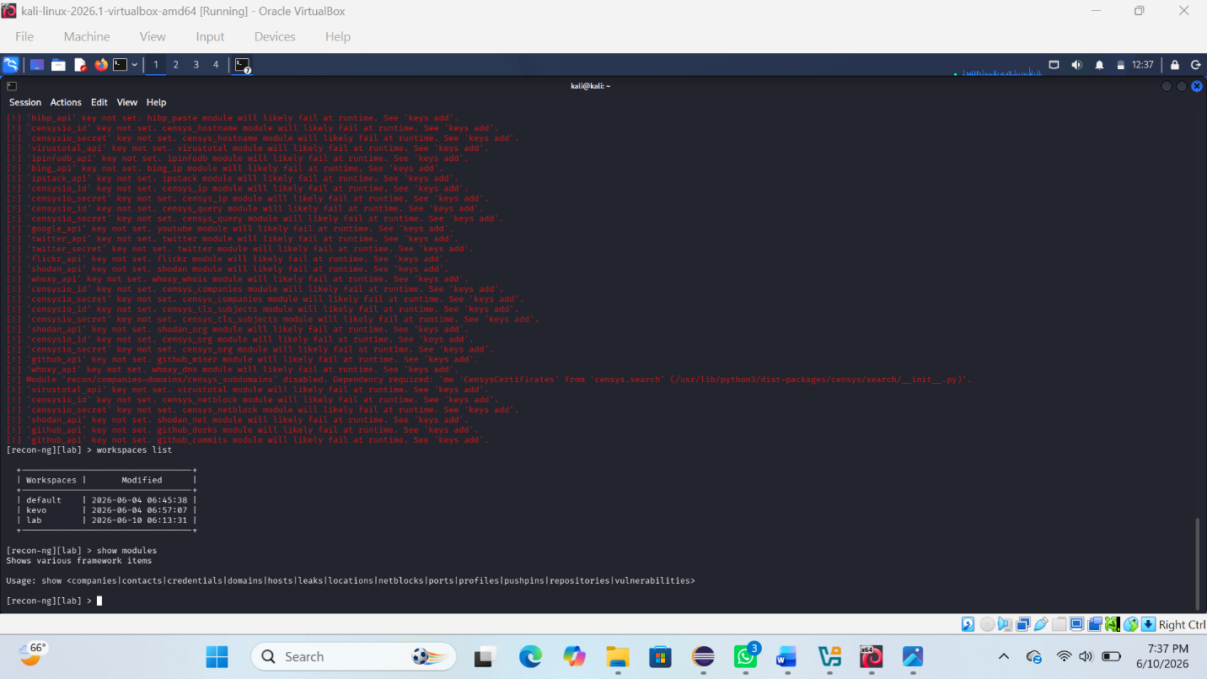

Fig: 2 Whois lookup
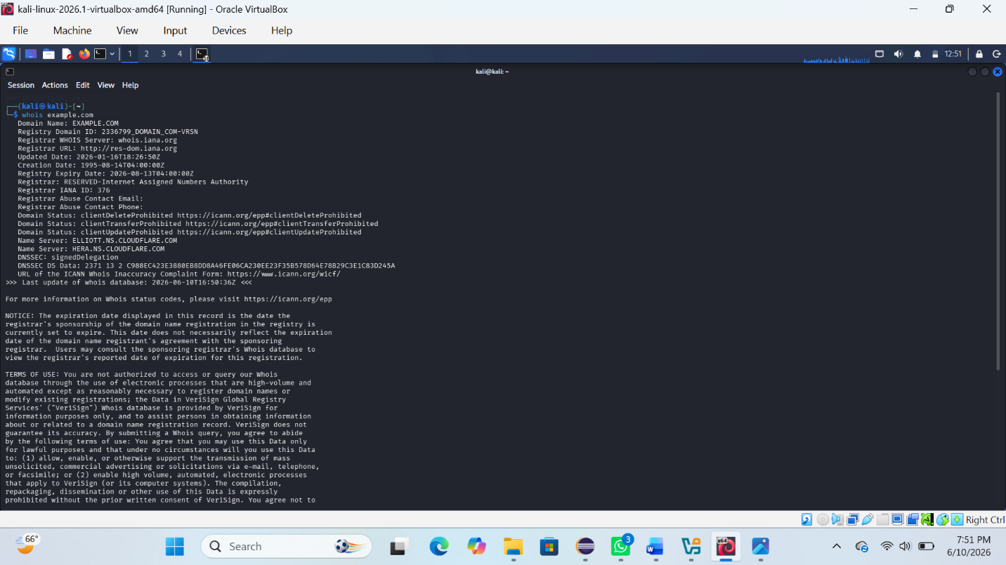
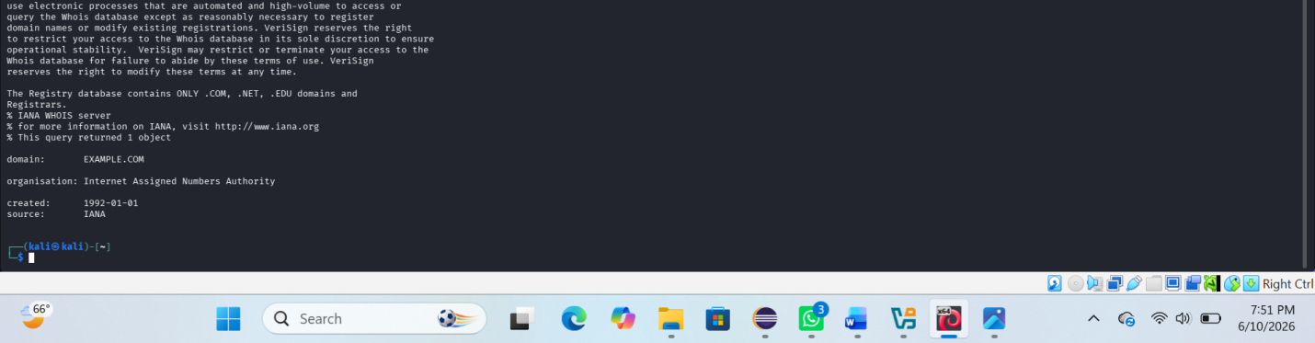

REFLECTION:
I learned footprinting techniques using Recon-ng and OSINT tools to gather basic information about a target system and domain.

WEEK 4 DNS & OSINT FOOTPRINTING

Fig: 1Whois results
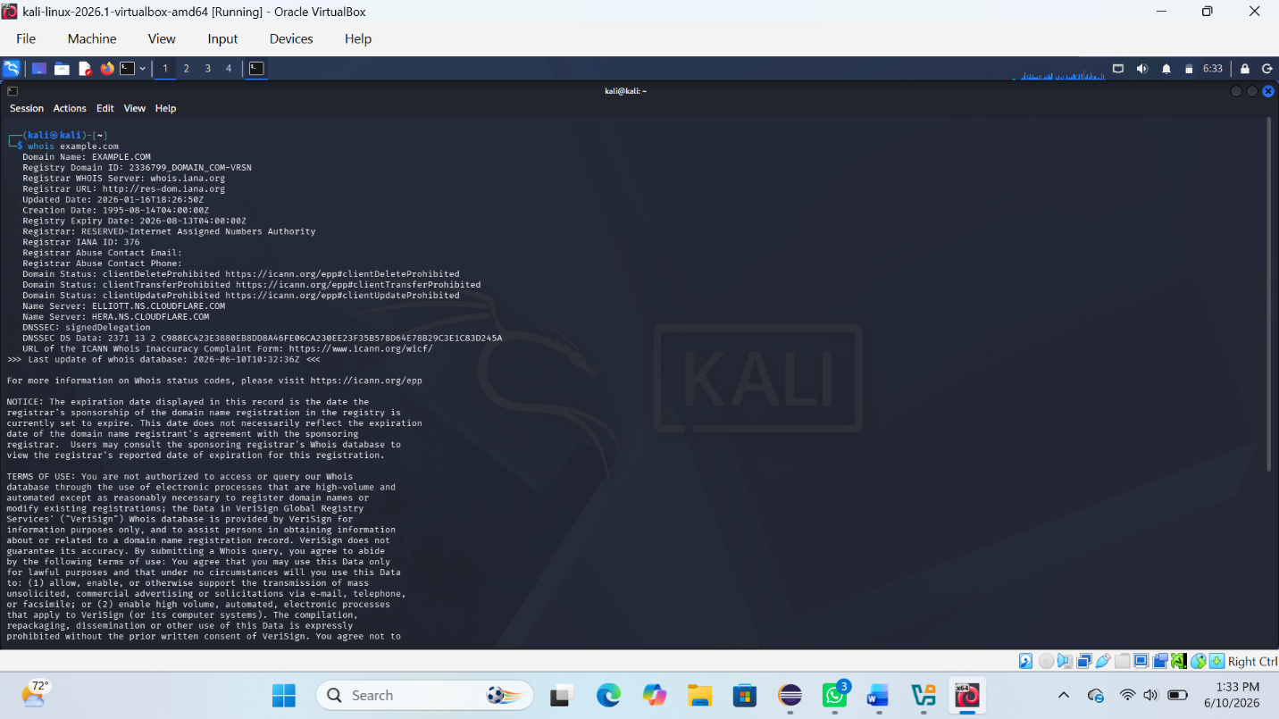
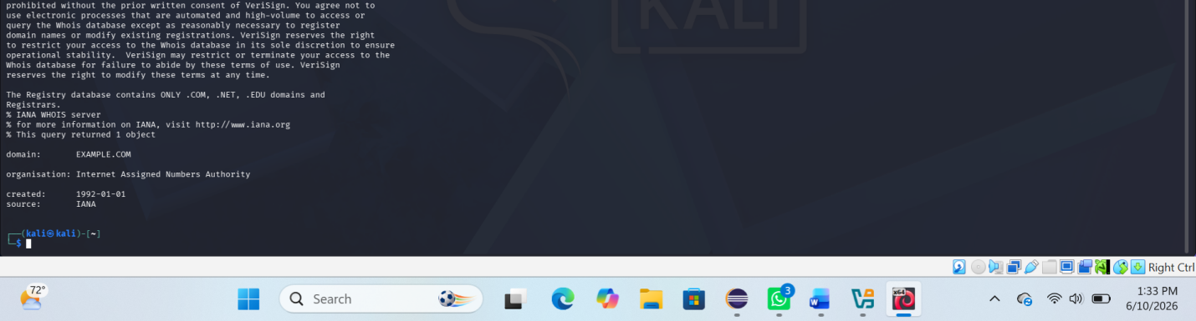

Fig 2:DNS information gathering
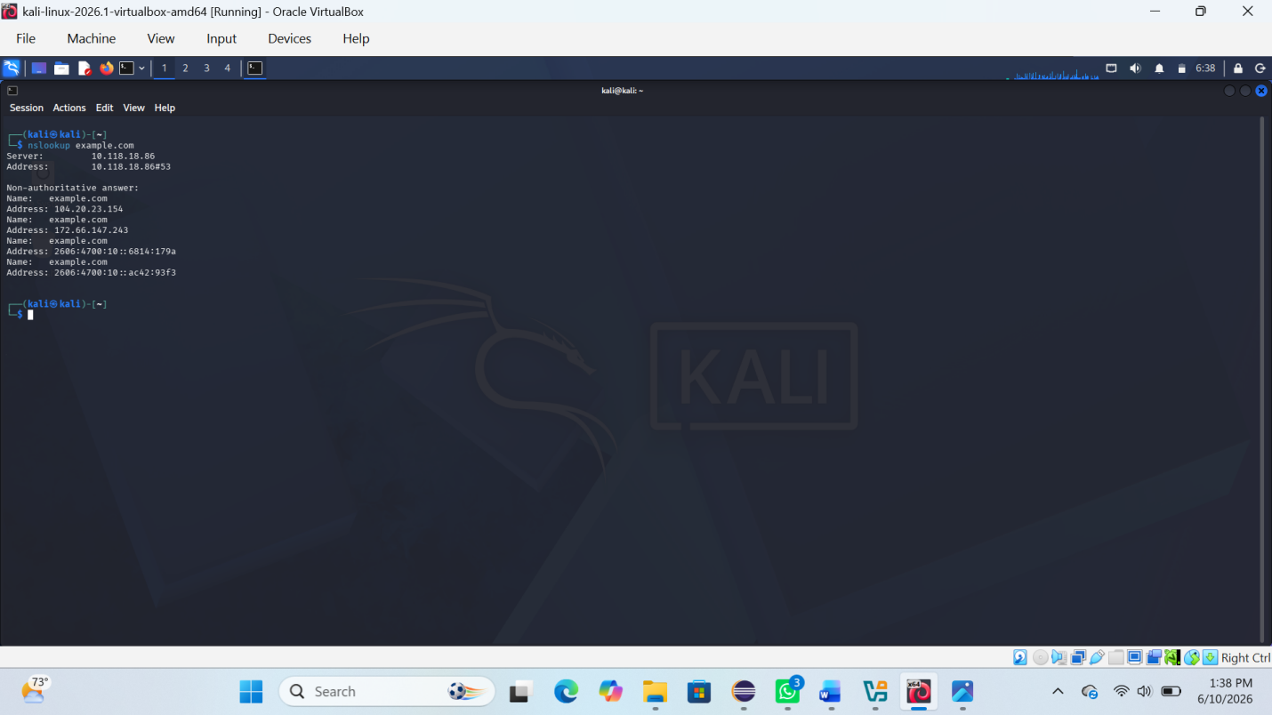

REFLECTION:
I learned how DNS and WHOIS tools help collect domain information and understand network structures during reconnaissance.

WEEK 5: NETWORK SCANNING

Fig: 1 Nmap full network scanning
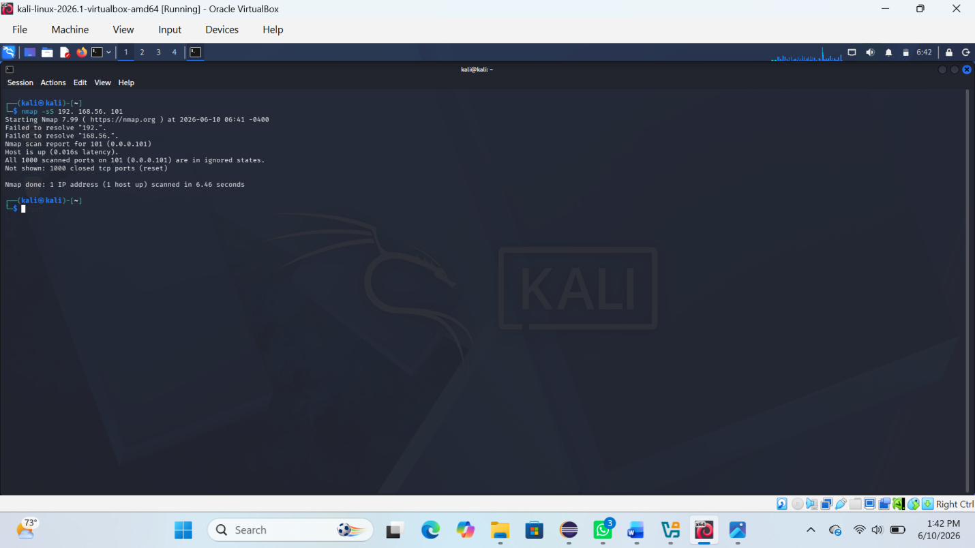

Fig 2: Scanning and service interaction
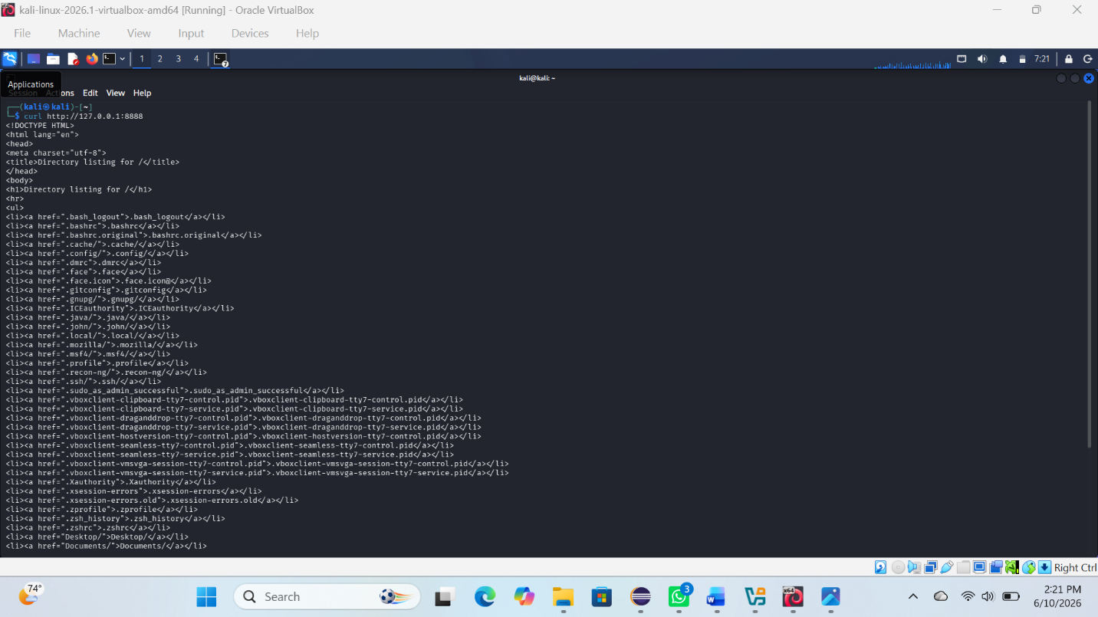
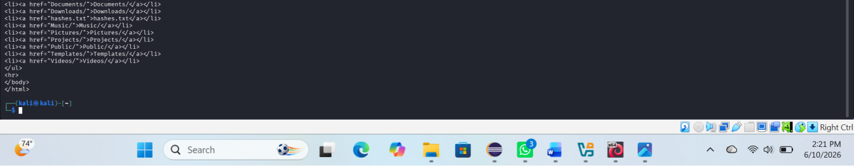

REFLECTION:
I learned how to scan networks using Nmap and Wireshark and how enumeration helps extract detailed service and system information.

Week6 Vulnerability Assessment and scanning

Figure1 Active hosts discovered on network
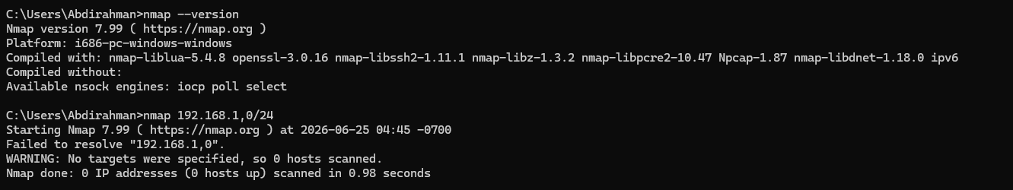

Figure2 open port on localhost
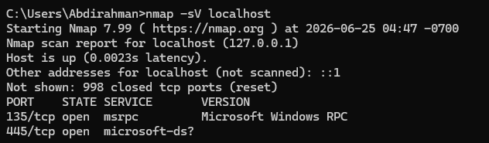

Week6 reflection
This week taught me that identifying vulnerabilities before attackers do is the foundation of cybersecurity. Through vulnerability assessment, scanning tools like Nmap and Nessus, and understanding CVE and CVSS scoring, I learned how to systematically find, prioritize, and recommend fixes for security weaknesses. The key takeaway is that no system is perfectly secure, but with regular scanning, proper patch management, and continuous monitoring, organizations can significantly reduce their risk and stay one step ahead of potential threats.

