Steam Game Recommender
CPS840

Abstract - The purpose of this report was to tackle the difficult task of recommending Steam video games to users. The technology used includes concepts learned during the CPS840 Machine Learning course project at Ryerson University, such as utilization of the K Nearest Neighbors algorithm, and the Principal Component Analysis.
Awale Hassan, 500704868, Shiqi Dong, 500638538

Index Terms— Machine Learning, KNN, Dataset, Data Science

INTRODUCTION
THe purpose of this document is to provide a written report to the final project in the class CPS840, Machine Learning.
The knowledge and methods utilized in this project mostly came from the notes Professor Bruce supplied during lectures and online.
While many different recommendation algorithms exist for large companies like YouTube, Netflix and Spotify, nothing of the sort exists for Steam. Even though it is the largest retailer for online video games, most recommendations for steam games is done from user to user or salespeople. We believe it is possible to create a Steam game recommendation service using a machine learning algorithm.
We attempt to predict whether a user will like a game or not by studying their Steam game library. The user would then be classified based on the games they have within their library, and the playtime for each game. We will then use that information with the KNN algorithm. Finally we would compare the libraries of the initial user and its neighbors, determining which game has the highest playtime that the user does not own. With that we would have our recommendation, based on other steam users.

Methods

Dealing with raw data
The formulation of this problem begins with a desire to recommend video games to Steam users, without repeatedly recommending games users already own. The first step to this process is retrieving an appropriate dataset from Kaggle. The exact data set is named “Steam Video Games”. This included data on over 3600 games, with over 11,000 users. First the dataset had to be pruned and manipulated,
Certain columns were renamed, and the repetition of entries needed to be dealt with. If a user owned a game and had played it, they would appear as two entries, one for purchasing the game, and one showing the length of time they played this game. We merged these two instances, so users would only appear once for a particular game. To demonstrate if a user had played the game or not, the playtime column was utilized. If a user’s playtime for a game is less than zero, they own the game but have not purchased it. If a user’s playtime for a game is greater than zero, they have played the game. Simply subtract zero from the playtime to get a user’s actual playtime.

PCA
From the website The Glowing Python, we were able to find an adequate PCA algorithm that could handle the data we processed. As our matrix was saved in a np.nparray, we could not utilize sklearn PCA function. Here is the result:

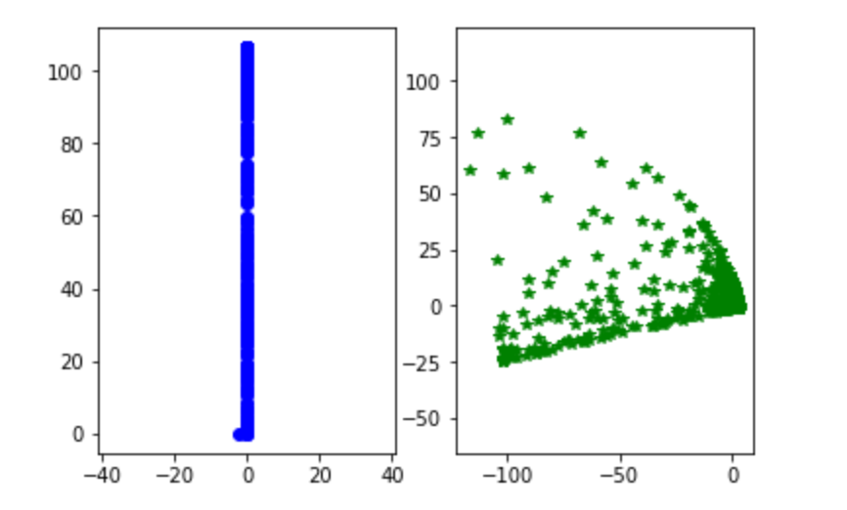
On the left is the initial representation of the data, on the right is the data after pushing it through the PCA function. As a 2D representation of a higher dimensional space, the second is much easier to determine difference.

K Nearest Neighbors
The implementation of the KNN algorithm involved the usage of the built-in NearestNeighbors function from sklearn. Once the neighbors were found, the indices and the distances between them were calculated.

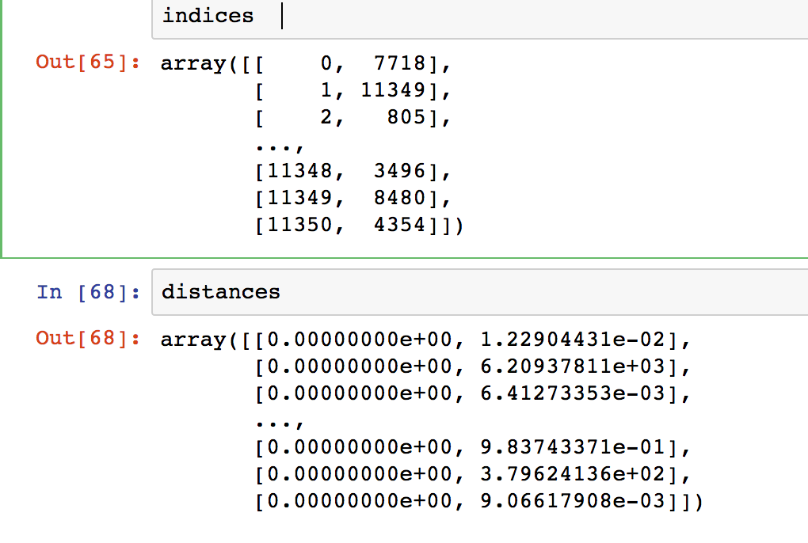

Conclusion
In conclusion, our raw data required a significant overhaul before we could implement any sort of algorithm on it.
References
- The Glowing Python, Principal Component Analysis with numpy,2011
- Scikit learn, 1.6. Nearest Neighbors,2007
- Sample IEEE Paper, https://paginas.fe.up.pt/~jca/wrsc/templates/IEEE-Conference-A4-format.pdf

