Data Product - Technical Catalog
System Design Document
August 2026

Table of Contents
Table of Contents 1
1. What is the Technical Catalog 1
2. Design Principles and Goals 1
3. Scope 1
3.1 In Scope 1
3.2 Out of Scope 1
4. System Architecture 1
4.1 Governance Plane 1
4.2 Indexing & Query Plane 1
4.3 API Plane (FastAPI & Kafka) 1
4.4 User Experience Plane 1
5. Product Page Example 1
6. Product Page Overview 1
7. Search & Discovery 1
8. Lineage 1
8.1 Relationships 1
8.2 Data P&L 1
8.3 Schema Lineage 1
9. Validation 1
10. Tooling 1
11. Query Interfaces 1
11.1 Query (Table) 1
11.2 Query (Files) 1
12. Unstructured Search & Chat 1
12.1 Search (Dataset View) 1
12.2 Chat with Data 1
13. Data APIs 1
14. Artifact Library 1
14.1 Rules 1
14.2 Agreements 1
14.3 Tools 1
15. Actions Menu 1
16. Chat Assistant 1

1. What is the Technical Catalog
The Technical Catalog is the governed, consumer-facing layer of the data lake for data products. It holds the curated subset of the lake that has been shaped into products, each with a registered schema, a bound data model and agreement, a validation history, a named maintainer, and a resolvable location.
Think of it as the data mart layer over the lake. Consumers come here for data that is described, versioned, entitled, and stable enough to build against, instead of rebuilding equivalent products themselves. Producers come here to publish, registering an access-controlled product and making it discoverable, searchable, and transparent.
Publishing
Producers publish by registering the artifacts that make a product governable:
- Data model — the logical schema the product conforms to, versioned so consumers can pin to it safely.
- Supporting tooling — the transform and analysis components that produce the product, bound to the versions that ran.
- Agreement — the data contract with consumers, covering what is delivered, on what cadence, and to what standard.
- Quality rules — the validations the product is checked against on every run.
Products can also be registered programmatically at runtime, so pipelines and services can publish and update their own products as they evolve rather than waiting on a manual onboarding step.
Consuming
Consumers reach the catalog through three paths:
- Notifications — subscribe to a data product and receive updates as new versions, schema changes, or agreement revisions are published.
- Discovery and query UI — browse and search the catalog to find products, inspect their schemas and agreements, and query them directly.
- APIs and streams — bind to a product programmatically for request/response access or continuous consumption.
Product types
The catalog supports five product types:
- Tabular Products — structured datasets built for query and analysis.
- Transparency Products — the evidence behind a product: lineage, ownership, and validation record.
- Streaming Products — the same governed data delivered as live event feeds.
- Reference Products — shared lookups and master values that other products bind to.
- Discovery Products — the metadata that makes the estate searchable.
Product modalities
Independently of its type, a product is classified by how it relates to other products:
- Aggregated — a product assembled from several parent datasets or products, combining them into a single record with its own model, agreement, and validation history.
- Child — a sub-product that inherits the business unit, parent datasets, data model, and agreement of its parent, while maintaining delivery-specific metadata independently, so multiple delivery variants sit under one logical product.
- Derived — a product produced by transforming an existing product into a new shape, carrying its own model and agreement with lineage back to the source it was derived from.

2. Design Principles and Goals
- Automate metadata collection and publication.
- Assemble data product records dynamically from registries through ETL Jobs.
- Provide a centralized enterprise metastore for reading and writing data lake tables.
- Enforce fine-grained (column /row level) access control.
- Enable self-service discovery, search, and query.
- Minimize operational overhead through shared infrastructure.
- Automatically publish ETL-generated metadata for search and discovery.
- Build self-describing, discoverable, and transparent data products.
- Enable content-based dataset search.
- Track data product lifecycle and delivery progress.
- Present the data lake through a clear, navigable catalog experience.
- Standardized and templatized easy-to-develop APIs.
- Support cross-dataset discovery through Discovery Products.
- Hide implementation complexity behind a simplified user experience.
- Unified UI/UX

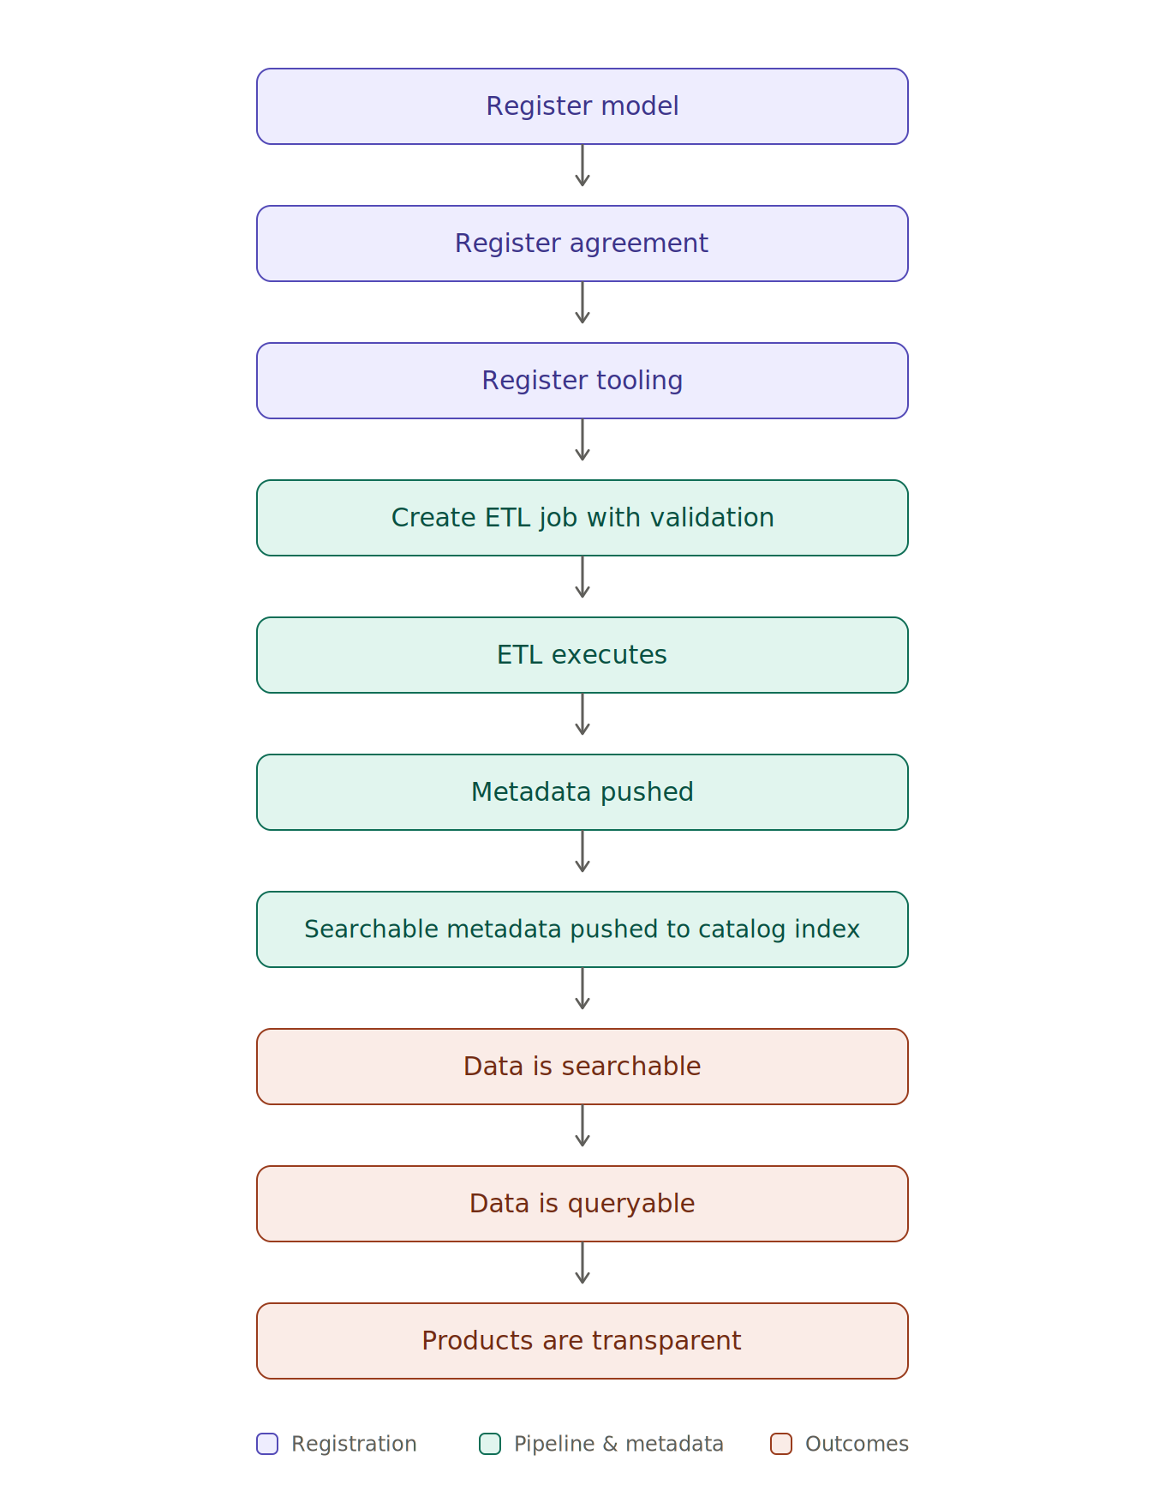

3. Scope
This section defines the boundaries of the Data Product Technical Catalog. The system is responsible for serving governed data products in the Data Catalog and providing the supporting governance capabilities required to manage them. Items listed as out of scope are explicitly excluded from this effort and, where applicable, are owned by other initiatives.

3.1 In Scope
- Data product discovery and transparency activities related to cataloging products.
- An access-controlled metastore, such as Apache Polaris, enabling systems to read and write data to the data lake.
- Content-based access-controlled cross-dataset discovery through Discovery Products, tied to the global search bar.
- Dataset level Content search and natural language search using contents extracted from within the dataset boundary.
- A registry of data artifacts used to bind data product records at runtime
- Utilizing data lake services to build lineage and status capabilities.
- A prototype UI delivered as a two-step build process into the Unified Experience.
- A robust, under-one-week development methodology to add access control and document Data APIs.
- Deduplication of shared infrastructure that accumulates cost.
- Data retention cataloging and record purging, in coordination with data lake services.

3.2 Out of Scope
- Indexing or query as-a-service for systems other than the Enterprise Catalog.
- User level access to workspace discovery or management.
- Triaging / querying un-processed data
- Multi–data lake product governance.
- Rebuilding of Data Lake services.
- Dataset parent–child governance handling.
- Data ingest forms.
- P&L Tracking and UI display.
- Relationships Tracking and UI display.

4. System Architecture
The platform is organized into four planes. A governance plane hosts the metastore, fine-grained access control, product agreements, data models, data quality rules, and data tools registries, all correlated together by an authoritative product registry. Governed data products are served through a thin indexing / query layer (Trino for structured products, OpenSearch for discovery and reference indexes, and a vector database for semantic search) into an access-controlled FastAPI layer that exposes data APIs, metadata APIs, and API forwarding into the enterprise catalog’s search index, with a Kafka data bus alongside it carrying platform events to subscribers.
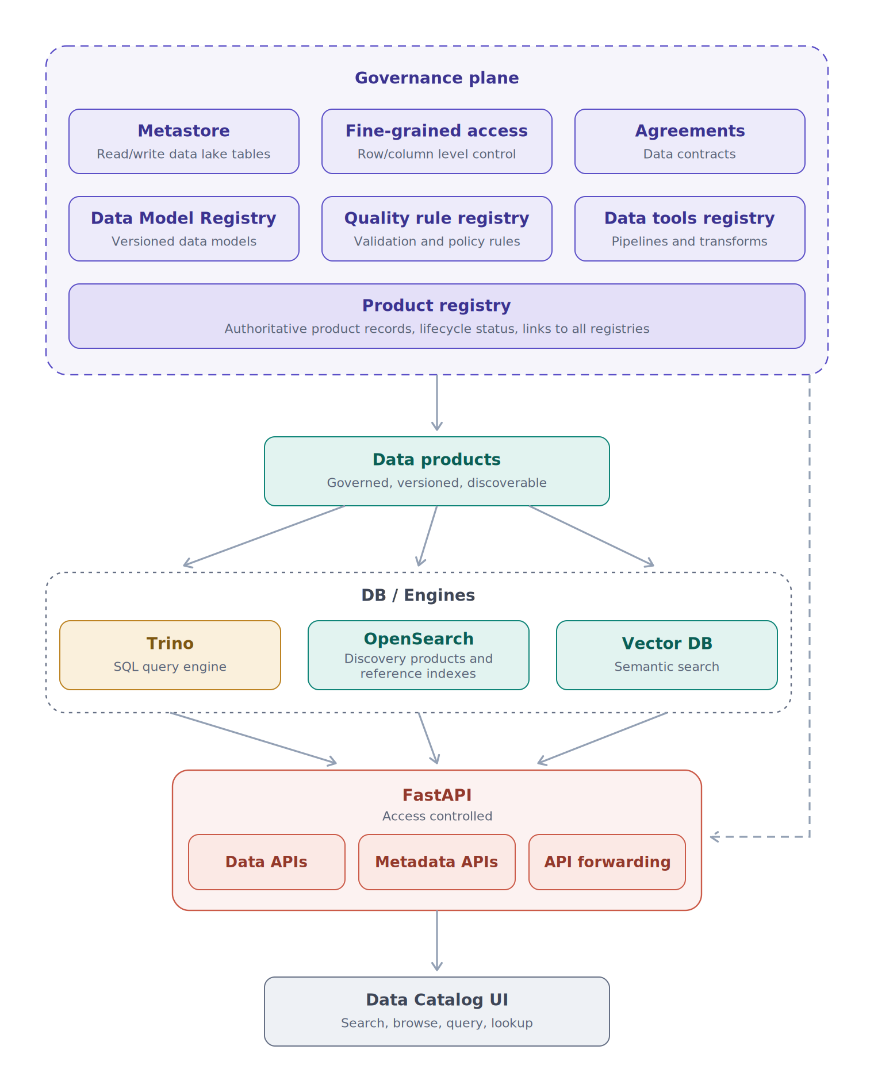
Figure 1 — Data product platform schematic.

4.1 Governance Plane
Product Registry. The product registry is the automated product metadata aggregator for the platform: every data product record originates here, and every other registry entry (model, agreement, rules, tools) is joined to a product through it. — Exposed through the Artifact Library & Product Page
Metastore (Apache Polaris). The metastore is the access-controlled front door for systems reading and writing tables in the data lake. Its purpose is to give every engine—Trino and ETL jobs—one consistent view of table schemas and snapshots, and access to the table. Design choices to consider: Data Lake Credential Vending, entitlements and access control
Fine-Grained Access Control. Access control is a governance-plane policy service, not a per-engine setting. Its purpose is to hold entitlements in one place—who may see which products, down to column and row level—and have every enforcement point (Trino filters, OpenSearch index permissions, FastAPI authorization) derive from it.
Artifact Registries (Models, Agreements, Rules, Tools). The artifact registries store the versioned specifications that product records bind to at runtime: data models, product agreements, data quality rules, and transform/analysis tools. Their purpose is to keep specifications independently versioned and reusable across products. Design choices to consider: tools and rules should be pushed through CI/CD from the code that owns them. Validator repositories push rules, tool repositories push tool records, because manual forms drift out of sync with the validations code. semantic versioning with explicit breaking-change signals lets consumers pin to products safely. — Exposed through the Artifact Library

4.2 Indexing & Query Plane
Trino. Trino is the SQL engine over structured products, serving the Query (Table) sandbox and any programmatic SQL access. Its purpose is an interactive query directly against lake tables through the metastore, with no data copies. Design choices to consider; enforce product-scoped access by resolving catalogs and schemas through Polaris grants rather than Trino-local rules. — Exposed through the Query (tables) tab
OpenSearch. OpenSearch holds the discovery and reference indexes: product metadata for global search, extracted document content for dataset-level full-text search, and the reference datasets served through Data APIs. Its purpose is fast keyword and faceted retrieval over metadata and small-to-medium content, not big-data serving. — Exposed through Reference data APIs or Discovery APIs and Query (Files) tab
Vector Database. The vector database stores embeddings of extracted dataset content and powers semantic search and the grounding retrieval behind Chat with Data. Its purpose is meaning-based retrieval where keyword search falls short. — Exposed through the chat with Data feature

4.3 API Plane (FastAPI & Kafka)
The FastAPI layer is the only supported request/response doorway to the platform. It serves three surfaces: data APIs (reference and discovery data drawn from OpenSearch, intentionally not for big data), metadata APIs (assembled product records, bindings, validation results, lineage), and API forwarding, which pushes searchable product metadata into the enterprise catalog’s global search index. Design choices to consider: build the recommended FastAPI template with authentication, product-scoped authorization, usage reporting, and OpenAPI documentation baked in, so a new Data API is configuration plus schema rather than new infrastructure; rate-limit and meter per consumer to protect the shared engines; and make catalog forwarding event-driven so the enterprise index tracks registry changes without full republishes. — Offered to data partners, Reference Data Users, Catalog Search Bar, Metadata Publishers & Consumers, Catalog API tab
Kafka Data Bus. The Kafka data bus is the streaming doorway alongside the request/response APIs, carrying platform events—registry changes, product publication and lifecycle transitions, validation run outcomes, and access policy updates—as durable, replayable topics. Its purpose is to let consumers react to changes as they happen rather than poll the metadata APIs, and to decouple the systems that emit events from the systems that respond to them. Design choices to consider: topics should be product-scoped and governed by the same fine-grained access control as the APIs, so a subscription cannot surface what a request would be denied; event schemas should be registered and versioned with the same breaking-change signals as product models, so consumers can pin safely; catalog forwarding should ride this bus rather than a separate push path, giving the enterprise index one event-driven source of registry changes; and the bus should carry events and reference-sized payloads, not bulk data movement out of the lake. — Offered to data partners, Metadata Publishers & Consumers, Catalog Search Bar

4.4 User Experience Plane
The Unified Experience UI is the client over the metadata APIs: product pages, search, lineage, validation, query sandboxes, the Artifact Library, the Actions menu, and the portal Chat Assistant. We will be taking a two-step build into the Unified Experience to create the appropriate architecture before unifying.

Product User Experience
Design
August 2026

5. Product Page Example
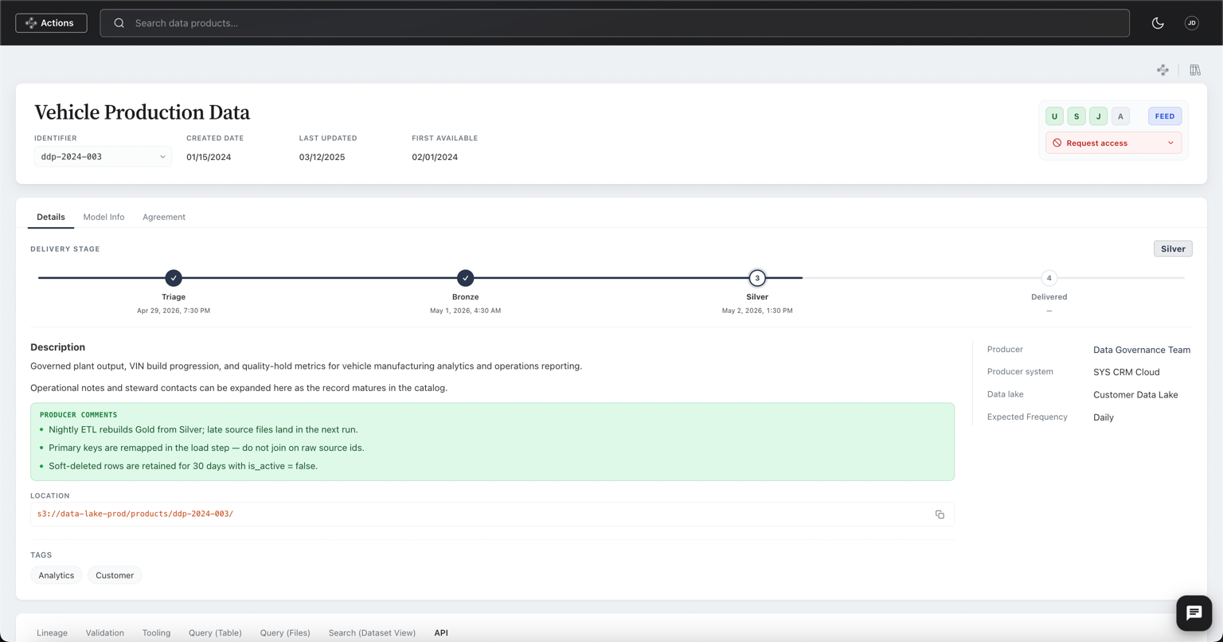
Figure 2 — Data product record example.

6. Product Page Overview
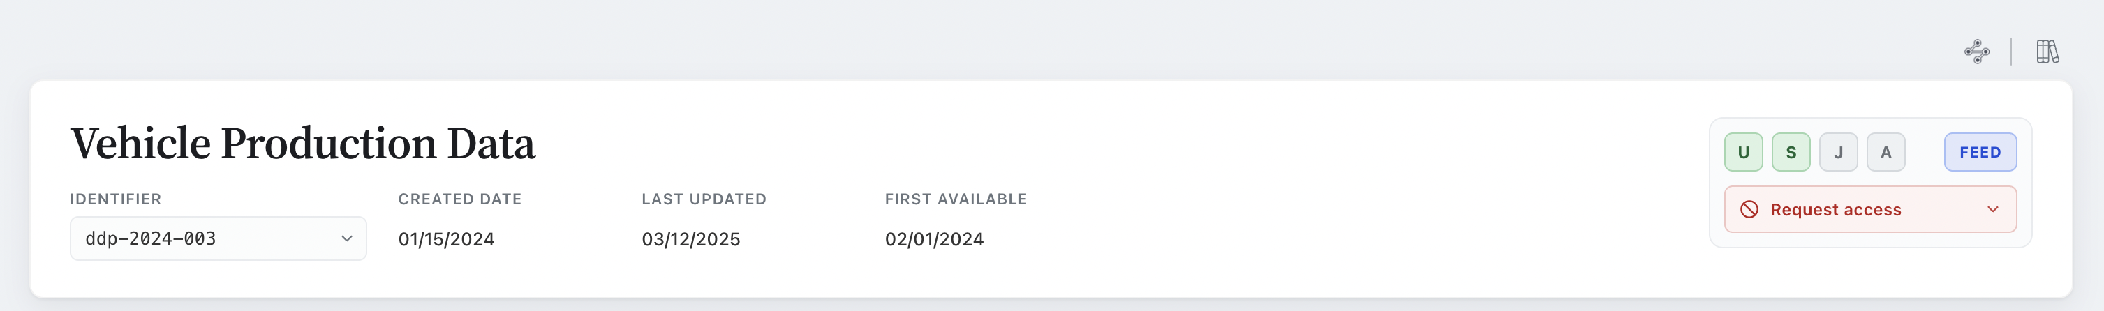
Figure 3 — Product header for Vehicle Production Data.
The product header shows the identifier, created date, last-updated date, and first-available date. Environment chips (U/S/J/A and Periodicity of the product) indicate where the product is deployed, and a Request Access control gates entitlement to the underlying data.

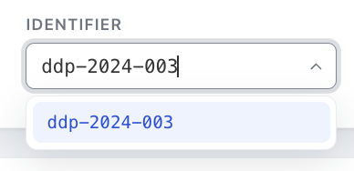
Figure 4 — Identifier version selector.
The Identifier field is implemented as an editable combo box. As a user types, the list is dynamically filtered to display matching registered product identifiers, allowing them to quickly locate and select the appropriate sub-product. When a user navigates to the page from a dataset, the identifier is automatically populated based on the selected dataset. This is common when the product name and model name are the same.
This design keeps the product catalog concise by avoiding the need to create a separate top-level product record for every delivery variant. Instead, related deliveries are represented as sub-products.
A sub-product is a child data product that inherits the same business unit (product name), parent datasets, data model, and data agreement as its parent product. All remaining metadata—including delivery-specific attributes—is maintained independently for each sub-product, allowing multiple delivery variants to be managed under a single logical data product.
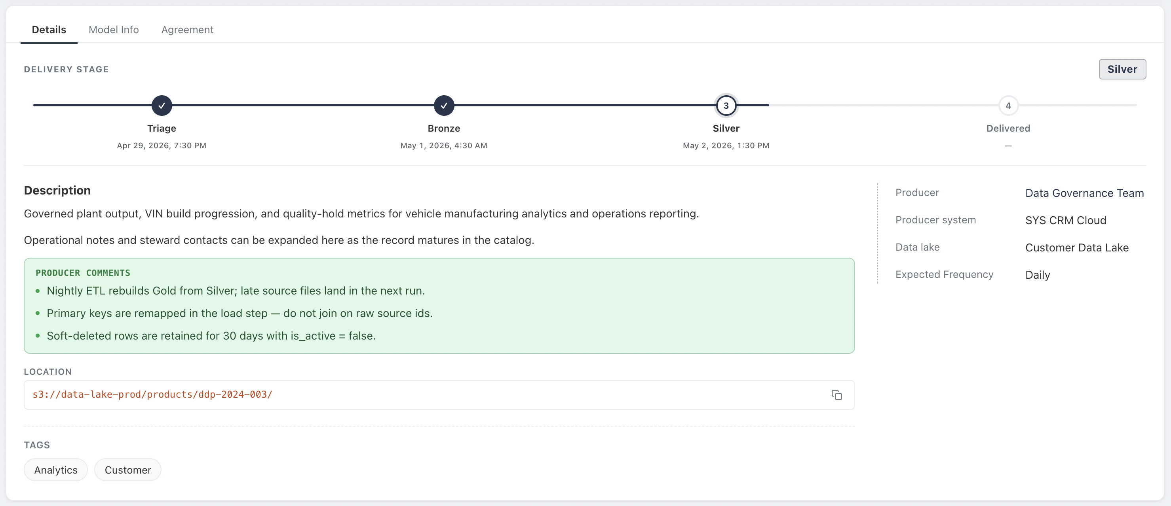
Figure 5 — Details tab with delivery stage tracker.
The Details tab tracks the product through a delivery lifecycle defined through a data product agreement with timestamps for each completed stage; this product currently sits at Silver. The description section is produced during ETL by the data producer or auto-populated from the model description when the mapping is one-to-one. This choice is API-driven: the description is supplied by the producer, or left blank and populated by the API from the model metadata.
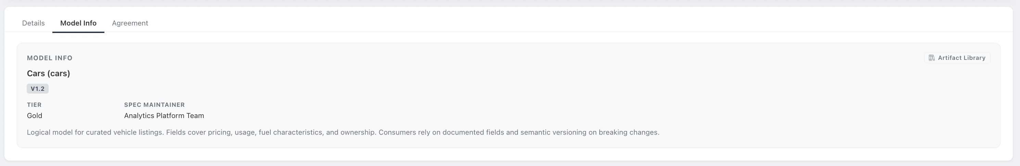
Figure 6 — Model Info tab.
The Model Info tab binds the product to its logical data model from the Data Model Registry. The binding is pulled by the API and registered at runtime to capture point-in-time registry information. Consumers rely on documented fields with semantic versioning on breaking changes. A shortcut opens the full record in the Artifact Library.
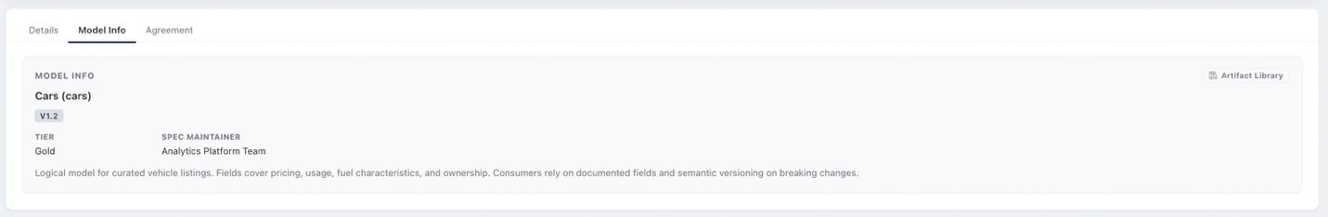
Figure 7 — Agreement tab.
The Agreement tab binds the product to its agreement created from the Agreement Registry. This binding also occurs at runtime.

7. Search & Discovery
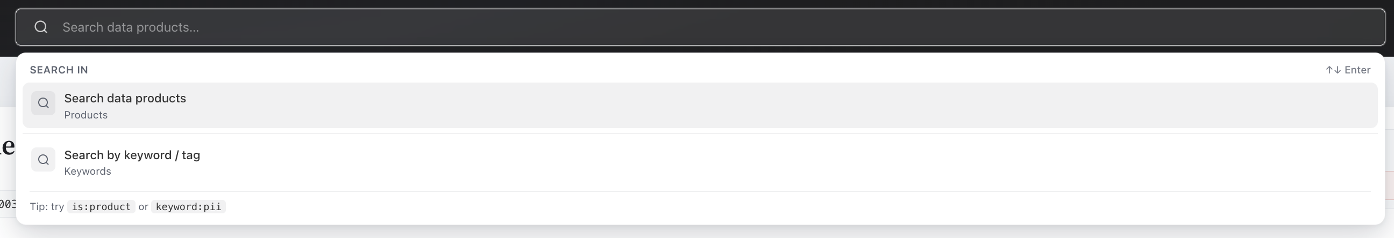
Figure 8 — Global search with scoped modes.
Global search supports two scopes: searching data products directly, or searching by keyword/tag. Query operators such as is:product and keyword:pii let users narrow results without leaving the search bar. Discovery is backed by the OpenSearch indexes in the DB/Engines layer.

8. Lineage

8.1 Relationships
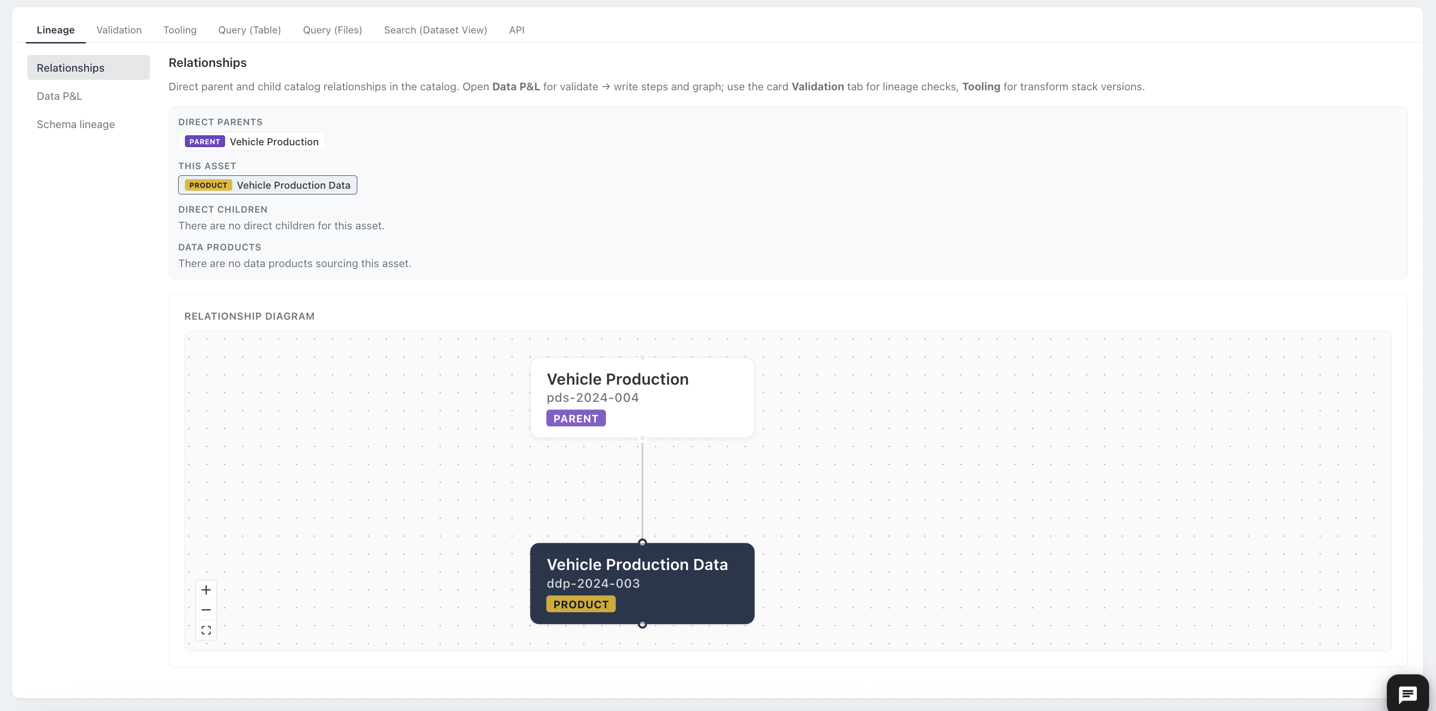
Figure 9 — Relationships view with parent/child diagram.
The Relationships view lists direct parents, the current asset, direct children, and any data products sourcing this asset, alongside an interactive relationship diagram. (Out of scope – Inherits from Catalog)

8.2 Data P&L
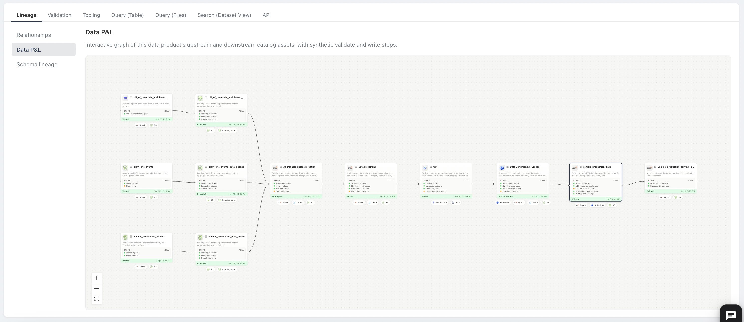
Figure 10 — Data P&L pipeline graph.
Data P&L (Provenance and Lineage) renders the end-to-end pipeline as an interactive graph: each node carries its steps, file counts, timestamps, and technology badges. (Out of scope – Inherits from Catalog)

8.3 Schema Lineage
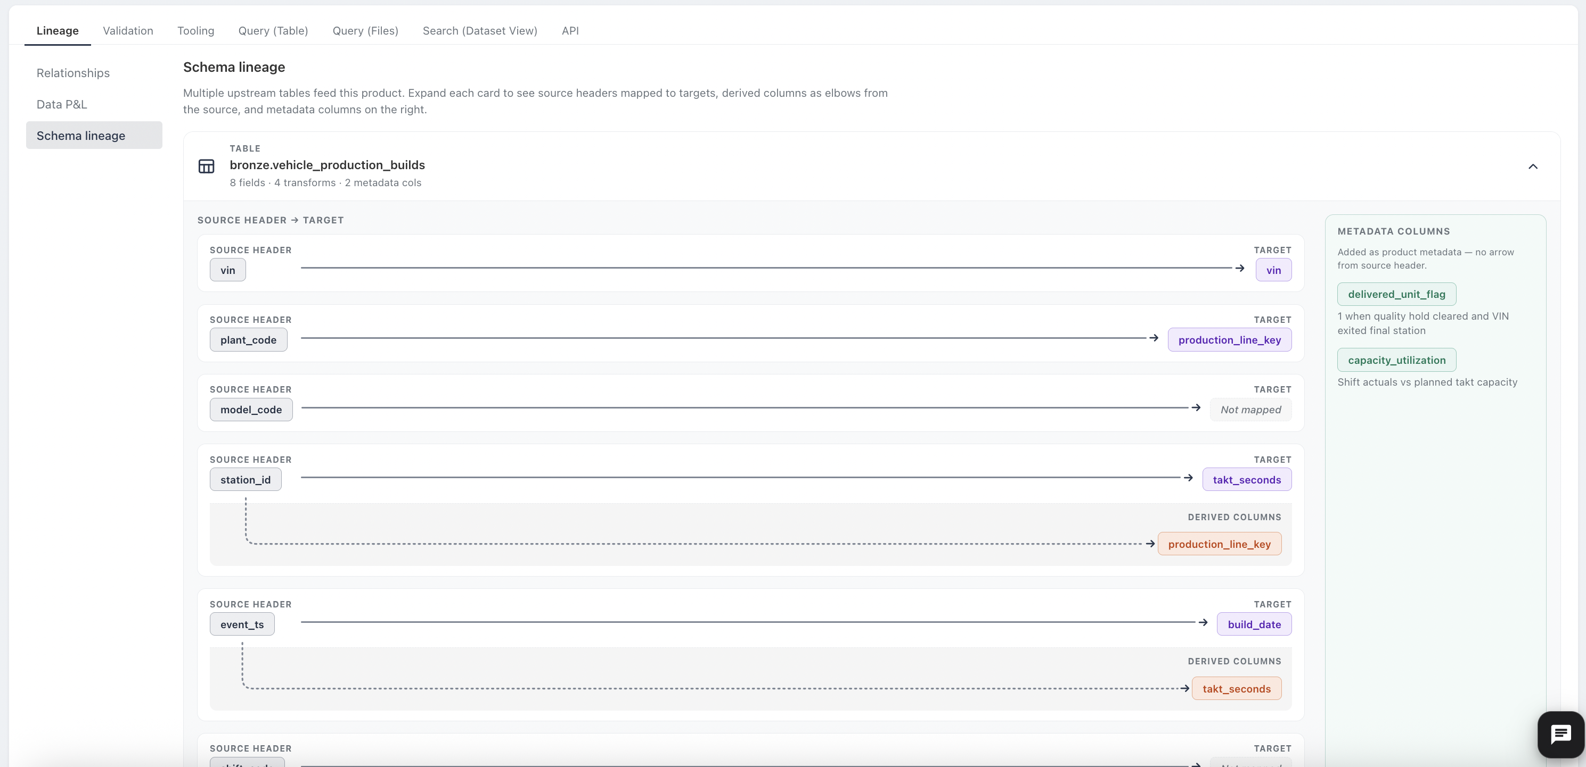
Figure 11 — Schema lineage: source headers mapped to targets.
Schema lineage is populated for structured tabular data products. It maps source headers to their destination headers. Product-level metadata columns are documented on the right, with no source arrow.

9. Validation
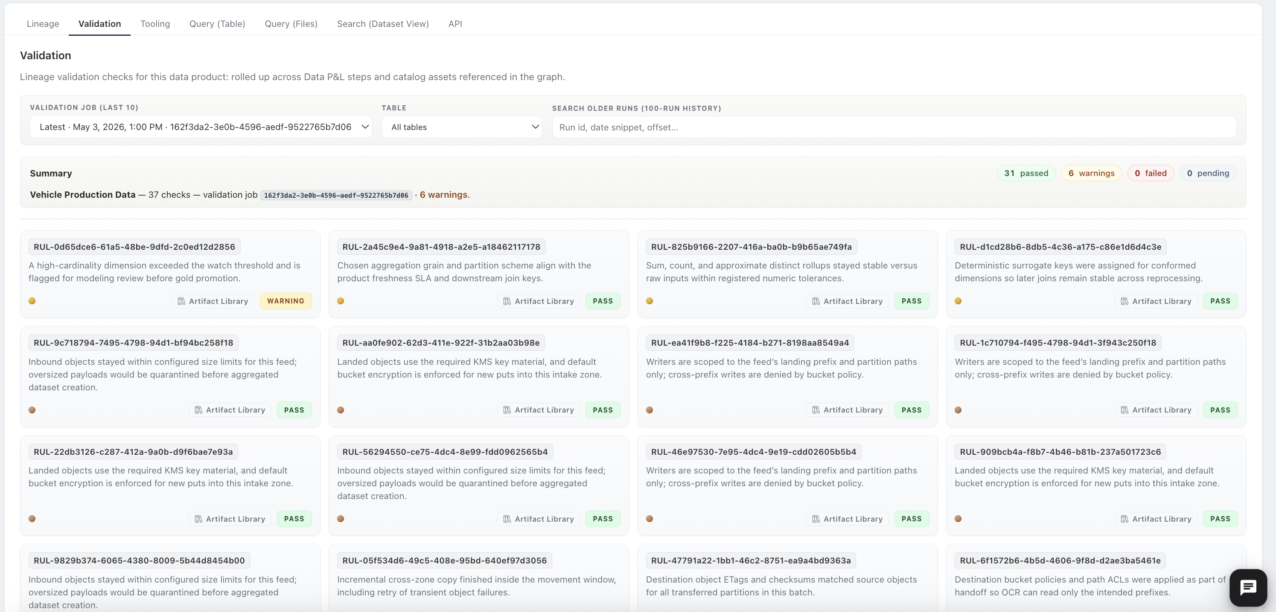
Figure 12 — Validation dashboard for the latest job run.
Validation is generated per run of the product. Users can select from the last ten validation jobs, filter by table, or search a 100-run history by run ID. Each rule card carries its identifier, a plain-language description, a pass/fail/warning status, and a link back to its Artifact Library record.

10. Tooling
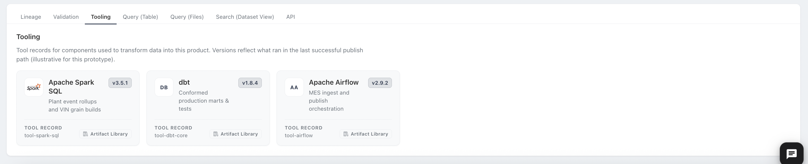
Figure 13 — Tool records for the transform stack.
The Tooling tab lists the components used to transform or analyze data into this product, bound to the versions that ran during production. Each card links to its tool record in the Artifact Library.

11. Query Interfaces

11.1 Query (Table)
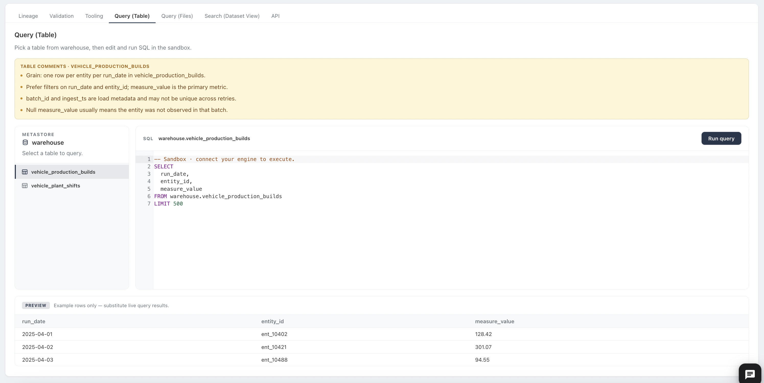
Figure 14 — SQL sandbox over warehouse tables.
Query (Table) lets users pick a table from the product-scoped metastore and edit/run SQL in a sandbox. ETL comments for the table are also shown in this view to communicate to data consumers and query users any decision points the producers want to share. The tables are queryable by anyone with proper access to the data product.

11.2 Query (Files)
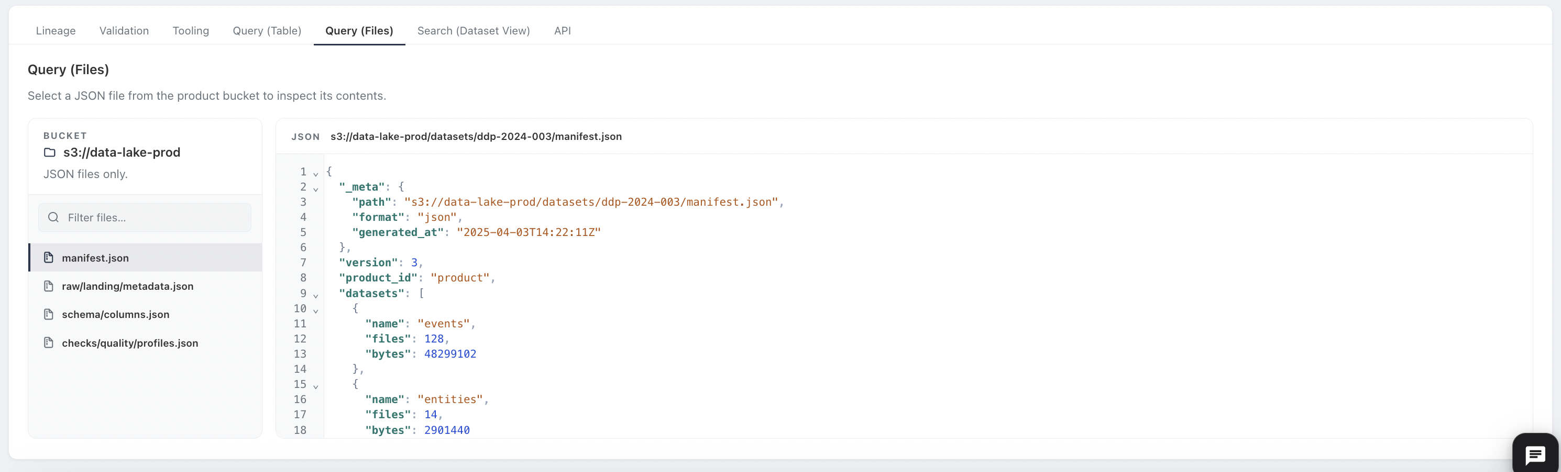
Figure 15 — JSON file inspector over the product bucket.
Query (Files) is designed for products delivered by files. Each of the files is filterable and viewable by anyone with proper access to the data product.

12. Unstructured Search & Chat

12.1 Search (Dataset View)
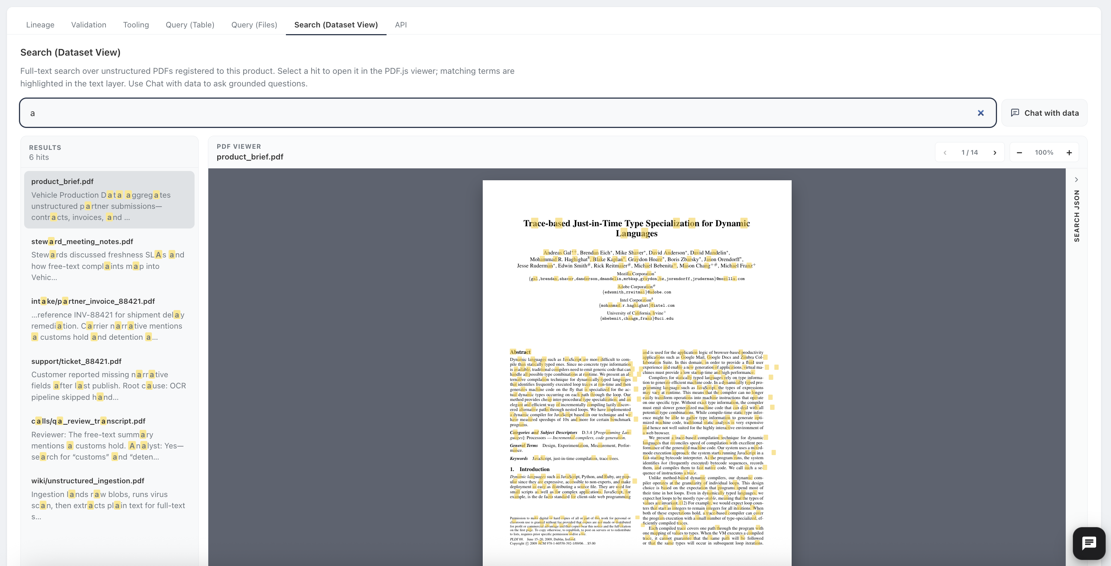
Figure 16 — Full-text search with inline PDF viewer.
The Search tab should only be visible through a dataset record page since its primary focus will be data discovery and not product usage. This feature provides search capabilities from extracted content. Hits are listed with highlighted snippets, and selecting one opens the document in a viewer with matching terms emphasized.

12.2 Chat with Data

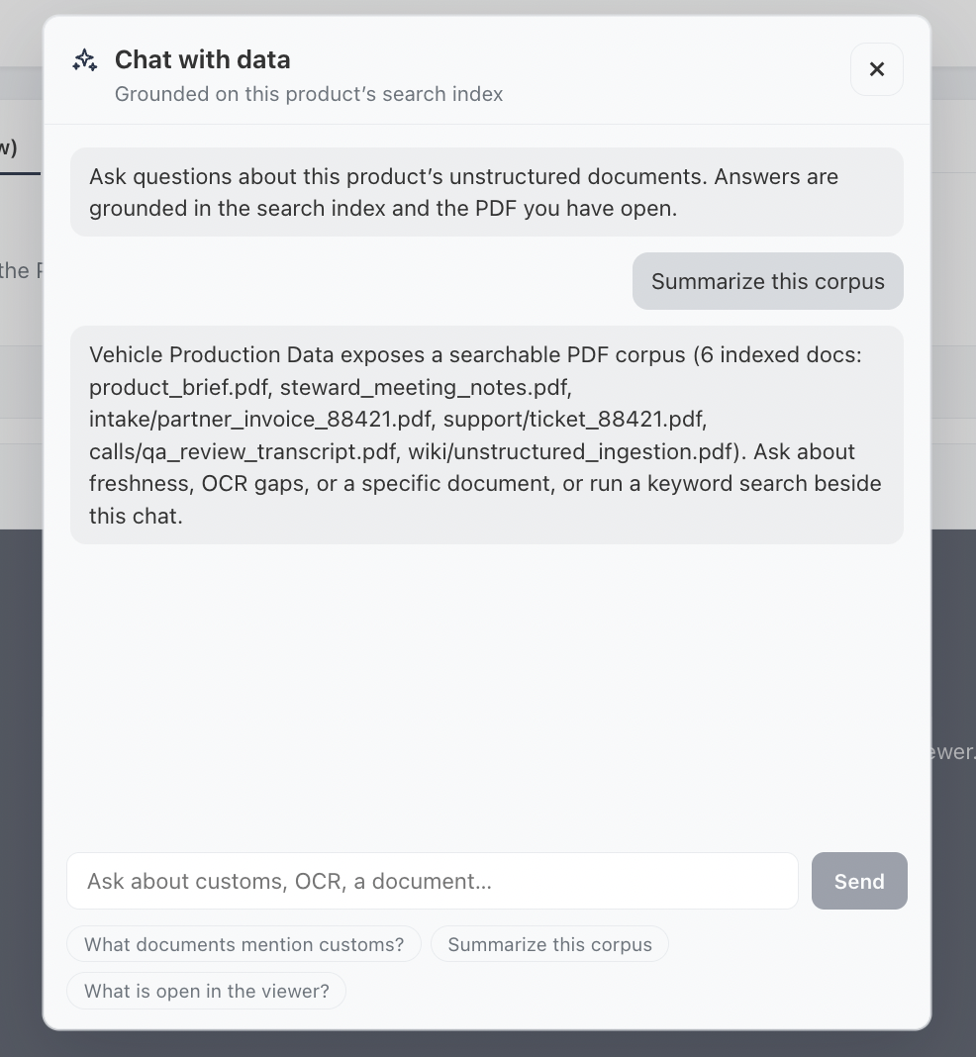
Figure 17 — Grounded chat over the product's search index.
Chat with Data answers questions grounded in the product's search index. This capability is served by the OpenSearch and vector database engines behind FastAPI.

13. Data APIs
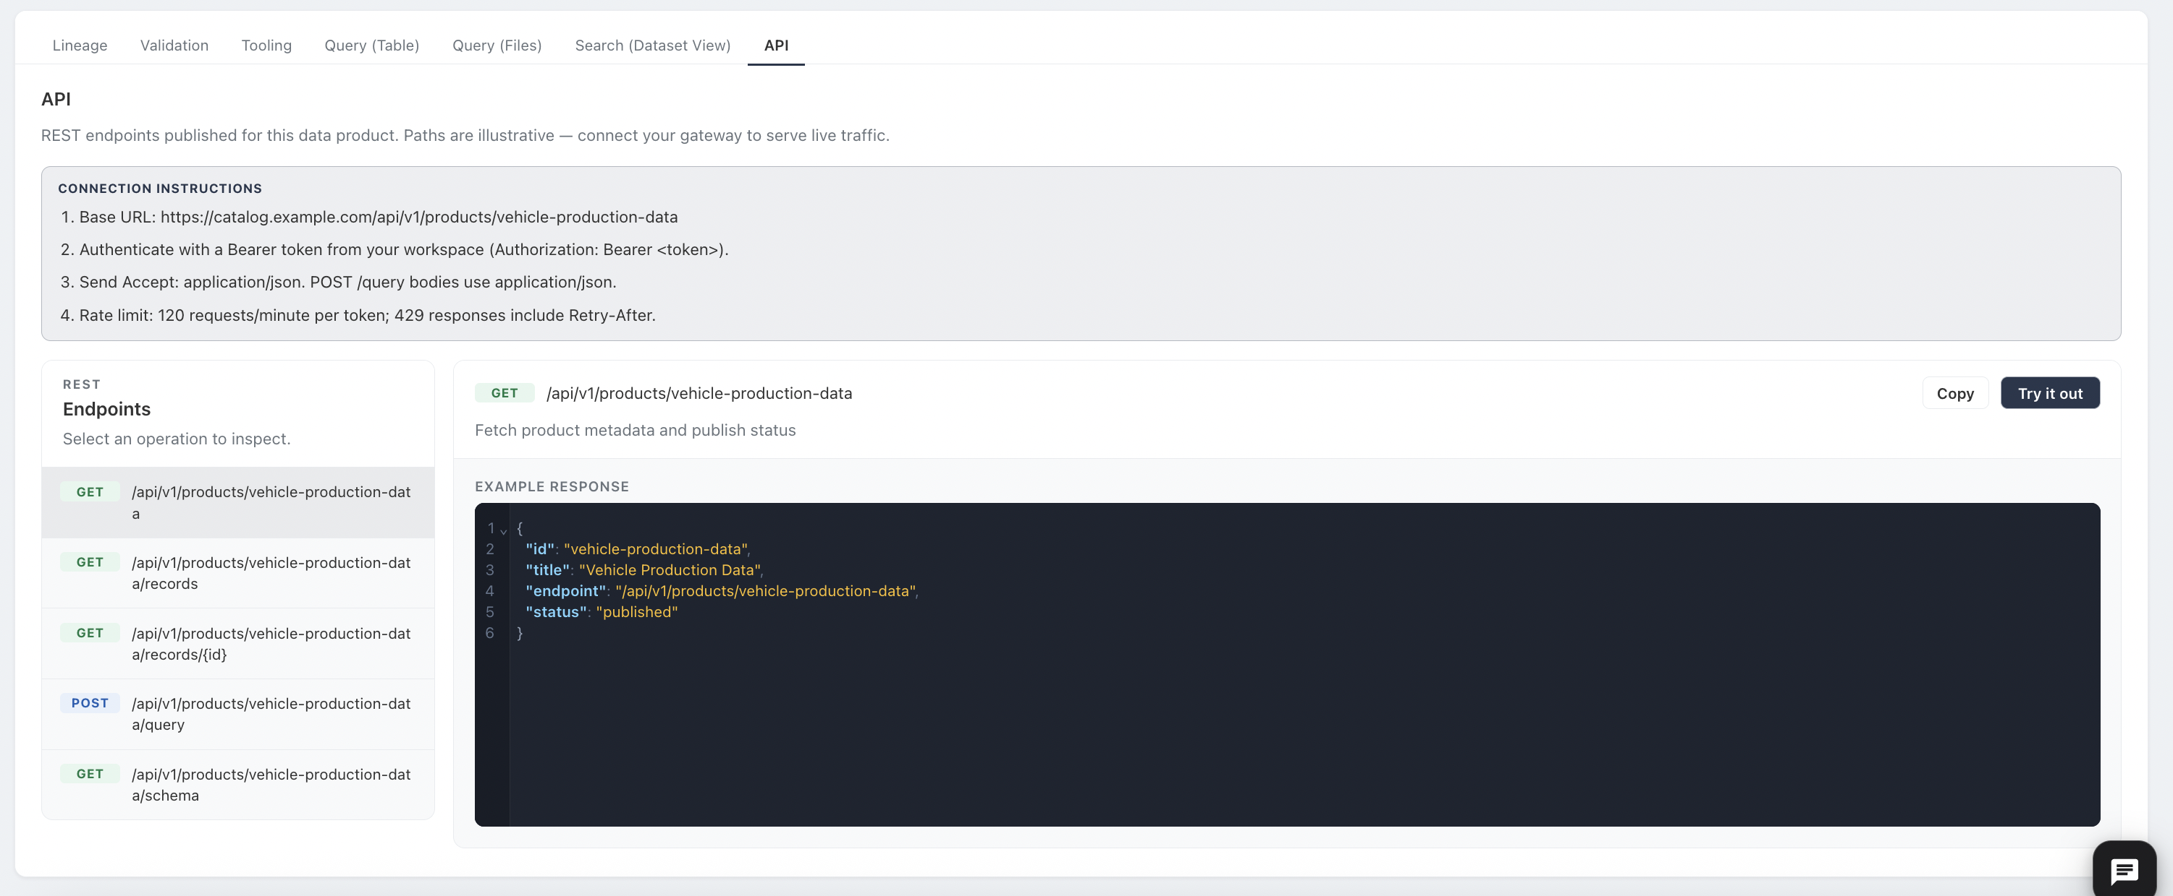
Figure 18 — Published REST endpoints with try-it-out console.
The API tab documents the REST endpoints published for the product. This feature should not be used for big data; it is intended for discovery data products and reference data.

14. Artifact Library
The Artifact Library is the browsable face of the governance-plane registries. A single filterable panel spans data models, tools, rules, agreements, systems, data lakes, identities, and tags, with lifecycle status (Draft, In Review, Published) on every record.

14.1 Rules
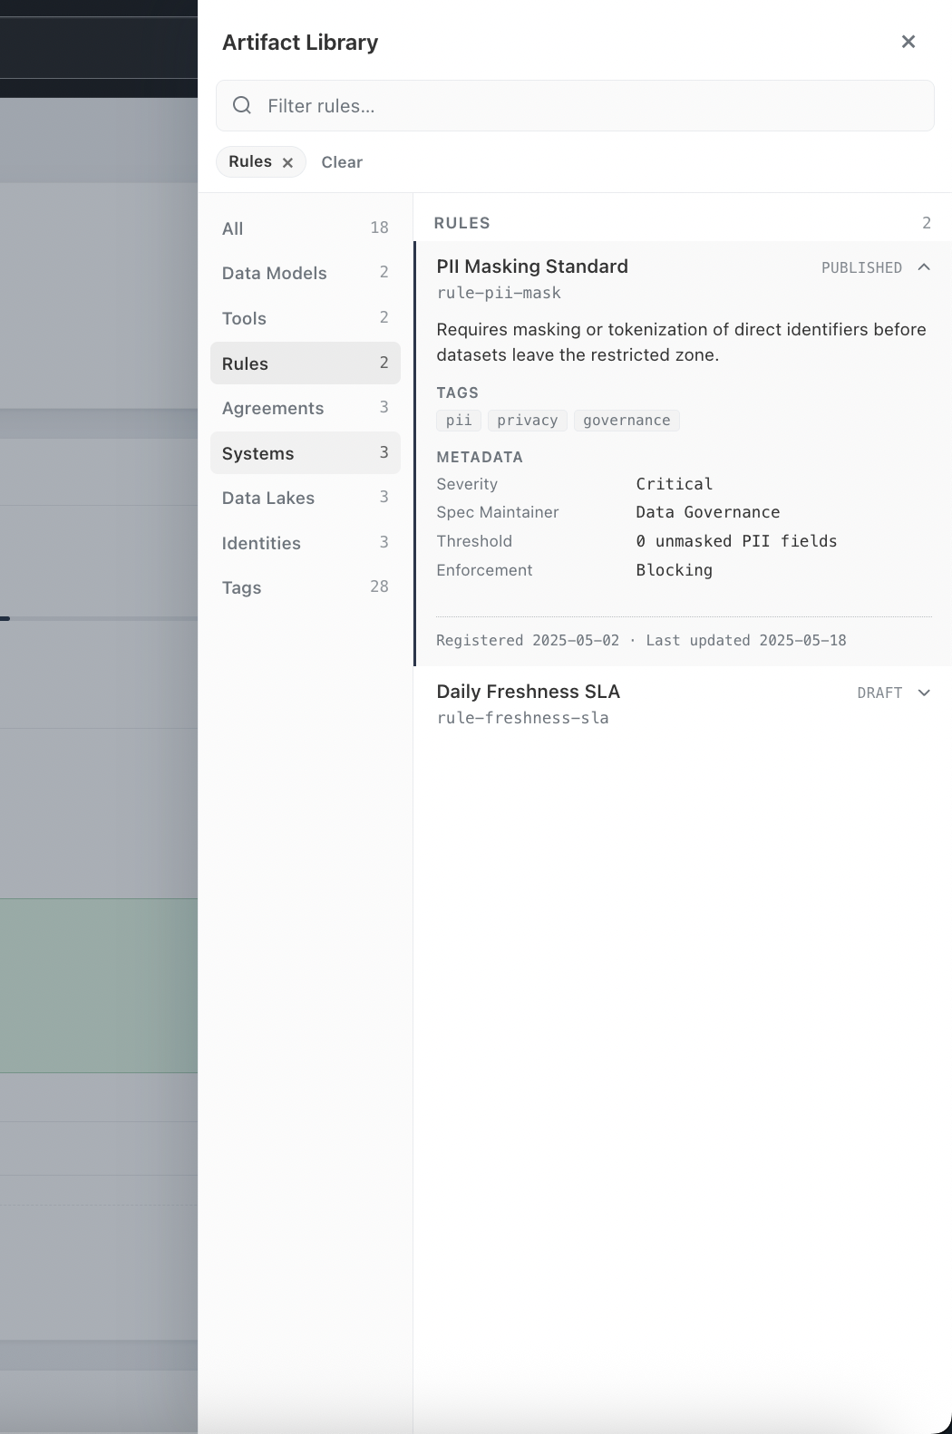
Figure 19 — Quality rule records.
Data quality rules are a type of spec that are used during the data validation process. These rules are usually maintained in tight coupling with the validation tooling. The rules should be pushed to the artifact registry through the CI/CD pipeline of the validator code. Manual forms for rule creation are not preferred, since they quickly fall out of sync with the validators.

14.2 Agreements
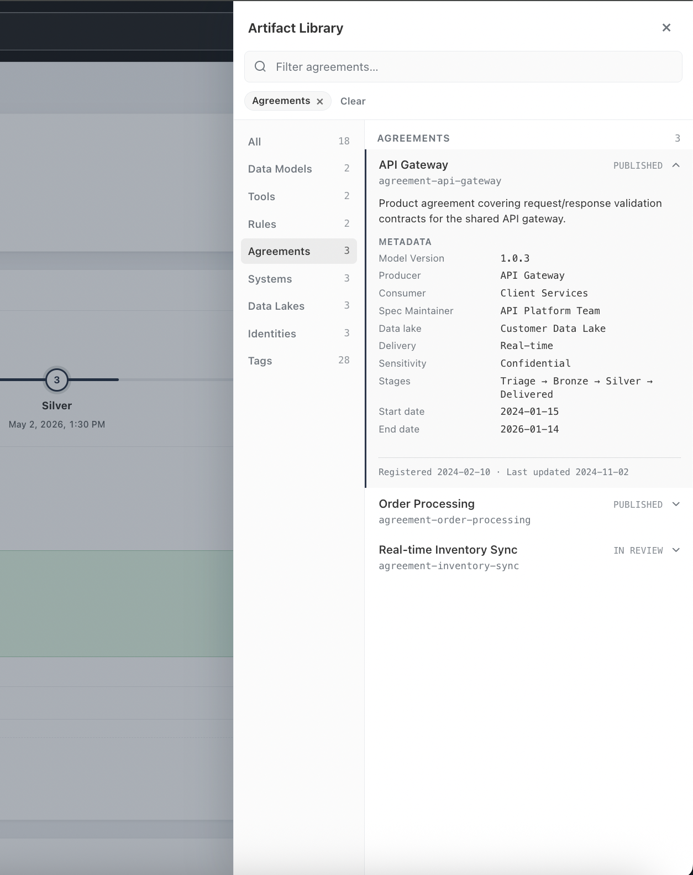
Figure 20 — Product agreement records (data contracts).
Agreement records capture data contracts between producers and consumers. This is a grouping of metadata attributes to provide transparency between the producer and consumer on what is produced and consumed. It’s also dynamic and versioned to help bind metadata fields into product records during runtime.

14.3 Tools
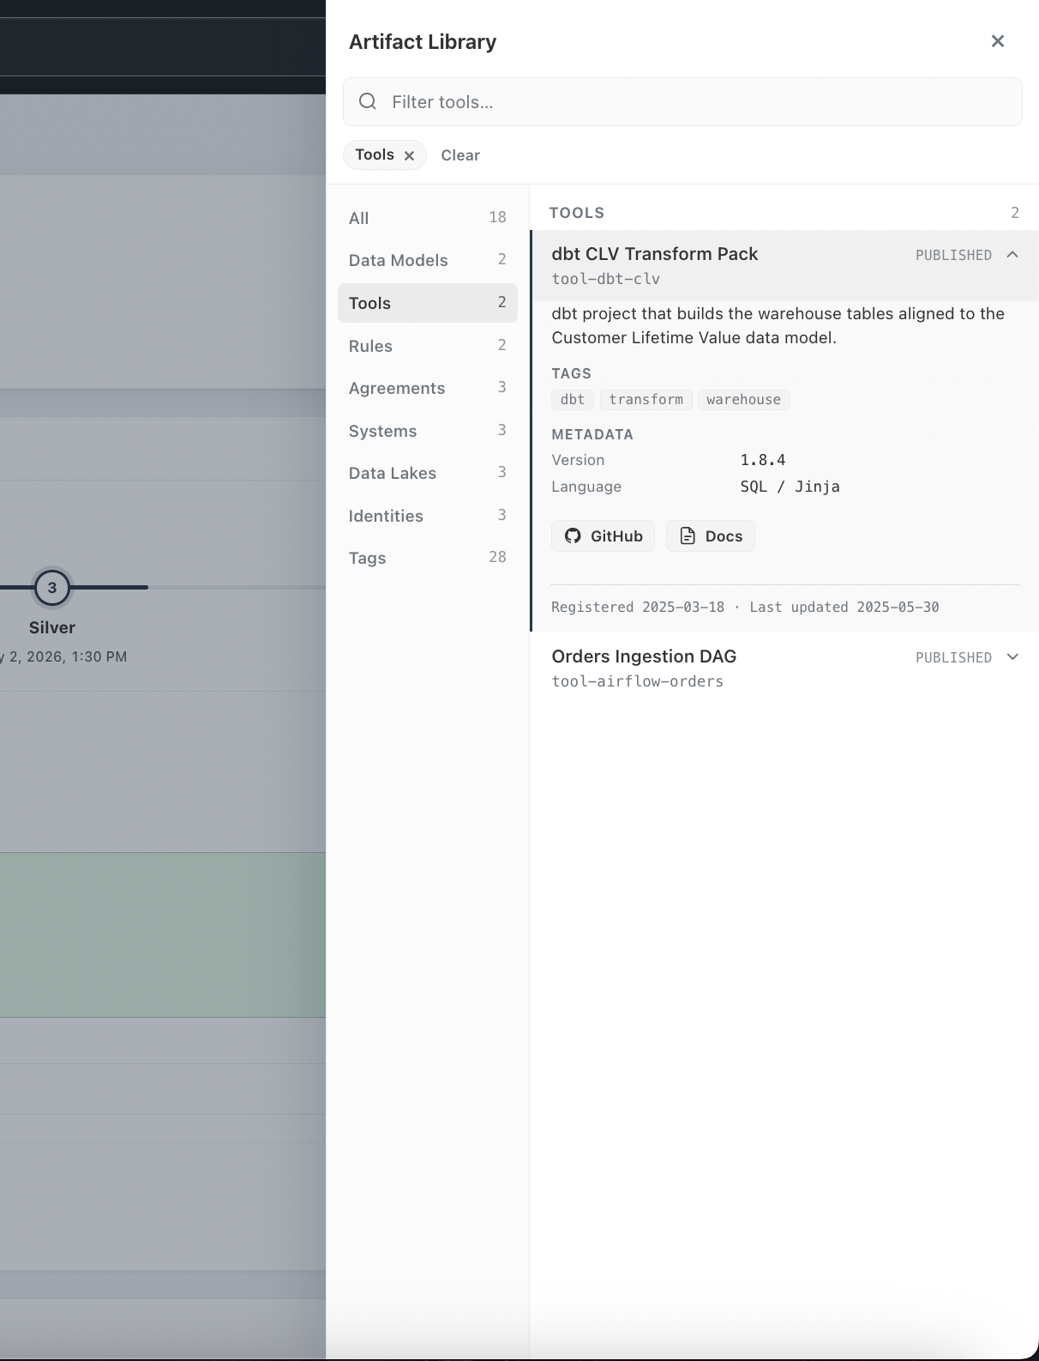
Figure 21 — Tool records with source links.
Tool records document transform and data analytic components with tags, version, and language metadata plus direct links to its GitHub repository and documentation, if available. The tools should also be pushed to the artifact registry through the CI/CD pipeline of the tool code. Manual forms for tool registration are not preferred, since they quickly become stale.

15. Actions Menu
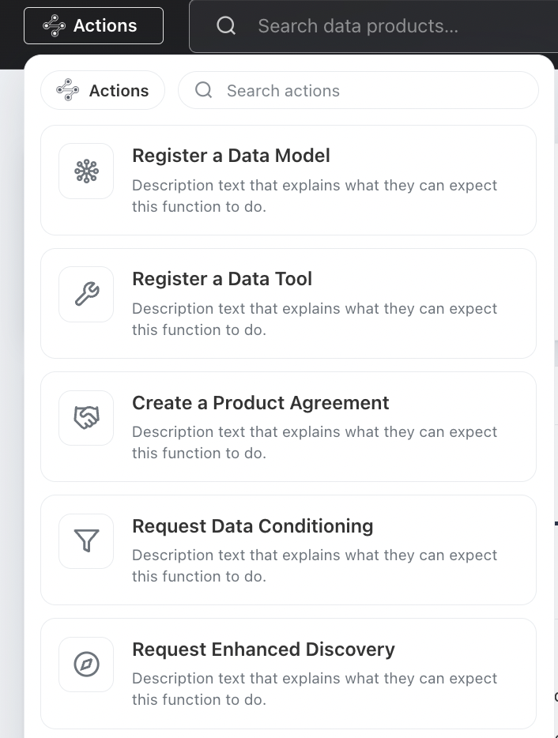
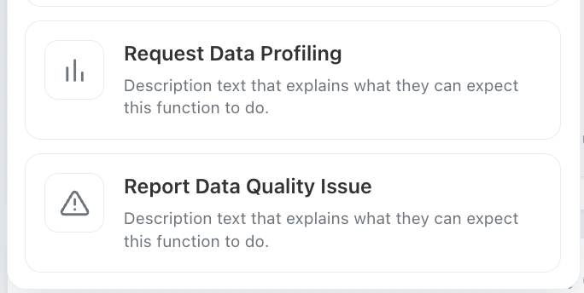
Figure 22 — Actions menu.
The global Actions menu provides searchable, self-service workflows. Actions are gated by data professional roles.

16. Chat Assistant
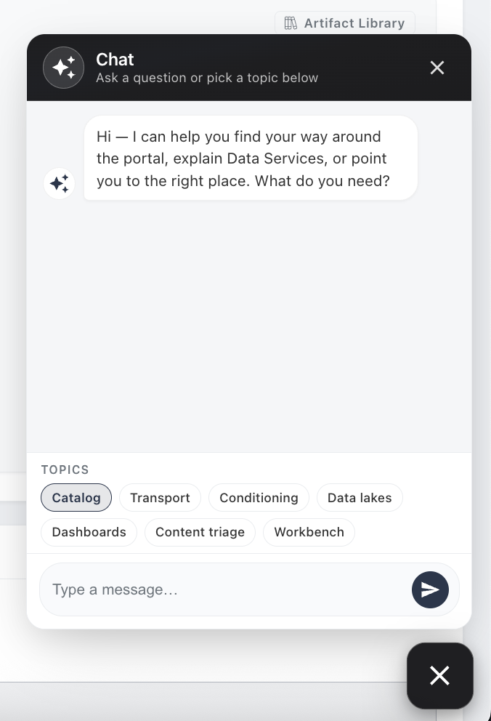
Figure 23 — Portal chat assistant with topic shortcuts.
The Chat Assistant is a floating widget available throughout the portal, launched and dismissed from a persistent button in the corner of every page. It helps users find their way around the portal, explains Data Services, and points them to the right place. Unlike the product-scoped Chat with Data feature (Section 12.2), which answers questions grounded in a single product’s search index, the Chat Assistant is portal-wide and focused on navigation, orientation, and self-service help.

