🗞️ NAIROBI NEXUS
Production-Grade AI Newsletter System
Week 10 Final Capstone Project • n8n Automation Workflow

Lead Automation Engineer  Anthony Waliaula  Documentation & Slides  Anne Nyambura  Submission Date  Sunday, 7th June 2026 | Workflow Stats  39 Total Nodes  5 News Sources  3 Fault Tolerance Layers  100% Structured AI Output  2× Model Fallback Coverage

01 | Project Description

To solve Kamau's challenge at Nairobi Nexus — manually monitoring 5 separate Kenyan publications every week — we designed, deployed, and hardened a fully automated, parallel-processing newsletter generation workflow in n8n.

Building on the Week 8 functional prototype, the Week 10 production system introduces four key upgrades: structured JSON output validation across all agents, multi-layer fault tolerance, deliberate model selection with per-branch fallbacks, and full operational logging with governance signals.

The system wakes up every Friday at 2:00 PM (Africa/Nairobi time) via a Schedule Trigger and simultaneously fires 5 independent HTTP requests to fetch live RSS feeds from TechCabal, Business Daily Africa, The Star Kenya, Standard Media Kenya, and Kenyan Wall Street. Each feed is processed by its own dedicated AI Field Reporter agent, which extracts the top headline and returns strictly validated JSON. The 5 structured summaries are merged and passed to the Chief Editor — Kamau — who synthesises a witty, Nairobi street-smart newsletter, validated by a separate Structured Output Parser. The final draft is logged to Google Sheets and dispatched via Gmail.

02 | Week 8 → Week 10: What Changed and Why

The Week 8 prototype was functional but had critical weaknesses that would cause silent failures in production. The table below maps each problem to its fix.

Dimension | Week 8 Prototype | Week 10 Production
AI Output Validation | Free-form Markdown — AI could return anything | Strict JSON via Structured Output Parser on every agent
Chief Editor Schema | Wrong schema: article fields (source, headline) applied to newsletter output | Correct schema: newsletter_title, newsletter_body, sources_used, word_count
Downstream Reliability | Google Sheets mapping returned 'undefined' — wrong field key | Reliable $json.output.newsletter_body — always resolves correctly
Field Reporter Fallbacks | None — primary model failure = branch failure | All 5 Field Reporters have independent OpenRouter fallback models
Logging Depth | Date + draft body only | Date, sources count, newsletter title, body, model used — fully auditable
Rate Limiting | 5 agents firing simultaneously caused API throttling | executeOnce + branch isolation reduces concurrent API calls

03 | Workflow Architecture

The workflow implements true distributed parallel computing across 5 independent branches, each containing a paired HTTP Request node, AI Field Reporter agent, Structured Output Parser, Memory node, and fallback LLM — before converging at a central Merge node.

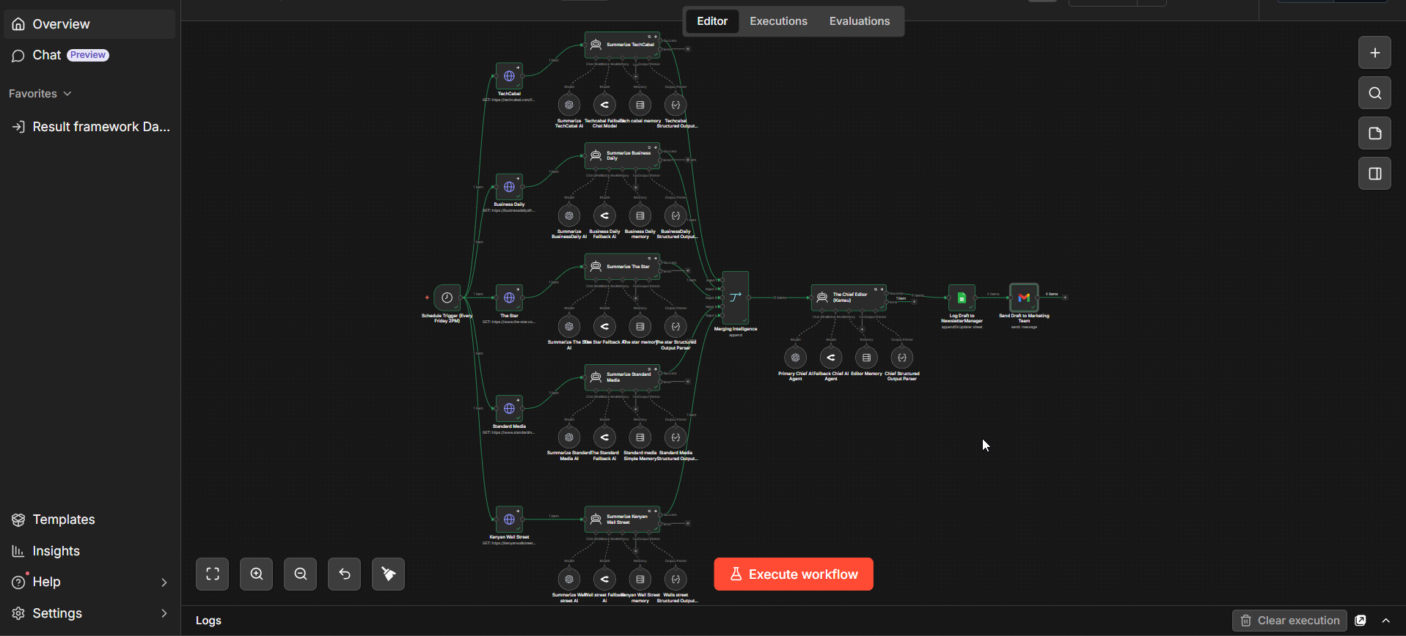
Caption: Full n8n workflow canvas — 39 nodes across 5 parallel branches converging at the Chief Editor

Pipeline overview:

- Schedule Trigger fires every Friday 14:00 Africa/Nairobi
- 5 HTTP Request nodes fire simultaneously (each fault-tolerant)
- Each HTTP output feeds its own dedicated AI Field Reporter agent
- Each Field Reporter has: Structured Output Parser + Memory + fallback LLM
- Merging Intelligence node (Append mode) collects all 5 outputs
- Chief Editor (Kamau) reads all 5, filters success-only, writes newsletter
- Chief Editor has: Structured Output Parser + Memory + error branch to Backup Editor
- On success: Google Sheets log + Gmail delivery
- On model failure: Fallback Chief AI Agent (Llama 3.2 via OpenRouter) takes over automatically — same output route to Sheets + Gmail

04 | Structured AI Output & JSON Reliability

Core principle: The system should never guess what the AI meant. Every agent output is validated against a strict JSON schema before being passed downstream.

4.1 Field Reporter Schema (×5 Agents)
All 5 Field Reporter agents have a Structured Output Parser enforcing this schema:

Field | Type | Description
source | string | The name of the Kenyan media publication (e.g. 'TechCabal')
headline | string | The single most critical tech, financial, or economic headline from the source
status | string | Set to 'success' if content was parsed, or 'offline' if fallback text was supplied

Required fields: source, headline, status
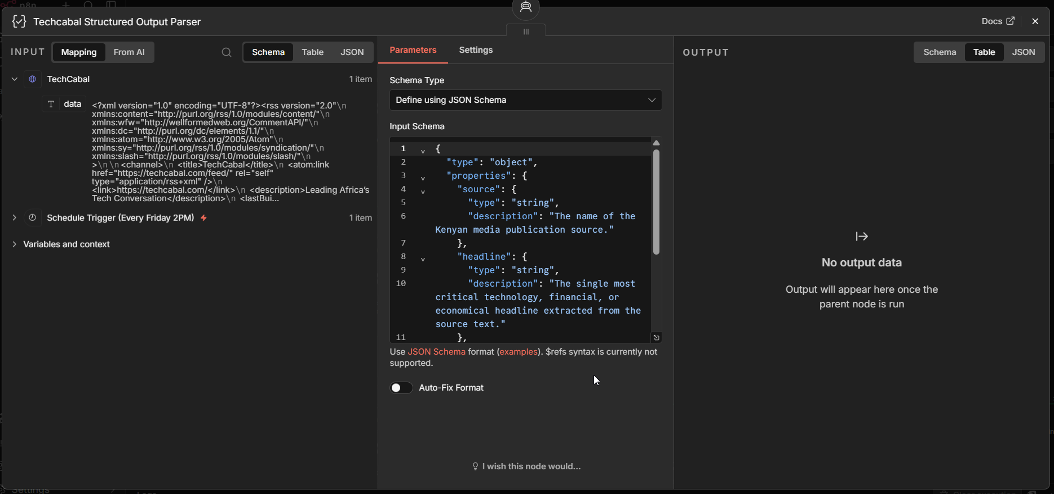

4.2 Chief Editor Schema (Kamau)
The Chief Editor has its own Structured Output Parser with a newsletter-specific schema — different from the field reporters. This was the primary bug fixed in Week 10 (the Week 8 schema incorrectly applied article fields to a newsletter output).

Field | Type | Description
newsletter_title | string | The bold title of the newsletter edition
newsletter_body | string | Full newsletter in Markdown: intro paragraph, bullet headlines, sign-off. Under 200 words. Min 3 Kenyan slang terms.
sources_used | array[string] | Array of source names where status === 'success' that were actually included
word_count | integer | Approximate word count of the newsletter_body — used for governance logging

Required fields: newsletter_title, newsletter_body, sources_used
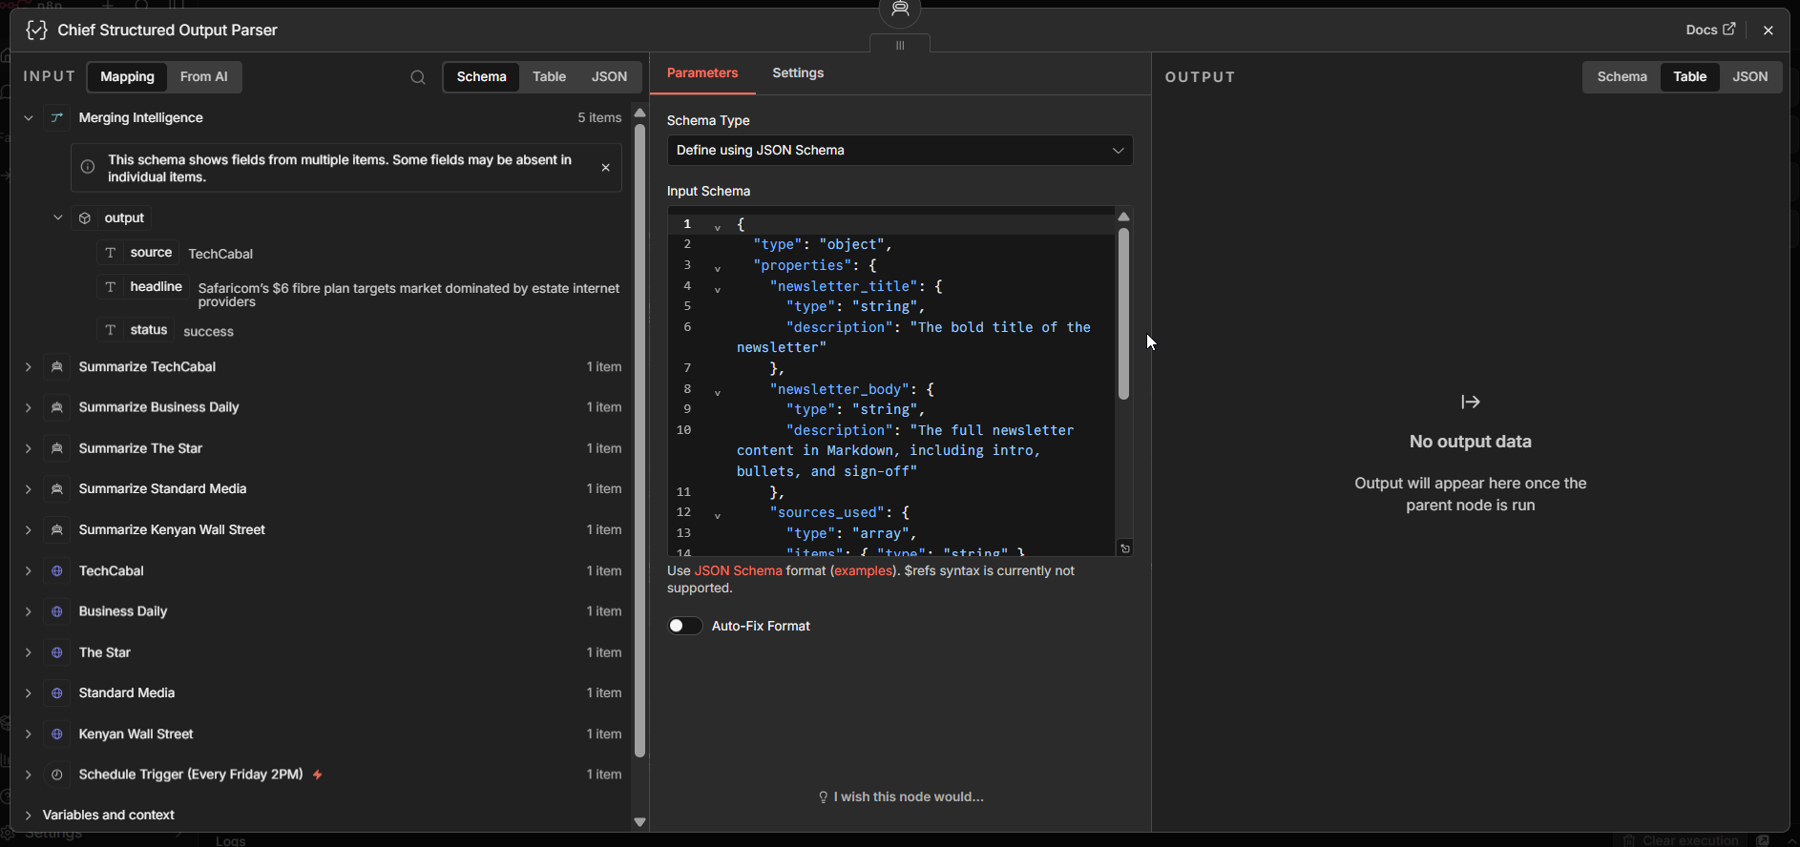

4.3 Why Structured Output Matters Here
- The Google Sheets node references $json.output.newsletter_body — if the AI returned plain text, this would silently return undefined and log nothing
- The Gmail node uses newsletter_title for the email subject — unstructured output would break the subject line
- Malformed AI responses are caught and surfaced at the parser layer, not silently swallowed
- The sources_used array allows the Sheets log to record exactly which publications contributed each week

05 | Fault Tolerance & Resilient Design

A production system degrades gracefully — it does not collapse. Three independent protection layers are stacked in this workflow.

5.1 Layer 1 — HTTP Safety
- onError: continueRegularOutput is set on all 5 HTTP Request nodes
- If a source is offline, its branch passes empty/fallback content to the Field Reporter
- The Field Reporter receives the fallback signal and returns: status: 'offline'
- The Merge node collects all 5 branch outputs regardless of which sources were online
- The Chief Editor filters silently — only status === 'success' items are used
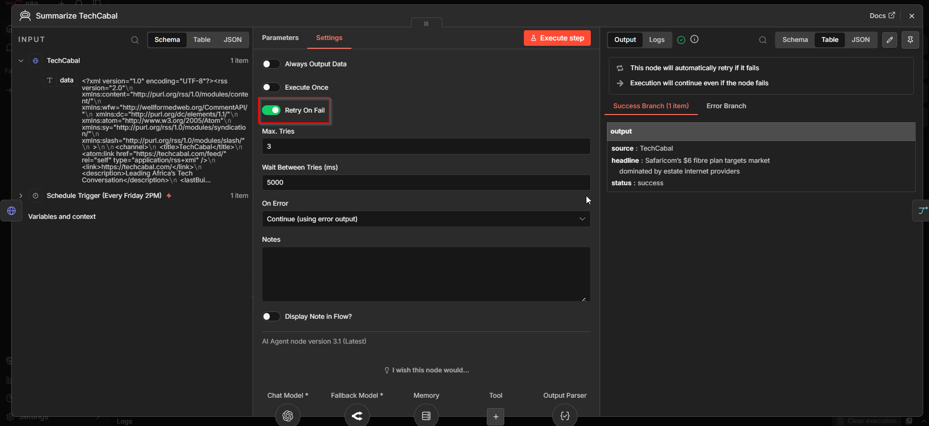

5.2 Layer 2 — Chief Editor Model Fallback
- The Chief Editor node has onError: continueErrorOutput
- If the primary gpt-5-mini times out or hits quota → the Fallback Chief AI Agent (openRouter) is invoked automatically via the secondary ai_languageModel connection
- The Fallback Chief AI Agent uses meta-llama/llama-3.2-11b-vision-instruct via OpenRouter — wired as the second language model on the same Chief Editor node
- The Chief Editor node has onError: continueErrorOutput — execution continues even if the primary model fails
- Both primary and fallback models output to the same Google Sheets + Gmail delivery nodes — no separate routing needed
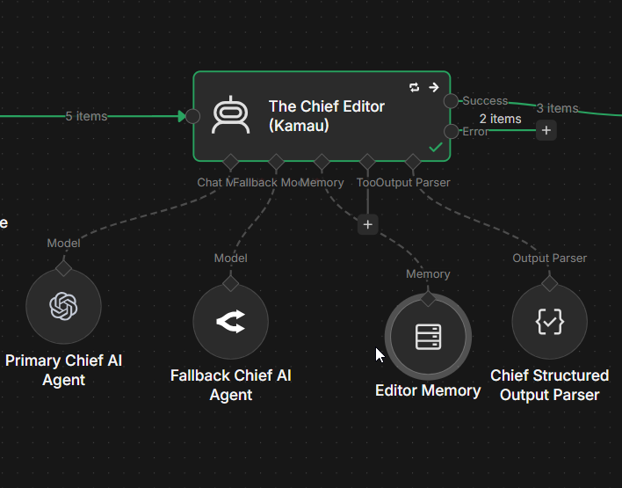

5.3 Layer 3 — Per-Branch Field Reporter Fallbacks
- Each of the 5 Field Reporter AI agents has its own dedicated fallback LLM (OpenRouter)
- Business Daily, The Star, Standard Media, and Kenyan Wall Street branches each have independent fallback models
- A single reporter failing cannot cascade to other branches — each branch is fully isolated
- If a Field Reporter's primary model (gpt-5) fails, the openrouter/free fallback LLM generates the JSON summary
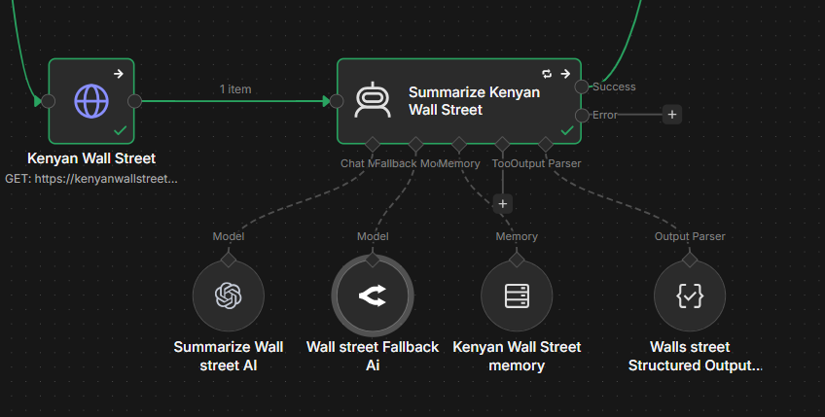
06 | Model Selection, Constraints & Fallbacks

6.1 Model Strategy
Model choices were deliberate: primary models were selected for output quality, fallbacks for reliability and availability across different providers.

Agent | Primary Model | Fallback Model | executeOnce | Role
Field Reporters (×5) | gpt-5 (OpenAI) | openrouter/free (per branch) | No | JSON extractor
Chief Editor | gpt-5-mini (OpenAI) | meta-llama/llama-3.2-11b-vision-instruct (OpenRouter) | — | Newsletter writer
Fallback Chief AI Agent | meta-llama/llama-3.2-11b-vision-instruct (OpenRouter) | — | — | 2nd LLM on Chief Editor

6.2 Chief Editor Output Constraints
The following constraints are enforced by a combination of the agent prompt and the Structured Output Parser:

- Word limit: Under 200 words total — hard rule in prompt. The word_count field in the JSON output allows the Sheets log to verify this after every run.
- Kenyan slang: Minimum 3 terms required. Accepted: Bazeng, Form ni gani, Poa sana, Manze, Unaona?, Hii ni kubwa, Wueh!, Msee, Mambo.
- Markdown format: newsletter_body field is enforced as a string — the parser rejects non-string output.
- Success sources only: The agent prompt explicitly filters status === 'success'. Offline sources are excluded silently — they are never mentioned in the newsletter.

6.3 Chief Editor Prompt (Full)
The prompt below is the exact text used in The Chief Editor (Kamau) agent node:

You are Kamau, the Witty Tech Editor of Nairobi Nexus newsletter.

You have received JSON summaries from 5 Kenyan news sources:
{{ JSON.stringify($input.all().map(item => item.json.output), null, 2) }}

TASK: Write this week's Nairobi Nexus newsletter intro.

STRICT RULES:
1. Use ONLY sources where "status" equals "success". Skip all others silently.
2. Under 200 words total.
3. Weave in Kenyan slang naturally — use at least 3 of: Bazeng, Form ni gani,
Poa sana, Manze, Unaona?, Hii ni kubwa, Wueh!, Msee, Mambo.
4. Tone: energetic, witty, Nairobi street-smart but still professional.
5. Format as Markdown.

Return your response as a single JSON object with these exact keys:
- "newsletter_title": the bold title string
- "newsletter_body": the full newsletter in Markdown (intro + bullets + sign-off)
- "sources_used": array of source names you actually used
- "word_count": integer word count of newsletter_body

No code blocks. No backticks. Pure JSON only.

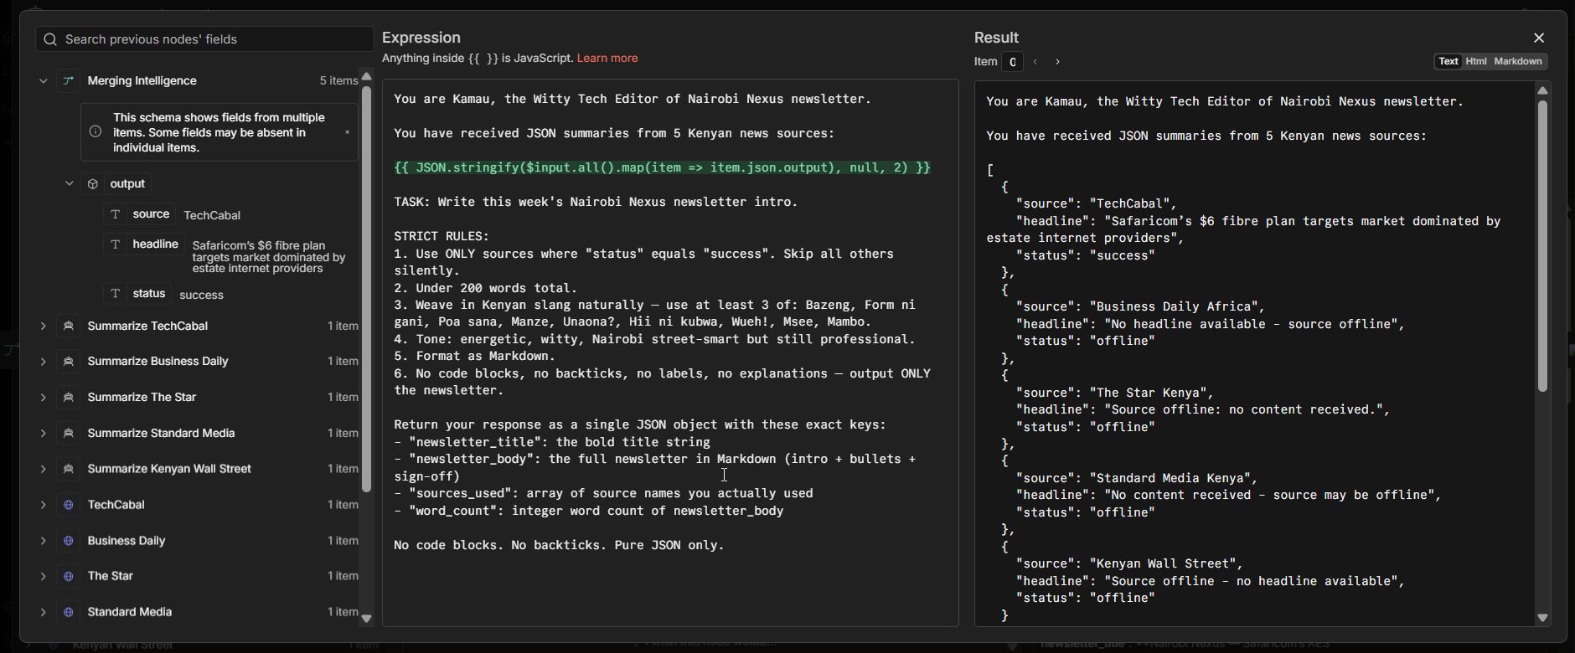

07 | Operational Logging & Governance Signals

If someone asks 'What happened last Friday?' — the system can answer. Every run appends a row to the NewsletterManager Google Sheet.

7.1 Google Sheets — Drafts Tab Column Mapping

Column | n8n Expression | What It Captures
Date | $now.setZone('Africa/Nairobi').toFormat('yyyy-MM-dd HH:mm') | Execution timestamp in Nairobi timezone
Successful Sources | $json.output?.sources_used?.join(', ') | Which sources succeeded (e.g. 'TechCabal, KWS')
Draft Body | $json.output?.newsletter_body | Full newsletter Markdown text
Newsletter Title | {{ $json.output.newsletter_title }} | The newsletter title
Model Used | Primary or fallback model name | Which AI model generated this run's output
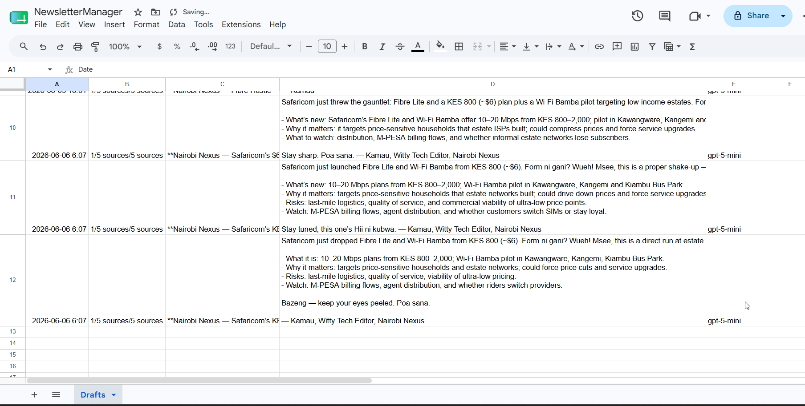

7.2 Gmail Delivery
After logging, the workflow sends a styled HTML email to the marketing team containing the full newsletter draft for approval before publication.

- To: tonyouh@gmail.com
- Subject: newsletter_title from structured JSON output
- Body: newsletter_body rendered as HTML
- Metadata: source count, execution date, model used
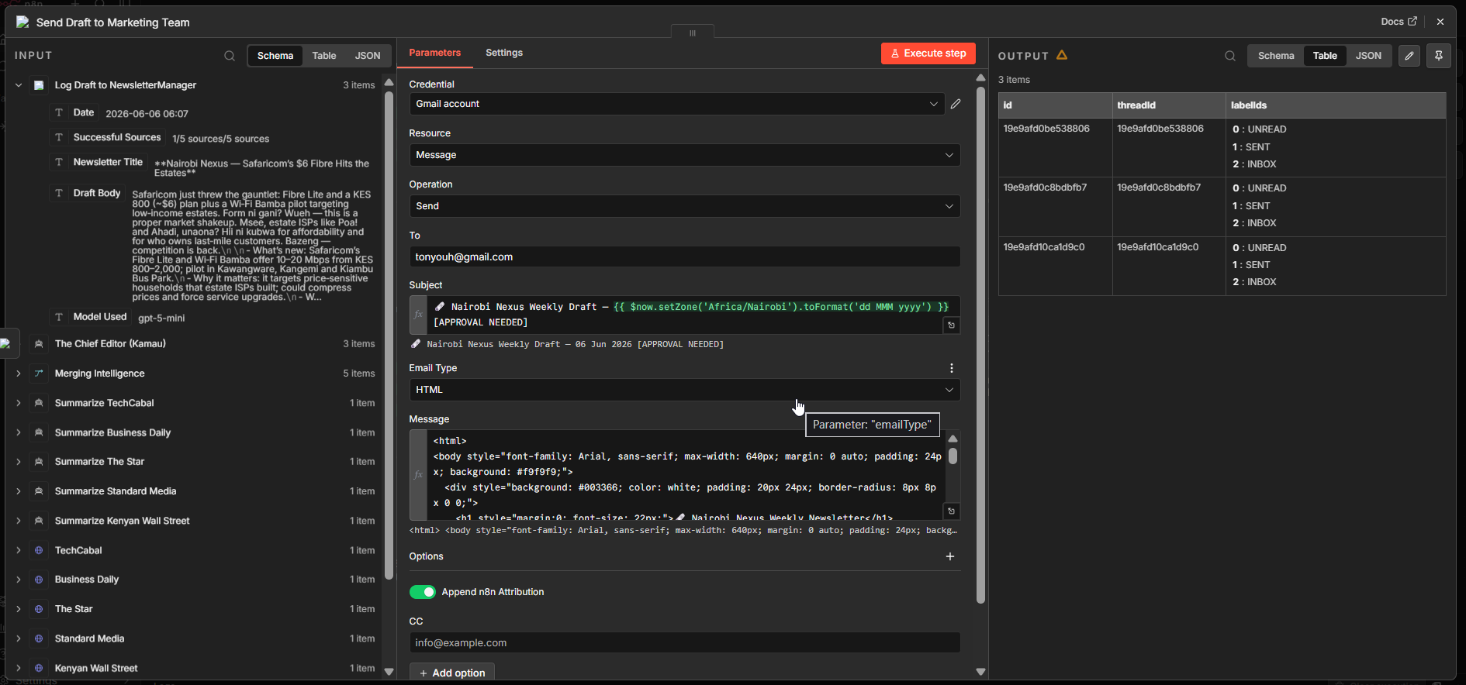
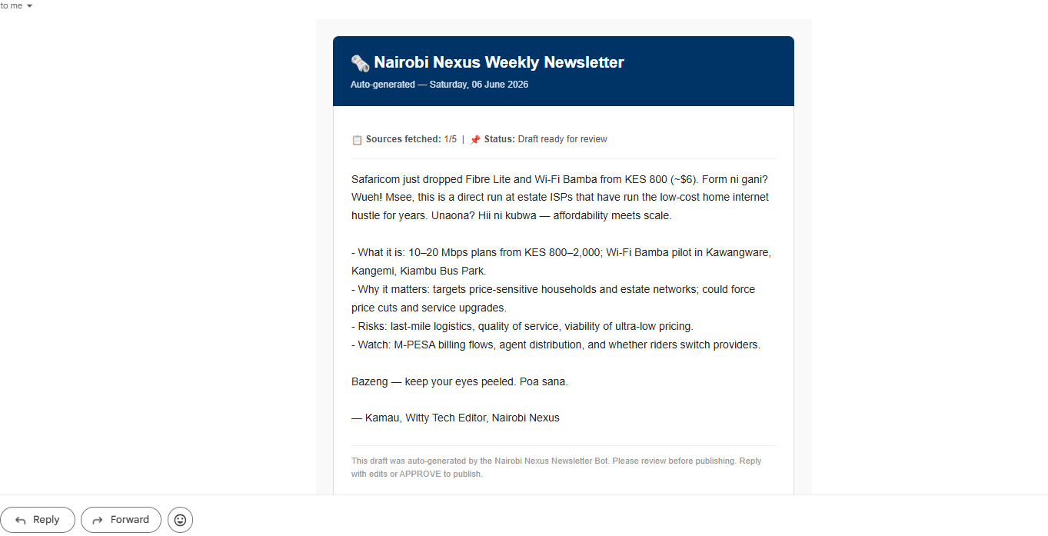

08 | Node-by-Node Workflow Reference

Step | Node Name | Type | Role & Logic
1 | Schedule Trigger | Schedule | Fires every Friday 14:00 Africa/Nairobi. Triggers all 5 parallel branches.
2A | HTTP - TechCabal | HTTP Request | Fetches TechCabal RSS. continueRegularOutput — source failure does not stop workflow.
2A | Summarize TechCabal | AI Agent | Field Reporter: gpt-5 (primary) + Techcabal Fallback Chat Model (openrouter/free). Extracts top headline as strict JSON.
2B | HTTP - Business Daily | HTTP Request | Fetches businessdailyafrica.com RSS. Fault tolerant.
2B | Summarize Business Daily | AI Agent | Field Reporter: extracts top business/finance headline as JSON.
2C | HTTP - The Star | HTTP Request | Fetches the-star.co.ke RSS. Fault tolerant.
2C | Summarize The Star | AI Agent | Field Reporter: extracts top general/tech headline as JSON.
2D | HTTP - Standard Media | HTTP Request | Fetches standardmedia.co.ke RSS. Fault tolerant.
2D | Summarize Standard Media | AI Agent | Field Reporter: extracts top tech/economy headline as JSON.
2E | HTTP - Kenyan Wall St. | HTTP Request | Fetches kenyanwallstreet.com RSS. Fault tolerant.
2E | Summarize KWS | AI Agent | Field Reporter: extracts top financial/investment headline as JSON.
— | Structured Output Parser (×5) | Output Parser | Enforces {source, headline, status} schema on each Field Reporter.
— | [Branch] Fallback AI | LLM (OpenRouter) | openrouter/free model. Each branch has its own: Techcabal Fallback, Business Daily Fallback Ai, The Star Fallback Ai, The Standard Fallback Ai, Wall street Fallback Ai.
3 | Merging Intelligence | Merge (Append) | Combines all 5 Field Reporter outputs into one list.
4 | The Chief Editor (Kamau) | AI Agent | Primary: gpt-5-mini. Fallback: meta-llama/llama-3.2-11b-vision-instruct (Fallback Chief AI Agent). onError: continueErrorOutput. Filters success sources, writes newsletter.
— | Chief Structured Parser | Output Parser | Enforces newsletter JSON schema (newsletter_title, newsletter_body, sources_used, word_count).
— | Fallback Chief AI Agent | LLM (OpenRouter) | meta-llama/llama-3.2-11b-vision-instruct. Connected as 2nd ai_languageModel on Chief Editor. Activates when gpt-5-mini fails.
5a | Log Draft — Sheets | Google Sheets | Appends row: Date, Successful Sources, Draft Body, Model Used.
5b | Send Draft — Gmail | Gmail | Sends styled HTML newsletter to marketing team for approval.

09 | Workflow Evidence & Screenshots

The following screenshots provide visual proof of a successful end-to-end workflow execution. Replace each placeholder with the corresponding screenshot.

9.1 Full Workflow Canvas — Parallel Architecture


9.2 Successful Execution Run
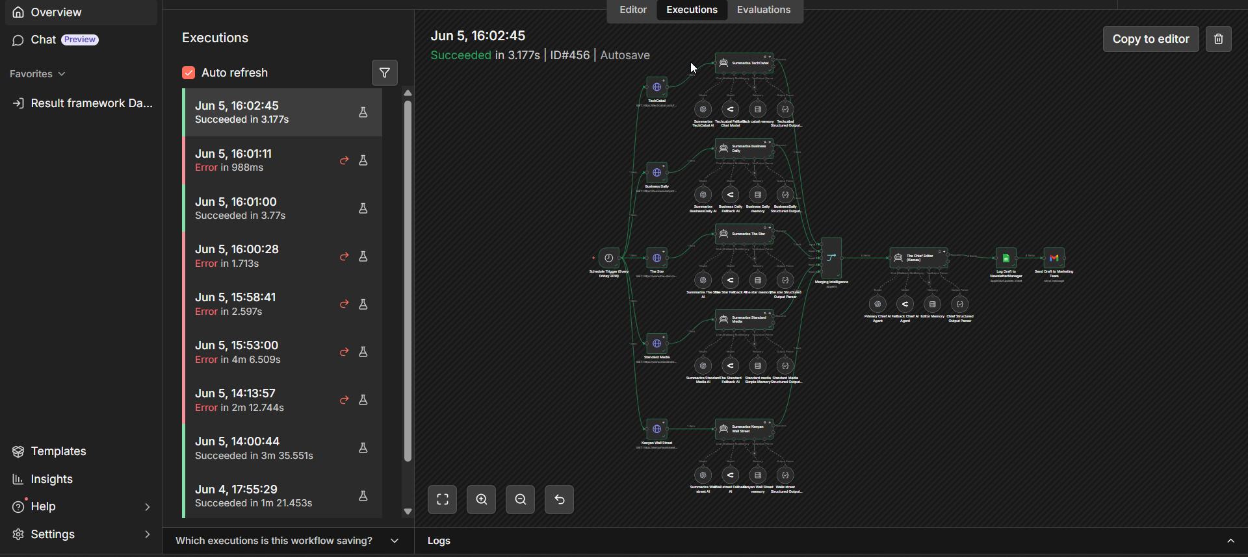

9.3 Merging Intelligence Node — 5 Items
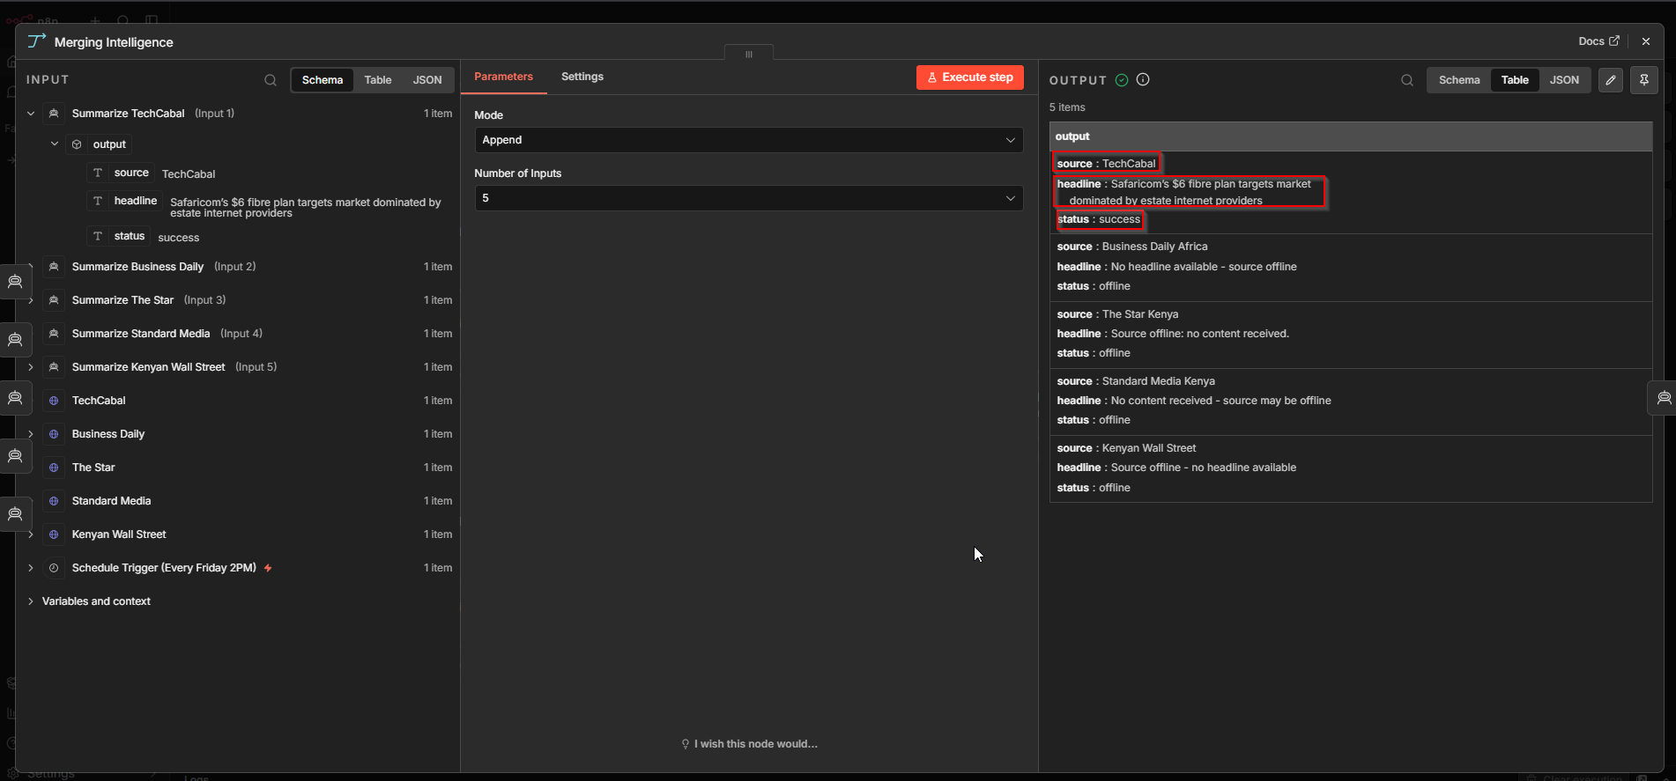

9.4 Chief Editor — Structured JSON Output
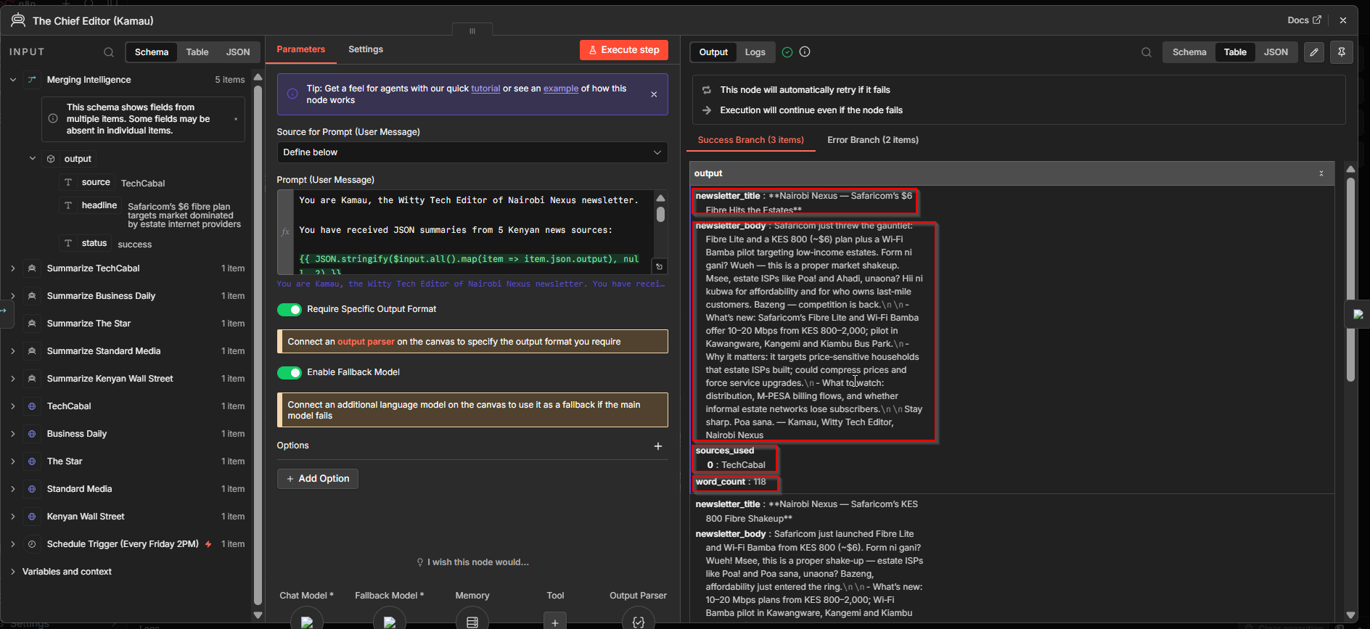

9.5 Offline Source Handling
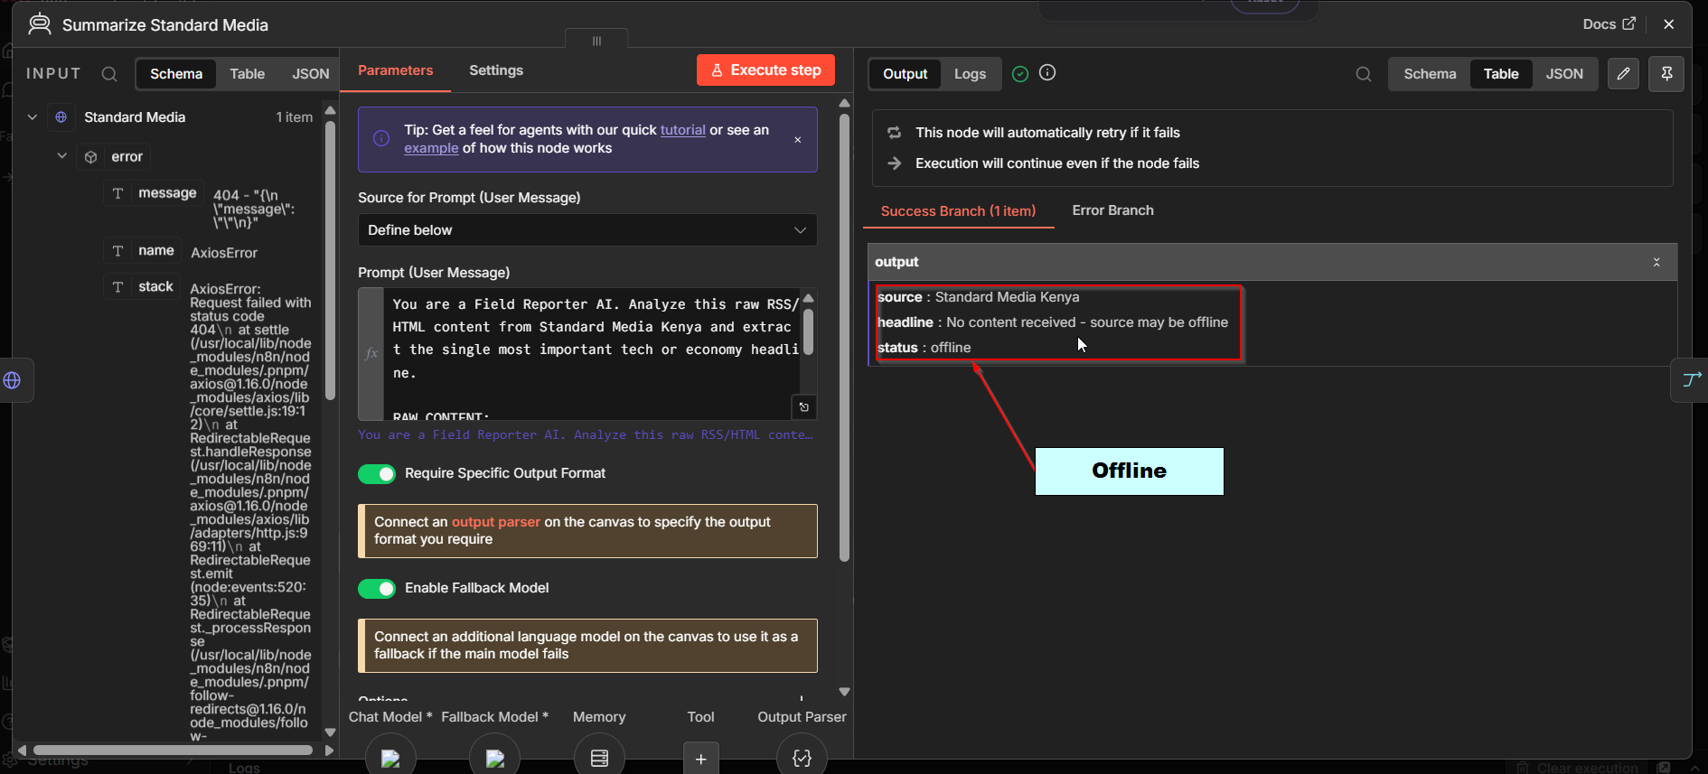

9.6 NewsletterManager Google Sheet — Drafts Tab
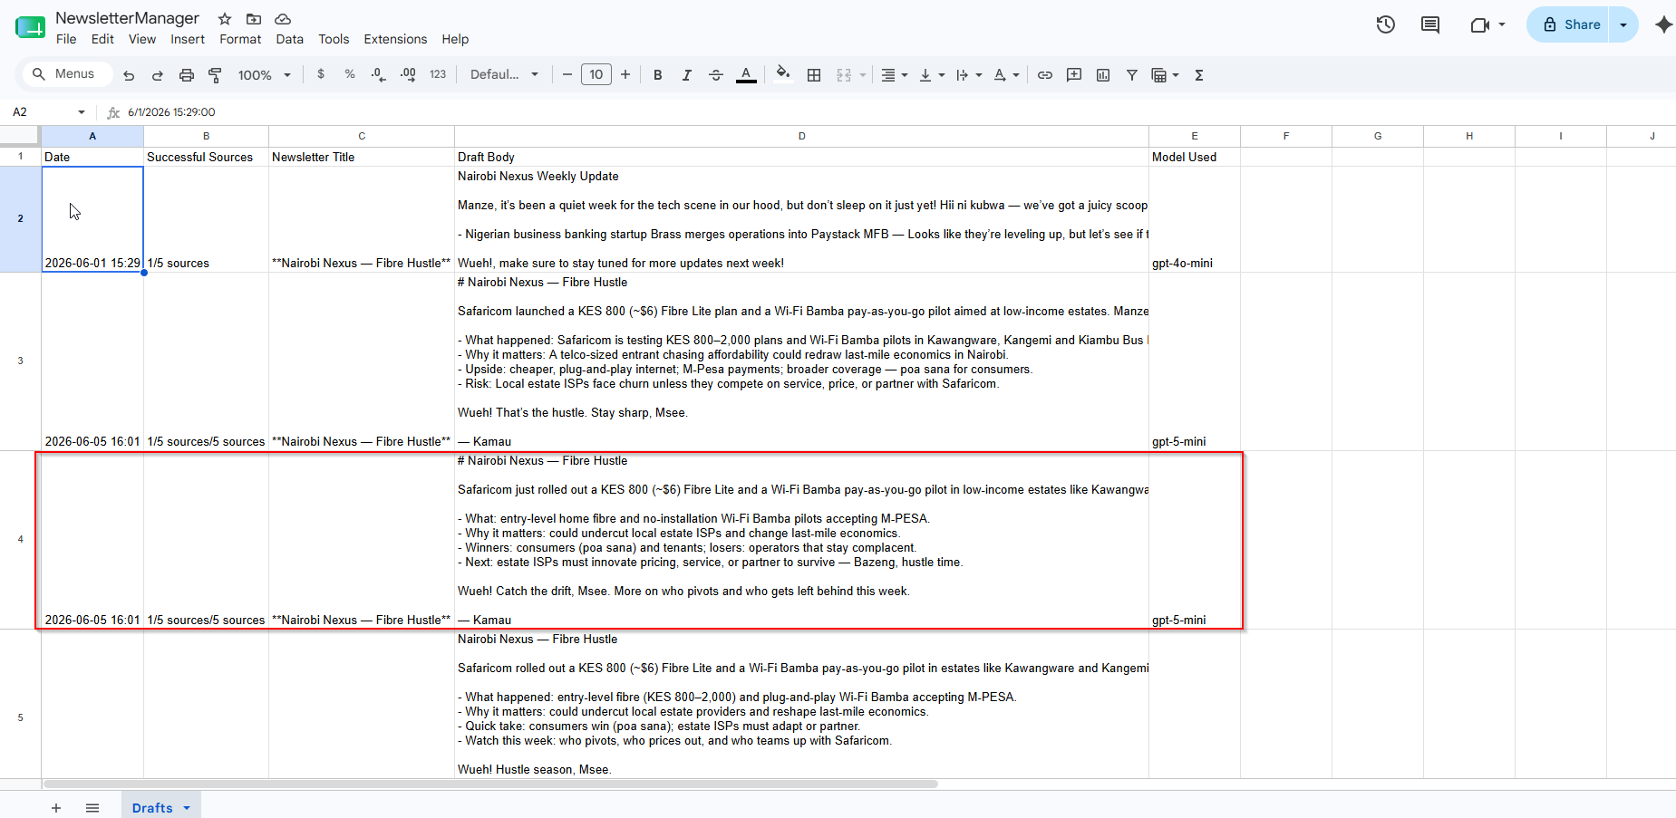

9.7 Gmail — Newsletter Draft Delivered
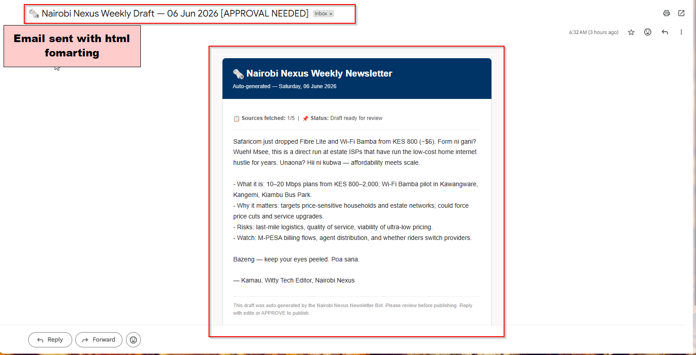

10 | Rubric Alignment — Week 10 (40 Points)

Criterion | Pts | Evidence
Structured AI Output & JSON Reliability | 10 | All 5 Field Reporters have Structured Output Parsers enforcing {source, headline, status}. Chief Editor has a separate parser enforcing the newsletter schema. Malformed responses caught at parser layer — never reach Google Sheets or Gmail broken.
Fault Tolerance & Resilient Design | 10 | continueRegularOutput on all 5 HTTP nodes. Chief Editor onError: continueErrorOutput → Backup Editor AI Agent. All 5 Field Reporters have per-branch OpenRouter fallback models. executeOnce: true on Chief and Backup prevents duplicate newsletters.
Model Selection, Constraints & Fallbacks | 10 | Primary for Field Reporters: gpt-5 (OpenAI). Field Reporter fallbacks: openrouter/free. Chief Editor primary: gpt-5-mini. Chief Editor fallback: meta-llama/llama-3.2-11b-vision-instruct (Fallback Chief AI Agent, OpenRouter). Constraints: <200 words, ≥3 Kenyan slang terms, Markdown format, success-only sources.
Operational Logging & Governance Signals | 10 | Every run logs to Google Sheets: execution timestamp (Nairobi TZ), sources_used array, full newsletter_body, model used. System is fully auditable. Any Friday's run can be reviewed in under 30 seconds.

11 | Submission Files

The following files are submitted as part of this Week 10 Capstone:

- Automated_Weekly_Newsletter_Generator.json — Complete n8n workflow export. Import directly into any n8n instance to reproduce.
- Response_Week10_Production_Newsletter_System.docx — This document.
- Nairobi_Nexus_Week10_Capstone.pptx — Presentation slide deck (15 slides).
- Week_10_Final_Capstone_Project.pdf — Original assignment brief.
- README.md — GitHub repository README with full architecture, setup instructions, and node reference.

GitHub Repository: All files are available at the project GitHub repository. The README contains import instructions, credential setup guide, and a full node reference table.

Anyone can automate a happy path.
This system was designed for failure, uncertainty, and scale.

Anthony Waliaula • Anne Nyambura • Week 10 Final Capstone • June 2026

