INFRASTRUCTURE ARCHITECTURE / RA
v1.4 linked worked design: WD — resources, paths, build receipts and acceptance

Portable Multi-Tenant
Secure Hosting
Infrastructure Reference Architecture and Cross-Platform Provisioning Strategy
Draft v1.4 | 16 September 2026
The selected infrastructure topology, trust boundaries, vendor realizations and provisioning strategy. Engineering detail is delegated to the linked supplements without making a custom automation application mandatory.
Document control | Record
Document ID / parent | RA — parent architecture
Status | Proposed reference design and engineering guidance; adoption and qualification remain separate.
Baseline | Draft v1.2 infrastructure architecture, with retained v1.2 requirements and verification catalogues.
Audience | Infrastructure, security, network, platform, storage, service and operations owners; provisioning engineers.
Authority | Applicable external obligations and adopted controls prevail; supplements cannot silently weaken the parent.
Release boundary | Documentation and local document checks only. No live infrastructure deployment, qualification or authorization asserted.

Engineering supplements: GM — Architecture Gap Map and Design Decision Register • NET — Fabric, Security Boundaries and Infrastructure Interfaces • VND — Vendor-Stack Realizations and Common Reference Environment • PROV — Cross-Stack Provisioning and Commissioning Strategy • SVC — Shared Services, Data Protection and Recovery Architecture • QUAL — Site Design, Qualification and Operational Acceptance
Keep the eight Word files together after extracting the release package. Cross-document links use sibling filenames and stable bookmarks. START_HERE.html provides an additional navigation index.

Architecture summary
The hosting service is a set of governed infrastructure environments. Sites contain resilient transport, protected management, provider-operated security and shared services, and bounded pools of native platform capacity. Tenants consume isolated compute, data and network resources within those foundations. A tenant, a workload security domain, a vendor cluster and a site are different boundaries. [B2 §§3–7]
The selected large-site pattern uses routed leaf/spine transport and independent Nutanix, VMware/NSX or OpenStack realizations. Each independent security-domain instance has its own routing and policy authority and an isolated handoff to the applicable ZIP/security service. Shared equipment does not imply shared routing, administrative permission or a proven independent failure domain. Privileged administration and recovery access remain separate from workload and service-consumption paths. [B2 §§5–8, 15–18]
Architectural layer | Responsibility | Design boundary
Site and hosting cell | Provide qualified physical and native platform capacity. | Actual failure, co-residency and management dependencies recorded.
Tenant and security domain | Define ownership, workload placement and controlled connectivity. | No implicit cross-tenant, inter-zone or management reachability.
Provider service and ZIP | Deliver selected service endpoints and governed trust transitions. | Consumption is distinct from administration and backend data entitlement.
Provisioning work packages | Establish foundations, allocate resources, verify and activate. | Supported tools execute under the appropriate infrastructure owner.

Provisioning commissions physical and management foundations, then native platform and common-service capability, before ordinary tenant allocation. Terraform provisions supported resources across the selected hosting stack and required edge, address/name, data-protection and trust integrations. Native installers and lifecycle tools retain operations they own. A new custom portal, routing compiler or controller application is not a prerequisite. [B2 §§20–24]
The linked supplements turn remaining design questions into engineering records: NET explains actual paths and attachment accounting; VND maps the common reference environment to native stacks; PROV defines ownership and build order; SVC explains service/data/recovery dependencies; QUAL defines site measurements and acceptance; GM records the gaps and open decisions. None substitutes for actual supported versions, site values, executable integrations, measured qualification or formal authorization.
Read next: System topology • Vendor realization • Provisioning work packages • Gap and decision map

Contents
1. Purpose, scope and architectural authority 5
2. Design drivers and selected reference pattern 6
3. System context and physical hosting topology 7
4. Hosting cells, resource pools and failure boundaries 9
5. Physical fabric and platform attachment 10
6. Management, platform control and out-of-band access 11
7. Tenant environments and security-domain placement 13
8. Zone interfaces, routing and security-edge topology 14
9. Shared services, ingress and controlled egress 15
10. Addressing, name services and end-to-end traffic 17
11. Compute pools, hypervisors and workload placement 18
12. Storage, backup and data-isolation architecture 19
13. Identity, cryptography and service trust 20
14. Availability, multi-site operation and recovery topology 21
15. Cross-vendor realization model 22
16. Nutanix hosting-stack reference realization 24
17. VMware and NSX hosting-stack reference realization 26
18. OpenStack hosting-stack reference realization 28
19. Physical workloads and future platform extensions 30
20. Provisioning model and infrastructure work packages 31
21. Day-0 bootstrap and physical commissioning 32
22. Vendor-platform and shared-service commissioning 33
23. Tenant, domain and workload provisioning sequence 35
24. Terraform across the vendor stacks 36
25. Change, brownfield adoption and configuration ownership 38
26. Operating model, capacity and observability 39
27. Recovery, migration and retirement 40
28. Architecture acceptance and verification 42
29. Architecture decisions and alternatives 43
30. Implementation handoff and delivery sequence 44
Appendix A — Revision scope and baseline traceability 47
Appendix B — Infrastructure interface schedule 49
Appendix C — Architecture terminology 50
Appendix D — Sources and review status 52
Appendix E — Linked engineering knowledge and decision map 57
v1.4 — Connected infrastructure design and acceptance 58

Use the contents and named section links to navigate. After later edits, update Word fields and verify pagination before release.

PART 1 / Infrastructure purpose and topology

1. Purpose, scope and architectural authority
This document defines the infrastructure that provides portable, secure multi-tenant hosting. It describes the arrangement of sites, physical networks, hosting platforms, security boundaries, management services, compute and storage resources, and the sequence used to provision and operate them. Nutanix, VMware/NSX and OpenStack are alternative realizations of that architecture. Terraform is one provisioning mechanism within the delivery strategy; the architecture does not depend on a bespoke service-controller application.
The reference envelope comprises virtual machines and their networks, data services, controlled external access and operational dependencies. Bare-metal and container hosting are explicit extensions. The security context is Unclassified, Protected A and Protected B with independently determined integrity and availability impacts. Classified and Protected C services need an additional architecture and authorization; an HRZ or dedicated-host label does not extend this scope. This scope is consistent with the boundaries stated by the Cyber Centre zoning guidance. [S01; S02]
This reference architecture decides | The implementation design supplies
Infrastructure layers, trust boundaries, selected topology patterns and ownership | Named sites, physical inventories, port/cable schedules and actual failure-domain assignments
How the same hosting requirement is realized on each vendor stack | Exact hardware, product/API/provider releases, entitlements and supported feature combinations
Provisioning packages, dependency gates, change boundaries and operational handover | Executable modules, platform installer configuration, pipeline tooling, credentials and environment values
Required isolation, recovery, verification and lifecycle outcomes | Measured capacity, approved service targets, executed evidence and formal authorization

Draft v1.4 retains the v1.2 architecture-led structure and develops its engineering handoffs through linked supplements. The v1.2 narrative superseded the explanatory structure of v1.1. Its retained security and operational requirements are preserved in the accompanying traceability package, with explicit dispositions rather than silent deletion. API implementation detail, schema envelopes and controller algorithms are supporting implementation material, not the organizing model of this document. Appendix A explains the two historical v1.2 requirement clarifications preserved in this release.

Authority and interpretation
Statements describing the reference design are proposed architectural decisions. They are not represented as verbatim government requirements. Applicable policy, the adopted control profile and authorization conditions take precedence. Standards citations identify their source context; implementation references describe products, not their approval. The approving authority must resolve conflicts before commissioning, and record variations with their effect on isolation, recovery and portability.
Use ITSP.80.022 together with ITSP.80.023 for zoning, ITSP.70.010 for virtualization risk, and the applicable security-risk lifecycle and control selection. The current ITSP.10.033 catalogue explicitly supersedes ITSG-33 Annex 3A; this is not a statement that every ITSG-33 lifecycle document was withdrawn. Preserve source editions when reconciling existing control records. [S01; S02; S03; S05]

Linked engineering document family
Draft v1.4 adds a controlled set of engineering supplements and a gap/decision register around this parent architecture. The parent remains the home of durable topology, security and provisioning choices. NET develops fabric, attachments and paths; VND develops the native realizations; PROV develops work-package execution; SVC develops services/data/recovery; QUAL develops site design and evidence; GM tracks unresolved decisions. A supplement cannot silently amend an adopted parent requirement.
Documentation coverage, approved site/vendor decisions, implemented automation, observed qualification and formal authorization remain separate states. The gap register identifies the owner role, blocking gate and proof still required for each unresolved implementation question. Relative document links work when the delivered files remain together; readable document and section IDs provide a fallback.
Related engineering: GM §1 — Document family, scope and precedence

2. Design drivers and selected reference pattern
The design addresses four linked needs: isolate independently administered tenants, deliver capacity without a bespoke infrastructure project for every workload, retain security outcomes across vendor changes, and limit the effect of faults and privileged changes. It assumes that workloads can be compromised, administrators can make mistakes, native defaults can be permissive and shared dependencies can fail. The design therefore separates routing authority, administrative authority, resource ownership and failure domains rather than treating a private network as a trust boundary.
Driver | Selected architectural response | Consequence
Tenant scale | Precommissioned hosting cells and attachment capacity; routine tenant state in vendor overlays | Growth adds qualified capacity; a tenant request does not normally reconfigure leaf/spine switches
Security separation | Independent domain routing, mandatory workload policy and explicit two-zone ZIP boundaries | No common unrestricted transit path, even where physical equipment is shared
Operational control | Separate platform, fabric, edge, management and workload authority | Several scoped provisioning packages replace one all-powerful deployment identity
Portability | Stable hosting requirements and service classes, with native vendor realization | Equivalent outcomes, not identical object names, gateways or disk formats
Resilience | Site-local failure domains, independent management recovery and reserved surviving capacity | Recovery does not rely on bypassing security or borrowing capacity already promised elsewhere
Implementation practicality | Existing management APIs, platform installers and supported automation tools | A new custom portal, scheduler or route-compiler application is not a prerequisite

Reference choices
The large-site pattern is a routed leaf/spine fabric with redundant platform and security-edge attachments. Vendor overlays terminate within their own platform boundaries. Independent security domains connect through a provider-operated security-edge service. A separate management environment contains privileged access and infrastructure control endpoints; physically independent OOB access provides the recovery path where supported. Shared service consumers reach selected endpoints, not the whole provider environment.
The default inter-zone realization is a routed, stateful security-edge service with isolated logical contexts. Distributed enforcement can replace or supplement it only through an explicit equivalence decision covering routing, inspection, authority, logging and failure behaviour. It is not the default simply because a hypervisor offers a distributed firewall. The reference keeps one clear enforcement path while allowing a qualified native implementation where it preserves all boundary functions.
Confidentiality, integrity and availability impacts remain separate from service performance. A security classification does not select a VLAN, host cluster or uptime percentage by itself. A security profile sets controls; an isolation profile defines allowed sharing; compute and storage classes define resource characteristics; availability and recovery classes define measured service outcomes. These are architecture parameters, whether selected through a catalogue, a form, an API or an approved deployment specification.
The central trade-off is deliberate: precommissioned infrastructure consumes some reserve capacity, and explicit security boundaries consume routing and inspection resources. In return, routine provisioning has a bounded set of safe choices. Capacity and policy limits are visible before a request is accepted rather than discovered after unrestricted connectivity has been created.
Related engineering: GM §2 — Primary knowledge homes and cross-cutting changes

3. System context and physical hosting topology
A hosting service comprises one or more sites. Each site contains a transport fabric, a protected management environment, shared security and service infrastructure, and one or more hosting cells. A cell provides a bounded pool of vendor-platform capacity. The provider operates these foundations; tenants consume allocated compute, storage, networks and service access within them. A tenant is not a site, a cell or a physical fabric partition.
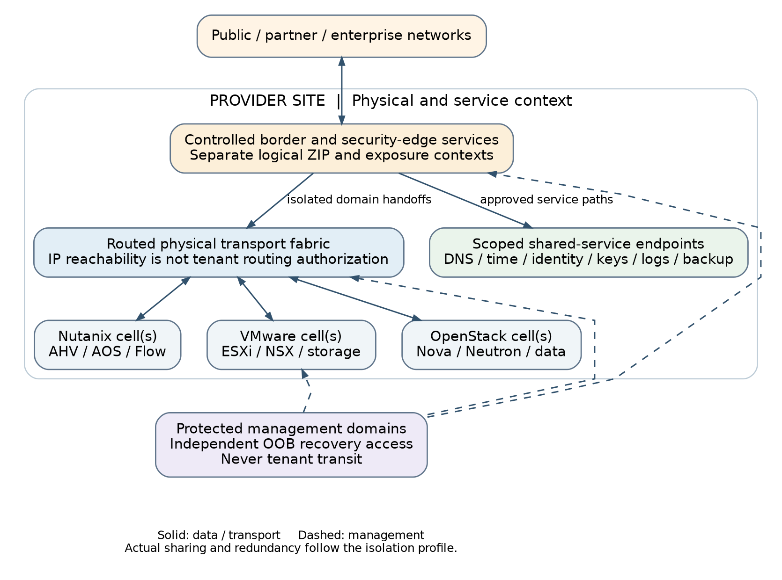
Figure 1. Reference hosting topology: common infrastructure with separate vendor realizations
External networks terminate at provider-controlled border/security interfaces. Workload traffic enters or leaves a domain only through its authorized attachment. The physical fabric supplies transport between platform tunnel endpoints and service attachments; it does not become an implicit inter-tenant router. A platform-local routing boundary therefore remains meaningful even when two cells use the same physical leaf switches.
Infrastructure area | Components and responsibility | Must not imply
External and security edge | Border handoffs, controlled public/partner access, logical ZIP contexts, ingress and egress | General reachability from an enterprise circuit to every tenant
Hosting cells | Compute pools, platform networking, storage integration and platform-local operational services | A shared administrative or routing authority across unrelated tenants
Provider services | DNS/time, identity, PKI/KMS, logging, backup, approved image and update services | Workload access to their management interfaces
Management foundation | Privileged access, platform managers, infrastructure tooling and recovery access | A workload network carrying privileged administration
Physical transport | Redundant IP connectivity, optional fabric EVPN and controlled physical attachments | A universal security-zone VRF taxonomy or a common vendor overlay

The topology is a functional deployment view, not a cable diagram. Components shown separately have separate authority and interface requirements; physical separation is determined by the adopted isolation profile. A shared edge or shared storage backend must disclose that dependency. The low-level design records the exact power, rack, host, storage, switching and controller failure domains behind every apparently redundant symbol.
Related engineering: QUAL §2 — Site low-level design and dependency schedule

4. Hosting cells, resource pools and failure boundaries
A hosting cell is the provider unit for commissioning, capacity expansion, version control and failure containment. It is introduced here as an architectural term, not as an OpenStack Nova cell or a vendor product. A cell normally uses one qualified platform stack, a defined site, named compute/storage resources and explicit attachments to management, transport and security services. Several cells can share a site fabric without sharing tenant routing.
The reference separates management capacity, security-edge capacity and tenant workload capacity. Within workload capacity, host pools enforce the adopted zone and co-residency policy. A small site may combine some physical roles only through a documented variation that preserves the required isolation and recovery behaviour. It must not describe logical separation as physical independence.
Cell boundary | Required design decision | Growth action
Compute | Eligible hosts, zone/domain sharing, accelerators, host/rack failure tolerance | Add qualified hosts or a new pool; validate evacuation and restart constraints
Storage | Backend and controller scope, usable capacity, rebuild reserve, copy locations | Expand an existing supported fault domain or add a separately qualified storage pool
Network | Transport endpoints, routed attachment slots, prefix/route/policy limits | Increase commissioned capacity; do not silently share an exhausted isolation context
Control | Managers, API authority, release compatibility and recovery dependencies | Scale or introduce a separate management scope before its supported limit
Security services | Logical contexts, inspection/session capacity, log throughput and failure headroom | Expand the edge service before accepting additional protected connectivity

The provider advertises available capacity by service class, not merely total free CPU or terabytes. Usable capacity is the amount that remains deliverable after the agreed failure and operational reserves. Capacity that is installed but lacks a compatible storage tier, security-edge slot, licence, address pool or operational owner is not ready for tenant allocation. Ordered, received, staged, commissioned, available, reserved and consumed capacity are separate inventory states.
No specific number of hosts, switches or firewall instances is prescribed for every site. The site design derives counts from quorum, supported platform minima, sustained load under failure, maintenance and growth. A two-node symbol in a topology means redundant roles, not a claim that two nodes satisfy every product or assurance requirement. The commissioning record establishes the actual independent resources and bottlenecks.
Routine tenant growth consumes previously commissioned pools. Provider growth changes pools, attachments or cells under a separate infrastructure change. This separation is the practical meaning of capacity on demand: ordinary workload requests do not trigger procurement, physical cabling or an unreviewed fabric design. A capacity deficit results in an explicit queue, alternate eligible placement or rejection.
A cell is not declared independently resilient until actual power, rack, switching, storage, control, security and trust dependencies are recorded. Count logical attachment slots separately from redundant links and edge processing capacity. A free slot is not usable capacity when another required resource is exhausted. QUAL §3 supplies unit-aware illustrative admission arithmetic; its numbers are not site sizing or approved service commitments.
Related engineering: QUAL §2 — Site low-level design and dependency schedule • QUAL §3 — Capacity, service envelopes and growth triggers • NET §2 — Isolated attachment units and bounded capacity

5. Physical fabric and platform attachment

Selected physical design
Use routed leaf/spine connectivity at a large site, with each applicable leaf connected to the spine set and with qualified multipath forwarding. Dual-attached hosts and appliances use the supported host teaming and multihoming design. The switching control plane carries only the transport and physical-service state for which it is authoritative. Platform overlay tunnel endpoints must be reachable with the required MTU; tenant routing does not need to be imported into every transport switch.
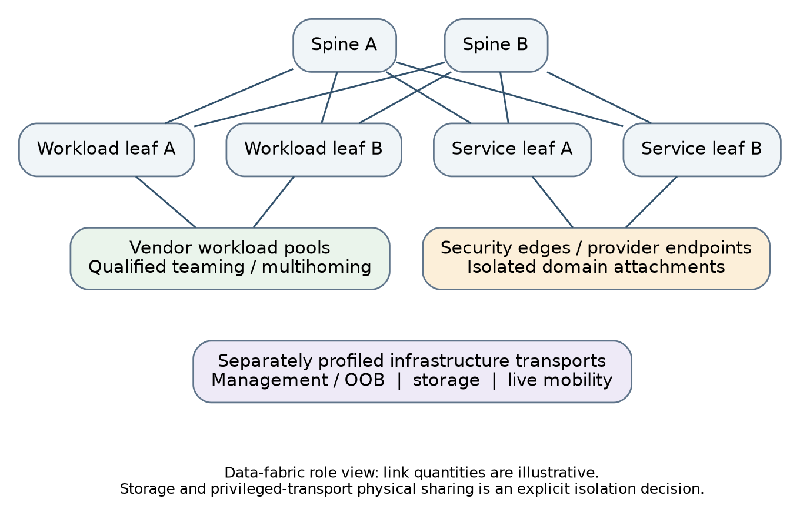
Figure 2. Physical transport and attachment roles within a site

Underlay, fabric overlay and platform overlay
The underlay is routed IP transport. Fabric EVPN/VXLAN is optional where physical attachment or a specific switching service needs it. Nutanix, NSX and Neutron overlays remain separate platform realizations; using the same encapsulation family does not create a shared control plane or authorize exchanging their VNIs and route targets. The reference cross-vendor handoff is controlled IP routing through a security boundary, not direct federation of vendor overlays. EVPN signalling and overlay transport are distinct specifications and must be qualified as an implemented combination. [S21; S22]
For a routed fabric, the provider selects the underlay ASN/address allocation, BGP neighbour policy, route limits, loopback reachability, ECMP behaviour, convergence targets and maintenance procedures. Import and export policies are explicit. No consumer can supply a BGP neighbour or a route target. The selected hardware/software profile must show how authentication, control-plane policing and unauthorized advertisement handling are enforced. [S20]
Attachment class | Reference handling | Commissioning proof
Platform transport | Precommissioned subnets/links for platform tunnel endpoints; no per-workload fabric routing | Cross-host reachability, MTU/PMTU, multipath and link/leaf failure
Security-edge attachment | Bounded isolated interfaces or contexts connecting a domain to the security service | No connected-route, ARP/ND or alternative-gateway bypass
Storage and live mobility | Provider-owned endpoint membership and controlled transport; routed only where justified | Supported latency/loss, bandwidth under failure, non-workload accessibility
Physical workload | Dedicated approved VLAN/VRF or equivalent attachment with explicit gateway owner | Required boundary path, tenant membership and cleanup on reassignment
OOB | Dedicated management interfaces and independent transport where available | Administration remains possible for the defined production-fabric failure

A physical VRF is justified when the fabric must provide a separate routing authority. Calling a function backup, migration or platform is neither a sufficient reason to create a VRF nor a reason to prohibit one. A storage VLAN that is not routed does not need an invented routing domain; a physical partner handoff may require one. Record the actual isolation objective and its enforcement rather than standardizing a list of functional VRF names.
MLAG and EVPN multihoming are different designs. Use a qualified combination and test peer-link or Ethernet-segment failure, split-brain, orphan ports and maintenance. Do not form a cross-vendor MLAG pair on the assumption that the feature names match. Vendor interoperation normally occurs at an explicit L3/BGP or other documented handoff. Nested overlays require an end-to-end encapsulation budget and observed effective MTU, not a blanket jumbo-frame setting.
Treat a domain attachment as an owned bundle of routing/enforcement identity and supported transport members, not automatically one VLAN or cable. Precommissioning bounds tenant changes only within available accepted capacity. NET §2 defines reservation and reuse conditions; NET §5 supplies the layer-specific MTU and multihoming evidence method. Actual identifiers, component limits and routing policies remain site inputs.
Related engineering: NET §1 — Transport, routing and overlay ownership • NET §2 — Isolated attachment units and bounded capacity • NET §5 — MTU, performance and failure engineering

6. Management, platform control and out-of-band access
Management is a separate infrastructure environment. It contains privileged access services, platform managers, fabric and security administration, storage administration and the management interfaces of shared services. Tenant guest administration is a different authority and follows its own approved access path. A tenant role that can restart a VM must not thereby acquire control over the host, virtual fabric, storage backend or security edge.
The Management Zone describes the trust and access policy. OOB describes a transport and recovery property. The reference uses dedicated OOB interfaces and switching where supported; platform control APIs that use ordinary Ethernet remain in separately protected management networks. Their independence must be described honestly when they share production links, power or hosting resources. The cloud-zoning guidance supports an isolated management approach. [S02]
Administrative path | Termination and authority | Separation rule
Infrastructure operator | Hardened admin endpoint → privileged-access boundary → authorized management service | Scoped identity; no direct route from ordinary workload networks
Automation execution | Authority-specific runner → allowlisted platform or infrastructure API | No shared privileged identity spanning fabric, edge and tenant resources
Hardware recovery | Controlled emergency access → OOB network → BMC/switch console | Survives the specified production failure; separately authenticated and logged
Tenant guest operator | Approved guest-access service → assigned guest endpoints | No reuse of host-management credentials or implicit access to infrastructure APIs
Supplier support | Time-limited approved session → named target | Recorded scope; no standing unrestricted access or uncontrolled diagnostic export

The management environment is an umbrella for isolated management domains, not one universally routed MZ. Management authority follows the zones and resources being administered; shared tooling does not create direct MZ-to-MZ connectivity. The on-premises virtualization guidance also recommends separate zone-management and virtualization-storage environments and physical separation of privileged transports. Any consolidated HCI/control/transport realization therefore needs an explicit applicability and tailoring decision; this architecture does not assert that logical isolation automatically satisfies those physical recommendations. [S03]
Platform managers are not in the normal workload packet path, but their unavailability can still affect scheduling, policy updates, restart and recovery. Host and controller failure behaviour is therefore qualified for the selected release rather than inferred from the diagram. Management compute and the minimum bootstrap services must remain recoverable without first restoring every tenant workload.
The provider service area is not one large management network. DNS queries, log ingestion, backup data transfer and key-use requests terminate on consumption interfaces. Directory administration, collector configuration, backup deletion and key destruction terminate on management interfaces. Where a product combines them on one appliance, separate access paths and authorization remain required. Shared hardware must not erase the trust boundary.
Break-glass access is a controlled exception to the normal identity path, not an exception to accountability. Recovery procedures identify who may activate it, what endpoints it can reach, how activity is retained when central services are unavailable, and how credentials and sessions are revoked afterwards. Test that access against the failure it is intended to repair.
Related engineering: NET §6 — Management paths and interface handover • SVC §3 — Identity, certificates, keys and independent recovery
PART 2 / Logical hosting and security

7. Tenant environments and security-domain placement
A tenant environment is an administrative allocation of hosting services. It contains one or more Workload Security Domains (WSDs), which group resources with a common service owner, lifecycle and security/recovery requirements. The WSD is a useful architectural deployment boundary; it is not an application microservice, a mandatory custom API type or necessarily one Terraform state.
A logical Security Domain establishes one zone class and security authority. A Security Domain Instance realizes that domain in a site/platform routing and enforcement context. A network belongs to one instance. A WSD can require several domains, for example an Operations Zone for an internal processing tier and a Restricted Zone for its protected data tier. A second tenant receives independent domains even when its zone labels are identical.
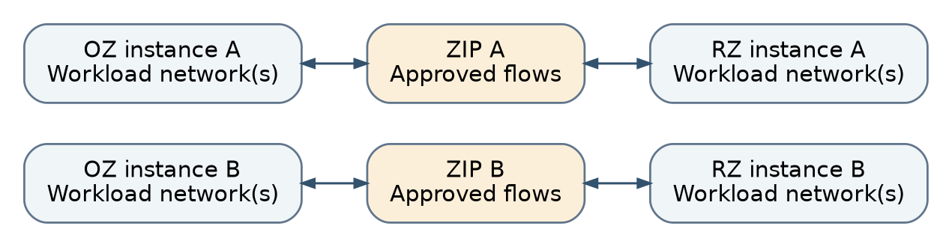
Figure 3. Logical tenancy and zone boundaries, independent of vendor topology
Architectural allocation | Scope | Lifecycle relationship
Tenant | Administrative ownership, roles, entitlements and quotas | Longer-lived than an individual workload; does not own provider foundations
WSD | Compute/storage/network requirements and operational acceptance | Created, changed, recovered and retired as a bounded service environment
Logical Security Domain | Zone class, authority, allowed sharing and routing policy | May outlive a WSD when explicitly shared
Domain Instance | Site/platform realization of the domain | Recreated at another site or stack without redefining its security purpose
Network and resource attachment | Endpoint membership in one instance with approved identity | Cannot be attached across authorities merely by changing a label or adding a NIC

Sharing and physical placement
Retain the v1.1 zone-specific host-pool baseline. Cross-zone co-residency is not enabled simply because the platform can create isolated virtual networks. The Cyber Centre virtualization guidance strongly recommends against hosting VMs from different network security zones on the same physical hardware. The adopting authority must explicitly assess any alternative, including shared controllers, HCI storage, host compromise and recovery placement. [S03]
Compatible tenants may share a qualified pool only under the approved domain/zone sharing decision; matching an RZ label is not itself that decision. Enhanced isolation can add dedicated routing and security contexts. Physical dedication is defined separately for hosts, storage, edge, management, backup and key custody. A dedicated host with a shared management plane is not an independently administered platform.
Within a shared domain instance, deny unapproved WSD-to-WSD and tier-to-tier traffic. Mandatory rules and provider-controlled identity attributes take precedence over tenant policy. The same rule applies to same-host, same-subnet and cross-host traffic. Scheduler evacuation, recovery and live mobility must preserve placement and policy constraints; lack of eligible surviving capacity cannot be resolved by weakening them.
Related engineering: VND §1 — One reference environment, three native realizations • VND §2 — Physical placement and the sharing decision

8. Zone interfaces, routing and security-edge topology
The reference uses PAZ, OZ, RZ and HRZ for workload-capable internal zone classes, with MZ reserved for controlled administration. Public and Restricted Extranet Zone relationships are represented as external authorities. A ZIP is a controlled interface between two zones, not another workload zone. The internal/external representation is a local modelling decision aligned with the distinct authorities in the source guidance; it does not redefine the government zone vocabulary. [S01; S02]
HRZ is modelled only as an optional higher-assurance extension, not an automatically available cloud service. ITSP.80.023 specifically limits cloud HRZ suitability; neither including HRZ in a schema nor placing it on dedicated hosts establishes approval. An on-premises realization and its applicable controls must be assessed on their own basis before this extension is offered. [S02]

Selected boundary pattern
Each independent domain has a native gateway and an isolated attachment toward the security-edge service. The edge hosts a logical boundary context with explicitly identified source and destination domains, routes, stateful policy, required inspection and logging. A physical security cluster can host several logical ZIPs. It cannot collapse their routing or administrative scopes into one permissive transit context. A multi-interface appliance may implement several pairwise ZIP relationships; the architectural two-zone relationship is not a physical two-port limitation.
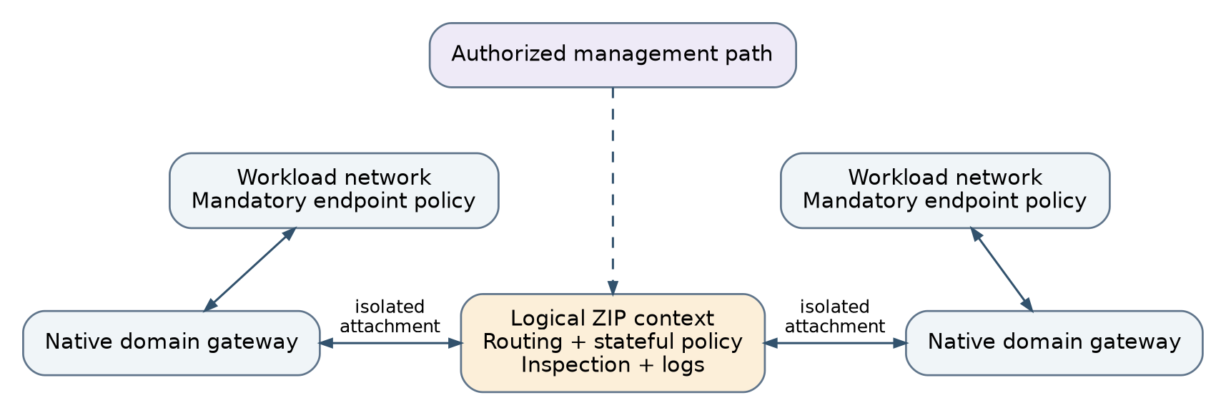
Figure 4. Reference inter-domain data path and the separate management path
Relationship | Reference treatment
Public ↔ PAZ | Declared public service through an external boundary; no direct attachment to internal workloads
PAZ ↔ OZ; OZ ↔ RZ | Separate approved ZIP relationships; default traffic remains denied
RZ ↔ HRZ extension | Not a base portable cloud service; requires explicit higher-assurance applicability and implementation approval
Partner/REZ ↔ approved internal domain | Agreement, authenticated endpoint and explicitly approved boundary; not automatic enterprise trust
Different domains with the same zone class | Independent isolation still applies; use a declared boundary or service relationship
MZ ↔ managed interface | Management-specific access boundary and privileged identity; never a workload transit shortcut
Other adjacency | Not enabled by the base pattern; adopt an explicit extension with complete path and authority analysis

Routes establish reachability; security policy authorizes use of that reachability. Both must be correct. The provider owns allowed prefix sets, next-hop choices, default routes, route import/export and edge advertisements. In this document, Route Authority means that engineering responsibility and its controlled automation, not a requirement to develop a new routing compiler application. The delivered routing table must be explainable from the approved domain and service connectivity.
There is no default unrestricted transit VRF, common Tier-0 routing table, shared Neutron external segment or VPC external subnet connecting all independent domains. A connected route can bypass a downstream firewall before its policy is ever evaluated. Shared attachment designs are allowed only after their actual connected, neighbour, gateway, NAT and return paths preserve the boundary. Otherwise allocate dedicated isolated contexts from precommissioned capacity.
The security-edge design identifies state synchronization, active/standby or supported active/active behaviour, return-path symmetry, connection revocation, scale limits and fail-secure behaviour. Routes must not switch to an uninspected backup path when the edge fails. A distributed ZIP alternative must identify where every required function occurs, including same-host paths and administration. Neither a router nor a distributed-firewall licence alone qualifies it as a ZIP.
For every accepted boundary, record an explicit forward path, reply path, initiating party, allowed service, translation and unavailable-next-hop behaviour. Review native distributed and connected routes in addition to the visible firewall rules. The common two-tenant fixture in VND §1 and path schedule in NET §3 make these outcomes comparable across the three stacks without requiring identical topology.
Related engineering: NET §2 — Isolated attachment units and bounded capacity • NET §3 — Worked inter-zone routing and enforcement schedule

9. Shared services, ingress and controlled egress
Shared services are provided through explicit consumption interfaces. The architecture distinguishes the service endpoint exposed to a tenant from the backing service infrastructure and its management. A service binding identifies which domain or workload may use which service, with the required direction, protocol, authentication and recovery expectation. It is a connectivity and entitlement decision, not necessarily a new software resource type.
Service | Workload-facing path | Provider-only administration
DNS and time | Approved resolver/time endpoints; necessary protocol behaviour only | Zones, delegation, clock sources and server configuration
Identity, certificates and keys | Entitled authentication, certificate enrolment or key-use endpoint | Directory administration, trust roots, key lifecycle and recovery custody
Logging and monitoring | Authenticated ingestion or tightly scoped collection | Collector configuration, search authorization, retention and evidence control
Backup and recovery | Approved agent, proxy or data-mover path appropriate to the platform | Policy, catalogue, repositories, immutability and disposal authority
Images and updates | Approved artifact repository or software distribution endpoint | Publishing, signing, provenance and retirement
File and object services | Tenant-authorized data endpoint with namespace and access controls | Storage controllers, replication policy, snapshots and cross-tenant sharing

A service may expose endpoints aligned to several zones while sharing backend capacity. Those endpoints are not automatically independent failure domains. Record common storage, controllers, credentials and certificates. Network authorization is also not data authorization: two tenants able to contact a storage or key service must still be unable to enumerate or access each other’s resources.

Public access
Public traffic terminates through an approved perimeter and PAZ ingress service such as a reverse proxy, load balancer or application firewall where required. A separately approved backend flow crosses the internal ZIP. Certificate identity, TLS termination or passthrough, backend re-encryption, health checks, denial-of-service handling and source attribution are explicit design choices. A public address on an internal VM is not the default realization.

Egress and other external networks
Internet egress is absent until an approved egress service is attached. The design states whether it uses a proxy, routed security edge, translation or a qualified combination. NAT is an address transformation, not an access-control policy. Record both original and translated identities where needed for attribution. FQDN restrictions require a defined DNS resolution and refresh method; they cannot be inferred from a generic TCP allow rule.
Private circuits, enterprise networks and cloud interconnects terminate at named external-domain boundaries. Their presence does not grant broad access to all tenants or shared-service subnets. Partner sharing, inter-tenant sharing and migration are separately approved relationships. New exposure is activated only after baseline policy, route symmetry, certificates, monitoring and ownership have been verified; withdrawal includes established-session behaviour.
Publish the service protocol set, not just a service name. Ordinary resolver consumption requires the applicable UDP and TCP DNS behaviour, including fallback testing; authoritative updates, administrative operations and any encrypted-DNS variant remain separately scoped. RFC 7766 provides the TCP DNS basis. SVC §2 describes the corresponding endpoint and lifecycle decisions. [S38]
Related engineering: SVC §1 — Shared service placement and consumption boundaries • SVC §2 — Name, time, initialization and telemetry profiles

10. Addressing, name services and end-to-end traffic
The address plan has separate scopes for underlay links/loopbacks, management/OOB, platform transport, provider data services, edge attachments and tenant networks. Allocation follows routing authority, site and service requirements rather than an inherited /16-per-function pattern. Tenant prefixes are unique by default. Overlap is an explicit migration or service exception with translation and unambiguous ownership. VLANs, VNIs, RDs and RTs are provider implementation identifiers, not consumer inputs.
Authoritative IPAM reserves addresses before dependent network creation, confirms them after realization and releases them only after routes, leases, DNS and policy are reconciled. DNS forward/reverse records, delegation, resolver bindings and relevant TTLs are part of the same lifecycle. A platform’s native IPAM must either be authoritative for its delegated scope or reconcile to the enterprise authority; two independent writers must not allocate the same pool.
Each service class declares which of IPv4-only, IPv6-only and dual-stack it offers and qualifies; support for every mode is not assumed. The entire path must support its offered families: host, overlay, gateway, ZIP, service, monitoring and recovery. Even IPv4-only service needs a deliberate treatment of IPv6 link-local traffic and transition mechanisms. Required ICMPv6 and path-MTU behaviour must not be broken by a blanket deny copied from an IPv4 ruleset. [S23; S24]

Reference path catalogue
Path | Forwarding and enforcement | Required observation
Same domain, same host | Endpoint → host virtual switch and mandatory workload policy → endpoint | The control is enforced without a physical gateway hop
Same domain, different hosts | Endpoint policy → vendor overlay/underlay transport → destination policy | Tunnel path, MTU and destination identity remain correct
Different domains or zones | Source gateway → isolated attachment → ZIP → destination attachment/gateway | Permitted flow appears at the boundary; an alternate native route does not exist
Shared service consumption | Domain → approved service path/ZIP where needed → service endpoint | Only the entitled endpoint and resource scope are accessible
Public ingress | External boundary → PAZ ingress → separate approved internal flow | Internal VM is not directly public; return path and client attribution are defined
Privileged administration | Hardened admin path → management boundary → authorized interface | No dependence on a tenant transit route
Virtual disk I/O | Guest virtual device → hypervisor/storage stack → authorized backend | Storage attachment and backend isolation; not an assumed guest IP firewall hop
Guest file/object access | Guest NIC → approved network/service path → tenant data endpoint | Both network policy and data-service authorization
Backup | Snapshot/API/proxy or guest-agent path selected for the service | Data mover has only required scope; management credentials remain isolated
Live mobility / replication | Provider endpoints on controlled infrastructure transport | No guest bridging or cross-domain escape; eligibility survives relocation

For each deployed path, the low-level design records source/destination identity, address family, routing owner, enforcement point, NAT if any, return path, service dependencies and fault behaviour. Positive tests establish endpoint health and allowed operation; negative tests show the intended control denies unauthorized traffic. A timeout from an unhealthy destination is not evidence of isolation.
Persistent infrastructure versus temporary migration — Hypervisor live-mobility and storage-replication networks may be persistent provider infrastructure. The time-bound migration rule applies to temporary cross-domain or cross-platform transfer access. It must not be interpreted as requiring vMotion, HCI replication or equivalent platform transport to be rebuilt for every operation.
Related engineering: NET §3 — Worked inter-zone routing and enforcement schedule • NET §4 — Address, naming and protocol-family decisions • SVC §2 — Name, time, initialization and telemetry profiles

11. Compute pools, hypervisors and workload placement
Compute capacity is grouped into qualified pools with explicit hardware characteristics, security-domain eligibility and failure boundaries. The reference separates provider management workloads, security/service infrastructure and tenant workloads. Tenant host pools implement the adopted zone/co-residency policy. Host grouping must be enforced by scheduling, restart and migration controls; naming a cluster or adding a tag is not sufficient.
Pool characteristic | Architecture requirement | Provisioned realization
Security eligibility | Known tenant/domain/zone sharing policy and privileged boundary | Cluster or host group membership; enforced placement and mandatory endpoint policy
CPU and memory | Defined compatibility, reservations, oversubscription and performance envelope | Approved VM sizes/flavours, reservations and placement constraints
Failure containment | Host/rack independence appropriate to the service and surviving capacity | Anti-affinity, restart/evacuation policy and reserved headroom
Boot and platform trust | Supported firmware/hypervisor, approved boot mode and required attestation | Verified image/template, firmware baseline, secure boot/TPM controls where applicable
Special devices | Explicit accelerator, passthrough, nested virtualization and mobility limitations | Dedicated eligible hosts and restricted device assignment
Lifecycle | Supported patch path, maintenance evacuation and retirement | Controlled image/host lifecycle and tested rollback or recovery

CPU, memory and storage are admitted together. A VM is not a valid allocation if its compute is available but its storage class, key service, network attachment or recovery requirement cannot be delivered. The service distinguishes requested resources, guaranteed reservations and observed consumption. Oversubscription is a published service property and must not consume capacity reserved for a security or failure requirement.

Placement across vendor stacks
The provider first selects an eligible site, cell and service class, then uses the platform scheduler within the approved pool. This two-level decision prevents a vendor scheduler from choosing a host outside the security or recovery boundary. New allocation, resize, evacuation, HA restart, restore and migration use the same eligibility rules. If a required dedicated or zone-specific pool is unavailable, the operation pauses or selects another already authorized pool; it does not silently become shared.
Images and templates are versioned infrastructure inputs. They identify operating system, virtual hardware/boot mode, drivers, protection agents, hardening, provenance, supported lifetime and known limitations. An image may require a separate vendor variant while preserving the same service requirements. The provider governs publishing and retirement; the workload owner remains accountable for application configuration and business data. This is a responsibility boundary, not a design of the application itself.
The reference does not require every platform to expose identical virtual CPUs, device models, snapshot types or guest tooling. These differences belong in the realization and portability records. Features that constrain exit, such as device passthrough or platform-specific virtual security devices, are declared before allocation and included in the recovery/migration design.
Related engineering: VND §2 — Physical placement and the sharing decision • QUAL §3 — Capacity, service envelopes and growth triggers

12. Storage, backup and data-isolation architecture
Storage is a set of governed data services, not a single datastore attached to all tenants. The reference supports block, file and object access where the selected platform or associated service provides the required semantics. Compute-facing storage attachment, guest-facing data access, backend replication and storage administration are separate paths with different controls.
Storage path | Reference separation | Principal control
VM virtual disk | Hypervisor-mediated attachment to an authorized backend object | Tenant/WSD ownership, attachment authorization, encryption and copy controls
Guest block/file/object client | Explicit tenant data-service interface | Network authorization plus protocol identity, namespace/ACL/policy enforcement
Backend replication/rebuild | Provider-only storage transport and member endpoints | Cluster membership, supported encryption, capacity and fault-domain placement
Snapshot/clone/export | Controlled management/data-mover operation | Copy lineage, destination authorization, category/location and retention inheritance
Storage administration | Protected management path | Least privilege and separation from tenant data consumption
Backup/recovery repository | Independent protection and recovery authority as required | Protected copies, keys/catalogue availability and deletion/hold controls

A storage class defines usable capacity, access protocol, expected latency/throughput/IOPS, contention policy, availability/durability objectives, encryption and key scope, snapshot/clone behaviour, replication, backup and sanitization. Hardware labels such as all-flash or HCI do not substitute for those outcomes. Capacity planning includes replication or erasure overhead, rebuild reserve, snapshots, retained backups and degraded operation.
In HCI, separating guest VM placement does not by itself separate controller, disk or management dependencies. The design explicitly records which storage components are shared across pools and how authorization and confidentiality are enforced. A virtual disk operation is not assumed to traverse the guest network ZIP; the relevant boundary may be hypervisor authorization and backend isolation. A guest accessing a file share over IP follows the normal controlled data-service path.

Data protection and recovery
Backup selection follows the workload service requirement and the platform’s supported capture mechanism. A backup proxy may use a management API for snapshot orchestration and a separate data path for transfer. The guest does not receive management access as a side effect. Backup administration and deletion authority are separated from routine production operation for copies designated independent or immutable.
Protection includes the data, backup catalogue, configuration and keys needed to restore it. Retained copies keep ownership, location, classification, consistency and disposal obligations even after the live WSD is retired. A copy is not considered recoverable merely because a backup job succeeded. An isolated restore must demonstrate useful data, required identity/key access and the selected recovery point and time.
The portable storage requirement describes necessary behaviour, not a promise that every S3-compatible endpoint or snapshot format is equivalent. Qualify required object operations, multipart handling, metadata, policy, versioning, retention and encryption semantics; qualify file identity/ACL and block attachment behaviour separately. Export and restore methods are included in the service’s exit design.
Release for reuse requires an approved sanitization method appropriate to media, key scope and retained copies. Deleting a volume record is not proof that snapshots, replicas, exported keys or caches were destroyed. NIST SP 800-88 Rev. 2 is a supporting technical reference; applicable organizational media-handling requirements remain authoritative. [S27]
Related engineering: SVC §4 — Storage, copies and retained-data ownership • SVC §5 — Backup capture, independent protection and isolated restore

13. Identity, cryptography and service trust
Identity is enforced at every administrative and data-service interface, not inferred from network location. Human administrators, automation executors, workload identities and recovery identities have separate roles and credential lifecycles. A tenant’s ability to use a service does not grant authority over its configuration, keys or other tenants’ data.
Federated identity supplies authoritative user/group membership where supported. Privileged access is task-scoped through the approved management path, with strong authentication, controlled duration and auditable approval. Machine credentials are restricted to the APIs and resources required by their provisioning package. Where short-lived credentials are unavailable, vaulted static credentials need bounded privilege, rotation, revocation and monitoring; that limitation is visible in the platform design.
Trust service | Required architectural decision | Failure expectation
Identity/PAM | Issuer, role mapping, privileged path, token/session lifetime and emergency authority | New privileged activity stops or uses the explicitly controlled emergency path
PKI | Trust roots, issuing scope, endpoint identity, renewal and revocation | No disabled certificate validation as a recovery shortcut
KMS/HSM | Key-use versus administration, tenant/provider scope, recovery custody and location | No plaintext or replacement-key fallback; cached-key behaviour is documented
Artifact signing | Who builds, approves, signs and publishes platform images and modules | Untrusted or revoked artifacts are not promoted into privileged execution
Evidence protection | Who can write, read, retain or dispose of operational evidence | Collection loss is visible and follows the agreed safe-state policy

The cryptographic architecture separates key use, key administration, key recovery and destruction. It identifies whether keys are tenant-controlled, provider-controlled or shared-service controlled, and what access administrators can exercise. Data replicas, backups, logs and diagnostics are included in the location and custody model. Residency alone does not establish control over administrative access or legal obligations; approved constraints come from the responsible authorities.
Use a versioned cryptographic profile rather than a permanent algorithm shortcut in the architecture. The current ITSP.40.111 reference includes version 5 and its effective date; implementation must select approved algorithms, operating modes and applicable validated modules for its exact environment. Maintain a crypto inventory and transition dependencies without claiming that every vendor feature already meets them. [S10]
Key and identity recovery must avoid circular dependencies. The sole means of unlocking a failed storage platform cannot exist only on that encrypted platform. The recovery design provides controlled access to the minimum independent trust material and tests it during a management/platform outage. Retained data must not lose its only usable key because the associated live workload was deleted.
Terraform plans, state and logs receive the same information-handling care as other privileged infrastructure records. Display redaction is not proof that secrets are absent from stored state. Short-lived credentials and supported secret-avoidance mechanisms reduce exposure, but backend access control, encryption, retention and recovery remain necessary. The architecture assigns these controls to the provisioning service rather than exposing them to every tenant operator.
Algorithm selection and secure protocol configuration are complementary decisions. Use the adopted ITSP.40.111 algorithm profile together with applicable protocol guidance such as ITSP.40.062; record endpoint identity, trust, required configuration and implementation evidence separately from product feature labels. SVC §3 develops the custody and recovery dependencies. [S10; S39]
Related engineering: SVC §3 — Identity, certificates, keys and independent recovery

14. Availability, multi-site operation and recovery topology
The reference uses site-local domain instances, local security enforcement and an explicit routed inter-site service. It does not stretch every tenant Layer 2 network between sites. A WSD can have instances in more than one site while retaining its security purpose and service identity. Different site labels are not evidence of independence when they share storage, power, control, identity or security-edge dependencies.
Service pattern | Reference topology | Recovery consequence
Single site, resilient | Redundant qualified hosts, storage and security paths inside the site | Survives the specified local failure, not an undeclared complete-site loss
Primary and recovery site | Independent target instance and preauthorized recovery/service paths | Restore or replicate, fence old writers, validate target and switch service exposure
Active across sites | Independent local instances with application/data coordination explicitly supplied by the service owner | Requires consistency, split-brain, latency and dependency analysis beyond VM restart
Layer-2 stretch variation | Only for a documented requirement with supported topology and failure controls | Partition, gateway ownership, failure blast radius and failback are separately qualified

Availability classes define a measurable service indicator, observation period, maintenance treatment and tolerated failure. Recovery classes define the scope, recovery time objective (RTO), recovery point objective (RPO), data consistency and acceptance responsibility. Medium availability impact is not a numerical uptime target. The site implementation must populate and approve actual objectives; this revision does not invent measured values for an unspecified environment.
Security and recovery capacity are sized for surviving operation. Evaluate compute evacuation, storage rebuild, edge inspection/session load, routed inter-site capacity, IP pools, service dependencies and log ingestion together. A service cannot meet its failure promise by disabling inspection, moving to an ineligible host or sharing a key outside its approved scope. A useful admission rule is: accepted demand must not exceed measured surviving qualified capacity minus the operational reserve for the agreed failure model.
Control-plane failure and data-plane failure are assessed separately. Existing workloads can continue only where the selected stack demonstrably maintains forwarding, storage access and enforcement without its management component. New changes stop when required authority, IPAM, state or policy checks are unavailable. Logging loss triggers buffering, alerting and the profile’s operating restrictions; it never opens traffic by default.
Recovery re-establishes trusted administration and minimum identity/time/name services, then the fabric/platform/storage and security foundations, then workloads and service access. Exposure changes occur after current isolation and recovery checks pass. Fencing prevents the original and recovered copies becoming independent writers. Failback is a planned migration with its own consistency point, not an automatic reversal during an unresolved partition.
Related engineering: SVC §6 — Failure, recovery, migration and failback topology • QUAL §4 — Service parameter and requirement decisions
PART 3 / Vendor realization

15. Cross-vendor realization model
Worked reference: WD §§3–8 connects the component, tenant address, isolated handoff, forward/return route, service permission and native realization schedules. Its TEST-NET and IPv6 documentation addresses are explanatory values, not actual allocations. Shared-service and temporary-probe resources are counted separately from the four-domain base fixture.
The reference architecture is stable; its native realization is not identical across products. Each implementation supplies the same tenant isolation, domain routing, zone transitions, resource classes, management separation and lifecycle outcomes. Its compute, network, storage and protection functions may be managed through several APIs. Selecting a hosting platform therefore selects a set of integration responsibilities, not one provider that creates the entire service.
Architecture component | Nutanix realization | VMware/NSX realization | OpenStack realization
Platform control | Prism and selected Flow management functions | vCenter and NSX management; associated storage/protection control | Keystone and service control planes; selected distribution tooling
Compute pool | AHV cluster/eligible host pool | ESXi cluster/host groups and enforced placement | Nova/Placement with eligible hosts, aggregates and scheduling policy
Domain instance | VPC/routing context per approved domain | Tier-1 with isolated upstream routing context in the reference pattern | Neutron network/router context with approved backend and edge attachment
Workload segmentation | Qualified Flow security and protected selectors | Distributed policy with provider-owned groups and rule hierarchy | Port security/security groups plus protected mandatory policy boundary
Inter-domain ZIP | Isolated external attachment → security-edge context | Isolated Tier-0 VRF/approved equivalent → security-edge context | Isolated external/provider attachment → security-edge context
Storage | AOS and qualified block/file/object/protection services | Qualified datastores/storage policies and associated data services | Cinder and selected backend; optional separate file/object services
Provisioning | Nutanix APIs/provider plus shared infrastructure integrations | vSphere and NSX APIs/providers plus shared infrastructure integrations | OpenStack APIs/provider plus installer and shared-service integrations

The mappings above are proposed reference realizations, not blanket capability certification. The subsequent chapters identify physical roles, forwarding paths, shared and dedicated resources, and build order. Each site selects the exact supported product, API, hardware and automation versions. A product feature advertised in documentation does not prove its behaviour when combined with the selected backend, licence, policy hierarchy and failure topology.

Three different meanings of cross-platform
Portable deployment means an equivalent environment can be created on another eligible stack from the same hosting requirement. Composite deployment means one approved environment uses resources or services from several stacks at once, with explicit inter-domain connections. Migration means data and workload state are transferred and cut over. These are separate capabilities. Terraform can provision resources for all three, but it does not itself guarantee data conversion, application consistency or live migration between unrelated hypervisors.
The default is to place a bounded WSD realization in one eligible cell and consume shared services through its controlled interfaces. A split-platform WSD is an explicit variation with a defined reason, latency budget, failure analysis and recovery ownership. Cross-vendor connectivity uses the approved routing/security boundary, not an assumption that the native overlays can be joined directly.
Mandatory capability gaps cause an explicit rejection or an approved alternative realization. Optional platform extensions remain visible with their portability consequences. The qualification record includes the offered service classes, actual limits, unsupported features, operations coverage and current evidence. It remains separate from the architecture document and from formal system authorization.
VND §1 defines a single symbolic qualification environment: two tenants, four independent OZ/RZ domain instances, four logical domain attachments, two tenant inter-zone relationships and explicitly scoped services. It is a test fixture, not a production node-count or application-availability design. Each realization must account for additional service, management and redundant physical resources; the logical counts cannot be used as a hardware bill of materials.
Related engineering: VND §1 — One reference environment, three native realizations • VND §6 — Portable, composite and migrated service choices • VND §7 — Implementation tuple and decision package

16. Nutanix hosting-stack reference realization

Component placement
The Nutanix pattern uses AHV compute with AOS storage services and Prism-based administration. Selected Flow networking and security functions supply tenant virtual networking and workload controls. Vendor guidance distinguishes VPC external connectivity from overlay workload networks, and describes NAT and no-NAT external attachment options. Their exact limits and current implementation depend on the selected release. [S17; S31; S32]
The proposed site layout places Prism and required control services in the protected management environment, with recovery placement compatible with the product. Workload AHV resources are allocated to eligible zone/co-residency pools. AOS/controller membership, management, storage transport and guest placement are assessed together. Security-edge capacity is a provider service with independent administrative authority and the required failure isolation; it is not created anew as an unmanaged guest appliance for every tenant.
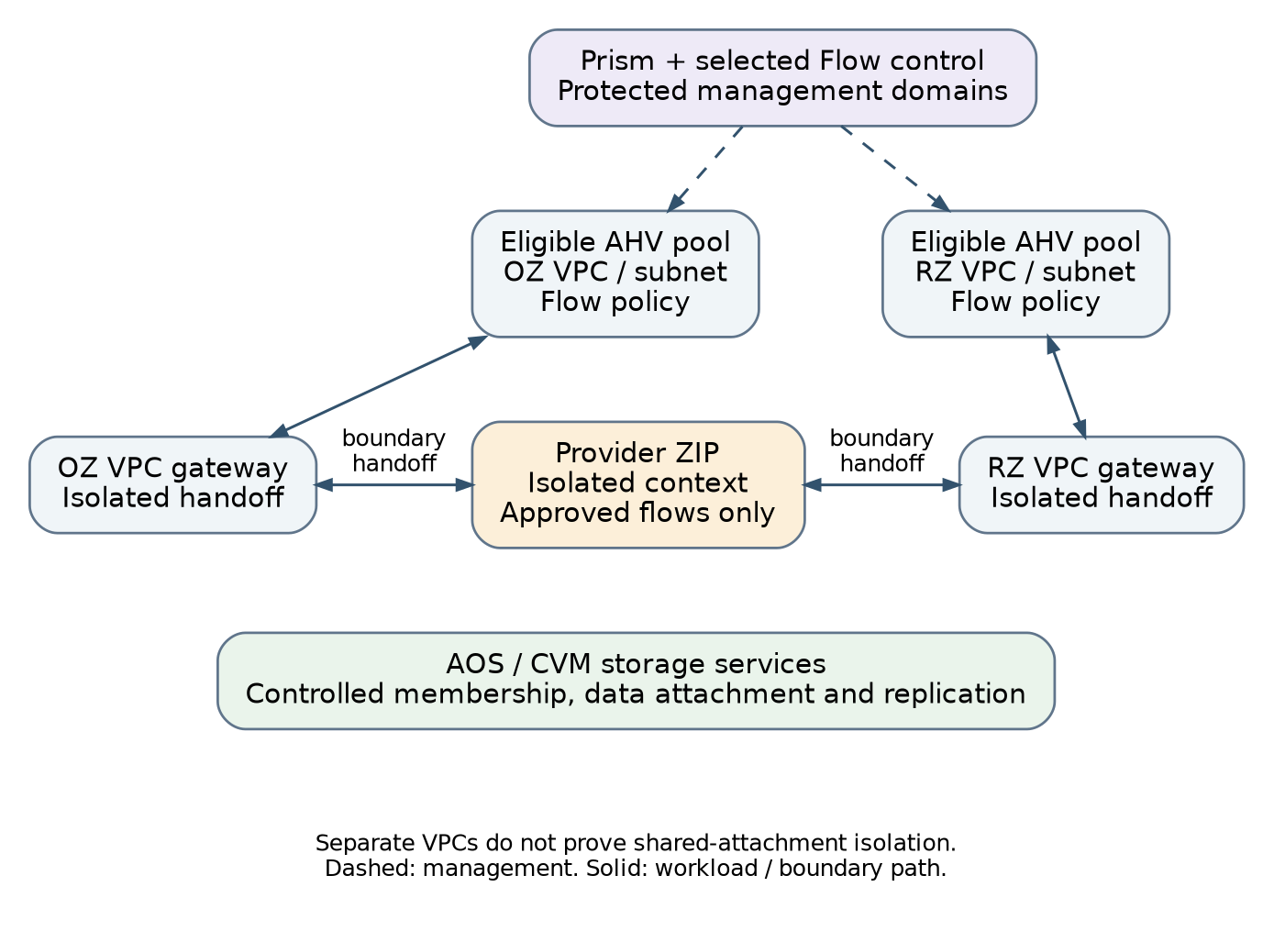
Figure 5. Nutanix reference: VPC domains with controlled external security handoffs

Domain and data-path realization
Use a separate VPC or equivalently qualified routing context for each independent Security Domain Instance. Do not put OZ and RZ networks in one generally routed VPC and assume a diagrammed firewall will intercept native routing. Provider-controlled categories identify tenant, WSD, domain and approved role for policy; they are distinct from project/RBAC entitlement and from a routing boundary.
Within one domain, approved traffic can use the native overlay and mandatory endpoint controls. Between domains, the path is source subnet/gateway, isolated external attachment, the declared security-edge context, destination attachment/gateway and destination subnet. The reverse path is qualified for the selected NAT, no-NAT and routing behaviour. A common connected external subnet is not accepted merely because the VPCs have different names.
The selected default for unique-address internal service is a routed no-NAT handoff where the actual stack supports it and qualification preserves source identity and isolation. NAT remains an explicit option for overlapping address transition or a specific service requirement. A dedicated attachment context is the safe baseline when isolation of a shared external network has not been demonstrated. Precommission isolated attachment slots so routine VPC allocation does not require a new physical VLAN at every request; pool exhaustion triggers a foundation expansion.
Build responsibility | Commission once per approved capacity boundary | Allocate or change for the tenant/domain
Platform | Supported cluster and management deployment; Flow enablement; host/storage/transport baseline | VMs, images/templates and resource policies within entitled pools
Tenancy | Provider IAM, protected categories and approved policy framework | Tenant scope, entitlements and immutable security associations
Networking | Platform transport and bounded isolated external-attachment capacity | VPC, overlay networks, approved gateway/route association and endpoint membership
Security edge | Resilient provider edge and logical-context capacity | Pairwise ZIP relationship, explicit prefixes and permitted flows
Data services | Storage/protection classes, keys and backup infrastructure | Owned storage, protection assignment, service bindings and recovery records

Provisioning order and operational limits
The platform installer or supported bootstrap process first establishes cluster and management services. Terraform starts where a supported management API and protected execution path exist. The provisioning workflow then resolves tenant identity and host eligibility, reserves addresses and attachment capacity, creates the VPC/subnets under deny, establishes the matching edge context and routes, applies required security selectors/policy, and creates compute/storage attachments. Approved service connectivity is activated only after realized-state and path checks.
Nutanix platform resources and shared firewall/IPAM/DNS/backup resources have separate owners, identities and state boundaries even when they contribute to one deployment. Provider v2/v4-backed resource coverage is reviewed against the actual AOS, Prism and Flow combination; a resource name does not prove support for an operation or release. Unsupported bootstrap, policy or protection operations remain declared integration work, not hidden shell commands labelled as complete Terraform provisioning.
Acceptance includes same-host segmentation, shared-attachment bypass, policy selector tampering, route/NAT symmetry, storage isolation, management loss, host evacuation and restore. It also verifies that supported update and delete operations remove obsolete native objects. Existing traffic during Prism or Flow management loss is measured on the selected tuple; the architecture does not promise uninterrupted operation merely because control is conceptually separate from forwarding.
Related engineering: VND §3 — Nutanix: component, path and lifecycle realization

17. VMware and NSX hosting-stack reference realization

Component placement
The VMware pattern uses vCenter-managed ESXi capacity, an explicit networking/security layer such as NSX, and qualified storage and protection services. Plain vSphere networking is not assumed to supply the complete portable security model. NSX distinguishes distributed routing from Edge-hosted service routing. Tier-0/Tier-1 hierarchy and route advertisement affect actual packet paths. Broadcom documents Tier-0 VRF gateways as isolated routing instances under a parent Tier-0. [S18; S33; S34]
The proposed physical layout separates management workloads, Edge/service capacity and tenant workload pools according to the isolation profile. ESXi transport nodes attach to the platform transport network; Edge nodes have separately controlled uplinks toward the security service and border. vCenter, NSX managers and storage/protection administration use protected management paths. Required host mobility and storage networks remain provider infrastructure.
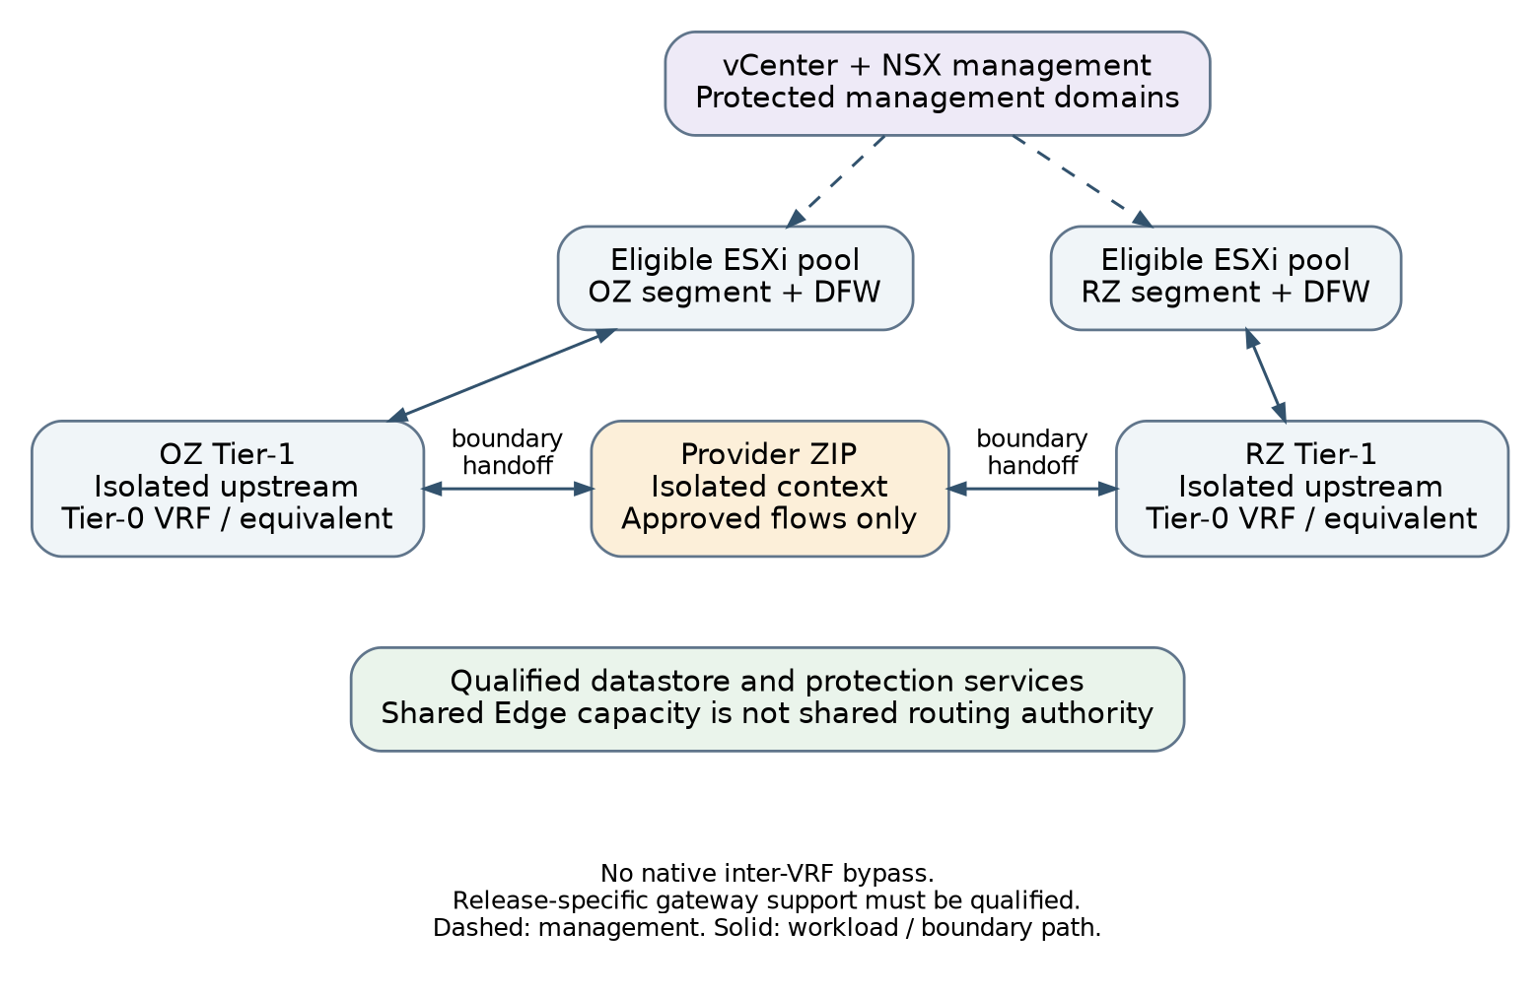
Figure 6. VMware/NSX reference: independent domain routing through the security edge

Selected routing and enforcement pattern
The reference assigns a Tier-1 routing context to each independent domain instance and uses an isolated upstream context, such as a supported Tier-0 VRF, to hand it to the provider security edge. Unrestricted native inter-VRF route leaking is not enabled. A shared parent gateway or Edge cluster is a shared resource/failure dependency, not shared routing authorization. Where the selected release cannot provide this pattern, use another qualified isolated upstream design or do not offer that service class.
This choice deliberately avoids connecting all independent Tier-1 gateways to a common unrestricted Tier-0 table and relying on a downstream firewall. The site design must show the domain prefixes, advertisements, default routes, Edge placement, upstream attachment and return path. It must verify connected and distributed routes as well as centralized service-router policy. A Tier-1 object by itself is not a ZIP, and a conceptual Edge symbol does not prove that every inter-domain packet traverses stateful inspection.
Mandatory distributed policy handles same-domain microsegmentation and protects endpoints on same-host and cross-host paths. Provider-controlled groups/tags and policy hierarchy prevent tenant rules from expanding mandatory permission. The inter-zone ZIP remains a distinct function with joint domain authority, inspection where required, logging and session-revocation behaviour. A native gateway/distributed ZIP variation needs a complete functional equivalence decision, not just a replacement product name.
Build responsibility | Commissioned platform resources | Tenant/domain realization
Compute and storage | vCenter/ESXi pools, eligible hosts, storage policies/backends, images and protection integration | VM placement, virtual hardware, owned disks and protection assignment
Virtual networking | NSX control, transport-node configuration, transport zones and Edge capacity | Project/scope as applicable, segments, Tier-1 and isolated upstream associations
Security | Provider rule hierarchy, group ownership and security-edge capacity | Endpoint membership, explicit domain boundary and permitted flow rules
Management | Protected vCenter/NSX/host/storage administration; credential boundaries | Entitled tenant resource access, not global routing or host administration
Automation | vSphere and NSX integration plus edge, name/address and protection services | Several ordered scoped resource changes for one environment

Provisioning order and failure behaviour
Commission vCenter/ESXi and storage before offering compute capacity; commission NSX transport and Edge/uplink design before offering tenant networking. The tenant workflow establishes entitled scope, reserves addresses and isolated upstream capacity, creates segments and domain gateways under deny, applies distributed and boundary policy, provisions the VM/storage attachments, and then enables approved service routes and exposure. vSphere and NSX resources are managed as separate technical and authority concerns even when one workflow coordinates them.
vMotion or equivalent live mobility remains constrained to eligible pools and supported network/storage arrangements. VM restart after host failure must not break co-residency rules. If target capacity is unavailable, the declared service degrades rather than using an ineligible host. Edge failover must preserve the approved session/routing behaviour; active/active or active/standby is a selected, tested mode, not a generic guarantee.
Acceptance verifies Tier-1/Tier-0 route propagation, no unauthorized inter-VRF path, same-host endpoint enforcement, Edge loss, upstream asymmetry, workload migration, storage/key dependency and restore. Platform and provider release compatibility, gateway feature limits and entitlements are recorded in the implementation profile. The official VRF reference was available as an indexed excerpt during this revision; full-page retrieval was restricted, so this document does not claim a complete review of its release-specific limitations.
Related engineering: VND §4 — VMware/NSX: isolated upstream routing and enforcement

18. OpenStack hosting-stack reference realization

Selected platform pattern
The OpenStack reference selects a supported distribution with Keystone identity, Nova/Placement compute, Neutron networking and an explicitly chosen backend, Glance images and Cinder block storage. The illustrated networking backend is ML2/OVN. File, object, key, load-balancing and backup services are included only where the adopted stack supplies and qualifies them; OpenStack is not treated as a fixed identical product bundle.
OpenStack’s OVN documentation separates controller/database, compute and gateway roles and describes distributed east-west routing as distinct from external gateway traffic. This matters because sending an external path through a network node does not prove that traffic between two attached internal subnets will use that node. [S35]
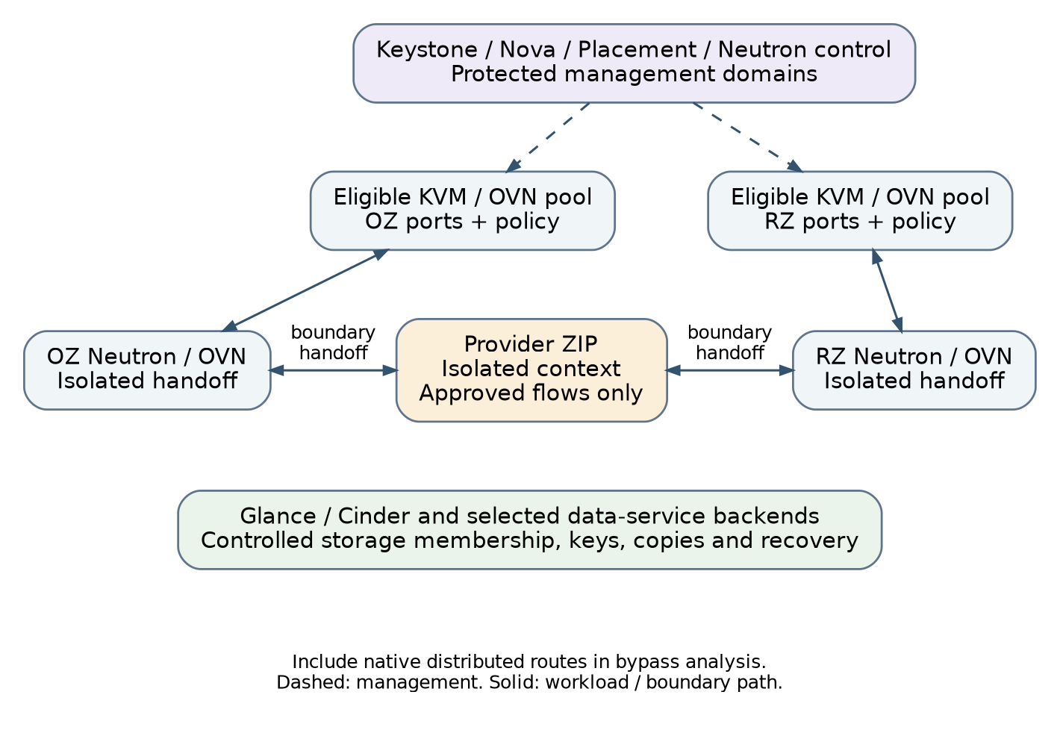
Figure 7. OpenStack reference: project domains with explicit boundary attachments

Compute, tenant and network separation
The proposed deployment separates protected service controllers and databases from tenant compute. Gateway capacity provides the approved external handoff; storage backend services have defined membership, credentials and replication paths. Host aggregates and Placement constraints implement eligible pools with the required zone/tenant restrictions. Availability zones describe offered failure/placement groupings only when backed by actual independent resources. Nova documentation requires explicit scheduler and aggregate configuration for tenant isolation; a group name alone is not an isolation control. [S37]
Keystone projects provide administrative scope. Each independent Security Domain Instance receives a separate Neutron routing/network context and a controlled external attachment. The reference does not connect OZ and RZ subnets through one unrestricted Neutron router and call the result an inspected boundary. Approved inter-domain traffic leaves its isolated context, crosses the provider ZIP, and returns to the destination context. Native distributed routes and any provider-network connections are included in bypass analysis.
Security groups are port-level allow policies; the default group normally permits egress, and multiple groups are additive. Port-security and additional address-pair controls affect the anti-spoofing boundary. The reference removes unapproved default egress while preserving required bootstrap services and protects mandatory policy from tenant override. Tenant roles cannot freely disable port security, attach arbitrary provider networks or create floating-address paths outside the approved exposure service. [S36]
Build responsibility | Commissioned platform resources | Tenant/domain realization
Control | Distribution, service databases/messaging, identity, image, scheduler and API policy | Project/role scope and quotas within the approved service envelope
Compute | Eligible hosts, enforced scheduling/aggregates, image and virtual-hardware classes | Instances/flavours, affinity and owned volume attachments
Networking | Chosen Neutron backend, transport, provider bridges and gateway capacity | Networks, subnets, ports, isolated routers/attachments and approved groups
Data | Cinder backend classes and separate file/object/protection services as offered | Owned data objects, access scope, encryption and backup association
Security boundary | Provider-managed ZIP capacity and restrictions on alternative paths | Explicit domain-to-domain or external service policy and routes

Provisioning and operating sequence
Use the selected distribution’s supported deployment and lifecycle tooling to build the control plane, compute services, networking backend and storage integration. Terraform then provisions supported service resources through qualified APIs; it is not presumed to install or upgrade the entire distribution. Project scope and quotas precede network/port and volume allocation. Baseline policy and isolated boundary attachments precede endpoint activation. Metadata, DHCP/DNS and necessary identity access are explicitly included so a deny baseline does not accidentally prevent secure initialization.
A provider-owned policy or enforcement layer is required where tenant-editable security groups cannot guarantee the mandatory baseline. Direct edits to backend OVS/OVN objects must not compete with Neutron ownership. Distributed floating-IP or direct provider-network paths are disabled for the base internal service unless specifically qualified. The chosen behaviour is recorded, not inferred from generic OpenStack documentation.
Acceptance includes project and port authority, default-group normalization, internal distributed routing, gateway/HA failure, additional NIC/address-pair behaviour, policy persistence after relocation, Cinder attachment isolation, backend/key dependencies and complete deletion. Queues, databases, OVN control and storage quorum are shared dependencies that must be represented in the failure model. Replacing the Neutron backend is an architecture-impacting change, not merely a Terraform provider update.
Related engineering: VND §5 — OpenStack: selected services, backend and mandatory policy

19. Physical workloads and future platform extensions
Bare-metal workloads use the same tenant, domain and service requirements but a different attachment and lifecycle path. Their network may be realized directly by the physical fabric, so creating a new physical routing or attachment context can be an authorized foundation operation. This is a declared service class, not a hidden violation of the routine-overlay no-switch-change objective.
The reference physical-workload pattern includes authenticated hardware management, approved boot and firmware, controlled port membership, an explicit gateway/security-edge path, authorized storage access and media sanitization before reuse. Provider bootstrap traffic is separated from ordinary tenant data. A tenant does not receive unrestricted BMC, switch-port or storage-array authority merely because it has exclusive use of a server.
Container hosting is an extension with separately qualified cluster control, node isolation, workload admission, networking and storage. A namespace by itself is not accepted as a hostile-tenant security boundary. The extension must decide whether tenants share nodes or control planes and identify the actual network-policy enforcement, privileged-workload restrictions and recovery dependencies. The core VM architecture does not require deploying a container platform just to orchestrate its provisioning. [S25; S26]
A new stack joins by implementing the same infrastructure/service interfaces and providing equivalent assurance and lifecycle evidence. It may use different routing, storage or management components. Optional accelerators, high-performance packet processing and special devices remain declared extensions with their constraints on migration, inspection and support. The architecture rejects a required capability gap rather than describing an unsupported approximation as portable.
Boundary of the extension — This chapter defines admission to the architecture, not a complete Kubernetes, bare-metal installer or hardware-driver design. The selected extension needs its own component topology and provisioning profile before it is offered as a production service.
Related engineering: QUAL §8 — Extensions and release maintenance
PART 4 / Provisioning strategy

20. Provisioning model and infrastructure work packages
Provisioning is the controlled realization of the preceding architecture. It has three different scopes: commissioning shared capacity, allocating a tenant environment within that capacity, and changing or retiring the delivered service. They use different authority, timing and failure boundaries. Zero-touch applies to routine approved allocations and changes inside an already commissioned service envelope; it does not mean that racking equipment, establishing trust or approving new security boundaries disappears.
Work package | Infrastructure it owns | Primary execution responsibility
P0 — Bootstrap and trust | Initial privileged access, minimum independent services, trusted tooling and recovery material | Platform/foundation bootstrap process
P1 — Physical foundation | OOB, transport, physical routing and platform/edge attachment capacity | Network and hardware automation; supported configuration interfaces
P2 — Platform commissioning | Cluster/control installation, storage, overlay, eligible pools and protected management | Vendor/distribution installer and lifecycle tooling, supplemented by supported APIs
P3 — Security and common services | Edge contexts/capacity, identity, keys, names, logging, backup and service interfaces | Service owners using their scoped management tools/providers
P4 — Tenant and domain allocation | Entitlements, placement, address reservations, native domain/network objects and mandatory policy | Cross-platform provisioning workflow and qualified Terraform modules/APIs
P5 — Workload and service activation | VMs, volumes, service bindings, approved routes/exposure and operational handover | Platform plus edge/data-service execution under separate authority
P6 — Change and retirement | Resize, repair, migration, restoration, access withdrawal and disposal | Lifecycle owner with dependent platform/service work packages

Each package publishes a bounded handoff: resource identity, eligible service classes, capacity, permitted use, dependencies and readiness. The next package consumes that handoff rather than modifying its predecessor’s infrastructure through a convenient privileged credential. An attachment identifier can be shared; the entire security-edge state file and its administrative credentials need not be.
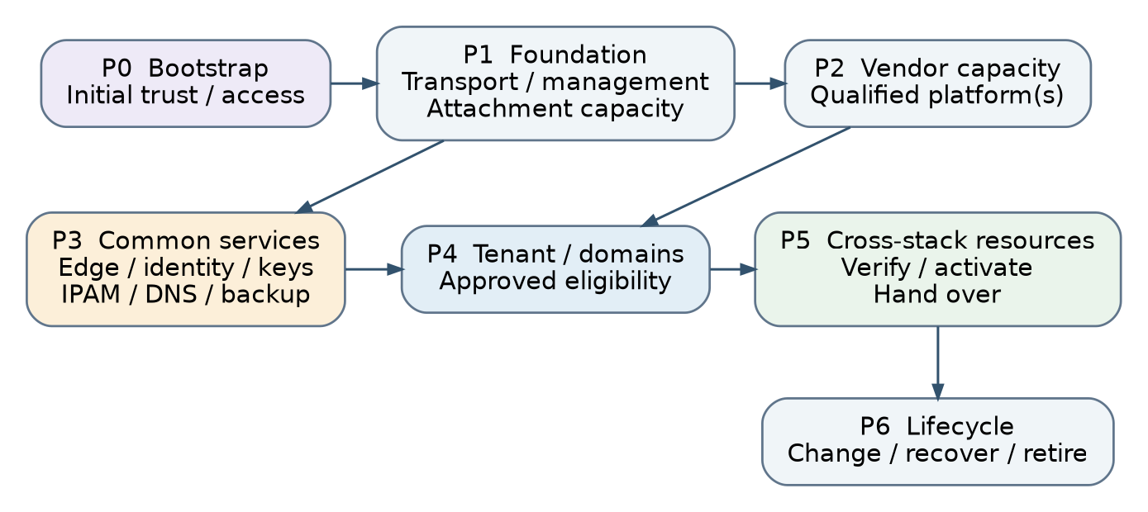
Figure 8. Provisioning dependencies and separate execution authorities

Functional responsibilities, not a prescribed application
The provisioning service needs request intake, authorization, placement checks, reservation, ordered execution, status tracking and evidence. These can be supplied by an existing service catalogue, change workflow, automation platform and inventory system. This reference does not prescribe microservices, a database schema, message bus, programming language or a new custom controller. The implementation must preserve the functions and authority boundaries regardless of tool choice.
Architecture and security owners define eligible templates, profiles and connectivity patterns. Platform and service owners implement native modules and interfaces. A delivery workflow coordinates approved changes, while each package executes with scoped authority. Risk approval and technical verification remain distinct from automated execution. Routine scale changes can be pre-authorized within limits; new exposure, trust relationships or isolation changes require the appropriate authority.
The work-package graph includes explicit bootstrap exceptions to avoid circular commissioning. P2 installation may initially consume accepted P0 name/time/trust services; P2 platform service acceptance and P3 shared-service acceptance are completed together before P4 allocation. Temporary dependencies have named owners and verified steady-state transfer. PROV §§1–2 provide the handoffs and dependency-cut review.
Related engineering: PROV §1 — Provisioning scopes, ownership and accepted handoffs

21. Day-0 bootstrap and physical commissioning
An empty site cannot be provisioned by assuming that the platform APIs, identity service, DNS, certificate trust and Terraform state backend already exist. Day 0 establishes a minimum trusted management and recovery path first. The bootstrap procedure has an accountable owner, a restricted temporary execution environment, verified artifacts and a recorded handover to steady-state management.
Order | Bootstrap or foundation activity | Exit condition
1 | Confirm site resources, power/fault domains, supported hardware, cabling roles and secure staging | Inventory and physical design accepted; no unassigned default-access device exposed
2 | Establish restricted console/OOB and initial administrator trust | Authorized hardware access exists independently of tenant networks
3 | Provide minimum trusted name/time, identity or controlled emergency access, certificate trust and artifact access | Required management dependencies available; temporary credentials and exceptions recorded
4 | Prepare protected automation execution and configuration/state recovery | Verified tooling, scoped network access, encrypted records and recoverable bootstrap material
5 | Commission transport routing, multihoming, platform transport and physical service attachments | Routing, MTU, failure and management-isolation checks pass
6 | Hand over the physical foundation to its steady-state owner | Configuration source, inventory, credentials, monitoring and safe maintenance procedure accepted

Use supported switch/hardware configuration interfaces and platform installation methods. Terraform may manage a resource once its relevant API/provider capability is qualified; it is not assumed to configure every switch operating system or install every hypervisor. A provider coverage gap must be recorded with its supported alternative, owner, error handling and evidence. An arbitrary command embedded in a Terraform run does not become a supported declarative resource merely because the run exits successfully.
Bootstrap services may be temporarily external to the new hosting cell. Their location, access scope, lifetime and transition are documented. When steady-state identity, names, keys and automation are established, migrate ownership without losing recovery access, revoke temporary grants and reconcile configurations. Do not destroy the only recovery material as part of a bootstrap cleanup step.

Foundation changes after Day 0
Adding hosts, new attachment pools, service leaves or another cell follows the same foundation controls without becoming an ordinary tenant operation. Drain or isolate affected resources, verify compatibility and surviving capacity, apply the approved change and requalify impacted paths. A new switch or host is not eligible simply because its management API is reachable. It becomes eligible after its baseline, inventory and operational ownership are accepted.
The commissioning record includes the physical topology, device and firmware inventory, management dependencies, addresses/ASNs, allowed interfaces/neighbours, MTU budget, backup configuration, test evidence and explicit limitations. Those are the inputs Terraform and other provisioning tools consume; they are not values that a workload request invents.
Related engineering: PROV §2 — Day-0 and steady-state commissioning without circular dependencies

22. Vendor-platform and shared-service commissioning
Platform commissioning turns installed capacity into an offered hosting service. The target platform must already have a functioning management path and supported installation. Commissioning establishes eligible compute pools, storage classes, overlay transport, baseline policy, security-edge integration and operational dependencies before any ordinary tenant request is admitted.
Commissioning layer | Nutanix | VMware/NSX | OpenStack
Install/control | Supported cluster and Prism deployment; required Flow components | vCenter/ESXi and selected NSX control deployment | Supported distribution and service control/database/messaging deployment
Resource pools | Eligible AHV hosts, storage/controller scope and placement restrictions | ESXi clusters/host groups, datastore policies and placement restrictions | Nova/Placement hosts, enforced aggregates/traits/flavours and Cinder classes
Network foundation | Platform transport, VPC capability and isolated external-attachment capacity | Transport nodes/zones, Edge capacity and isolated upstream gateway pattern | Chosen Neutron backend, overlay transport, gateway roles and provider mappings
Mandatory security | Protected selectors, default policy and explicit ZIP integration | Provider rule hierarchy, protected groups and explicit ZIP integration | Controlled API/port/group defaults and explicit ZIP integration
Operational service | Identity, logging, images, keys, backup, monitoring and recovery integration | Same architectural dependencies with native integration | Same architectural dependencies with selected distribution services

The platform owner publishes an implementation profile showing the chosen topology, actual versions, supported operations and dependencies. The profile explicitly identifies what Terraform can create, read, update, import and delete, what installer/lifecycle tooling owns, and what requires another service’s execution. API read access alone is not full lifecycle automation. Destructive replacement semantics, asynchronous tasks and eventual consistency are included in the support record.

Common-service commissioning
The edge owner commissions resilient capacity, isolated routing/policy contexts, management controls and observability. Identity and key owners publish authorized consumption endpoints and role/key policies. Network services publish delegated address pools and DNS/DHCP ownership. Backup owners publish supported capture/restore methods, protected repositories and retention classes. Monitoring owners establish independent collection and tenant attribution. These services are not recreated independently by each vendor adapter.
Before the cell is advertised, execute a representative two-tenant environment with separate domain instances, approved shared-service access and protected management. Verify ordinary allocation, changes, fault behaviour, isolated restore and retirement. Prove the selected attachment design, including any shared connected network, under both normal and failed conditions. The measured capacity includes enabled inspection and failure reserve rather than unprotected throughput figures.
Platform readiness requires an accepted topology, supported product/API/provider combination, measured service limits, operational owners and current evidence for the service classes being offered. It is distinct from formal system authorization and from the health of any particular workload. A candidate feature that has only been documented is not advertised as a production capability. Existing service restrictions must remain visible after qualification expires or a dependency changes.
Build order versus ownership — Some installation tasks can run in parallel, but a tenant allocation cannot depend on a security, storage or management foundation that has not been accepted. A shared-service handoff is an explicit gate, not a promise that another team will configure it later.
Related engineering: PROV §2 — Day-0 and steady-state commissioning without circular dependencies • PROV §3 — Terraform, native tools and operation-level support • SVC §1 — Shared service placement and consumption boundaries

23. Tenant, domain and workload provisioning sequence
The consumer supplies the required hosting environment, not the vendor topology. Minimum inputs are accountable tenant/service ownership; confidentiality, integrity and availability context; requested compute/storage classes; zone membership; permitted service flows; shared-service needs; external exposure; availability/recovery and location constraints; and lifecycle/retention requirements. These can be captured in a human-readable deployment specification and translated to automation inputs. Detailed schema design belongs to the implementation annex.
Step | Infrastructure action | Gate and safe failure state
1 — Admit | Check requester authority, approved profiles, quotas, security-zone relationships and declared dependencies | Reject before resource allocation if mandatory requirements conflict
2 — Place and reserve | Select eligible site/cell/pools; reserve compute, storage, addresses and isolated attachment/edge capacity | Reservation has an owner and expiry; no invented address or unqualified target
3 — Establish scope | Create/reuse entitled tenant scope and approved domain instances; assign accountable ownership | Shared domains are not owned exclusively by one retiring WSD
4 — Build denied networks | Create native networks, gateways and domain attachments with mandatory baseline already effective | Endpoints remain absent, disconnected or quarantined until enforcement exists
5 — Establish boundary | Create the paired edge context/association, exact routes and approved policy under edge authority | No alternate native route or uninspected default; return path verified
6 — Provision resources | Allocate approved image/VMs and data objects in eligible pools; attach only authorized networks/storage | Failed placement or attachment does not relax isolation or reassign another tenant’s resource
7 — Attach services | Register names, identity, logging, keys and backup/protection; enable approved service bindings | Required initialization traffic is narrow and attributable; no broad shared-subnet permit
8 — Verify internally | Check health, ownership, policy, route paths, service access, management denial and recovery/protection assignments | Failed or unknown checks keep the environment restricted
9 — Activate | Enable only the approved external exposure/production connections; verify the live service path | Activation is reversible; failed external checks withdraw exposure without destroying data
10 — Hand over | Record as-built resources, responsibilities, evidence and accepted operating conditions | Service Ready only when the delivered scope and required authorization conditions are satisfied

The forward sequence is not one atomic transaction. A cloud API may accept a request before routing or policy is realized, and a runner can lose a response after a resource was created. Operations therefore keep stable request/resource identities, discover actual state and resume or safely compensate. Capacity, address and attachment reservations are reconciled rather than leaked or duplicated.

Cross-stack example
Consider a tenant requesting one internal OZ network, one RZ network, compute in both, protected storage, DNS/time/logging/backup and one approved OZ-to-RZ service flow, with no Internet exposure. On Nutanix, the domain realization uses separate qualified VPC contexts and Flow policy. On VMware/NSX, it uses segments, Tier-1s and isolated upstream contexts. On OpenStack, it uses separate Neutron domain contexts, ports and baseline security controls. All three also require the provider ZIP, authoritative addresses/names, protection service and evidence under their respective owners.
The requirement and acceptance outcome remain the same; the native build steps differ. Creating VMs successfully on each platform is not enough. The deployment must also demonstrate that the intended inter-zone flow works, unapproved paths are denied, management is unreachable from workloads, storage/protection ownership is correct, and later changes and retirement clean up the associated resources.

Updates to an existing environment
A resize within entitled pools follows the normal resource-change path. Adding a zone, new partner relationship, public exposure or a different isolation profile requires renewed architecture/security evaluation. Changed plans must match current resource state and approval. An emergency containment action remains authoritative until explicitly released; ordinary reconciliation must not restore the old allow path behind the incident owner’s back.
Related engineering: PROV §4 — End-to-end fixture provisioning and safe activation • VND §1 — One reference environment, three native realizations

24. Terraform across the vendor stacks

Terraform’s architectural responsibility
Terraform provisions and maintains supported infrastructure resources through their management providers. It does not decide what the enterprise security architecture should be, independently authorize a zone transition, install every physical platform or make a workload portable by converting its data. Its inputs are approved architecture parameters and references to commissioned infrastructure. Its outputs are native resource identities, realized configuration and evidence for the responsible work package.
A deployment is composed from the chosen hosting-stack implementation and the shared services it uses. The workflow selects Nutanix, VMware/NSX or OpenStack resource modules for a domain realization, and also selects the applicable edge, IPAM/DNS, storage/protection and trust-service integrations. Selecting one vendor adapter does not remove the need to provision across those other stacks. The reference deliberately rejects a single all-platform, all-tenant state with unrestricted credentials.
Execution scope | Terraform or associated execution | Inputs and outputs at the boundary
Physical foundation | Qualified network/hardware provider where available; otherwise supported managed configuration tooling | Accepted physical design → transport and attachment capacity; separate foundation credentials
Nutanix resources | Qualified Nutanix provider/API modules | Eligible cluster/VPC/service parameters → owned VM, network, policy and data references
VMware resources | Qualified vSphere and NSX providers, separately scoped as needed | Eligible compute/storage and gateway topology → VM, segment, routing and policy references
OpenStack resources | Qualified OpenStack provider/API modules | Project, service/backend eligibility and quotas → instance, volume, port, router and policy references
Security edge | Selected supported firewall/security-service integration | Approved domain pair and flows → isolated context/policy, routes and enforcement evidence
Names, addresses and common services | IPAM/DNS, backup, key/identity and other supported integrations | Approved allocations/bindings → authoritative reservations, registrations and service acceptance

The implementation records coverage per operation, not merely per provider name: create, observe, update, import/adopt, replace, delete and reconcile failure. An operation unsupported by the provider needs a documented alternative under the same lifecycle and evidence requirements. It must not be represented as completed solely by a placeholder, a no-op module or a script that cannot observe and safely update what it creates.

Module and state boundaries
Root configurations hold provider configuration and pass the required provider references to focused modules, consistent with HashiCorp guidance. Modules express infrastructure work packages such as a domain network, workload resource set or security-edge context. They are not required to mirror every abstract object in the previous schema package. The workflow assembles them according to ownership, lifecycle and dependencies. [S13]
State boundaries follow authority and blast radius: foundation, management, platform/shared services, edge, domain and workload are separately governed scopes, subdivided where necessary. The exact number of state files is an implementation decision. A shared edge may need centralized ownership and serialized updates even while per-tenant workload states run concurrently. Two states or tools must not compete to manage the same native object.
Exchange minimal versioned handoffs rather than granting broad access to another team’s state. A domain workflow can consume an attachment reference or readiness receipt without holding firewall administrator credentials. Protect state and plans with encryption, scoped authentication, locking, versioned recovery and audit. Restoring an old state file is not rollback of the real infrastructure; reconcile real resources before any further apply.

Change execution and reproducibility
Pin supported providers and verify their packages. Commit dependency lock files, but also pin remote module references and execution images independently: Terraform’s provider lock file does not lock remote module selections. An approved change identifies its inputs, dependencies, relevant state versions and policy baseline. Stale or altered changes require re-evaluation rather than reuse of an unrelated approval. [S14]
Use a gated multi-package sequence: reserve, create under deny, configure boundaries, verify, activate and record. Each package has a defined completion signal and data-safe compensation. A failed downstream step may release an unused address but must not destroy shared domains, held backups or newly written production data. Bounded retries and human recovery for ambiguous outcomes are operational requirements, not a demand for a particular saga engine or database implementation.
This document defines what the Terraform solution must provision and its execution boundaries. Working modules, provider bindings, resource arguments, schema validation and CI implementation are separate engineering deliverables. No executable cross-vendor deployment or live integration test is claimed by issuing this architecture revision.
Operation coverage is recorded per actual native resource and management tuple: observe, create, update, adopt/import, replace, delete and recover an uncertain outcome. Unsupported or externally owned operations have a named alternative and accepted handoff. PROV §3 supplies this matrix without claiming that a provider name proves full lifecycle support. PROV §5 addresses delayed native tasks and competing writers after execution failure.
Related engineering: PROV §3 — Terraform, native tools and operation-level support • PROV §5 — Concurrency, ownership and failed execution
PART 5 / Operations and lifecycle

25. Change, brownfield adoption and configuration ownership
Infrastructure changes are classified by their effect on service, isolation and shared failure domains. Ordinary workload scaling within a qualified envelope is different from changing a fabric, storage backend, edge routing, management path or isolation policy. A file in a tenant repository cannot downgrade a foundation-level change simply because Terraform can address the target.
Change class | Required handling
Routine allocation/resize | Validate quota, placement, current state and surviving capacity; preserve mandatory controls
Connectivity/security change | Obtain relevant domain and security authority; verify routes, policy precedence, sessions and both address families
Shared foundation or platform upgrade | Compatibility review, representative test/canary, surviving capacity, backup and supported rollback/recovery
Emergency containment | Scoped authority, evidence where feasible and explicit override protected from ordinary reconciliation
Profile or trust change | Assess all dependent placements and inherited controls; define transition and current-service restrictions
Retirement/disposal | Dependency and retention review; remove live authority and sanitize only the data/resources approved for destruction

Brownfield onboarding
An existing environment is discovered before it is adopted. Inventory physical and logical topology, ownership, active routes, security policies, data locations, credentials, images and operational dependencies. Compare actual behaviour with the reference architecture. Register gaps explicitly; do not call an imported resource compliant because Terraform has a state record for it.
Adoption proceeds in controlled scopes. Assign one authoritative owner/tool to each resource, reconcile desired configuration against current state, review a non-destructive plan, and then import or adopt using the supported mechanism. Prevent accidental replacement of VMs, disks, gateways or shared networks. Resources owned by another controller remain under that owner unless a deliberate handover removes dual management. Importing configuration is not authorization to tear down live infrastructure.
A brownfield migration may require temporary translation, parallel gateways or a staged tenant move. Those are explicit transition designs with owners, expiry, permitted flows and rollback limits. The reference’s steady-state topology remains the target; a transition exception must not become an undocumented permanent shared transit path.

Support and drift
Version and vulnerability management cover hardware/firmware, hypervisors, platform controllers, storage, SDN/security edges, images, providers/modules and privileged execution environments. Remediation windows come from the adopted risk and maintenance policy, not invented universal deadlines. Qualify upgrades against used features and APIs, then promote in stages. Some changes require restore or forward repair because a software downgrade is not supported.
Configuration drift is compared against both the approved design and actual operation. Security-significant drift triggers an accountable decision to restrict, contain or repair. Historical authorization evidence is retained rather than rewritten to suggest it never existed. Exceptions identify scope, authority, compensating controls, review/expiry and closure evidence; an expired exception does not silently become the new architecture.
Related engineering: PROV §5 — Concurrency, ownership and failed execution • PROV §6 — Brownfield adoption, growth and retirement

26. Operating model, capacity and observability
Operations are organized around delivered services and shared infrastructure boundaries. Network engineering owns transport and physical attachment authority; platform engineering owns qualified vendor capacity; security-edge operations owns boundary realization; storage, identity, backup and logging teams own their services. The tenant service owner supplies workload requirements, acceptance and data obligations. The provisioning service coordinates these responsibilities rather than acquiring all their privileges.
A managed service may transfer guest or application operational tasks to the provider, but the responsibility is explicit. The architecture supplies compute, network, storage and declared service controls; it does not claim to prove application business logic or record-level authorization. Guest patching, application secrets, consistency and restored-data acceptance need a named owner. Unresolved mandatory responsibilities prevent handover.
Operating measure | Required distinction or action
Capacity | Separate ordered, staged, commissioned, available, reserved and consumed capacity; record stranded capacity and its cause
Performance | Measure compute/storage/edge/service paths with realistic load and enabled security features, including the agreed failure
Quota and noisy neighbours | Apply accountable tenant limits and reservations across compute, data, routes, sessions, logs and APIs
Health | Distinguish platform/control availability, data-path enforcement and workload service health
Change and support | Track actual versions, configuration ownership, support expiry, maintenance and known limitations
Evidence and incidents | Correlate domain/workload identity with policy, route, storage, identity and privileged-action records

The capacity plan uses measured surviving capability rather than nominal installed totals. Edge sizing includes packets per second, new and concurrent sessions, inspection cost, NAT-port pressure where applicable, logical-context limits and logging. Storage sizing includes rebuild and retained-copy load. Provider API rate limits and address/attachment pool exhaustion are operational bottlenecks too. Expansion is forecast before the service breaches its safe admission limit.
Collect independently attributable infrastructure evidence: privileged operations, configuration changes, route and domain membership, endpoint policy decisions, data-copy operations, key use, backup administration and provisioning execution. Log time and receipt time support correlation when a source clock is unreliable. Stable tenant/WSD/domain identifiers are more useful than names that change during reorganization or migration. The organizational logging baseline governs centralized collection and access. [S11]
Logging is not unlimited payload collection. Apply classification, minimization, tenant-scoped access, integrity and retention. Define buffering, loss indication and safe operating behaviour when central collection is unavailable. Monitoring the ZIP from within the compromised tenant alone is not independent enforcement evidence. The reference prefers service-health and policy-path checks that do not require exposing management interfaces to workloads.
Handover includes the as-built topology, owner/escalation, service parameters, failure dependencies, recovery procedures, access model, backup and key custody, capacity limits, monitoring, support status and active exceptions. The service owner accepts the actual delivered envelope rather than a generic claim that the Terraform run was successful.
Related engineering: QUAL §3 — Capacity, service envelopes and growth triggers • QUAL §7 — Operating accountability, handover and change

27. Recovery, migration and retirement

Recovery and incident containment
Containment is scoped to the affected workload, domain, service binding, external exposure or platform capability. Use the narrowest effective boundary while checking dependencies such as identity, DNS, logging and backup. The incident authority can suspend ordinary provisioning, isolate endpoints or withdraw exposure without redesigning the physical fabric. Emergency blocks remain effective until explicitly released and reconciled into the approved configuration.
Recovery begins by selecting authority and fencing ambiguous writers. Restore trusted OOB/management and minimum identity/time/name/key access, then source/configuration/state/catalogue records, then fabric/platform/storage and security services. Recover data and workloads into authorized isolated target domains. Validate integrity, consistency, required services and security before changing production exposure. Record achieved RTO/RPO and any exclusions rather than equating a completed VM restore with a recovered service.

Cross-platform migration
A migration builds the target infrastructure from the same hosting requirements using the target stack’s realization. It then transfers data and workload state through an explicitly approved temporary connection. Guest drivers, firmware/boot mode, virtual security devices, storage format, application consistency, identity, certificates, keys, DNS, backup and operating procedures are all checked. Terraform creates target resources and connectivity; specialized transfer, conversion or application recovery tooling moves state.
The cutover establishes a final consistency point, prevents conflicting writers, verifies the target, changes service access and observes stability. A rollback after writes on the target may require reverse synchronization or another recovery operation; it is not necessarily safe to start the old VM. Temporary transfer access expires or is explicitly converted into an approved steady-state service. Live migration within a vendor pool remains separate from this cross-platform transition.
Lifecycle phase | Completion condition
Target preparation | Eligible pools, domains, service bindings, keys and protection exist under deny
Transfer and consistency | Approved source/target scopes, integrity checks, defined data-consistency point and bounded transition access
Cutover | Writer fencing, target tests, authorized name/exposure change and operating ownership
Stabilize and failback/exit | Measured service behaviour, tested return/exit feasibility and documented residual dependencies
Source retirement | No obsolete live routes, policy, credentials or public exposure; retained copies remain explicitly owned

Retirement and retained data
Retirement is not a blind Terraform destroy. First identify shared resources, dependent services, required exports/backups and retention holds. Preserve the access needed to satisfy those obligations before withdrawing live service. Remove public and discretionary access, retire workload resources, remove obsolete domain attachments/routes and DNS/DHCP records, revoke identities/certificates/secrets and release addresses through quarantine. Delete a shared domain only when it has no remaining authorized dependents.
Reconcile snapshots, replicas, backups, caches and key lifetimes. Sanitize only resources approved for reuse or disposal, with method and verification evidence. Retained copies move to an accountable retention scope with their necessary keys and controlled recovery access. Final records distinguish the live service being retired from all data being destroyed. Reusing a name, IP address or disk must not inherit stale authority.
Periodic recovery and exit exercises validate the architecture across more than one qualified platform. Measure operational effort, downtime, transfer capacity, policy equivalence and unsupported dependencies. Results drive changes to placement, service classes and procurement rather than a claim that an open disk format alone eliminates lock-in.
Related engineering: SVC §4 — Storage, copies and retained-data ownership • SVC §6 — Failure, recovery, migration and failback topology • PROV §6 — Brownfield adoption, growth and retirement

28. Architecture acceptance and verification
Acceptance dependency: gate IDs identify decision types rather than chronology. Before production activation, the delivered service must already have the applicable operational and promised recovery readiness described by G4, current platform/service qualification and valid operating authority. Restricted non-production qualification is separately authorized and may precede G2 acceptance. WD §9 defines the complete relationship.
Acceptance has three distinct levels: the document describes a coherent reference architecture; an implementation qualifies a specific component/version/topology combination; and an authorized service is accepted for operation. This revision addresses the first level and defines evidence for the other two. It does not mark an unexecuted infrastructure test as passed or issue formal authorization.
Architecture question | Required implementation evidence
Does the built topology match the design? | As-built component/connection inventory, management and data-path diagrams, release tuple and declared variations
Are independent tenants and zones isolated? | Positive/negative tests including same-host, shared attachment, native route propagation, alternative NIC and both offered address families
Are management and shared services separated? | Actual management routes/roles and bounded service/data access; no broad provider-network permission
Are compute and data boundaries real? | Scheduler/HA/migration behaviour, storage attachment/copy isolation, key custody and protected recovery
Does provisioning preserve the architecture? | Successful create/update/adopt/delete, partial-failure reconciliation, authority separation and no orphan resources
Does the service survive its promised failures? | Measured load, convergence/session behaviour, quorum/fencing and recovery of key/identity/control dependencies
Can it be operated and exited? | Named owners, monitoring/support, restore/cutover/retirement procedures and representative second-platform evidence

The retained 80-test catalogue is an assurance specification, not a deployment report. Select tests by the offered service and actual topology; add path-specific procedures for the new realization choices. An automated test must verify that its endpoints and allowed control paths are healthy before treating denied traffic as a security success. Blocked, not-run or unjustified not-applicable results do not satisfy a mandatory gate.
Fault injection, spoofing and outage tests run only in an approved representative environment or controlled production safety envelope. Test scope protects unrelated tenants and includes a restoration procedure. Verification depth grows with exposure, sharing and failure risk. A small laboratory test does not establish the maximum production scale or prove the absence of every possible path.

Evidence and authorization
The evidence set ties the approved design and deployment change to actual resources, routing/policy, service versions, tests, time and active exceptions. It preserves access controls and artifact integrity. Evidence freshness is evaluated after material changes: yesterday’s successful path check does not prove a newly advertised route is safe. Technical conformance and service readiness can change without rewriting historical authorization decisions.
Platform qualification is scoped. A stack may be eligible for one IPv4 internal class but not dual-stack, dedicated isolation or public ingress. Unsupported or expired capabilities stop new placement for the affected service class, while existing service handling follows the approved risk/continuity decision. Formal authorization remains the responsibility of its designated authority and requires the applicable control tailoring and assessment.
Reference implementation gate — Demonstrate two tenants with independent OZ/RZ domains, controlled shared services, protected management, correct placement, restore and complete retirement on the first stack. Repeat the same architectural outcomes on a second stack before claiming multi-platform portability. The third stack is not accepted merely because its object names have been mapped in a table.
Select verification by assertion, service class, topology and stage. First-stack qualification uses the applicable single-stack observations; second-stack comparison and representative data/image recovery then establish the separately claimed portability scope. Do not make two already-qualified platforms a prerequisite to the first platform’s qualification. QUAL §5 records this applicability method while preserving the inherited procedures as not-run.
Related engineering: QUAL §5 — Qualification stages, applicability and evidence • QUAL §6 — Control inheritance, assurance and organizational interfaces
PART 6 / Decisions and implementation

29. Architecture decisions and alternatives
The following decisions make the reference design specific without pretending to select an unknown site’s product versions or hardware counts. They are proposed for architecture adoption. Each implementation records acceptance or an explicit variation, its rationale and the controls and tests affected. The terms cell and work package are architecture concepts; they do not require corresponding software services.
Decision | Selected baseline and rationale | Alternative and acceptance condition
AD-01 — Infrastructure first | Describe components, connections and failure/authority boundaries before automation. Terraform implements that design. | Use existing delivery tools; no custom-controller project is required
AD-02 — Bounded cells | Scale through qualified platform capacity and explicit attachments rather than tenant-driven physical topology churn. | Small-site consolidation requires a documented isolation and recovery design
AD-03 — Native overlays | Vendor overlays remain local to their platform; controlled routed/security handoffs connect stacks. | Direct overlay federation requires an independently qualified interoperability architecture
AD-04 — Explicit ZIP edge | Routed stateful provider boundary with independent logical contexts is the default inter-domain pattern. | Distributed/native ZIP only with complete functional, authority and failure equivalence
AD-05 — Isolated attachments | Use independently isolated domain attachments; do not assume shared connected networks enforce separation. | Shared attachment only with direct-path, neighbour, NAT and failover proof
AD-06 — Zone-aware hosts | Retain zone-specific host-pool baseline and disclose HCI/storage/control sharing. | Alternative co-residency requires explicit security analysis and authorized variation
AD-07 — Management independence | Separate MZ semantics, platform control and OOB recovery transport. | A logically isolated shared transport cannot be labelled physically independent
AD-08 — Consumption endpoints | Shared services expose scoped data/service interfaces; management remains separately governed. | A shared backend is acceptable only with documented authorization and dependency boundaries
AD-09 — Site-local default | Use independent site domain instances and routed replication/recovery. | L2 stretch only for a demonstrated need with partition/fencing analysis
AD-10 — Persistent platform traffic | Storage replication and live mobility may be enduring provider transports; cross-domain migration grants are bounded. | Routing separation follows actual trust/forwarding need, not a functional name
AD-11 — Composite provisioning | Coordinate selected platform providers and shared infrastructure integrations with separate authority/state. | One module/provider cannot be assumed to provision every dependency
AD-12 — Explicit bootstrap boundary | Installers and supported hardware/platform lifecycle tools establish the APIs that declarative provisioning consumes. | Unsupported operations require a declared alternative, not a hidden no-op or unmanaged script
AD-13 — Safe activation | Default-deny infrastructure and mandatory services precede production exposure; verify after activation too. | A failed verification withdraws exposure while preserving owned data for recovery
AD-14 — Single configuration owner | One accountable controller/tool owns each native object; brownfield adoption is reviewed before mutation. | Ownership transfer requires explicit reconciliation and removal of dual writers
AD-15 — Evidence, not counts | Qualification depends on actual outcomes and current topology; page/schema/test counts are not security proof. | Reference documentation, live conformance and formal authorization remain distinct

These decisions intentionally separate a stable target architecture from choices that belong in a low-level implementation. A permitted variation does not silently alter the common service promise. Where an alternative cannot satisfy the mandatory outcome, either exclude that service class or obtain an explicit change to the approved architecture and its assurance basis.
Related engineering: GM §4 — Open decision package for implementation

30. Implementation handoff and delivery sequence
The architecture handoff converts the selected reference into a buildable design for a named site and platform tuple. It is not another application-design exercise. The implementation team supplies the following records, with accountable owners and approval gates. Unresolved values are blocking decisions at their indicated gate, not placeholders that can be silently replaced with product defaults.
Required design record | Contents | Must be resolved before
Site and cell deployment | Physical inventory; racks/power/failure groups; cell boundaries; shared/dedicated resources | Physical commissioning
Network design | Port/link roles; underlay addressing/ASNs; routing/multihoming; VLAN/VNI/RT authority where used; MTU and attachments | Fabric and platform transport acceptance
Management and trust | MZ/OOB topology; admin access; identity/key/certificate dependencies; bootstrap/recovery path | Privileged production operation
Vendor realization | Exact stack/API/provider releases; supported hardware; licences; gateway/storage/host topology and restrictions | Platform qualification
Zone and path schedule | Domain authorities; two-zone relationships; prefixes; flow direction; enforcement and return paths | Tenant connectivity activation
Capacity and service parameters | Usable/surviving capacity; quotas/reserves; performance; SLO/RTO/RPO; limits and recovery cadence | Advertising the service class
Provisioning implementation | Work packages; ownership; tool/provider operation coverage; state/credentials; dependency gates and error handling | Automated tenant allocation
Operating and assurance pack | As-built inventory; support/patch/monitoring; test evidence; exceptions; runbooks; handover and authorization | Service Ready

Delivery sequence
First adopt the topology, isolation choices and ownership model. Commission one site foundation and a small first-platform cell, then the management/security/shared-service dependencies needed for a complete tenant environment. Implement the minimum end-to-end provisioning path across those owners. Prove two-tenant isolation, the approved zone path, changes, recovery and retirement before expanding feature count or scale.
Next realize the same architecture on a second stack and rehearse a representative migration or restore. Use the result to correct resource abstractions and service promises. Add the remaining platform and optional service classes through their own qualification. Do not attempt to achieve portability by making every vendor reproduce a proprietary topology chosen for the first one.
The architecture may be adopted before every target stack is ready, provided unsupported classes remain excluded. Production use still requires named operating owners, actual service parameters, applicable controls and current qualification/authorization evidence. The controlled delivery backlog distinguishes missing design decisions, missing automation coverage and tests not yet executed; those are different kinds of work.
Definition of done for this revision — The revised document provides the infrastructure topology, logical boundaries, vendor-specific reference realizations, shared-service interfaces, provisioning sequence, Terraform boundaries and lifecycle acceptance model. The accompanying mapping preserves the v1.1 requirement and assurance baseline and records the architectural corrections. It is not a claim that the environment has been deployed or qualified.
Use GM §3 as the live design-gap map and GM §4 as the implementation decision package. Each record links this parent to the primary engineering treatment and distinguishes supplied documentation from open site/vendor/build/evidence work. G0–G4 are coordination gates for design adoption, foundation acceptance, platform/service acceptance, tenant activation and operational/recovery acceptance; they map to existing organizational processes rather than creating a required new application.
Related engineering: GM §3 — Detailed gap register and treatment • QUAL §1 — From proposed architecture to accepted service • QUAL §2 — Site low-level design and dependency schedule

Appendix A — Revision scope and baseline traceability
The historical v1.2 revision basis was the 105-page v1.1 handbook and its companion catalogues. Draft v1.4 develops the architecture-led v1.2 document as its immediate baseline. [B1; B2] The change is primarily architectural framing and engineering specificity: physical and logical components, selected native realizations, infrastructure interfaces and provisioning work packages now lead. Detailed API objects, controller status mechanics, schema definitions and code patterns are not part of the main architecture narrative.
v1.1 material | v1.2 treatment
Foundations, tenant/domain/zone model | Retained and connected to physical topology and resource placement
Compute, storage, identity, keys, backup and recovery | Retained as hosting infrastructure; operational paths and dependency boundaries made explicit
Vendor implementation profiles | Expanded into deployment, routing/security and provisioning reference patterns
API/controller and Terraform internals | Translated to functional execution/ownership requirements; detailed code/schema design is supporting material
194 requirements and 80 test procedures | Preserved in the accessible traceability package rather than embedded as the main architectural story
Historic source and migration records | Retained with explicit lineage; newly inspected references and access limitations identified

Explicit requirement clarifications

API-003
Where a consumer-facing provisioning API is provided, it SHALL enforce immutable IDs, idempotent create, optimistic concurrency, typed/closed schemas, authorized references and authoritative service-owned status; stale or unauthorized updates SHALL fail before side effects. These controls MAY be implemented by an existing qualified service interface.
Scope clarification: preserves interface safety without requiring a new custom API/controller application. Existing qualified catalogue or service interfaces can implement the controls.

TF-003
The provisioning workflow SHALL select the required hosting-platform and shared-service adapters before execution; adapters SHALL preserve their authority and lifecycle boundaries. A single giant conditional module SHOULD NOT attempt to implement all platforms.
Composite provisioning clarification: a chosen hosting stack is coordinated with independently owned security, address/name, data-protection and trust-service integrations.
All 194 requirement texts in the v1.2 catalogue remain unchanged in this v1.3 reference register. The two historical v1.2 clarifications above are retained, not newly revised. Every one of the 62 v1.1 chapters maps to one or more architecture chapters. The full requirement JSON and the linked CSV registers provide the full statements, owners, source identifiers, test links and original text. Moving a control into supporting material does not remove it. Requirements concerning interfaces can be implemented through existing qualified systems; no implicit authority is granted to weaken security because the main document is less code-centric.
The retained 80 verification procedures (including document/package and optional-interface checks) and 12 realization-specific addenda are explicitly not-run in the inherited execution records. New local document checks are reported separately and do not qualify infrastructure. Local integrity and publishing checks validate this document package only. Architecture decisions, actual platform qualification, service acceptance and formal authorization remain separate records. The companion audit register records documentation treatments, not live remediation claims.
Document relationship — Read the parent as the proposed infrastructure reference and provisioning strategy. Use the six linked supplements for engineering knowledge and open decisions, and the reference registers for retained normative statements and verification workload. The site low-level design still supplies actual physical values, product compatibility, executed integrations and evidence.
The legacy API/schema companion is not incorporated as a functioning implementation. Its earlier code-level audit findings are not closed by reorganizing the architecture. Any later adoption of that optional implementation requires its own corrected specification, testing and controlled compatibility decisions. GM explains documentation versus decision and qualification closure.
Related engineering: Document family and precedence • Current gap map

Appendix B — Infrastructure interface schedule
Each deployed interface has an owner, endpoint membership, routing/security authority, protocol/address-family profile, failure behaviour and lifecycle. The schedule below defines the interface classes to instantiate; the site design fills their actual addresses, ports, capacity, identifiers and release-specific parameters. It is not a software API schema.
ID / interface | Connection and boundary | Required design record
IF-01 Underlay | Leaf/spine or equivalent physical routed adjacency | ASN/address scope, permitted neighbours/prefixes, multipath, control protection and convergence
IF-02 Platform transport | Tunnel endpoints within a vendor realization over IP transport | Eligible hosts, encapsulation/MTU, address family, isolation and failure behaviour
IF-03 Domain edge attachment | Native domain gateway to its isolated security-service handoff | Independent routing context, allowed prefixes, NAT if used, return path and reuse policy
IF-04 Logical ZIP | Approved relationship between two security authorities | Both domain owners, rules/inspection, policy precedence, logging, sessions, HA and management
IF-05 Privileged management | Authorized administration/automation to named infrastructure interfaces | Identity scope, trusted path, certificates, audit and emergency procedure
IF-06 OOB recovery | Independent authorized access to hardware console/management | Physical dependencies, permitted devices, recovery credentials and test evidence
IF-07 Platform data transport | Hypervisor/controller/storage or live-mobility endpoints | Membership, physical/logical separation, keys, performance and recovery restrictions
IF-08 Shared-service consumption | Tenant/domain to entitled service endpoint | Protocol, direction, identity/data scope, zone boundary and service dependencies
IF-09 Provisioning handoff | One infrastructure owner/work package to its dependent package | Resource reference, eligibility/capacity, ready state, version and ownership; no shared broad credentials
IF-10 Inter-site service | Replication, recovery or explicit cross-site access | Data consistency, bandwidth/latency, encryption, failure ownership, fencing and activation
IF-11 External access | Public/enterprise/partner boundary to a declared exposure service | External authority, entry path, protection, names/certificates, allowed flows and withdrawal
IF-12 Operational evidence | Infrastructure event/measurement to approved collection and review | Source identity/time, protected transport, tenant attribution, access, retention and loss behaviour

Do not infer an interface’s trust from a product label. A provider network can carry a tenant escape path; a management API can change a workload without any guest route; a virtual disk can reach storage without using the guest NIC. The topology and actual authority determine which controls must be implemented and tested.

Appendix C — Architecture terminology
Term | Meaning in this document
Tenant / provider | Consumer administrative scope / operator of the hosting infrastructure and its shared services; provider does not mean a particular manufacturer
Hosting cell | Provider unit of qualified capacity, lifecycle and fault containment; not necessarily a vendor cluster or Nova cell
WSD | Workload Security Domain: bounded hosting-service requirements, lifecycle and ownership for related resources
Security Domain / Instance | Logical zone/authority boundary / its site-and-platform realization
PAZ / OZ / RZ / HRZ | Public Access / Operations / Restricted / Highly Restricted Zone. HRZ is an explicitly approved extension, not a default cloud capability
PZ / REZ / MZ | Public Zone / Restricted Extranet Zone / Management Zone; public and partner authorities are external to the local domain realization
ZIP | Zone Interface Point: the governed boundary relationship and security functions between two zones
OOB | Out-of-band management: a separately designed access/recovery transport, not merely a management VLAN label
Underlay / overlay | Physical IP transport / a logical network carried over transport; different vendor overlays are not automatically interoperable
eBGP / ASN / ECMP | External Border Gateway Protocol / autonomous system number / equal-cost multipath forwarding
EVPN / VXLAN | Ethernet VPN signalling / Virtual Extensible LAN encapsulation; qualified together where used
VLAN / VNI / RD / RT | Virtual LAN / VXLAN network identifier / route distinguisher / route target; implementation allocations owned by the provider
MLAG | Multi-chassis link aggregation; a qualified attachment mechanism distinct from EVPN multihoming
HCI / CVM | Hyperconverged infrastructure / Nutanix Controller VM; controller/storage sharing must be included in isolation analysis
SDN / DFW / OVN | Software-defined networking / distributed firewall / Open Virtual Network, a possible Neutron backend
IPAM / DHCP / DNS | IP address management / dynamic host configuration / domain name services, managed as a consistent lifecycle
IAM / PAM / PKI | Identity and access management / privileged access management / public key infrastructure
KMS / HSM | Key management service / hardware security module; key use, administration, recovery and destruction are separate authorities
SLO / RTO / RPO | Service-level objective / recovery time objective / recovery point objective; require actual adopted and measured parameters
Service binding / exposure | Scoped use of a provider service / an approved relationship with an external access domain
Provisioning work package | An owned infrastructure change scope with prerequisites, execution authority, handoff and completion evidence
Qualification / authorization | Evidence that a specific implementation meets an offered profile / a separately issued acceptance of system security risk
Portable / composite / migrated | Equivalent deployment on another stack / one delivery using several stacks or shared services / transfer and cutover of actual workload/data state

Appendix D — Sources and review status
Source IDs distinguish baseline-derived architecture from external context. References inform the stated design, not automatic adoption, installed compatibility or authorization. New engineering examples are local proposals. Review status below is specific to this release; inherited dates are not recertified merely by copying the source register.

B1 — Portable Multi-Tenant Secure Hosting Handbook, Draft v1.1
September 2026, 105 pages | User-provided/generated conversation baseline
Primary revision basis. Requirement/test records and section lineage retained. The content is architecture guidance, not proof of live conformance.
Review status: Inherited baseline reference; not independently reverified in this release.

B2 — Portable Secure Hosting — Infrastructure Reference Architecture and Cross-Platform Provisioning Strategy, Draft v1.2
16 September 2026; 55-page conversation baseline | Source baseline, not external authority
Primary parent narrative, diagrams, 30 sections, 194 requirement IDs and referenced verification catalogues.
Review status: Entire text read; three vendor diagram pages also inspected through Files; source bytes verified.
Source file: Portable_Secure_Hosting_Infrastructure_Architecture_v1_2.docx. Complete baseline fingerprint is in registers/release_manifest.json.

S01 — ITSP.80.022 - Baseline security requirements for network security zones, version 2.0
Effective 2021-01-12 | Cyber Centre guidance
Sections 2-4 and annexes A-F. Zone definitions, joint ZIP authority and management boundaries. Architecture requirements in this handbook are local translations, not quotations.
Review status: Inherited baseline reference; not independently reverified in this release.
Open official source — ITSP.80.022 - Baseline security requirements for network security zones, version 2.0

S02 — ITSP.80.023 - Cloud network security zones
Effective 2023-06-12 | Cyber Centre guidance
Companion to ITSP.80.022; cloud ZIP functions, isolated MZ approach and control/data-plane distinctions. Limited to Unclassified/Protected A/Protected B context.
Review status: Full official page reviewed: cloud-zone scope, management and ZIP context.
Open official source — ITSP.80.023 - Cloud network security zones

S03 — ITSP.70.010 - Best practices for data centre virtualization
Effective 2020-03-27 | Cyber Centre guidance
Section 3: strong recommendation against co-locating VMs from different network security zones on the same physical hardware. Sharing requires explicit risk analysis, not a VPC claim.
Review status: Full official page reviewed: virtualization/management/storage separation context.
Open official source — ITSP.70.010 - Best practices for data centre virtualization

S05 — ITSP.10.033 - Security and privacy controls and assurance activities catalogue: Foreword, overview, introduction
Effective 2026-03-31 | Cyber Centre control catalogue
Explicitly supersedes ITSG-33 Annex 3A. Canadian-specific 100-series identifiers move to 400-series. Source families are starting points for tailoring, not automatic control equivalence.
Review status: Full official page reviewed: 2026 catalogue transition; not a selected-control assessment.
Open official source — ITSP.10.033 - Security and privacy controls and assurance activities catalogue: Foreword, overview, introduction

S10 — ITSP.40.111 - Cryptographic algorithms for Unclassified, Protected A and Protected B information, version 5
Effective 2026-05-29 | Cyber Centre cryptographic guidance
Use a versioned cryptographic profile and migration inventory; a fixed legacy algorithm list is insufficient.
Review status: Full official page reviewed: versioned algorithm guidance; no product validation asserted.
Open official source — ITSP.40.111 - Cryptographic algorithms for Unclassified, Protected A and Protected B information, version 5

S11 — Event Logging Guidance
Public page reviewed 2026-09-16 | GC operational guidance
Centralized protected event collection, event classes and operational ownership. Local retention examples are not attributed as GC-mandated durations.
Review status: Inherited baseline reference; not independently reverified in this release.
Open official source — Event Logging Guidance

S13 — Terraform - Providers within modules
Documentation snapshot 2026-09-16 | Implementation documentation
Provider configuration in root modules; explicit provider passing and aliases where required.
Review status: Full official page reviewed: root provider configuration and module passing.
Open official source — Terraform - Providers within modules

S14 — Terraform - Dependency lock file
Documentation snapshot 2026-09-16 | Implementation documentation
Locks provider selections/checksums, not remote module selections; pin module versions or immutable revisions separately.
Review status: Full official page reviewed: provider lockfile versus remote module versioning.
Open official source — Terraform - Dependency lock file

S17 — Nutanix Terraform provider - official repository
Version information inherited from the prior review; no current provider selection made | Implementation documentation, not certification
Provider provenance reference only. Earlier README version notes are not a current or qualified implementation tuple.
Review status: Inherited baseline reference; not independently reverified in this release.
Open official source — Nutanix Terraform provider - official repository

S18 — VMware NSX Terraform provider - official repository
Documentation snapshot 2026-09-16 | Implementation documentation, not certification
Provider provenance and NSX realization context; exact product/provider tuple must be qualified before placement.
Review status: Inherited baseline reference; not independently reverified in this release.
Open official source — VMware NSX Terraform provider - official repository

S20 — RFC 8212 - Default External BGP route propagation behavior without policies
2017 | IETF technical specification
Import/export policy requirements inform the provider-owned fabric profile; confirm vendor implementation behavior.
Review status: Inherited baseline reference; not independently reverified in this release.
Open official source — RFC 8212 - Default External BGP route propagation behavior without policies

S21 — RFC 7432 - BGP MPLS-Based Ethernet VPN
2015; update/errata chain reviewed | IETF technical specification
Foundational EVPN signaling and multihoming concepts; it is not by itself a VXLAN conformance claim.
Review status: Inherited baseline reference; not independently reverified in this release.
Open official source — RFC 7432 - BGP MPLS-Based Ethernet VPN

S22 — RFC 8365 - A network virtualization overlay solution using EVPN
2018 | IETF technical specification
EVPN overlay use. Qualify extensions and interoperability rather than assuming equal product feature sets.
Review status: Inherited baseline reference; not independently reverified in this release.
Open official source — RFC 8365 - A network virtualization overlay solution using EVPN

S23 — RFC 8200 - Internet Protocol, Version 6 specification
2017 | IETF technical specification
IPv6 transport foundation; security semantics and operational profiles remain explicit.
Review status: Inherited baseline reference; not independently reverified in this release.
Open official source — RFC 8200 - Internet Protocol, Version 6 specification

S24 — RFC 4890 - Recommendations for filtering ICMPv6 messages in firewalls
2007 | IETF guidance
Avoid blanket ICMPv6 denial that breaks required protocol operation; filter by the selected profile.
Review status: Inherited baseline reference; not independently reverified in this release.
Open official source — RFC 4890 - Recommendations for filtering ICMPv6 messages in firewalls

S25 — Kubernetes - Multi-tenancy
Documentation snapshot 2026-09-16 | Implementation documentation
Namespace isolation is not a complete hostile-tenant boundary; compute/control-plane choices require threat analysis.
Review status: Inherited baseline reference; not independently reverified in this release.
Open official source — Kubernetes - Multi-tenancy

S26 — Kubernetes - Network Policies
Documentation snapshot 2026-09-16 | Implementation documentation
NetworkPolicy depends on enforcement support; connectivity policy does not replace identity, host or storage controls.
Review status: Inherited baseline reference; not independently reverified in this release.
Open official source — Kubernetes - Network Policies

S27 — NIST SP 800-88 Revision 2 - Guidelines for Media Sanitization
Final 2025 | Supporting technical guidance; GC tailoring required
Sanitization methods and verification; use applicable GC media-handling rules and approved technical methods.
Review status: Inherited baseline reference; not independently reverified in this release.
Open official source — NIST SP 800-88 Revision 2 - Guidelines for Media Sanitization

S31 — Nutanix — Configuring NAT and No NAT VPCs in Flow Virtual Networking
2022-10-18; conceptual reference | Official implementation documentation; not certification
External subnet and NAT/no-NAT concepts; historic feature limits are not asserted as current release limits.
Review status: Historic official article reviewed for NAT/no-NAT concepts only; not current product limits.
Open official source — Nutanix — Configuring NAT and No NAT VPCs in Flow Virtual Networking

S32 — Nutanix — Enabling Flow Virtual Networking on AHV
2022-12-12; conceptual reference | Official implementation documentation; not certification
Prism/Flow enablement and management dependency context; exact deployment/version requires current product qualification.
Review status: Inherited baseline reference; not independently reverified in this release.
Open official source — Nutanix — Enabling Flow Virtual Networking on AHV

S33 — Broadcom — NSX Tier-0 VRF gateways
NSX 4.2 documentation reference | Official implementation documentation; not certification
Isolated routing instances under a parent Tier-0. Official indexed excerpt inspected; full-page request returned HTTP 403. Release-specific limitations not independently verified.
Review status: Official indexed excerpts inspected; full-page retrieval unavailable. Exact release/feature limits remain unverified.
Open official source — Broadcom — NSX Tier-0 VRF gateways

S34 — VMware — Multi-tiered routing with NSX-T
2018-02-20; conceptual reference | Official implementation documentation; not certification
Tier-0/Tier-1 and distributed/service-routing concepts; not a current compatibility or licensing statement.
Review status: Inherited baseline reference; not independently reverified in this release.
Open official source — VMware — Multi-tiered routing with NSX-T

S35 — OpenStack Neutron — OVN reference architecture
2026.1 documentation branch | Official implementation documentation; not certification
Role separation, distributed routing and external gateway behaviour. Documentation branch is not the chosen production release.
Review status: Official 2026.1 reference branch reviewed for OVN roles/routing; not selected installed release.
Open official source — OpenStack Neutron — OVN reference architecture

S36 — OpenStack Neutron — OpenStack Networking
2026.1 documentation branch | Official implementation documentation; not certification
Port/security-group/provider-network semantics; selected backend-specific behaviour is separately qualified.
Review status: Official 2026.1 reference branch reviewed for security-group and network semantics.
Open official source — OpenStack Neutron — OpenStack Networking

S37 — OpenStack Nova — Host aggregates
2026.1 documentation branch | Official implementation documentation; not certification
Scheduling and Placement/aggregate controls; labels do not alone establish isolation.
Review status: Official 2026.1 reference branch reviewed for aggregate/scheduling context.
Open official source — OpenStack Nova — Host aggregates

S38 — RFC 7766 — DNS Transport over TCP: Implementation Requirements
March 2016 | IETF standards-track reference
General-purpose DNS TCP support and fallback; not a blanket firewall policy for all DNS roles.
Review status: Official full text reviewed.
Open official source — RFC 7766 — DNS Transport over TCP: Implementation Requirements

S39 — ITSP.40.062 — Guidance on securely configuring network protocols
Official web guidance reviewed 16 September 2026 | Cyber Centre guidance; applicability and selected configuration require adoption
Secure protocol configuration as distinct from algorithm selection.
Review status: Official full page reviewed.
Open official source — ITSP.40.062 — Guidance on securely configuring network protocols

Appendix E — Linked engineering knowledge and decision map
Each supplement is subordinate to the parent architecture. The tables and worked reference environment provide engineering detail, not invented site values or platform qualification. Stable document/section links identify the primary knowledge home and the gap register identifies what still requires an actual decision or evidence.
Parent topic | Supplement home | Remaining implementation obligation
Site/cells and service capacity | QUAL §§2–4 | Actual site/failure inventory, measured service limits and approved parameters.
Fabric, attachments and zone paths | NET §§1–6 | Native route/interface schedule, supported multihoming/MTU and path evidence.
Native hosting stacks | VND §§1–7 | Exact supported tuple, operation coverage and the common outcome fixture.
Infrastructure provisioning | PROV §§1–6 | Working scoped integrations, bootstrap, lifecycle and safe failure recovery.
Services, data, trust and recovery | SVC §§1–6 | Actual consumption/management paths, copy/key custody and tested recovery.
Acceptance and open decisions | GM §§3–5; QUAL §§5–8 | Owned decisions, assertion-level evidence, operational and formal acceptance.

Related engineering: Architecture Gap Map and Design Decision Register • Fabric, Security Boundaries and Infrastructure Interfaces • Vendor-Stack Realizations and Common Reference Environment • Cross-Stack Provisioning and Commissioning Strategy • Shared Services, Data Protection and Recovery Architecture • Site Design, Qualification and Operational Acceptance
The registers directory supplies editable gap, site-decision, operation-coverage, requirement-to-document and source-review data. Every open item distinguishes source-derived observation, proposed treatment and actual implementation proof still required. Keep the Word documents in the same folder after extraction for cross-document links.

v1.4 — Connected infrastructure design and acceptance

Acceptance dependencies and the worked reference
The linked WD supplement connects the component inventory, isolated handoffs, exact illustrative routes, service permissions, provisioning receipts and verification assertions. It preserves the four-domain fixture while accounting separately for service-facing paths and temporary test resources. These are proposed reference values, not a site bill of materials. Production activation requires current G2 qualification, the applicable G4 operational and recovery readiness, per-workload checks and valid authority to operate. Restricted pre-production qualification can occur under a separate test authorization before G2 acceptance; it is not production Service Ready.
Authoritative linked treatment: WD — Worked Infrastructure Design, Build Schedules and Acceptance
Read this clarification with the original chapter. It does not create an exemption to an adopted requirement, waive a mandatory control, select an unknown site value or report a live test as passed.

