INFRASTRUCTURE ARCHITECTURE / VND
v1.4 linked worked design: WD — resources, paths, build receipts and acceptance

Portable Multi-Tenant
Secure Hosting
Vendor-Stack Realizations and Common Reference Environment
Draft v1.4 | 16 September 2026
A common two-tenant reference environment and its native component, routing, data and lifecycle realization on Nutanix, VMware/NSX and OpenStack.
Document control | Record
Document ID / parent | VND — supplement to RA v1.4
Status | Proposed reference design and engineering guidance; adoption and qualification remain separate.
Baseline | Draft v1.2 infrastructure architecture, with retained v1.2 requirements and verification catalogues.
Audience | Infrastructure, security, network, platform, storage, service and operations owners; provisioning engineers.
Authority | Applicable external obligations and adopted controls prevail; supplements cannot silently weaken the parent.
Release boundary | Documentation and local document checks only. No live infrastructure deployment, qualification or authorization asserted.

Start here: Parent architecture — RA • Document family and gap map — GM
Keep the eight Word files together after extracting the release package. Cross-document links use sibling filenames and stable bookmarks. START_HERE.html provides an additional navigation index.

Contents
1. One reference environment, three native realizations 3
2. Physical placement and the sharing decision 4
3. Nutanix: component, path and lifecycle realization 5
4. VMware/NSX: isolated upstream routing and enforcement 7
5. OpenStack: selected services, backend and mandatory policy 8
6. Portable, composite and migrated service choices 10
7. Implementation tuple and decision package 11
References — Parent basis and external context 13
v1.4 — Connected infrastructure design and acceptance 14

Use the contents and named section links to navigate. After later edits, update Word fields and verify pagination before release.

1. One reference environment, three native realizations
Additional test capacity: one endpoint in each of four domains does not supply a same-domain endpoint pair. WD §11 adds one authorized disposable probe used sequentially, with peak five endpoints; simultaneous extra probes require separate capacity. Test same-host placement only where that co-residency is permitted.
Parent architecture: RA §7 • RA §15 • RA §23
The reference environment is a small qualification fixture, not a minimum production bill of materials. It contains two independent tenants, one WSD per tenant, an OZ and RZ domain instance for each WSD, and one disposable processor and data-service endpoint per tenant. The two endpoint roles exist to test hosting, placement, routing, storage and recovery; no business application design is prescribed. Production endpoint counts, quorum and availability are separate service decisions. [B2 §§7, 15, 23]
Stable identity | Meaning | Native allocation outcome
tenant-01 / WSD-01 | First administrative scope and bounded workload environment. | Entitled resource access; no provider-wide management rights.
D01O / D01R | Independent OZ and RZ instances; symbolic prefixes P01O/P01R. | Separate routing/policy realization and qualified host-pool eligibility.
A01O / A01R; Z01 | Domain attachments and the approved tenant-01 OZ↔RZ boundary. | Isolated handoffs, correct forward/return routing and explicit policy.
tenant-02 / WSD-02 | Second administrative scope with no default path to tenant-01. | Same service outcomes but independently owned native resources.
D02O / D02R | Second pair of OZ/RZ instances; prefixes P02O/P02R. | No shared routing authority merely because zone labels match.
A02O / A02R; Z02 | Second pair of attachments and boundary relationship. | Policy and lifecycle remain independent of Z01.
Resolver/time/log/backup/key services | Approved shared consumption interfaces selected for the fixture. | Bindings and service-side entitlement, not broad provider-subnet access.

The baseline fixture has no public ingress or general Internet egress. REF-DATA-HTTPS permits a processor to initiate TCP/443 to its own data endpoint with endpoint TLS validation. Necessary name, time, protection and initialization flows are separately declared. The same expected outcomes apply when the entire fixture is recreated on each stack; this does not require identical native object names or a shared overlay.
Accounting item | Fixture quantity | Not included by implication
Tenants / WSDs | 2 / 2 | Independent platform installations per tenant are not implied.
Domain instances / native routing scopes | 4 / at least the isolated scopes required by the selected realization | Four routing scopes do not establish four independent physical failure domains.
Logical domain attachments | 4 | Redundant links, physical ports and service-side contexts counted separately.
OZ↔RZ boundary relationships | 2 | Additional shared-service and management boundaries depend on actual placement.
Disposable compute endpoints | 4 | Not a production HA application or sufficient product cluster size.
Data/protection objects | Owned per endpoint/WSD as required by the selected test service | Snapshots, replicas, retained backups and keys are additional attributable objects.

Qualification compares observed service outcomes: correct allocation, placement, intra-domain enforcement, approved inter-zone communication, management denial, data entitlement, service consumption, safe change, isolated restore and clean retirement. A successful VM create on all three platforms is insufficient. The fixture’s symbolic names are translated to actual native resource identifiers and retained in its as-built record.
Related engineering: Shared path schedule • Fixture provisioning sequence • Qualification stages

2. Physical placement and the sharing decision
Parent architecture: RA §4 • RA §7 • RA §11 • RA §12 • RA §14
A security-domain boundary is logical, but compromise and failure can cross shared physical or administrative dependencies. Document sharing separately for compute hosts, cluster control, storage controllers/media, transport, security-edge hardware, management, backup and keys. The parent retains zone-specific host pools as its baseline. Any alternative requires the appropriate security decision; an isolation label or platform project is not sufficient evidence. [B2 §§7, 11–14; S03]
Layer | Baseline reference placement | What must be decided and demonstrated
Management/control | Protected management capacity and scoped administrative domains. | Exact hosting/recovery dependency; management availability during workload-cell failure.
OZ and RZ compute | Eligible zone-specific pools; compatible tenant sharing only when approved. | Actual domain authorities permitted to share, scheduler restrictions and restart/evacuation behaviour.
Security-edge services | Separately governed capacity with bounded failure and privilege effects. | Dedicated or shared hardware, per-context routing/policy and surviving inspection load.
Storage/controller | Backend and copy ownership explicitly recorded. | HCI controller/media sharing, access scope, encryption, rebuild and copy operations.
Transport | Shared fabric may carry isolated platform and service paths. | No route/connected-path bypass; actual rack/uplink common failures.
Recovery infrastructure | Preauthorized target with usable keys, names, catalogues and eligible capacity. | No dependency on the sole failed primary resource to recover itself.

Choose a sharing outcome at each layer: dedicated physical, dedicated logical on shared hardware, or explicitly approved shared service. Record who can administer the layer and what a compromise at that layer can affect. Physical dedication of hosts does not make shared identity, storage, security edge or backup independent. Failure-domain independence and administrative independence are two different observations.
The low-level design translates the decision into scheduler restrictions, host/cluster membership, service placement, credentials and fail actions. Test normal placement, resize, live mobility where offered, evacuation, HA restart and restore. A lack of eligible spare capacity should produce a defined service degradation or rejection, not an unapproved move across a zone or dedication boundary.
Related engineering: Physical dependency worksheet • Control inheritance

3. Nutanix: component, path and lifecycle realization
Parent architecture: RA §16 • RA §22 • RA §24
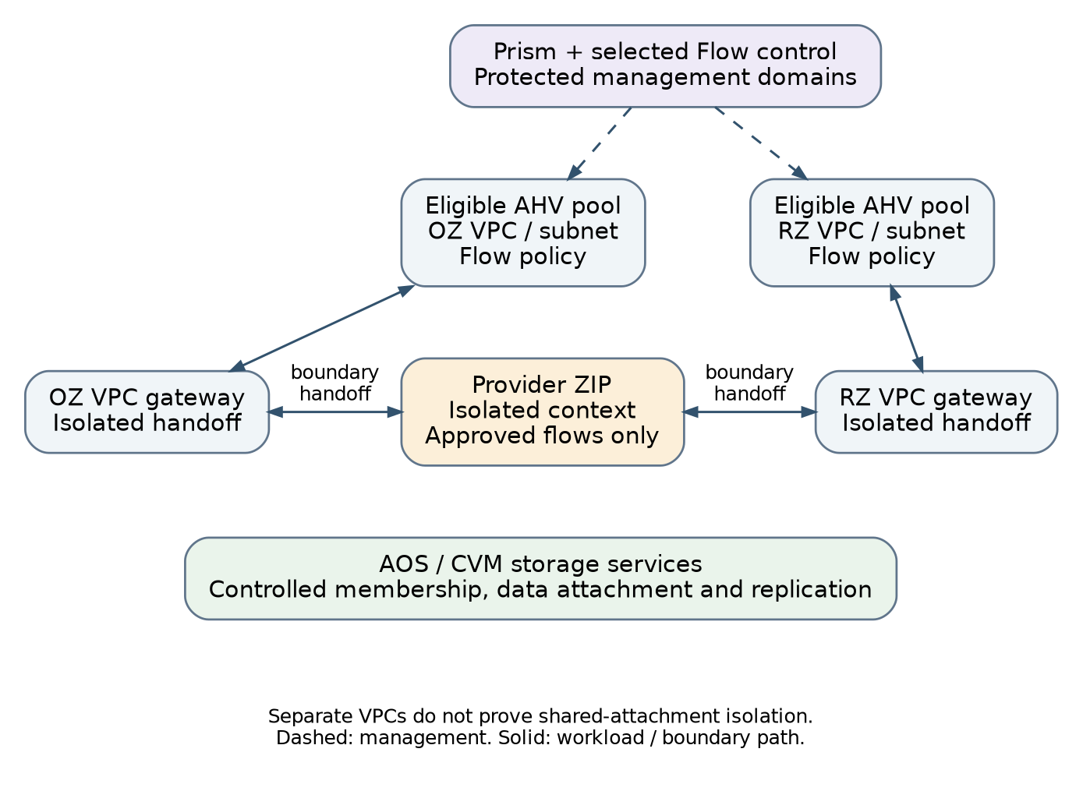
Figure 1. Nutanix reference realization inherited from the parent architecture
The proposed Nutanix realization uses AHV compute, AOS storage and Prism-based administration with selected Flow networking/security functions. Tenant administrative scope, provider-owned security categories, VPC routing and workload policy are distinct responsibilities. A VPC per independent domain instance supplies a candidate routing separation mechanism; it does not prove shared-attachment or host/storage isolation on its own. [B2 §16]
Architectural element | Candidate native realization | Commissioned versus allocated
Management and eligible capacity | Prism, required Flow control and AHV/AOS cluster resources with accepted placement policy. | Commissioned by supported platform tooling; tenant workflow consumes eligible capacity.
D01O/D01R/D02O/D02R | Four independently controlled VPC/routing contexts with appropriate overlay subnets. | Allocated within the accepted networking service; exact object scope is release-specific.
A01O…A02R | Isolated external handoffs toward the security service. | Underlying attachment capacity commissioned; slots assigned and owned per domain.
Z01/Z02 | Provider ZIP associations, routes and permitted service flows. | Edge service commissioned independently; domain relationships applied under edge authority.
Endpoint identity and policy | Protected categories/selectors and qualified Flow policy. | Provider baseline precedes endpoint attachment; tenant labels cannot override it.
Owned data and protection | VM disk/data objects, storage policy and supported protection integration. | Storage/protection classes commissioned; allocations and recoverable copies owned per WSD.

For PATH-01, traffic leaves the source overlay through its native VPC gateway and isolated handoff, crosses Z01, and returns through the destination’s isolated handoff and gateway. Review return routes and any translation. The parent prefers a supported no-NAT internal handoff for unique addresses; NAT is an explicitly chosen alternative. The historic vendor NAT/no-NAT article explains the concept but is not a current compatibility matrix or source of current scale limits. [B2 §16; S31]
AOS virtual-disk access is mediated by the virtualization/storage stack, not assumed to traverse the guest’s inter-zone IP firewall. The design must therefore verify the actual disk attachment, controller/storage access and copy permissions. Guest file/object access, where offered, uses the normal IP service path plus tenant data authorization. Include controller, management and replication co-residency in the adopted sharing decision.
Build/change stage | Required result | Evidence or unresolved qualification
Platform commissioning | Supported cluster/control/Flow enablement; eligible pools and storage/protection service. | Actual hardware, AOS/Prism/Flow/API/provider tuple and licences remain site inputs.
Domain allocation | Identity scope, address and attachment reservation; VPC/subnets and policy under deny. | Readiness and connected/native paths inspected before use.
Boundary/endpoint activation | Matching edge policy/routes, owned VM/data attachments and necessary services. | Positive/negative paths, correct source identity and service-side entitlement.
Change/recovery/retirement | Observe asynchronous task outcome; preserve placement, copies and shared resources. | Import/update/delete/restore support and failure reconciliation tested per operation.

Unresolved implementation questions include the selected release’s VPC/attachment and IPv6 coverage, effective mandatory-policy precedence, external-network isolation, API task/readiness semantics and provider operation coverage. Resolve each against current official product material and the installed environment. The source family establishes a candidate mechanism, not permission to fill unsupported gaps with unobserved scripts.
Related engineering: Operation coverage record • Attachment accounting • Data-path and copy controls

4. VMware/NSX: isolated upstream routing and enforcement
Parent architecture: RA §17 • RA §22 • RA §24
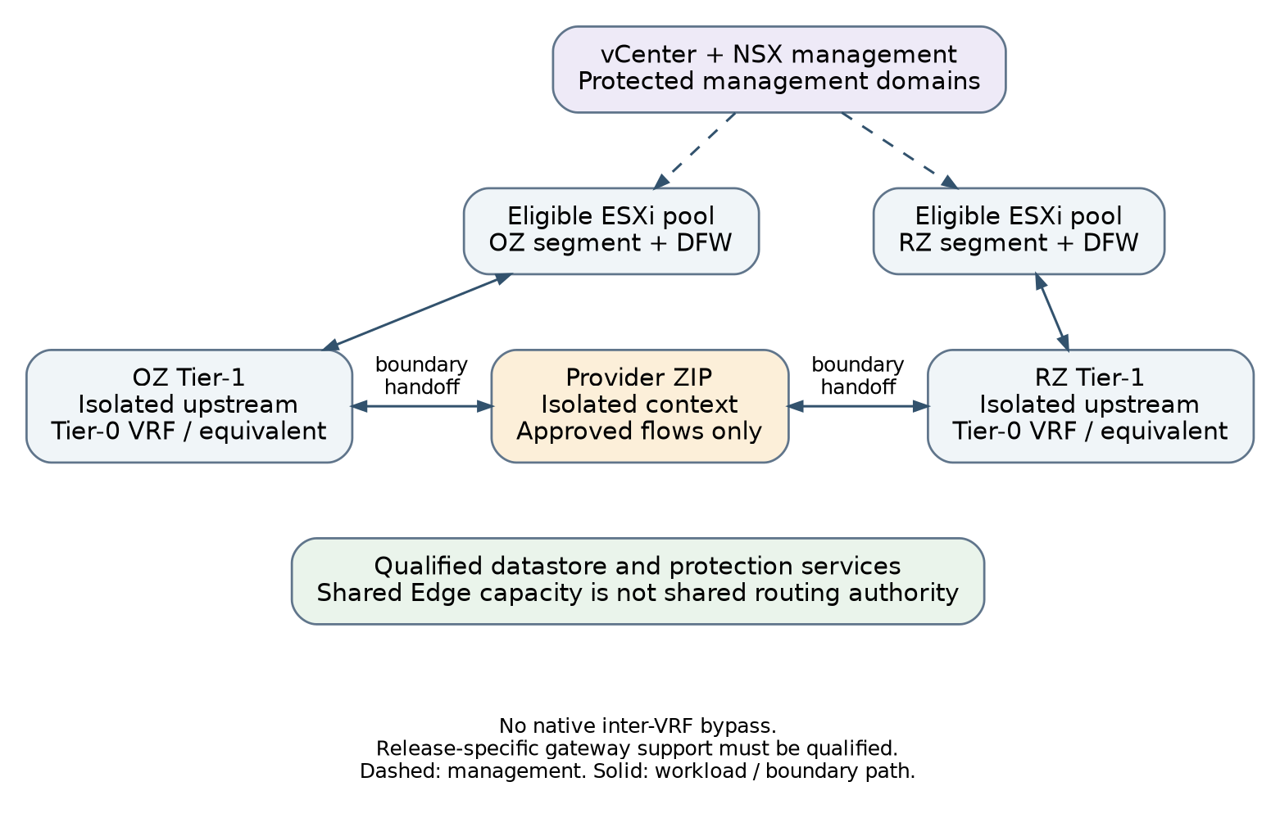
Figure 2. VMware/NSX reference realization inherited from the parent architecture
The proposed realization separates vCenter/ESXi compute and storage management from NSX networking/security and the provider security-edge service. A tenant domain uses a qualified routing context, such as a Tier-1, and an independently isolated upstream handoff, such as an available Tier-0 VRF design. A shared parent gateway or Edge cluster remains a shared failure/control dependency rather than permission to route between all domains. [B2 §17]
Architectural element | Candidate native realization | Required restriction
Tenant administration | Entitled inventory/roles and NSX project scope where used. | Project or inventory visibility does not grant global routing or provider policy control.
Domain network | Segments and Tier-1/routing context for each independent instance. | No unrestricted native joining of OZ/RZ networks.
Upstream isolation | Supported Tier-0 VRF or another qualified isolated routing handoff. | No unapproved inter-VRF route leaking or shared connected bypass.
Workload policy | Provider-owned groups/tags and distributed policy hierarchy. | Same-host enforcement and resistance to lower-priority tenant overrides.
Boundary service | Actual Edge/service-router and external security-edge functions identified. | A conceptual Tier-1/Edge symbol does not prove stateful inspection.
Compute/data | Eligible ESXi pools, placement rules and qualified datastore/protection services. | Host restart, migration and copy operations preserve the accepted sharing and key scope.

The site routing schedule identifies the actual distributed routing functions, service-router placement, route advertisements, upstream interfaces, prefix ownership and return paths. Traffic must not be able to use a common upstream table to reach another domain before the intended firewall. Native gateway or distributed enforcement may implement an alternative ZIP only when the complete required function, authority and failure analysis is accepted. [B2 §17]
The official Tier-0 VRF documentation was available through an indexed excerpt, while full-page retrieval remained restricted in the review available for this release. The candidate isolation concept is retained, but release-specific feature combinations, limits, licensing and supported provider resources are not asserted as verified. Current vendor-backed design confirmation is an open G13/G32 item, not a documentation gap closed by redrawing the diagram. [S33]
Sequence | Owned work | Completion signal
Commission compute/storage | vCenter/ESXi, eligible host groups/clusters, datastore policy and images. | Accepted control, placement, storage/key and recovery dependencies.
Commission NSX and edge | Transport nodes/zones, Edge/uplink capacity and supported isolated upstream pattern. | Actual path and gateway limits tested; baseline policy owner assigned.
Allocate domains | Tenant scope, segments/Tier-1 associations and isolated attachment capacity. | No unauthorized connected/distributed/inter-VRF path; endpoints under deny.
Create and activate endpoints | vSphere VM/data changes coordinated with NSX/edge/service changes. | Current endpoint policy, route, identity, backup and live-path verification.
Maintain/recover | vMotion/HA/restart only within eligible pools; qualified Edge failover and target restore. | Actual failure, session, placement and datastore/key results.

Do not make Terraform state boundaries synonymous with vendor products. Separate authority/lifecycle where needed; one deployment can involve a compute resource owner, NSX network owner, shared edge owner and protection owner. Document who may observe or change each native object and the safe handoff when a shared Edge or routing context is maintained.
Related engineering: Stateful boundary schedule • Authority-specific work packages • Qualification evidence

5. OpenStack: selected services, backend and mandatory policy
Selected base authority model: provider-owned identities mutate the mandatory network baseline, security groups used for that baseline, port-security settings, permitted address pairs and external attachments. Ordinary tenant direct mutation of those controls is not enabled by the base service. Existing approved request tooling may coordinate changes. Bounded direct delegation is an extension requiring effective-policy and alternate-path qualification; additive allow groups are not a mandatory deny hierarchy.
Parent architecture: RA §18 • RA §22 • RA §24
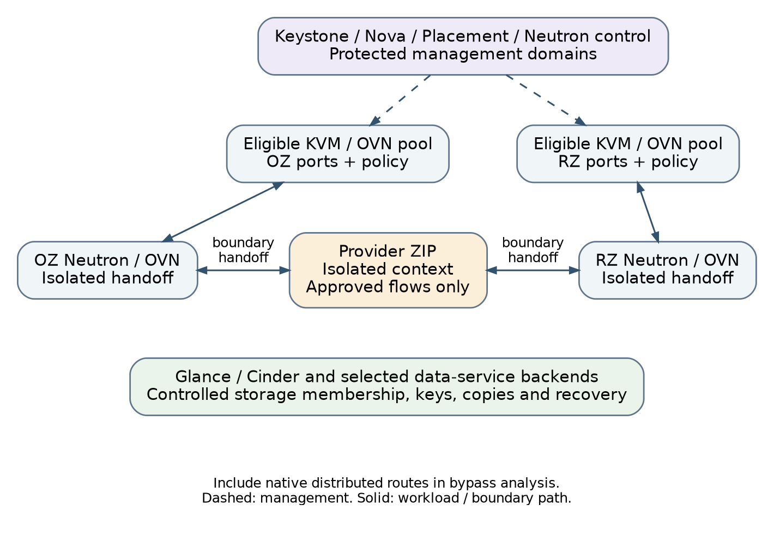
Figure 3. OpenStack reference realization inherited from the parent architecture
The reference selects a distribution with Keystone, Nova/Placement, Neutron, Glance and Cinder and illustrates ML2/OVN as its networking backend. These are an architectural candidate, not a claim that all distributions install the same service set. The official OVN reference separates control, compute and gateway roles and distinguishes distributed routing from external gateway traffic. The site must identify the actual release/backend/extensions and their failure dependencies. [B2 §18; S35]
Architectural element | Candidate native realization | Qualification focus
Administrative scope | Keystone projects, scoped roles and controlled API policy. | A tenant cannot administer provider networks or another project.
Eligible compute | Nova/Placement and configured host/aggregate scheduling constraints. | Aggregate names alone do not enforce tenant/zone placement; verify configured filters/constraints.
Domain network and route | Separate Neutron networks/subnets/ports and routing contexts, realized by the chosen backend. | OZ and RZ must not be joined by an unrestricted native router.
External handoff | Controlled provider/external attachment and selected OVN gateway placement. | No floating-address, direct provider-network or shared connected bypass.
Mandatory endpoint policy | Qualified provider-controlled baseline plus entitled tenant policy. | Security-group changes must not override mandatory isolation.
Storage and images | Glance, Cinder and selected storage/key/protection backends. | Ownership, allowed attachment/copy, consistency and recovery are independent of network reachability.

Neutron security-group policy is allow-based and groups are additive; ordinary defaults can permit egress. The reviewed official networking documentation supports treating these defaults as something to normalize, not as proof of the parent’s mandatory deny baseline. The implementation must identify a durable provider-owned enforcement or authority mechanism and test that tenant changes cannot expand the protected baseline. Direct competing edits to Neutron-owned backend objects are not an acceptable substitute. [S36]
For the common fixture, each domain has its own authorized routing context and isolated external handoff. Enumerate native logical routes, distributed paths and gateway/external paths. Sending some traffic through a gateway chassis does not prove that traffic between two subnets on a native logical router traverses that chassis or the ZIP. Include metadata, DHCP/DNS and narrow image/identity initialization requirements without creating general provider-network access.
Lifecycle stage | Supported execution owner | Required result
Control-plane installation and upgrade | Selected distribution installer/lifecycle tooling. | Accepted databases, messaging, control/network/storage services and protected management.
Tenant/project foundations | Scoped service APIs/providers under assigned authority. | Correct roles, quotas and eligible compute/storage/network service classes.
Network and boundary allocation | Neutron owner coordinated with separate security-edge owner. | Denied initial ports/networks, isolated routes/attachments and provider baseline.
Instance/volume creation | Nova/Cinder and image/protection integrations. | Correct owner, placement, image, volume and service attachments.
Observe/update/delete/recover | Authoritative service owner, not competing raw backend automation. | Asynchronous ports/routers/volumes reconcile; no stale routes or orphan grants.

The open implementation decisions are the exact distribution and service versions, configured scheduling isolation, Neutron backend/extension support, mandatory-policy protection, address-family support, external gateway topology, Cinder/key/backup integration and provider operation coverage. Qualification must also include control database/messaging/OVN and storage quorum dependencies; a healthy API endpoint alone does not establish a resilient hosting service.
Related engineering: Native operation coverage • Address-family acceptance • Platform-aware backup and restore

6. Portable, composite and migrated service choices
Parent architecture: RA §15 • RA §27
Delivery choice | Use when | Required additional design
Portable alternative placement | One bounded environment can be rebuilt on another eligible stack. | Equivalent resource/service requirements, target image/data compatibility and outcome comparison.
Composite delivery | A deliberate service uses resources across several stacks concurrently. | Explicit domain/service boundaries, latency/capacity budget, common dependency and coordinated recovery ownership.
Cross-platform migration | Actual workload/data state moves from one stack to another. | Supported transfer/conversion, consistency point, fencing, cutover, reverse-data handling and source retirement.
Intra-platform live mobility | The qualified vendor platform moves a running workload inside an eligible arrangement. | Supported compute/storage/transport compatibility, retained policy and placement constraints.

The default remains one bounded WSD realization in an eligible cell with explicitly consumed shared services. A composite placement needs a reason beyond spare capacity: network delay, data consistency, coupled maintenance and cross-stack restore can become dominant dependencies. It does not require a common cross-vendor overlay. Independent domains communicate through the approved service/security boundary. [B2 §§15, 27]
Terraform can prepare target resources and controlled transfer connectivity; it does not itself make application state consistent or guarantee live migration across unrelated hypervisors. Data and image transfer uses a supported tool and an approved owner. After writes begin at the target, returning to the source may require reverse synchronization or restore; restarting a stale source is not a safe generic rollback.
Acceptance compares the same architectural outcomes, not identical topology. Record any lost optional function, changed operating task, required guest driver/boot change, data export limitation or special device dependency. A mandatory capability cannot be silently downgraded to keep a portability claim. Extensions remain visible in the service description and exit plan.
Related engineering: Recovery and failback • First-stack and portability qualification

7. Implementation tuple and decision package
Parent architecture: RA §15 • RA §16 • RA §17 • RA §18 • RA §22 • RA §30
Each native realization needs a controlled implementation record before it is offered. This is an engineering record, not a new custom API schema. Preserve the exact hardware/firmware, product/service releases, enabled features, licences/entitlements, network/storage backends, management topology, API/provider versions and installer/tool ownership. A source review date or a provider repository version is not evidence that the installed combination is supported.
Record | Must answer | Blocking condition
Component and interface schedule | What exists, where it runs, how it connects and who owns it. | A diagrammed boundary has no actual routing/enforcement component.
Sharing and failure map | Which hosts, storage, managers, edge and trust dependencies are common. | Claimed dedication or independence is unsupported.
Operation support | Which tool creates, observes, changes, adopts, replaces, deletes and reconciles each native resource. | Required operation has only a placeholder or unmanaged side effect.
Service capability and limits | Which families, exposure, recovery and isolation classes were measured under which conditions. | An optional/unsupported feature is advertised as mandatory capability.
Evidence and decisions | Which tests ran on this tuple, which limits or exceptions apply and who approved use. | Candidate documentation or expired evidence substitutes for qualification.
Source currency | Which documentation edition was reviewed, what was inaccessible and what requires vendor confirmation. | A historic or restricted page is represented as full current verification.

The supplied operation-coverage CSV is intentionally unqualified. Populate a row with actual resource types and supported operations, attach current vendor evidence and execute the lifecycle scenarios. Where another owner or installer manages the resource, name that owner and the accepted handoff rather than forcing the object into Terraform state. A provider change may require requalification even if the running platform release is unchanged.
Related engineering: Vendor decision gaps • Operation-level matrix • Evidence applicability

References — Parent basis and external context
Source IDs distinguish baseline-derived architecture from external context. References inform the stated design, not automatic adoption, installed compatibility or authorization. New engineering examples are local proposals. Review status below is specific to this release; inherited dates are not recertified merely by copying the source register.

B2 — Portable Secure Hosting — Infrastructure Reference Architecture and Cross-Platform Provisioning Strategy, Draft v1.2
16 September 2026; 55-page conversation baseline | Source baseline, not external authority
Primary parent narrative, diagrams, 30 sections, 194 requirement IDs and referenced verification catalogues.
Review status: Entire text read; three vendor diagram pages also inspected through Files; source bytes verified.
Source file: Portable_Secure_Hosting_Infrastructure_Architecture_v1_2.docx. Complete baseline fingerprint is in registers/release_manifest.json.

S03 — ITSP.70.010 - Best practices for data centre virtualization
Effective 2020-03-27 | Cyber Centre guidance
Section 3: strong recommendation against co-locating VMs from different network security zones on the same physical hardware. Sharing requires explicit risk analysis, not a VPC claim.
Review status: Full official page reviewed: virtualization/management/storage separation context.
Open official source — ITSP.70.010 - Best practices for data centre virtualization

S31 — Nutanix — Configuring NAT and No NAT VPCs in Flow Virtual Networking
2022-10-18; conceptual reference | Official implementation documentation; not certification
External subnet and NAT/no-NAT concepts; historic feature limits are not asserted as current release limits.
Review status: Historic official article reviewed for NAT/no-NAT concepts only; not current product limits.
Open official source — Nutanix — Configuring NAT and No NAT VPCs in Flow Virtual Networking

S33 — Broadcom — NSX Tier-0 VRF gateways
NSX 4.2 documentation reference | Official implementation documentation; not certification
Isolated routing instances under a parent Tier-0. Official indexed excerpt inspected; full-page request returned HTTP 403. Release-specific limitations not independently verified.
Review status: Official indexed excerpts inspected; full-page retrieval unavailable. Exact release/feature limits remain unverified.
Open official source — Broadcom — NSX Tier-0 VRF gateways

S35 — OpenStack Neutron — OVN reference architecture
2026.1 documentation branch | Official implementation documentation; not certification
Role separation, distributed routing and external gateway behaviour. Documentation branch is not the chosen production release.
Review status: Official 2026.1 reference branch reviewed for OVN roles/routing; not selected installed release.
Open official source — OpenStack Neutron — OVN reference architecture

S36 — OpenStack Neutron — OpenStack Networking
2026.1 documentation branch | Official implementation documentation; not certification
Port/security-group/provider-network semantics; selected backend-specific behaviour is separately qualified.
Review status: Official 2026.1 reference branch reviewed for security-group and network semantics.
Open official source — OpenStack Neutron — OpenStack Networking

v1.4 — Connected infrastructure design and acceptance

Concrete schedules and protected network-policy ownership
The same WD resource and path identities are mapped to each native platform. For the base OpenStack realization, provider-owned roles retain mutation of mandatory network policy, port security, address pairs and external attachment. Tenant requests may use existing approved tooling; a bespoke controller is not required. Direct delegated editing is an extension requiring evidence that it cannot widen the mandatory envelope. Additive security-group allows are not a provider deny hierarchy. The complete fixture also reserves a temporary intra-domain probe; four single-endpoint domains alone cannot prove paired same-domain behavior.
Authoritative linked treatment: WD — Worked Infrastructure Design, Build Schedules and Acceptance
Read this clarification with the original chapter. It does not create an exemption to an adopted requirement, waive a mandatory control, select an unknown site value or report a live test as passed.
Policy model | Base service choice | Extension condition
Provider-managed baseline | Only approved provider identities mutate protected network policy and attachment settings. | Actual API/native roles and alternate creation paths tested.
Bounded tenant delegation | Not part of the unqualified base offer. | A supported effective-policy envelope must survive additive permits, new ports/NICs, address pairs and alternate router/external paths.

